**Thread Group->**Thread group is the basic element of the JMeter Test plan. As said in the name Thread group is a group of threads that are executing the same scenario.

**Ramp Up Time->**The JMeter Ramp-up Period is the amount of time in seconds it will take in JMeter to add all test users (threads) to a test execution. Or, in other words, how long it will take for JMeter to start execution of all the threads.

**View Tree Listener->**The **View Results Tree** listener displays samples that the JMeter samplers generate, and the assertion results that are related to these samples. This listener displays the samples in the order they are generated by the JMeter script, and provides parameters and data for each of them.

**Aggregate Graph🡪** Essentially it creates a table to show the outcome with a line for each example independently and displays data about Throughput, KB/Sec worth, Average Time, Median worth, 90% Line, 95% Line, almost 100% Line, Minimum Response Time, Maximum Response Time, Error %. At the lower part of the table, you can likewise track down the Total incentive for every last one of these fields.

**Summary Report->**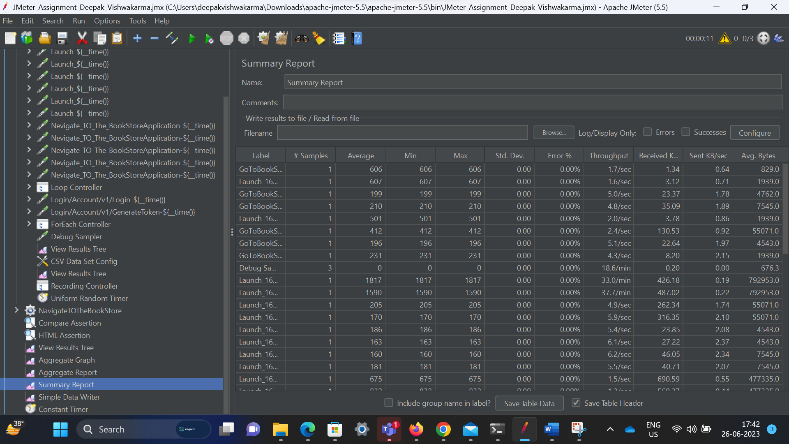

**Simple Data writer**

**Aggregate report🡪**

