Financial Loan Application
Project Requirement Document (Microservices)
Angular • ASP.NET Core Microservices (4) • Ocelot API Gateway • SQL Server • EF Core Code-First • JWT

A) Application Overview
Cap FinLoan is a web-based loan onboarding and approval system. Applicants can register, apply for loans using a guided wizard, upload KYC/income documents, and track the application status in real time. Admin users can verify documents, review applications, approve/reject with sanction terms, and generate operational reports. The solution is built as microservices with an Ocelot API Gateway.

B) Objective
• Provide an end-to-end digital loan journey for applicants.
• Reduce manual processing time using clear statuses, validations, and document verification.
• Enforce role-based security using JWT + Angular route guards.
• Demonstrate enterprise-ready architecture: 4 microservices + API gateway + EF Core code-first + automated testing.

C) Roles & Access Control
Mandatory Roles:
1) Applicant
• Register/Login
• Create/Update draft application
• Submit application
• Upload/replace documents
• Track status timeline and view decision
2) Admin
• View application queue
• Verify documents (mark verified/unverified)
• Review applications and approve/reject with remarks and terms
• Generate reports and manage users
Security Implementation:
• Angular: ApplicantGuard protects /applicant/*, AdminGuard protects /admin/*.
• Backend: JWT Bearer auth + [Authorize(Roles="ADMIN")] for admin endpoints.
• All service APIs are called via Ocelot gateway; direct service calls are blocked in production setup.

D) UI Design Architecture (Angular)
Angular Modules (recommended):
• CoreModule: layout (navbar/sidebar/footer), interceptors, error handling
• SharedModule: reusable UI (table+filters, status badge, stepper form controls, modal dialogs, upload component)
• AuthModule: login, signup
• ApplicantModule: dashboard, apply wizard, documents, status tracking
• AdminModule: queue dashboard, review/decision, verification, users
• ReportsModule (optional): reports charts and exports
Routing (example):
• /auth/login, /auth/signup
• /applicant/dashboard, /applicant/apply, /applicant/documents, /applicant/status/:id
• /admin/dashboard, /admin/review/:id, /admin/reports, /admin/users
JWT Integration:
• Use HttpInterceptor to attach Authorization: Bearer <token>.
• Store token securely (session storage recommended for training).

UI Design Pattern
Chosen pattern: Wizard/Stepper Pattern
• Why: Loan application forms are long; a stepper reduces user drop-off by splitting input into small steps.
• Where: Apply Loan flow uses 4 steps (Personal → Employment → Loan Details → Review).
• Rules: Users can Save Draft at any step; Submit allowed only after validations pass.

E) Page-by-Page Functional Requirements

1. Landing Page
Purpose: Public homepage for product discovery and entry.
UI: Hero banner, product cards, CTA buttons.
Validations: N/A
API: Optional GET /products
Navigation: Apply Now → Signup/Login.

2. Signup Page
Purpose: Create Applicant account.
Fields: Name, Email, Phone, Password.
Validations: Email format, unique email, strong password.
API: POST /auth/signup (Auth Service).
Messages: Account created / duplicate email.

3. Login Page
Purpose: Login for Applicant/Admin.
Fields: Email, Password.
API: POST /auth/login returns JWT + role.
Navigation: Role-based redirect to Applicant/Admin dashboard.

4. Applicant Dashboard
Purpose: Applicant overview.
UI: KPI cards, applications table.
API: GET /applications/my (Core Service).
Actions: Apply New, Upload Docs, Track Status.

5. Apply Loan (Wizard)
Purpose: Create and submit an application.
Steps: Personal, Employment, Loan Details, Review.
Validations: Required fields, numeric ranges, eligibility checks.
API: POST /applications (draft), PUT /applications/{id}, POST /applications/{id}/submit (Core Service).

6. Document Upload & Management
Purpose: Upload/replace KYC/income documents.
UI: Drag-drop area + uploaded table.
Validations: File type PDF/JPG/PNG, max size.
API: POST /documents/upload (Documents Service).

7. Track Status (Timeline)
Purpose: Show status flow with dates and next steps.
UI: Timeline component.
API: GET /applications/{id}/status (Core Service) + GET /decisions/{id} (Admin/Reporting Service).

8. Admin Dashboard (Queue)
Purpose: Admin operational view.
UI: Filters + queue table.
API: GET /admin/applications (Admin/Reporting Service).
Actions: Open Review.

9. Admin Verification
Purpose: Verify documents.
UI: Document list + preview.
API: PUT /admin/documents/{docId}/verify (Documents Service via gateway).
Rules: If unverified, request re-upload and update status note.

10. Admin Review & Decision
Purpose: Approve/Reject with terms.
UI: Applicant summary + docs + decision panel.
API: POST /admin/applications/{id}/decision (Admin/Reporting Service).
Messages: Approved/Rejected notification triggered.

11. Admin Reports
Purpose: Operational reports.
UI: Charts, summary metrics, export.
API: GET /admin/reports/summary (Admin/Reporting Service).
Exports: CSV/PDF.

12. Admin User Management
Purpose: Manage users/roles.
UI: User list, activate/deactivate.
API: GET /admin/users, PUT /admin/users/{id}/status (Auth Service or Admin service based on design).

F) Status Lifecycle
Standard statuses:
Draft → Submitted → Docs Pending → Docs Verified → Under Review → Approved/Rejected → Closed
Who can change status:
• Applicant: Draft → Submitted
• Documents Service/Admin: Submitted → Docs Pending/Docs Verified
• Admin: Docs Verified → Under Review → Approved/Rejected → Closed

G) Microservices System Architecture (4 Services + Ocelot)
Architecture style: Microservices with API Gateway.
• All Angular clients call the Ocelot Gateway.
• Gateway routes requests to 4 independent services.
• Each service uses EF Core Code-First and maintains its own data boundaries.
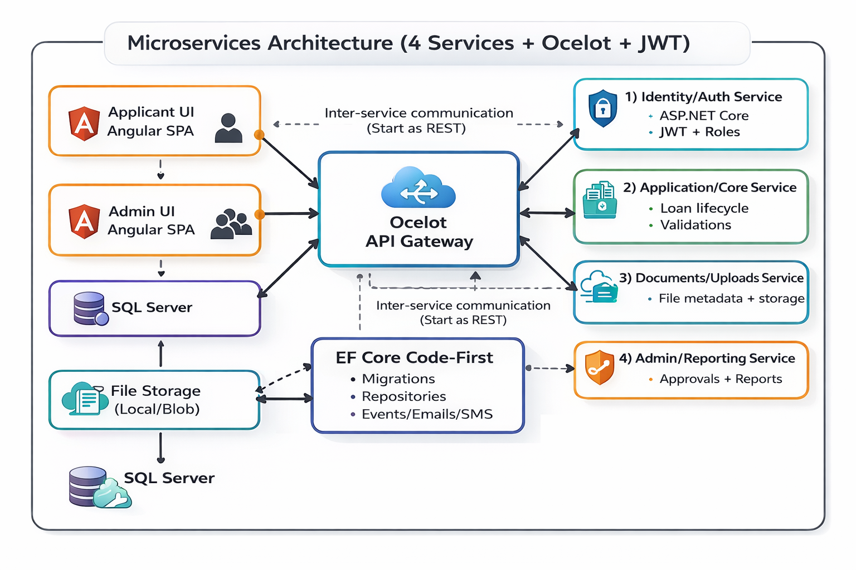

Microservices List
1) Identity/Auth Service
• Authentication (JWT), roles, user activation.
2) Application/Core Service
• Loan application lifecycle, validations, status transitions.
3) Documents/Uploads Service
• Document upload, metadata, verification flags, storage integration.
4) Admin/Reporting Service
• Admin workflows: queue, decisions, reports, exports.

Ocelot Gateway Route Outline (Example)
• /gateway/auth/* → Identity/Auth Service
• /gateway/applications/* → Application/Core Service
• /gateway/documents/* → Documents Service
• /gateway/admin/* → Admin/Reporting Service
Note: Actual upstream/downstream paths will be defined in ocelot.json.

H) Database Design (SQL Server + EF Core Code-First)
Approach: EF Core Code-First.
• Entities are defined in code (C# models) inside each service.
• Migrations are generated per service and applied to SQL Server.
• For training, shared SQL Server instance is acceptable; use schemas per service or separate databases.
Recommended training option: Shared SQL Server with separate schemas
• auth.Users, core.LoanApplications, docs.Documents, admin.Decisions, admin.Reports
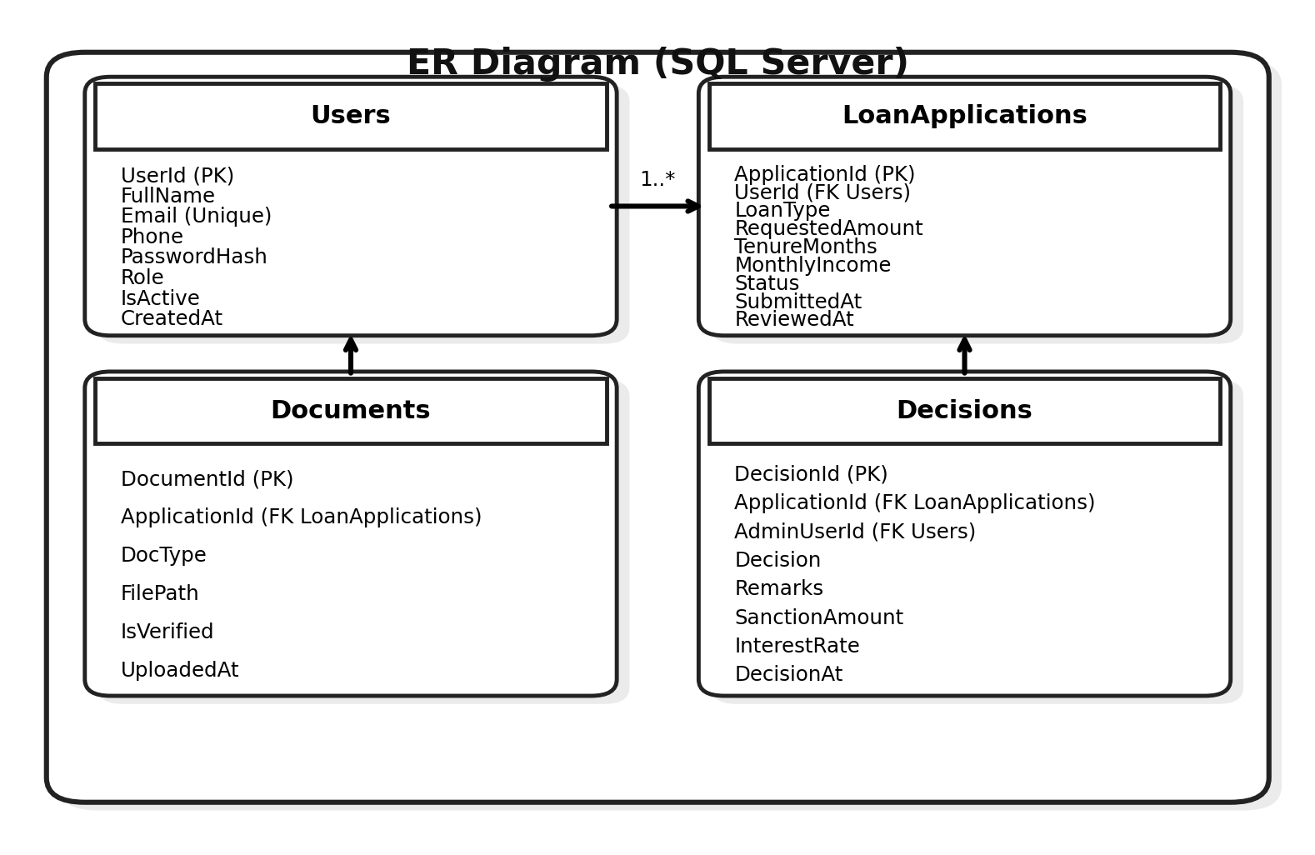
This is sample ER Diagram associate can come with own design and diagram

EF Core Code-First Steps (Student must implement)
1) Create entity classes (Models).
2) Create DbContext per microservice.
3) Add EF Core packages.
4) Create migrations: Add-Migration InitialCreate (or dotnet ef migrations add).
5) Apply migrations: Update-Database (or dotnet ef database update).
6) Verify tables in SSMS.
Note : DTO models should used for data transactions.

I) REST API Summary (By Service + Gateway)
Gateway (Ocelot):
• POST /gateway/auth/login
• POST /gateway/auth/signup
• GET /gateway/applications/my
• POST /gateway/applications
• POST /gateway/applications/{id}/submit
• POST /gateway/documents/upload
• GET /gateway/admin/applications
• POST /gateway/admin/applications/{id}/decision
• GET /gateway/admin/reports/summary
Service endpoints must be grouped inside the PRD per microservice (Auth/Core/Documents/Admin).
Use Postman/Swagger for Api testing and API Documentation.

J) Software Required
- Frontend:
• Node.js LTS
• Angular CLI ( from 19)
• VS Code
- HTML, CSS
Backend:
• .NET SDK (LTS)
• Visual Studio 2022 / VS Code
API Gateway:
• Ocelot NuGet package
Database:
• SQL Server Developer
• SSMS
Quality:
• SonarQube (optional local setup) or analyzer extensions

K) Testing & Quality Plan
Backend Unit Testing (NUnit):
• Write unit tests for services, validators, and repositories.
• Mock dependencies (e.g., repositories, file storage adapters).
• Code coverage target: ≥ 90%.
• Coverage tooling suggestion: coverlet.collector + ReportGenerator.
Frontend Unit Testing (Angular - Jasmine/Karma):
• Test critical components: Apply wizard, Upload component, Status timeline.
• Test services with HttpTestingController.
• Test guards for role-based access.
Code Quality + Vulnerability Testing:
• Prefer SonarQube for code smell, bug and vulnerability analysis.
• Alternatives (acceptable): .NET analyzers, Roslyn analyzers, npm audit (Angular dependencies).

L) Student Deliverables (Diagrams + Planning)
Students must create and submit the following diagrams:
1) Use Case Diagram
2) Class Diagram
3) Sequence Diagram (for Apply Loan + Document Upload workflow)
4) ER Diagram (SQL Server schema)
Students must also create project planning artifacts:
• WBS (Work Breakdown Structure) for UI, gateway, and 4 services.
• Agile sprint plan (2-week sprints recommended) using Azure Boards / Jira / Trello.
• Sprint-wise backlog with story points/hours, sprint goals, and Definition of Done.

M) Test Cases (Table Format)
Test Case | Role | Steps | Expected Result | Type | Related Service
TC01 | Applicant | Signup with valid details | Account created, can login | Positive | Auth Service
TC02 | Applicant | Signup with duplicate email | Validation error, no user created | Negative | Auth Service
TC03 | Applicant | Login with valid creds | JWT issued and stored, redirected | Positive | Auth Service
TC04 | Applicant | Create application draft | Draft created with ApplicationId | Positive | Core Service
TC05 | Applicant | Submit with missing required fields | Inline errors, submit blocked | Negative | Core Service
TC06 | Applicant | Upload PDF within size limit | Upload success, doc listed | Positive | Documents Service
TC07 | Applicant | Upload unsupported file type | Upload rejected with message | Negative | Documents Service
TC08 | Admin | View admin queue | Queue list displayed | Positive | Admin/Reporting Service
TC09 | Admin | Verify KYC as valid | Doc status Verified; visible to applicant | Positive | Documents Service
TC10 | Admin | Approve with sanction terms | Status Approved; decision saved | Positive | Admin/Reporting Service
TC11 | Admin | Reject with reason | Status Rejected; reason saved | Positive | Admin/Reporting Service
TC12 | Applicant | Try to access /admin route | Blocked (guard) + API returns 403 | Security | Gateway + Auth

N) Deliverables & Evaluation Criteria
Area | What to Evaluate | Weightage
Architecture | 4 microservices + Ocelot routing working end-to-end | 20%
Security | JWT auth + role-based access (Angular guards + API authorize) | 15%
Data Layer | EF Core code-first, migrations, clean models | 15%
UI | Screens match wireframes; Wizard/Stepper pattern implemented well | 15%
Testing | NUnit coverage ≥ 90%; Jasmine tests for key modules | 20%
Quality & Planning | Sonar/Lint + vulnerability check; WBS + sprint plan; diagrams | 15%

O) Conclusion
This PRD provides a complete blueprint for building a Financial Loan Application using Angular, ASP.NET Core microservices, Ocelot API Gateway, SQL Server, and EF Core code-first. It includes well-designed wireframes, a microservices architecture diagram, a database ER diagram, and clear student deliverables covering diagrams, testing, quality checks, and agile planning.

📲 Screen Design (Wireframes)
The following wireframes must be implemented by students during development.
Wf01 Landing
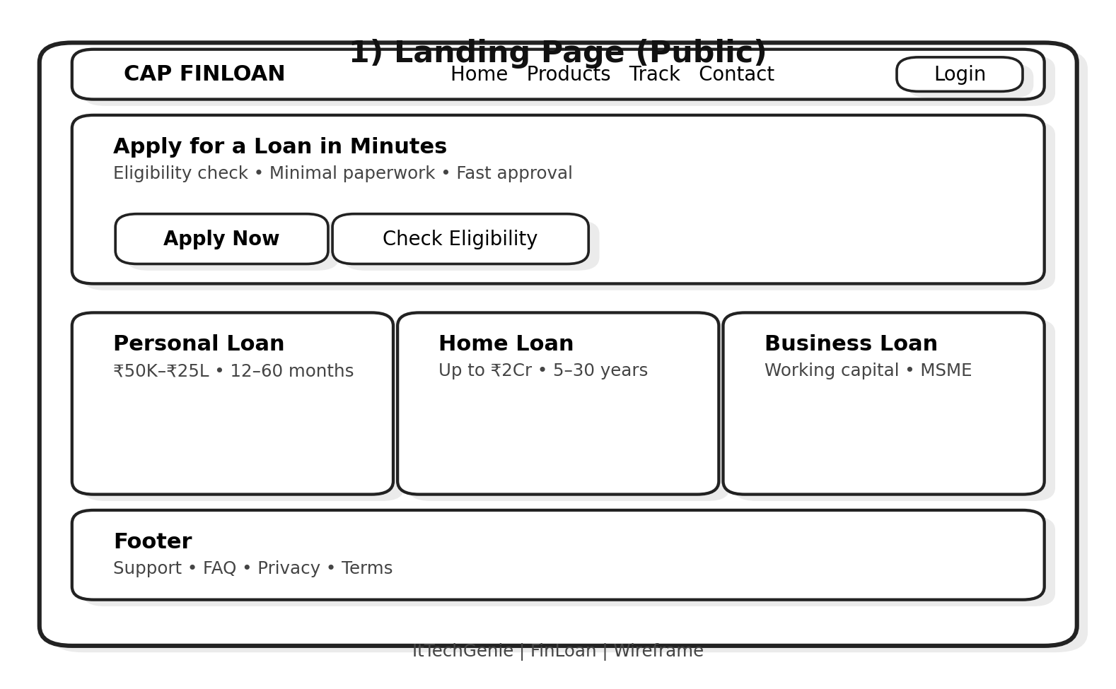

Wf02 Auth
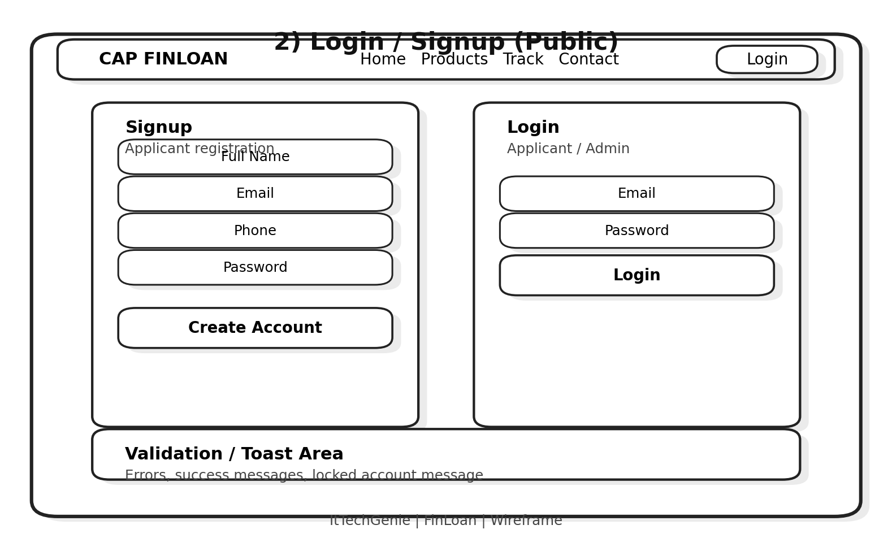

Wf03 Applicant Dashboard
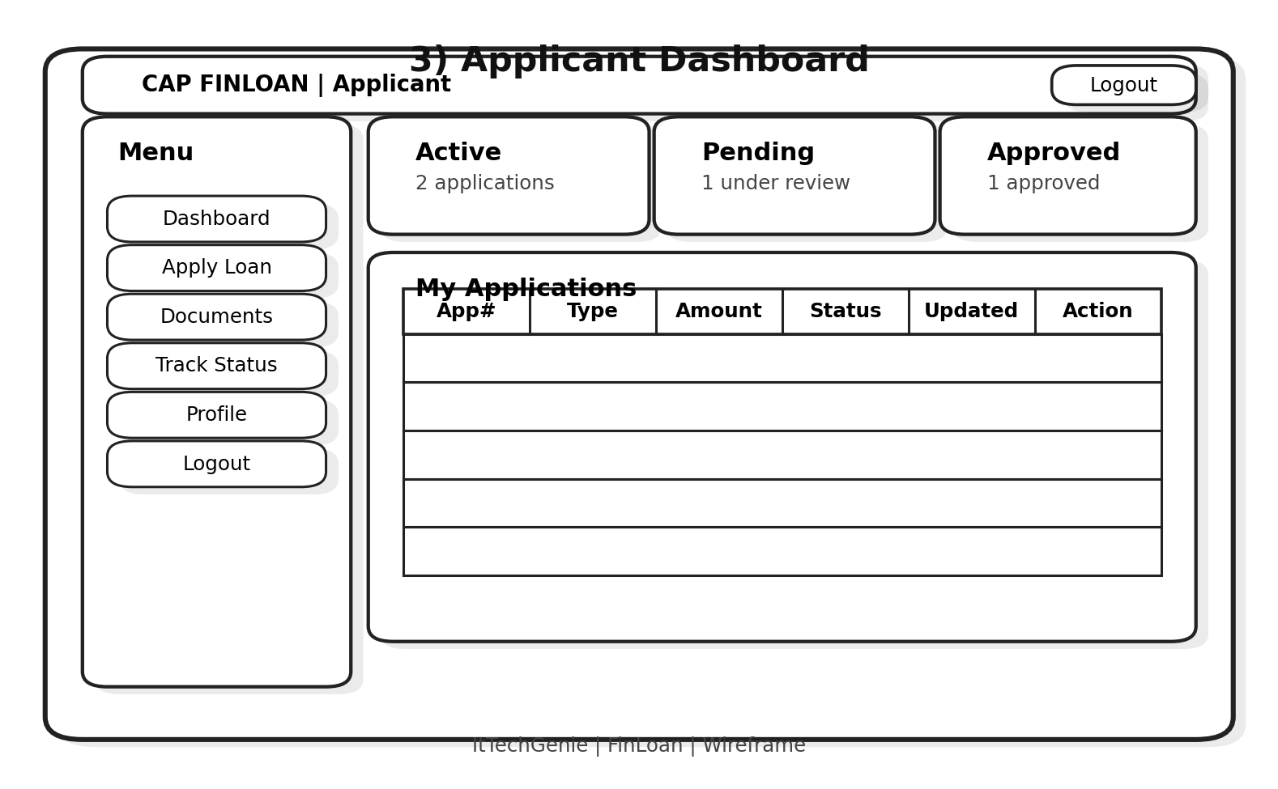

Wf04 Apply
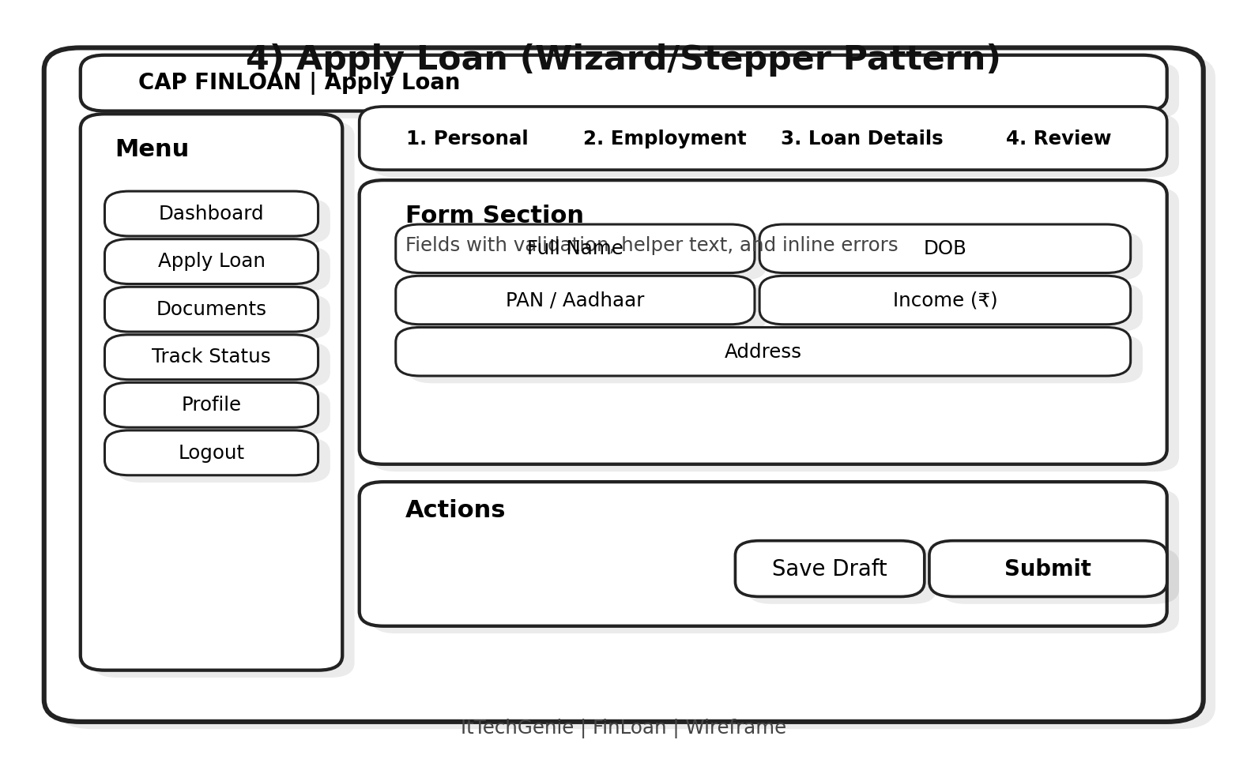

Wf05 Documents
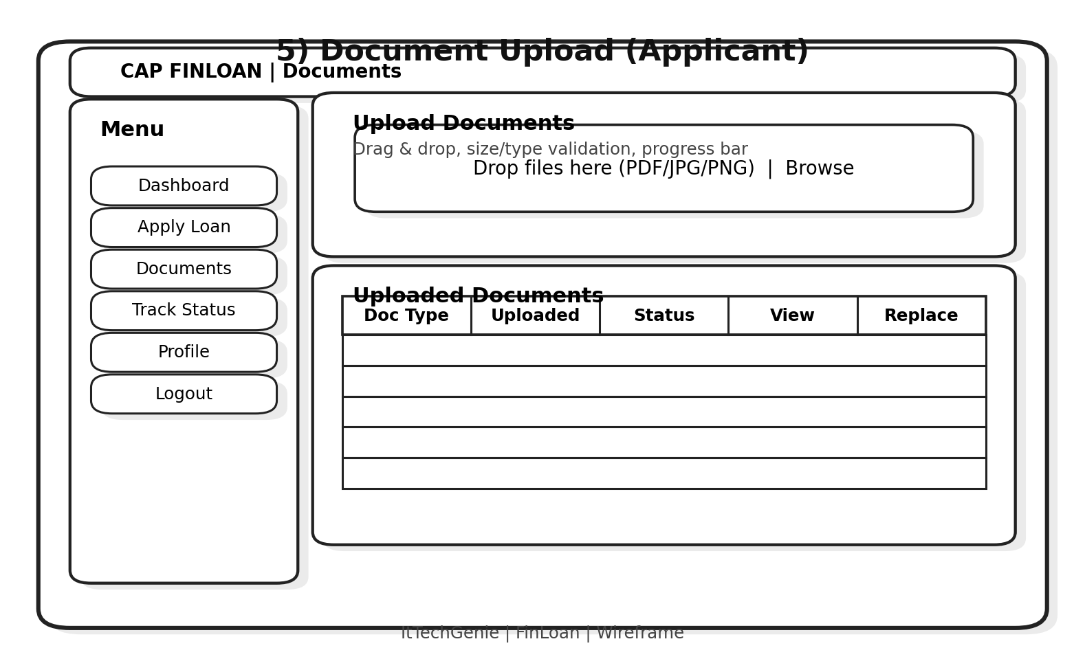

Wf06 Status
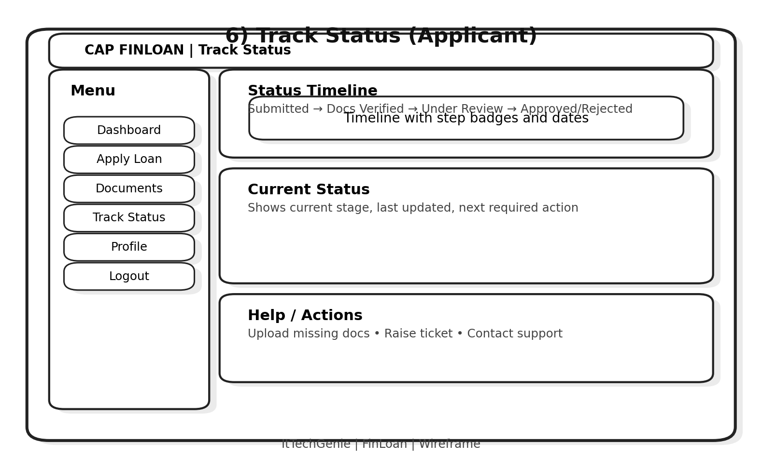

Wf07 Admin Dashboard
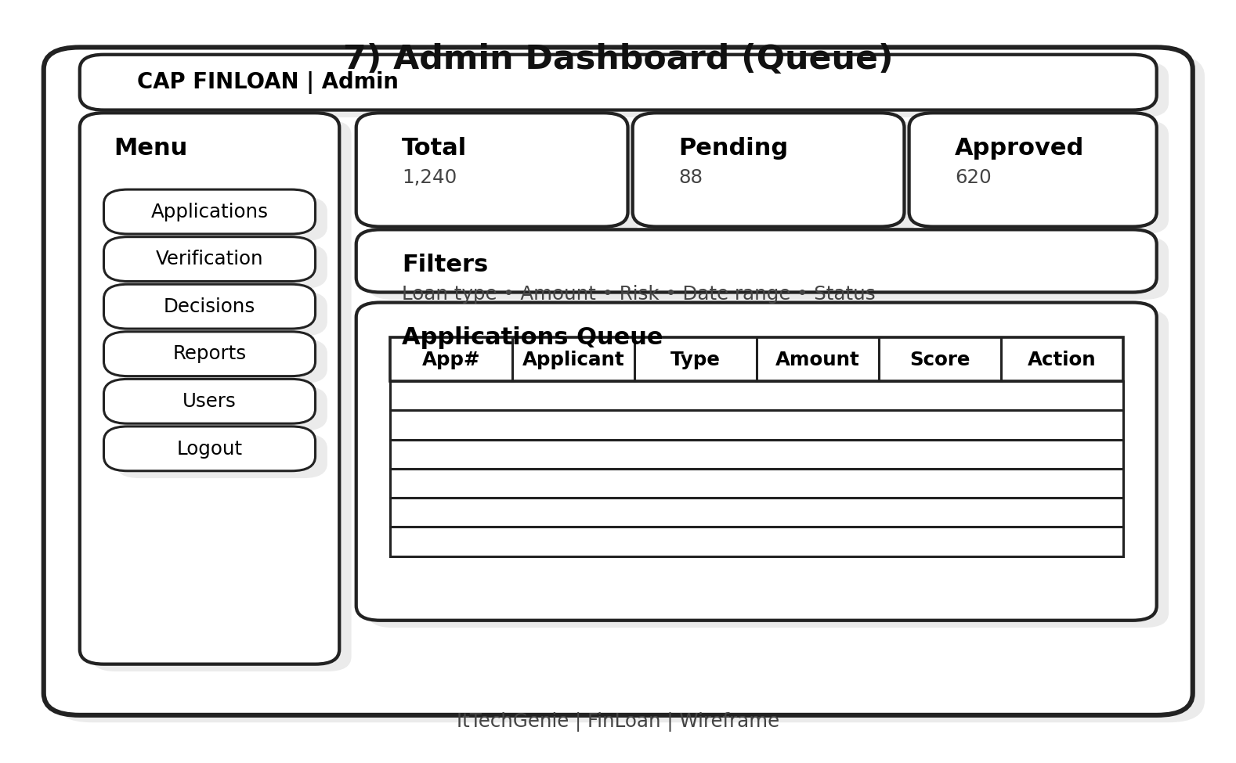

Wf08 Admin Review
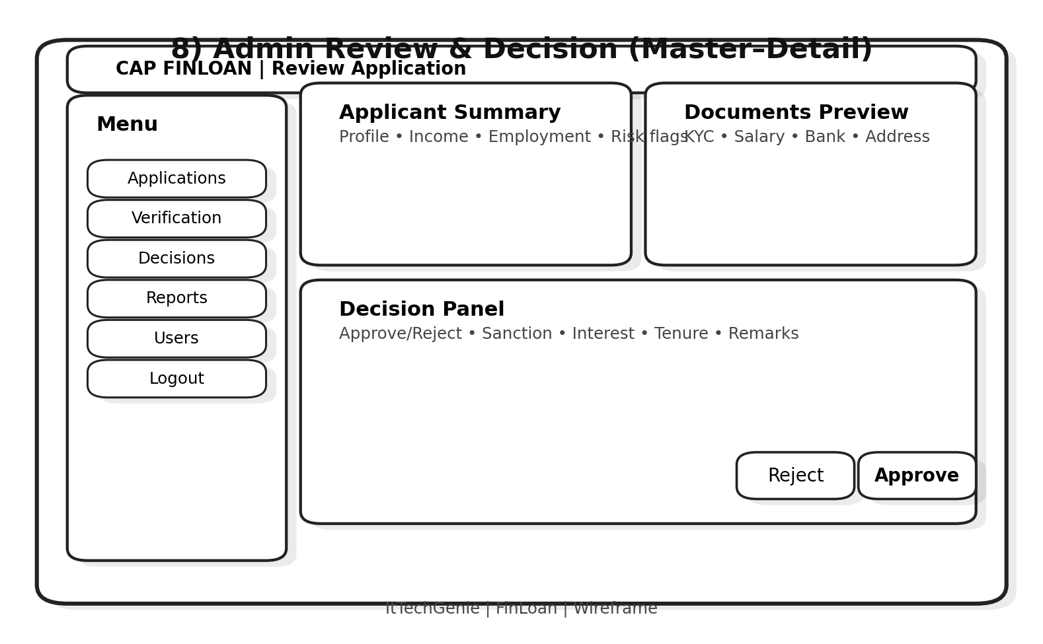

Wf09 Reports
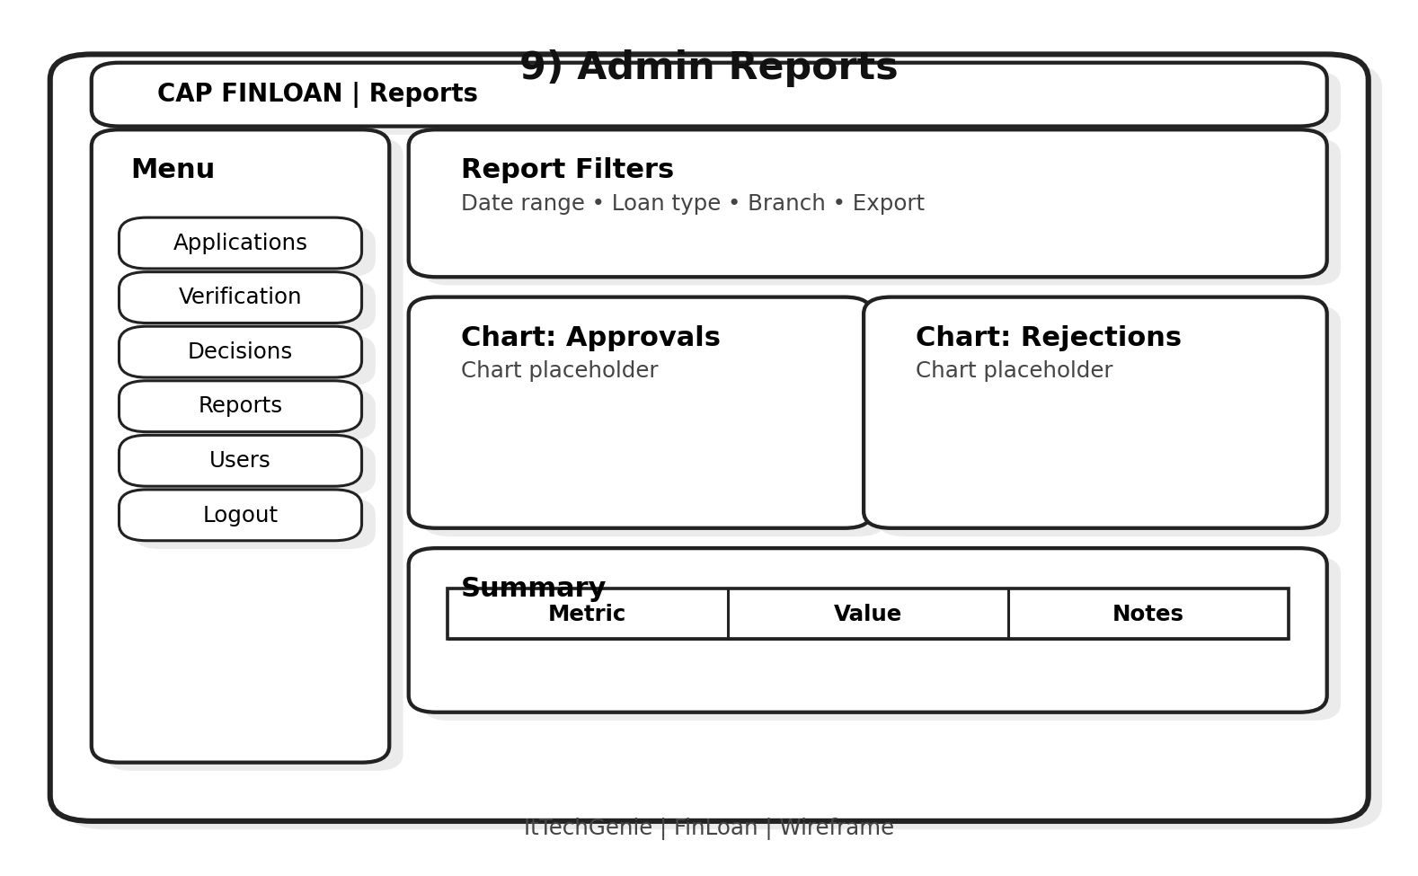

Wf10 Users
