Value-Aware Team-Level Stopping for Multi-Robot Exploration
Study guide to the revised proposal deck: every slide, formula, metric, result and likely question explained
Chaitanya Goyal (2024A7PS0557P)
Supervisor: Prof. Avinash Gautam · BITS Pilani
Companion to Value_Aware_Stopping_Proposal_v2.pptx · 30 September 2026

How to use this document
This document explains everything in the revised deck (Value_Aware_Stopping_Proposal_v2.pptx, 32 slides): every term, every formula, every number, where each number comes from, what it does and does not prove, and the questions your professor is likely to ask. It is written so that you can present the project without memorising anything you do not understand.
Read it in this order:
- Part 1 (the story and the corrections) — 10 minutes. Read this first, even if you read nothing else.
- Part 2 (background concepts) — every technical word used in the deck, explained from zero.
- Parts 3–4 (formulation and prototype) — exactly what the problem is and exactly what the code does.
- Parts 5–6 (metrics and results) — how methods are judged, and every result with its honest interpretation.
- Part 7 (slide by slide) — for each slide: what it shows, what to say, and what not to say.
- Part 8 (cross-questions) — about 45 likely questions with answers.
- Part 9 (reading list) — verified papers, what each one does, what to read first.
- Part 10 (numbers cheat sheet and full results table).
Where the numbers and citations come from
Every number in the deck and in this document was recomputed from the saved experiment runs in the prototype folder (results/). The scripts extra_metrics.py to extra_metrics4.py in the prototype reproduce them; results/extra_metrics.json stores them.
Every paper cited was checked against its publisher page, DOI or arXiv entry. One very recent preprint that appeared in searches (ICMAPE, "In-Context Multiagent Pure Exploration", arXiv 2609.33986, posted around 29 September 2026) could not be opened because the site rate-limited the request. Read its abstract before the presentation in case it overlaps.

Part 1. The story in one page, and what changed

1.1 The project in plain words
A team of robots is sent into a building nobody has mapped. They move around, see what is near them, share what they see, and build a map together. Every cycle of this costs something: the robots drive (energy, time), they send map updates to each other (bandwidth), and the team has to re-plan who goes where (computation, coordination).
At the start, every cycle reveals whole rooms. Near the end, the unexplored space is small corners and pockets spread across the building; reaching them needs long drives for little new map. At some point one more cycle costs more than it is worth. The project asks: can the team learn to recognise that point and stop there?
Today, exploration systems stop with a fixed rule: when nothing unknown is reachable, when some percentage of the area is mapped, or when a time budget runs out. These rules do not look at what the rest of the map is likely to be worth compared with what it will cost, and the thresholds have to be re-tuned whenever the team, the building or the cost of communication changes.
The proposal treats this as an optimal stopping problem (a classical branch of probability: when should you stop a process to get the best expected result?) and wants to learn the stopping decision with hierarchical multi-agent reinforcement learning: a team-level policy that decides stop/continue once per cycle (Level 1) on top of per-robot policies that decide where each robot goes (Level 2).

1.2 What the week-1 prototype shows, honestly
- In the training setting (2 robots, 32×32 maps), the learned stop scores 91% of the best possible net value, against 92% for the best hand-tuned rule. The 95% confidence intervals overlap: it is a tie, not a win.
- Its estimate of "how much value is left" ranks situations well against the value known in hindsight (correlation r = 0.88; right sign — continue vs stop — at 89% of decision points).
- Tested without retraining on 36 settings (2–8 robots, 32–64 cell maps, three communication costs; 35 new settings plus the training setting, all on unseen maps), it is as good as the best tuned rule in a typical setting (interquartile mean 89% vs 89%), but much safer in the worst case: in no setting does it lose more than 9.9% of the map's worth of value on average (single maps can be worse), while the tuned coverage rule loses up to 25.3%, and the tuned rules collapse badly (large negative scores) when teams are big and messages are expensive.
- A simple rule that is re-tuned separately for every new setting (using that setting's own test maps) does about as well as the learned rule. So the learned rule's value is that it gets there without needing data and tuning for every new deployment.
- It has one clear failure: with 2 robots on bigger maps (48×48, 64×64) it stops 20–33 cycles too early and scores about 75% against about 92% for the coverage rule.
- It is not yet multi-agent RL: robot movement (Level 2) is a fixed greedy rule and the stop (Level 1) is learned by one central learner. Making it genuinely MARL is the semester's work.

1.3 Corrections to what I told you earlier
While re-checking every number for this document I found four things that were wrong or misleading in the old deck or in my earlier explanations. The new deck fixes all of them. Do not use the old slide 9.
What was said before | What is correct | Why it matters
"83% vs ≤52%: mean across 36 unseen settings" (old slide 9) | Averaging percentages across settings is misleading here. In the hardest settings the best achievable value is tiny (≈27 cells on average for 8 robots, 32×32, high communication; on 14 of 40 maps there it is not worth exploring at all). Dividing by a tiny number turns small losses into −732% or −1411%, which drags the average down. With a robust average (interquartile mean) learned and coverage both score 89%. | A professor who knows statistics can break the "83 vs 52" claim in one question. The robust version (same typical score, much better worst case) cannot be broken.
"93% vs 92%" on the training setting | 93% was on the 100-map test set. A second, independent set of 40 maps from the same setting gave 87% vs 93% (coverage better). Pooled over all 140 maps: 91% [89–93] vs 92% [91–94], difference not significant. | "Tie" is correct; "slightly better" is not.
"One-step look-ahead" baseline | The rule stops after the first cycle whose value was negative. It looks back at the last cycle, not ahead. The new deck calls it the myopic rule: stop after a losing cycle. | If asked "how does your look-ahead predict the next cycle?" the old name has no answer.
Info-gain rule: "stop when expected new cells < 1.6 × cycle cost" | The rule stops when α × (expected gain ÷ cycle cost) < 1 with α = 1.6, i.e. when expected gain < cycle cost ÷ 1.6 ≈ 0.63 × cost. | Getting a baseline's definition wrong in front of the professor looks careless.

The headline you should use
The honest headline is weaker than the old one: "matches the best tuned rule in typical conditions, avoids its catastrophic failures when costs change, needs no re-tuning; fails on much larger maps with small teams; not yet MARL."
That is fine for a proposal. A proposal is judged on whether the question is real, the method is sound, and the evaluation is honest. A first prototype that ties strong baselines and shows exactly where the idea helps and where it fails is good evidence. An inflated claim that collapses under one question is not.

1.4 Is this incremental research? Yes — and that is normal
Almost all research is incremental: it takes known pieces and combines or extends them to answer a question nobody answered before. Here the known pieces are frontier-based exploration (1997), optimal stopping theory (1970s), batch reinforcement learning (fitted Q-iteration, 2005) and cooperative MARL with centralised training (2017–2022). The new part is the question (a learned, team-level, cost-aware decision to end a multi-robot exploration mission), its formulation (optimal stopping inside a Dec-POMDP with motion, communication and coordination costs), and the evaluation protocol (train small, test on unseen team sizes, map sizes and costs, against tuned rules and a hindsight oracle).
For incremental work, the question "is my way better than the others?" is answered by four things, all covered in Part 5:
- A fair comparison: the same maps, the same robot behaviour, the same data for tuning or training, and baselines tuned to their best case.
- Metrics that match the goal: net value relative to the best achievable stop (the goal itself), plus regret, timing error, operational cost and robustness.
- Statistics: confidence intervals, paired comparisons, several training seeds, all settings reported (not just the good ones).
- Ablations: remove one component at a time to show where the improvement comes from (the ablation table on slide 26).

Part 2. Background concepts, from zero
Each concept below is used somewhere in the deck. For each one: what it is, a small example, and how it appears in this project.

2.1 Robot exploration and the occupancy grid
Exploration is the task of building a map of an environment that nobody has mapped. The most common map representation is an occupancy grid: the floor is divided into square cells, and each cell is labelled free (a robot can be there), occupied (a wall or furniture) or unknown (not seen yet). Real systems store a probability of occupancy per cell; the prototype uses the three labels directly because its sensor is noise-free.
In the prototype: maps are square grids of 32×32, 48×48 or 64×64 cells. At the start every cell is unknown to the team.

2.2 Sensing, line of sight
A robot sees cells within its sensor radius (4 cells in the prototype). It sees along straight lines (rays) from its position; a wall blocks the ray, so the robot sees the wall cell but nothing behind it. The prototype draws rays with Bresenham's line algorithm, the standard way to list the grid cells a straight line passes through.
Why it matters: because walls block sight, exploring a room requires actually entering it or looking through its door. That is what makes the late part of exploration expensive: the last unknown pockets are behind doors and around corners.

2.3 Frontiers and frontier-based exploration
A frontier cell is a known free cell that has at least one unknown neighbour (up, down, left or right in the prototype). Standing at a frontier and looking around reveals new space. Frontier-based exploration (Yamauchi 1997) is the classical algorithm: repeatedly drive to a frontier, sense, update the map, and stop when no reachable frontier is left.
Example: in the grid on slide 3, the pale-orange cells are frontiers: free cells next to the grey unknown area. A robot that drives to one of them and looks around will uncover part of the grey region.

2.4 Multi-robot coordination and task allocation
With several robots, the problem is which robot goes to which frontier, so that robots spread out instead of all going to the same place. This is a case of multi-robot task allocation (MRTA). Gerkey & Matarić (2004) classify MRTA problems along three axes: single-task vs multi-task robots, single-robot vs multi-robot tasks, and instantaneous vs time-extended assignment. Exploration with one frontier per robot, re-planned every cycle, is roughly single-task robots, single-robot tasks, instantaneous assignment, repeated over time.
Classic methods: Burgard et al. (2005) assign targets by trading the utility of a frontier (how much it will reveal) against the cost of reaching it, and reduce the utility of frontiers near targets already given to teammates. MinPos (Bautin et al. 2012) lets each robot pick the frontier where it ranks best among teammates by distance. Market-based methods let robots bid for frontiers.
In the prototype (Level 2): a greedy allocator repeatedly gives the globally closest (robot, frontier) pair, then blocks every frontier within 8 cells (twice the sensor radius) of that target so the next robot goes elsewhere. This is deliberately simple: allocation is not the contribution.

2.5 Reinforcement learning (RL) basics
In RL an agent interacts with an environment over time. At each step it sees a state s, chooses an action a, receives a reward r, and the environment moves to a new state s′. A policy π tells the agent which action to take in each state. The goal is to maximise the return: the (possibly discounted) sum of future rewards.
Term | Meaning | In this project (Level 1)
State s | What the agent knows when deciding | A 7-number summary of the team's situation after each cycle
Action a | What it can do | Continue for one more cycle, or stop
Reward r | Immediate feedback | Net value of the cycle: cells revealed minus motion, message and coordination cost
Episode | One run from start to end | One exploration of one map
Return | Sum of rewards over the episode | Total net value when the team stops
Policy π | Rule mapping state to action | Stop if Q(s) ≤ 0, otherwise continue

Value functions. V(s) is the expected return from state s if you follow the policy. Q(s, a) is the expected return if you take action a now and follow the policy afterwards. The Bellman equation expresses a value in terms of the next step: the value now = the reward of this step + the value of where you land. Everything in RL is some way of estimating these values and acting greedily with respect to them.
Tiny example. You are at a buffet. Each extra plate gives enjoyment but also discomfort. The value of "take one more plate" = enjoyment of that plate − discomfort + the value of being in the new state (fuller, and able to decide again). You should stop when that value is no longer positive. The stopping problem in this project has exactly this structure.

2.6 MDP, POMDP and belief
A Markov decision process (MDP) assumes the agent sees the full state. A partially observable MDP (POMDP) (Kaelbling, Littman & Cassandra 1998) assumes it only gets observations that reveal part of the state. The agent must then act on a belief: its best summary of what it knows. In exploration the true map is the hidden state; the known part of the map is the observation history.
In the prototype: the Level-1 decision uses a hand-designed summary of what the team knows (the 7 features, Part 4). That summary plays the role of the belief. It is an approximation, which is standard practice.

2.7 Dec-POMDP: many agents, each with partial view
A decentralised POMDP (Dec-POMDP; Oliehoek & Amato 2016) is a POMDP with several agents that share one reward but each act on their own observations. It is written as a tuple ⟨I, S, {Aᵢ}, P, R, {Ωᵢ}, O⟩: agents I, states S, each agent's actions Aᵢ, transition probabilities P, shared reward R, each agent's observations Ωᵢ, and the observation model O. Slide 10 maps each symbol to the project.
Solving Dec-POMDPs exactly is computationally very hard (finite-horizon Dec-POMDPs are NEXP-complete; Bernstein et al. 2002), which is why practical work uses learning and approximations. You do not need to prove anything about this; you only need to know why the problem is stated as a Dec-POMDP: the map is unknown (partial observability) and each robot acts on what it sees (decentralised).

2.8 Multi-agent RL (MARL) and CTDE
MARL trains several agents at once. The main difficulty is that, from each agent's point of view, the others are part of a changing environment, and the shared reward makes it hard to know which agent deserves credit (credit assignment).
Centralised training, decentralised execution (CTDE) is the standard answer: during training (in simulation) a critic or mixer may use global information such as the full map and all robot positions; at execution time each agent's policy uses only its own observations. Common CTDE algorithms:
- MAPPO (Yu et al. 2022): PPO with a centralised value function. Simple and strong; the planned Level-2 learner.
- QMIX (Rashid et al. 2018): value-based; combines per-agent Q-values through a monotonic mixing network so greedy per-agent actions are consistent with the team's best joint action.
- COMA (Foerster et al. 2018): actor-critic with a counterfactual baseline for credit assignment.
- MADDPG (Lowe et al. 2017): actor-critic with centralised critics, for continuous actions.
Parameter sharing means all robots use the same network weights (with their own observations as input). It makes training faster and lets the policy run on any number of robots, which matters for the team-size tests.
Be precise
The week-1 prototype is not MARL. Robot movement is a fixed rule and the stop is learned by a single central learner. Say this clearly before anyone asks.

2.9 Hierarchical RL, options and termination
Hierarchical RL splits decisions across time scales. In the options framework (Sutton, Precup & Singh 1999) an option is a temporally extended action: a sub-policy plus a termination condition that says when it ends. The option-critic architecture (Bacon, Harb & Precup 2017) learns termination conditions by gradient. Han et al. (2019) study learned ("dynamic") termination of options in multi-agent settings.
Difference from this project: those works learn when each agent's sub-policy ends. This project learns when the whole mission ends, for the whole team, based on expected remaining value versus team cost. That distinction is one of the four qualifiers of the novelty claim (slide 8).

2.10 Communication in MARL
Robots share map updates. In MARL, communication is itself a research topic: learning what to send and to whom (TarMAC, Das et al. 2019), and coping with limited bandwidth or dropped messages (Tan et al. 2023 train with random communication dropouts). In this project communication is not learned; it is modelled as a cost (every robot sends its update to every other robot each cycle: N(N−1) messages), and later as a constraint (range and bandwidth limits).

2.11 Optimal stopping
Optimal stopping asks: you observe a process step by step; at each step you may stop and collect a payoff, or continue; when should you stop to maximise the expected payoff? Classic examples: selling a house (accept this offer or wait?), the secretary problem, exercising an American option in finance.
A stopping time is a rule that decides to stop at time t using only information available at time t (it cannot peek into the future). The central equation compares the value of stopping now with the value of continuing:
value now = max( payoff if you stop now , expected value of continuing )
The expected value of continuing is called the continuation value. Much of the practical literature estimates it by regression: Longstaff & Schwartz (2001) regress realised future payoffs on features of the current state and exercise an option when the immediate payoff beats the estimated continuation value; Tsitsiklis & Van Roy (1999) give convergence results for approximate methods; Becker, Cheridito & Jentzen (2019) learn the stop/continue decisions with neural networks.
In this project the payoff of stopping now is 0 (nothing more is gained or paid), and the continuation value is Q(s): the expected net value of doing one more cycle and then continuing to decide optimally. So the rule is simply: stop when Q(s) ≤ 0.
A key fact that makes the prototype valid
In optimal stopping, the decision does not change the process until you stop. The robots move the same way whether or not a stop was considered at some earlier cycle. So a log of the process run to the very end contains everything needed to evaluate every possible stopping time and to learn the continuation value. This is exactly why the prototype can explore each map once, to the end, and then evaluate every stopping rule on that log (Part 4.6). It is the same reason Longstaff–Schwartz can price options from simulated price paths.

2.12 Fitted Q-iteration and extra-trees
Fitted Q-iteration (FQI) (Ernst, Geurts & Wehenkel 2005) is a batch RL method: it learns from a fixed dataset of transitions (s, a, r, s′) instead of interacting with the environment. It repeats: (1) compute a target for each transition using the current Q estimate: y = r + value of the best action in s′; (2) fit a regression model that predicts y from s; (3) use that model as the new Q. After enough rounds, Q approximates the optimal action-value.
Extra-trees (extremely randomised trees) is the regression model used. It is an ensemble of decision trees, each built with random split points, and the prediction is the average over trees. Ernst et al. showed it works well inside FQI. It needs no feature scaling, is fast on a CPU, and rarely diverges, which is why it was chosen for a first prototype. The deep-learning version of the same idea is Neural Fitted Q (Riedmiller 2005) and, later, DQN.

2.13 Generalisation and cost randomisation
Generalisation means the policy works in situations it was not trained on. Here: more robots, bigger maps, different communication costs. The main enemy is distribution shift: the test situations produce feature values the model never saw in training.
Domain randomisation (Tobin et al. 2017) trains on many randomly varied versions of the simulator so the real world looks like just another variation. The prototype uses the same idea for costs: cost randomisation. Because costs do not change how robots move, each training run can be re-scored under several random cost settings for free, and the learner sees how the right stopping point moves when costs change.

2.14 Statistics used in the results
Term | Meaning | Where it is used
Mean / median | Average / middle value | Everywhere
10th percentile | The value below which the worst 10% of maps fall | Slide 19, "worst 10% of maps"
Ratio of totals | Sum of a rule's net value over all maps ÷ sum of the oracle's | The main % score. It gives more weight to maps with a larger achievable value, and avoids dividing by tiny per-map values
Bootstrap 95% CI | Resample the test maps with replacement 5,000 times, recompute the score each time, and take the middle 95% of the results | Brackets on slide 18. If two intervals overlap a lot, the difference may be noise
Paired comparison | Compare two rules on exactly the same maps | All comparisons; it removes map-to-map luck from the difference
Pearson correlation r | How well two quantities move together on a straight line; 1 = perfect, 0 = none | Slide 20, learned Q vs true remaining value
Interquartile mean (IQM) | Mean of the middle 50% of values; ignores the top and bottom 25% | Slide 22; recommended by Agarwal et al. (2021) as robust to outliers
Probability of improvement | Share of settings in which method A scores higher than method B | Part 6.4

Part 3. The formulation, step by step
This part explains slides 10–13 in full. If you can reproduce the worked examples below on a whiteboard, you understand the formulation.

3.1 The time line of one episode
An episode is one exploration of one map. Time is counted in cycles. In one cycle every robot that has a target takes up to 6 steps (one grid cell per step), sensing after each step. Between cycles the team shares maps, re-plans, and makes the Level-1 decision: continue or stop.
Decision point | What has happened so far | Decision
t = 0 | Robots placed, first look around, first targets planned; no cycle run yet | Run cycle 0, or stop now (explore nothing)
t = 1 | Cycle 0 done | Run cycle 1, or stop
… | … | …
t = T | Cycles 0 … T−1 done | If the team stops here, it has run T cycles

If nobody stops the team, the episode ends by itself when no reachable frontier is left (the map is fully explored as far as the robots can reach). In the training setting this takes about 28 cycles on average.

3.2 The value of one cycle (slide 11)
r(t) = ΔI(t) − c_move · d(t) − c_comm · N(N−1) − c_coord
Term | Meaning | Value in the prototype | Why this form
ΔI(t) | Cells that became known during cycle t | Counts every newly seen cell, free or wall | Information gained, in the simplest unit: map cells
d(t) | Robot steps actually taken during cycle t (summed over robots) | 0 to 6N; idle robots add 0 | Motion costs time and energy
c_move | Cost of one robot step, in cells | 2 | An exchange rate: one step is worth two new cells to the operator
N(N−1) | Map-sharing messages per cycle: each robot sends its update to every other robot | 2 for N = 2, 56 for N = 8 | All-to-all sharing grows roughly with N²
c_comm | Cost of one message, in cells | 0.05 (low), 0.2 (medium), 0.6 (high) | Bandwidth, latency, energy for radio
c_coord | Fixed overhead per cycle | 2 | Re-planning, synchronisation

Worked example 1 (slide 11). A full cycle with 2 robots at medium communication cost: motion 2 × 12 steps = 24, messages 0.2 × 2 = 0.4, coordination 2, total 26.4. The cycle must reveal at least 26.4 cells to be worth running. With 8 robots at high cost: 2 × 48 = 96, 0.6 × 56 = 33.6, plus 2, total 131.6. The same exploration step must now reveal five times more to pay for itself.
Worked example 2. Suppose a cycle with 2 robots reveals 40 cells and both robots walk 6 steps: r = 40 − 24 − 0.4 − 2 = +13.6. Late in the episode, one robot has nothing left to do and the other walks 6 steps down a corridor revealing 5 cells: r = 5 − 12 − 0.4 − 2 = −9.4. That cycle lost value.
Total value of stopping after T cycles is the sum of the cycle values:
V(T) = r(0) + r(1) + … + r(T−1), V(0) = 0
Details you may be asked about
Why cells as the unit? It makes every term comparable and easy to explain. The weights are an operator's preference, not physics. That is why the evaluation varies them (three communication levels) and why training randomises them.
Why is the message term fixed per cycle? In the prototype every robot shares its map with every other robot once per cycle, even if it did not move. That is a simplification; limited range and bandwidth come later.
Is ΔI including walls a problem? No for the comparison (all rules are scored with the same reward), and it is reasonable: learning where walls are is part of the map. Coverage (a separate metric) counts only free space.

3.3 The objective: choose the stopping time
The team wants to choose T to maximise the expected total value E[V(T)], where T must be a stopping time: the decision to stop at t may only use information available at t. It cannot see the future cycle values.
This is exactly the classical optimal stopping problem, with three twists that make it a research question: (1) the process is partially observed (the map is unknown), (2) there are many agents whose behaviour and number affect the costs, and (3) the costs depend on coordination (messages grow with team size).

3.4 The value of continuing, Q, and the stopping rule (slide 12)
Define Q(s) = the expected total net value from now on if the team runs one more cycle from state s and then keeps deciding optimally. The value of stopping now is 0. So the best value from state s is max(0, Q(s)), and Q satisfies a Bellman equation:
Q(s) = E[ r(t) + max(0, Q(sₜ₊₁)) | sₜ = s ]
Read it as: the value of continuing = what this cycle earns + the best of (stop, continue) at the next decision point. The rule that follows is:
stop at the first t with Q(sₜ) ≤ 0
If the map is fully explored after a cycle (no frontiers left), the episode ends and nothing more can be earned, so the value after that cycle is 0.
Worked example 3. Suppose that from the current state the next three cycles would earn +10, −8, +3 and then the episode ends. If the team continues and then decides optimally, the best it can do is: +10, then at the next point compare stop (0) with continuing (−8 + max(0, 3) = −5) → stop. So Q = 10 + max(0, −5) = 10 > 0 → continue now, stop after one cycle. Note that the myopic rule would also continue here, but it would only stop after seeing the −8 cycle, one cycle too late.
In reality the future cycle values are uncertain, so Q is an expectation, and the prototype estimates it from data (Part 4.7).

3.5 The hindsight oracle (best stop in hindsight)
After a run has finished, all cycle values are known, so we can compute the best possible stopping point for that map:
T∗ = argmax over T = 0 … T_end of V(T)
The oracle is not a policy. It uses the future. It is the 100% line: no stopping rule can do better than the oracle on the same run, because every stopping rule picks some T and the oracle picks the best one. Every rule is scored as a percentage of the oracle's value (Part 5).
The oracle can choose T∗ = 0 ("do not explore at all") when every prefix sum is negative. This happens on 14 of 40 maps in the setting 8 robots / 32×32 / high communication. That is why percentages become unstable there, and why the deck uses regret for comparisons across settings.

3.6 Why two levels (slide 13)
The decisions happen on different time scales. Where each robot goes changes every step and depends on local information: it is naturally decentralised (Level 2). Whether the whole team keeps going is a team decision taken once per cycle from a team summary (Level 1). Splitting them is the hierarchical part, and it lets each level be learned and evaluated separately (the ablation table on slide 26 uses exactly this).
 | Week-1 prototype | Final system
Level 1 | Stop or continue; learned by fitted Q-iteration (one central learner) | Stop, continue, or continue with fewer robots; learned within the MARL hierarchy
Level 2 | Greedy nearest-frontier allocation (fixed) | Learned per-robot policy with shared parameters, trained with CTDE (e.g. MAPPO)
Communication | A cost only | A cost and a constraint (range, bandwidth)

Connect the failure to the plan
The final Level 1 has a third action: continue with fewer robots. The prototype's hardest setting (8 robots, small map, costly messages) is where every rule, including the learned one, loses value (the learned rule loses least). A plausible remedy, not yet tested, is exactly that third action: continue with fewer robots.

Part 4. The prototype, exactly as built
This part explains slides 14, 15 and 17, and what the code in the prototype folder does. File names are given so you can open the code if asked.

4.1 Maps (`mapgen.py`)
- Square grid, walls around the border.
- A random room size between 7 and 10 cells. Straight walls are placed every room-size cells, horizontally and vertically; each wall line is skipped with probability 0.2, so rooms have varied sizes.
- Each wall segment between two crossings gets a 2-cell door with probability 0.9.
- Clutter (furniture): size²/70 random blocks of 1–3 by 1–3 cells (about 14 blocks on a 32×32 map).
- Only the largest connected free region is kept (the rest becomes wall), so every free cell is reachable and "coverage" means coverage of space the team could actually reach.

4.2 Robots, sensing, frontiers (`env.py`)
- The team starts clustered around one random free cell (the first N free cells found by breadth-first search from it).
- Sensor: a disc of radius 4 cells with line of sight (Bresenham rays). A ray stops at the first wall; the wall cell itself becomes known.
- Movement: 4-connected (up, down, left, right), one cell per step, only through known free cells. Paths are shortest paths by breadth-first search on the known map.
- Frontier: a known free cell with an unknown 4-neighbour.

4.3 Level 2: greedy allocation with spreading
- Compute each robot's shortest-path distance to every frontier.
- Repeatedly pick the (robot, frontier) pair with the smallest distance among robots without a target; assign it.
- Block every frontier within 8 cells of the chosen target in both directions (Chebyshev distance ≤ 8, i.e. a 17×17 square centred on it), so the next robot goes somewhere else.
- During the cycle, a robot that reaches its target, or whose target stopped being a frontier, immediately picks the nearest frontier that is not close to a teammate's target (in-cycle re-planning).
A robot with no reachable frontier idles and costs no motion. The episode ends when no robot has a target.

4.4 What is logged
Before each decision point the environment records a team observation, and after each cycle it records the outcome:
Logged value | Meaning
known_frac | Fraction of all grid cells (free and wall) that are known
free_coverage | Known free cells ÷ all reachable free cells (the "map covered" metric)
n_frontier | Number of frontier cells
frac_assigned | Share of robots that have a target
mean_target_dist | Mean shortest-path distance from robots to their targets
potential | Unknown cells inside the 9×9 square around each planned target (union): a rough, optimistic estimate of what the next cycle could reveal
gain, steps (per cycle) | Cells revealed and robot steps taken during the cycle

4.5 The seven features of the Level-1 state (slide 14)
The stopping policy sees seven numbers at each decision point. All are fractions or ratios, so the same policy can be run with other team sizes, map sizes and costs. "Expected cycle cost" means the cost of one cycle if every robot that has a target walks 6 steps: c_move × (frac_assigned × N × 6) + c_comm × N(N−1) + c_coord.
# | Feature | Formula | Why it helps
1 | Map known | known_frac | How far along the exploration is
2 | Expected gain ÷ cost | potential ÷ expected cycle cost | Is the next cycle likely to pay for itself? Includes the cost weights, so the policy can react to expensive messages
3 | Last gain ÷ cost | gain of the previous cycle ÷ expected cycle cost | How well the last cycle paid off
4 | Previous gain ÷ cost | gain two cycles ago ÷ expected cycle cost | A trend: is the pay-off falling?
5 | Distance to targets ÷ 6 | mean_target_dist ÷ steps per cycle | Far targets mean cycles spent driving, not revealing
6 | Share of robots with a target | frac_assigned | Idle robots mean the remaining work is small
7 | Frontier density | n_frontier ÷ map side | How much frontier is left, scaled by map size

At t = 0 there is no history, so features 3 and 4 are set equal to feature 2; at t = 1, feature 4 equals feature 3.
Two points worth understanding
Features 2–4 are where cost enters: when communication gets expensive, the expected cycle cost rises and these ratios fall. That is the mechanism that lets the learned rule adapt to new cost settings without retraining, and the reason the cost-blind rules (fixed budget, coverage threshold) cannot.
Q itself is not a ratio: it is in cells. So Q values on a 64×64 map can be far larger than anything seen in training on 32×32 maps. Tree models cannot predict outside the range of their training targets. This is one likely contributor to the failure with 2 robots on large maps (Part 6.5).

4.6 Why one full run per map is enough
The stopping decision does not change how robots move before the stop. So the prototype explores each map once, to the very end, and logs every cycle. Stopping after t cycles simply means keeping the first t cycle values. Every stopping rule, including the oracle, is evaluated on the same logged runs; only the stopping moment differs. This is valid because each rule's decision at t uses only information logged up to t (no look-ahead), except the oracle, which is allowed to look ahead by definition.
It is also what makes the comparison paired: all rules face exactly the same maps and exactly the same robot behaviour.

4.7 Training the stop with fitted Q-iteration (`stopping.py`)
- For every training run and every cycle t, build a transition: state features s_t, reward r(t), next features s_t+1, and a flag done = 1 if cycle t was the last one (no frontiers after it).
- Start with Q = 0 everywhere.
- Compute the target for each transition: y = r(t) + (1 − done) × max(0, Q(s_t+1)).
- Fit an extra-trees regressor (80 trees, at least 8 samples per leaf, random seed 0) that predicts y from s_t. This becomes the new Q.
- Repeat steps 3–4 for 25 rounds.
After round 1, Q is just the expected next cycle value (a one-step estimate). After round k, it looks up to k cycles ahead. After 25 rounds (close to the typical episode length of about 28 cycles), it approximates the full continuation value.
Data size. 300 training maps × about 28 cycles × 4 cost settings ≈ 33,000 transitions.

4.8 Cost randomisation
Each of the 300 training runs is re-scored under 4 random cost settings drawn independently: c_move uniform in [1, 3], c_comm uniform in [0.05, 0.6], c_coord uniform in [1, 40]. That makes 1,200 scored runs, from only 300 simulations, because costs do not affect how robots move. The team size (2 robots) and map size (32×32) are not randomised: generalisation to other team and map sizes comes only from the ratio features.

4.9 Baselines exactly (slide 15)
Rule | Exact definition | Tuning
Explore until no frontiers | Never stops early; runs until the episode ends | None
Fixed budget | Stop after B cycles (or earlier if the episode ends) | B searched over 1…79; best on training maps: B = 19
Coverage threshold | Stop at the first t where known_frac ≥ τ (fraction of all grid cells known) | τ searched over 0.50…1.00 in steps of 0.02: τ = 0.84
Myopic rule | Stop at the first t ≥ 1 where the previous cycle's value r(t−1) < 0 | None
Gain-vs-cost rule | Stop at the first t where α × (potential ÷ expected cycle cost) < 1, i.e. potential < cost ÷ α | α searched over 0.05…3.00 in steps of 0.05: α = 1.6
Learned value-aware stop | Stop at the first t where Q(s_t) ≤ 0 | Trained by FQI on the cost-randomised runs
Oracle | T∗ = argmax V(T), computed after the run | Not a policy

How the tuned rules were tuned: for each candidate value, the rule's total net value over the 300 training maps (training cost setting: medium communication) was computed; the best value was kept. That is the best case for these rules in the training setting.
A sensitivity check (in results/results.json): if the baselines are instead tuned on the cost-randomised data (the same data the learned rule sees), the gain-vs-cost rule's average across the 36 settings improves (raw mean 44% → 65%), but its training-setting score drops slightly (89% → 88%), and the coverage threshold's training-setting score drops a lot (92% → 67%). There is no tuning choice that makes a single fixed threshold good everywhere; that is the point of the comparison.

4.10 Data splits
Set | Maps | Setting | Used for
Training | 300 (seeds 1000–1299) | 2 robots, 32×32 | Training the learned rule, tuning the baselines
Test (training setting) | 100 (seeds 50000–50099) + 40 from the grid below | 2 robots, 32×32, medium | Slides 18–20 (140 maps pooled)
Generalisation grid | 40 per team-size × map-size combination (12 × 40 = 480 runs), each scored at 3 communication costs | 2/4/6/8 robots × 32/48/64 × low/medium/high = 36 settings | Slides 21–23

No test map is ever used for training or tuning. (The only exception is the deliberately optimistic "re-tuned per setting" control rows on slide 22, which are labelled as such.)

4.11 Compute and the live demo
Everything runs on a laptop CPU. Generating all runs and evaluating everything takes about 15 minutes; with cached runs, run_experiments.py takes about 5. demo.py explores a brand-new random map live and prints, per cycle, the map mapped, new cells, cycle cost, net value so far, Q and the decision, then compares the learned stop with exploring to the end and with the best stop in hindsight. In two separate checks on 30 fresh maps each (3 robots, 40×40), the median score was 97% of the best stop, with 23–24 of 30 maps at 90% or more and roughly 1 map in 8 to 10 below 70%. These checks are not part of the saved results; treat them as indicative. If you demo, say that before you start.

Part 5. Metrics: how to judge whether one method is better
You asked what the fundamental metrics should be. The principle is: judge a stopping rule by the thing it is supposed to achieve, which is the best net value, and then add metrics that explain how it achieves it, what it costs, and whether it holds up in new conditions. Slide 16 shows the six groups; this part defines each one precisely.

5.1 Net value as a percentage of the best stop (the main score)
score = Σ over maps of V(T_rule) ÷ Σ over maps of V(T∗) × 100%
For each test map, V(T_rule) is the net value when the rule stops and V(T∗) the net value at the best stop in hindsight. The score is the ratio of the totals over all maps in a setting, not the average of per-map percentages. Reason: on some maps V(T∗) is close to 0, and a per-map percentage with a tiny denominator explodes.
Example. Three maps with best values 500, 300 and 10; a rule gets 450, 270 and −5. Ratio of totals: (450 + 270 − 5) ÷ 810 = 88%. Mean of per-map percentages: (90% + 90% − 50%) ÷ 3 = 43%. The one near-worthless map would dominate the second number.
Properties. 100% means as good as perfect hindsight. 0% means as good as not exploring at all. Below 0% means worse than not exploring: the rule spent more than it found.
The pitfall that broke the old slide 9
Even the ratio of totals becomes unstable when the whole setting has a tiny best value. In the setting 8 robots / 32×32 / high communication the oracle's average is only about 27 cells, so a rule that ends about 200 cells below zero per map scores −732%. That is why the percentage is used within a setting, and regret (next) is used to compare across settings.

5.2 Regret
regret = V(T∗) − V(T_rule) (cells)
normalised regret = regret ÷ cells revealed by full exploration of that map (% of map)
Regret is the value lost by not stopping at the best moment. It is never negative (the oracle is the best possible). Normalising by the size of the map (all cells the full exploration reveals) makes it comparable across 32×32 and 64×64 maps and keeps it meaningful when the best achievable value is small, because the denominator is the map size, not the (possibly tiny) best value. This is the metric used to compare across the 36 settings (slides 21–22).

5.3 Stop-time error
stop-time error = T_rule − T∗ (cycles; negative = too early, positive = too late)
Reported as the mean error, the mean absolute error, and the share of maps where the rule stopped early, exactly on time, or late. It is diagnostic: it tells you how a rule fails. Exploring to the end is late on 97% of maps; the myopic rule is early on 76%; the learned rule errs on the early side (51% early, 29% exact, 19% late).

5.4 Per-map success and tail
- Share of maps with ≥ 90% of the best value: how often the rule gets it nearly right.
- Median per-map score: the typical map.
- 10th percentile of per-map scores ("worst 10% of maps"): how bad the bad cases are. Users care about bad cases.

5.5 Operational cost (what the stop saves, what it leaves)
- Coverage at stop: known free cells ÷ reachable free cells. Not the goal, but it must be reported so that nobody can say the method "wins" by leaving half the building unmapped. RQ3 says without losing meaningful coverage; this metric answers it.
- Cycles to stop (mission time), robot steps (distance, energy), messages (= cycles × N(N−1)): the resources the stop saves.
These are the standard metrics of the exploration literature (exploration time, travel distance, communication volume; see for example Tan et al. 2023 and Juliá et al. 2012), so reporting them makes the results comparable with other papers.

5.6 Quality of the value estimate
- Pearson correlation between the estimated Q at each decision point and the value of continuing computed in hindsight (the best achievable sum of future cycle values, knowing the future).
- Sign accuracy: share of decision points where Q > 0 exactly when the hindsight value of continuing is > 0. This is what the decision actually depends on.
- Mean absolute error (optional): average size of the estimation error, in cells.
These answer RQ2 ("can the policy tell when further exploration has low marginal value?") directly, independently of how well the stop scores.

5.7 Robustness across settings (generalisation)
- Per-setting scores for every one of the 36 settings (Part 10 lists them all). Always report all of them.
- Interquartile mean (IQM) of the per-setting scores: the mean of the middle 50%, robust to a few extreme settings (Agarwal et al. 2021).
- Worst case: the worst setting's score or regret. A method deployed in unknown conditions is judged by its worst case.
- Counts above and below thresholds: settings with ≥ 80% of the best value, settings with < 50%. This is a simple form of the performance profile in Agarwal et al. (2021).
- Probability of improvement: share of settings in which method A beats method B.

5.8 Metrics for the MARL phase (Level 2, RQ1)
When Level 2 is learned, allocation quality must be measured separately from stopping (stopping held fixed): time and distance to reach 80%/90%/95% coverage, total travel, redundancy (cells sensed by more than one robot, or robots crossing each other's areas), load balance (spread of distance across robots), and messages. Then the full system is measured with the stopping metrics above.

5.9 Learning and computational metrics
- Sample efficiency: how many training maps (or environment steps) are needed to reach a given score.
- Variance across training seeds: train with at least 5 random seeds and report mean ± interval (Henderson et al. 2018 show single-seed RL results are unreliable). The prototype currently uses one seed; this is listed as a limitation.
- Training time and decision time: the stop must be cheap enough to run every cycle on a robot.

5.10 How to decide that one method is better: a checklist
Requirement | How it is met in this project
Same data, same conditions | All rules evaluated on the same logged runs (paired); tuned rules tuned on the same 300 training maps
Baselines at their best | Thresholds tuned for the training setting; plus the optimistic per-setting re-tuned controls
Held-out test data | Test maps never used for training or tuning
Uncertainty reported | 95% bootstrap intervals; paired differences; ≥ 5 seeds planned
All settings reported | Full 36-setting table in the appendix, including the failures
Metrics fixed in advance | The metric list on slide 16 is fixed before the MARL experiments start
Where does the gain come from? | Ablation table (slide 26): swap one component at a time

A reasonable decision rule for the paper: method A is better than B if the paired 95% interval of the difference in the main score excludes 0 in the relevant settings, A is not worse on worst-case regret, and the difference holds across training seeds. By that rule, in the training setting today the learned rule is not better than the tuned coverage threshold (it is a tie); across unseen settings it is safer (worst-case regret 9.9% vs 25.3%).

Part 6. Every result, and what it does and does not prove

6.1 The motivating example (slide 5)
Map 50018, 3 robots, 40×40 map, medium communication. The learned rule stopped at cycle 20 with 83% of the free space mapped and a net value of 554 cells. Exploring until no frontiers remained took 37 cycles, reached 100%, and ended with a net value of 319. On this map the learned stop coincides with the best stop in hindsight. The last 17 cycles added 17% more map and destroyed 42% of the value (554 → 319).
This map was chosen as a clear illustration, not as a typical result. Say so if asked: the typical results are on slides 18–23.

6.2 Training setting: 140 unseen maps (slides 18–19)
Rule | Score [95% CI] | Median map | Worst 10% | ≥ 90% maps | Coverage | Cycles | Steps | Early / exact / late
Explore until no frontiers | 74% [71–77] | 76% | 51% | 17% | 100% | 27.8 | 300 | 0 / 3 / 97%
Fixed budget (19) | 91% [89–92] | 92% | 78% | 56% | 88% | 18.9 | 214 | 36 / 18 / 46%
Coverage threshold (0.84) | 92% [91–94] | 94% | 82% | 71% | 90% | 19.5 | 219 | 47 / 15 / 38%
Myopic rule | 68% [63–73] | 74% | 22% | 35% | 56% | 10.3 | 115 | 76 / 0 / 24%
Gain-vs-cost (α 1.6) | 89% [86–91] | 92% | 77% | 59% | 89% | 19.8 | 222 | 19 / 19 / 61%
Learned value-aware stop | 91% [89–93] | 96% | 72% | 69% | 78% | 15.1 | 170 | 51 / 29 / 19%
Best in hindsight | 100% | 100% | 100% | 100% | 90% | 18.3 | 207 | —

How to read each row:
- Explore until no frontiers (74%): maps everything but is late on 97% of maps, by about 9 cycles on average. The final third of its cycles cost more than they reveal. This is the classical approach, and it loses about a quarter of the achievable value.
- Fixed budget, coverage threshold, gain-vs-cost (89–92%): good here because their one number was tuned for exactly this setting. The coverage threshold is the strongest baseline.
- Myopic rule (68%): stops after the first losing cycle. Cycle values are noisy (a corridor cycle reveals little, the room behind it a lot), so it quits too early on 76% of maps and its worst 10% of maps score only 22%.
- Learned rule (91%): statistically tied with the coverage threshold. The paired 95% interval of the difference (learned − coverage) is [−3.3, +1.6] points, which contains 0. On individual maps, learned is better on 46%, worse on 41%, equal on 13%.
Why does the learned rule cover less (78% vs 90%) but score about the same? It stops earlier on maps where the remaining space is expensive to reach (far away, behind narrow doors), where continuing loses value anyway. On average it stops 3.2 cycles before the best stop, so it does err early; its typical map is excellent (median 96%) but its bad maps are worse than the coverage rule's (worst 10%: 72% vs 82%).
Why 140 maps, and why the old deck said 93%
The 140 maps are the original 100-map test set plus 40 maps of the same setting from the generalisation grid. On the 100-map set alone: learned 93% [91–95], coverage 92% [90–94]. On the 40-map set alone: learned 87% [83–92], coverage 93% [90–95]. Pooling both gives the most reliable estimate, which is the one in the deck. Mention the 40-map result if asked about stability; it shows why a single number without an interval is not enough.

6.3 Does it know the value that is left? (slide 20)
At every decision point of the 140 test maps (3,886 points), compare the policy's estimate Q with the hindsight value of continuing: the best achievable sum of the remaining cycle values, computed afterwards, knowing the future (it can be negative if every continuation loses value). Because it uses the future, it is an optimistic upper bound on what anyone could expect at that moment.
- Pearson r = 0.88: the estimate ranks situations in nearly the same order as the hindsight value.
- Sign accuracy 89%: at 89% of decision points the estimate says "continue" exactly when continuing turned out to be worth it.
- The dots sit below the diagonal across the whole range: Q is lower than the hindsight value (for example, where the hindsight value is 100–200 cells, Q averages about 80). That is expected: an estimate made without seeing the future is an average over possible futures, while the hindsight value picks the best one. So the size of Q should not be compared with the diagonal; its ranking (correlation) and its sign are what matter, and the stop depends only on the sign near zero.
The old deck said r = 0.87. That number was computed on the 100-map set and with the hindsight value clipped at zero (max(0, ·)). The new figure uses all 140 maps and the unclipped value (0.88); clipped, on 140 maps, it would be 0.874. Either way the conclusion is the same.

6.4 Generalisation without retraining: 36 settings (slides 21–22)
The trained policy and the tuned thresholds are applied unchanged to every combination of 2/4/6/8 robots, 32/48/64 cell maps and low/medium/high communication cost, with 40 new maps per combination.
Rule | Mean regret (% map) | Worst regret | IQM of scores | ≥ 80% settings | < 50% settings | Worst score | Raw mean score | Median score
Explore until no frontiers | 11.4 | 44.6 | 69% | 5 | 9 | −1411% | −13% | 72%
Fixed budget (19) | 9.1 | 37.1 | 72% | 13 | 8 | −1146% | 28% | 70%
Coverage threshold (0.84) | 4.7 | 25.3 | 89% | 27 | 5 | −732% | 46% | 90%
Myopic rule | 11.4 | 24.5 | 56% | 0 | 12 | −12% | 52% | 57%
Gain-vs-cost (α 1.6) | 6.9 | 15.8 | 79% | 17 | 7 | −389% | 44% | 79%
Learned | 3.6 | 9.9 | 89% | 27 | 1 | −10% | 83% | 89%
Control: coverage re-tuned per setting | 3.1 | 9.9 | 90% | 30 | 3 | −223% | — | —
Control: budget re-tuned per setting | 3.2 | 4.1 | 87% | 30 | 3 | −20% | — | —

What this shows:
- Typical setting: a tie. IQM 89% vs 89%, the same number of settings above 80% (27 of 36), medians 89% vs 90%. Do not claim the learned rule is better in a typical setting.
- Worst case: much safer. Worst regret 9.9% of the map vs 25.3% for the coverage threshold and 15.8–44.6% for the others. Only 1 setting below 50% vs 5–12 for the others. Worst score −10% vs −732%.
- Probability of improvement (share of the 36 settings where the learned rule scores higher): 61% vs coverage threshold, 78% vs gain-vs-cost, 92% vs fixed budget, 94% vs explore-all, 100% vs myopic.
- The re-tuned controls choose the best threshold separately for each setting using that setting's own test maps. That is optimistic (it tunes on test data) and impractical (it needs data from every new deployment), but it shows what a perfectly re-tuned simple rule could do. The learned rule gets close (mean regret 3.6% vs 3.1–3.2%) without any re-tuning. The re-tuned budget has a better worst case (4.1%) than the learned rule (9.9%): an honest point to concede.
- The raw mean score (83% vs ≤ 52%) is shown only for completeness. It is distorted by the few settings where the best value is tiny and should not be used as the headline.

6.5 Where it wins and where it fails (slide 23)
Setting | Learned | Coverage 84% | Gain-vs-cost | Learned stop error | Explanation
32×32, 6 robots, high | 84% | 5% | −16% | +1.4 | A full cycle costs ~92 cells; tuned rules keep going to 84% known at a loss; learned sees gain ÷ cost fall and stops
48×48, 8 robots, high | 58% | −251% | −251% | +2.7 | Even costlier; every tuned rule loses more than it finds
64×64, 6 robots, high | 89% | 59% | 30% | −3.3 | Large map, costly team
48×48, 2 robots, medium | 76% | 92% | 88% | −20.0 | Failure: stops ~20 cycles too early
64×64, 2 robots, medium | 73% | 93% | 79% | −33.2 | Failure: stops ~33 cycles too early
32×32, 8 robots, high | −10% | −732% | −389% | +2.0 | Exploring is barely worth it (best value ≈27 cells; on 14/40 maps the best choice is not to explore). Every rule fails; learned fails least

Why the 2-robot, large-map failure happens (honest answer: not yet diagnosed). The most likely causes, in the order I would test them:
- Unseen feature combinations. It is not simply that the episodes are longer: on 48×48 maps the learned rule stops at about 25 cycles on average, well inside the episode lengths seen in training (about 28 on average, up to 40). But at the same cycle, a bigger map produces different combinations of features (much less of the map known, different frontier counts and distances) than any 32×32 training map. Trees map such inputs to the nearest training leaves, which may be late-episode leaves with Q ≤ 0.
- Q is in cells, not a ratio. Remaining values on big maps are far larger than any training target, and tree predictions cannot exceed the training range.
- Map-size-dependent features. "Map known" rises much more slowly on a big map, so its meaning changes with map size.
Fixes to try: train on a mix of map sizes (map-size randomisation, like cost randomisation), make the value target scale-free (e.g. value ÷ expected cycle cost), and check feature distributions between training and test. This is written into the risk table (slide 29).

6.6 Claims you can and cannot make
You CAN say | You CANNOT say
The stop decision can be learned from data as an optimal stopping problem, and the learned value tracks the true remaining value (r = 0.88). | The learned stop beats the best tuned rule. (It ties.)
In the training setting it ties the best hand-tuned rule (91% vs 92%, intervals overlap). | It achieves 93%. (Only on one subset of maps.)
Without retraining it matches the tuned rule in typical settings and avoids its catastrophic failures when teams grow or messages get expensive. | It averages 83% vs 52% across settings. (Distorted by tiny denominators.)
It gets close to a rule re-tuned for every setting, without needing any re-tuning. | It generalises to any team size and map size. (It fails with 2 robots on large maps.)
This is a proposal with a working prototype of Phases 1–2. | This is multi-agent RL / deep RL. (Not yet.)
To my knowledge, no prior work learns the team-level decision to end a multi-robot exploration mission as a cost-aware stopping problem. | Nobody has studied stopping in exploration / nobody has learned a stop. (Both false: see slide 8.)

Part 7. Slide by slide
For each slide: a picture, what it shows, the details behind every element, a short script (about 30–60 seconds; the speaker notes in the .pptx contain a longer version), and what to be careful about. Total speaking time at this pace: about 20–22 minutes.

Slide 1: Title

Slide 1
What it shows. The project title, that this is the revised proposal, your name and ID, the supervisor, and the date.
- "Value-aware" = the stop is based on the estimated value of continuing. "Team-level" = one decision for the whole team. "Hierarchical MARL" = the final system has a team level and a robot level, both learned.
What to say
"This is my revised proposal after your feedback. It asks one question: can a hierarchical multi-agent RL policy learn when continued multi-robot exploration is no longer worth its motion, communication and coordination cost? I'll cover the problem, what exists, the formulation, a first prototype with honest results, and the plan."
Careful
Check the date on the title slide (currently October 2026) and the supervisor line before presenting.

Slide 2: What this talk covers
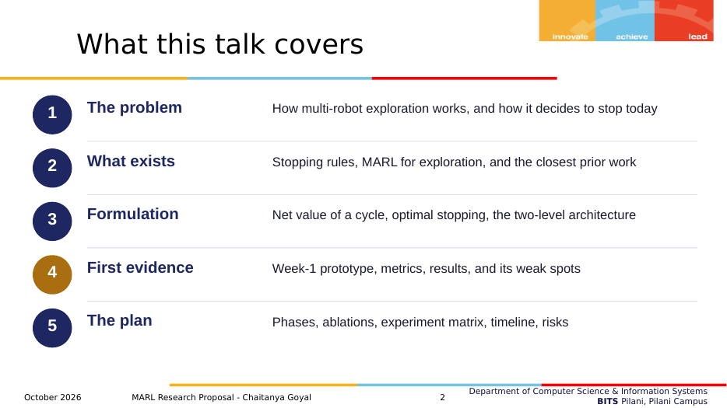
Slide 2
What it shows. The five parts of the talk. Part 4 is highlighted because it contains the new evidence.
What to say
"Five parts: the problem, what already exists, the formulation, the first evidence, and the plan."

Slide 3: Multi-robot exploration
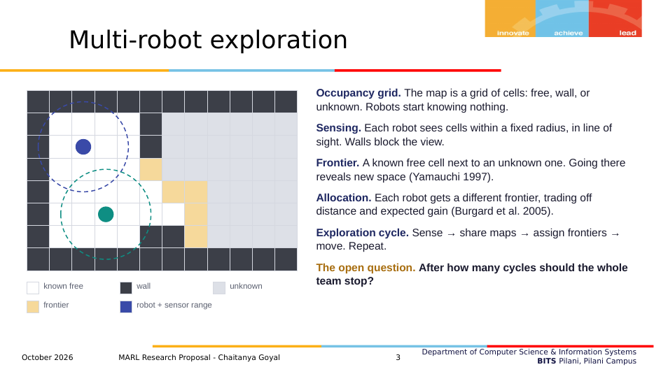
Slide 3
What it shows. A small illustrated grid map (white = known free, dark = wall, grey = unknown, orange = frontier, two robots with their sensor ranges) and the key definitions.
- The picture is an illustration, not an actual prototype map.
- The citations: Yamauchi 1997 for frontiers; Burgard et al. 2005 for coordinated allocation that trades distance against expected gain.
What to say
"The team builds a grid map. Robots see a few cells around them, and walls block the view. A frontier is a known free cell next to unknown space. Each cycle the team senses, shares maps, gives each robot a frontier, and moves. Classical exploration repeats this until no frontier is left. My question is: after how many cycles should the whole team stop?"

Slide 4: How exploration stops today
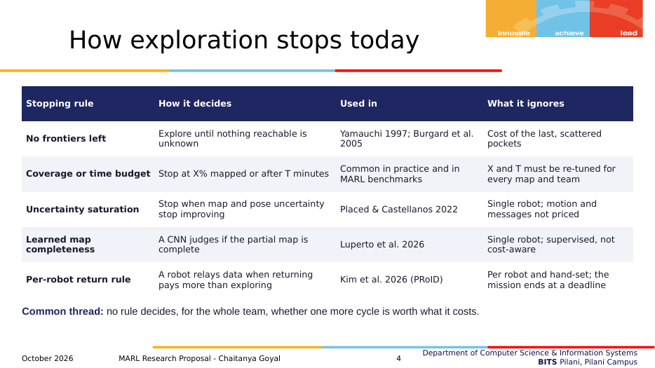
Slide 4
What it shows. The five kinds of stopping rules in use today, how each decides, where it is used, and what it ignores.
- Placed & Castellanos stop active SLAM when the map/pose uncertainty and mapped area stop improving (hand-set threshold, one robot).
- Luperto et al. train a CNN to classify a partial map as complete or not; exploration time drops by more than 35% (one robot, supervised, no cost model).
- PRoID: each robot decides when to stop exploring and go back to relay data, comparing information delivery rates; hand-designed rule; the mission ends at a fixed deadline.
What to say
"Today, exploration stops with one of these rules. Frontier exhaustion ignores the cost of the last pockets. Coverage and time budgets need re-tuning for every map and team. Recent work has single-robot stopping criteria, based on uncertainty (Placed and Castellanos 2022) or on a learned map-completeness classifier (Luperto et al. 2026), and a per-robot rule for when to return and relay data (PRoID, 2026). None decides, for the whole team, whether one more cycle is worth what it costs."
Careful
Do not say "nobody has studied stopping". People have; the gap is narrower (slide 8).

Slide 5: When should the team stop?
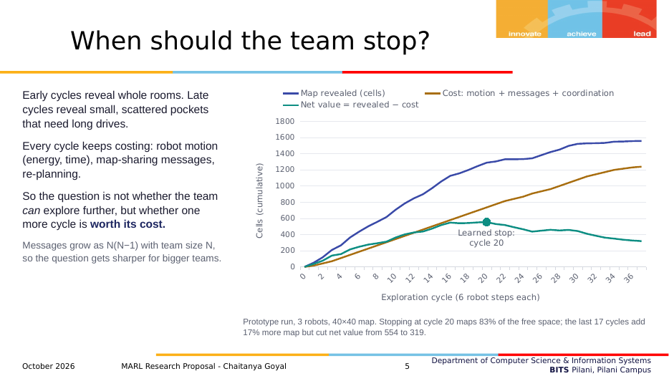
Slide 5
What it shows. One real run (map 50018, 3 robots, 40×40): cells revealed (blue), cost (amber), net value (teal), and where the learned policy stopped.
- The x-axis is cycles (6 robot steps each). The y-axis is cumulative cells.
- This map is an illustration; on this map the learned stop equals the hindsight-best stop. It is not a typical case: typical results are on slides 18–23.
- Messages grow as N(N−1), so the question gets sharper for bigger teams.
What to say
"Here is one run from my prototype. The map revealed rises fast and then flattens, because the last part of a map comes in small scattered pockets. The cost keeps rising at a steady rate. Net value is the difference: it peaks and then falls. The learned policy stopped at cycle 20 with 83% mapped. Carrying on to the last frontier took 17 more cycles, added 17% more map, and cut the net value from 554 to 319."
Careful
If asked "is this cherry-picked?" say yes, it is chosen to illustrate the trade-off; the averages come later.

Slide 6: Three problems, one contribution
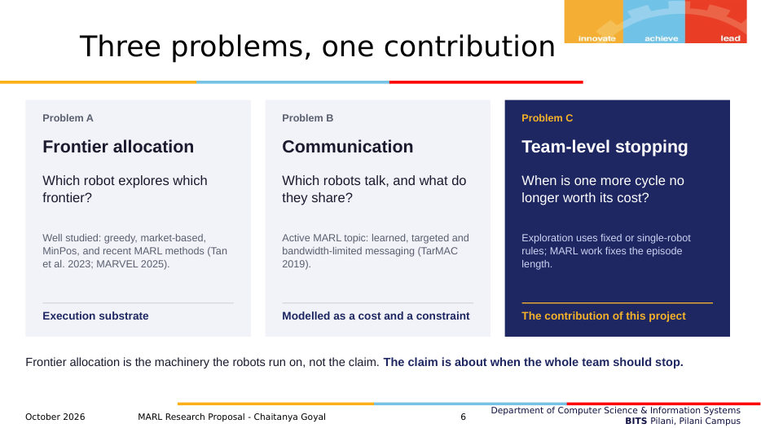
Slide 6
What it shows. The professor's point that frontier allocation, communication and stopping are three separate problems, and that the contribution is only C.
What to say
"Following your feedback I separate three problems. Frontier allocation and communication are active research areas, so I treat them as machinery: allocation is the substrate, and communication is modelled as a cost and a constraint. The contribution is C: when the whole team should stop."

Slide 7: What is already known
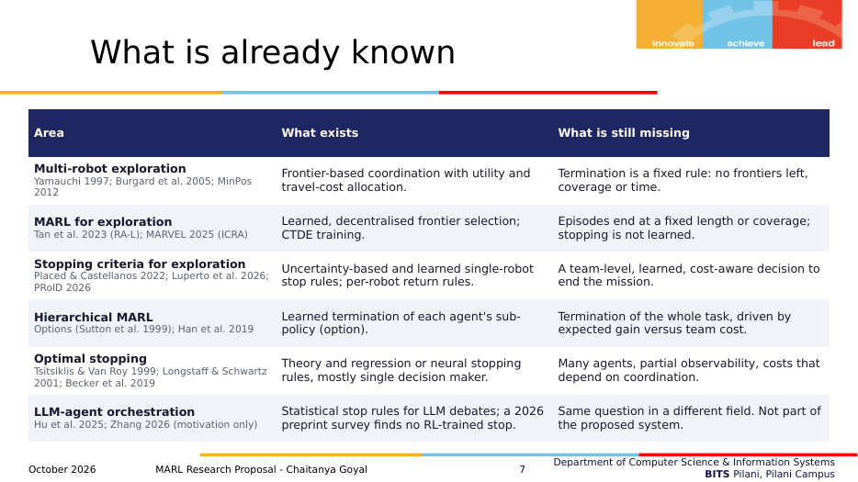
Slide 7
What it shows. The literature by area: what exists and what is missing in each.
- The full gap analysis document (2–3 pages, 20–30 papers) is still to be written; this slide is its summary.
What to say
"Multi-robot exploration has good allocation methods but fixed termination rules. MARL for exploration learns where robots go, but episodes end at a fixed length or coverage. Stopping criteria exist for single robots. Hierarchical MARL learns when sub-policies end, not when the task ends. Optimal stopping theory is mostly single decision maker. The LLM orchestration papers ask the same question in another field; they are only motivation."
Careful
The Zhang 2026 paper is an unrefereed preprint by a single independent author. Cite it only as motivation.

Slide 8: Closest prior work, and the gap
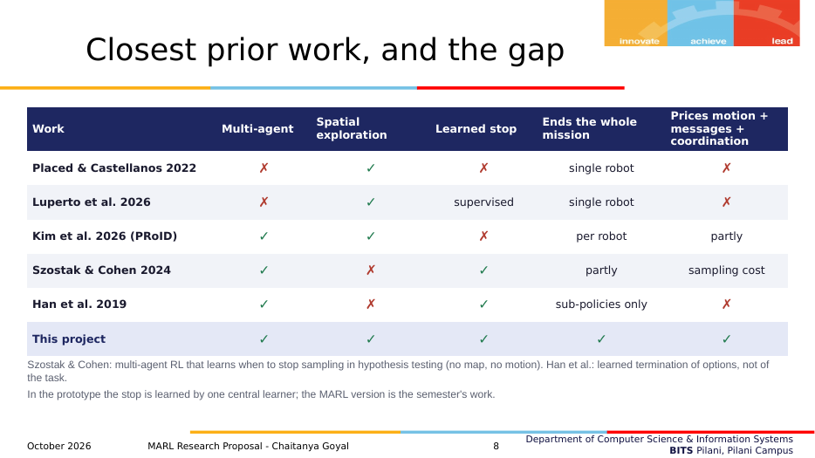
Slide 8
What it shows. The five papers a reviewer could say "already did this", checked against the five parts of the claim.
- "partly" for PRoID's costs: it accounts for travel time and failure risk, not message and coordination costs.
- "partly" for Szostak & Cohen's mission end: agents jointly declare a hypothesis, which ends the task, but it is not a spatial mission.
- The last row is the final system. In the prototype the learned stop comes from one central learner, not MARL (footnote).
What to say
"This table is the novelty claim. Each row is a close paper; each column is part of my claim. Placed and Castellanos and Luperto et al. stop single robots. PRoID is multi-robot but decides per robot with a hand-set rule. Szostak and Cohen learn multi-agent stopping, but in hypothesis testing: no map, no motion. Han et al. learn when sub-policies end. None has all five. So the claim is narrow: to my knowledge, no prior work learns the team-level decision to end a multi-robot exploration mission as a cost-aware stopping problem."
Careful
Say "to my knowledge". The literature search is not finished; one very recent preprint (ICMAPE, arXiv 2609.33986) could not be checked yet.

Slide 9: Research questions
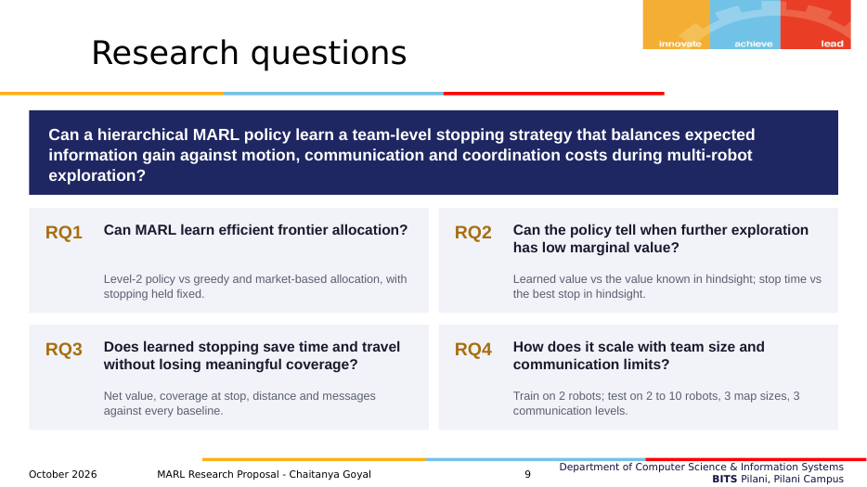
Slide 9
What it shows. The main question (the professor's wording) and four sub-questions, each with how it will be tested.
What to say
"The main question is in your wording. RQ1 is about allocation, tested with stopping fixed. RQ2 asks whether the policy knows when the remaining value is low. RQ3 asks whether stopping saves time and travel without losing meaningful coverage. RQ4 is about scaling. RQ2 and RQ4 already have first answers from the prototype; RQ1 needs the MARL Level 2."

Slide 10: Formulation 1: the setting
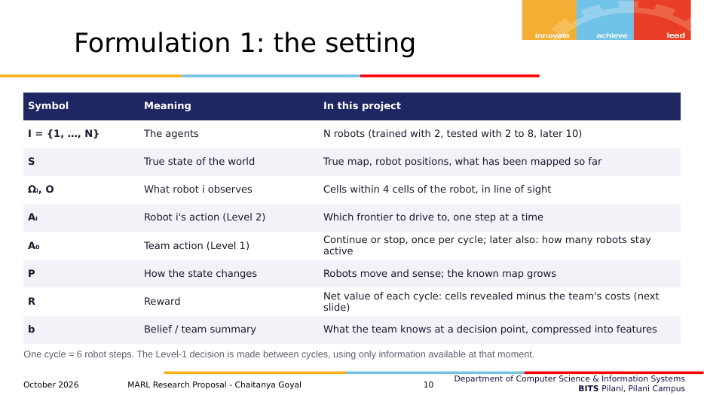
Slide 10
What it shows. The Dec-POMDP symbols and what each means in the project.
- A₀ is the team action (Level 1); Aᵢ are robot actions (Level 2).
- b is the belief: in practice, the 7-feature team summary.
What to say
"Formally this is a decentralised POMDP: partially observable because nobody sees the true map, decentralised because each robot acts on its own observations. On top sits a team action once per cycle: continue or stop. The reward is the net value of each cycle."

Slide 11: Formulation 2: value of a cycle
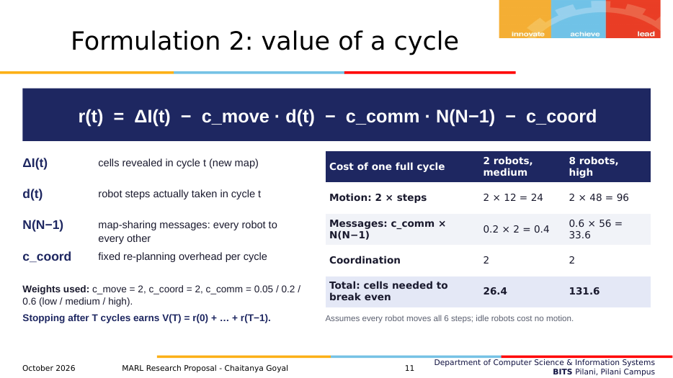
Slide 11
What it shows. The reward formula, each term, the weights, and a worked example of the break-even point for 2 vs 8 robots.
- Worked examples are in Part 3.2 of this document.
What to say
"Everything is measured in map cells. A cycle earns the cells it reveals and pays for robot steps, messages and coordination. The weights are an exchange rate: c_move = 2 means a step is worth two new cells. With 2 robots at medium cost, a cycle must reveal 26 cells to break even; with 8 robots at high cost, 132. So the right stopping point depends strongly on the team."
Careful
The weights are a modelling choice, not measured from real robots. That is why training randomises them and testing varies them.

Slide 12: Formulation 3: optimal stopping
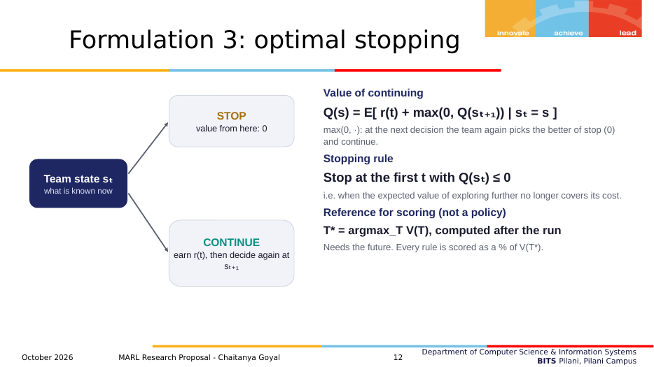
Slide 12
What it shows. The decision diagram (stop gives 0; continue earns r and decides again), the definition of Q, the stopping rule, and the oracle.
- max(0, Q(next state)): at the next decision the team again picks the better of stop and continue. Worked example 3 in Part 3.4.
What to say
"Choosing when to stop is an optimal stopping problem. Q is the value of continuing now and then continuing to decide optimally. Stopping is worth zero from that point on, so the rule is: stop the first time Q is not positive. The oracle is the best stop computed after the run; it needs the future, so it is only the 100% reference."

Slide 13: Two-level architecture
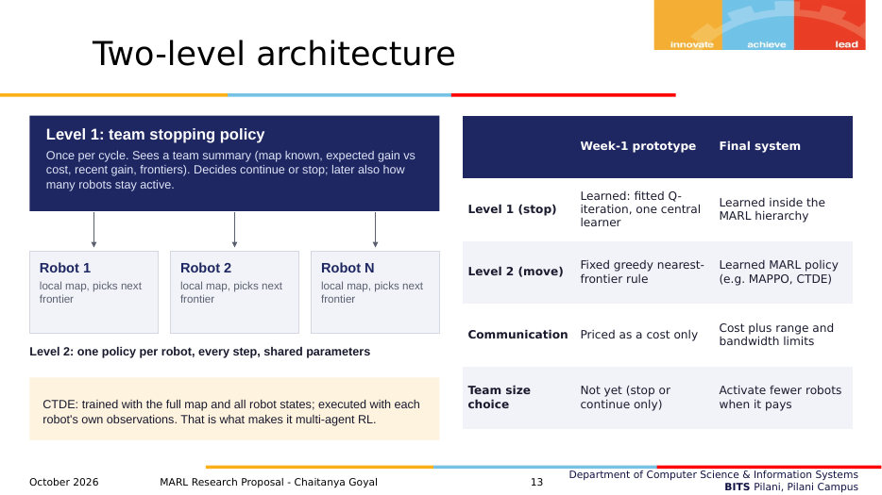
Slide 13
What it shows. Level 1 (team stop) on top of per-robot Level 2 policies, CTDE, and a table of what is built now versus in the final system.
What to say
"Level 1 decides once per cycle for the whole team; Level 2 moves each robot every step. In the final system both are learned and trained with centralised training and decentralised execution. In the week-1 prototype only Level 1 is learned; Level 2 is a fixed greedy rule and communication is only a cost."
Careful
This slide is where you pre-empt "is this really MARL?" Answer before they ask: not yet; the table shows what changes.

Slide 14: How the stop is learned
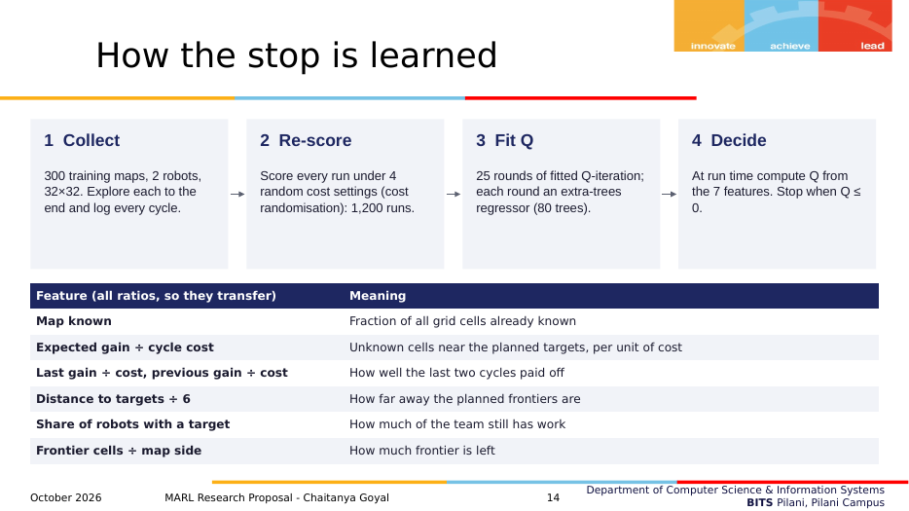
Slide 14
What it shows. The four-step training pipeline and the seven features.
- Why one full run per map is enough: Part 4.6.
- Exact feature formulas: Part 4.5.
What to say
"I explore each training map to the end and log every cycle. Each run is re-scored under four random cost settings: robot motion does not depend on the costs, so this is free, and it teaches the policy how costs move the stopping point. Then fitted Q-iteration fits Q in 25 rounds with an extra-trees regressor. At run time, the robots stop when Q is not positive. The features are all ratios so they transfer to other team and map sizes."

Slide 15: Baselines for comparison
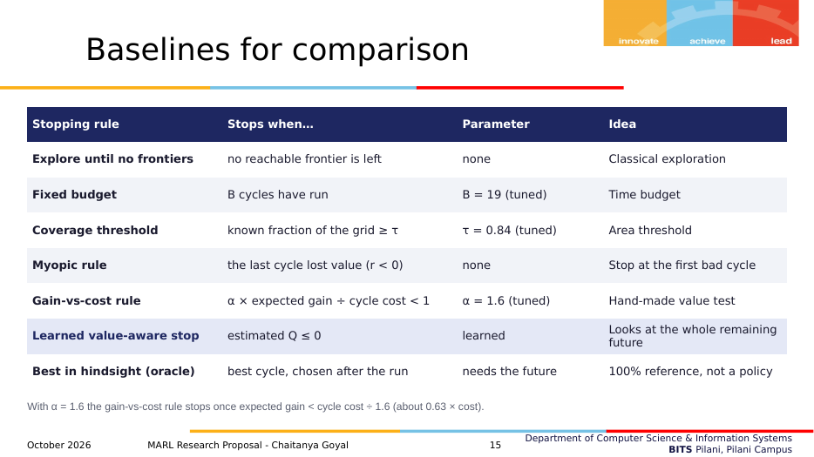
Slide 15
What it shows. Every rule compared, its exact stopping condition, parameter and idea.
What to say
"Every rule is evaluated on the same maps with the same robot motion; only the stopping moment differs. The three tuned rules had their one number tuned on the same 300 training maps, for the training setting: that is their best case. The myopic rule stops after the first cycle that lost value. The gain-vs-cost rule stops when the expected gain falls below the cycle cost divided by 1.6."
Careful
The coverage threshold uses the known fraction of the whole grid (free and wall cells), not the free-space coverage metric.

Slide 16: Evaluation metrics
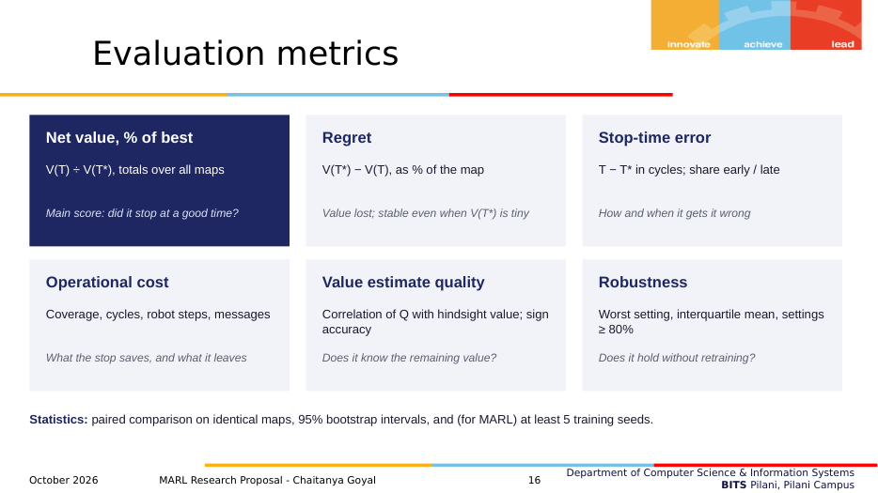
Slide 16
What it shows. The six metric groups (main score, regret, stop-time error, operational cost, value-estimate quality, robustness) and the statistics used.
- Every metric is defined in Part 5.
What to say
"The main score is net value relative to the best stop in hindsight. Regret is the same information in cells, normalised by map size, which stays meaningful when the best achievable value is tiny. Stop-time error shows how rules fail. Coverage, cycles, steps and messages show what a stop saves and leaves. For the value estimate I report correlation and sign accuracy. Across settings I report the interquartile mean and the worst case. All comparisons are paired, with 95% bootstrap intervals."

Slide 17: Week 1: a working prototype
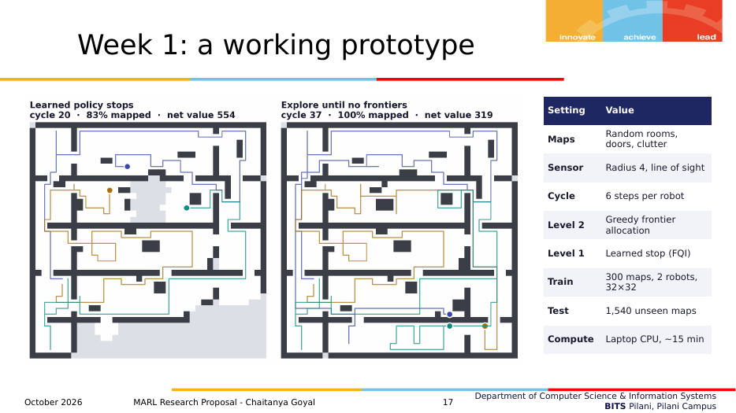
Slide 17
What it shows. The same map as slide 5, where the learned policy stops (left) and after exploring until no frontiers (right), plus the prototype settings.
- Test: 1,540 distinct unseen maps (100 test maps + 12 team/map combinations × 40 maps, each scored at 3 communication costs). The 140-map training-setting results pool the 100 test maps with the 40 grid maps of that setting.
What to say
"On the left, the learned policy has stopped at cycle 20 with 83% mapped; on the right, exploring until no frontiers remain takes 37 cycles. The policy leaves the far corner because reaching it costs more than it would reveal at these weights. Everything runs on a laptop CPU in about 15 minutes."

Slide 18: Result 1: training setting
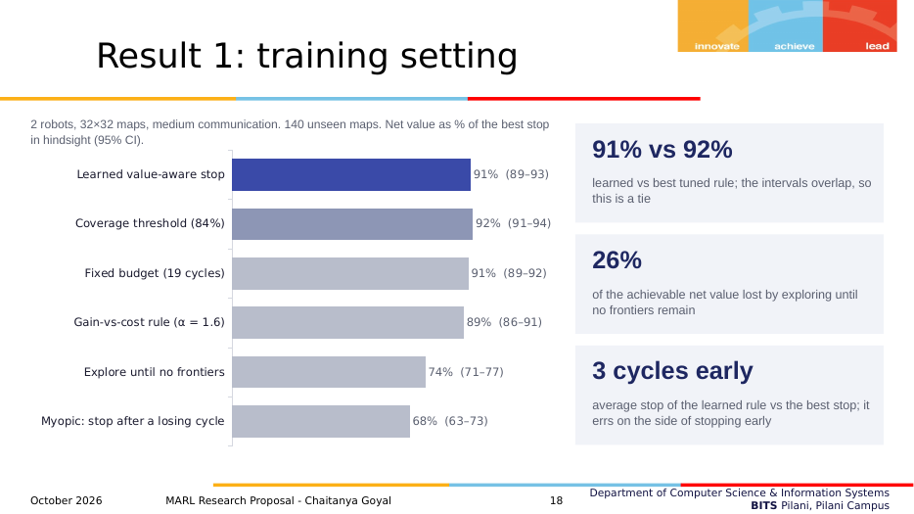
Slide 18
What it shows. Net value as % of the best stop for each rule, 140 unseen maps, with 95% confidence intervals, and three key numbers.
- Numbers in brackets are 95% bootstrap intervals.
- The coverage bar is darker because it is the strongest baseline.
What to say
"In the setting it was trained on, the learned rule reaches 91% of the best achievable value, the tuned coverage threshold 92%. The intervals overlap, so this is a tie, not a win. Exploring until no frontiers loses about a quarter of the achievable value, and stopping at the first bad cycle loses about a third. The learned rule stops about three cycles early on average."
Careful
Say "tie". If asked why the old version said 93%: that was one test subset; Part 6.2 explains.

Slide 19: Result 2: how each rule stops
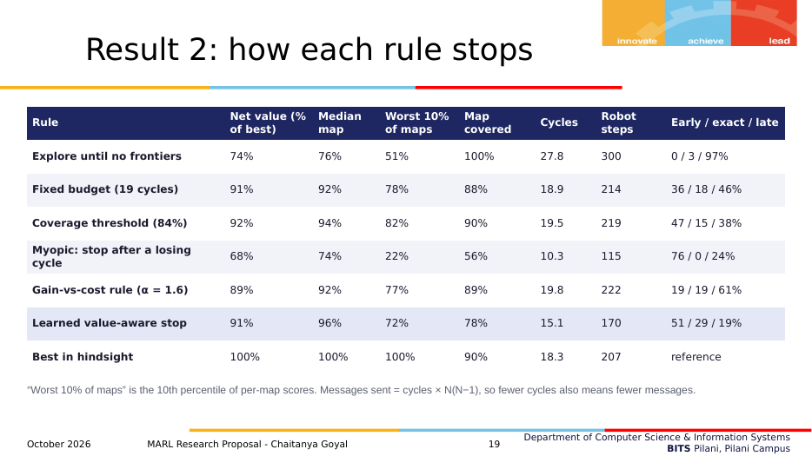
Slide 19
What it shows. Coverage, cycles, steps, per-map median and 10th percentile, and early/exact/late shares for every rule.
- Messages = cycles × N(N−1), so fewer cycles means fewer messages.
What to say
"The learned rule maps less, 78% against 90%, but scores the same, because it stops early on maps where the rest is expensive to reach. Its typical map is excellent, a median of 96%, but its bad maps are worse than the coverage rule's: the worst 10% of maps score 72% against 82%. Exploring to the end is late on 97% of maps; the myopic rule is early on 76%."

Slide 20: Result 3: value estimate
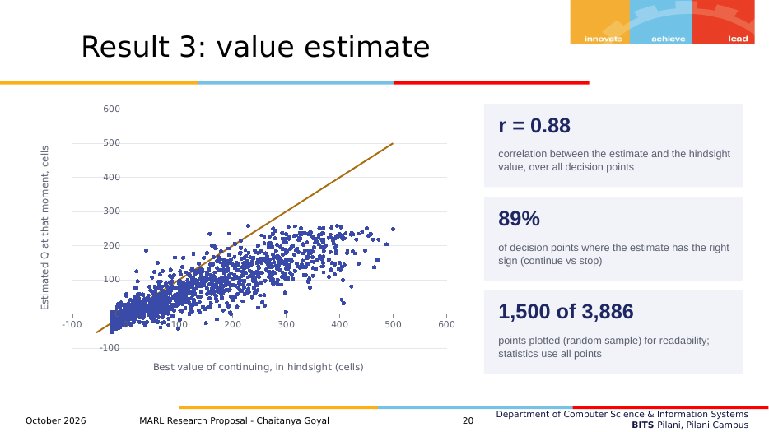
Slide 20
What it shows. Estimated Q versus the hindsight value of continuing at every decision point (1,500 of 3,886 plotted), with correlation and sign accuracy.
What to say
"Each dot is one decision point. Horizontal is the best value of continuing in hindsight, knowing the future, which is an optimistic upper bound; vertical is the policy's estimate at that moment, without the future. So the dots should sit below the diagonal, and they do. What matters is that the estimate ranks situations correctly, a correlation of 0.88, and that its sign, continue versus stop, is right at 89% of decision points."

Slide 21: Result 4: 36 test settings
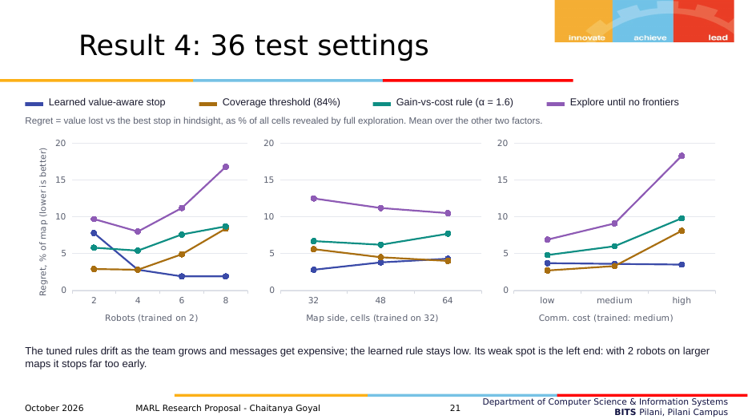
Slide 21
What it shows. Regret (lower is better) by team size, map size and communication cost, averaged over the other two factors, for four rules.
- Each team-size point averages 9 settings (3 map sizes × 3 costs); each map-size or cost point averages 12 settings; 40 maps per setting.
- The learned line at 2 robots (7.8%) is worse than the coverage threshold (2.9%). Point this out yourself.
What to say
"Now the policy is used unchanged in 36 test settings: 35 new ones plus the training setting, all on unseen maps. The metric is regret: the value lost against the best stop, as a percentage of the map. As the team grows and messages get expensive, the tuned rules drift up; the learned rule stays low. Its weak spot is the left end: with 2 robots on larger maps it stops far too early."

Slide 22: Result 5: robustness
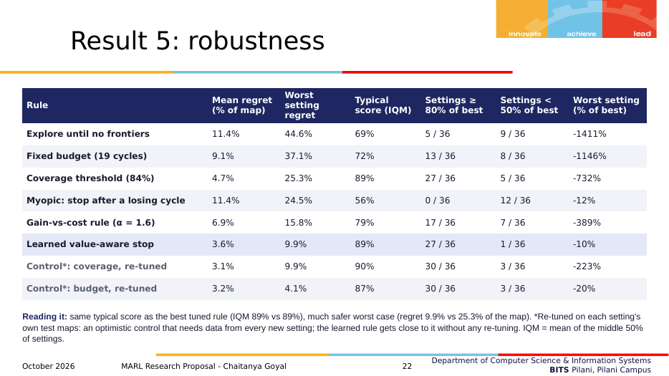
Slide 22
What it shows. Per-rule summary across the 36 settings, including two optimistic control rows.
What to say
"In a typical setting the learned rule and the coverage threshold are equally good: same interquartile mean, 89%, and the same 27 of 36 settings above 80%. The difference is the worst case: in its worst setting it loses 9.9% of the map on average, against 25% for the coverage rule, and only one setting is below 50%. The grey rows re-tune a simple rule for each setting using that setting's own test maps. That is the best an engineer could do with data from every new deployment, and the learned rule comes close to it without any re-tuning. I don't use the raw average of percentages as a headline, because in the hardest settings the best achievable value is only a few dozen cells, and dividing by it produces numbers like minus 700%."
Careful
Concede the control rows honestly: a per-setting re-tuned budget has a better worst case (4.1%). The learned rule's advantage is that it needs no per-setting data.

Slide 23: Where it wins, and where it fails
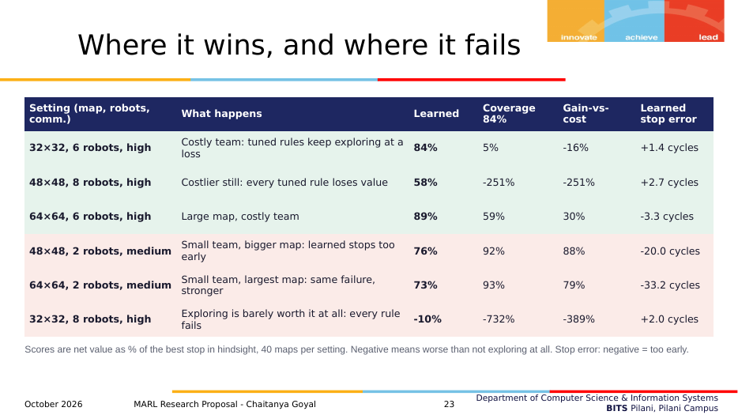
Slide 23
What it shows. Six settings: three wins (costly teams), two failures (small team, big map), one where every rule fails.
- Diagnosis and fixes for the failure: Part 6.5.
What to say
"Top three: when the team is costly, the tuned rules keep exploring at a loss and the learned rule stops in time. Next two: with only 2 robots on bigger maps, the learned rule stops 20 to 33 cycles too early; I have not diagnosed why yet, and my best guess is feature combinations that the small training maps never produce. Last: 8 robots on a small map with expensive messages, where on 14 of 40 maps it is not worth exploring at all; every rule fails there, and the right answer is to use fewer robots, which the policy cannot choose yet."

Slide 24: What it shows, and what not
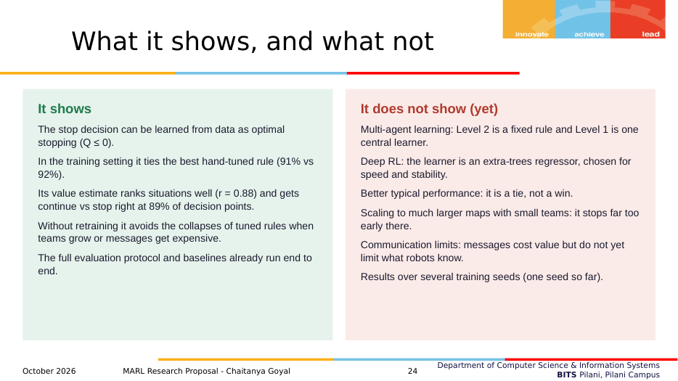
Slide 24
What it shows. The scope of the evidence: five things it shows, six things it does not.
What to say
"To be clear about scope: the prototype shows the stop can be learned, that it ties the best tuned rule at home, that its value estimate is meaningful, and that it is safer when conditions change. It is not yet MARL, not deep RL, not better in the typical case, it fails on large maps with small teams, communication does not yet limit what robots know, and it uses one training seed."

Slide 25: Phased plan
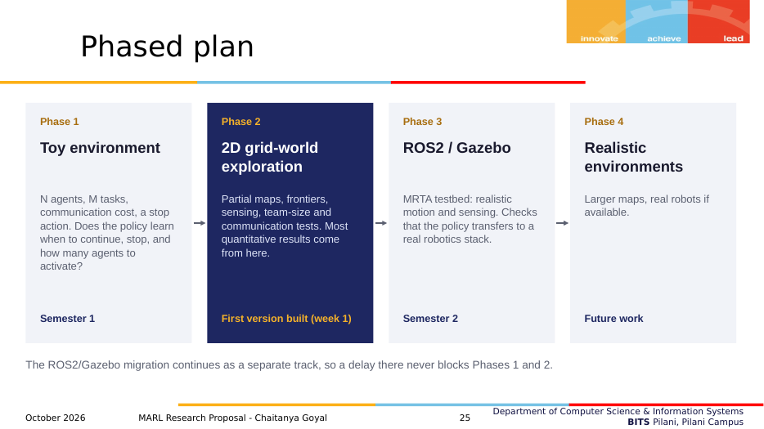
Slide 25
What it shows. The four phases (toy environment, grid-world, ROS2/Gazebo, realistic), with Phase 2 highlighted as started.
What to say
"This is the abstract-to-robotics sequence you endorsed. Each phase starts only when the previous one works, so RL problems and simulator problems are never debugged together. The ROS2 migration continues separately."

Slide 26: Ablations
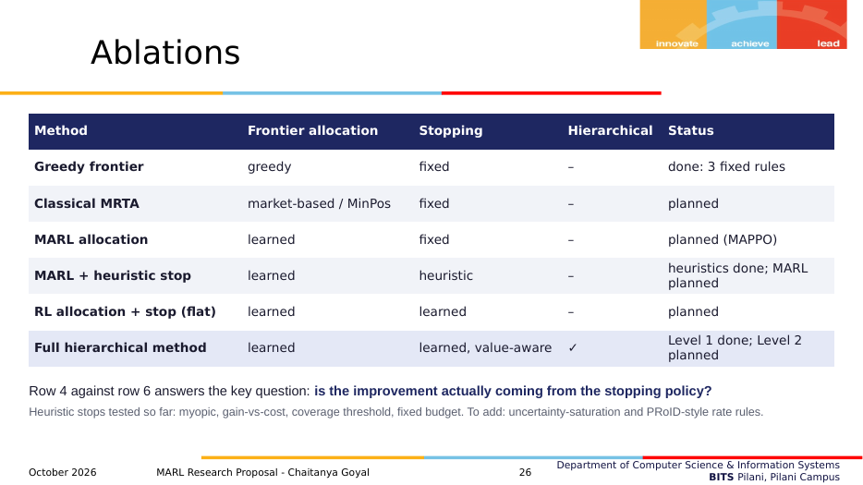
Slide 26
What it shows. Six system variants that swap allocation and stopping components one at a time, with their status.
What to say
"Row 4 against row 6 is the key comparison: MARL allocation with a strong heuristic stop against the full method. It isolates whether the improvement comes from the stopping policy. I will also add the stopping rules from the recent literature as baselines: uncertainty saturation and PRoID-style rate rules."

Slide 27: Experiment matrix
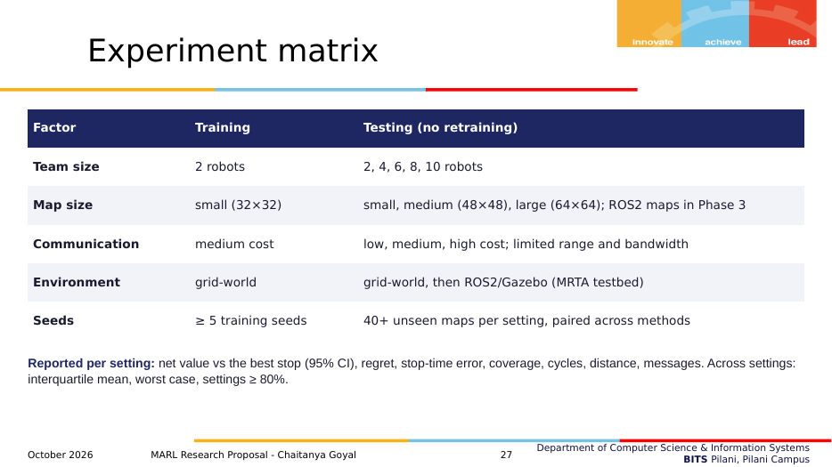
Slide 27
What it shows. Training vs testing conditions and what is reported.
What to say
"Train small, test large, without retraining: team size up to 10, three map sizes, three communication costs, then ROS2 maps, with at least five training seeds."

Slide 28: Timeline
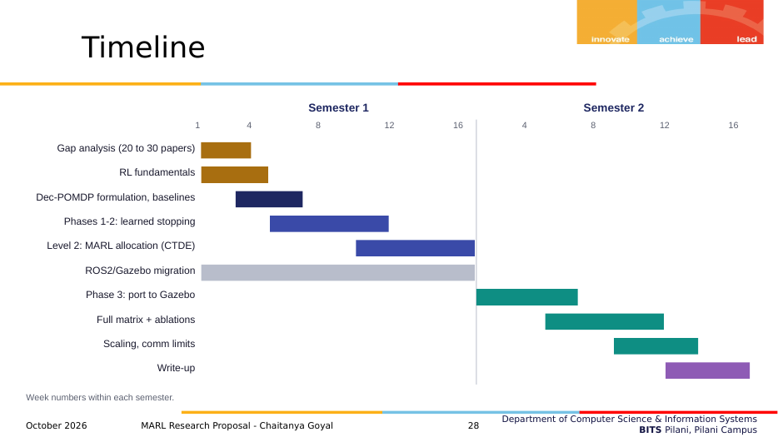
Slide 28
What it shows. Two-semester Gantt chart.
What to say
"Literature and formulation first, as you asked. MARL for Level 2 starts only once the learned stop holds in the grid-world. Gazebo runs in the background in semester 1; porting, the full matrix, scaling and writing are in semester 2."

Slide 29: Risks and mitigations
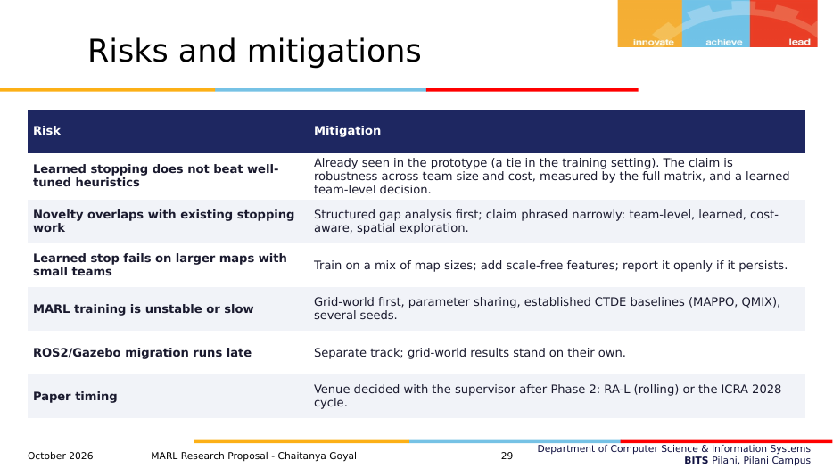
Slide 29
What it shows. Six risks and how each is handled.
What to say
"The first risk has partly happened already: the learned stop ties a well-tuned rule at home. So the claim is robustness and a learned team-level decision, not a higher everyday score. The large-map failure is handled by training on mixed map sizes and scale-free targets."

Slide 30: Key references (1 of 2)
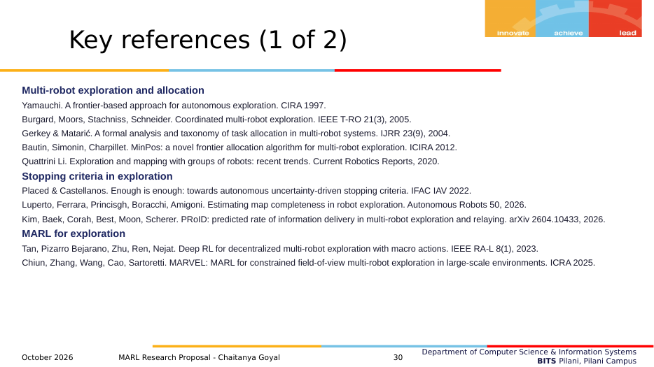
Slide 30
What it shows. Exploration, stopping criteria, MARL for exploration.
What to say
Do not read references aloud. Say: "All references were checked for authors, year and venue."

Slide 31: Key references (2 of 2)
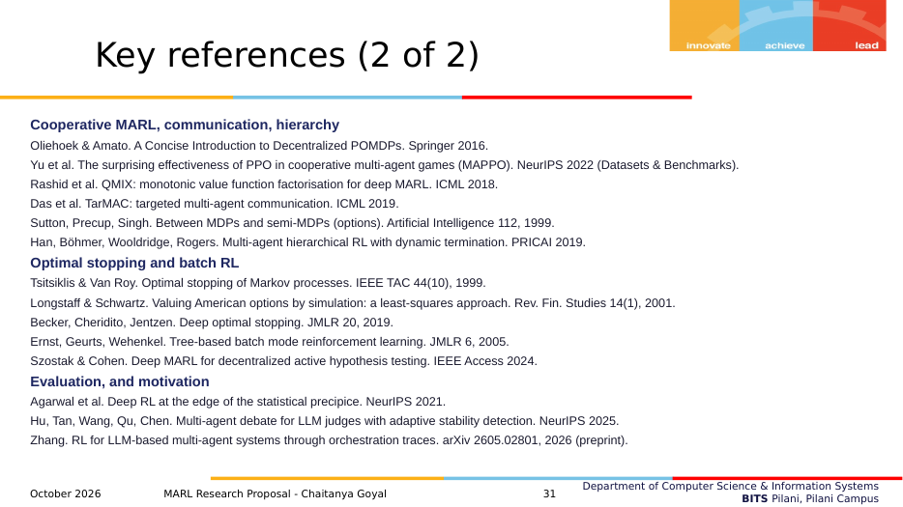
Slide 31
What it shows. MARL, hierarchy, optimal stopping, evaluation, motivation.
What to say
As above.

Slide 32: Thank you
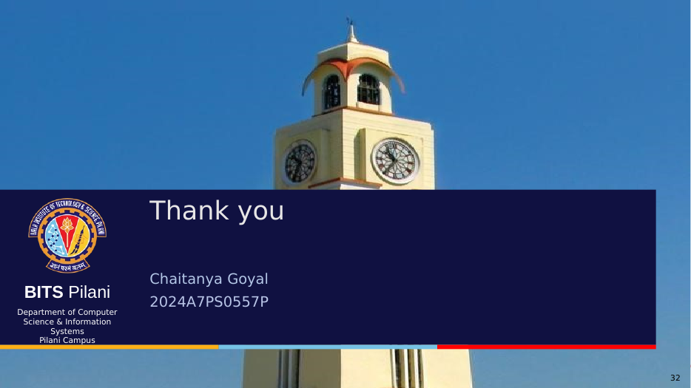
Slide 32
What it shows. Closing slide.
What to say
"Thank you. I'm happy to take questions, and I can run the live demo on a new random map if useful."

Part 8. Cross-questions and answers
Grouped by topic. Answers are short enough to say out loud. Where an honest answer is "not yet" or "I don't know yet", it says so. That answer, followed by how you will find out, is far better than a guess.

8.1 The problem and why it matters
Q. Why not just explore everything? Isn't a complete map always better?
Not when exploring costs something. In the training setting, exploring until no frontiers remain loses about a quarter of the achievable net value. The last part of the map comes in small scattered pockets that need long drives, messages and re-planning. If the operator really wants a complete map, that is a different cost model (a big penalty for unmapped cells), and the same method applies with that reward.
Q. Where do the cost weights come from? Aren't they arbitrary?
They are an operator's preference, an exchange rate between map and resources, not a physical constant. That is exactly why I don't fix them: training randomises them, and testing varies communication cost by a factor of 12 (0.05 to 0.6). A useful stopping policy must work across preferences, and the results show where it does and where it doesn't.
Q. In a real robot, what is a "cycle"?
One planning period: the robots execute their current targets for a fixed time (here, 6 moves each), then share maps and re-plan. Real systems re-plan every few seconds; the cycle length is a parameter.
Q. Why would a real team stop exploring? When does this matter in practice?
- Battery or time is limited and the robots are needed for the next task (inspection, delivery, search).
- Bandwidth is shared and limited (underground, disaster sites).
- The operator only needs the map to be good enough, not complete (e.g. to find a route).
In all of these the last few percent of the map may not be worth what it costs.

8.2 Novelty and related work
Q. Hasn't stopping in exploration been done already?
Stopping has been studied, but only in narrower forms: single-robot uncertainty criteria (Placed & Castellanos 2022), a learned single-robot map-completeness classifier (Luperto et al. 2026), and per-robot return rules with hand-set thresholds (PRoID, 2026). To my knowledge, no prior work learns the team-level decision to end a multi-robot exploration mission as a cost-aware stopping problem. Slide 8 lists the differences.
Q. What about PRoID? It also decides when robots stop exploring.
PRoID decides, per robot, when to stop exploring and go back to relay data, using a hand-designed rate comparison, and the mission ends at a fixed deadline. I learn one team-level decision to end the mission, with message and coordination costs in the objective. PRoID-style rules are baselines I will add.
Q. Luperto et al. learn when to stop. How is yours different?
Theirs is a supervised classifier on the map image for one robot: "is this map complete enough?". It does not model cost, and it is not a sequential decision. Mine estimates the expected future net value of continuing for a team, and it reacts to team size and communication cost.
Q. Isn't this just options / option termination?
Option termination (Sutton et al. 1999; option-critic; Han et al. 2019) decides when an agent's sub-policy ends. Here the decision is when the whole task ends for the whole team, driven by expected gain versus team cost. The final architecture is hierarchical, so the tools are related, but the decision is different.
Q. Szostak and Cohen already learn stopping with multi-agent RL.
Yes, in active hypothesis testing: agents choose what to sample and when to declare an answer, with a sampling cost. There is no map, no motion and no coordination cost. My setting is spatial exploration, where continuing costs travel, messages and re-planning, and the gain comes from a partially known map.
Q. Why did you cite LLM papers?
Only as motivation: the question of when a multi-agent system should stop also appears in LLM orchestration (a 2026 preprint survey finds no RL-trained stopping decision there). They are not part of the method or the gap claim.
Q. Is this incremental?
Yes, like most research. The pieces (frontier exploration, optimal stopping, batch RL, CTDE MARL) exist. The new part is the problem (a learned, team-level, cost-aware end-of-mission decision), its formulation, and a protocol that tests transfer across team sizes and costs. The contribution is judged by whether the question is new and whether the evidence is sound.

8.3 Formulation
Q. Why is this a Dec-POMDP and not an MDP?
Nobody sees the true map (partially observable), and each robot acts on its own observations (decentralised). The Level-1 decision uses a team summary, which plays the role of a belief.
Q. Why is Q defined with max(0, ·)?
Because at every future decision point the team can stop, and stopping is worth 0. So the value of being at the next state is the better of stopping (0) and continuing (Q). This is the standard Bellman equation for optimal stopping.
Q. Why stop at Q ≤ 0 and not Q < some threshold?
Because the value of stopping is exactly 0 in this reward. If Q is positive, continuing is expected to add value. A different threshold would mean a different reward (for example, a bonus for finishing).
Q. Is the oracle a fair reference? It can see the future.
It is not a competitor, it is the ruler. No rule can beat it on the same run. Scoring against it tells you how much of the achievable value each rule captures. It is also why percentages are unstable when the oracle's value is near 0, and why I use regret across settings.
Q. Why does the message term not depend on how many robots actually moved?
Simplification: every robot shares its map with every other robot once per cycle. Communication limits (range, bandwidth), which make this realistic, are the next step.

8.4 Method
Q. Why fitted Q-iteration and not deep RL?
For the first result I wanted something fast, stable and easy to inspect. FQI with extra-trees trains in under a minute on a laptop CPU and rarely diverges (Ernst et al. 2005). It is a proper RL method: it solves the Bellman equation from batch data. The deep version (neural fitted Q or DQN) is straightforward once the formulation is fixed.
Q. How can you train from runs that never stopped?
In optimal stopping the decision doesn't change the process before the stop. So a run explored to the end contains every possible stopping point; stopping after t cycles just keeps the first t. Longstaff–Schwartz option pricing uses the same idea. Each rule's decision at t uses only information available at t, so there is no look-ahead leak.
Q. What exactly are the inputs of the policy?
Seven team-level ratios: map known, expected gain ÷ cycle cost, the last two cycle gains ÷ cycle cost, distance to targets ÷ 6, share of robots with work, and frontier cells ÷ map side. Part 4.5 has the formulas.
Q. What is cost randomisation and why does it work?
Costs don't affect how robots move, so each training run can be re-scored under random cost weights at no extra simulation cost. The policy sees the same situation with different costs and learns how the right stopping point shifts. It is the cost version of domain randomisation (Tobin et al. 2017).
Q. Why 25 iterations, 80 trees, leaf size 8?
Twenty-five rounds let the value look about as far ahead as a typical training episode (about 28 cycles). The tree settings are sensible defaults and were not tuned on test data. A proper sensitivity study is part of the plan, and I will report it.
Q. Did you tune anything on the test set?
No. The thresholds were tuned on the training maps, and the learned rule was trained on the training maps. The only exception is the deliberately optimistic "re-tuned per setting" control rows on slide 22, which are labelled as tuned on the test maps.

8.5 Evaluation and fairness
Q. Your baselines are tuned for one setting and the learned rule is trained on randomised costs. Isn't that unfair?
Two answers.
- The tuned rules represent what an engineer does: tune for the expected deployment. In that setting they are at their best, and the learned rule only ties them.
- I also tuned the baselines on the same randomised-cost data (sensitivity check): the gain-vs-cost rule then generalises better (raw mean 44% → 65%) but no single threshold works everywhere, and the coverage rule drops to 67% even in the training setting. And the per-setting re-tuned controls show the best a simple rule can do with data from each setting; the learned rule comes close without that data.
Q. The coverage threshold and fixed budget can't see costs at all. Of course they fail when costs change.
True, and that is the point of including them: they are the classical rules. The gain-vs-cost rule does see costs and still fails in costly settings (worst score −389%), because one hand-set α can't capture the whole trade-off. I will add stronger cost-aware baselines from the literature (uncertainty saturation, PRoID-style rate rules).
Q. Why ratio of totals and not the mean of per-map percentages?
On maps where the best achievable value is close to zero, a per-map percentage explodes. The ratio of totals is the fraction of all achievable value captured over the test set. The same problem at the level of whole settings is why I use regret across settings.
Q. Why is your old headline (83% vs 52%) not on the slides?
Because it is distorted: in the hardest settings the best achievable value is tiny, so a mean of percentages is dominated by a few huge negative numbers. The robust summaries (interquartile mean, regret, worst case) show the real picture: a tie in typical settings, and much safer worst cases.
Q. Is 91% vs 92% significant?
No. The paired 95% interval of the difference is −3.3 to +1.6 points. It is a tie, and I call it one.
Q. How many seeds?
One training seed so far. The results are averaged over many test maps (140, and 40 per setting), but variance across training seeds is not yet measured. At least 5 seeds are in the plan (Henderson et al. 2018 show why).
Q. How did you compute confidence intervals?
Bootstrap: resample the test maps with replacement 5,000 times, recompute the score each time, take the 2.5th and 97.5th percentiles. For differences, the same maps are resampled for both rules (paired).
Q. What does r = 0.88 actually prove?
That the learned estimate ranks decision points in nearly the same order as the value of continuing computed in hindsight. The hindsight value knows the future, so it is an upper bound and Q is lower in size, as it should be; the ranking and the sign are what matter. It supports RQ2. It does not by itself prove good stopping; that is what the net value results show. The more directly relevant number is sign accuracy: 89% of decision points get continue-vs-stop right.

8.6 Results
Q. So the learned rule is not better?
Not in the setting it was trained for: there it ties a well-tuned rule. Its advantage is robustness: without re-tuning it matches the tuned rule in typical settings and avoids its failures when teams grow or messages get expensive (worst-case regret 9.9% vs 25.3% of the map). That is the property you want when deployment conditions are not known in advance.
Q. Why does it fail with 2 robots on large maps?
It stops 20–33 cycles too early. It is not simply episode length: on 48×48 maps it stops at about 25 cycles, within the lengths seen in training. My leading hypothesis is that bigger maps produce feature combinations the 32×32 training maps never do (much less of the map known at the same cycle), and tree models cannot extrapolate. Q is also in cells, and remaining values on big maps exceed the training range. Fixes: train on mixed map sizes, make the value target scale-free, and check feature distributions. I haven't verified the cause yet.
Q. Why does every rule fail with 8 robots on a small map with expensive messages?
Because exploring with 8 robots there is barely worth it: the best achievable value averages about 27 cells, and on 14 of 40 maps the best choice is not to explore at all. The right decision is to use fewer robots, which is the third Level-1 action planned for the final system.
Q. Why does the learned rule cover only 78% of the map?
Because it stops earlier on maps where the rest is expensive to reach, and it errs on the early side (on average 3 cycles before the best stop). Its net value is the same as the rule covering 90%. If an application needs a minimum coverage, that becomes a constraint or a penalty in the reward.
Q. Is the example on slide 5 cherry-picked?
It was chosen to illustrate the trade-off clearly, and on that map the learned stop happens to equal the best stop. The averages are on slides 18–23. On fresh random maps in the demo, the median is 97% of the best stop, and about 1 map in 8 scores below 70%.

8.7 MARL and the plan
Q. Where is the multi-agent learning?
Not in the prototype. Level 2 is a fixed greedy rule and Level 1 is one central learner. The plan replaces Level 2 with a shared-parameter MARL policy trained with CTDE (MAPPO first), keeps Level 1 as the team decision, and adds the "continue with fewer robots" action. The ablation table tests each change separately.
Q. How will Level 1 and Level 2 be trained together?
Step by step: first learn Level 2 with the stop fixed (RQ1), then learn Level 1 on top of the trained Level 2 (as in the prototype), then optionally fine-tune jointly. Training them simultaneously from scratch is unstable, and the phased plan avoids it.
Q. Will the stop still work when Level 2 changes?
It must be retrained or fine-tuned on runs of the new Level 2, because the robots' behaviour changes what each cycle reveals. The pipeline is the same. The features are designed to be about the team's situation, not the allocator, which should help.
Q. Why MAPPO?
It is a strong, simple CTDE baseline for cooperative tasks (Yu et al. 2022), and MARL exploration work such as MARVEL uses similar actor-critic methods. QMIX is the value-based alternative.
Q. What about communication limits?
Next step: robots only share maps within a communication range and bandwidth. Then each robot has its own partial map, the team summary for Level 1 has to be built from what is shared, and communication becomes a constraint as well as a cost.
Q. What if the learned stop never beats tuned heuristics?
Then the contribution is the formulation, the evaluation protocol, and a documented robustness property: no re-tuning needed and no catastrophic failures. That is still a valid result, and I'd frame the paper around it. This is risk 1 on slide 29.
Q. Which venue?
Decided with you after Phase 2: RA-L (rolling submissions) or the ICRA 2028 cycle.

8.8 About the prototype code
Q. How long does it take to run?
About 15 minutes on a laptop CPU for everything; 5 minutes with cached runs. The demo starts instantly.
Q. Could the result come from a bug?
Things that make that unlikely: every rule is evaluated by the same code on the same logged runs; the oracle is an exact upper bound (all rules score ≤ 100% per map); decisions at t use only information up to t; and the value estimate correlates with hindsight truth it never saw. Independent checks planned: a second evaluation script and a small unit test on hand-made runs.
Q. Why do the maps look like this?
Random rooms with doors and furniture, so that the late part of exploration involves going through doors into small spaces, which is the situation where stopping matters. Only the largest connected free region is kept, so coverage is always of reachable space.

Part 9. Reading list (verified)
Every entry was checked against the publisher page, DOI or arXiv. Tier 1 is what to read before the presentation: at least the abstract, introduction and the section named. Tier 2 is for the first weeks of the project. Tier 3 is background or motivation.

Tier 1: read before presenting
B. Yamauchi. A frontier-based approach for autonomous exploration. IEEE CIRA 1997, pp. 146–151.
- Link: https://doi.org/10.1109/CIRA.1997.613851
- What it does: Introduces frontiers (boundaries between known free and unknown space) and the loop: drive to the nearest frontier, sense, repeat until no frontier is left.
- Why it matters to you: Defines the classical stopping rule you improve on.
- Read first: The whole paper (6 pages).
W. Burgard, M. Moors, C. Stachniss, F. Schneider. Coordinated multi-robot exploration. IEEE Transactions on Robotics 21(3):376–386, 2005.
- Link: https://doi.org/10.1109/TRO.2004.839232
- What it does: Assigns frontiers to robots by trading the utility of a target against the cost of reaching it, discounting utility near targets already assigned to teammates; much faster than uncoordinated exploration.
- Why it matters to you: The standard gain-vs-cost idea, but used for where to go, not when to stop. Your Level 2 is a simple version of this.
- Read first: The target-assignment section.
J. A. Placed, J. A. Castellanos. Enough is enough: towards autonomous uncertainty-driven stopping criteria. IFAC-PapersOnLine 55(14):126–132, 2022 (IFAC IAV).
- Link: https://doi.org/10.1016/j.ifacol.2022.07.594 (arXiv 2204.10631)
- What it does: Argues that time and coverage rules suit unknown environments badly, and stops single-robot active SLAM when the uncertainty measure and mapped area stop improving.
- Why it matters to you: Closest single-robot stopping work; shows stopping is recognised as an open problem.
- Read first: Introduction and the stopping criterion section.
M. Luperto, M. M. Ferrara, M. Princisgh, G. Boracchi, F. Amigoni. Estimating map completeness in robot exploration. Autonomous Robots 50, article 6, 2026 (online Dec 2025).
- Link: https://doi.org/10.1007/s10514-025-10221-8 (arXiv 2406.13482)
- What it does: A CNN classifies whether a partial grid map is complete enough and estimates the explored percentage; used as a stop rule, it cuts exploration time by more than 35% while keeping map quality.
- Why it matters to you: A learned stop, but supervised, single robot, no cost. Its related work lists existing stopping criteria: useful for your gap analysis.
- Read first: Introduction and related work.
S. Kim, D. Baek, M. Corah, G. Best, B. Moon, S. Scherer. PRoID: Predicted Rate of Information Delivery in multi-robot exploration and relaying. arXiv 2604.10433, 2026.
- Link: https://arxiv.org/abs/2604.10433
- What it does: Each robot decides when to stop exploring and return to relay data by comparing the information it can deliver now per unit time with the rate it predicts for continuing (using learned map prediction); a variant accounts for failure risk.
- Why it matters to you: The closest multi-robot work. Differs from yours: per robot, hand-designed rule, mission ends at a deadline.
- Read first: Abstract, introduction, the PRoID criterion.
D. Ernst, P. Geurts, L. Wehenkel. Tree-based batch mode reinforcement learning. JMLR 6:503–556, 2005.
- Link: https://jmlr.org/papers/v6/ernst05a.html
- What it does: Introduces fitted Q-iteration with tree-based regressors (including extremely randomised trees) and studies convergence.
- Why it matters to you: It is the algorithm in your prototype.
- Read first: The sections presenting the fitted Q-iteration algorithm.
F. A. Longstaff, E. S. Schwartz. Valuing American options by simulation: a simple least-squares approach. Review of Financial Studies 14(1):113–147, 2001.
- Link: https://doi.org/10.1093/rfs/14.1.113
- What it does: Estimates the continuation value by regressing realised future payoffs on the current state, and exercises when the immediate payoff beats it, working backward in time.
- Why it matters to you: The same idea as your learned stop, in finance. Explains why learning from simulated paths works for stopping.
- Read first: Section 1, the 8-path numerical example.
A. H. Tan, F. Pizarro Bejarano, Y. Zhu, R. Ren, G. Nejat. Deep reinforcement learning for decentralized multi-robot exploration with macro actions. IEEE RA-L 8(1):272–279, 2023.
- Link: https://doi.org/10.1109/LRA.2022.3224667 (arXiv 2110.02181)
- What it does: MARL (CTDE, macro actions) for exploration with communication dropouts; beats baselines on time, distance and exploration rate, and scales with team size.
- Why it matters to you: A strong MARL exploration reference and likely Level-2 baseline; its metrics are the standard ones.
- Read first: Problem formulation and experiments.
J. Chiun, S. Zhang, Y. Wang, Y. Cao, G. Sartoretti. MARVEL: Multi-Agent Reinforcement Learning for Constrained Field-of-View Multi-Robot Exploration in Large-Scale Environments. ICRA 2025, pp. 11392–11398.
- Link: https://doi.org/10.1109/ICRA55743.2025.11127700 (arXiv 2502.20217)
- What it does: Graph-attention MARL policy for exploration with limited field-of-view sensors; generalises to other team sizes without retraining; real-drone validation.
- Why it matters to you: State of the art for learned allocation; its episodes end with a fixed rule, which is your gap.
- Read first: Method and experiments.
R. Agarwal, M. Schwarzer, P. S. Castro, A. Courville, M. G. Bellemare. Deep reinforcement learning at the edge of the statistical precipice. NeurIPS 2021, pp. 29304–29320.
- Link: https://proceedings.neurips.cc/paper/2021/hash/f514cec81cb148559cf475e7426eed5e-Abstract.html
- What it does: Shows that point estimates from few runs mislead; recommends interval estimates, interquartile mean, performance profiles and probability of improvement.
- Why it matters to you: Justifies the robust metrics on slides 16 and 22.
- Read first: The recommendations section.

Tier 2: first weeks of the project
R. S. Sutton, A. G. Barto. Reinforcement Learning: An Introduction, 2nd ed. MIT Press, 2018.
- Link: http://incompleteideas.net/book/the-book-2nd.html (free)
- What it does: The standard RL textbook.
- Why it matters to you: Foundations: MDPs, value functions, Bellman equations, TD learning, function approximation.
- Read first: Chapters 3–6; Section 17.2 on options.
F. A. Oliehoek, C. Amato. A Concise Introduction to Decentralized POMDPs. Springer, 2016.
- Link: https://doi.org/10.1007/978-3-319-28929-8
- What it does: Short book on Dec-POMDPs.
- Why it matters to you: The formal model on slide 10.
- Read first: Chapter 2.
C. Yu, A. Velu, E. Vinitsky, J. Gao, Y. Wang, A. Bayen, Y. Wu. The surprising effectiveness of PPO in cooperative multi-agent games. NeurIPS 2022 (Datasets and Benchmarks Track).
- Link: https://arxiv.org/abs/2103.01955
- What it does: MAPPO: PPO with a centralised value function is competitive with or better than off-policy MARL on standard benchmarks; practical implementation advice.
- Why it matters to you: Planned Level-2 learner.
- Read first: Implementation factors and recommendations.
T. Rashid et al. QMIX: monotonic value function factorisation for deep multi-agent reinforcement learning. ICML 2018.
- Link: https://proceedings.mlr.press/v80/rashid18a.html
- What it does: Mixes per-agent values monotonically so decentralised greedy actions match the team optimum.
- Why it matters to you: Value-based CTDE alternative.
- Read first: The monotonic mixing section.
R. S. Sutton, D. Precup, S. Singh. Between MDPs and semi-MDPs: a framework for temporal abstraction in reinforcement learning. Artificial Intelligence 112:181–211, 1999.
- Link: https://doi.org/10.1016/S0004-3702(99)00052-1
- What it does: Defines options (temporally extended actions with termination conditions).
- Why it matters to you: Theory behind the two-level hierarchy.
- Read first: Definitions of options and interruption.
D. Han, W. Böhmer, M. Wooldridge, A. Rogers. Multi-agent hierarchical reinforcement learning with dynamic termination. PRICAI 2019, LNCS 11671, pp. 80–92.
- Link: https://doi.org/10.1007/978-3-030-29911-8_7 (arXiv 1910.09508)
- What it does: Learned, flexible termination of options in multi-agent settings.
- Why it matters to you: Closest hierarchical-MARL termination work; differs because it terminates sub-policies, not the task.
- Read first: The dynamic-termination Bellman equation.
J. Szostak, K. Cohen. Deep multi-agent reinforcement learning for decentralized active hypothesis testing. IEEE Access, 2024.
- Link: https://ieeexplore.ieee.org/document/10602508 (arXiv 2309.08477)
- What it does: Agents with limited communication learn what to sample and when to stop and declare a hypothesis, minimising sampling cost plus a joint terminal cost.
- Why it matters to you: Learned multi-agent stopping, but non-spatial. Be ready to distinguish it.
- Read first: Problem formulation.
C. Cheng, X. Huan. Optimal stopping for sequential Bayesian experimental design. arXiv 2509.21734, 2025.
- Link: https://arxiv.org/abs/2509.21734
- What it does: Learns experiment design and stopping jointly with policy gradients; stops when the terminal reward beats the expected continuation value; uses a curriculum from forced continuation to adaptive stopping.
- Why it matters to you: Same principle as yours, single agent; the curriculum trick may help when Level 1 and Level 2 are trained together.
- Read first: Abstract and method.
J. N. Tsitsiklis, B. Van Roy. Optimal stopping of Markov processes: Hilbert space theory, approximation algorithms, and an application to pricing high-dimensional financial derivatives. IEEE TAC 44(10):1840–1851, 1999.
- Link: https://doi.org/10.1109/9.793723
- What it does: Convergence theory for approximate value-based optimal stopping from simulated trajectories.
- Why it matters to you: Theory for regression-based stopping.
- Read first: Section 4.
S. Becker, P. Cheridito, A. Jentzen. Deep optimal stopping. JMLR 20(74):1–25, 2019.
- Link: https://jmlr.org/papers/v20/18-232.html
- What it does: Learns stopping decisions with neural networks from Monte Carlo samples; accurate in high dimensions.
- Why it matters to you: The deep-learning route for Level 1.
- Read first: The formulation as a sequence of stop/continue decisions.
B. P. Gerkey, M. J. Matarić. A formal analysis and taxonomy of task allocation in multi-robot systems. IJRR 23(9):939–954, 2004.
- Link: https://doi.org/10.1177/0278364904045564
- What it does: The standard MRTA taxonomy (ST/MT, SR/MR, IA/TA).
- Why it matters to you: Places your allocation problem in the taxonomy.
- Read first: The taxonomy section.
A. Bautin, O. Simonin, F. Charpillet. MinPos: a novel frontier allocation algorithm for multi-robot exploration. ICIRA 2012, LNCS 7507, pp. 496–508.
- Link: https://doi.org/10.1007/978-3-642-33515-0_49
- What it does: Each robot picks the frontier where it ranks best among teammates by distance; balanced spreading, cheap to compute.
- Why it matters to you: Classical allocation baseline in the ablation table.
- Read first: The algorithm section.
J. Tobin et al. Domain randomization for transferring deep neural networks from simulation to the real world. IROS 2017, pp. 23–30.
- Link: https://doi.org/10.1109/IROS.2017.8202133
- What it does: Randomises simulator parameters so the real world looks like another variation.
- Why it matters to you: The idea behind cost randomisation.
- Read first: Method.
P. Henderson, R. Islam, P. Bachman, J. Pineau, D. Precup, D. Meger. Deep reinforcement learning that matters. AAAI 2018.
- Link: https://doi.org/10.1609/aaai.v32i1.11694
- What it does: Shows how seeds, hyperparameters and implementations change RL results; reporting guidelines.
- Why it matters to you: Why you need several seeds.
- Read first: Seeds and recommendations sections.
L. P. Kaelbling, M. L. Littman, A. R. Cassandra. Planning and acting in partially observable stochastic domains. Artificial Intelligence 101:99–134, 1998.
- Link: https://doi.org/10.1016/S0004-3702(98)00023-X
- What it does: Tutorial on POMDPs and belief states.
- Why it matters to you: Background for partial observability.
- Read first: Section 3.

Tier 3: background and motivation
- Y. S. Chow, H. Robbins, D. Siegmund. Great Expectations: The Theory of Optimal Stopping. Houghton Mifflin, 1971. Classical theory; cite for definitions.
- J. Foerster et al. Counterfactual multi-agent policy gradients (COMA). AAAI 2018. https://doi.org/10.1609/aaai.v32i1.11794
- R. Lowe et al. Multi-agent actor-critic for mixed cooperative-competitive environments (MADDPG). NeurIPS 2017.
- A. Das et al. TarMAC: targeted multi-agent communication. ICML 2019, PMLR 97:1538–1546.
- P.-L. Bacon, J. Harb, D. Precup. The option-critic architecture. AAAI 2017. https://doi.org/10.1609/aaai.v31i1.10916
- M. Riedmiller. Neural fitted Q iteration. ECML 2005, LNCS 3720, pp. 317–328.
- R. Simmons et al. Coordination for multi-robot exploration and mapping. AAAI 2000. Robots bid expected information gain minus travel cost; notes diminishing returns from extra robots.
- F. Bourgault et al. Information based adaptive robotic exploration. IROS 2002.
- M. Juliá, A. Gil, O. Reinoso. A comparison of path planning strategies for autonomous exploration and mapping of unknown environments. Autonomous Robots 33(4):427–444, 2012.
- A. Quattrini Li. Exploration and mapping with groups of robots: recent trends. Current Robotics Reports 1(4):227–237, 2020. A short survey.
- T. Hu, Z. Tan, S. Wang, H. Qu, T. Chen. Multi-agent debate for LLM judges with adaptive stability detection. NeurIPS 2025 (arXiv 2510.12697). Hand-designed statistical stopping of LLM debates. Motivation only.
- C. Zhang. Reinforcement learning for LLM-based multi-agent systems through orchestration traces. arXiv 2605.02801, 2026. Unrefereed single-author preprint; reports finding no RL-trained stopping decision in its surveyed pool. Motivation only.
Not yet verified
Two further papers appeared in the literature search but I did not check them myself, so they are not on the slides: M. Ghaffari Jadidi et al., "Sampling-based incremental information gathering…", IJRR 2019 (an entropy-based automatic stopping rule), and J. A. Placed et al., "A survey on active SLAM", IEEE T-RO 2023. Check them before citing.
ICMAPE ("In-Context Multiagent Pure Exploration", arXiv 2609.33986, posted around 29 September 2026) appeared in search results but could not be opened. Read the abstract before the presentation.

Part 10. Numbers cheat sheet and full results

10.1 Numbers to know by heart
Quantity | Value
Training data | 300 maps, 2 robots, 32×32, re-scored under 4 random cost settings → 1,200 runs (≈33,000 transitions)
Learner | Fitted Q-iteration, 25 rounds, extra-trees (80 trees, leaf ≥ 8), 7 ratio features, stop when Q ≤ 0
Cost weights | c_move 2, c_coord 2, c_comm 0.05 / 0.2 / 0.6 (low / medium / high); randomised in training: c_move 1–3, c_comm 0.05–0.6, c_coord 1–40
Break-even per cycle | 26.4 cells (2 robots, medium) vs 131.6 (8 robots, high)
Tuned baselines | Budget 19 cycles; coverage τ = 0.84 of the whole grid known; gain-vs-cost α = 1.6
Training setting (140 maps) | Learned 91% [89–93], coverage 92% [91–94], budget 91%, gain-vs-cost 89%, explore-all 74%, myopic 68%
Paired difference learned − coverage | [−3.3, +1.6] points → tie
Coverage / cycles | Learned 78% / 15.1; coverage rule 90% / 19.5; oracle 90% / 18.3; explore-all 100% / 27.8
Stop timing (learned) | 51% early, 29% exact, 19% late; mean −3.2 cycles
Value estimate | r = 0.88; sign accuracy 89%; 3,886 decision points
36 settings: typical | IQM learned 89%, coverage 89%; settings ≥ 80%: 27 vs 27
36 settings: worst case | Worst regret 9.9% vs 25.3% of the map; settings < 50%: 1 vs 5; worst score −10% vs −732%
36 settings: mean regret | Learned 3.6%, coverage 4.7%, gain-vs-cost 6.9%, budget 9.1%, explore-all 11.4%, myopic 11.4%
Re-tuned controls | Coverage re-tuned per setting: mean regret 3.1%, worst 9.9%; budget re-tuned: 3.2%, worst 4.1%
Failure | 2 robots on 48×48 / 64×64: learned ≈ 75% vs coverage ≈ 92%; stops 20 / 33 cycles early
Hardest setting | 8 robots, 32×32, high: best value ≈ 27 cells; 14/40 maps not worth exploring
Example map (50018) | Learned stop cycle 20, 83% mapped, net 554; explore-all 37 cycles, 100%, net 319
Demo on fresh maps | 3 robots, 40×40 (two unsaved checks of 30 maps): median 97% of best; 23–24/30 maps ≥ 90%; roughly 1 in 8–10 below 70%

10.2 All 36 generalisation settings
Map = side length of the square map in cells; N = robots. Scores are net value as % of the best stop in hindsight (ratio of totals over 40 maps). "Best value" is the oracle's mean net value per map in cells; "not worth" is the number of maps (of 40) where the best choice is not to explore at all. The last two columns are normalised regret (% of map) for the learned rule and the coverage threshold.
Map | N | Comm. | Best value | Not worth | Learned | Cover. | Gain-cost | Budget | Myopic | Explore | Regret L | Regret C
32 | 2 | low | 359 | 0 | 87 | 93 | 88 | 90 | 64 | 78 | 4.8 | 2.8
32 | 2 | medium | 354 | 0 | 87 | 93 | 88 | 90 | 64 | 77 | 4.8 | 2.9
32 | 2 | high | 339 | 0 | 88 | 92 | 87 | 89 | 59 | 74 | 4.3 | 3.0
32 | 4 | low | 311 | 0 | 92 | 93 | 87 | 83 | 74 | 82 | 2.5 | 2.2
32 | 4 | medium | 286 | 0 | 92 | 92 | 84 | 79 | 70 | 77 | 2.5 | 2.4
32 | 4 | high | 226 | 0 | 93 | 86 | 65 | 62 | 67 | 54 | 1.6 | 3.5
32 | 6 | low | 276 | 0 | 93 | 89 | 82 | 83 | 68 | 81 | 2.0 | 3.4
32 | 6 | medium | 216 | 0 | 93 | 83 | 72 | 70 | 69 | 62 | 1.7 | 4.1
32 | 6 | high | 97 | 1 | 84 | 5 | -16 | -63 | 39 | -108 | 1.6 | 10.4
32 | 8 | low | 271 | 0 | 95 | 92 | 87 | 85 | 69 | 81 | 1.7 | 2.6
32 | 8 | medium | 170 | 0 | 87 | 74 | 64 | 48 | 49 | 32 | 2.5 | 5.0
32 | 8 | high | 27 | 14 | -10 | -732 | -389 | -1146 | -12 | -1411 | 3.2 | 25.3
48 | 2 | low | 846 | 0 | 75 | 92 | 88 | 62 | 51 | 73 | 9.5 | 3.1
48 | 2 | medium | 832 | 0 | 76 | 92 | 88 | 62 | 51 | 72 | 9.2 | 3.1
48 | 2 | high | 797 | 0 | 76 | 92 | 88 | 63 | 50 | 69 | 8.9 | 3.1
48 | 4 | low | 709 | 0 | 93 | 92 | 89 | 83 | 65 | 80 | 2.3 | 2.6
48 | 4 | medium | 665 | 0 | 92 | 90 | 86 | 84 | 63 | 75 | 2.3 | 2.9
48 | 4 | high | 553 | 0 | 91 | 85 | 78 | 84 | 58 | 57 | 2.2 | 3.9
48 | 6 | low | 603 | 0 | 92 | 90 | 83 | 86 | 71 | 76 | 2.3 | 2.9
48 | 6 | medium | 508 | 0 | 92 | 85 | 73 | 86 | 67 | 61 | 1.8 | 3.6
48 | 6 | high | 308 | 1 | 88 | 45 | 20 | 68 | 45 | -29 | 1.8 | 8.0
48 | 8 | low | 524 | 0 | 92 | 90 | 86 | 88 | 59 | 79 | 1.9 | 2.4
48 | 8 | medium | 356 | 0 | 90 | 79 | 63 | 85 | 52 | 44 | 1.7 | 3.6
48 | 8 | high | 92 | 8 | 58 | -251 | -251 | -135 | 6 | -585 | 1.8 | 15.3
64 | 2 | low | 1519 | 0 | 75 | 93 | 79 | 37 | 36 | 76 | 9.7 | 2.6
64 | 2 | medium | 1496 | 0 | 73 | 93 | 79 | 37 | 36 | 75 | 9.9 | 2.6
64 | 2 | high | 1435 | 0 | 74 | 93 | 79 | 38 | 36 | 72 | 9.3 | 2.6
64 | 4 | low | 1261 | 0 | 85 | 93 | 85 | 62 | 60 | 80 | 4.6 | 2.1
64 | 4 | medium | 1182 | 0 | 86 | 92 | 82 | 63 | 57 | 76 | 4.1 | 2.3
64 | 4 | high | 985 | 0 | 86 | 88 | 70 | 67 | 46 | 60 | 3.5 | 2.9
64 | 6 | low | 1058 | 0 | 92 | 90 | 81 | 69 | 61 | 76 | 2.1 | 2.7
64 | 6 | medium | 909 | 0 | 91 | 86 | 73 | 71 | 54 | 63 | 2.1 | 3.2
64 | 6 | high | 572 | 0 | 89 | 59 | 30 | 72 | 35 | -7 | 1.5 | 5.9
64 | 8 | low | 871 | 0 | 92 | 87 | 75 | 76 | 58 | 70 | 1.6 | 2.9
64 | 8 | medium | 636 | 0 | 93 | 72 | 47 | 80 | 49 | 33 | 1.2 | 4.5
64 | 8 | high | 224 | 6 | 68 | -146 | -181 | 36 | 17 | -386 | 1.8 | 13.9

