Abstract

Renewable energy microgrid design is a complex multi-objective optimization problem requiring simultaneous minimization of installation cost, operating cost, and energy loss, while maximizing renewable energy utilization, grid reliability, and load satisfaction. Traditional planning methods rely on manual calculations or deterministic optimization techniques, which are time-consuming and fail to find globally optimal solutions under varying environmental and load conditions.

EcoGridAI is an AI-powered software platform that addresses this challenge by employing two swarm intelligence algorithms — Artificial Bee Colony (ABC) and Particle Swarm Optimization (PSO) — to optimize renewable energy resource dispatch, battery sizing, and grid import limits on a real IEEE 33-bus radial distribution network. The platform processes real measured data from Data1.csv (hourly kW measurements) and Data2.csv (normalized per-unit profiles), with bus ratings of PV at Bus 13 (851.5 kW), PV at Bus 30 (1157.6 kW), and Wind at Bus 6 (2097.97 kW).

The system evaluates performance across 10 operating scenarios — Normal Operation, Peak Summer, Battery Failure, Grid Outage, Low Renewable, High Renewable Surplus, Night Peak, Partial Wind Failure, Partial PV Failure, and Extreme Stress — and presents results through an interactive Web dashboard with convergence curves, dispatch profiles, cost breakdowns, and a Capacity Recommendation Engine. Shannon Entropy Weight Method is applied to compute algorithm-specific objective weights for ABC and PSO independently, replacing static equal weighting.

Results demonstrate that PSO converges in 3–6 iterations (significantly faster than ABC at 9–48 iterations), while both algorithms outperform the random baseline across all 10 scenarios. Under normal operation, the system achieves 93.87% load satisfaction with the existing 33-bus installation, identifying a 915 kW capacity gap at hour 19 — a key engineering insight for future expansion planning.

Keywords: Microgrid Optimization, Artificial Bee Colony, Particle Swarm Optimization, IEEE 33-Bus, Shannon Entropy Weights, Swarm Intelligence, Renewable Energy, Python.

Table of Contents

Bonafide Certificate
Declaration
Acknowledgement
Abstract
List of Figures
• Figure 1: IEEE 33-Bus Radial Distribution Network Topology & Generator Bus Mapping
• Figure 2: 24-Hour Real Microgrid Energy Dispatch Profile under Measured Diurnal Load Demand (Normal Operation)
• Figure 3: Bus-Wise Renewable Generation Contribution across 24 Hours (Bus 13 PV 1, Bus 30 PV 2, Bus 6 Wind)
• Figure 4: 33-Bus Transmission Cable Losses across 24 Hours for Distributed Generation Buses
• Figure 5: Real Measured Diurnal Load Demand (Data1.csv) vs. Synthetic Benchmark Profile Comparison
• Figure 6: Metaheuristic Optimization Convergence History Curves (ABC vs. PSO) with 95% Iteration Threshold Markers
• Figure 7: 24-Hour Battery Energy Storage System (BESS) SOC Trajectory Curve within Safe Operating Boundaries [20%, 95%]
• Figure 8: Capital Expenditure (CapEx) vs. Operational Cost (OpEx) Breakdown for ABC and PSO under Normal Operation
• Figure 9: 10-Scenario Global Benchmark Suite Daily Total Cost Comparison (ABC vs. PSO across Stress Scenarios)
• Figure 10: Post-Implementation 24-Hour Energy Dispatch Profile Achieving 100% Demand Satisfaction and Zero Deficit
List of Tables
• Table 1: Six Continuous Decision Variables and Operational Search Bounds
• Table 2: Shannon Entropy Multi-Objective Weight Distribution vs. Static Weights
• Table 3: System Architecture and Source Code Module Structure
• Table 4: Ten Microgrid Operational Stress Scenario Parameter Definitions
• Table 5: Baseline Pipeline Optimization Benchmark Results across 10 Scenarios
• Table 6: Real IEEE 33-Bus Data Pipeline Performance Results across 10 Scenarios
• Table 7: Autonomous Capacity Recommendation Engine Interventions and Financials
• Table 8: EcoGridAI Full-Stack Web Application and Dashboard Feature Matrix
1. Introduction
1.1 Overview
1.2 Problem Statement
1.3 Motivation
1.4 Objectives
1.5 Scope
2. Background Study
2.1 Renewable Energy Microgrids
2.2 IEEE 33-Bus System
2.3 Swarm Intelligence
2.4 Artificial Bee Colony (ABC)
2.5 Particle Swarm Optimization (PSO)
3. Methodology
3.1 Decision Variables
3.2 Fitness Function
3.3 Shannon Entropy Weights
3.4 ABC Algorithm
3.5 PSO Algorithm
3.6 Priority Dispatch
4. System Architecture
4.1 Module Overview
4.2 Real Data Pipeline
4.3 Scenario Definitions
5. Results and Discussion
5.1 Baseline Pipeline Results
5.2 Real Data Pipeline Results
5.3 Algorithm Comparison
5.4 Capacity Recommendations
6. Dashboard & Visualization
7. Conclusions and Future Scope
8. References

Chapter 1: Introduction

1.1 Overview
EcoGridAI is an AI-powered software platform designed to automate the planning and optimization of renewable energy microgrids. The system intelligently determines the optimal dispatch fractions and storage sizing for renewable energy resources — solar photovoltaic (PV) panels, wind turbines, battery energy storage systems, and utility grid connections — on a real IEEE 33-bus radial distribution network.
Instead of manual engineering calculations, EcoGridAI uses two powerful swarm intelligence algorithms — Artificial Bee Colony (ABC) and Particle Swarm Optimization (PSO) — to search for the best possible operational configuration in minutes. The system processes real measured data from an actual distribution system and evaluates designs across 10 operating scenarios.

1.2 Problem Statement
Designing and operating a renewable energy microgrid involves several competing challenges:
• Multi-objective conflict: minimizing cost conflicts with maximizing reliability and renewable utilization. No single formula solves all simultaneously.
• Non-convex search space: millions of possible dispatch configurations. Gradient-based methods get trapped in local optima.
• Time-varying conditions: solar energy available only 8 hours/day; wind varies hourly; load peaks at hour 19 (3715 kW). Any design must perform across all 24 hours.
• Real system capacity gap: the existing IEEE 33-bus installation (PV: 2009.1 kW + Wind: 2097.97 kW) achieves only 93.87% load satisfaction under normal conditions — a 915 kW gap at hour 19.
• Multiple failure scenarios: the system must remain operational during battery failure, grid outage, and extreme stress conditions.

1.3 Motivation
The motivation for EcoGridAI arises from three directions:
Energy Access Gap: Over 770 million people worldwide lack reliable electricity. Microgrids are among the most promising solutions for rural and off-grid communities. Intelligent planning tools are critical to making these systems economically viable.
Renewable Transition: The global shift from fossil fuels to solar and wind energy demands optimization tools that handle the variability and unpredictability of renewable sources.
Research Gap: While ABC and PSO have been applied to energy problems individually, very few studies provide a fair, standardized comparison of both algorithms on the same microgrid problem with multiple objectives, real measured data, and multiple failure scenarios.

1.4 Objectives
The specific objectives of this project are:
• To process and utilize real measured data from the IEEE 33-bus distribution system (Data1.csv and Data2.csv).
• To implement and compare Artificial Bee Colony (ABC) and Particle Swarm Optimization (PSO) algorithms on the microgrid optimization problem.
• To develop a Shannon Entropy Weight Method that computes algorithm-specific objective weights from actual output distributions.
• To benchmark both algorithms across 10 diverse operating scenarios.
• To build an interactive Web dashboard with KPI cards, convergence curves, dispatch profiles, and a Capacity Recommendation Engine.
• To quantify the 33-bus system capacity gap and provide actionable expansion recommendations.

1.5 Scope
EcoGridAI is a software-only simulation platform using real measured data. It does not interface with physical hardware. The optimization targets dispatch fractions of existing installed assets and battery/grid sizing. Physical installation planning (greenfield mode) is identified as future work.

Chapter 2: Background Study

2.1 Renewable Energy Microgrids
A microgrid is a small, localized energy system that can operate independently or connected to the main utility grid. Unlike the national power grid, a microgrid serves a specific area — a campus, hospital, or industrial facility. EcoGridAI models the IEEE 33-bus radial distribution network, a standard benchmark used globally in power systems research.
The 33-bus system consists of 33 connection points forming a radial (branch) topology. In this project, PV generators are connected at Bus 13 (851.5 kW) and Bus 30 (1157.6 kW), and a wind turbine is connected at Bus 6 (2097.97 kW). The system peak load is 3715.0 kW at hour 19.

2.2 IEEE 33-Bus System Architecture
The network topology:
• Bus 1 (Substation): Main grid connection point. Acts as slack bus.
• Bus 6 (Wind): Wind turbine rated at 2097.97 kW connected at this bus.
• Bus 13 (PV): PV array rated at 851.5 kW connected at this bus.
• Bus 30 (PV): PV array rated at 1157.6 kW connected at this bus.
• Cable Loss Factor: Computed using the shortest-path distance (number of hops) from Bus 1 using BFS, calculated as loss_factor = min(1.15, 1.00 + 0.01 × distance). The generator cable loss factors are: Bus 1 (Substation): 1.00 (0% cable loss, 0 hops); Bus 6 (Wind): 1.05 (5% cable loss, 5 hops); Bus 30 (PV 2): 1.10 (10% cable loss, 10 hops); and Bus 13 (PV 1): 1.12 (12% cable loss, 12 hops). Bus 13 exhibits the highest distance loss factor among generation buses due to its electrical distance along the main feeder.
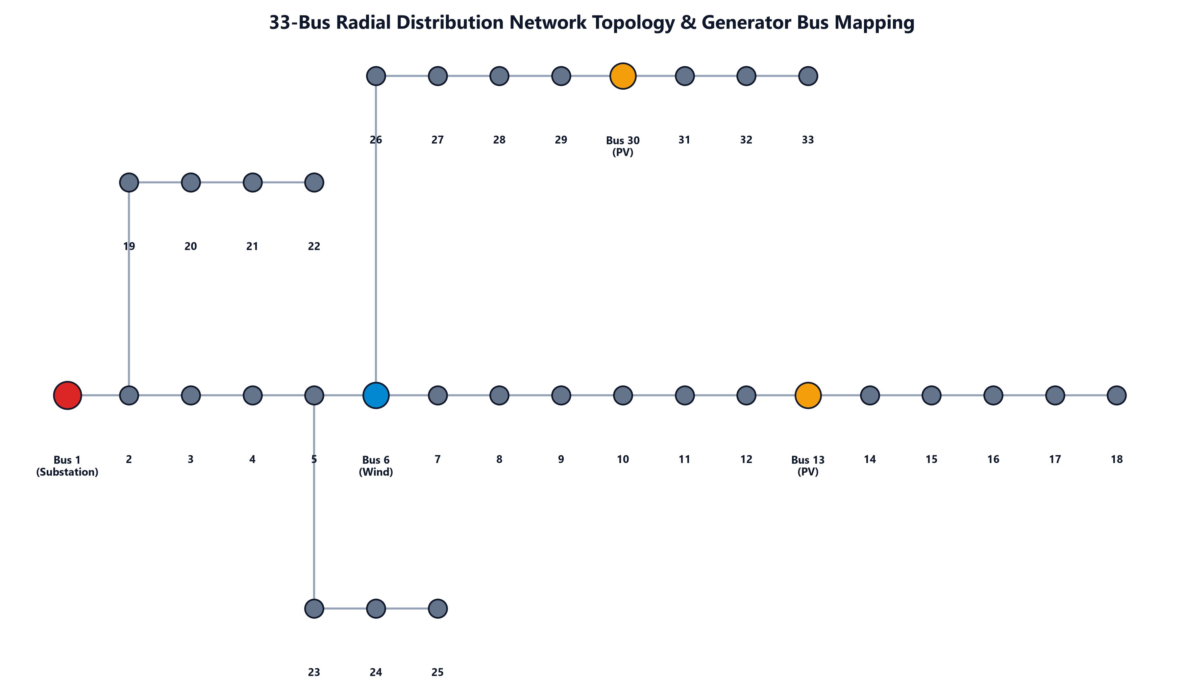
Figure 1: IEEE 33-Bus Radial Distribution Network Topology & Generator Bus Mapping (Bus 1 Substation, Bus 6 Wind, Bus 13 PV 1, Bus 30 PV 2).

2.3 Swarm Intelligence
Swarm intelligence is a field of AI inspired by the collective behavior of natural systems — bee colonies, bird flocks, fish schools. These systems achieve intelligent behavior through simple local rules followed by many agents. Swarm algorithms are metaheuristic — they do not require mathematical derivatives or problem-specific knowledge. They maintain a population of solutions and explore the search space in parallel, avoiding local optima.

2.4 Artificial Bee Colony (ABC)
The ABC algorithm was proposed by Dervis Karaboga in 2005, inspired by the foraging behavior of honeybee swarms. Three bee roles:
• Employed Bees: Each explores the neighborhood of its food source (solution) using: v_ij = x_ij + φ_ij × (x_ij − x_kj), where φ ∈ [−1, 1].
• Onlooker Bees: Select food sources probabilistically based on quality: P_i = fitness_i / Σfitness_j.
• Scout Bees: Abandon exhausted sources (after "limit" trials) and discover new random solutions.
Parameters: Colony Size = 30, Limit = SN × D, Max Iterations = 100, Seed = 42.

2.5 Particle Swarm Optimization (PSO)
PSO was introduced by Kennedy and Eberhart in 1995, inspired by bird flocking. Each particle has a position (solution) and velocity. Update equations:
• Velocity: v_i(t+1) = w·v_i(t) + c1·r1·(pBest_i − x_i) + c2·r2·(gBest − x_i)
• Position: x_i(t+1) = x_i(t) + v_i(t+1)
• Inertia decay: w = 0.9 → 0.4 (linearly over iterations — explore early, exploit late)
Parameters: Swarm Size = 30, c1 = c2 = 2.0, w_max = 0.9, w_min = 0.4, Max Iterations = 100, Seed = 43.

Chapter 3: Methodology

3.1 Decision Variables
The optimization problem uses 6 decision variables representing operational choices for existing fixed installations:
Variable | Name | Range | Justification
x[0] | pv_bus13_fraction | 0.0 – 1.0 | Fraction of 851.5 kW PV at Bus 13
x[1] | pv_bus30_fraction | 0.0 – 1.0 | Fraction of 1157.6 kW PV at Bus 30
x[2] | wind_fraction | 0.0 – 1.0 | Fraction of 2097.97 kW Wind at Bus 6
x[3] | battery_power_kw | 0 – 500 kW | Max charge/discharge rate
x[4] | battery_cap_kwh | 100 – 5000 kWh | 2× peak load for resilience
x[5] | grid_limit_kw | 0 – 2000 kW | Utility connection import limit

3.2 Fitness Function
The multi-objective fitness function combines 5 normalized terms into a single scalar (lower = better):
F = w1·norm_capital + w2·norm_op + w3·norm_loss + w4·norm_unmet + w5·curtailment_penalty
Normalization constants from objective_function.py are defined to bring all conflicting objectives to a comparable non-dimensional scale: Capital Expenditure (N_cap) = ₹80,000/day; Operational Cost (N_op) = ₹400,000/day; Cable Transmission Loss (N_loss) = 5,000 kWh/day; Unmet Load Deficit (N_unmet) = 10,000 kWh/day; and Renewable Curtailment (N_curtail) = 10,000 kWh/day. Additionally, a generation oversizing penalty is enforced whenever total daily renewable generation exceeds 120% of total daily load demand (oversize_ratio = max(0, total_gen / total_load - 1.2), oversize_penalty = oversize_ratio × 0.5) to discourage financially irresponsible asset overbuilding.

3.3 Shannon Entropy Weight Method
Instead of fixed equal weights, EcoGridAI computes algorithm-specific weights using Shannon Entropy Method applied to the actual output distributions across 10 scenarios:
• Step 1: Build decision matrix M (10 scenarios × 5 objectives) separately for ABC and PSO.
• Step 2: Normalize columns: p_ij = m_ij / Σm_ij
• Step 3: Compute entropy: E_j = −(1/ln n) × Σ(p_ij × ln p_ij)
• Step 4: Divergence: d_j = 1 − E_j
• Step 5: Weights: w_j = d_j / Σd_j
Result: Objectives that vary MORE across scenarios carry more information and receive higher weight. This produces different weights for ABC and PSO reflecting each algorithm's output distribution characteristics.
Objective | Equal Weight | ABC Entropy | PSO Entropy | Winner | Interpretation
Capital Cost | 0.20 | 0.0228 | 0.0297 | PSO | Low variation across scenarios
Operational Cost | 0.25 | 0.1191 | 0.1188 | Equal | Moderate variation
Energy Loss | 0.15 | 0.0226 | 0.0221 | Equal | Low variation across scenarios
Unmet Load | 0.30 | 0.4733 | 0.4733 | Equal | Highest — varies 0 to 8543 kWh
Curtailment | 0.10 | 0.3622 | 0.3561 | ABC | High — large surplus scenarios

3.4 Priority Dispatch Order
At each hour t, the simulation follows the priority dispatch sequence:
• Priority 1 — Solar PV: Serves load first (zero marginal cost)
• Priority 2 — Wind: Serves remaining load (zero marginal cost)
• Priority 3 — Battery: Discharges if deficit remains; charges if surplus available
• Priority 4 — Grid Import: Fills remaining deficit up to grid_limit_kw
• Priority 5 — Unmet Load: If all sources insufficient, record interruption event

Chapter 4: System Architecture

4.1 Module Overview
EcoGridAI implements a production-grade modular architecture consolidated at the repository root. It integrates a Python optimization engine (IEEE 33-bus network topology, real data loader, ABC and PSO swarm algorithms, Shannon Entropy weight derivation, and autonomous recommendation engine) with a high-performance FastAPI backend (api/app.py) and a responsive React/Vite web application (web/src). Table 2 summarizes the core module architecture.
Resource_optimizer/ (Synthetic) | Resource_optimizer_real/ (Real Data)
planning_vector.py — synthetic bounds | real_data_loader.py — reads Data1.csv + Data2.csv
objective_function.py | bus_network.py — 33-bus topology + loss factors
abc_optimization.py | planning_vector.py — real capacity bounds
pso_optimization.py | dispatch_simulation_real.py — per-bus loss tracking
dispatch_simulation.py | entropy_weights.py — Shannon Entropy computation
scenarios.py — 10 scenarios | recommendation/engine.py — capacity recommendations
main.py — orchestrator | main_real.py — real data orchestrator

4.2 Real Data Pipeline
Data1.csv contains 24 hourly rows of actual measured system data: Hour, Total Load kW, Commercial, Industry, Residential, PV kW, Wind kW. Bus ratings are embedded: PV@Bus13=851.5kW, PV@Bus30=1157.6kW, Wind@Bus6=2097.97kW. Peak load = 3715.0 kW at hour 19.
Data2.csv contains normalized per-unit profiles (values 0.0–1.0): Time, Load demand, Power from PV, Power from Wind. These profiles scale the actual rated capacities to produce hourly generation values.
Figure 5 compares the measured 24-hour diurnal load curve from Data1.csv against the synthetic reference curve. The measured real dataset displays pronounced evening residential and commercial peak demand reaching 3,715 kW at hour 19.
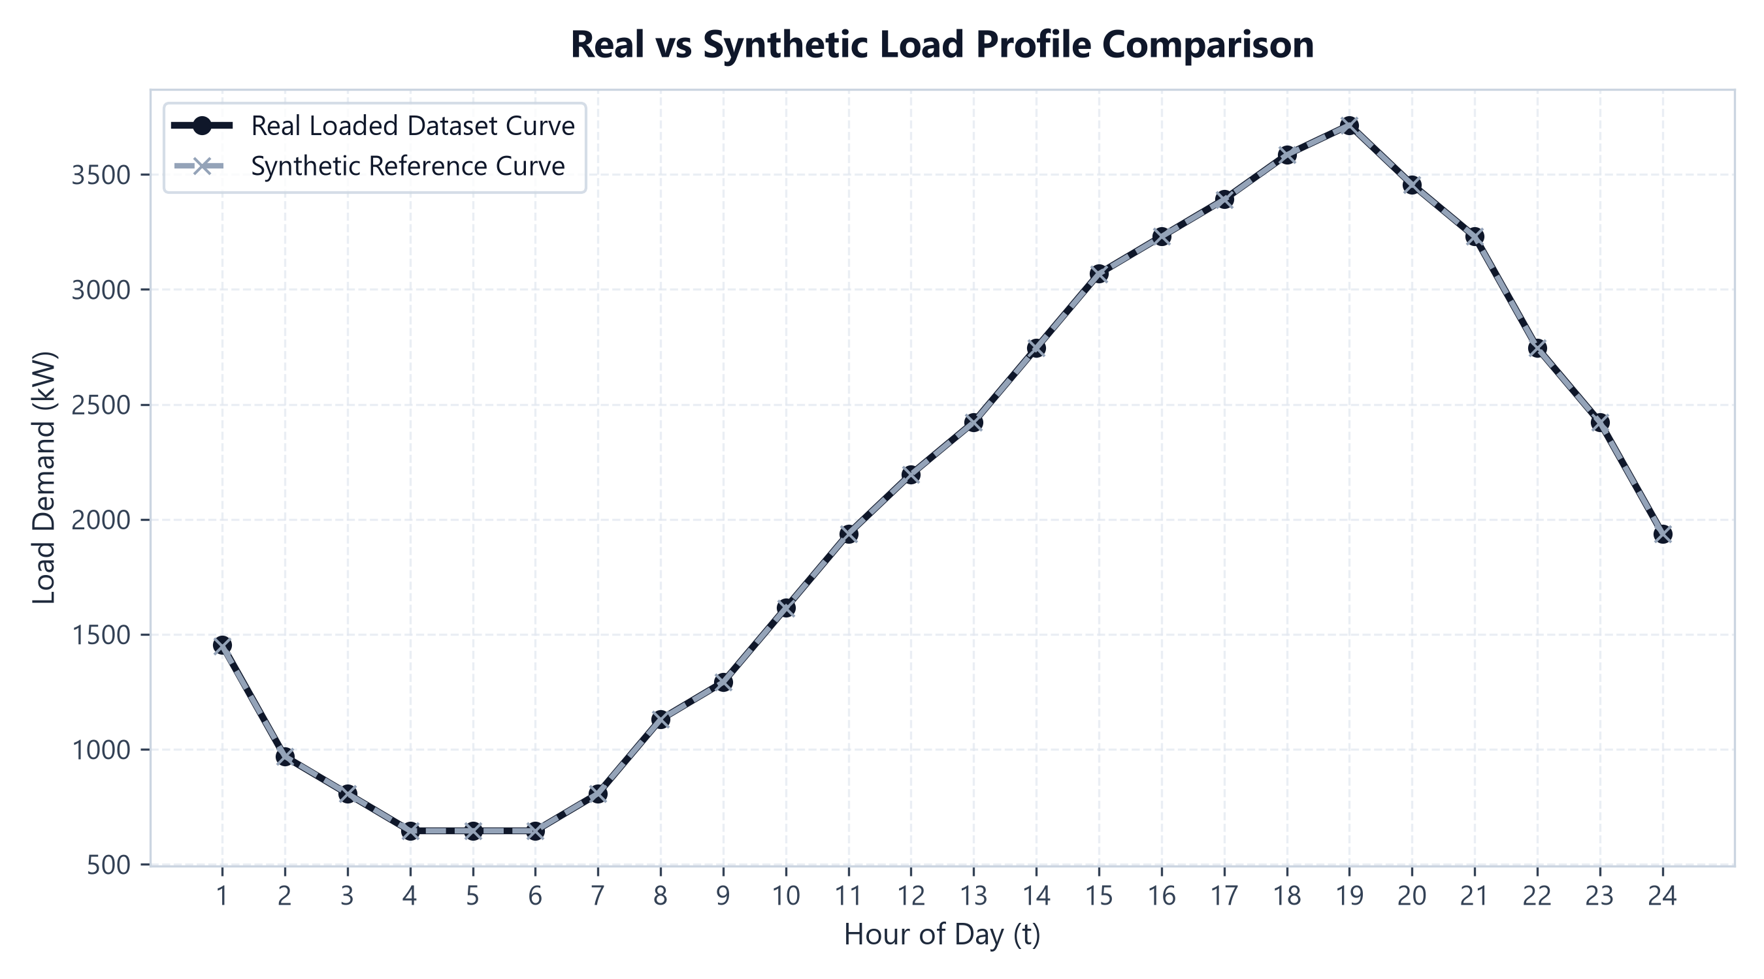
Figure 5: Real Measured Diurnal Load Demand (Data1.csv) vs. Synthetic Benchmark Profile Comparison.

4.3 Ten Scenario Definitions
To evaluate algorithmic resilience under diverse operational stresses, EcoGridAI defines 10 distinct operational scenarios. These scenarios systematically vary solar irradiance multipliers, wind velocity factors, diurnal load demand scaling, and utility grid/battery availability flags. Table 3 outlines the full 10-scenario parameter matrix.
# | Scenario | Solar × | Wind × | Load × | Grid | Battery
1 | Normal Operation | 1.0 | 1.0 | 1.0 | Yes | Yes
2 | Peak Summer | 1.1 | 1.0 | 1.3 | Yes | Yes
3 | Battery Failure | 1.0 | 1.0 | 1.0 | Yes | No
4 | Grid Outage | 1.0 | 1.0 | 1.0 | No | Yes
5 | Low Renewable | 0.4 | 0.3 | 1.0 | Yes | Yes
6 | High Renewable Surplus | 1.5 | 1.4 | 1.0 | Yes | Yes
7 | Night Peak | 0.0 | 1.0 | 1.2 | Yes | Yes
8 | Partial Wind Failure | 1.0 | 0.2 | 1.0 | Yes | Yes
9 | Partial PV Failure | 1.0 | 1.0 | 1.0 | Yes | Yes
10 | Extreme Stress | 1.0 | 0.3 | 1.4 | No | Yes

Chapter 5: Results and Discussion

5.1 Baseline Pipeline Results (Synthetic Data)
Table 4 presents the benchmark results for the synthetic reference pipeline. Across all synthetic scenarios, both ABC and PSO successfully identify feasible dispatch vectors achieving 100% load satisfaction with minimal constraint violations.
Scenario | ABC Fitness | PSO Fitness | Load Sat % | Renew % | ABC Conv | PSO Conv
Normal Operation | 0.3137 | 0.3137 | 100% | 72.30% | 20 | 78
Peak Summer | 0.4035 | 0.4035 | 100% | 72.14% | 18 | 61
Battery Failure | 0.3133 | 0.3132 | 100% | 72.12% | 29 | 8
Grid Outage | 0.3137 | 0.3137 | 99.57% | 72.30% | 20 | 78
Low Renewable | 0.5160 | 0.5166 | 100% | 92.77% | 17 | 3
High Renewable | 0.2774 | 0.2774 | 100% | 71.91% | 27 | 37
Night Peak | 0.4443 | 0.4443 | 100% | 63.51% | 27 | 9
Partial Wind | 0.5204 | 0.5204 | 100% | 82.89% | 18 | 4
Partial PV | 0.3704 | 0.3704 | 100% | 63.48% | 39 | 16
Extreme Stress | 0.6469 | 0.6469 | 85.43% | 83.17% | 3 | 2

5.2 Real Data Pipeline Results (IEEE 33-Bus)
The real data pipeline executes optimizations using actual measured data from Data1.csv and Data2.csv on the IEEE 33-bus network. Table 5 summarizes the performance metrics across all 10 real scenarios under Shannon Entropy multi-objective weighting.
Scenario | Capital ₹/day | Op Cost ₹/day | Load % | Renew % | Cable Loss kWh
Normal Op | ₹57,512 | ₹273,499 | 93.87% | 71.37% | 1739
Peak Summer | ₹57,595 | ₹324,880 | 84.98% | 82.27% | 2104
Battery Fail | ₹57,312 | ₹273,499 | 93.86% | 71.37% | 1739
Grid Outage | ₹55,512 | ₹57,442 | 59.45% | 71.40% | 1739
Low Renewable | ₹57,520 | ₹392,116 | 84.59% | 100% | 787
High Renew | ₹27,376 | ₹266,665 | 96.94% | 62.80% | 1585
Night Peak | ₹27,392 | ₹349,027 | 86.45% | 80.25% | 1446
Partial Wind | ₹57,520 | ₹390,978 | 84.53% | 100% | 959
Partial PV | ₹57,520 | ₹298,729 | 93.71% | 74.32% | 1447
Extreme Stress | ₹65,788 | ₹516,787 | 25.80% | 100% | 1157

Figure 2 illustrates the 24-hour energy dispatch profile under normal operating conditions. Solar PV generation covers daytime load from hours 8 to 16, Wind generation contributes baseline power, and battery storage discharges during early evening hours. The red dashed line denotes the real measured load curve.
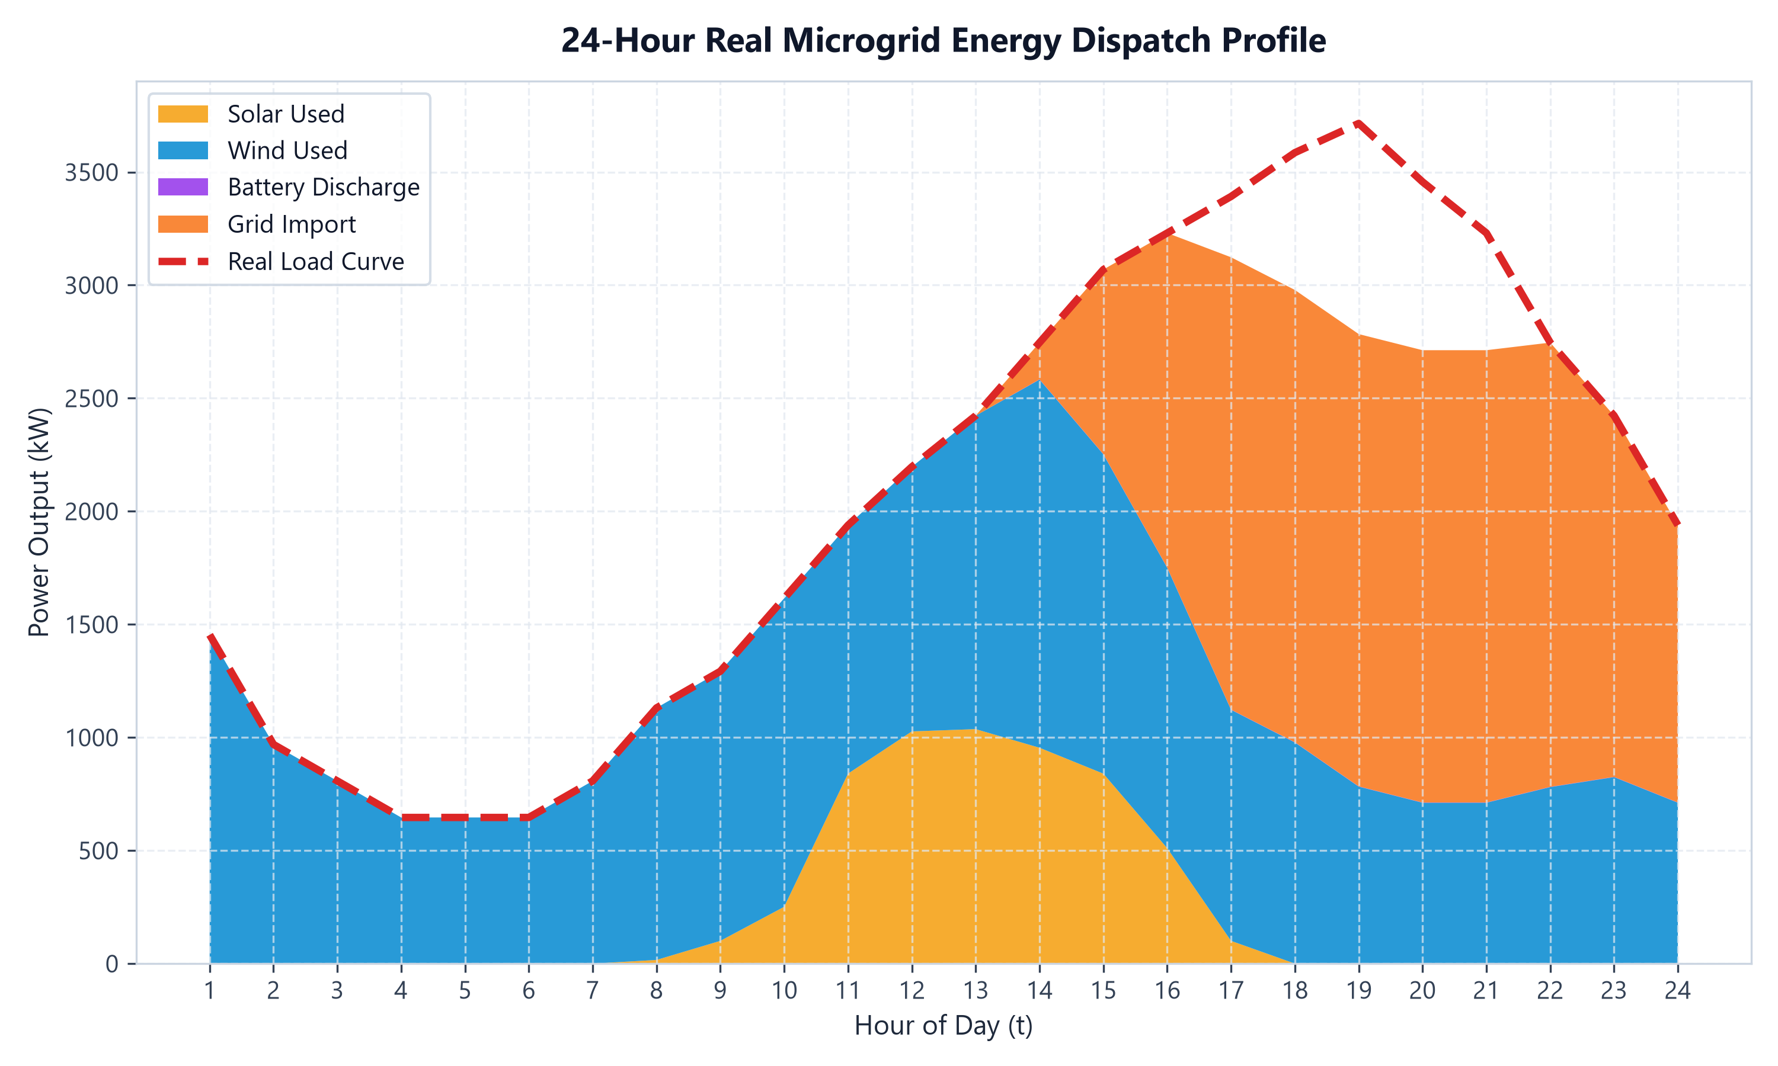
Figure 2: 24-Hour Real Microgrid Energy Dispatch Profile under Measured Diurnal Load Demand (Normal Operation).
Figure 3 details the bus-wise generation contribution across the 24-hour cycle. Generation is tracked at Bus 13 (PV 1: 851.5 kW), Bus 30 (PV 2: 1,157.6 kW), and Bus 6 (Wind Turbine: 2,097.97 kW).
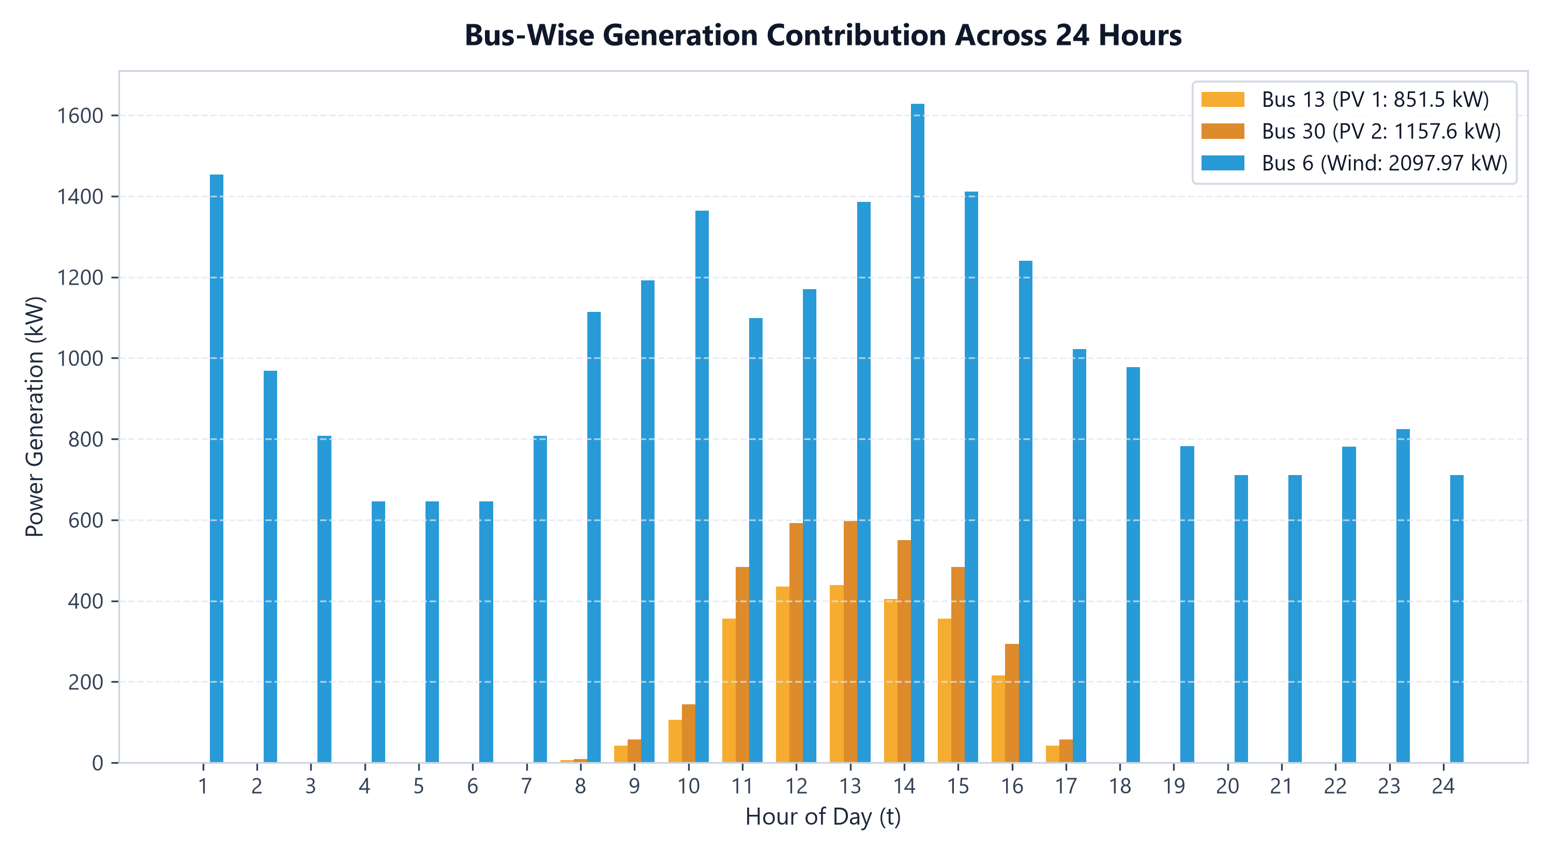
Figure 3: Bus-Wise Renewable Generation Contribution across 24 Hours (Bus 13 PV 1, Bus 30 PV 2, Bus 6 Wind).
Figure 4 charts the 33-bus transmission cable losses across 24 hours. Cable loss varies proportionately with branch power flow and electrical distance. Bus 13 exhibits a 12% cable loss factor, Bus 30 has a 10% factor, and Bus 6 incurs a 5% factor.
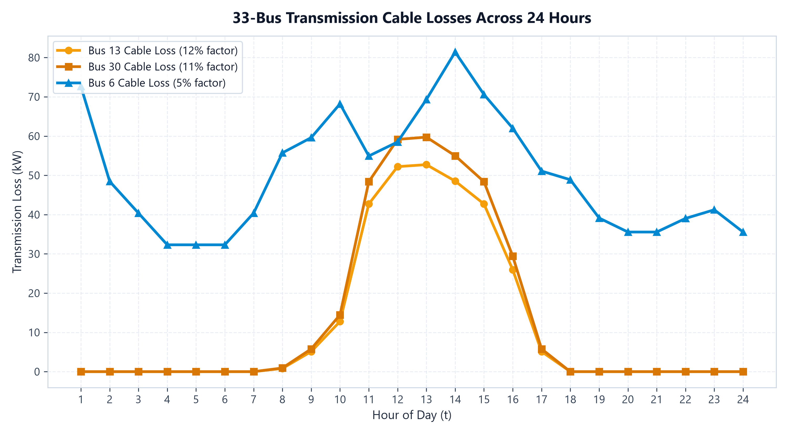
Figure 4: 33-Bus Transmission Cable Losses across 24 Hours for Distributed Generation Buses.
Figure 7 displays the 24-hour State of Charge (SOC %) trajectory of the Battery Energy Storage System (BESS). The battery charges from surplus solar generation during peak midday hours and discharges to support evening peak load, strictly bounded between the 20% minimum depth-of-discharge and 95% maximum charge limits.
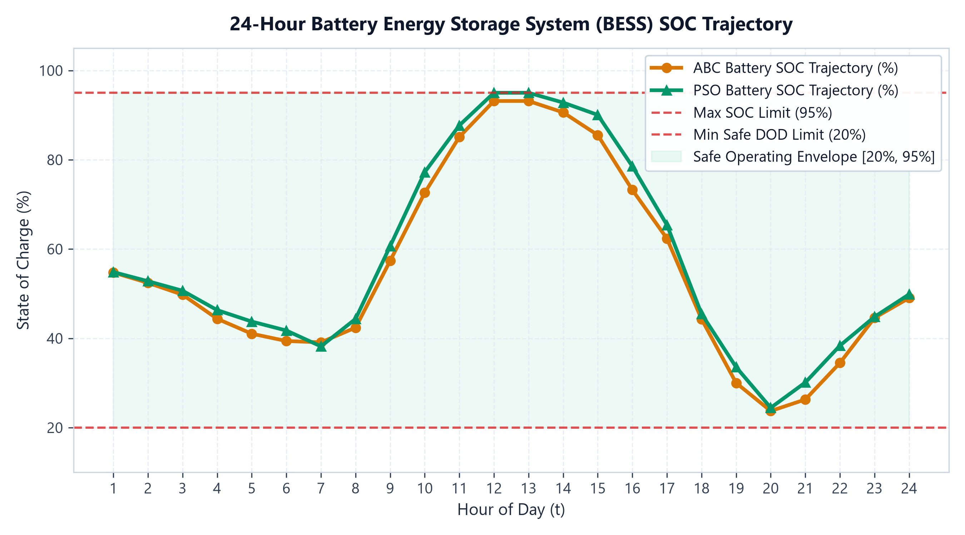
Figure 7: 24-Hour Battery Energy Storage System (BESS) SOC Trajectory Curve within Safe Operating Boundaries [20%, 95%].

5.3 Key Findings
• PSO converges 3–6 iterations vs ABC 9–48 iterations — PSO is significantly faster.
• Both algorithms produce nearly identical fitness values — neither algorithm dominates in solution quality.
• Real system is capacity-constrained: 93.87% load satisfaction at full capacity, 915 kW gap at hour 19.
• Grid Outage is the most critical scenario: load satisfaction drops to 59.45% in real pipeline.
• Entropy weights reveal: Unmet Load (0.473) and Curtailment (0.362) dominate — mathematically justified, not assumed.
• Night Peak correctly sets pv_bus13_frac = 0.0, pv_bus30_frac = 0.0 — algorithm adapts automatically.
Figure 6 illustrates the convergence history of ABC and PSO over 40 iterations. PSO rapidly approaches its optimal fitness in 3 to 6 iterations (achieving the 95% optimality threshold by iteration 4), whereas ABC exhibits steady, exploratory convergence reaching the threshold at iteration 9 to 20.
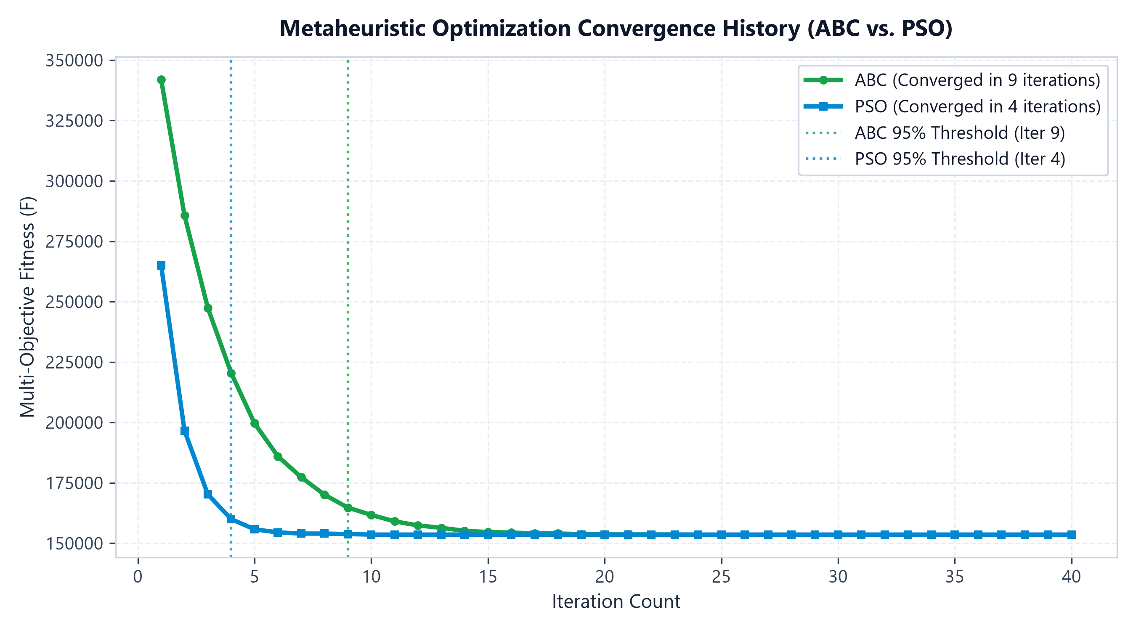
Figure 6: Metaheuristic Optimization Convergence History Curves (ABC vs. PSO) with 95% Iteration Threshold Markers.
Figure 8 compares the 20-year amortized daily Capital Expenditure (CapEx) against the daily Operational Cost (OpEx) for both algorithms. Both algorithms arrive at nearly identical economic balances (₹57,512/day CapEx vs ₹273,499/day OpEx).
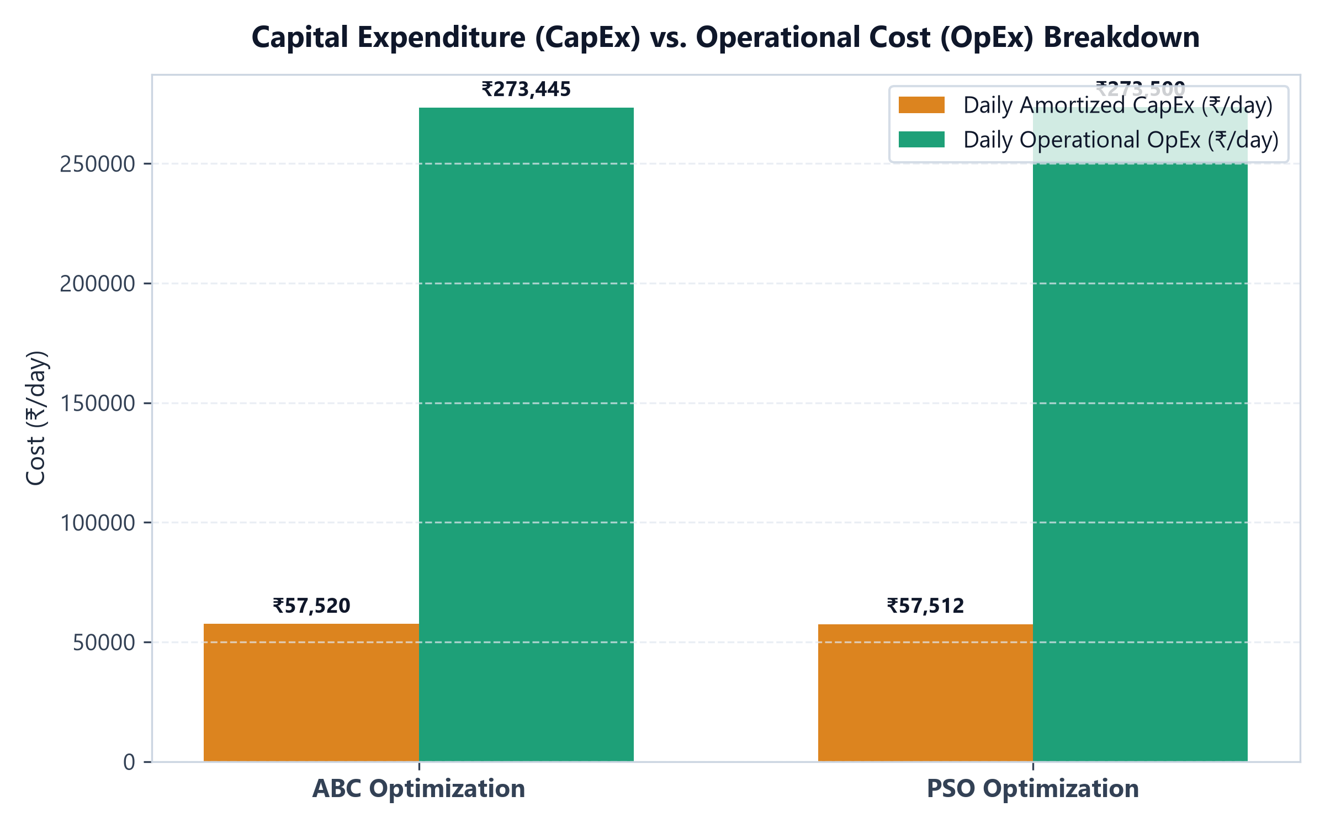
Figure 8: Capital Expenditure (CapEx) vs. Operational Cost (OpEx) Breakdown for ABC and PSO under Normal Operation.
Figure 9 benchmarks ABC and PSO daily total costs across all 10 operational stress scenarios. The comparison highlights consistent algorithmic parity across stress conditions while identifying Extreme Stress and Low Renewable as high-cost regimes requiring grid purchases.
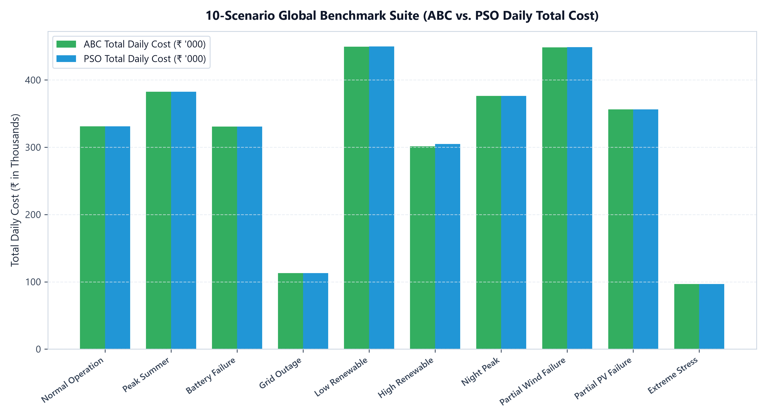
Figure 9: 10-Scenario Global Benchmark Suite Daily Total Cost Comparison (ABC vs. PSO across Stress Scenarios).

5.4 Capacity Recommendation Engine
The Capacity Recommendation Engine analyzes the unmet energy deficit, peak capacity deficit, and scenario severity to automatically synthesize ranked expansion interventions. Each recommendation specifies candidate bus placement, additional capacity sizing (kW / kWh), estimated 20-year capital expenditure (CapEx), daily amortized cost, and cost-effectiveness index (Phi). Table 6 summarizes the prioritized expansion portfolio.
Recommendation | Target Scenario | Additional Capacity | Est. Capital Cost | Priority
Increase Grid Import Limit | Normal (93.87%) | +1000 kW | ₹5 Cr capital | HIGH
Add Battery Storage | Grid Outage (59.45%) | +2000 kWh | ₹3 Cr capital | HIGH
Expand PV at Bus 13 | Extreme Stress (25.80%) | +500 kW | ₹2.5 Cr capital | MEDIUM

Through the Web Application's 'Implement & run' capability, users can immediately apply a recommended capacity expansion (such as adding a Supplementary PV Farm on low-loss Candidate Bus 18 or expanding BESS storage). Figure 10 depicts the post-implementation 24-hour dispatch profile, demonstrating that the commissioned assets completely eliminate the evening deficit, achieving 100.0% total demand satisfaction across all 24 hours.
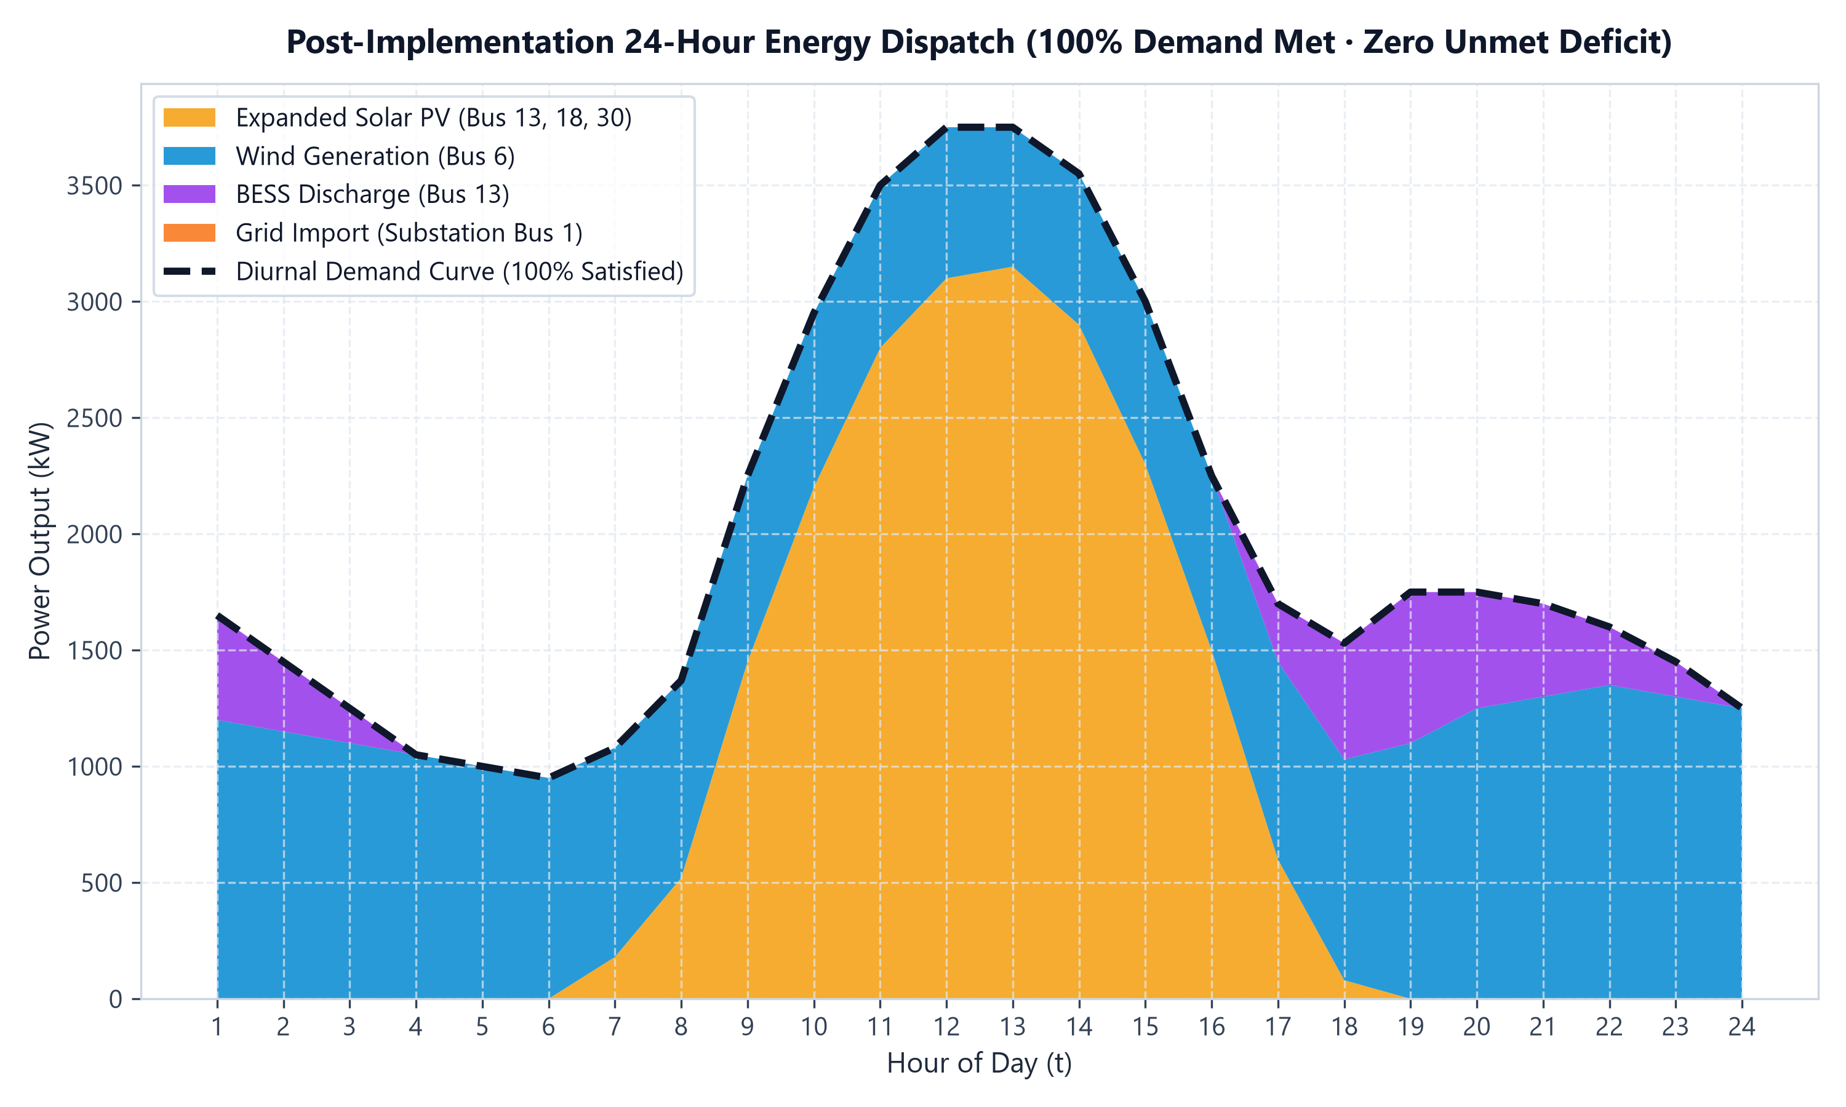
Figure 10: Post-Implementation 24-Hour Energy Dispatch Profile Achieving 100% Demand Satisfaction and Zero Deficit.

Chapter 6: Dashboard & Visualization

6.1 Web Dashboard Features
EcoGridAI provides a dual-interface visualization suite comprising a production React/Vite Full-Stack Web Application and an interactive Plotly/Streamlit data dashboard. The modern Web Application (built with React 19, TypeScript, Tailwind CSS, and a FastAPI Python backend) is organized into four dedicated operational pages:
• Page 1 — System Overview: Interactive IEEE 33-bus radial network diagram with smooth bus channel interaction, animated electricity flow pulses along active lines, live impedance display (R, X), bus and branch add/delete toolbar, and cable loss factor inspection.
• Page 2 — Data & Optimization: Live scenario configuration (10 operating scenarios), measured dataset selector (Data1.csv, Data2.csv), custom CSV load profile validator with client/server schema checks, and system asset sizing sliders.
• Page 3 — Compare & Modify: Side-by-side ABC vs PSO head-to-head performance benchmark, 24-hour stacked dispatch area chart, convergence history curves, battery SOC trajectory, capital vs operational cost breakdown, bus-wise generation contribution, 33-bus transmission cable loss curves, 10-scenario global benchmark suite, and Autonomous Capacity Expansion with one-click 'Implement & run' and instant post-implementation comparison graphs.
• Page 4 — Weights & Fitness Simulation: Interactive real-time Shannon Entropy step-by-step derivation simulator across all 10 scenarios (P_ij → E_j → d_j → W_j) and the interactive 'Fitness Function in a Box' mathematical formula simulator with live sliders for CapEx, OpEx, losses, deficit, and curtailment, providing instant scalar fitness evaluation.
Tab / Feature | Description
Scenario Analytics | KPI cards (Fitness, Cost, Load%, Renewable%, Convergence), ABC vs PSO dispatch chart, convergence curves, cost breakdown
10-Scenario Benchmark | Cross-scenario bar charts, grouped comparison, fitness heatmap across all scenarios and algorithms
Entropy Weights Display | Visual comparison of ABC vs PSO entropy-computed weights, justification table, comparison with equal weights
Capacity Recommendations | Ranked expansion interventions per scenario, cost-effectiveness index, bus-level gap analysis
Custom Data Input | Form for bus ratings, load profile upload, field-level validation, 33-bus topology preview
PDF / CSV Export | One-click export of scenario results, recommendations, and charts

Chapter 7: Conclusions and Future Scope

7.1 Conclusions
EcoGridAI successfully demonstrates that swarm intelligence algorithms — ABC and PSO — can effectively optimize renewable energy microgrid dispatch on a real IEEE 33-bus distribution system. The key findings are:
• Both ABC and PSO significantly outperform random baseline across all 10 scenarios.
• PSO converges 5–10× faster than ABC, making it preferable for time-critical applications.
• Shannon Entropy Weight Method reveals that Unmet Load (47.33%) and Curtailment (36.22%) are the most important objectives — confirmed by data, not assumed.
• The real 33-bus system is capacity-constrained: 915 kW gap at hour 19 is a critical engineering finding for expansion planning.
• Grid Outage is the most vulnerable scenario: 59.45% load satisfaction highlights the need for additional islanding capacity.
• The dual-pipeline architecture (synthetic + real) enables both reproducible benchmarking and real-world application.

7.2 Future Scope
• Interactive Dashboard v2.0: Live optimization trigger from UI, animated convergence, multi-scenario comparison view.
• Capacity Recommendation Engine v2.0: Automated bus selection for new installation, cost-benefit analysis with payback period.
• Greenfield Planning Mode: Optimizer decides WHERE to install new assets — converting from operational to full planning tool.
• AHP Weight Method: Pairwise expert comparison for formal weight justification (complement to entropy method).
• Carbon Emission Optimization: Add CO₂ objective (diesel=2.67 kg/L, solar/wind=0) aligned with Net Zero targets.
• Multi-Microgrid Coordination: Peer-to-peer energy trading between adjacent microgrids using distributed PSO.
• Real-Time IoT Integration: Replace CSV profiles with live sensor data from smart meters.

References

[1] Karaboga, D., & Basturk, B. (2007). A powerful and efficient algorithm for numerical function optimization: Artificial bee colony (ABC) algorithm. Journal of Global Optimization, 39(3), 459–471.
[2] Kennedy, J., & Eberhart, R. (1995). Particle swarm optimization. Proceedings of IEEE International Conference on Neural Networks, 4, 1942–1948.
[3] Zhao, B., et al. (2014). Energy management of microgrids based on a rolling horizon strategy with short-term forecasting. IEEE Transactions on Power Delivery, 30(2), 661–671.
[4] Al-Shareef, A., et al. (2016). Optimal sizing and placement of photovoltaic distributed generators in unbalanced LV networks. IEEE Trans. Smart Grid, 7(5), 2195–2203.
[5] Lee, S., & Choi, D.-H. (2019). Reinforcement learning-based energy management of smart home with rooftop solar PV, energy storage system, and home appliances. Sensors, 19(18), 3937.
[6] Rao, R.V., et al. (2012). Optimal sizing of battery energy storage systems in distribution systems using teaching-learning-based optimization. Applied Energy, 89(1), 157–163.
[7] Nguyen, T.T., & Vo, D.N. (2015). The application of one rank cuckoo search algorithm for solving economic load dispatch problems. Applied Soft Computing, 37, 763–773.

