**Week8 Exploring the Power of Swing Components in GUI Programming**

Hang Yang

IS 5103: Object Oriented Programming in JAVA

Prof. Abdalla Soliman

March 1, 2024

**Week8 Exploring the Power of Swing Components in GUI Programming**

Graphical User Interfaces (GUIs) are an integral part of modern software applications, providing users with an interactive and visually appealing way to interact with computer programs. In this exploration, we'll delve into the functions of Swing components used in a simple yet engaging number guessing game program. This game not only serves as a practical example but also showcases the versatility of Swing components in creating dynamic and responsive interfaces. Additionally, we'll briefly compare Java Swing and JavaFX, shedding light on the considerations that led to choosing Swing for this project.

**The Foundation of Swing Components**

**JFrame: Building the Foundation**

The JFrame class in Swing serves as the primary container for GUI components, providing a window in which other components can be organized. The setSize(Dimension) function allows developers to set the dimensions of the JFrame, determining its width and height. This capability is crucial for designing interfaces that fit the screen appropriately and offer a seamless user experience. In a real-world scenario, consider a multimedia application that requires a specific window size to display images or videos optimally. The ability to set the JFrame size ensures that the visual content is presented in the desired format, contributing to an enhanced user interface.

**JButton: Enhancing Interactivity**

Buttons are fundamental elements of GUIs, allowing users to trigger actions by clicking. In our number guessing game, we use JButton instances for User A, User B, and setting the target. The addActionListener(e) function is pivotal in associating an action with each button. In web development, buttons play a crucial role in user interaction. For instance, an e-commerce website may utilize buttons for actions like adding items to the shopping cart or proceeding to checkout. The addActionListener function, or its equivalent in web development frameworks, enables developers to define specific actions, ensuring a seamless flow of user interaction.

**JTextArea: Facilitating Text Display**

The JTextArea component is employed to display text, providing a versatile means of presenting information. In our number guessing game, it serves as a panel to record user guesses and game results. The setText() function allows dynamic updating of text within the JTextArea. In a practical context, consider a chat application where users exchange messages. The JTextArea component could be instrumental in displaying a conversation log in real-time. The ability to dynamically update text ensures that users receive the latest information, contributing to a responsive and engaging user interface.

**Bringing Components Together: add(components)**

The add(components) function is a cornerstone for assembling various components within a container, such as a JFrame. In our number guessing game, this function is utilized to organize buttons, labels, and the text area within the JFrame. This capability is fundamental in creating a well-structured and visually appealing layout. In a business application, an employee management system, for example, could use the add function to organize different components such as employee details, payroll information, and attendance records within a single interface. This enhances the usability of the application, making it more intuitive for users to navigate and perform tasks efficiently.

**setVisible(): Making Interfaces Visible**

The setVisible() function is instrumental in making JFrame and its associated components visible to users. In our number guessing game, this function is called to display the graphical user interface when the program starts. In real-world applications, the visibility of interfaces is a crucial aspect of user interaction. Consider a project management tool where project timelines, tasks, and milestones are visualized through a GUI. The setVisible function ensures that project stakeholders can access and interact with the project data seamlessly, contributing to effective collaboration and decision-making.

**A Glimpse into the World of Swing Components**

The functions discussed above, namely setSize(Dimension), addActionListener(e), setText(), add(components), and setVisible(), represent the building blocks of GUI programming using Swing components in Java. These functions empower developers to create visually appealing, interactive, and user-friendly interfaces across diverse applications. In the rapidly evolving landscape of software development, GUIs play a pivotal role in shaping user experiences. The versatility of Swing components and their associated functions makes them invaluable tools for developers seeking to create dynamic and responsive interfaces. Whether it's a game, a business application, or a multimedia tool, the principles and functions explored in this essay form the foundation of GUI programming excellence.

**Choosing Swing Over JavaFX: A Personal Journey**

In the vast realm of Java GUI libraries, Swing and JavaFX stand out as two prominent choices. Each has its strengths and weaknesses, but the decision to choose Swing for the number guessing game project was rooted in the author's familiarity and positive experiences.

**Learning Curve and Ease of Understanding**

For beginners venturing into GUI programming, the learning curve can be a significant factor. Java Swing, with its straightforward APIs and concepts, offers a gentle introduction to GUI development. The ease of understanding Swing components and their functions enables beginners to quickly grasp the essentials of creating graphical interfaces. In contrast, JavaFX, while powerful and modern, might have a steeper learning curve for those new to GUI programming. Its richer set of features and reliance on a declarative language (FXML) can be intimidating for beginners looking for a quick start.

**Familiarity and Hands-On Learning**

The author's first exposure to GUI programming in Java was through Swing. This hands-on experience provided a solid foundation for understanding the basics of creating windows, buttons, and text components. The familiarity gained with Swing's event-driven programming model made it a natural choice for smaller personal projects. JavaFX, introduced later as a successor to Swing, brought advancements in terms of visuals and multimedia capabilities. However, the decision to stick with Swing for this project was driven by the comfort and confidence derived from previous experiences.

In conclusion, while JavaFX offers modern features and improved visuals, the choice of Swing for the number guessing game project was a deliberate one. It reflects the author's journey in GUI programming, where a strong foundation in Swing paved the way for subsequent exploration. The decision underscores the principle that the best tool for a project is often the one that aligns with the developer's knowledge, preferences, and the specific requirements of the task at hand.

Figure 1-Program III.part1

*Note. Screenshot of Program III. Own work*

Figure 2 – ProgramIII.part2A screen shot of a computer

Description automatically generated*Note. Screenshot of Program III. Own work*

Figure 3 – ProgramIII.part3

*Note. Screenshot of Program III. Own work*

Figure 4 – ProgramIII.part4

*Note. Screenshot of Program III. Own work.*

Figure 5 – ProgramIII.part5 – Compiled and play Result

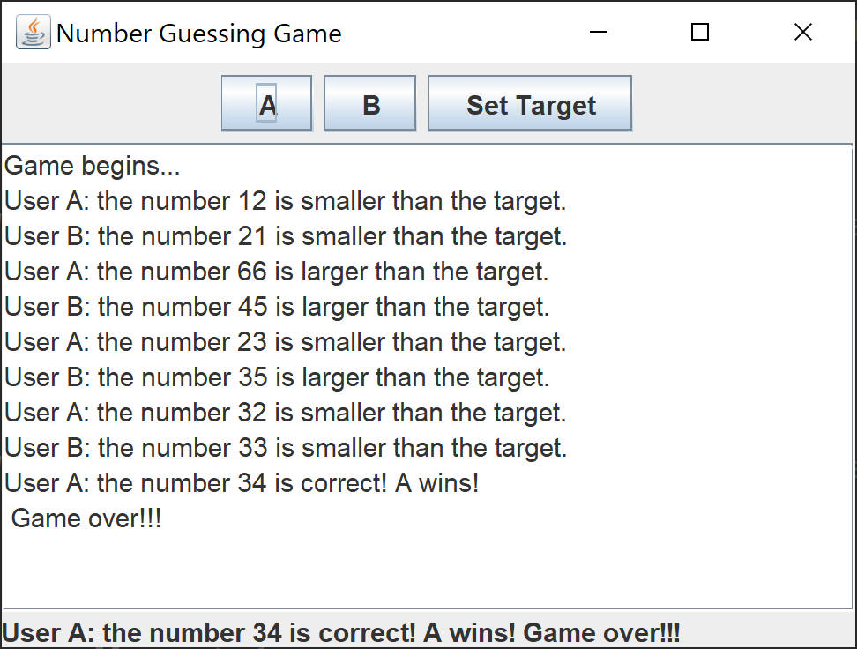

*Note. Screenshot of Program III. Own work*

**References**

Lee, A. (2020, Feb 6). *Java GUI Tutorial – Make a GUI in 13 Minutes #99.* [Video]. YouTube. <https://www.youtube.com/watch?v=5o3fMLPY7qY>

Larkin P. (2022, July 20). JavaFX vs Swing: The Key Difference. *Career Karma*. Retrieved from <https://careerkarma.com/blog/javafx-vs-java-swing/>

Rolandmack (2023, May 24). Introduction to Java GUI Programming with Swing. *Medium*. Retrieved from https://medium.com/@rolandmack63/introduction-to-java-gui-programming-with-swing-c9bedda86ee8