Which of the following is a valid JDBC URL?

Suppose conn is a valid … and the exhibits …

Suppose that the table counts has five rows with the numbers 1 to 5. How many lines does this code print?

Which is the first line containing a compiler error?

String url = “jdbc:hsqldb:file:zoo”

Suppose that the table counts has five rows with the numbers 1 to 5. How many lines …

Var sql = “Select num From counts Where num > ?”

Which can fill in the blank and have the code run without error?

Conn.setAutoCommit(false);

Suppose that the table names has five rows and following SQL statement updates all of them. …

Public static void main(…

Which of the following can fill in the blank?

Var sql = “”;

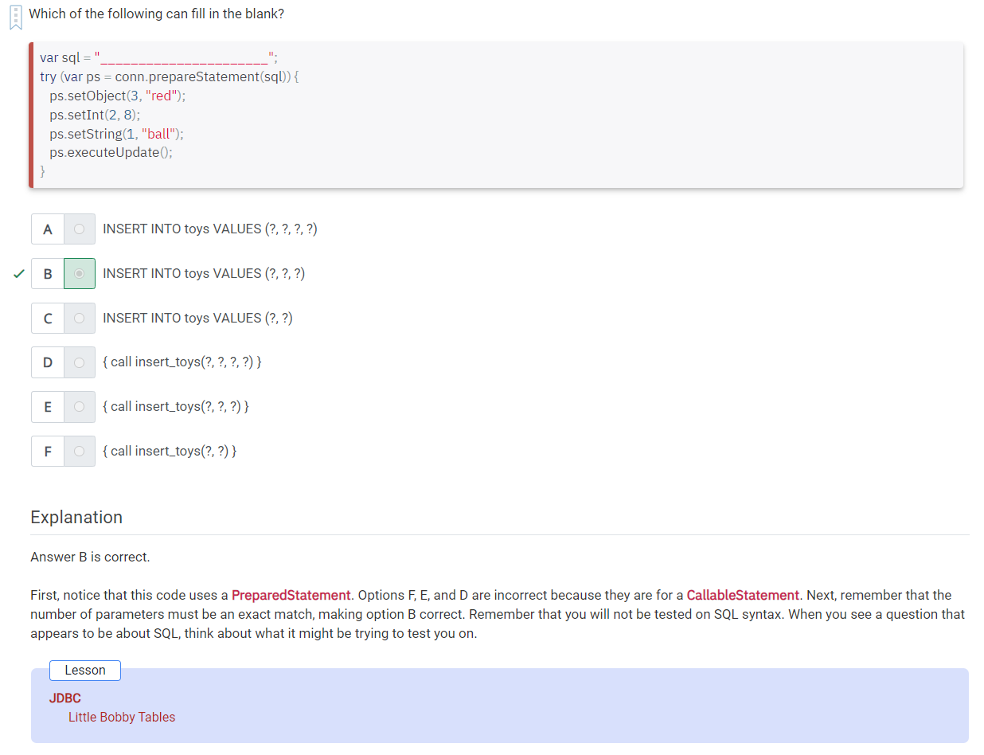

Suppose there are two rows in the table before this code is run, and executeUpdate() runs without error.

Which of the following options can fill in the blank to make the code compile and run without error?

Var sql = “UPDATE habitat WHERE …”;

Suppose we have a JDBC program that calls a stored procedure, which returns a set of results. …

There are currently 100 rows in the table species …

Suppose that you have a table named animal with two rows.

Var conn = new Connection(url, …)

Suppose that the table enrichment has three rows with the animals bat, rat and snake. …

Which of the options can fill in the blank to make the code compile and run without error?

Suppose that the table food has five rows, and this SQL statement updates all of them….

Suppose learn() is a stored procedure that takes one IN parameter and one OUT parameter. ..

Which option can fill in the blanks to make the code compile?

Boolean bool = ps….

Which interfaces or classes are in a database-specific JAR file?

Suppose learn() is …

Var sql = “call learn()”…

Which of the following can fill in the blank correct?

Var rs = ps.executeQuery…

