Chapter 1

1.1 INTRODUCTION TO AR & VR

In recent years, Augmented Reality (AR) and Virtual Reality (VR) have emerged as transformative technologies reshaping how we interact with the digital and physical world. Both are part of the extended reality (XR) spectrum, yet they offer distinct experiences and serve different purposes across industries like education, healthcare, gaming, real estate, retail, and manufacturing.
Augmented Reality (AR) overlays digital information — such as images, audio, or 3D models — onto the real-world environment in real-time. It enhances the user’s perception of reality by combining real and virtual elements, usually through devices like smartphones, tablets, or AR glasses. AR applications are widely used in navigation systems, product visualization, maintenance, and training simulations.
Virtual Reality (VR), on the other hand, provides a completely immersive experience by replacing the real world with a simulated digital environment. This is typically achieved using VR headsets and motion controllers. Users are fully engaged in a computer-generated environment where they can interact with objects, explore virtual spaces, and perform tasks. VR is heavily utilized in fields like gaming, architectural visualization, training and remote collaboration.
The integration of AR and VR is revolutionizing user experiences by offering innovative, interactive, and immersive ways to communicate, learn, and solve problems. A comprehensive understanding of the underlying technologies, tools, and frameworks used to build AR/VR applications is essential to fully leverage their potential. Practical implementation further highlights the versatility and impact of these technologies across real-world scenarios.
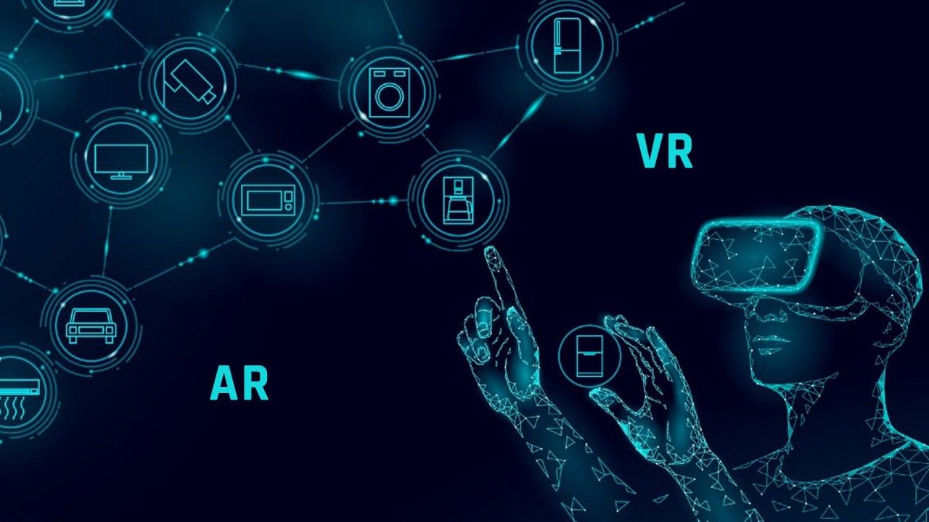

Fig. 1.1.1 AR/VR

1.2 EVOLUTION OF AR & VR

Virtual Reality (VR) History: The origin of VR started in the mid-20th century with inventions to place users within virtual worlds. In 1962, Morton Heilig created the Sensorama, an early multisensory simulator that stimulated sight, sound, and even smell. In 1968, computer scientist Ivan Sutherland invented the first head-mounted display system known as the "Sword of Damocles," which set the stage for contemporary VR headsets. Throughout the 1980s and 1990s, VR technology improved with greater computational power, supporting more realistic and interactive experiences. VPL Research, created by Jaron Lanier, was among the early companies developing VR. But the prohibitively high price, weak graphics, and large hardware hindered mass adoption until the 2010s. The introduction of low-cost consumer VR equipment like the Oculus Rift (2012) spurred renewed interest and fast expansion in VR applications.

Augmented Reality (AR) History: The history of AR is the same as for VR but with a focus on overlaying digital information onto the real world instead of replacing it. The first AR systems appeared in the 1990s, mostly within research facilities and military contexts. An early example is Louis Rosenberg's 1992 Virtual Fixtures system, which augmented human capabilities by overlaying virtual objects onto physical spaces. The widespread availability of smartphones and tablets with cameras and GPS in the late 2000s and early 2010s fueled AR's popularity. The release of apps such as Pokémon GO in 2016 showcased AR's mass consumer appeal potential.

Evolution and Emerging Trends: Both AR and VR have come a long way with hardware advancements e.g., enhanced sensors, screens, and processors, software such as Unity and Unreal Engine, and connectivity (5G networks).
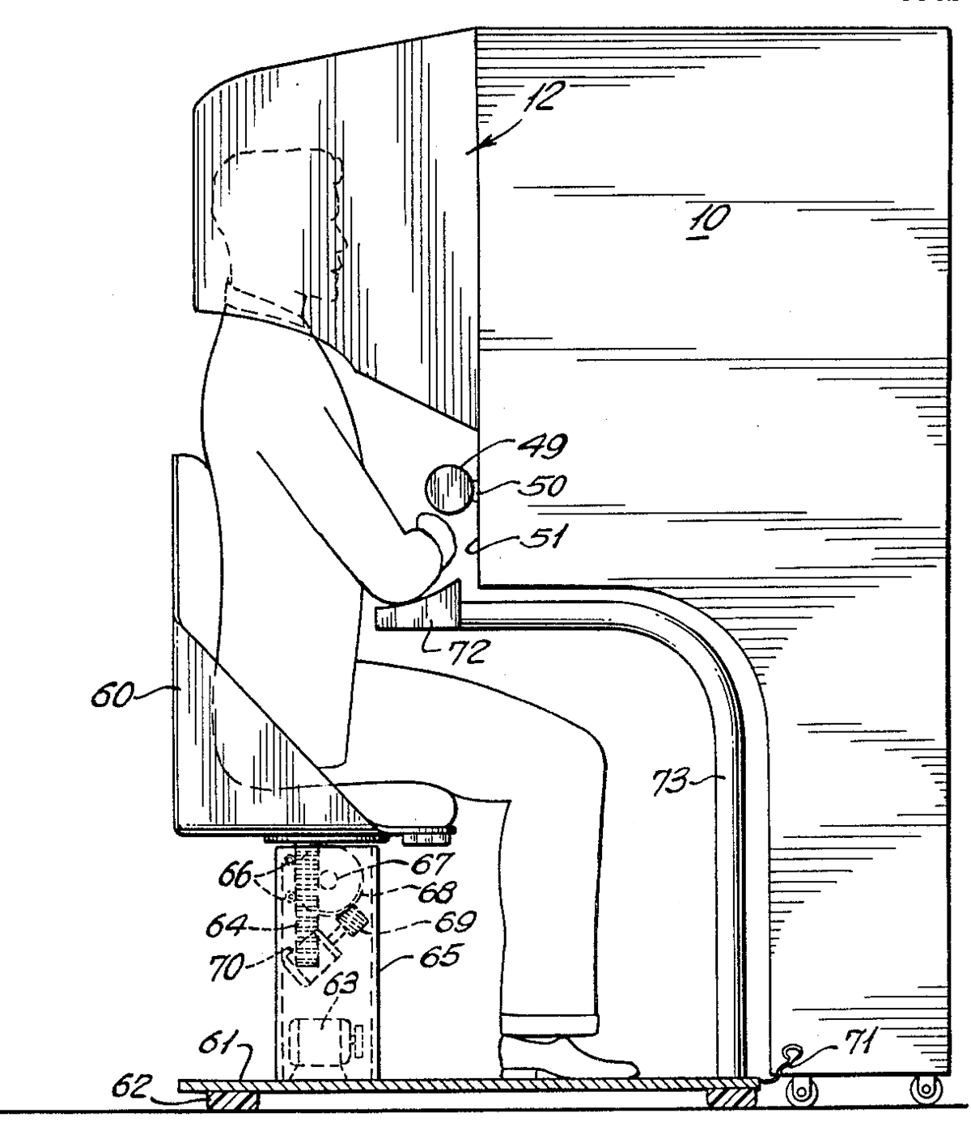

Fig.1.2.1 Sensorama

1.3 AR,VR,MR and XR

In the field of immersive technologies, several terms are commonly used to describe different ways of replacing reality with digital content. The four key parts are Augmented Reality (AR), Virtual Reality (VR), Mixed Reality (MR), and Extended Reality (XR). Each represents a unique approach for connecting digital experiences with the physical world.

1. Augmented Reality (AR) : Augmented Reality refers to the technology that overlays digital information such as images, sounds, or data onto the real-world environment in real time. AR enhances the user’s perception of reality by adding virtual elements without fully replacing the physical world. Users can see and interact with both the real environment and digital content simultaneously. Applications include mobile apps that display navigation directions on a live camera feed or social media app filters.

2. Virtual Reality (VR) : Virtual Reality is a fully immersive technology that replaces the user’s real-world surroundings with a computer-generated environment or virtual environment. By using VR headsets, users are transported into a completely virtual space, isolated from the physical world. This technology is often utilized for gaming(e.g. Oculus Rift), training simulations, and virtual tours, providing users with an experience that simulates presence in a different location or scenario.

3. Mixed Reality (MR) : Mixed Reality combines elements of both AR and VR, allowing real and virtual objects to interact in real time. Unlike AR, where digital content simply overlays the physical environment, MR sets virtual objects within the real world and enables interaction between digital and physical entities. This results in a more integrated and interactive experience. Examples include Microsoft Holo Lens, Magic Leap One, Apple Vision Pro,etc.

4. Extended Reality (XR) : Extended Reality is an umbrella term encompassing all immersive technologies, including AR, VR, and MR. XR broadly refers to any technology that extends or alters reality by blending physical and digital environments or by creating entirely virtual spaces. It represents the entire spectrum of immersive experiences and serves as a collective term for the evolving technologies in this domain.
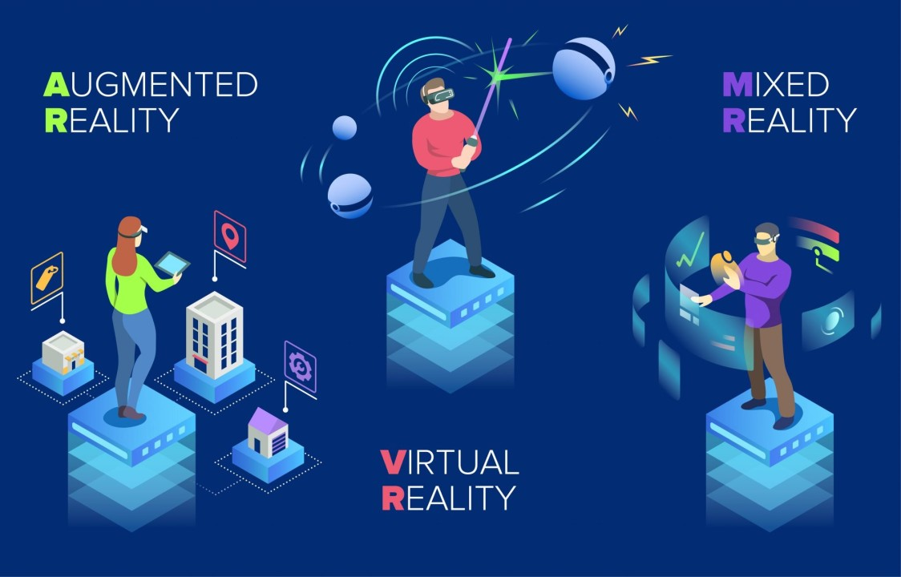

Fig. 1.3.1 eXtended Reality(XR)

1.4 AR/VR Hardware

Virtual Reality (VR) Devices :

1. Oculus Quest 2 (Meta Quest 2): A standalone wireless VR headset known for its ease of use, inside-out tracking, high-resolution display, and hand-tracking capabilities. It is widely used in virtual training, and remote collaboration.
2. HTC Vive Pro 2: A high-resolution PC-tethered VR headset offering precise external tracking via base stations. It is commonly used in professional VR applications, including simulations and enterprise training.
3. Valve Index: A premium PC-tethered VR headset that provides a high refresh rate of up to 144Hz and advanced finger-tracking controllers, enhancing immersive gaming and research applications.
4. Sony PlayStation VR2: Designed specifically for the PlayStation 5 console, this VR headset features eye tracking and haptic feedback, improving the gaming experience on consoles.

Augmented Reality (AR) Devices :

1. Microsoft HoloLens 2: A standalone mixed reality headset with see-through holographic lenses, spatial mapping, and hand tracking. It is extensively used in industrial design, healthcare, and remote assistance.
2. Magic Leap 2: An advanced standalone AR headset with enhanced optics and spatial computing, primarily targeting enterprise solutions like 3D visualization and interactive education.
3. Xreal Air: Lightweight AR glasses that connect to smartphones, providing portable augmented reality experiences such as media consumption and navigation.

AR/VR systems utilize supporting hardware including:
1. Controllers: Handheld input devices like Oculus Touch or Vive Controllers that allow users to interact with virtual environments.
2. Tracking Systems: Sensors or cameras that monitor the position and movement of the headset and controllers to provide accurate spatial awareness.
3. Haptic Devices: Gloves or vests that provide tactile feedback, enhancing the sensory immersion of AR/VR experiences.

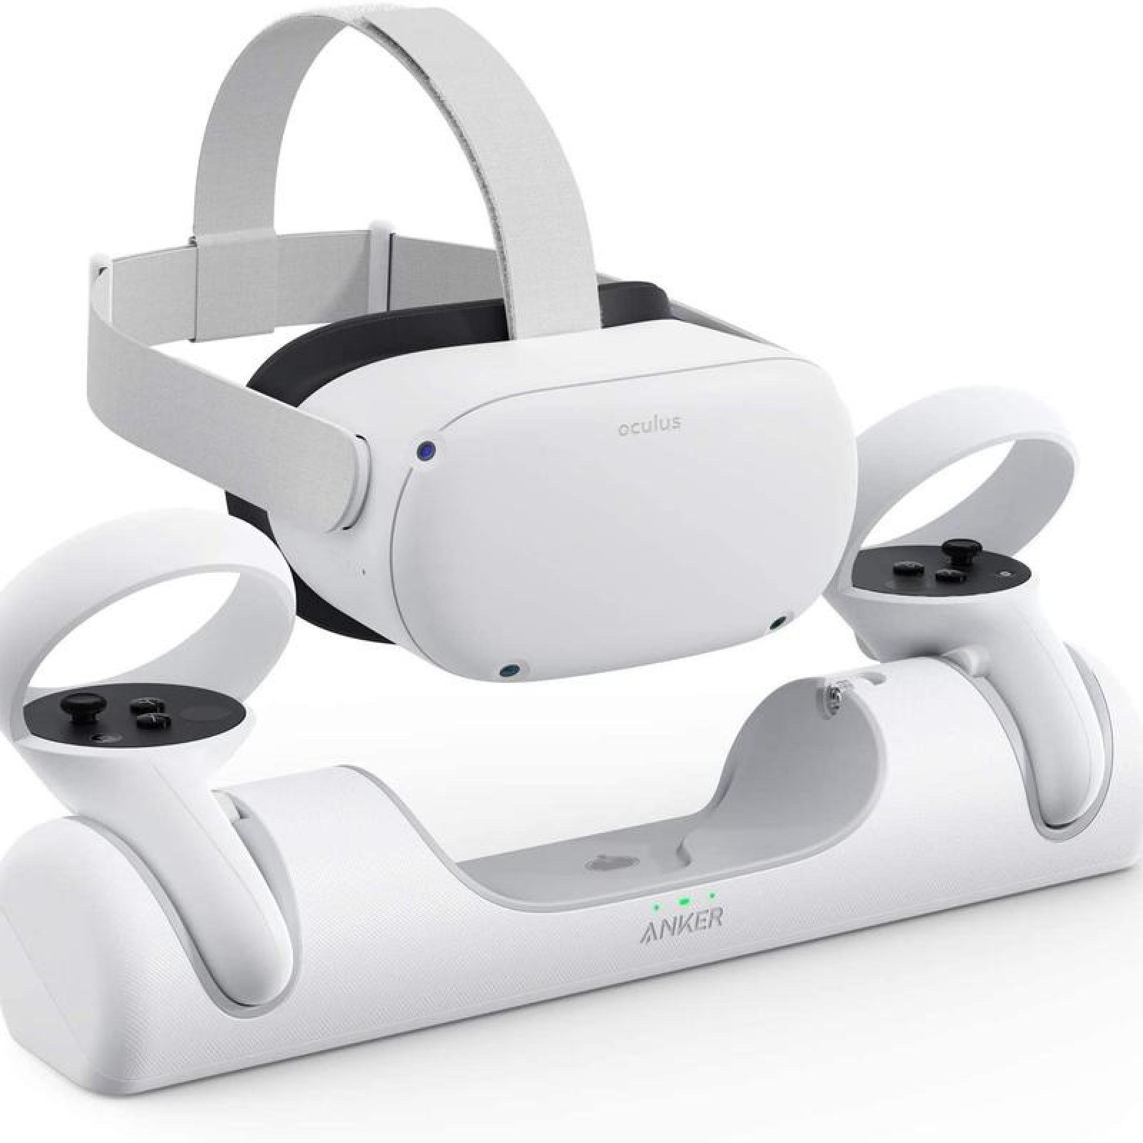
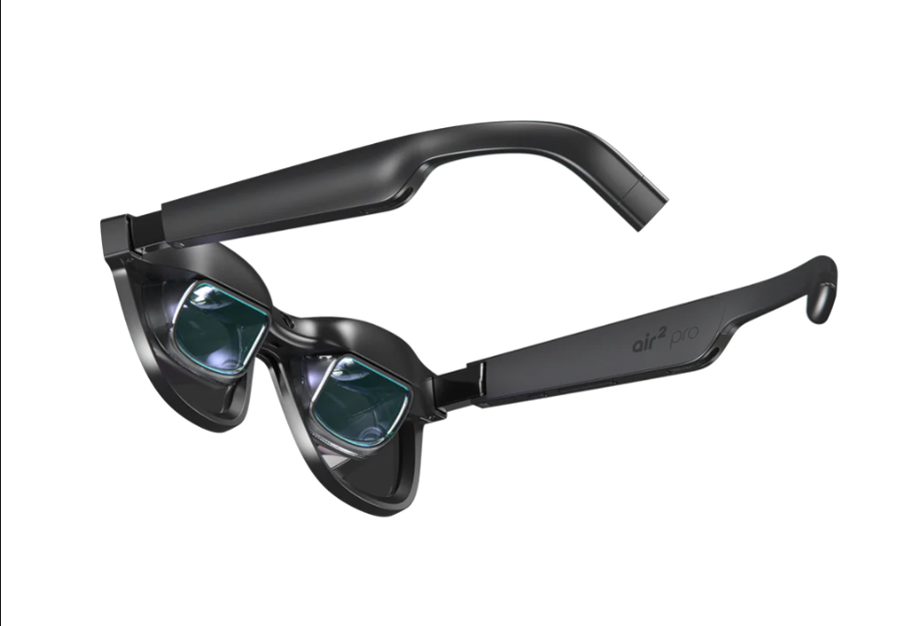

Fig. 1.4.1 Occulus Rift Fig. 1.4.2 Xreal AR

1.5 AR/VR Software & SDK’s

1. Unity : Unity is a widely used game engine and development platform for creating both AR and VR applications. It supports multiple programming languages, primarily C#, and allows cross-platform deployment. Unity integrates seamlessly with AR SDKs such as Apple’s ARKit, Google’s ARCore, and Vuforia, and supports VR headsets including Oculus Rift, HTC Vive, and PlayStation VR. Its extensive asset store provides ready-to-use 3D models, environments, and plugins, allowing rapid development.

2. Unreal Engine : Unreal Engine is a powerful game engine favored for developing high-fidelity AR and VR applications. Known for its photorealistic rendering capabilities, Unreal Engine uses Blueprint visual scripting which enables developers to build applications without extensive coding. It supports AR platforms like ARKit, ARCore, Microsoft HoloLens, and major VR devices, making it suitable for advanced immersive experiences.

3. Vuforia : Vuforia is a augmented reality software development kit (SDK) specializing in marker-based AR applications. It provides robust image and object recognition features, enabling AR experiences on mobile devices. Vuforia is commonly used in collaboration with Unity for rapid AR app development and supports a wide range of smartphones and tablets.

4. ARKit : Developed by Apple, ARKit is an AR SDK designed for iOS devices such as iPhones and iPads. It offers advanced capabilities including plane detection, face tracking, and environmental understanding, allowing developers to create rich AR experiences optimized for Apple hardware. ARKit can be used independently or integrated with Unity and Unreal Engine.

5. ARCore : Google’s ARCore is an AR SDK tailored for Android devices, providing motion tracking, environmental understanding, and light estimation features. It supports development with Unity and Unreal Engine, enabling a broad range of AR applications on compatible Android smartphones and tablets.

6. Microsoft Mixed Reality Toolkit (MRTK) : MRTK is a development framework designed for building AR and VR applications on Microsoft platforms such as HoloLens and Windows Mixed Reality headsets. It offers a set of pre-built components and user interface controls to facilitate mixed reality app development within Unity.
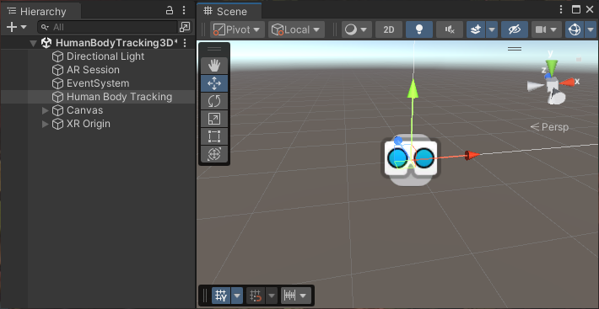
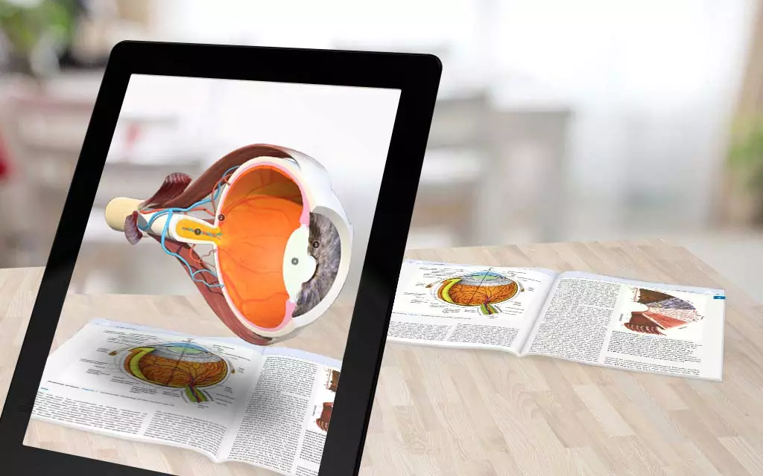

Fig. 1.5.1 Unity Editor Fig 1.5.2 E.g. Application
Chapter 2

2.1 Introduction to WebXR and A-Frame

WebXR :
Developers can create virtual reality (VR) and augmented reality (AR) experiences right within web browsers thanks to WebXR, a contemporary web standard. WebXR is a group of standards which is used to support rendering 3D scenes to hardware designed for presenting virtual worlds (virtual reality, or VR), or for adding graphical imagery to the real world, (augmented reality, or AR). The WebXR Device API implements the core of the WebXR feature set, managing the selection of output devices, render the 3D scene to the chosen device at the appropriate frame rate, and manage motion vectors created using input controllers.

WebXR-compatible devices include fully-immersive 3D headsets with motion and orientation tracking, eyeglasses which overlay graphics atop the real-world scene passing through the frames, and handheld mobile phones which augment reality by capturing the world with a camera and augment that scene with computer-generated imagery.
For development, we can use the low-level WebXR API directly, but many prefer libraries like Babylon.js or Three.js which simplify the integration. Babylon.js offers built-in, high-level WebXR support with easy-to-use helpers, built-in physics, and debugging tools, making it faster to prototype VR/AR apps. Three.js also supports WebXR but requires more manual setup and is highly flexible with a large community and many examples. Both frameworks allow rendering stereoscopic views, tracking head and controller positions, and enabling rich interactive experiences. Additionally, WebXR supports features like spatial anchors, teleportation, and hand tracking on compatible devices.

A-Frame:
WebXR and the well-known WebGL graphics library serve as the foundation for the open-source A-Frame web framework. It provides a declarative, HTML-based syntax for rapidly designing and creating immersive, 3D environments. A-Frame enables web developers to create interactive VR/AR scenes with little coding knowledge by demythologizing the complexity of 3D programming. It supports various features like 3D models, animations, user interactions, and multi-user experiences, making it a versatile tool for building immersive web applications.
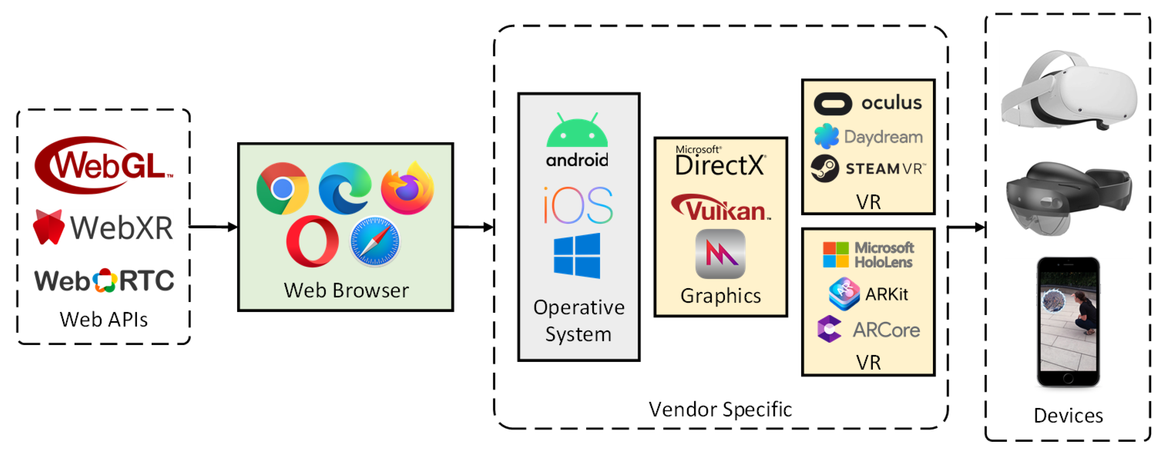

Fig.2.1.1 WebXR Workflow
Figure 2.1.1 : WebXR Workflow and Architecture Diagram
The diagram illustrates the workflow of WebXR applications from the web browser to the end-user devices. WebXR relies on core Web APIs such as WebGL for rendering 3D graphics and WebRTC for real-time communication. These APIs run inside modern web browsers like Chrome, Firefox, and Safari, which act as the platform to execute immersive web experiences.
The browser operates on top of the device’s operating system (e.g., Android, iOS, Windows), which manages hardware resources and graphics processing through vendor-specific graphics APIs such as DirectX, Vulkan, or Metal.
Above these layers, vendor-specific XR runtimes and SDKs like Oculus, SteamVR, Microsoft HoloLens, ARKit, and ARCore handle device specific features including motion tracking, input management, and spatial mapping.
Finally, the processed 3D content is rendered on various XR hardware devices, including VR headsets, AR smart glasses, and smartphones, enabling users to experience immersive virtual and augmented reality environments directly through their web browsers.
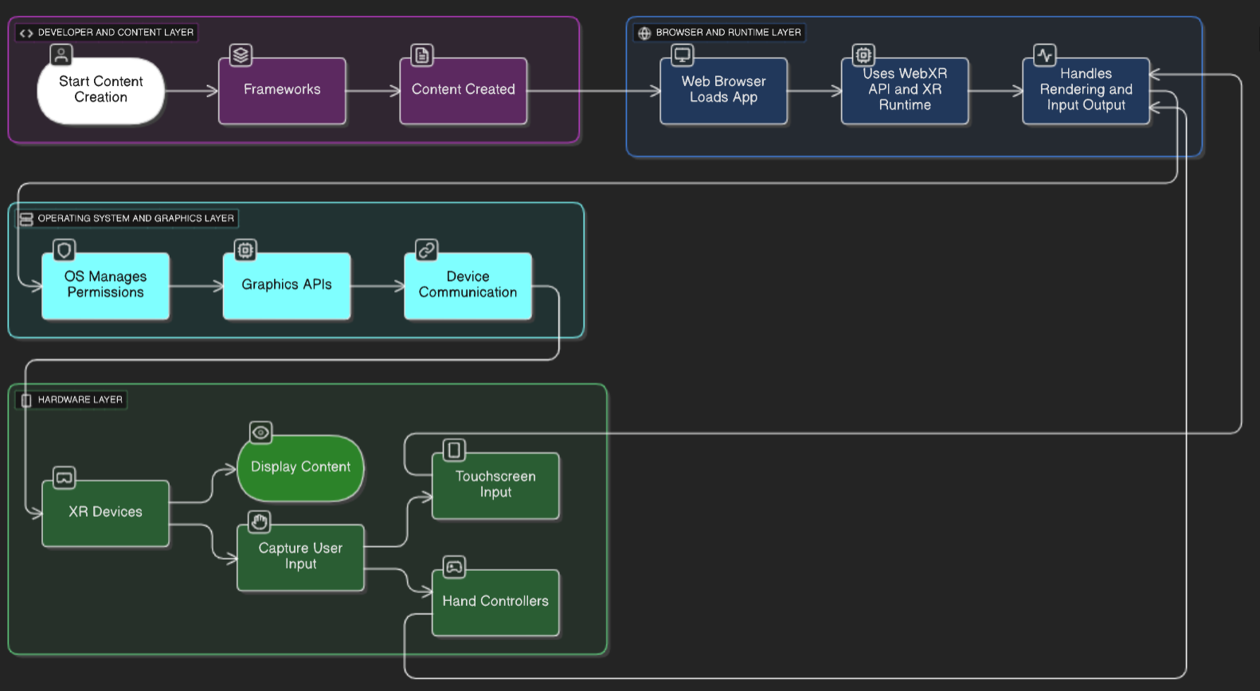

Fig.2.1.2 Flowchart – AR/VR application

Example in Practice - Flowchart :
Think of a developer (Developer Layer) making a virtual reality museum tour. They construct the 3D environment using a framework such as A-Frame (Framework). This tour is accessed by the user via a web browser (Browser Layer), which loads the application and connects to the VR headset via the WebXR API. The OS (OS and Graphics Layer) supports graphics and provides the required permissions. In addition to displaying the virtual museum, the headset records the user's hand controller movements or headset position (Hardware Layer), which the browser uses to update the scene in real time.

2.2 A-Frame Components and Syntax
A-Frame is a open-source web framework for building Virtual Reality(VR), Augmented Reality(AR) and 3D experiences, often within web-browsers, using HTML like markup. Built on top of WebXR and Three.js, allows developers to create AR and VR scenes easily in the browser.

Basic Syntax :
A-Frame uses a declarative syntax similar to HTML. Scenes are created using the <a-scene> element, which contains entities represented by <a-entity> tags. These entities can be primitives like boxes, spheres, or custom 3D models.
Example of simple A-Frame scene :
<a-scene>
<a-box position="-1 0.5 -3" rotation="0 45 0" color="#4CC3D9"></a-box>
<a-sphere position="0 1.25 -5" radius="1.25" color="#EF2D5E"></a-sphere>
<a-cylinder position="1 0.75 -3" radius="0.5" height="1.5" color="#FFC65D"></a-cylinder>
<a-plane position="0 0 -4" rotation="-90 0 0" width="4" height="4" color="#7BC8A4"></a-plane>
<a-sky color="#ECECEC"></a-sky>
</a-scene>

Components:
Components are reusable modules in A-Frame that define behavior or appearance of entities. They are attached to entities(a-box,a-plane,etc.) using HTML attributes.
- Position: Defines the location of an entity in 3D space (x, y, z).
- Rotation: Specifies the rotation of an entity in degrees on each axis.
- Scale: Adjusts the size of an entity.
- Geometry: Defines the shape of the entity (box, sphere, plane, etc.).
- Material: Controls the appearance, such as color and texture.
Components can also be custom-made with JavaScript to add interactivity or complex behaviors.
E.g.
<a-entity geometry="primitive: box" position="1 2 -3" material="color: red"></a-entity>
This creates a red box positioned at (1,2,-3) in the scene.

