1. Develop IDE

URL:<https://dl.espressif.com/dl/esp-idf/>

1) Espressif-IDF 2.12.0 with ESP-IDF v5.1.2-offline Installer(1GB)

2) ESP-IDF v5.1.2 - offline Installer Windows 10, 11(800MB)

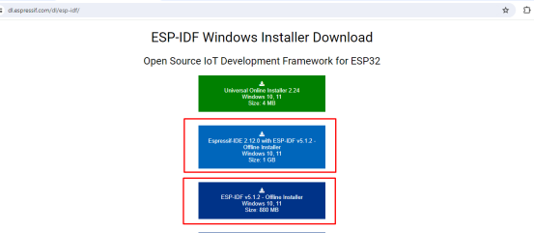

2. Tool and library

1) <https://www.espressif.com/en/support/download/other-tools>

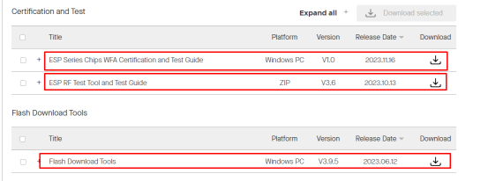

2) <https://github.com/espressif/arduino-esp32>

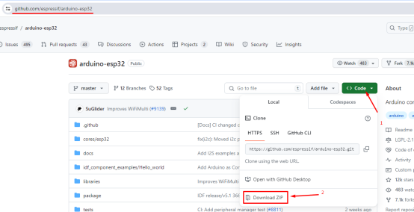

3)https://github.com/UncleRus/esp-idf-lib/tree/master

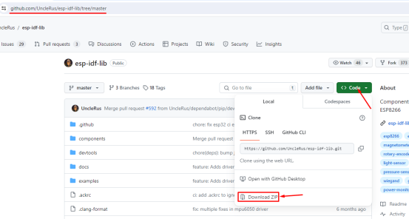

4)https://github.com/espressif/esp-idf/tree/master

5) <https://drive.google.com/file/d/1VZDuJD0rMkvfxaIdVBnjY5PjE0CZoNpU/view?usp=sharing>