Katadyn Survivor 35 Desalinator by Katadyn

€950.00

Article No. : **8013428**

**This desalinator is only available for governmental customers.**

The most widely-used emergency desalinator

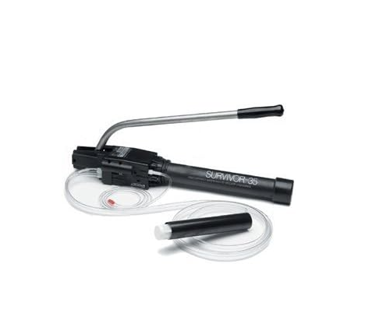

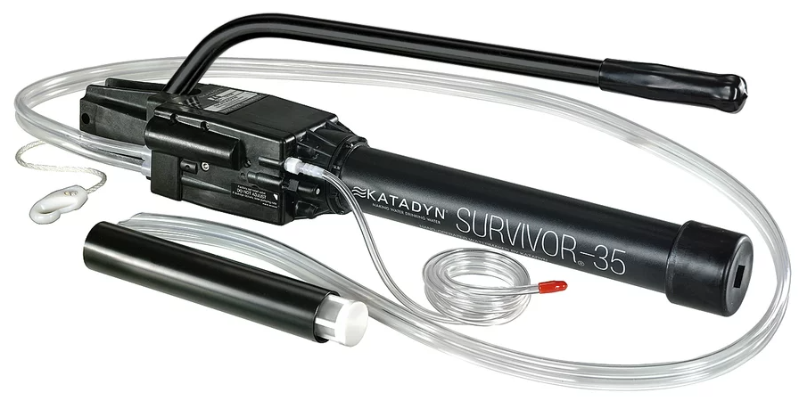

## Product description

Hand-operated emergency water pump for emergency kits, life rafts; Produces one ounce of drinking water in two minutes; nearly two pints per hour; Easily fits into an emergency kit; Weighs 2.5 pounds; Used by U.S. Navy, Coast Guard, and militaries around the world

Does this item need to be cleaned? Can you describe maintenance please.

Storage (7 days or longer)  
The Survivor-35 is shipped from the factory with a biocide solution inside, to prevent the growth  
of bacteria. After the unit has been operated and before it is stored again, it should be flushed with  
biocide as outlined below.  
IMPORTANT: Never let the membrane dry out. Be sure to follow these storage instructions.  
1. Turn the unit upside down, with the intake strainer out of the water.  
2. Fill a suitable container with about a quart (approximate 1 liter) of clean water. Freshwater is  
preferable, but clean seawater can be used if freshwater is not available.  
3. Mix one spoonful (10 grams) of the biocide with water until dissolved.  
4. Place the intake strainer into the biocide solution, and pump until water starts flowing out of the  
reject hose (indicating that the membrane housing is filled). Stop pumping immediately after  
water begins to flow from the reject hose.  
5. If seawater was used to mix the biocide solution, repeat the above procedure with freshwater  
as soon as it is available.  
6. Rinse any biocide solution off the outside of the unit. Allow the unit to dry completely before storing.  
IMPORTANT: For your safety, we require that the above procedure be completed once a year  
(storage temperature < 25°C/77°F). Please be aware to use only biocides supplied by Katadyn  
for your product. Other products like chlorine-based products will damage your membrane.

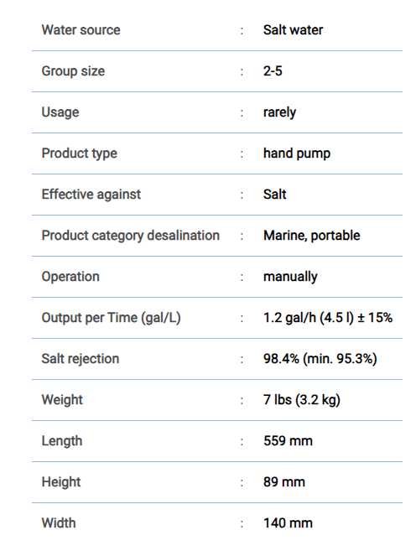

### **Spare Parts**

# Membrane Kit for PowerSurvivor PS40/80 / Survivor 35

# 468.60 €

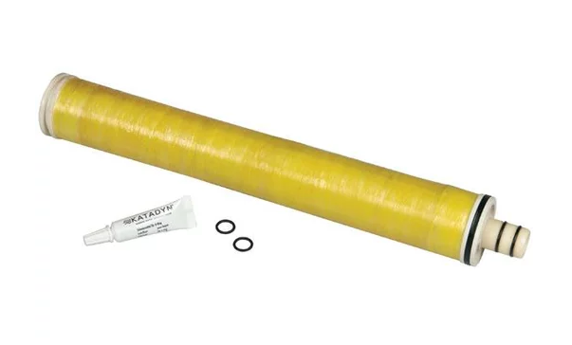

This product has a short shelf life, only purchase for immediate use.

Kit fits the following products:

Katadyn PowerSurvivor 40E **price 3,446.00 €**

Katadyn PowerSurvivor 80E (needs two kits) **price 4,295.00 €**

Katadyn Survivor 35 **price 2,315.55 €**

# Ecoviva Countertop Reverse Osmosis System RO Water Filter, 4 Stage Filtration, Real-time TDS Monitor, 3:1 Pure to Drain, Zero-Installation Portable Water Purifier (WP-RO-200G Black), 4.3*12.1*12.1''

**price 203.99$ (11 options), 183.35$(7 options)**

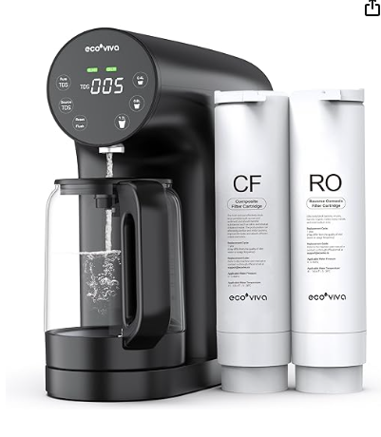

|  |  |
| --- | --- |
| **Brand** | Ecoviva |
| **Special Feature** | Portable, Built In TDS Meter, Change Filter Indicator, Tankless, Reduce TDS |
| **Product Dimensions** | 12.1"L x 4.3"W x 12.1"H |
| **Package Information** | Dispenser |
| **Installation Type** | Countertop |
| **Power Source** | Corded Electric |
| **Model Name** | WP-RO-200G-B |

# About this item

* 💧𝐂𝐎𝐔𝐍𝐓𝐄𝐑𝐓𝐎𝐏 𝐄𝐋𝐄𝐆𝐀𝐍𝐂𝐄 & 𝐑𝐄𝐈𝐍𝐅𝐎𝐑𝐂𝐄𝐃 𝐂𝐀𝐑𝐀𝐅𝐄: Farewell to other clunky countertop reverse osmosis system that ruins space aesthetic. Sleek design adds sophistication. No installation nightmare, refreshing water without hassle! Compact size of 4.3*12.1*12.1'' for easy mobility, whether in bedroom, kitchen or RV, RO water on the go! Reinforced carafe glass boasts 150% thicker and built-in stainless base. Goodbye to secondary pollution, glass carafe ensures the purest water for you and your loved ones!
* 💧𝐂𝐎𝐌𝐏𝐎𝐒𝐈𝐓𝐄 & 𝐂𝐘𝐂𝐋𝐈𝐍𝐆 𝐅𝐈𝐋𝐓𝐑𝐀𝐓𝐈𝐎𝐍: Ecoviva RO water filter system undergoes 4-stage deep composite filtration, especially the impressive RO filter membrane (0.0001μm accuracy), removing 1000+ contaminants such as PFOA/PFOS, heavy metals (Lead, Arsenicetc), **chlorine**, fluoride, nitrates/nitrites and etc. But we don't stop there! Our cycling filtration tech ensures your tap water undergo not one, but two thorough filtration cycles. Double the guarantee for your drinking water. Sip and Feel the Real!
* 💧𝐄𝐀𝐒𝐘 𝐎𝐏𝐄𝐑𝐀𝐓𝐈𝐎𝐍𝐒 𝐈𝐍 𝐎𝐍𝐄 𝐏𝐀𝐍𝐄𝐋: Designed to make all a breeze. Stay in the know and drink with confidence by monitoring real-time water quality, empowering you with the knowledge of what you're consuming, like your water superhero! The life reminders let you keep a close eye on filters lifespan, sending handy alert when it's time for change. Gone are the days of guesswork! Just a touch, effortlessly select the desired water volume, and watch as our system works its automatic wonders.
* 💧𝐅𝐀𝐒𝐓𝐄𝐑 𝐅𝐋𝐎𝐖 & 𝐋𝐎𝐖 𝐏𝐔𝐑𝐄 𝐓𝐎 𝐃𝐑𝐀𝐈𝐍: Woes of plastic waste and bottled water is the history. We've made it ridiculously simple to quench your thirst. Compared to the speed of other countertop RO system in market(0.26L/Min), ours is 0.42L/Min! It is with an impressive low 3:1 ratio of pure to drain, more effective than the lackluster models you find elsewhere, which typically claim 4:1/5:1 ratio. Join the revolution and enjoy the efficiency and convenience of our cutting-edge water solution!
* 💧𝐖𝐎𝐑𝐓𝐇 𝐘𝐎𝐔𝐑 𝐓𝐑𝐔𝐒𝐓: Without any rhetoric, our actions will tell. We're addicted to provide you the best support. Inside the manual, there is a 1-year warranty waiting for you, just scan the Q R code for hassle-free registration. Our tech support is with no expiration date. The countertop RO water filter system adopts food grade standard materials and some parts of this reverse osmosis water filtration system are strictly certified by European Conformity for ultimate quality.

## Product Description

Ecoviva are dedicated to harnessing technology to drive positive change and champion sustainable practices. Our unwavering commitment to environmental stewardship is ingrained in our approach to innovation. Within the Ecoviva brand, we’ve adopted sustainable solutions, exemplified by our reverse osmosis water filtration system. Not only does it guarantee unrivaled purity, but it also operates with a profound environmental focus. Through the minimization of water waste and the optimization of energy efficiency, we fervently aspire to diminish any adverse impacts on the planet. We firmly believe in the transformative power of technology, not only to enhance lives, but also to contribute to a healthier world. Join us in our mission to enact meaningful change. With Ecoviva, you can actively participate in a collective endeavor to foster a positive impact and foster a healthier, more sustainable world.

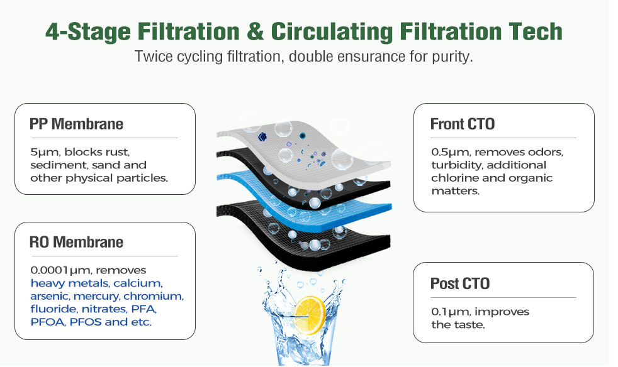

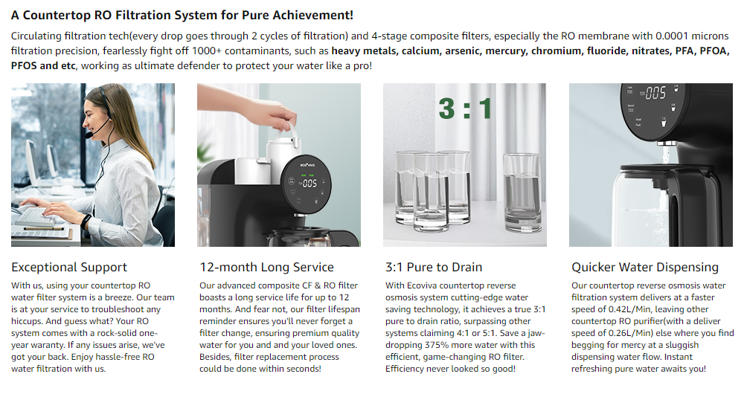

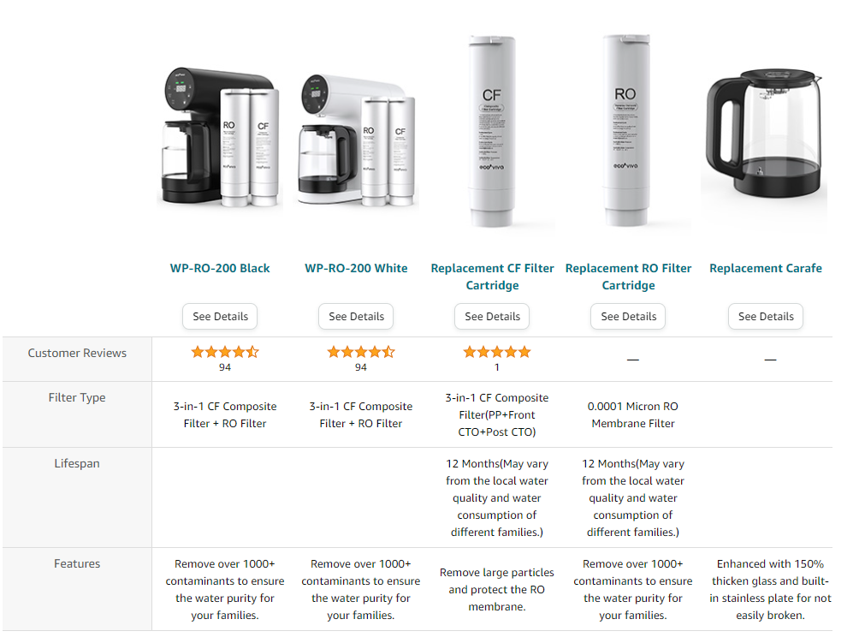

# PURFLO-5000 150GPD SH (Shut Off) 5 Stage Reverse Osmosis System

230.00€

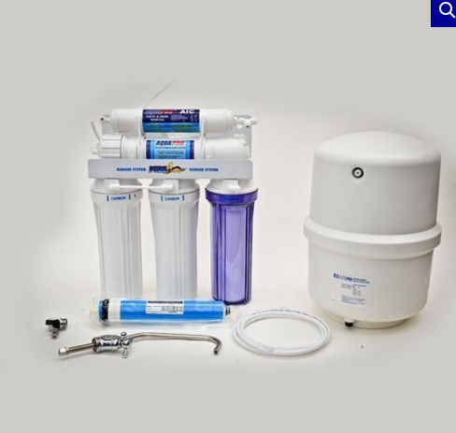

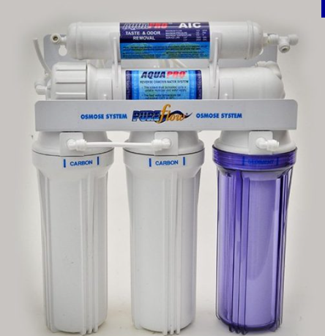

The cutting edge in water filter technology!

The **Reverse Osmosis Unit PURFLO-5000 is a complete 5 stage water treatment system** with metal support frame, ready for installation under the kitchen counter. The addition of an extra pre-filter (activated carbon GAC) in comparison to the 4 stage Reverse Osmosis system, ensures a complete removal of most organic pollutants. It also helps to assure complete removal of chlorine from incoming water, which can destroy the quality TFC RO membrane in the next stage.

Includes a 12 liters R.O. water storage tank, a chrome faucet (lead free), a filter wrench for changing the filters, 1/4″ tubing for the installation and bypass valve to connect to the cold water supply. Certified by NSF (National Science Foundation, USA) and CE.

Pre-filters should be changed every 6 months.

**Processing stages:**

* **Stage 1**: Sediment Filter 10 “polypropylene 5 microns  
  Removes rust, dirt, sand and other particles from the incoming water
* **Step 2**: Filter granular activated carbon type Carbon GAC 10 ”  
  Removes chlorine, heavy metals, volatile organic compounds and other VOC, THM
* **Stage 3**: Activated Carbon Filter Type Carbon Block 10 ”  
  Removes debris **chlorine**, volatile organic compounds and other contaminants
* **Stage 4**: Reverse Osmosis Membrane (Type Thin Film Composite)  
  Removes minerals, heavy metals, chemicals, microorganisms, cryptosporidia, and many other contaminants to leave crystal clean water in its purest state.
* **Stage 5**: Final Activated Carbon Filter  
  Removes odors, polishing the water and improving the taste

**Characteristics**

* Production of water: 600 liters per 24 hours
* Range for incoming water pressure for proper system operation: 50-100psi (min.3 Bar)
* Dimensions: System 37x20x45cm, Tank 28x28x35cm (LxWxH)
* R.O. system Weight: 9Kg, R.O. Tank 4Kg
* Osmosis membrane type Thin Film Composite, Made in the USA
* Annual cost of consumables package: xx ?

**The system can be upgraded with:**

* Lamp Ultraviolet (UV), for cases of water with increased bacterial load (eg bore water)
* Three-way faucet with modern aesthetic design, with independent mixer for hot / cold unfiltered water and separate for filtered potable water.
* Final Filter stage with Biocera Magnetic Deionization cartridge. Increases alkialinity of the water and hydrogen ion content for enriched antioxidant effect. Also ideal for improving R.O. product water taste.

|  |  |
| --- | --- |
| **Dimensions** | 500 × 390 × 480 mm |
| **Manufacturer** | Aqua Pro |

**AquaPro RO-5000**

**ECO-WORTHY 5L/H Portable Reverse Osmosis Water Filter System**

**China Frotec Seawater Desalination RO System**

**Puhui Portable Seawater Desalination RO System**

**APEC Water Systems**

**Kent RO Systems**

**PurePro®**

# <https://labbox.eu/product/zinc-powder-agr/>

# ZINC, POWDER AGR

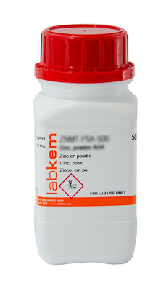

**Zn**  
**M.W:**65.38  **CAS:**7440-66-6  **EC:**231-175-3  **EC INDEX:**030-001-00-1    
**UN:**3077  **IMDG:**9 III UN 3077  **ADR:**9 III UN 3077   **IATA:**9 III UN 3077  **H:**H410  **P:**P273

* **Assay** ≥ 99%
* **Arsenic (As)** ≤ 0.00002%
* **Iron (Fe)** ≤ 0.05%
* **Lead (Pb)** ≤ 0.05%
* **Tin (Sn)** ≤ 0.01%
* **Chloride (Cl–)** ≤ 0.005%
* **Cadmium (Cd)** ≤ 0.005%

| reference | packaging | capacity | pcs/pack | price/pack |  |
| --- | --- | --- | --- | --- | --- |
| ZNMT-P0A-500 | plastic bottle | 500 g | 1 | 29.63 € |  |

<https://micronmetals.com/product/zinc-metal-powder/>

### ZINC POWDER

PRODUCT #: **ZN-102**

### **Specifications**

|  |  |
| --- | --- |
| **Formula** | **30Zn65.39** |
| **Purity** | **99.8% min** |
| **Particle Size** | **-325 Mesh** |
| **ECCN** | **-** |
| **Schedule B** | **7903.10.0000** |
| **CAS** | **CAS-7440-66-6** |
| **Melting Point** | **419.5°C / 787.1°F** |
| **Boiling Point** | **907°C / 1664.6°F** |
| **Density** | **7.12** |
| **Coef. of Expansion @ 20°C** | **30.2um/m-k** |
| **Crystal Structure** | **Hexagonal, close-packed** |
| **Electric Resistivity** | **59.0 nO·m** |
| **Composition** | **99.9% Pure Zinc Powder** |

### Product Description

ZN 102 is a dark gray metal powder widely used in the metallurgical and battery industries. Zinc powder is used in paint and coatings to impart corrosion inhibiting properties. They are almost insoluble in water, so they can also be used on offshore rigs and ships / vessels.

| **Quantity (LB)** | **Price** |
| --- | --- |
| 1-2 LB | **$25.54** |
| 3-10 LB | **$19.16** |
| 11-25 LB | **$17.88** |
| 26-100 LB | **$17.37** |

<https://micronmetals.com/product/zinc-metal-powder-3/>

### PRODUCT #: **ZN-101**

### ZINC POWDER

### **Specifications**

|  |  |
| --- | --- |
| **Formula** | **Zn: 65.39** |
| **Purity** | **99.9% min** |
| **Particle Size** | **1-5 microns** |
| **ECCN** | **-** |
| **Schedule B** | **7903.10.0000** |
| **CAS** | **CAS-7440-66-6** |
| **Melting Point** | **419.5°C / 787.1°F** |
| **Boiling Point** | **907°C / 1664.6°F** |
| **Density** | **7.12** |
| **Coef. of Expansion @ 20°C** | **30.2um/m-k** |
| **Crystal Structure** | **Hexagonal, close-packed** |
| **Electric Resistivity** | **59.0 nO·m** |
| **Composition** | **99.9% Pure Zinc Powder** |

### Product Description

ZN 101 is a dark gray metal powder widely used in the metallurgical and battery industries. Zinc powder is used in paint and coatings to impart corrosion inhibiting properties. They are almost insoluble in water, so they can also be used on offshore rigs and ships / vessels.

| **Quantity (LB)** | **Price** |
| --- | --- |
| 1-2 LB | **$20.21** |
| 3-10 LB | **$15.16** |
| 11-25 LB | **$14.15** |
| 26-100 LB | **$13.74** |

<https://www.msesupplies.com/products/mse-pro-zinc-zn-powder-40-mesh-99-999?variant=39259159953466>

# MSE PRO Zinc (Zn) powder, -40 mesh, 99.999%

# $ 55995/500g

# $ 86695/1kg

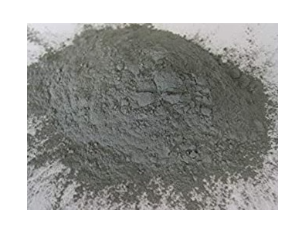

**Zinc (Zn) powder, -40 mesh, 99.999%**

* Product Number: **CM0109** (500 g), **CM0110** (1 kg)
* Formula: **Zn**
* CAS Number: 7440-66-6
* Molecular Weight: 65.38 g/mol
* Density: 7.13 g/cm³ at 25°C
* Melting Point: 420°C
* Boiling Point: 907°C
* Color: grey powder
* Thermal Expansion Coefficient: 30.2 um/(m*K) @ 25°C
* Thermal Conductivity: 116 W/(m*K)
* Particle size: -40 mesh (< 420 um)
* Purity: 99.999% 5N (trace metal basis)

**Applications**

The main use of Zinc (Zn) is in galvanizing and anti corrosion. Zinc is also used in making alloys such as brass and bronze.

**Shipping and handling:** This material is classified as a hazmat and requires special packaging and shipping to comply with regulatory requirements. Please contact us for specific details with shipping and handling.

**Typical Analysis 99.999% via ICP**

|  |  |
| --- | --- |
| **Element** | **ppm** |
| **Co** | **0.1** |
| **Cu** | **0.5** |
| **Al** | **0.5** |
| **Mg** | **0.5** |
| **Ni** | **0.1** |
| **Pb** | **1.5** |
| **Sn** | **1.0** |
| **Fe** | **0.5** |
| **In** | **0.5** |
| **As** | **0.5** |
| **Cd** | **1.0** |

<https://www.ottokemi.com/zinc/zinc-powder-140325-mesh-999-z-0155.aspx>

# Zinc powder, -140+325 mesh, 99.9%

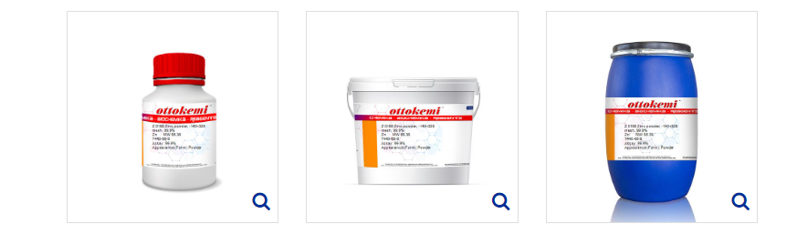

CAS

[7440-66-6](https://www.ottokemi.com/product/default.aspx?search=7440-66-6)

Mol. Formula

Zn

HSN Code

79031000

Mol. Weight

65.39

Packing

Bottle / Drum

GST Tax Rate

18%

|  |  |  |
| --- | --- | --- |
| **Packings** | **Price (INR)** | **Price (USD)** |
| **100 gm** | 39069.00 | 468.10 |
| **500 gm** | 96039.00 | 1150.70 |

<https://chaostrade.eu/zinc_powder_63um>

# Zinc powder 63um

Availability:large amount

Dispatched within:48 hours

Gross price: €16.10/kg, €4.39/200g

incl. 23% TAX, excl. shipping costs

Net price: €13.09/kg, €3.57/200g

excl. 23% TAX, excl. shipping costs

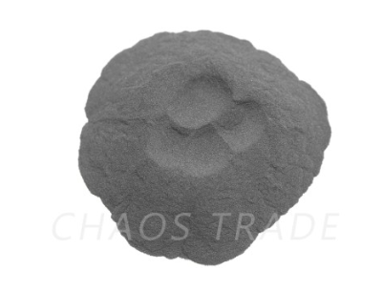

### **Description**

Zinc powder made by grinding in ball mill. Particles have flake shape.

**Important data:**

- Purity  99,9%

- Particle size 63um (0,063mm)

If you are not sure if this product will be good for your application feel free to write to us – we are always ready to help you.

<https://www.laborladen.de/Zinc-powder-40-lm-Zn-99995>

Item number: L10.0041

Category: [Metal powders & Metals](https://www.laborladen.de/Metal-powders-Metals)

Restrictions: [Not restricted](https://www.laborladen.de/navi.php?s=85)

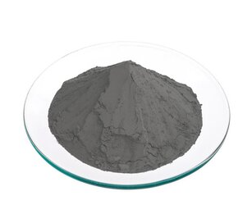

**Weight**

 100g **3,49 € (34,90 € per 1000 g)**

250g **5,90 € (23,60 € per 1000 g)**

500g **9,90 € (19,80 € per 1000 g)**

1000g **17,90 € (17,90 € per 1000 g)**

5000g **84,90 €** **Not available now!**

**Product information**  
Product name: Zinc powder Purity: min. 99,995%  
Particle size: Chemical formula: Zn  
CAS number: 7440-66-6  
  
**Restrictions**  
**Category 0 - No restrictions:** There are no restrictions for the sale to private and commercial customers.  
  
**Additional information (no liability)**  
Sehr feines, hochreines Zinkpulver. Qualitätsprodukt, hergestellt in Deutschland. Die Analyse lassen wir Ihnen auf Anfrage gerne zukommen. Großmengen ab Lager zu sehr guten Konditionen lieferbar, bitte anfragen.  
  
**GHS marking**  
**Hazard statements:** H410: Sehr giftig für Wasserorganismen mit langfristiger Wirkung.  
  
**EU safety statements:** P273: Freisetzung in die Umwelt vermeiden. P391: Verschüttete Mengen aufnehmen. P501: Inhalt/Behälter sind als gefährlicher Abfall zu entsorgen.  
  
**Signal word: Gefahr**