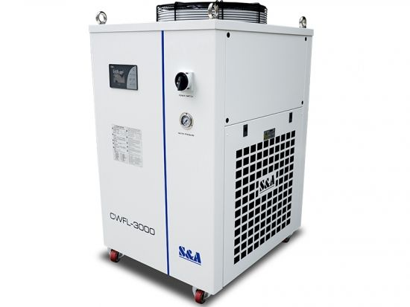

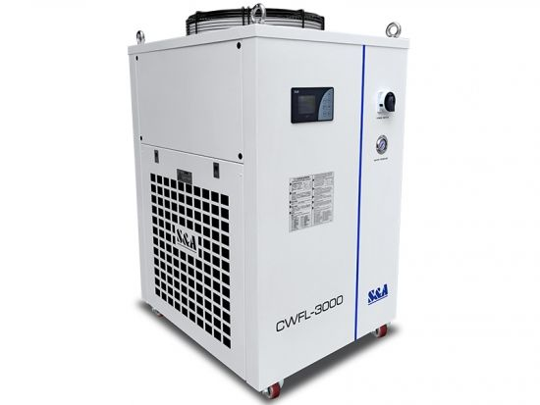

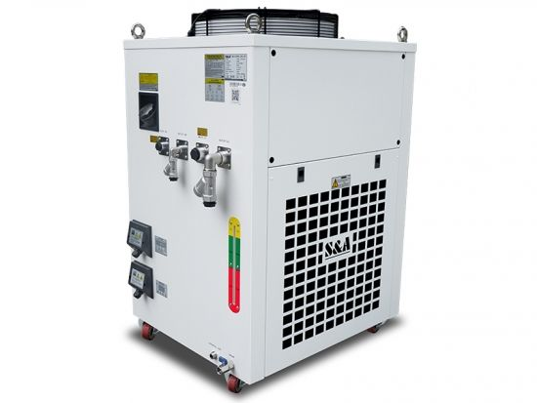

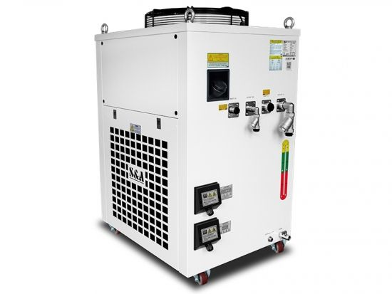

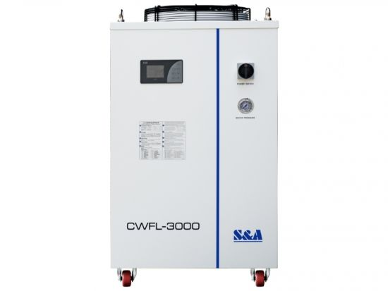

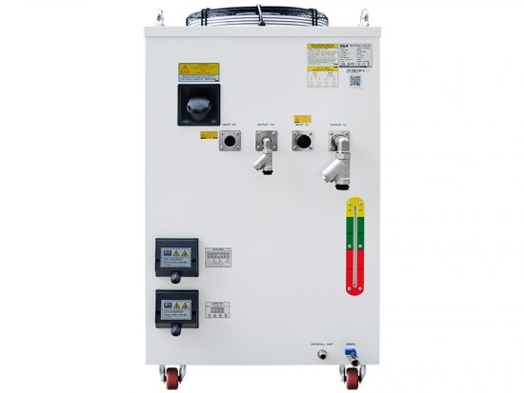

* 
* 
* 
* 
* 
* 

High power industrial water chillers CWFL-3000 for 3000W fiber lasers

CWFL-3000 water chiller developed by S&A Chiller is made especially for fiber laser applications up to 3KW. It highlights a dual circuit configuration. Two temperatures can be supplied from one single chiller unit for the fiber laser and the laser head, indicating up to 50% space saving comparing with the two-chiller solution.

* Item NO.:

CWFL-3000

* Product Origin:

Guangzhou,China

* Shipping Port:

Guangzhou,China

* Precision:

±0.5℃

* Voltage:

220/380V

* Frequency:

50/60Hz

* Refrigerant:

R-410a

* Reducer:

capillary

* Pump power:

1.1KW

* Inlet and outlet:

Rp1/2+Rp1

* N.W:

95Kgs

* G.W:

113Kgs

* Dimension:

77\*55\*103(L\*W\*H)

* Package dimension:

84\*74\*120(L\*W\*H)

[SEND INQUIRY NOW](https://www.teyuchiller.com/high-power-industrial-water-chillers-cwfl-3000-for-3000w-fiber-lasers_p21.html" \l "v61720f5b86fa6" \t "_self)

**Product Description**

****

**CWFL-3000 water chiller developed by S&A Chiller is made especially for fiber laser applications up to 3KW. It highlights a dual circuit configuration. Two temperatures can be supplied from one single chiller unit for the fiber laser and the laser head, indicating up to 50% space saving comparing with the two-chiller solution.**

With temperature stability of ±0.5℃, this **industrial water chiller** is efficient in mitigating the heat that is generated during the fiber laser operation. Reducing the operating temperature can help reduce maintenance and extend the lifespan of the fiber laser system. Being Modbus-485 capable, CWFL-3000 **high power water chiller** can communicate with the fiber laser very easily.

The warranty period is 2 years.

**Features**

1. Dual channel design for cooling fiber laser and the laser head, no need of a two-chiller solution;  
2. ±0.5℃ precise temperature control;

3. Temperature control range: 5-35 ℃;

4. Modbus-485 capable, easy communication with the fiber laser system;

5. Constant temperature and intelligent temperature control modes;  
6. Built-in alarm functions to avoid water flow problem or temperature problem;

7. CE, RoHS, ISO and REACH compliant;

8. Available in 220V or 380V;

9. User-friendly temperature controller for easy operation;

10. Optional heater and water filter

**Specification**

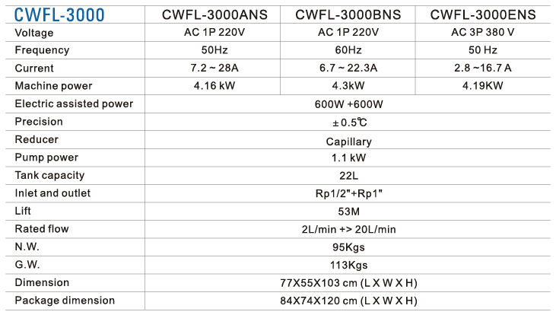

Note:   
1. The working current can be different under different working conditions; The above information is for reference only. Please subject to the actual delivered product;  
2. Clean, pure, impurity free water should be used. The ideal one could be purified water, clean distilled water, deionised water, etc.;  
3. Change out the water periodically (every 3 months is suggested or depending on the actual working environment);  
4. Location of the chiller should be well ventilated environment. There must be at least 50cm from the obstacles to the air outlet which is on the top of the chiller and should leave at least 30cm between obstacles and the air inlets which are on the side casing of the chiller.

**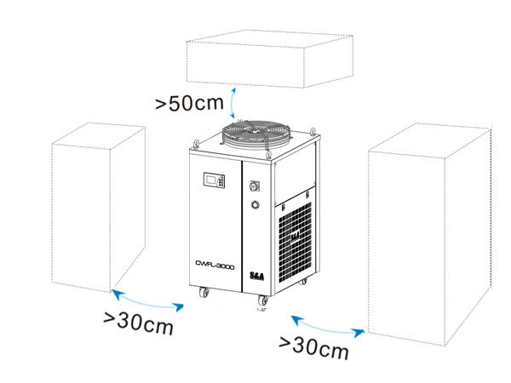**

**PRODUCT INTRODUCTION**

**User-friendly temperature controller for easy operation**

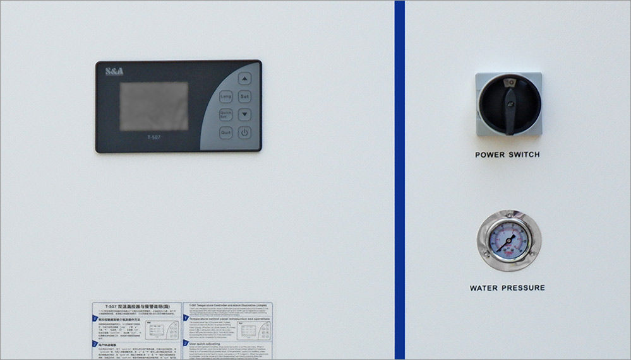

**Equipped with drain outlet with valve and universal wheels**

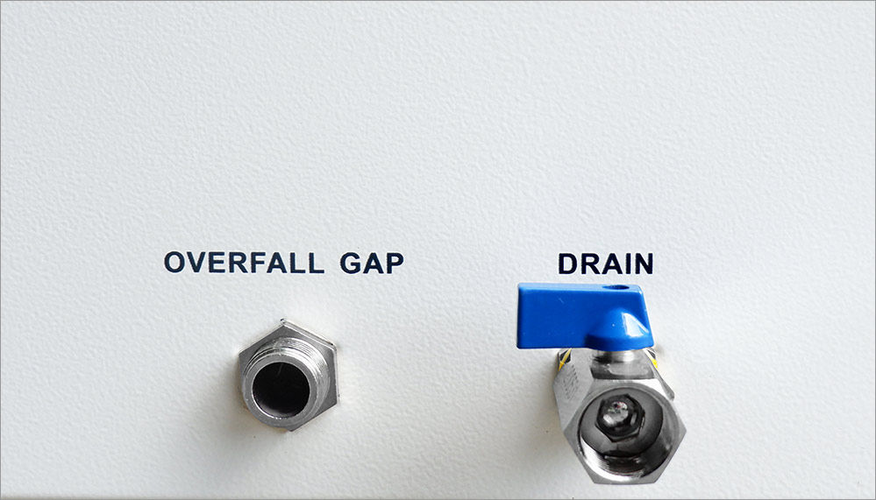

**Dual inlet and dual outlet port made of stainless steel to prevent potential corrosion or water leakage.**

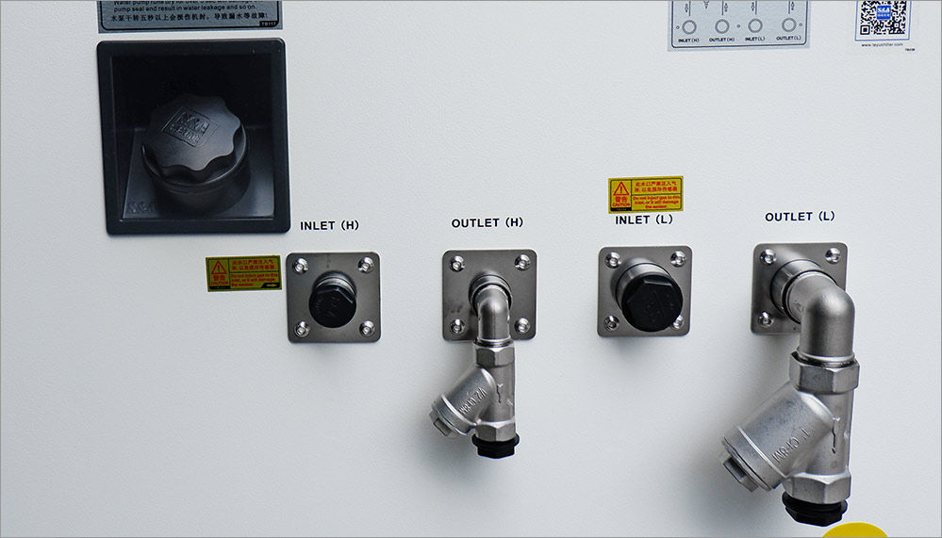

**Water level check lets you know when it’s time to refill the tank.**

**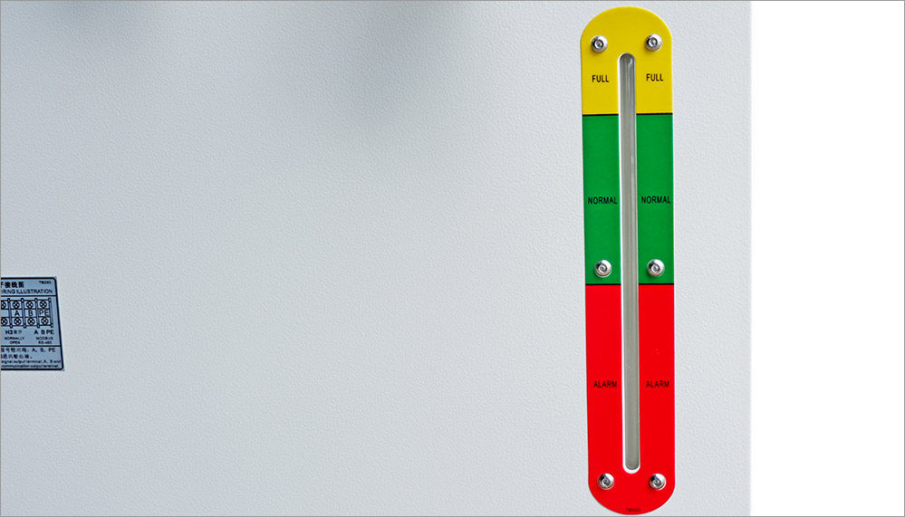**

**Cooling fan of famous brand installed.**

**With high quality and low failure rate.**

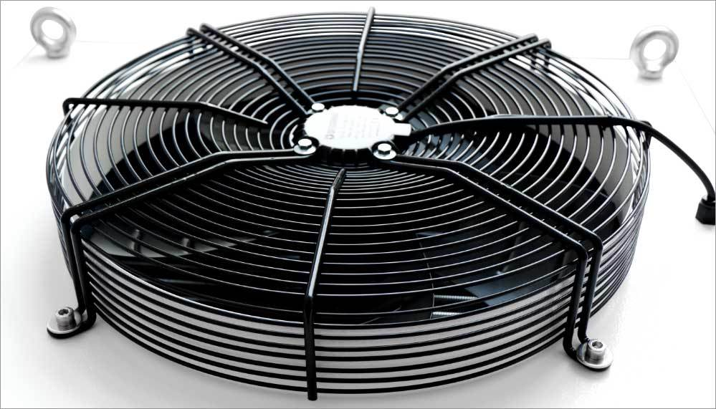

**Video**

How to set water temperature for T-507 temperature controller of dual temp chiller

S&A Chiller CWFL-3000 is applied for cooling medium and small power laser cutting machine

S&A water chiller system CWFL-3000 for 3KW precise fiber laser cutting machine

S&A  industrial cooling unit CWFL-3000 for cooling 3000W fiber laser

**CHILLER APPLICATION**

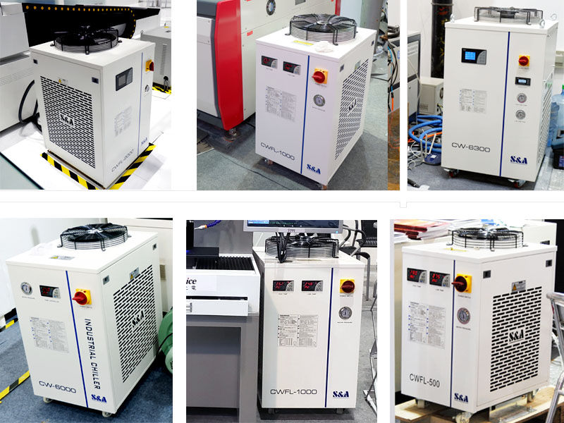

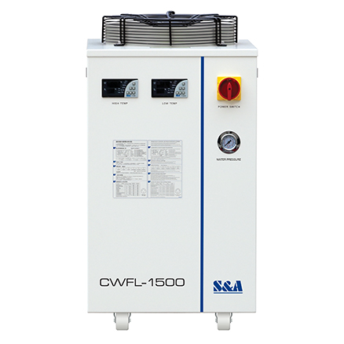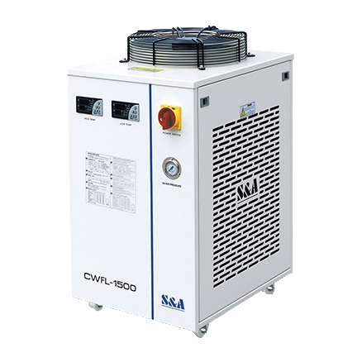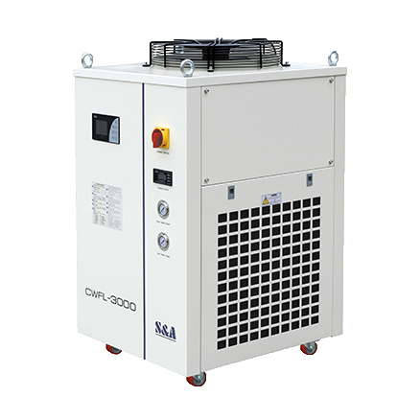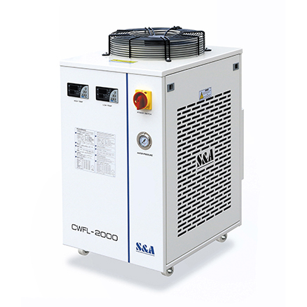

S&A CWFL Series Water Chiller

S&A CWFL series water chillers with dual cooling channels are specially designed for fiber lasers.

Through controlling the temperature of the laser device, our industrial chiller can prevent the laser cavity from thermal deforming, keep output power stable and ensure light beam quality to improve the working life and cutting accuracy of the laser device.

Features:

* Specially designed for fiber lasers
* Temperature stability covers +/- 0.3℃, +/- 0.5 ℃ and +/- 1℃ for better water temperature control and stability - Energy saving
* With two independent temperature control systems(high & low temperatures). Low temperature control system for colling the fiber laser while high temperature control system for cooling laser head - High temperature alarm
* Built-in fault find (with alarm) and dual temperature controls
* Provide stable and reliable cooling for fiber laser machines
* Suitable for all machines from 40w – 150w rated output power

Key Benefits When Buying From Us:

* One-year warranty (offered by Megacold)
* Cost effective
* Breakdown support (offered through Megacold)
* 45 years worth of experienced service engineers at your side.

Fill out the enquiry form below to find out specific lead times on the products listed in the table.

[ENQUIRE ABOUT THIS PRODUCT](https://www.megatech.com/brands/sa/sa-cwfl-series-water-chiller?qs=1&productenquiry=1)

CWFL series options

|  |  |  |  |  |  |  |  |  |  |  |  |  |  |  |
| --- | --- | --- | --- | --- | --- | --- | --- | --- | --- | --- | --- | --- | --- | --- |
| Model | Temperature precision (°C) | Flow rate (litres/min) | Lift (metres) | Refrigerant | Inlet/outlet (BSPT) | Tank capacity (litres) | Fibre laser cooled (watts) | Power requirments | Current    (Amps) | Machine power (Kilowatts) | Electric assisted power (Watts) | Pump power (kilowatts) | Weight (kg) | Dimensions (cm) |
| CWFL-500AN | +/- 0.3 | 2 + > 8 | 45 | R-410A | ½’’ + ½’’ | 10 | 500 | 220V, 1PH, 50Hz | 2.3-9.5 | 1.7 | 300 + 600 | 0.55 | 50 | 65 x 38 x 74 |
| CWFL-1000AN | +/-0.5 | 2 + > 12 | 45 | R-410A | ½’’ + ½’’ | 15 | 1000 | 220V, 1PH, 50Hz | 3.4-11.5 | 2.14 | 400 + 600 | 0.55 | 67 | 70 x 47 x 89 |
| CWFL-1500AN | +/-0.5 | 2 + > 15 | 53 | R-410A | ½’’ + ½’’ | 15 | 1500 | 220V, 1PH, 50Hz | 3.4-13.7 | 2.78 | 400 + 600 | 0.75 | 72 | 70 x 47 x 89 |
| CWFL-2000AN | +/-0.5 | 2 + > 20 | 53 | R-410A | ½’’ + 1’’ | 15 | 2000 | 220V, 1PH, 50Hz | 3.4-14.9 | 3.06 | 400 + 600 | 0.75 | 95 | 76 x 56 x 103 |

CWFL series options continued

|  |  |  |  |  |  |  |  |  |  |  |  |  |  |  |
| --- | --- | --- | --- | --- | --- | --- | --- | --- | --- | --- | --- | --- | --- | --- |
| Model | Temperature precision (°C) | Flow rate (litres/min) | Lift (metres) | Refrigerant | Inlet/outlet (BSPT) | Tank capacity (litres) | Fibre laser cooled (watts) | Power requirments | Current    (Amps) | Machine power (Kilowatts) | Electric assisted power (Watts) | Pump power (kilowatts) | Weight (kg) | Dimensions (cm) |
| CWFL-3000EN | +/-0.5 | 2 + > 40 | 53 | R-410A | ½’’ + 1’’ | 40 | 3000 | 380V, 3PH, 50Hz | 1.4-9.4 | 4.1 | 400 + 1800 | 1.1 | 136 | 87 x 65 x 117 |
| CWFL-4000EN | +/-1 | 2 + > 40 | 53 | R-407C | ½’’ + 1’’ | 40 | 4000 | 380V, 3PH, 50Hz | 3.9-5 | 4.79 | 400 + 1800 | 1.1 | 141 | 87 x 65 x 117 |
| CWFL-6000EN | +/-1 | 2 + > 50 | 53 | R-407C | ½’’ + 1’’ | 70 | 6000 | 380V, 3PH, 50Hz | 3.4-11.5 | 5.71 | 400 + 1800 | 1.1 | 200 | 105 x 71 x 133 |
| CWFL-8000EN | +/-1 | 3 + > 65 | 53 | R-407C | ½’’ + 1’’ | 150 | 8000 | 380V, 3PH, 50Hz | 3.2-18.9 | 9.41 | 600 + 3600 | 0.75 + 1.1 | 460 | 168 x 82 |