**Standard Deviation:**

**Covariance:**

**Normalization:**

**PCA:**

**Eigen values and values computation:**

**Recast:**

**Random Forest:**

**https://www.youtube.com/watch?v=v6VJ2RO66Ag&ab_channel=NormalizedNerd**

**Decision Tree Classifier/Regressor:**

<https://www.youtube.com/watch?v=UhY5vPfQIrA&ab_channel=NormalizedNerd>

<https://www.youtube.com/watch?v=ZVR2Way4nwQ&ab_channel=NormalizedNerd>

**Performance Metrics:**

<https://towardsdatascience.com/top-10-model-evaluation-metrics-for-classification-ml-models-a0a0f1d51b9>

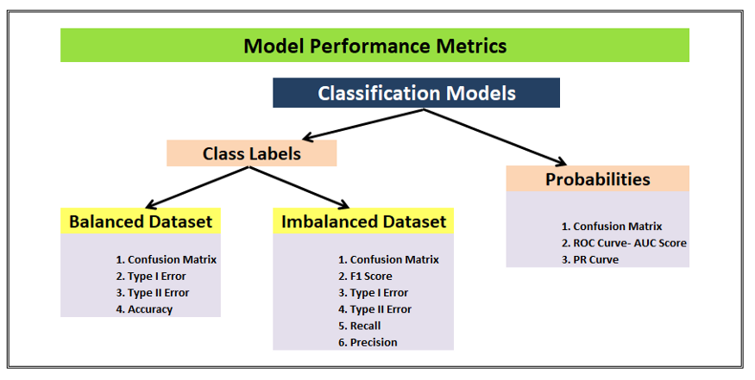

ROC_AUC Curve:

<https://towardsdatascience.com/understanding-auc-roc-curve-68b2303cc9c5>

<https://www.analyticsvidhya.com/blog/2020/06/auc-roc-curve-machine-learning/>

means measure of how well model fits a data