Points to remember:

-------------------

1-An abstract class can have abstract and/or non-abstract methods.

**Ans : Yes, abstract class have abstract and / non abstract methods.**

**Eg code.,**

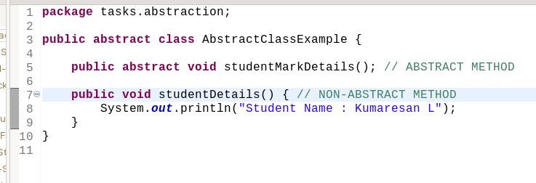

2-The abstract may or may not contain the final variables.

**Ans : Yes its true, abstract may contain final variables or may not.**

**Eg code., contain normal variable:-**

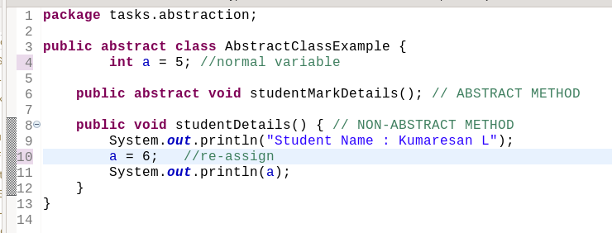

**Eg code., contain final variables**

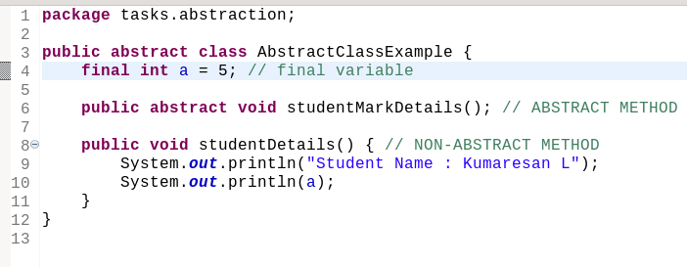

3-An abstract class can have final, static or non-static or non-final variables.

**Ans: Above all statements are true**

**\* Abstract class have final variable and static variable or may not. Eg code:-**

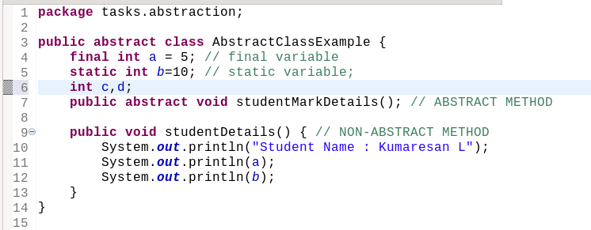

4-An abstract class may provide interface implementation.

**Ans : Yes abstract class provide interface implementation but instance of the interface will be not in abstract class, it may be in normal class or in another interfaces.**

**Eg code.,**

**interface A :-**

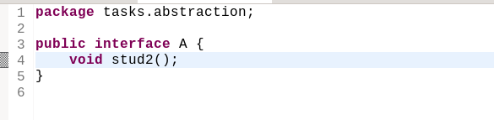

**A implememts in abstract class and also defining stud2() :-**

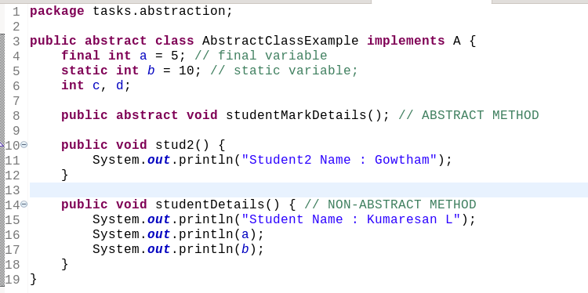

**But calling will be in studentMarks class that inherits AbstractClassExample that implements A so the think happened :-**

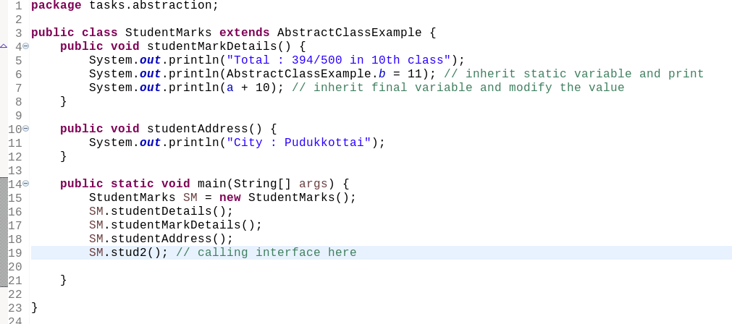

5-An abstract class is inherited using the “extends” keyword.

**Ans : Yes abstract class inherited using extends keyword in another class.**

**Eg.,**

**Abstract class :-**

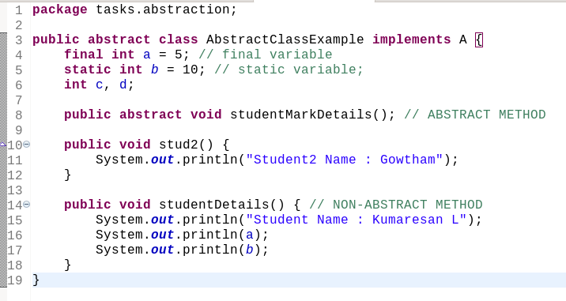**That is inherited in StudentNames class :-**

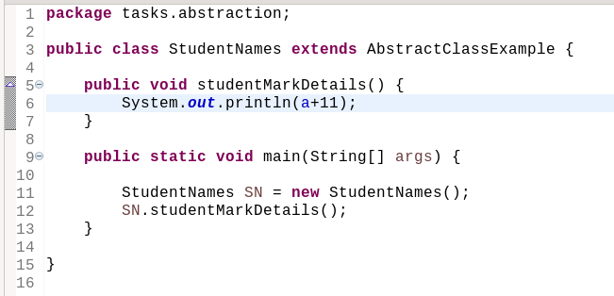

6-An abstract class can extend other classes or implement multiple interfaces.

**Ans : Yes, absrtact class can extend other classes alone. (without interface) and also implement multiple interfaces.**

**Eg., Abstract class implement multiple interface.**

**Interface A -**



**Interface B -**

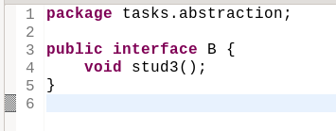

**Implements A and B in abstract class named AbstractClassExample -**

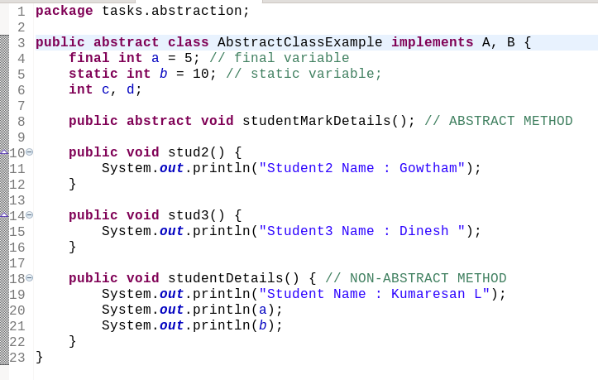

**But calling will be in studentMarks class that inherits AbstractClassExample that implements A and B so the think happened :-**

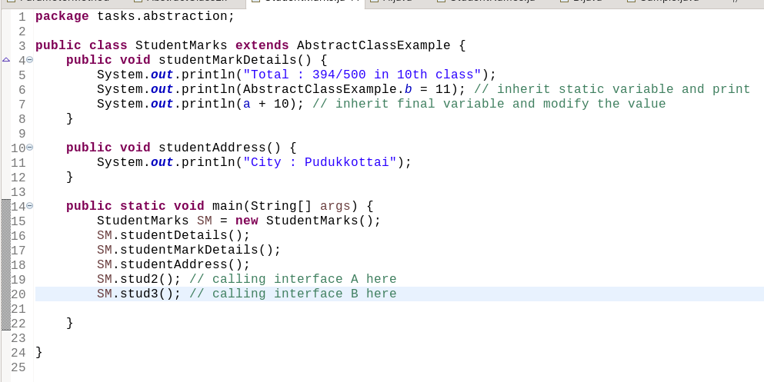

**Eg., An abstract class can extend other classes -**

**Now, here abstract class extends sample class:**

**sample.java -**

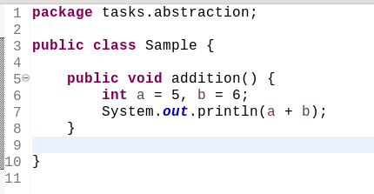

**Abstract class named AbstractClass2 extends Sample class:**

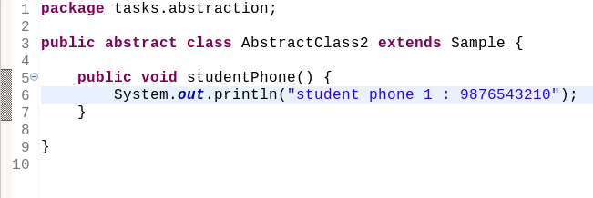 **But calling will be in studentPhone class that inherits AbstractClass2 that extends Sample so the think happened :-**

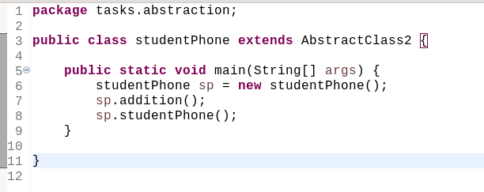

7-An abstract class can have private or protected data members apart from public members.

**Ans :- Yes, both the above statements are true. Abstract class can have private or protected members.**

**Eg.,**

