QUESTION 7:
------------
Description: Write a program to print the fibonacci series of a number 1 to 100.

Example:
--------
Output = 0,1,1,2,3,5.....

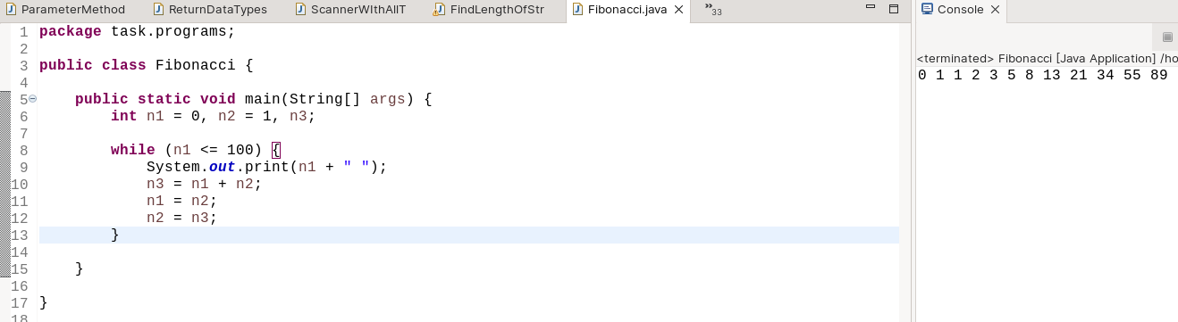
QUESTION 8:
-----------
Description: Find prime number or not.
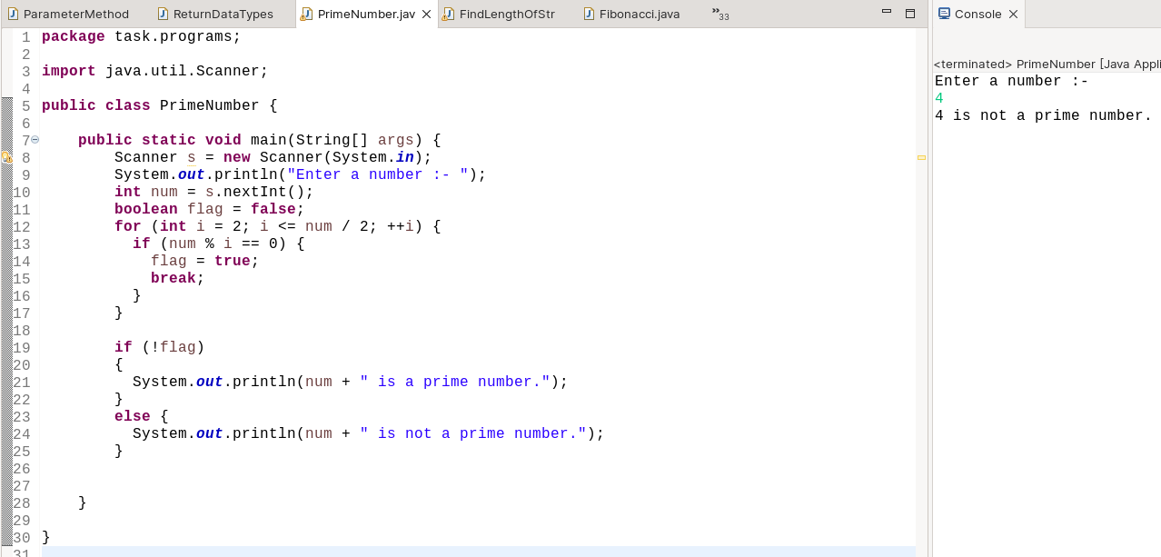
QUESTION 9:
-----------
Description : Print the below patterns using for loop.

Output:
-------
1
1 2
1 2 3
1 2 3 4
1 2 3 4 5
1 2 3 4 5 6
1 2 3 4 5 6 7
-----------------------
*
* *
* * *
* * * *
* * * * *
--------------------------
*
* *
* * *
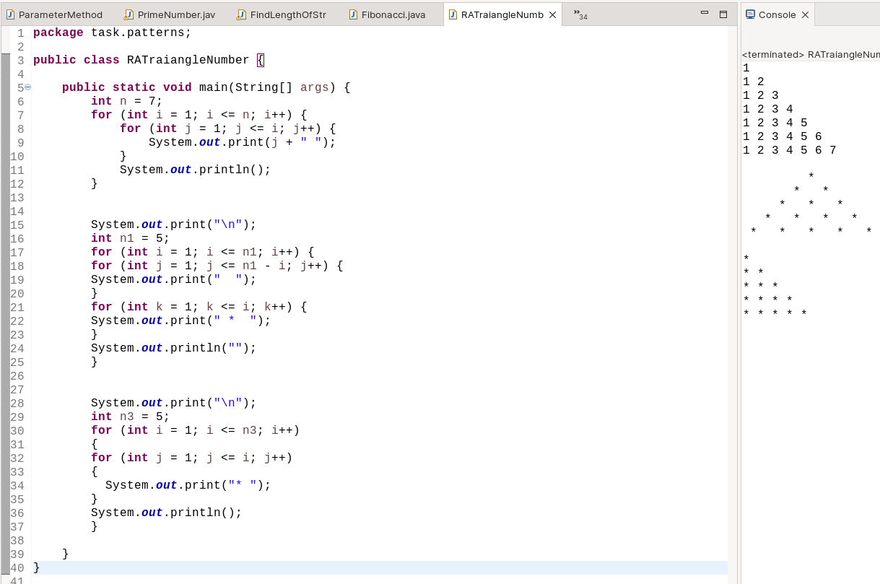
* * * *
* * * * *
QUESTION 10:
-------------
Description: Find Amstrong number or not

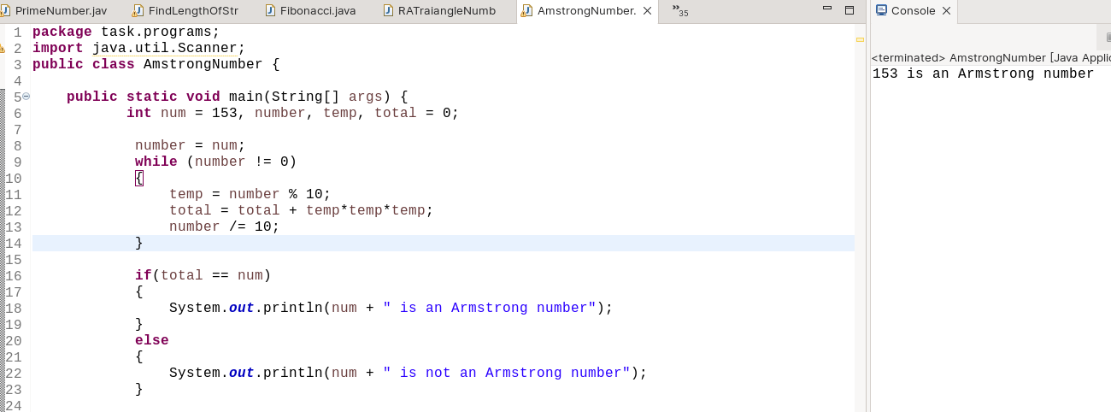
QUESTION 11:
-------------
Description: Reverse the number
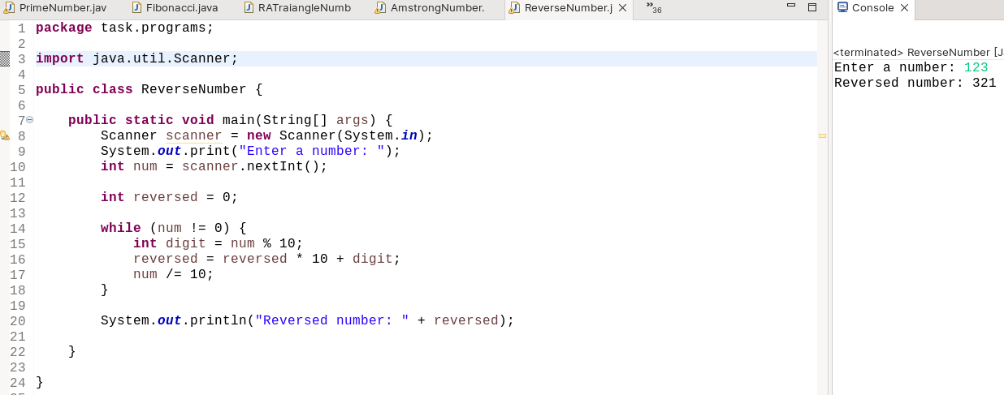
QUESTION 12:
-------------
Description: Count of the number
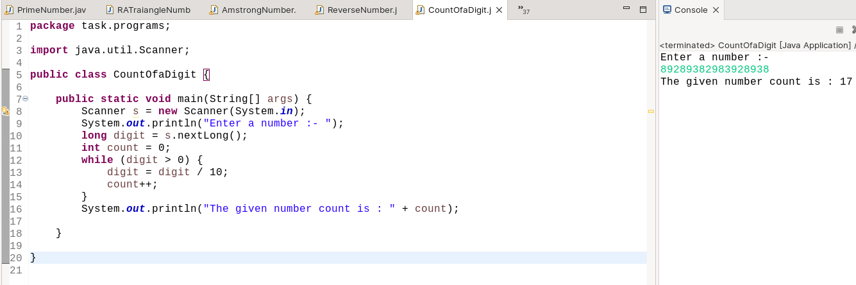
QUESTION 13:
-------------
Description: Sum of the number

Example:
--------
Input = 123
Output = 6

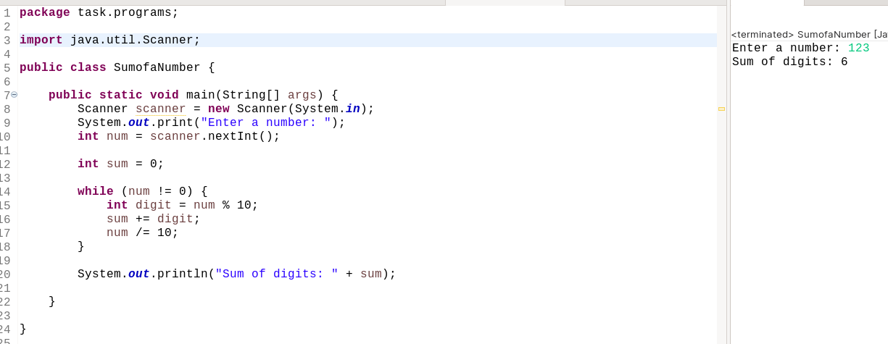
QUESTION 14:
--------------
Description: Verify the number is palindrome number not

Example:
--------
Input = 141
Output = Palindrome

