QUESTIONS(Programs)
------------------------------
QUESTION 1:
-----------
Description: Find the length of the below string
String 1: AlRightTechnology - 17
String 2: SeleniumAutomationtool - 22
String 3: shahul - 6
String 4: j a v a p r o g r a m - 21
String 5: 9095484678 - 10

Program & Output :-

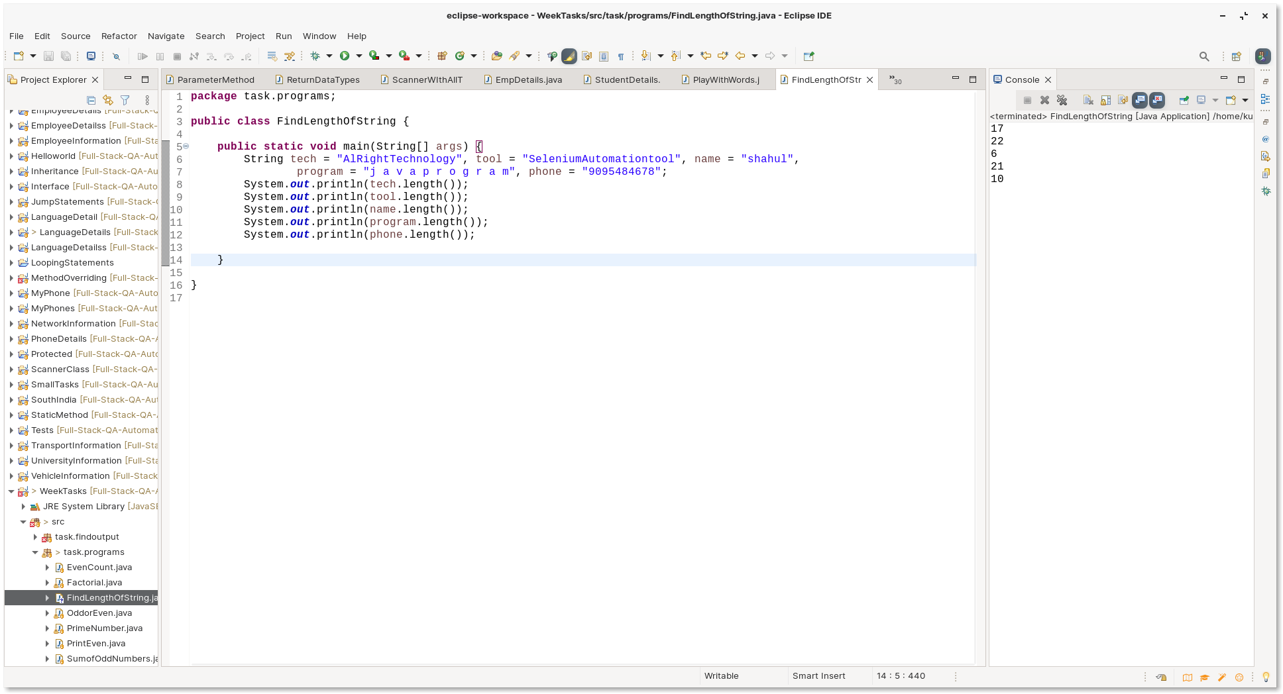
QUESTION 2:
-----------
Description: Find the particular character index in the given string
String 1: AlRightTechnology
Find the last index of o - 14

String 2: SeleniumAutomationtool
Find the index of o - 20

String 3: shahul
Find the index of n - -1

String 4: j a v a p r o g r a m
Find the last index of (emptyspace) - 19

String 5: 9095484678
Find the index of 8 - 9

Program & Output :-

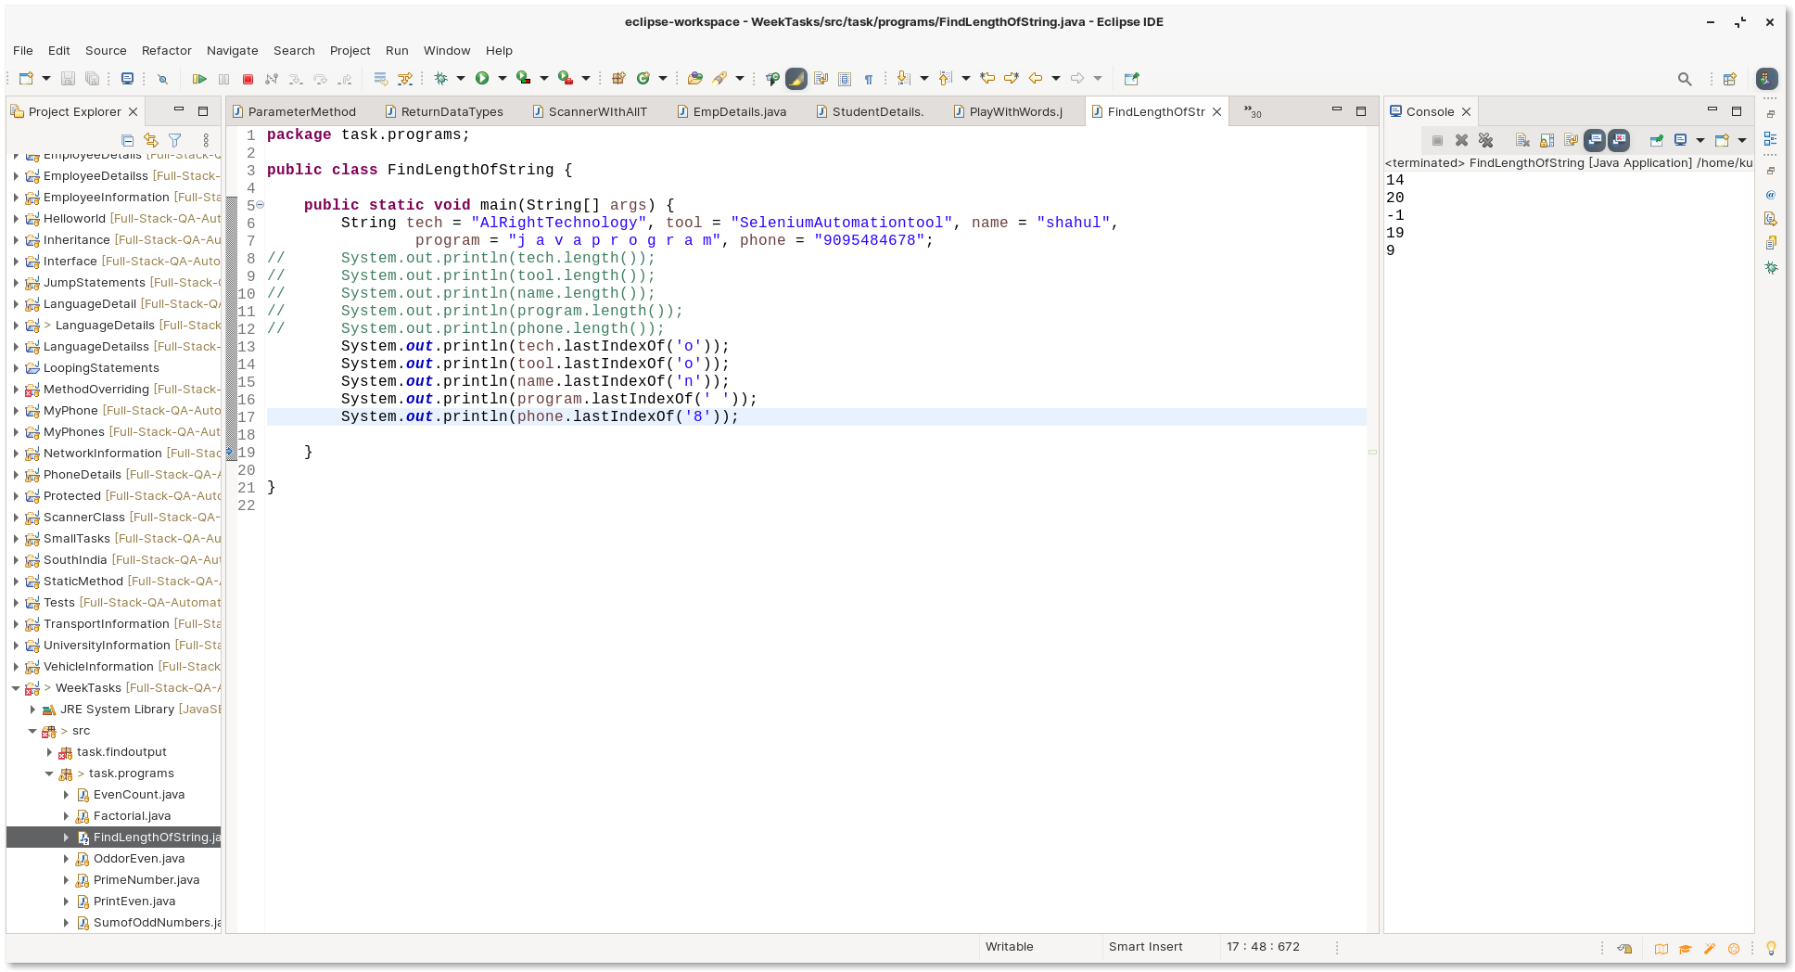
QUESTION 4:
-----------
Description : Get two input from user and check the equality
: print in the output whether it is Equal or not
Example:
--------
Input :
String 1 : Java
String 2 : Java

Example:
---------
Input :
String 1 : Java
String 2 : java

Example:
---------
Input :
String 1 : Aiite Technology
String 2 : AiiteTechnology.

Example(use equalsIgnoreCase):
---------
Input :
String 1 : Java
String 2 : java

Example(use equalsIgnoreCase) :
---------
Input :
String 1 : Nisha
String 2 : nisha
Output :-

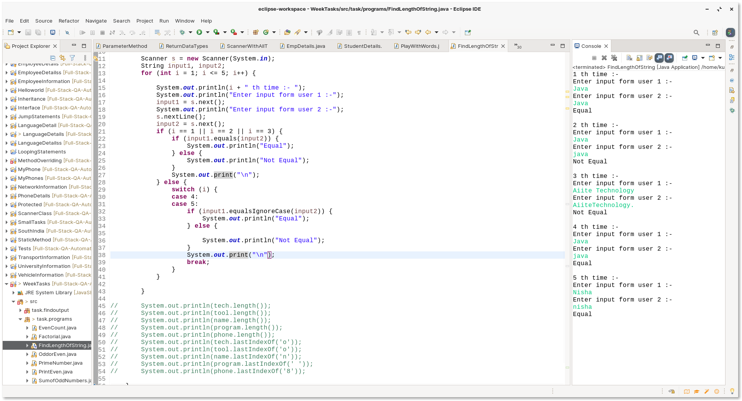
QUESTION 5:
------------
QUESTION 5.1:
------------
Description: Get the email id from the user and verify '@' is present or not?

Example:
------------
Input = shahulk451@gmail.com
Output = valid email id

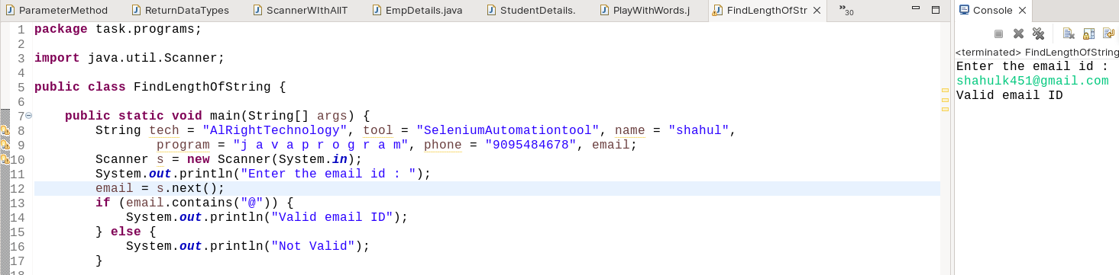
QUESTION 5.2:
------------
Description:Get the address from the user and verify "pincode" is present or not?

Example:
------------
Input = 5-35-2a,venkatesh nivas,Aruppukottai
Output = invalid address

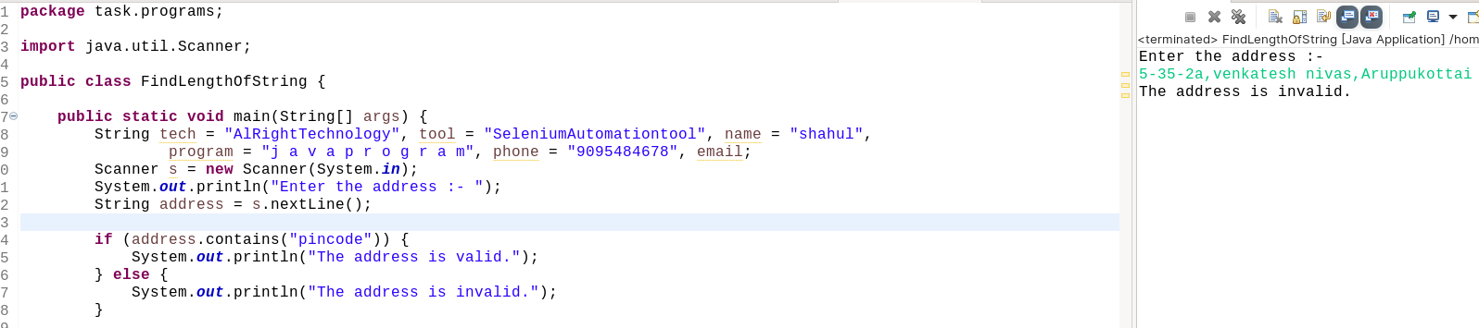
QUESTION 5.3:
------------
Description:Get the email from the user and verify '@' is present or not and return true or false?

Example:
------------
Input = YuvarajSekar12@gmail.com
Output = True/False

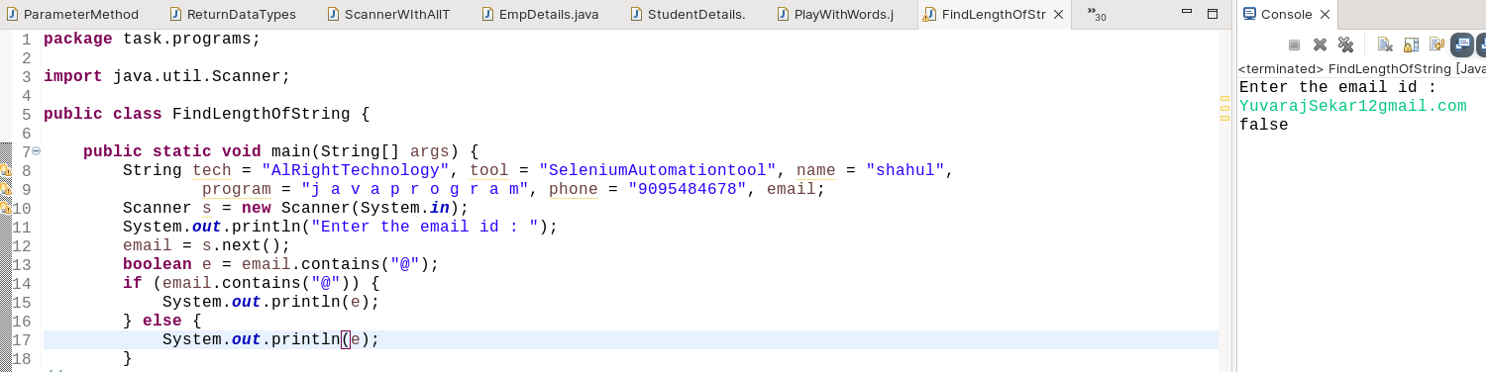
QUESTION 5.4:
------------
Description:Get the phonenumber from the user and verify any character is present or not .
If character is present return invalid number

Example:
------------
Input = 90954a6o78
Output = False

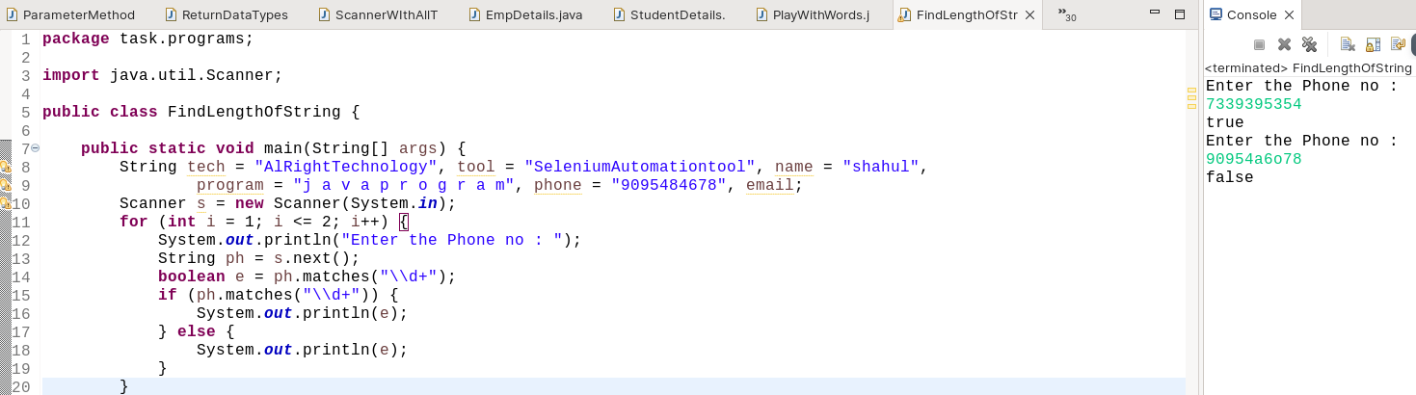
QUESTION 6:
-----------
Description:Get the phonenumber from the user .
If phonenumber exceeds greater than 10 then return invalid number

Example:
--------
Input = 89034256972365
output = invalid
Example 2:
---------
Input = 9095484678
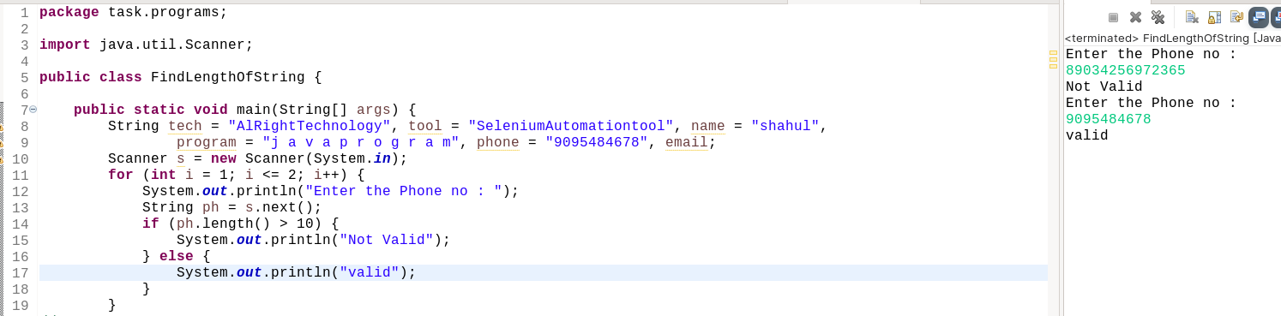
Output = valid
QUESTION 7:
------------
QUESTION 7.1:
-------------
Description:Given string as "Welcome to java class" and replace java into sql.

Example:
-----------
Input = Welcome to class java
output = Welcome to class sql

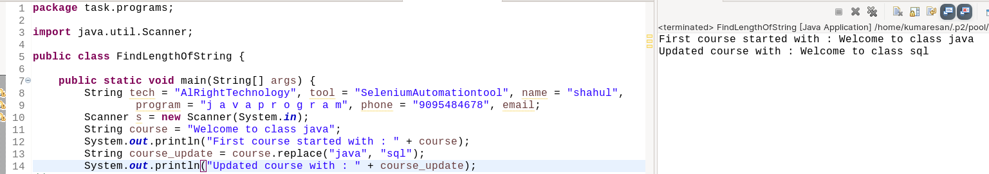
QUESTION 7.2:
-------------
Description:Given string as "AlRight Adayar"and replace Adayar into Omr.

Example:
-----------
Input = AlRight Adayar
Output = AlRight Omr

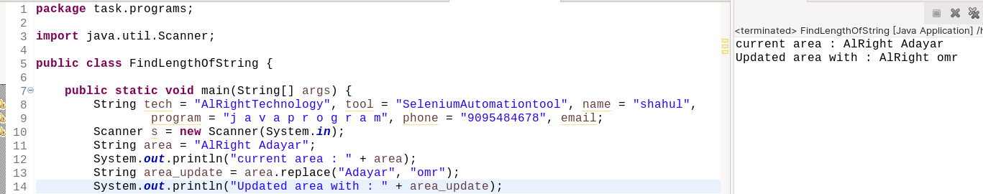
QUESTION 7.3:
-------------
Description: Given String as "Welcome to java class" and Replace space into '#'

Example:
----------
input:Welcome to java class
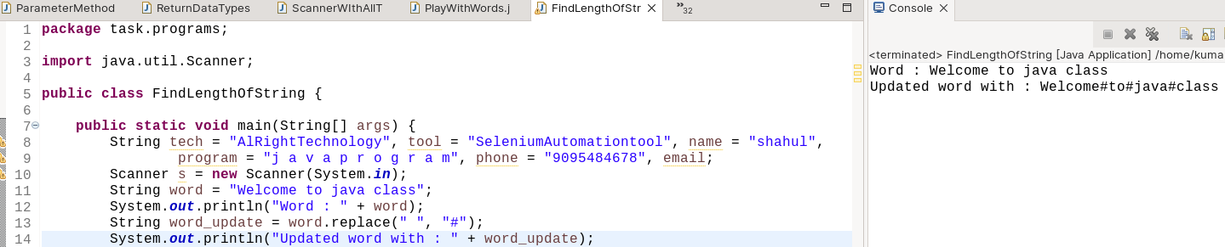
output:Welcome#to#java#class
QUESTION 7.4:
------------
Description:Get the email from the user and verify "gmail" is present or not.
If present replace that gmail into yahoo

Example:
------------
Input = YuvarajSekar12@gmail.com
Output = YuvarajSekar12@yahoo.com

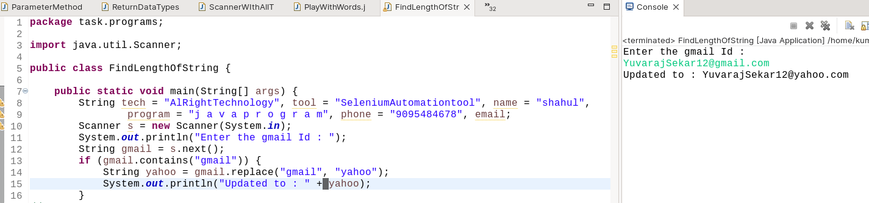
QUESTION 7.5:
------------
Description:Get the address from the user and verify "pincode" is present or not.
If present replce the pincode with empty space

Example:
------------
Input = 5-35-2a,venkatesh nivas,Aruppukottai,pincode-626101
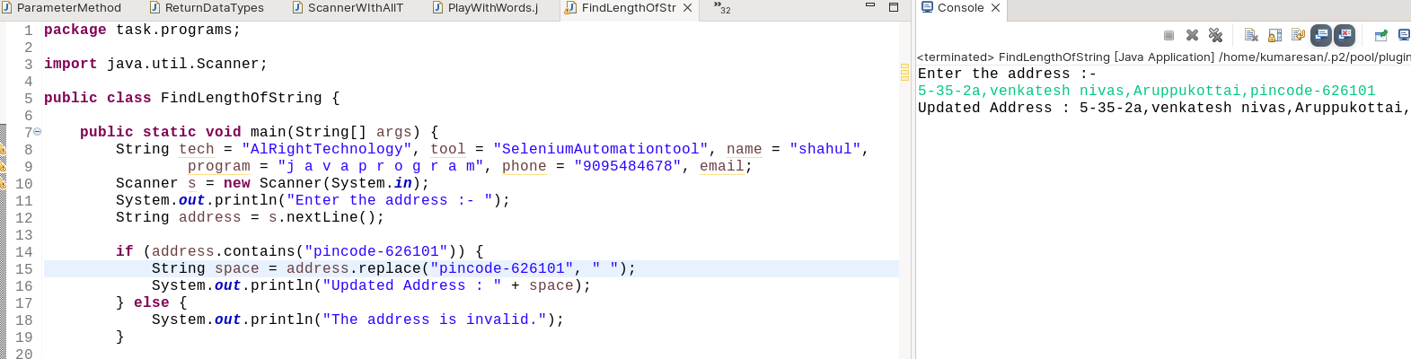
Output = 5-35-2a,venkatesh nivas,Aruppukottai
QUESTION 8
----------
QUESTION 8.1
-------------
Description:Get the input from the user and print that word in lowercase

Example:
--------
Input = NISHANTHI
Output = nishanthi

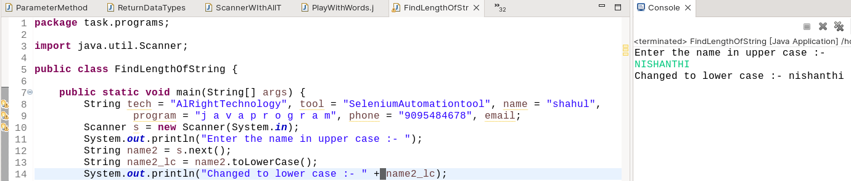
QUESTION 8.2
-------------
Description:Get the input from the user and print that word in Uppercase

Example:
--------
Input = nishanthi
Output = NISHANTHI

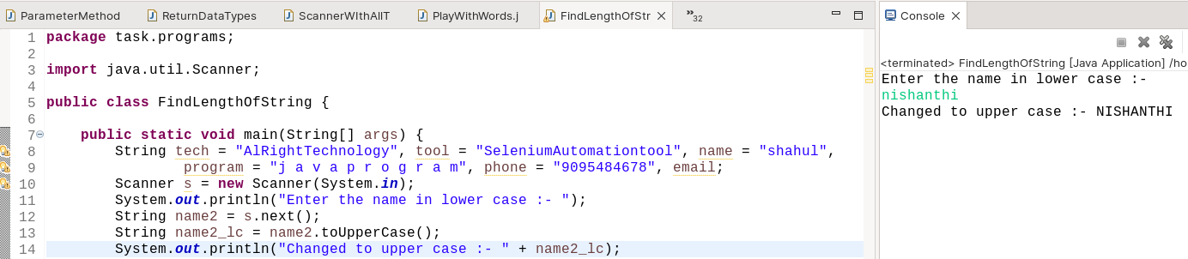

QUESTION 8.3
---------------
Description:Convert all small letter and into capital letter

Example:
----------
Input = WelcomE
Output = wELCOMe

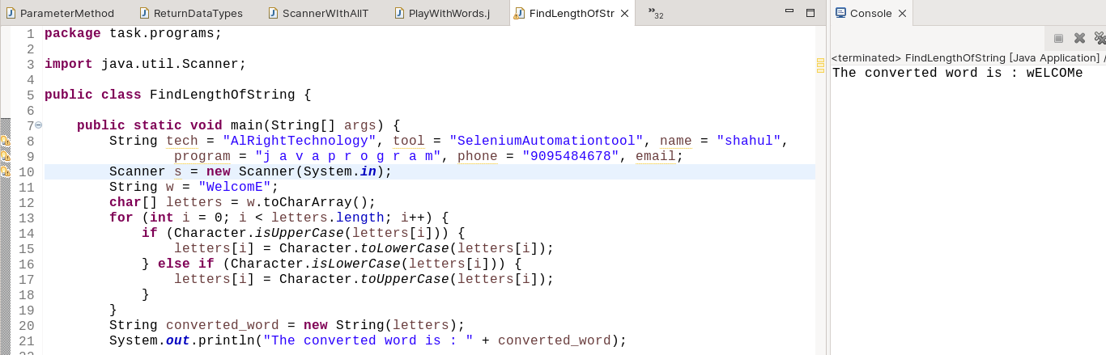
This is charcter array concept, In string type first we have to convert string to character array like {W,e,l,c,o,m,E}, then we have to check whether if each letter in upper or lowercase by using index, to change and vice versa using Character.isLowerCase(variable) or Character.isLowerCase(variable).

QUESTION 8.4
--------------
Description:Find the number of uppercase count and lowercase count in the given String

Example:
--------
Input = WelComeToJava
Output: UC = 4, LC =9

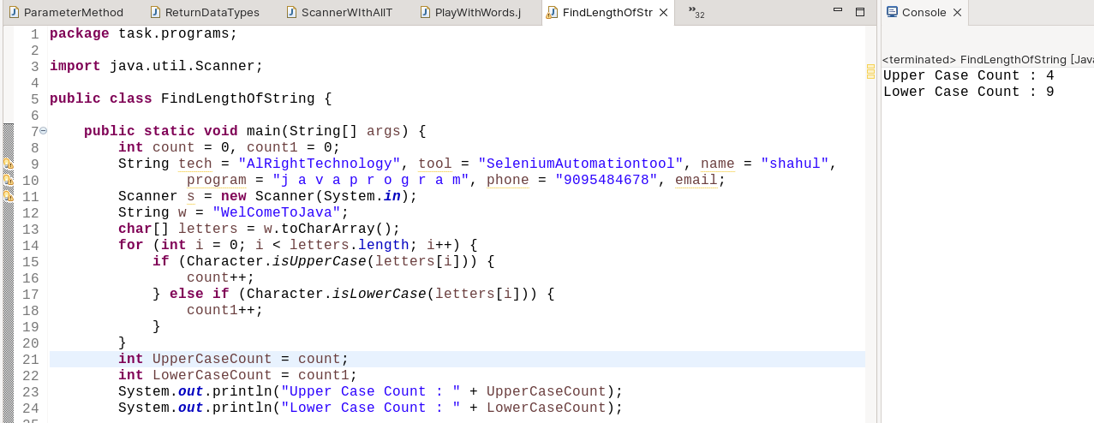

QUESTION 9
------------
QUESTION 9.1
--------------
Description: Given String as "Welcome to java class" and verify whether the given string startsWith welcome

Example:
-----------
Input = Welcome to class java
output = True

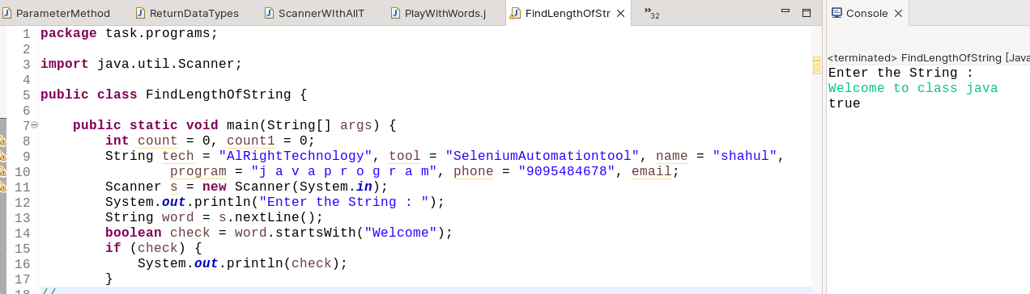
QUESTION 9.2
--------------
Description: Given String as "Hai i am nisha" and verify whether the given string startsWith welcome

Example:
-----------
Input = Hai i am nisha
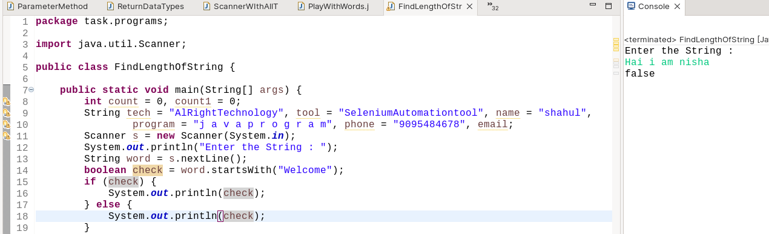
output = False
QUESTION 9.3
--------------
Description: Given String as "Welcome to java class" and verify whether the given string endsWith class

Example:
-----------
Input = Welcome to java class
output = True

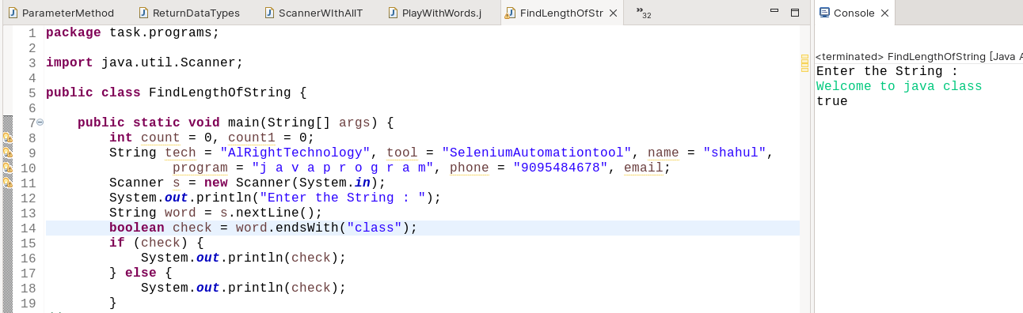
QUESTION 9.4
--------------
Description: Given String as "Welcome to java class" and verify whether the given string endsWith java

Example:
-----------
Input = Welcome to java class
output = False

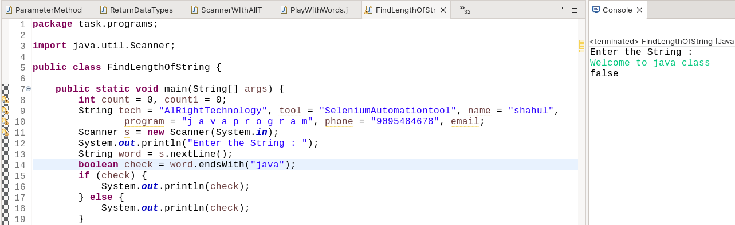
QUESTION 9.5
--------------
Description: Given String as "Welcome to java class" and verify whether the string is empty or not

Example:
-----------
Input = Welcome to java class
output = False

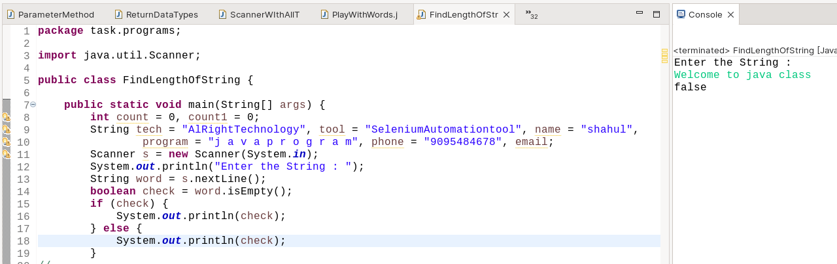
QUESTION 9.6
--------------
Description: Given String as "" and verify whether the string is empty or not

Example:
-----------
Input = ""
Output = False
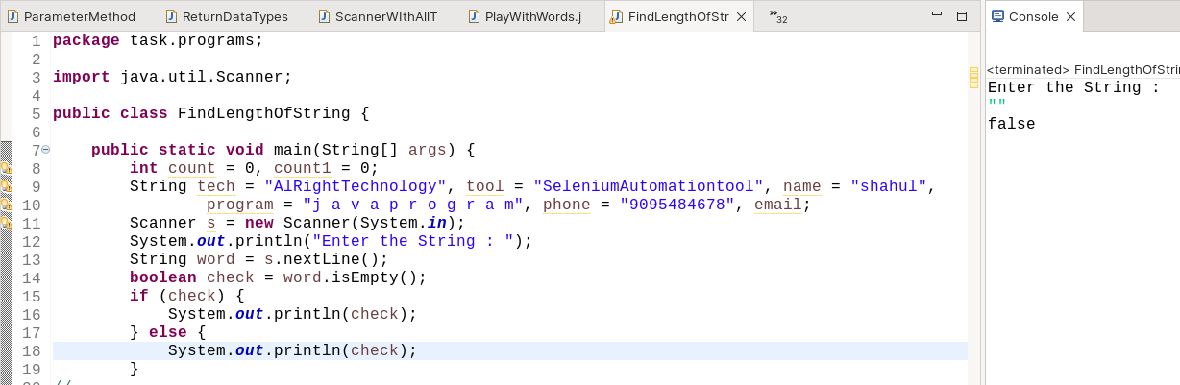
QUESTION 10
-----------
Description : Get two input from user and Compare

Example
---------
String 1 : Nisha
String 2 : nisha
Example
---------
String 1 : Nia
String 2 : nisha
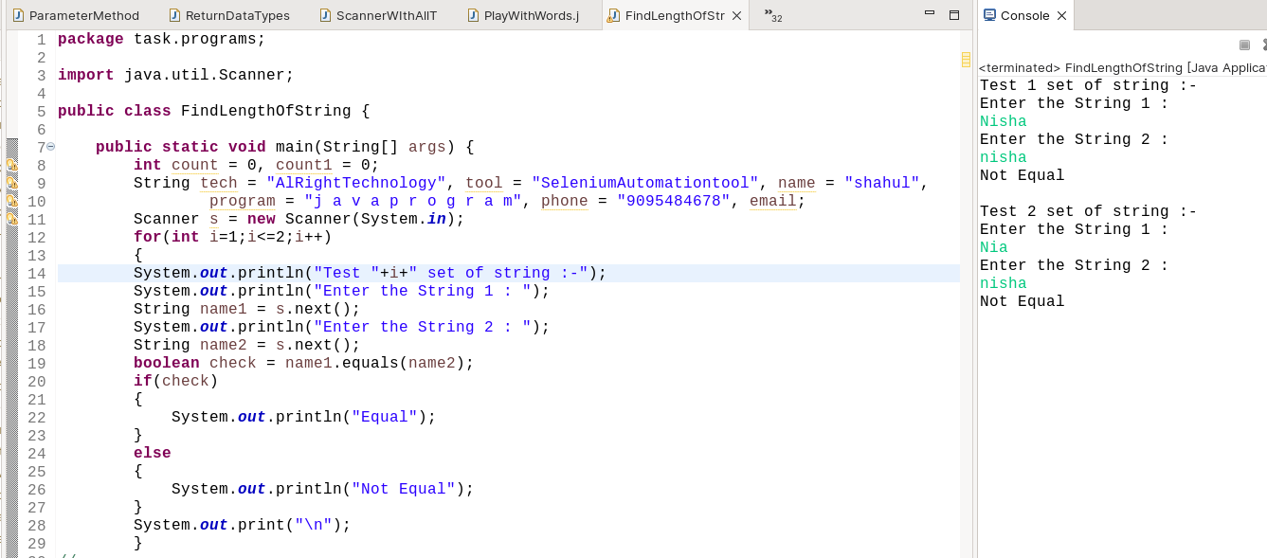
QUESTION 11
------------
QUESTION 11.1
---------------
Description : Generate the two literal string and find the identityHashCode()

Example
---------
String 1 : Nisha
String 2 : Nisha
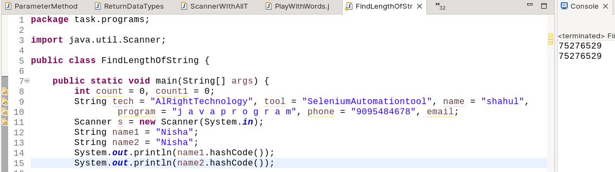
QUESTION 11.2
---------------
Description : Generate the two non literal string and find the identityHashCose()

Example
---------
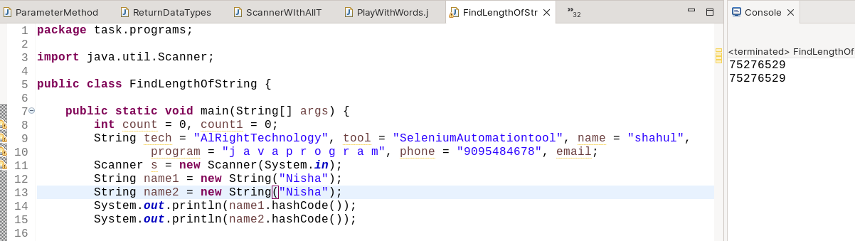
String 1 : Nisha
String 2 : Nisha
QUESTION 11.3
---------------
Description : Generate the three non literal string and find the identityHashCose()

Example
---------
String 1 : Nisha
String 2 : Rengan
String 3 : NishaRengan
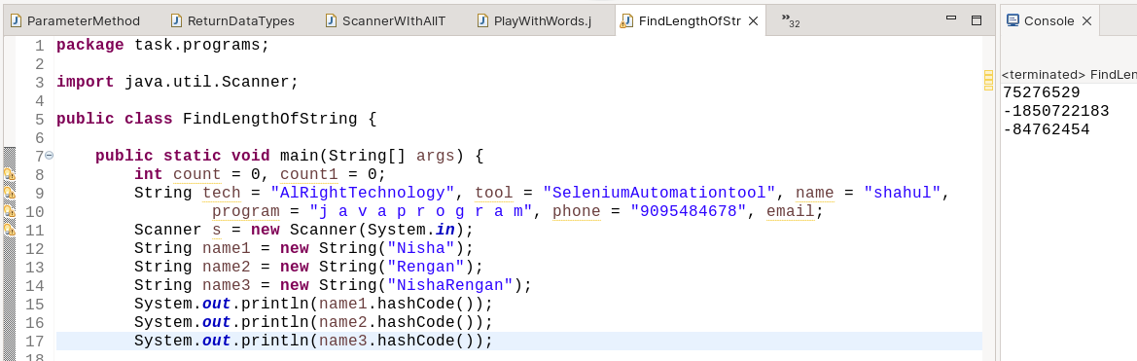
QUESTION 11.4
---------------
Description : Generate the three literal string and find the identityHashCose()

Example
---------
String 1 : Nisha
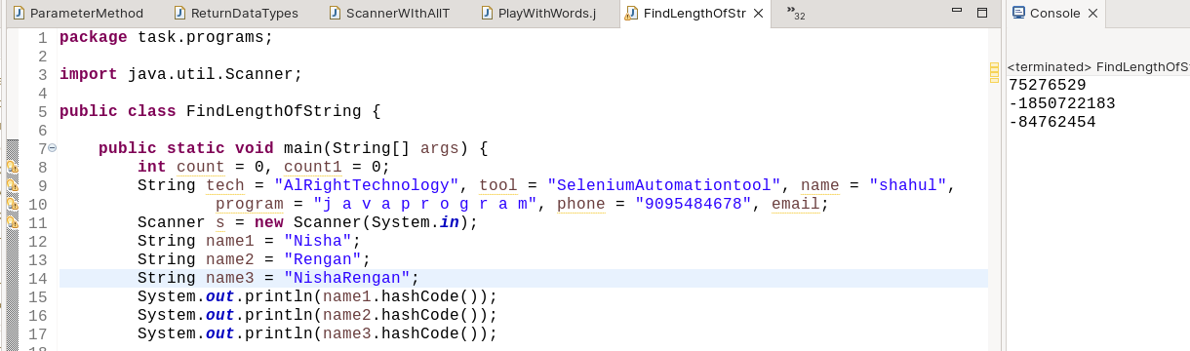
String 2 : Rengan
String 3 : NishaRengan
QUESTION 12
------------
QUESTION 12.1
--------------
Description: Given String as "Welcome to java class" and split it by space.

Example:
--------
Input :Welcome to java class
Output:
-------
Welcome
to
java
class
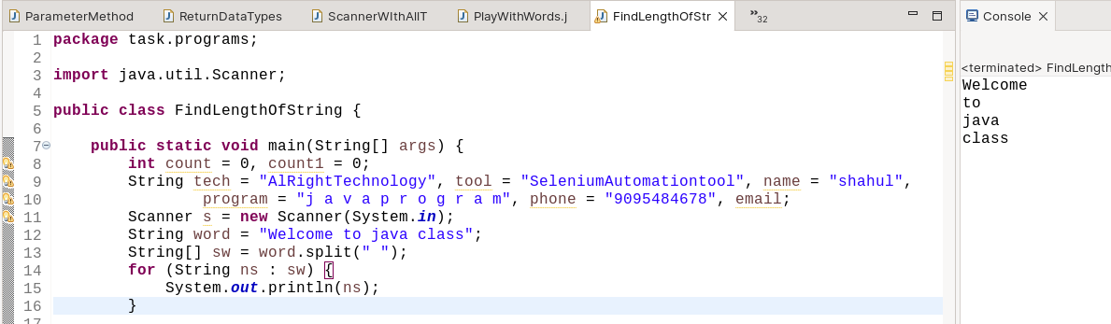
QUESTION 12.2
--------------
Description: Given String as "Welcome to java class" and split it by l

Example:
--------
Input :Welcome to java class
Output:
-------
We
come to java c
ass
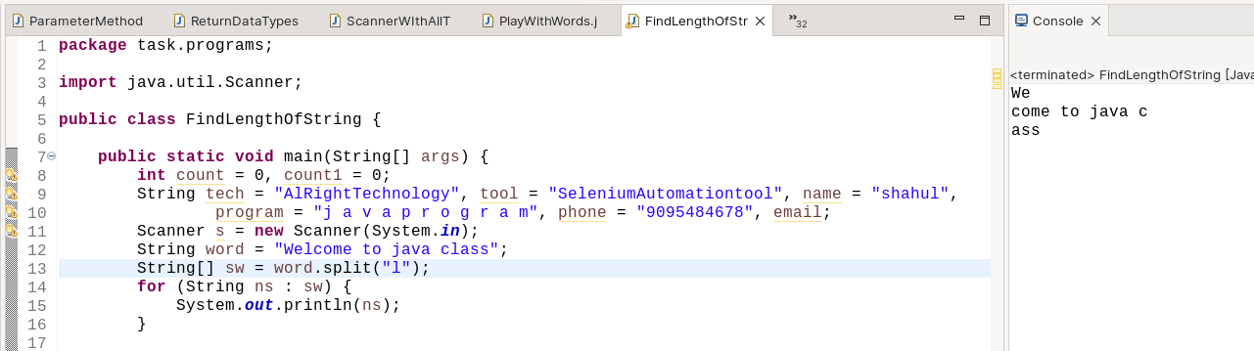
QUESTION 13
------------
QUESTION 13.1
--------------
Description: Given String as "Welcome to java class" and generate a substring.

Example:
--------
Input :Welcome to java class
Output:
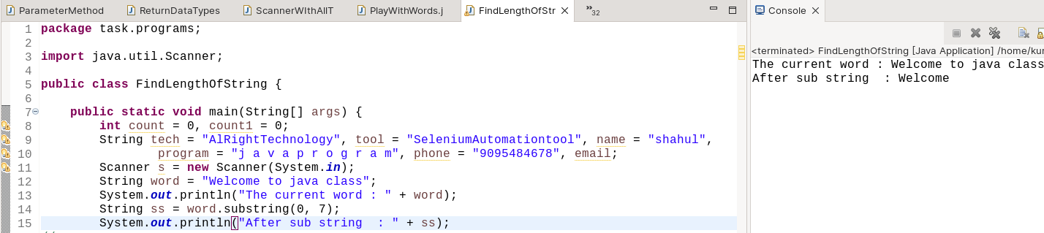
-------
Welcome
QUESTION 14
-----------
Description: Given String as "Welcome" and the number of consonant count and vowels count

Example:
---------
Input = Welcome
output:
-------
vowels = 3
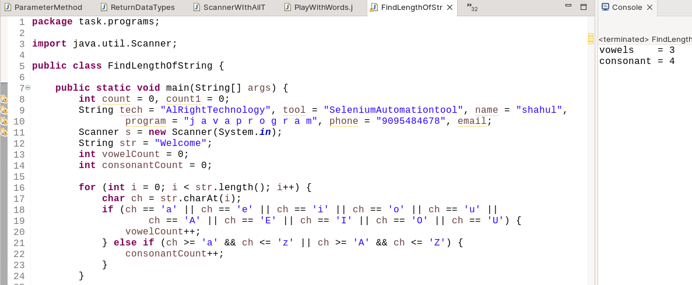
consonant = 4
QUESTION 15:
------------
Description: Find the count of caps,small,number and special character in given string

Example:
-----------
Input : Welcome To Java class @123
Output
------
caps count :3
small count :15
number count:3
Special char:5
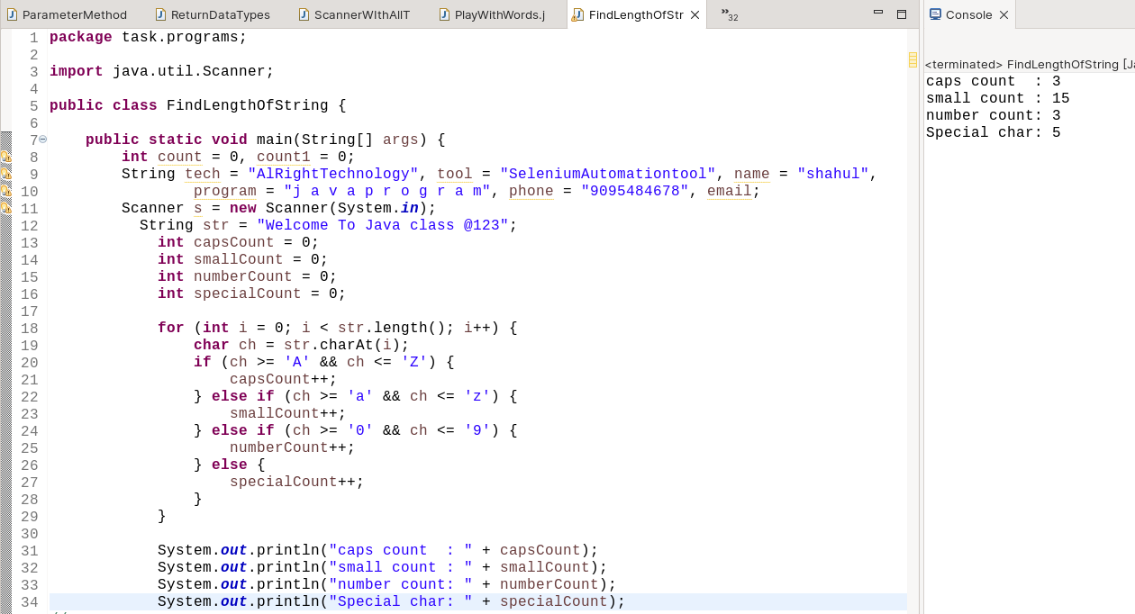
QUESTION 16
------------
Description: Replace all vowels char into '@'

Example:
----------
Input = Welcome
Output = W@lc@m@
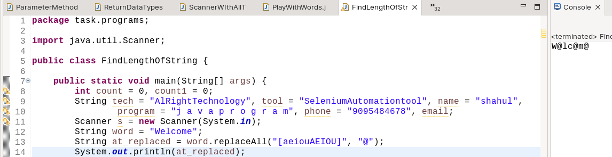
Question 3:
-----------
Description: Find the particular character in the given string
String 1: AlRightTechnology
print the character h

String 2: SeleniumAutomationtool
print the character o

String 3: shahul
print the character u

String 4: j a v a p r o g r a m
print the character p

String 5: 9095484678
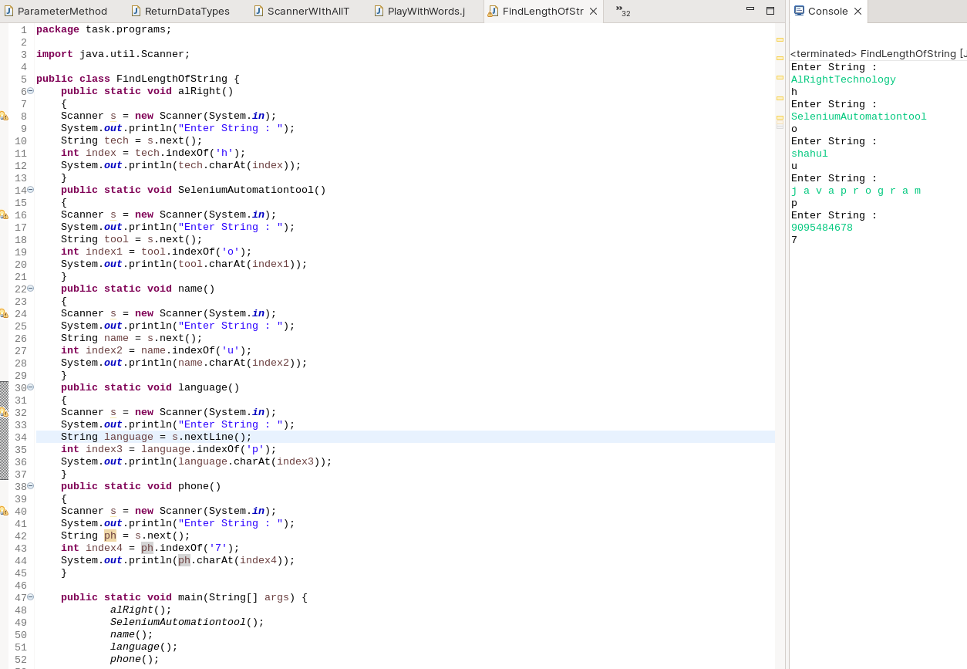
print the character 7

