Arrays -

QUESTION 1:
-----------
Description : Write a Java program to sum values of an array
Input a[]= {1, 2, 3, 4, 5, 6, 7, 8, 9, 10}
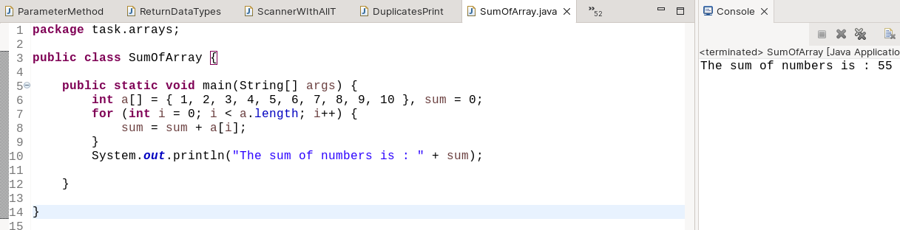
Output = 55
Program & Output :-
QUESTION 2:
------------
Description : Write a Java program to calculate the average value of array elements.
Input a[]= {1, 2, 3, 4, 5, 6, 7, 8, 9, 10}
Output = average = 5.5
Program & Output :-
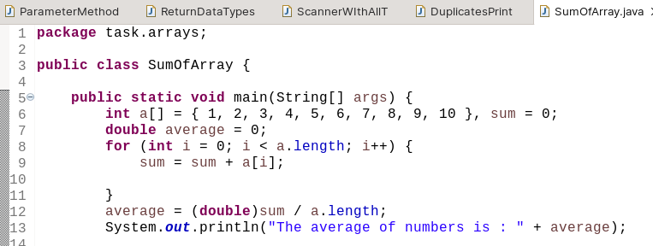
QUESTION 3:
Description : Write a Java program to remove duplicates from array
Input a[]= {10,10,20,50,60,80,60,50}
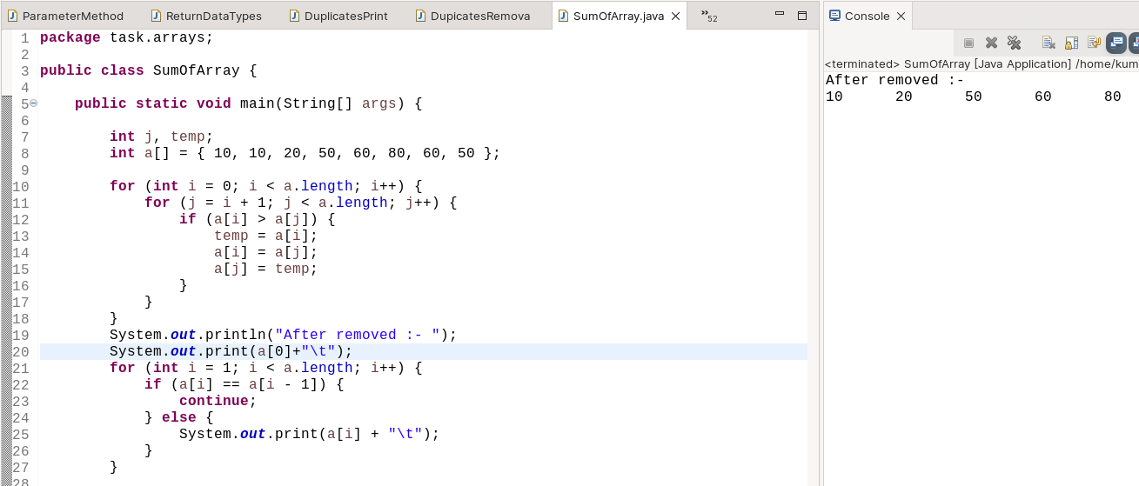
Output a[]= {10,20,50,60,80}
Program & Output :-

