1. The process of division in elementary schools is often performed in repeated subtraction method. Construct the flowchart that reads two positive integer x and y. Then divide x by y using repeated subtraction method. Write the quotient and the remainder. (Use do ... while loop construct)

x = ~~15 10 5~~ 0

y = 5

q= ~~0 1 2~~ 3

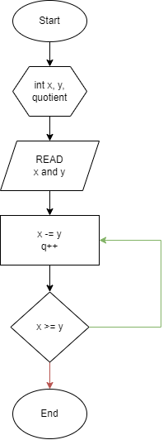

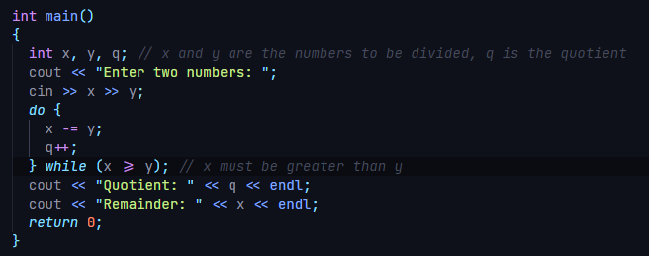

1. Assume the current population of Cebu City is approximately 170 000 and it grows 2.63% per annum. Design a flowchart that determine the year when the population od Cebu City reaches 1million. (Use while loop construct)

Population= ~~170000 174471 179059 183768 188601 193561 198651 203875 209236 214738 220385 226181 232129 238233 244498 250928 257527 264299 271250 278383 285704 293218 300929 308843 316965 325301 333856 342636 351647 360895 370386 380127 390124 400384 410914 421721 432812 444194 455876 467865 480169 492797 505757 519058 532709 546719 561097 575853 590997 606540 622492 638863 655665 672908 690605 708767 727407 746537 766170 786320 807000 828224 850006 872361 895304 918850 943015 967816 993269~~ 1019391

years= ~~0 1 2 3 4 5 6 7 8 9 10 11 12 13 14 15 16 17 18 19 20 21 22 23 24 25 26 27 28 29 30 31 32 33 34 35 36 37 38 39 40 41 42 43 44 45 46 47 48 49 50 51 52 53 54 55 56 57 58 59 60 61 62 63 64 65 66 67 68~~ 69

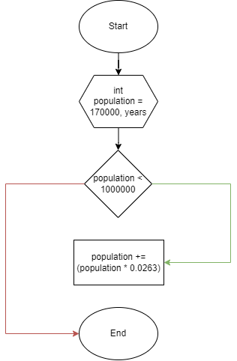

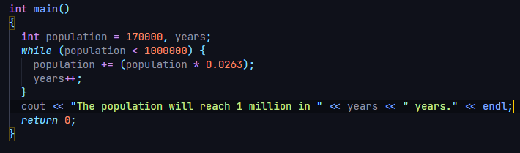

1. A prime number is a positive number is a number greater than 1 whose factors are 1 and itself. Accept a positive number less than 100 and then display all prime numbers from 2 up to or less than the inputted number.

