SMART ACCESS CONTROL SYSTEM

A Capstone Project
Presented to the Faculty of the
College of Information and Computing Innovation
Iloilo State University of Fisheries Science and Technology
Dingle, Iloilo

In Partial Fulfillment
Of the Requirements for the Degree
Bachelor of Science in Information Technology

By
Lou Vincent Baroro
Shamy Descalsota
Katherine Olido
Joysie Ann Notada
Catherine Lanado

2025–2026

CHAPTER I

INTRODUCTION

1.1 Background of the Study
Campus access management requires an institution to balance security, efficiency, and the orderly implementation of institutional policies. Traditional entry procedures commonly depend on security personnel to inspect identification and to determine whether students comply with prescribed entry requirements such as a valid enrollment record or an authorized guest pass. During periods of heavy student traffic these checks become repetitive, and the resulting decisions can be inconsistent from one guard to the next or from one hour to the next. Advances in computer vision, biometric recognition, and edge computing now make it possible to support these activities with an automated preliminary check while the security personnel retain supervision and override authority.
Recent research demonstrates the feasibility of combining biometric recognition with physical access control. Suethanuwong and Sukkasame (2023) developed an access control system that used RFID together with face verification and a university library turnstile, showing that biometric verification can be integrated with a physical access mechanism. Thai, Seo, and Huh (2024) likewise demonstrated that low-cost facial recognition can be delivered through an ordinary mobile device for attendance monitoring. These studies support the use of automated identity verification as a component of controlled entry.
Facial recognition has also been applied to educational attendance and monitoring. Do et al. (2024) developed a facial-recognition-based student attendance system that records student entry and exit information, illustrating how automated face recognition can reduce dependence on manual procedures. Identity verification alone, however, does not establish whether a student satisfies a separate institutional requirement such as pass validity, enrollment standing, or an active lockdown restriction.
Entry management must also admit legitimate visitors who are not enrolled students. Dela Peña et al. (2025) developed a campus visitors' information system for Saint Mary's University that replaced pen-and-paper logging with a validated digital record, demonstrating that a documented guest-pass workflow improves accountability at campus gates. QR-code methods have likewise been shown to make gate and attendance capture fast and auditable in educational settings (Hendrawan et al., 2025). The present study applies the same principle inside the access-control loop: the guard issues a time-bounded guest e-pass with a QR credential, and the kiosk verifies that pass as an explicit decision path alongside face recognition, so visitors are admitted through the system rather than around it.
The Smart Access Control System is designed for ISUFST Dingle Campus. It combines student identification by face recognition, school-uniform compliance checking, guard-issued guest e-pass verification, a policy engine with lockdown support, access-decision logic, entry monitoring, AI-assisted daily briefings, and prototype gate control. Unlike conventional designs in which recognition is performed on a server, a graphics workstation, or a single-board computer, this system performs all artificial-intelligence inference inside the browser of the device stationed at the gate. Face detection uses MediaPipe, face recognition uses an ArcFace model executed through ONNX Runtime Web, and uniform checking uses a CLIP vision encoder executed through the same runtime, all running on the tablet itself. The kiosk also announces each decision with offline voice prompts rendered once from the Piper neural text-to-speech engine and shipped as audio files, so announcements work with no connectivity.
The system is delivered as three cooperating web applications that share one cloud database: a Kiosk Progressive Web App mounted at the gate, a Guard Station used to enroll students, and an Administrative Dashboard used for monitoring. The kiosk is offline-first: enrolled student records, face embeddings, and access logs are kept in the browser's IndexedDB and are synchronized with the cloud database whenever a connection is available, so recognition continues to work when the campus network is down.
The enrollment dataset for this study consists of five guided photographs per student captured at the Guard Station — front, left-45-degree, right-45-degree, up, and down — from each of which one ArcFace embedding is generated and stored. Because recognition runs fully on-device against these enrolled embeddings, no training workstation is required after deployment. Gate control is provided by an ESP32 microcontroller that the tablet reaches over its own Wi-Fi hotspot through a WebSocket connection, with an Arduino over USB as a fallback transport, and a physical button on the controller preserves manual operation.
The project therefore focuses on developing and evaluating a working prototype rather than claiming a completed campus-wide deployment. The system is intended to assist security personnel by providing a consistent automated preliminary check while retaining human intervention for exceptional situations. The evaluation determines the prototype's functional performance, reliability, security, and user acceptance after the components have been integrated and tested.

1.2 Objectives of the Study
The general objective of this study is to design, develop, integrate, and evaluate a Smart Access Control System that supports automated student identification, school-uniform compliance checking, guest e-pass verification, policy-governed entry decisions, and entry monitoring at ISUFST Dingle Campus.
Specifically, the study aims to:
1. develop a student identification component that recognizes authorized students on-device using face detection and ArcFace embeddings, with a school-ID QR fallback when the face cannot be read, and that supports an automated access decision;
2. develop a guard-issued guest e-pass with a QR credential and expiry, together with a kiosk verification path that admits visitors through explicit coded decisions (GUEST_PASS_VALID, GUEST_EXPIRED);
3. develop a uniform compliance component that determines whether the person at the gate is wearing the prescribed school uniform and supports the access decision, denying entry with an explicit uniform reason code when the requirement is enabled and no uniform is detected;
4. implement the on-device policy engine and decision-code scheme (POLICY_PASS, LOCKDOWN_ACTIVE) on the tablet kiosk and establish communication between the access-control application and the microcontroller-based gate controller;
5. record and monitor entry events and access decisions, keeping them available offline and synchronizing them to the cloud for administrative and security purposes; and
6. evaluate the developed prototype using selected applicable characteristics of ISO/IEC 25010:2023, particularly functional suitability, performance efficiency, reliability, security, and interaction capability, supplemented by a user-acceptance measure.

1.3 Conceptual Framework
The study follows an Input–Process–Output (IPO) framework, as illustrated in Figure 1. The input consists of student identification data, live camera images, the torso image region, the enrollment photographs and embeddings, the guest e-pass records, the policy settings including the uniform requirement, the machine-learning models, and the system requirements. The process involves image capture, on-device face detection, face-embedding extraction and matching, uniform compliance checking against uniform and non-uniform prompts, guest-pass verification, policy evaluation, access-decision logic, event recording, and communication with the gate controller. The output is an access decision, the corresponding gate response, the uniform verdict stored on the entry record, and an entry record available for monitoring and reporting.
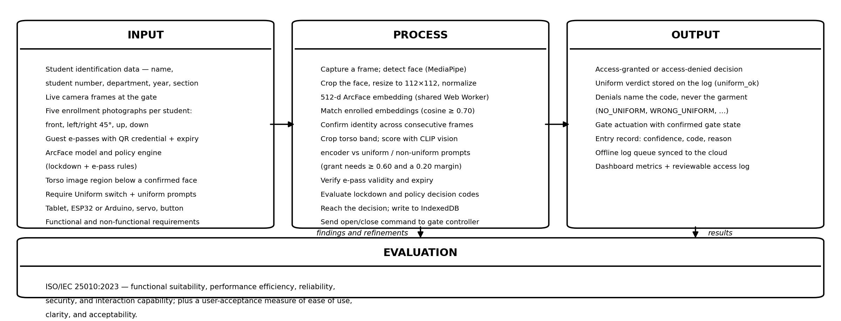
Figure 1. Input–Process–Output (IPO) framework of the study.
Input. Student identification information (name, student number, course, year level, and section), live camera images captured at the gate, five enrollment photographs per student, the enrolled ArcFace embeddings, the guest e-pass records, the ArcFace and CLIP models, the torso image region below a confirmed face, the Require Uniform switch and the uniform prompt set, the hardware components, and the functional and non-functional requirements constitute the principal inputs.
Process. The system captures a frame, detects a face with MediaPipe, crops and normalizes the face region, computes a 512-dimensional ArcFace embedding in a Web Worker, and compares that embedding against every enrolled embedding using cosine similarity. When the identity is established and the uniform requirement is enabled, the system crops the torso band below the face and scores it with the CLIP vision encoder against uniform and non-uniform prompt embeddings; entry is granted only when the uniform score reaches 0.60 and leads the best non-uniform score by 0.20, otherwise the attempt is denied with a uniform reason code that names the code but never the garment. The policy engine then evaluates lockdown status, guest-pass validity, and the match result, and combines them into a coded access decision. The event is written to the local offline store and the appropriate control signal is sent to the gate controller.
Output. The system produces an access-granted or access-denied decision, physically activates the prototype gate when the access conditions are satisfied, records the uniform verdict on the entry record, and stores the entry information for monitoring and reporting in the administrative dashboard.
Evaluation. The developed prototype is evaluated through functional, performance, reliability, security, and user-acceptance testing using criteria derived from ISO/IEC 25010:2023 and the study's operational requirements.

1.4 Significance of the Study
ISUFST Dingle Campus. The project provides a working prototype for technology-assisted student entry and visitor management and may serve as a basis for future improvements in campus access management.
Security Personnel. The system is intended to reduce repetitive manual verification by providing automated preliminary identification and policy-governed entry decisions, while preserving human supervision and override capability through the guard interface and the physical button on the gate controller.
Students. The system may provide a faster and more consistent entry process, with visitors admitted through an explicit guest e-pass instead of an undocumented exception.
Students. The system may provide a faster and more consistent entry process, with visitors admitted through an explicit guest e-pass instead of an undocumented exception, and with school-uniform compliance checked the same way for every student at the gate.
Future Researchers. The project provides a documented enrollment and on-device embedding workflow, a reproducible ONNX deployment process, an offline-first browser architecture, and a microcontroller-based physical-control prototype that may be extended in future studies.

1.5 Scope and Limitation of the Study
The study covers the design, development, integration, and evaluation of the Smart Access Control System prototype for ISUFST Dingle Campus. Its primary functions are student enrollment and identification, school-uniform compliance checking, guest e-pass verification, policy-governed access-decision processing, entry monitoring, AI-assisted briefings, offline operation, offline voice announcements, and microcontroller-based prototype gate control. Enrollment uses five guided photographs per student captured at the Guard Station.
The study is limited to the participating departments and to the available dataset, hardware, and development resources. Recognition performance may be affected by lighting, camera angle, image quality, face occlusion, appearance variation, and enrollment photo quality. Uniform checking is likewise affected by lighting, occlusion, and heavy outerwear; its decision rule was verified on sample images during development, and measurement on the enrolled population at the gate is part of the evaluation. The system deliberately fails closed when the face or uniform models cannot be loaded, and a campus lockdown switch denies all entries except manual staff override. The system is a prototype and should not be interpreted as a fully deployed campus-wide security infrastructure. No accuracy figure is claimed for face recognition on the campus population until end-to-end testing with the enrolled population has been completed.

1.6 Definition of Terms
Access Control System. A security mechanism that regulates access to a physical or logical resource by permitting or restricting users according to defined authorization rules. In this study it refers to the prototype that verifies a student's identity or a visitor's guest-pass validity against the active policy before sending an access signal to the gate controller.
AI Briefing. A generated natural-language summary of recent gate activity produced by a large language model. In this study the Administrative Dashboard produces a daily incident briefing with the Gemini model so administrators can review gate activity without reading every log row.
ArcFace. A deep face-recognition model trained with an additive angular margin loss that produces highly discriminative facial embeddings (Deng et al., 2019). In this study the ArcFace w600k_mbf variant produces a 512-dimensional embedding for every detected face.
Biometric Authentication. The automated recognition or verification of an individual based on measurable biological or behavioral characteristics (ISO/IEC 2382:2015). In this study, facial characteristics are used to verify whether the person at the gate corresponds to an authorized student record.
Computer Vision. A field of computing concerned with acquiring, processing, analyzing, and understanding information contained in images or video, of which object detection is one of the major tasks (Li et al., 2024). In this study computer vision is used to analyze camera images for student identification and gate monitoring.
Cosine Similarity. A measure of the angle between two vectors, computed as the dot product of their normalized forms. In this study it is the metric used to compare a captured face embedding against the enrolled embeddings, with a decision threshold of 0.70.
Edge Computing. A computing paradigm that moves computation and data processing closer to the location where data are generated, reducing dependence on distant centralized resources (Shi et al., 2016). In this study inference runs on the tablet at the gate rather than on a remote server.
ESP32. A low-cost microcontroller with integrated Wi-Fi and Bluetooth used for embedded and Internet-of-Things projects. In this study the ESP32 creates its own Wi-Fi hotspot and runs a WebSocket server so that the tablet can command the gate without any network infrastructure.
Face Recognition. A computer-vision task that identifies or verifies a person from facial information in an image or video. In this study face recognition is the primary student-identification mechanism used to support the access decision.
IndexedDB. A transactional, client-side database built into modern web browsers. In this study it stores enrolled students, their face embeddings, queued access logs, and system settings so that the kiosk continues to operate without a network connection.
Internet of Things (IoT). A paradigm in which physical objects are equipped with sensing, processing, communication, and networking capabilities so that they can exchange data and interact with other systems. In this study the camera, tablet, ESP32 controller, and gate mechanism operate together as a connected prototype.
MediaPipe. A cross-platform framework from Google for on-device machine-learning pipelines (Google, 2024). In this study its Tasks Vision face detector locates faces in the camera frame before recognition is attempted.
Object Detection. A computer-vision task that identifies instances of objects and determines their locations within an image, commonly using bounding boxes and class labels (Li et al., 2024). In this study object detection is used to locate faces in the camera frame (BlazeFace) before recognition is attempted.
Offline-First. An architectural approach in which the application treats the local device as the primary source of truth and treats the network as an optional synchronization channel. In this study the kiosk performs recognition and logging locally and synchronizes with the cloud when connectivity is restored.
ONNX. An open format and ecosystem for representing machine-learning models so that they can be exchanged among compatible frameworks and runtimes (ONNX, 2024). In this study the ArcFace model is deployed as an ONNX file.
ONNX Runtime Web. A runtime that executes ONNX models inside a web browser (Microsoft, 2024). In this study it runs inference in a Web Worker using WebGPU where available and falling back to WebGL and then WebAssembly.
Progressive Web App (PWA). A web application that can be installed on a device, launched like a native application, and cached for offline use. In this study the kiosk is delivered as a PWA served over HTTPS.
Prototype. A preliminary working version of a product or system created to explore requirements, test functionality, obtain feedback, and support refinement (ISO 9241-210:2019). In this study the Smart Access Control System is treated as a prototype because it is developed and tested before any possible campus-wide deployment.
Supabase. A hosted backend platform that provides a PostgreSQL database, authentication, and object storage. In this study it is the shared cloud layer for the students, access logs, audit logs, guest passes, and system settings, protected by row-level security.
Guest E-Pass. A time-bounded digital visitor credential issued by the guard, carrying a QR code. In this study the kiosk verifies the pass and records an explicit GUEST_PASS_VALID or GUEST_EXPIRED decision.
School-ID QR. A machine-readable code derived from the student ID printed on the school ID. In this study the kiosk accepts an enrolled school-ID code as a fallback identity when the face cannot be read (injury, bandage, or no usable template); the uniform check and the access policy still apply, and the decision is logged with method "qr" and reason code QR_PASS.
Lockdown Mode. A campus-wide restriction state set by the administrator. In this study, when lockdown is active the kiosk denies every entry with a LOCKDOWN_ACTIVE decision except a manual staff override, which is itself logged.
Web Serial API. A browser interface that lets a web page communicate with a device connected over a serial port (Mozilla, 2024). In this study it is the fallback transport that connects the kiosk to an Arduino-based gate controller over USB.
Web Worker. A browser mechanism that runs JavaScript on a background thread so that heavy computation does not block the user interface. In this study a single shared Web Worker hosts all ONNX inference.
WebGPU. A modern browser API that exposes the device's graphics processor to web applications for general-purpose computation. In this study it is the preferred execution provider for ONNX Runtime Web inference.
Piper TTS. A fast, local neural text-to-speech engine maintained by the Open Home Foundation (OHF-Voice, 2025). In this study voice prompts are rendered once with Piper and shipped as audio files, so the kiosk announces decisions with no network or cloud dependency.
CLIP. A vision-language model trained with natural-language supervision that scores how well an image matches a set of text prompts (Radford et al., 2021). In this study the CLIP ViT-B/32 vision encoder, quantized and deployed as ONNX, scores the torso crop against uniform and non-uniform prompts.
Uniform Compliance Check. The verification that the person at the gate is wearing the prescribed school uniform. In this study the kiosk crops the torso band below a confirmed face and grants entry only when the uniform prompts outscore the non-uniform prompts under the configured rule.
Zero-Shot Classification. Classifying inputs into categories that were never explicitly trained on, by comparing the input against natural-language descriptions of each category (Radford et al., 2021). In this study the uniform check is zero-shot: no uniform photographs were used to train it.

CHAPTER II

REVIEW OF RELATED LITERATURE

2.1 Smart Access Control and Physical Security
Automated access control integrates identity verification, authorization rules, and a physical mechanism that regulates entry. Contemporary access-control research increasingly combines biometric recognition with electronic controllers in order to reduce manual verification and improve consistency (Suethanuwong & Sukkasame, 2023). This literature is relevant to the present study because the proposed system likewise connects an identity decision to a physical gate mechanism, and because it demonstrates that reliable operation depends as much on the controller and its feedback as it does on the recognition model.

2.2 Facial Recognition in Educational Environments
Facial recognition has been applied to student attendance and monitoring because it can automate identity verification from captured images. Do et al. (2024) developed a facial-recognition student attendance system, demonstrating the applicability of automated face recognition to educational monitoring. Thai et al. (2024) examined a low-cost mobile facial-recognition application for attendance and showed that adequate accuracy can be achieved on ordinary mobile hardware. Collectively these studies provide a technical basis for using facial recognition as the primary student-identification component of the proposed system, and they suggest that the computational burden can be carried by the device at the point of use rather than by dedicated infrastructure.

2.3 Biometric Security and Privacy
Biometric systems provide convenient identity verification but introduce privacy and security considerations because biometric characteristics are sensitive and cannot be replaced after compromise. Woubie et al. (2024) examined privacy-preserving face recognition using a federated learning approach and emphasized the importance of protecting biometric information, while the National Institute of Standards and Technology maintains a continuing program of face-technology evaluations that provides an objective framework for measuring recognition performance and error behavior (NIST, 2024). These findings inform two design decisions in the present study. First, the live overlay drawn over the kiosk camera view carries only detector telemetry — the face detection confidence and the current pipeline stage — and never a student's identity, so anyone waiting in line learns nothing about the person being scanned; the matched student's own name, a short identifier, the department, and the match percentage appear only on the decision card, after the decision has been reached. Second, access to the stored records is restricted through authentication and row-level security policies in the cloud database.

2.4 Computer Vision and Real-Time Object Detection
Object detection identifies and localizes objects within images and has become one of the major applications of deep learning (Li et al., 2024). For a gate kiosk the detector must complete its work quickly enough that a student standing at the gate is not made to wait, and it must run on the device itself: BlazeFace was designed expressly for sub-millisecond face detection on mobile GPUs (Bazarevsky et al., 2019). This balance between detection accuracy and inference time is central to the present study. The same framing extends beyond faces to garments: vision models have been used to verify that workers wear required protective equipment (Nath et al., 2020), and vision-language models such as CLIP classify images against natural-language prompts without task-specific training (Radford et al., 2021). The present study applies that idea to the gate: the torso crop is scored against uniform and non-uniform descriptions, so ordinary clothing is modeled explicitly instead of passing by default.

2.5 QR-Code-Based Guest Pass Management
Dela Peña et al. (2025) developed a campus visitors' information system that replaced pen-and-paper logging with a validated digital record and a satisfaction-evaluated workflow, demonstrating directly how a documented guest pass improves accountability at campus gates. QR-code methods have likewise been evaluated as a fast, auditable capture mechanism for gate and attendance flows in educational settings (Hendrawan et al., 2025). Their principal constraint is that logging alone does not decide: a visitor record still depends on the guard's judgment at the moment of entry. The present project closes that gap by coupling pass verification with face recognition inside one access decision, so a guest e-pass with a QR credential and an expiry is verified by the kiosk itself and recorded under an explicit decision code rather than admitted as an undocumented exception.

2.6 On-Device Speech Feedback and Neural Text-to-Speech
A gate kiosk must tell the student the decision without requiring the student to read a screen. Piper is an open-source, fast, local neural text-to-speech engine maintained by the Open Home Foundation (OHF-Voice, 2025) whose voice models are deployed as ONNX files and run fully offline, including on a Raspberry Pi 4 (openHAB, n.d.). For fixed gate announcements this enables a design with no cloud dependency at all: the grant, deny, and override prompts are rendered once with a natural female Piper voice and shipped with the kiosk as audio files, so every decision is announced identically and with no network latency, while a device-voice fallback covers only the case of a missing file.

2.7 Enrollment Data Quality and Multi-Angle Capture
Recognition performance depends strongly on the quality and representativeness of the enrollment data. A single frontal photograph fails as soon as the student tilts or turns the head, and poor lighting, low camera angles, and occluded faces all degrade the match score at the gate. The present project therefore captures five guided photographs per student at the Guard Station — front, left-45-degree, right-45-degree, up, and down — and stores one ArcFace embedding per photograph, so moderate head rotation at the gate does not defeat recognition. The decision threshold is kept strict at 0.70 so that strangers remain unknown rather than being matched to the nearest enrolled student.

2.8 Edge Computing and On-Device Inference
Edge computing places computation closer to the source of data, which can reduce latency and dependence on remote infrastructure (Shi et al., 2016). Applied to vision, the principle removes the need to transmit personal images to a remote service and allows the system to keep functioning when connectivity is interrupted. Web technologies now make this possible in the browser itself: MediaPipe provides on-device perception pipelines (Google, 2024) and ONNX Runtime Web executes trained models locally with hardware acceleration (Microsoft, 2024). The proposed project follows this principle by performing every recognition task on the tablet stationed at the gate.

2.9 Model Interoperability and ONNX
Machine-learning models are commonly trained in one environment and deployed in another. ONNX provides an open representation intended to improve interoperability between training frameworks and deployment runtimes (ONNX, 2024), and ONNX Runtime Web implements that representation for the browser (Microsoft, 2024). In the present study the ArcFace recognition model is deployed to the kiosk as ONNX and executed in a shared Web Worker in the same runtime that hosts face detection. This separation of training from deployment is what allows the recognition model to be replaced independently of the application logic.

2.10 Embedded Gate Control and the Internet of Things
An automated access decision must ultimately be translated into a physical action. Embedded controllers such as the ESP32 and the Arduino are commonly used to interface software decisions with electronic mechanisms because they are inexpensive, well documented, and easily interfaced through a serial or network link (Arduino, 2024). Arduino documentation describes both the hardware and the supporting software environment for such projects. In the proposed system the microcontroller is the gate-control layer: the tablet issues a short command and the controller drives the servo and reports its state, which allows the software and the physical components to be developed and tested independently before integration.

2.11 Web Application Architecture and Offline-First Synchronization
The reliability of an access-control system at a campus gate cannot depend on the availability of the campus network. This motivates an offline-first architecture, in which the client keeps a local, durable copy of the data it needs and treats the server as a synchronization target rather than a prerequisite (Mozilla, 2024). Modern browsers provide the necessary primitives through IndexedDB and service workers, while hosted platforms such as Supabase supply a managed PostgreSQL database with authentication and storage (Supabase, 2024). Offline-first operation with IndexedDB and service workers has been demonstrated as a workable pattern for sustaining data capture and synchronization in low-connectivity environments (Sirigiri et al., 2023). The present study applies this architecture so that identification, guest-pass verification, and event logging continue to operate without connectivity.

2.12 Generative-AI Administrative Assistance
Generative-AI assistants are moving from classrooms into school administration: Gemini for Education now offers assessment generation and automatic summarization of form responses, with administrative controls for the institution (Kirtikar, 2025), and recent work examines chatbot-supported analytics dashboards (Jin et al., 2025) and the rise of AI-assisted instructional leadership in schools (Berkovich, 2025). The pattern in all three is the same — the model reads routine operational data and returns a briefing a busy administrator can act on. The present study applies that pattern to gate management: the dashboard produces an AI daily incident briefing and an AI assistant chat over the access logs, so the administrator reviews a summary rather than every log row.

2.13 Software and Product Quality Evaluation
ISO/IEC 25010:2023 is the current international product-quality model for ICT and software products. It defines nine product-quality characteristics — functional suitability, performance efficiency, compatibility, interaction capability (usability), reliability, security, maintainability, flexibility, and safety — and provides a reference model for specifying, measuring, and evaluating product quality throughout the lifecycle (ISO, 2023). The 2023 revision replaced the withdrawn 2011 edition and reorganized several characteristics. Rojas et al. (2025) analyzed more than a thousand studies that apply the standard and found it in use across public administration, finance, education, and healthcare, while Pertiwi et al. (2024) applied it to an information-management application. The present study selects and operationalizes the characteristics relevant to a physical access-control prototype rather than claiming to test all nine exhaustively.

2.14 Research Gap and Synthesis
The reviewed literature establishes separate foundations for biometric identification, QR-based guest management, real-time object detection, on-device and edge inference, offline voice feedback, embedded gate control, offline-first synchronization, AI-assisted administration, and software-quality evaluation. The studies reviewed do not, however, establish the performance of a single low-cost prototype that combines authorized-student identification, school-uniform compliance checking, guest e-pass verification, lockdown policy enforcement, offline voice announcements, and AI-assisted briefings behind one microcontroller-controlled gate for ISUFST Dingle Campus, with all recognition performed on the gate device itself. The present project addresses that local integration gap. Its contribution is the development and evaluation of a localized prototype — and the documentation of that process — not the invention of a new face-recognition algorithm or a new uniform classifier.

CHAPTER III

METHODOLOGY

3.1 Project Description
The Smart Access Control System is a prototype designed to assist campus entry management at ISUFST Dingle Campus. It combines student identification, school-uniform compliance checking, guest e-pass verification, policy-governed access-decision processing, entry monitoring, and physical gate control. A camera captures the student's image; the identification component verifies the student; after a confirmed identity, the uniform component checks the torso band when the requirement is enabled; the policy engine checks lockdown status, guest-pass validity, and the match result; the decision logic determines whether the access conditions are satisfied; and the microcontroller-based controller operates the prototype gate.
The system is not a single program but three cooperating web applications that share one cloud database. The Kiosk, served as a Progressive Web App, runs on the tablet mounted at the gate and performs all recognition and gate control. The Guard Station is the enrollment interface used by security personnel to register a student, capture the five required photographs, and issue guest e-passes. The Administrative Dashboard provides authentication, access-log review, student management, guest-pass and lockdown settings, an AI daily briefing with an AI assistant, and kiosk-health monitoring.
The distinguishing architectural decision of this project is that all artificial-intelligence inference is performed inside the browser on the gate device. Face detection is performed with MediaPipe Tasks Vision, face recognition with an ArcFace model executed through ONNX Runtime Web, uniform checking with a CLIP vision encoder executed through the same runtime, and guest-pass verification with policy evaluation executed beside it on the same device. There is no server-side inference, no dedicated graphics server, and no single-board computer. The technology stack is a TypeScript monorepo built with Next.js 16 and React 19, organized with pnpm workspaces and Turborepo, styled with Tailwind CSS, and deployed to the cloud hosting platform Vercel.

3.2 Development Process
The study follows an Agile development process using a Scrum-based, iterative-incremental approach (Schwaber & Sutherland, 2020; Ng, 2018; Sommerville, 2016). Work is organized into short iterations; each iteration carries a selected set of requirements from planning through analysis, design, coding, and testing, and produces a working increment that is reviewed against the iteration goal and then refined in the following iteration. This approach was chosen because the project combines two kinds of uncertainty that a purely sequential process handles poorly: the accuracy of the recognition model can only be established empirically, and the behavior of the physical gate controller can only be validated on real hardware. Figure 2 shows the cycle, and the six phases below describe the work performed in each stage.
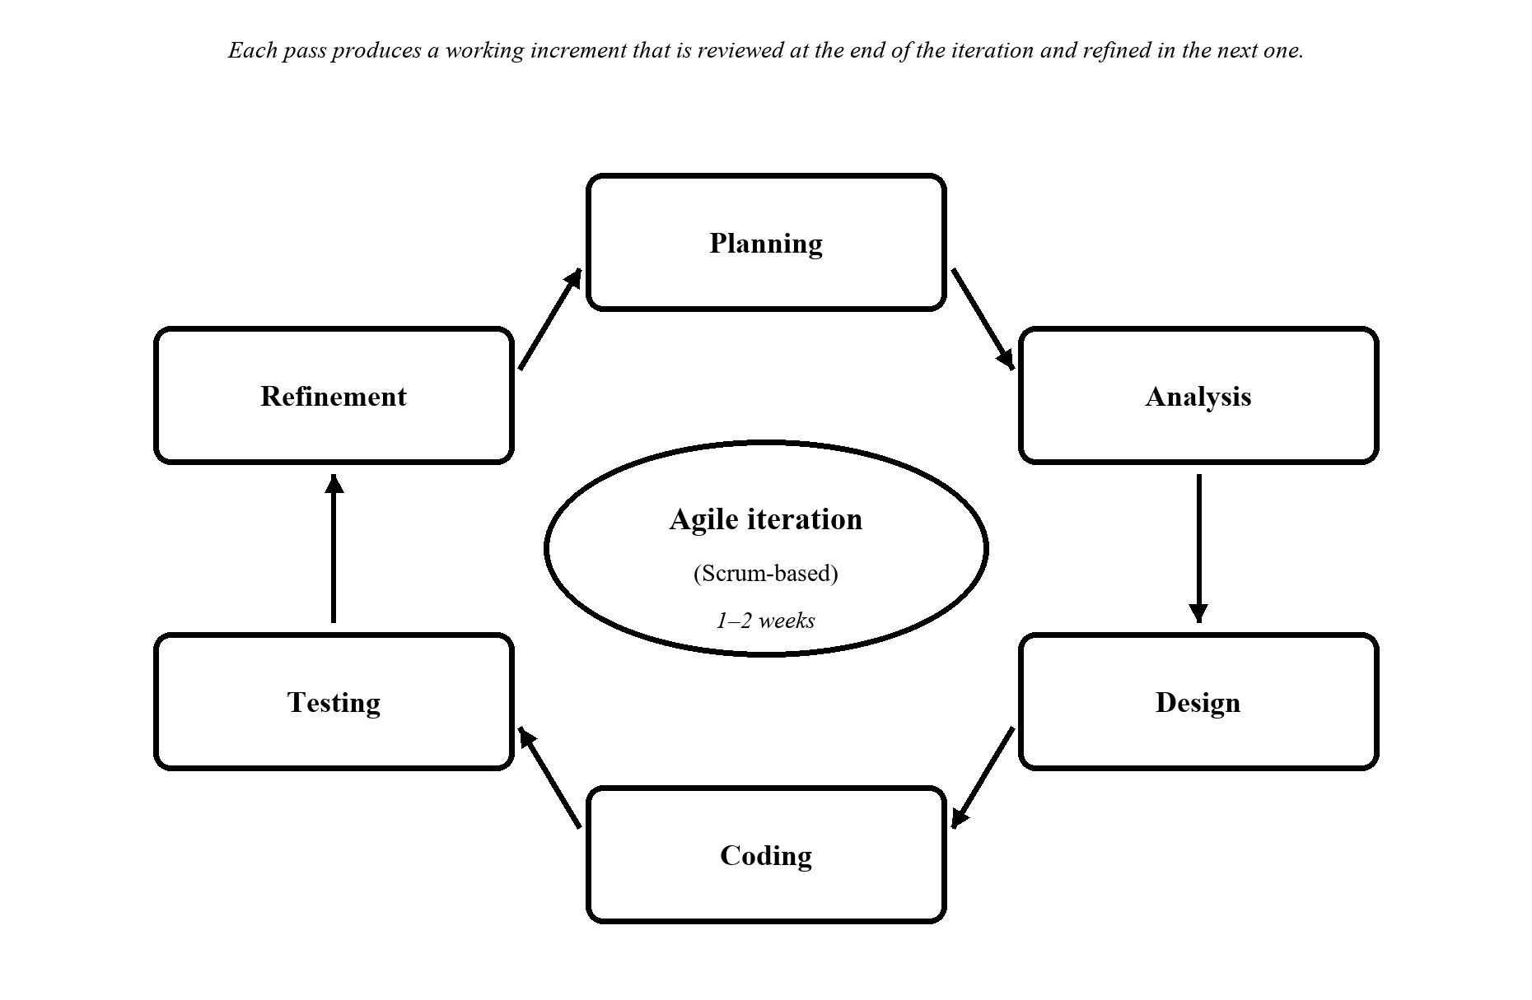
Figure 2. Agile (Scrum-based) iterative-incremental development process.

3.2.1 Planning
At the start of each iteration the researchers define or re-prioritize the work for that iteration. This covers the project scope, target users, functional and non-functional requirements, the database schema, the guest-pass policy, the decision codes, the lockdown rules, and the technology stack, and it involves consultation with campus security personnel and administrators to understand the current entry process and to identify the areas that most need improvement. The requirements selected during planning form the work to be completed in that iteration.

3.2.2 Analysis
Each iteration examines the existing manual entry process, identifies its operational problems — repetitive verification, inconsistency between guards, the absence of a durable record of entry events, and the difficulty of producing any summary of gate activity — analyzes the requirements selected for that iteration, and determines the specifications to be implemented. The analysis also considers lighting, camera position, appearance variation, hardware capability, and privacy requirements, since each of these can invalidate an otherwise correct implementation.

3.2.3 Design
For the requirements selected in an iteration the researchers design the system architecture, the database schema, the user interfaces, the recognition and synchronization flows, and the gate communication protocol. The design is revisited in later iterations as requirements are refined; the deployment topology, entity-relationship diagram, data-flow diagrams, and use-case model presented in Section 3.4 are the result of that repeated refinement.
The architecture separates three layers. The edge layer is the tablet kiosk, which performs face detection, face recognition, guest-pass verification, policy evaluation, detection, decision-making, and local logging, and which holds the student records, embeddings, queued logs, and settings in IndexedDB. The cloud layer is the Supabase project, which provides the PostgreSQL database, authentication, and object storage for student photographs. The web layer consists of the two authenticated applications, the Guard Station and the Administrative Dashboard, which are deployed independently and read and write the same shared data. Figure 3 illustrates this arrangement.
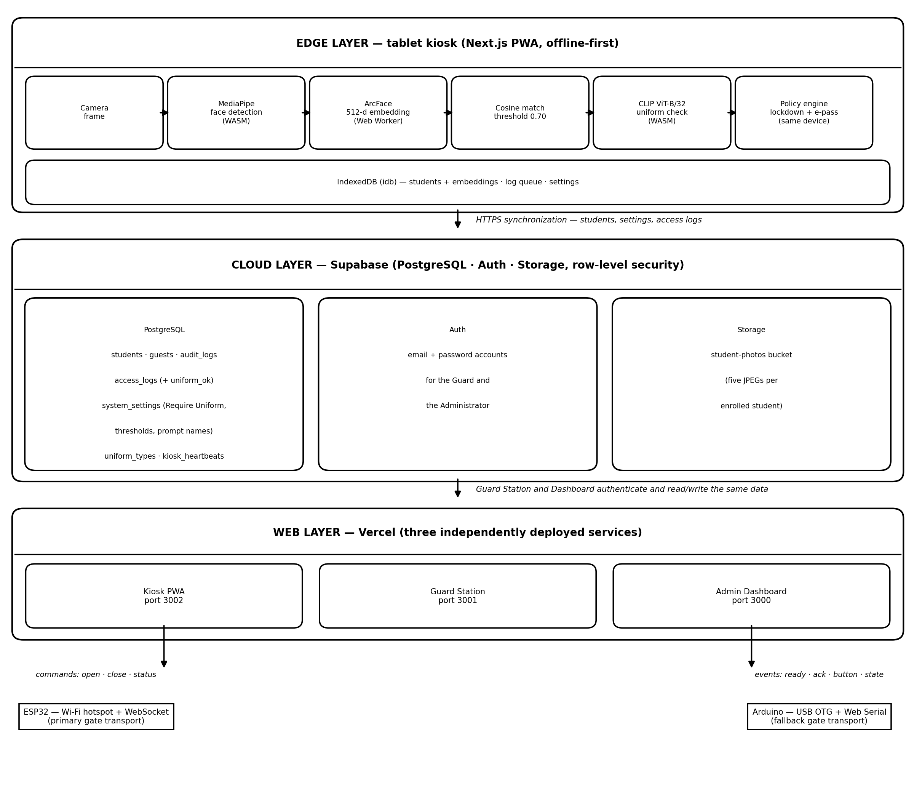
Figure 3. Three-tier edge–cloud–web architecture of the Smart Access Control System.

3.2.4 Coding
Each iteration develops the application code, refines the enrollment workflow and the guest e-pass issuance flow, implements the kiosk interface, and implements communication with the gate controller. The recognition path is implemented as follows: MediaPipe detects a face in the camera frame; the face region is cropped and resized to the 112×112 input expected by ArcFace and normalized; the normalized tensor is sent to a single shared Web Worker that hosts both ONNX sessions; the worker returns a 512-dimensional embedding; and the main thread compares that embedding against every enrolled embedding using cosine similarity, accepting the best match above the configured threshold of 0.70. Each student is represented by five embeddings, generated from the front, left-45-degree, right-45-degree, up, and down enrollment photographs, so that moderate head rotation at the gate does not defeat recognition.
Policy evaluation follows the identity decision. When lockdown is active the kiosk denies every entry with LOCKDOWN_ACTIVE except a manual staff override, which is itself logged. Otherwise a valid guest e-pass records GUEST_PASS_VALID and an expired one records GUEST_EXPIRED with renewal guidance, while a recognized student records POLICY_PASS; an unknown face is denied without opening the gate. When the administrator has enabled the Require Uniform switch, a recognized student is additionally checked: the kiosk crops the torso band and scores it with CLIP, a missing uniform denies with NO_UNIFORM and a non-matching garment denies with WRONG_UNIFORM, both recorded with the uniform verdict cleared, and the denial names only the code, never the garment. If the face or uniform models are unavailable the system fails closed and denies access rather than silently bypassing verification, which keeps the enforcement behavior predictable. Figure 4 presents this complete process as an activity diagram.
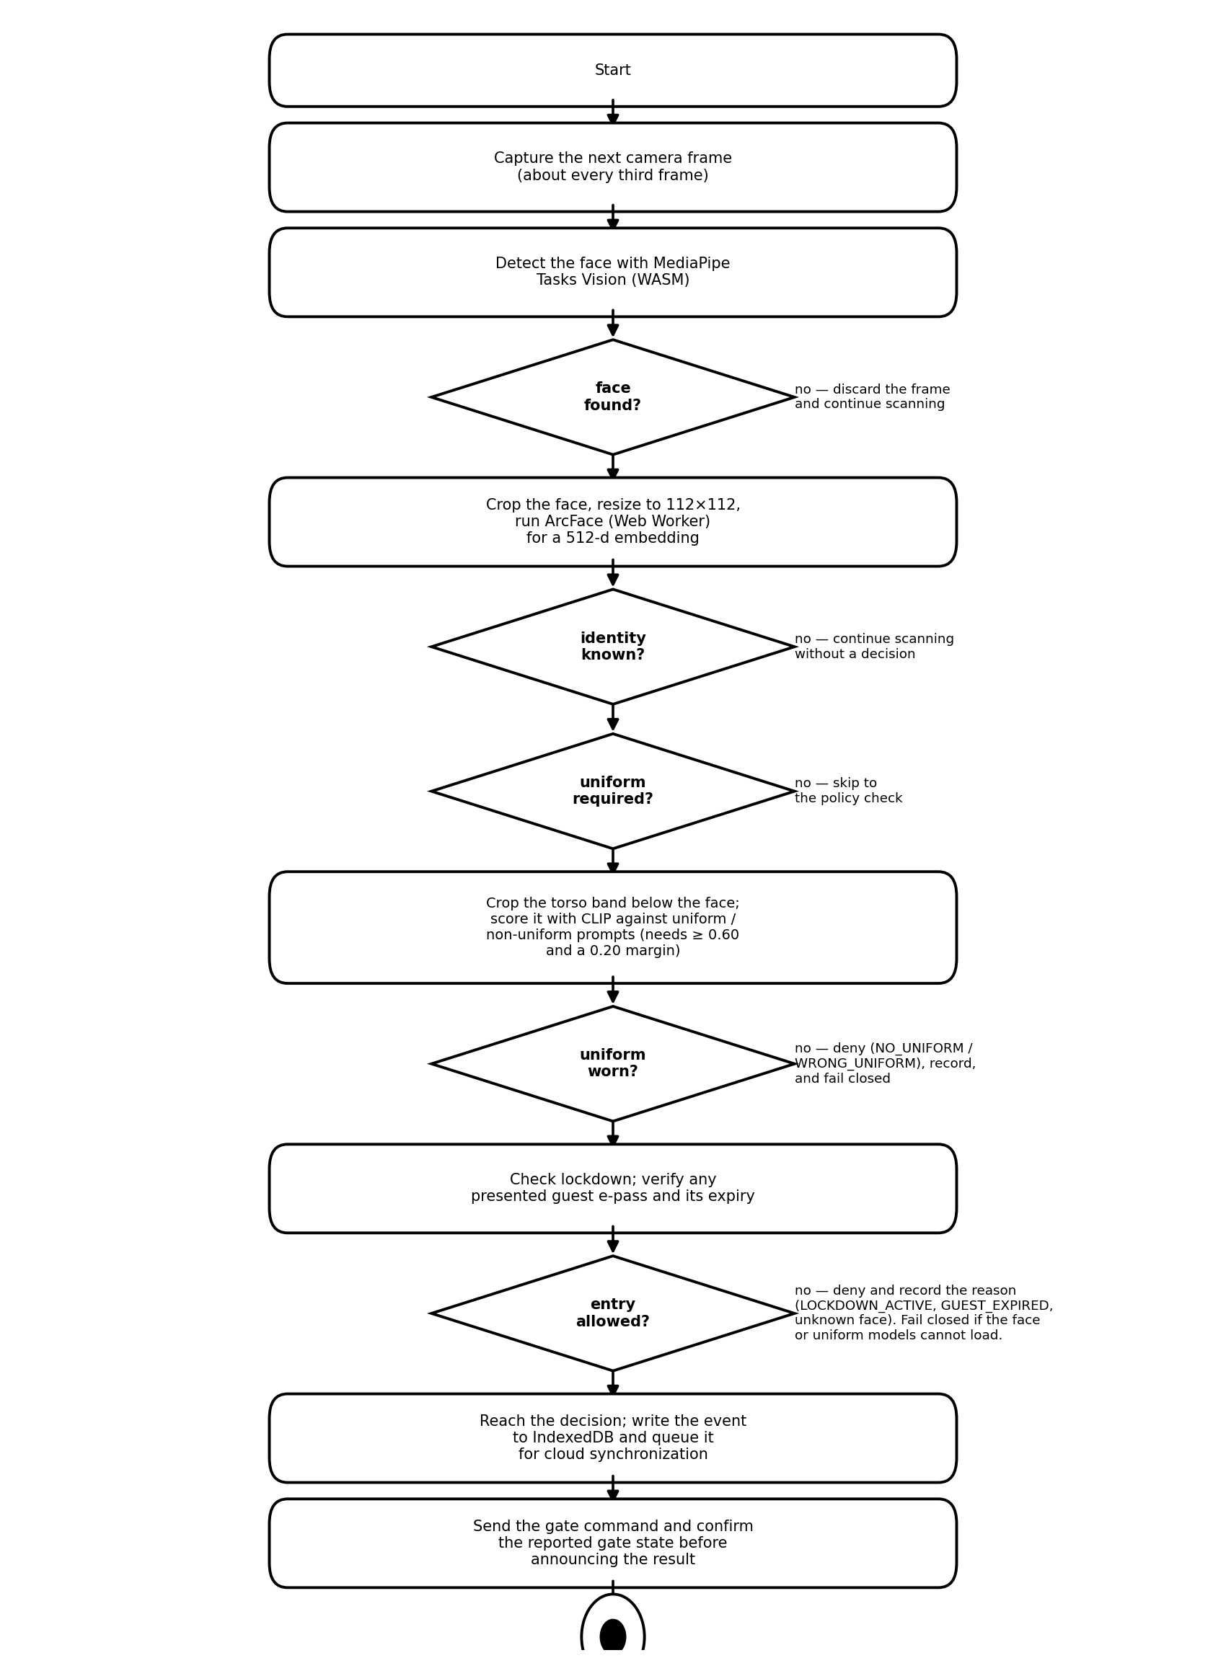
Figure 4. Activity diagram of the on-device recognition, policy evaluation, and access-decision process.
Because the application must remain usable even when the campus network is unavailable, all reads and writes are first performed against IndexedDB. A synchronization routine downloads student records and settings, generates embeddings for newly enrolled students, and uploads queued access logs in batches when connectivity is present. Idempotency keys prevent an interrupted upload from producing duplicate log entries, and a synchronization timeout guards against a stalled request leaving the routine permanently blocked.
Gate control is implemented behind a single transport-independent interface with two transports. The primary transport connects the tablet to an ESP32 over the ESP32's own Wi-Fi hotspot using a WebSocket connection, which requires no campus network and no cable. The fallback transport uses the Web Serial API to reach an Arduino over USB. Both transports use a short command protocol — a character to open, a character to close, a character to request status, and single-character events for ready, acknowledgement, and physical button press — and the controller reports its state so that the kiosk can confirm that the gate physically opened before it announces success.

3.2.5 Testing
Every iteration tests both the individual modules and the integrated system. Unit tests cover the pure decision and policy functions of the kiosk, including the recognition threshold logic, the identity-aware decision-window policy, the presence and re-arm behavior, the gate-state resolution, and the uniform decision rule; the suite currently contains 161 passing tests (146 kiosk and 15 dashboard). Integration testing covers the end-to-end scenario from face detection through gate actuation, as well as the synchronization path between the offline store and the cloud database. The decision policy was validated against a matrix of scenarios — enrolled and unknown faces, uniform and non-uniform dress, valid and expired passes, and active lockdown — and the observed decision codes are reported in Section 3.5.1. Any defect found during testing is returned to the next iteration for correction.

3.2.6 Maintenance/Refinement
Each iteration closes by refining the increment based on its test results, user feedback, and the adviser's recommendations. Refinements in this project have included raising the match threshold from 0.65 to 0.70 so strangers stay unknown, expanding enrollment from three to five guided photo angles, adding a feedback loop so that the kiosk reports the gate's true state rather than assuming the command succeeded, extending the recognition policy so that a new person stepping in front of the camera is decided immediately while a person already recorded is not re-decided within the same visit, and improving error handling and interface clarity. Refined requirements carry into the planning of the next iteration, so the cycle repeats until the requirements are met. Later refinements replaced the single-class garment detector, which could not separate a plain shirt from the uniform, with a zero-shot CLIP check that models non-uniform clothing explicitly, and moved the uniform model load off the boot path so the camera and the face pipeline start without waiting for it.

3.3 Development Environment
The prototype was developed and tested using the components summarized in Table 1.
Table 1
Component | Specification
Application framework | Next.js 16 (App Router) with React 19 and TypeScript
Language / runtime | TypeScript 5 (strict) on Node.js 20+
Monorepo tooling | pnpm 9 workspaces with Turborepo
Face detection | MediaPipe Tasks Vision (BlazeFace, WebAssembly)
Face recognition | ArcFace w600k_mbf, 512-dimensional embeddings, match threshold 0.70
Uniform compliance check | CLIP ViT-B/32 vision encoder (int8 ONNX, ~89 MB) against precomputed uniform/non-uniform prompts; grant needs P(uniform) ≥ 0.60 with a 0.20 margin; Require Uniform toggle; NO_UNIFORM / WRONG_UNIFORM codes
Guest e-pass | Guard-issued QR credential with expiry; kiosk codes GUEST_PASS_VALID / GUEST_EXPIRED
Policy engine | Lockdown switch with LOCKDOWN_ACTIVE deny-all except logged manual override; POLICY_PASS grants
AI assistance | Gemini daily incident briefing plus AI assistant chat on the dashboard
Voice announcements | Offline Piper neural TTS prompts shipped as MP3 (welcome, denied, override)
Inference runtime | ONNX Runtime Web in a shared Web Worker (WebGPU → WebGL → WASM)
Cloud database and auth | Supabase (PostgreSQL, Auth, Storage) with row-level security
Offline storage | IndexedDB via the idb library
Gate controller | ESP32 (Wi-Fi WebSocket, primary) or Arduino (USB Web Serial, fallback)
Gate mechanism | Servo motor with a physical override button and status LED
Styling | Tailwind CSS
Testing | Vitest (159 unit tests: 144 kiosk + 15 dashboard) with a GitHub Actions continuous-integration pipeline
Deployment | Vercel (three independently deployed services)
Client device | Android tablet with Chrome, camera, and USB-OTG support

3.4 User Design

3.4.1 Design Specification
The design specification defines the required behavior of the prototype. The system shall capture a student image, attempt identification, check uniform compliance when the requirement is enabled, verify any presented guest e-pass, evaluate the active policy including lockdown, combine the results into a coded access decision, display the decision, record the event, and send the corresponding control signal to the gate controller when the required conditions are satisfied. The system shall operate without a network connection for recognition and logging, and it shall support a human override mechanism for exceptional or emergency situations through both the guard interface and the physical button on the controller.
The Kiosk supports the following use cases: enrolling a student's identity data and five photographs, scanning a face at the gate, checking uniform compliance when required, verifying a guest e-pass, enforcing lockdown, granting access and opening the gate, denying access and recording the reason, performing a manual override, synchronizing data with the cloud, and monitoring system health through the operator panel. The Guard and the Administrator interact with the system through the Guard Station and the Administrative Dashboard respectively. Figure 5 presents the use-case model for those actors.
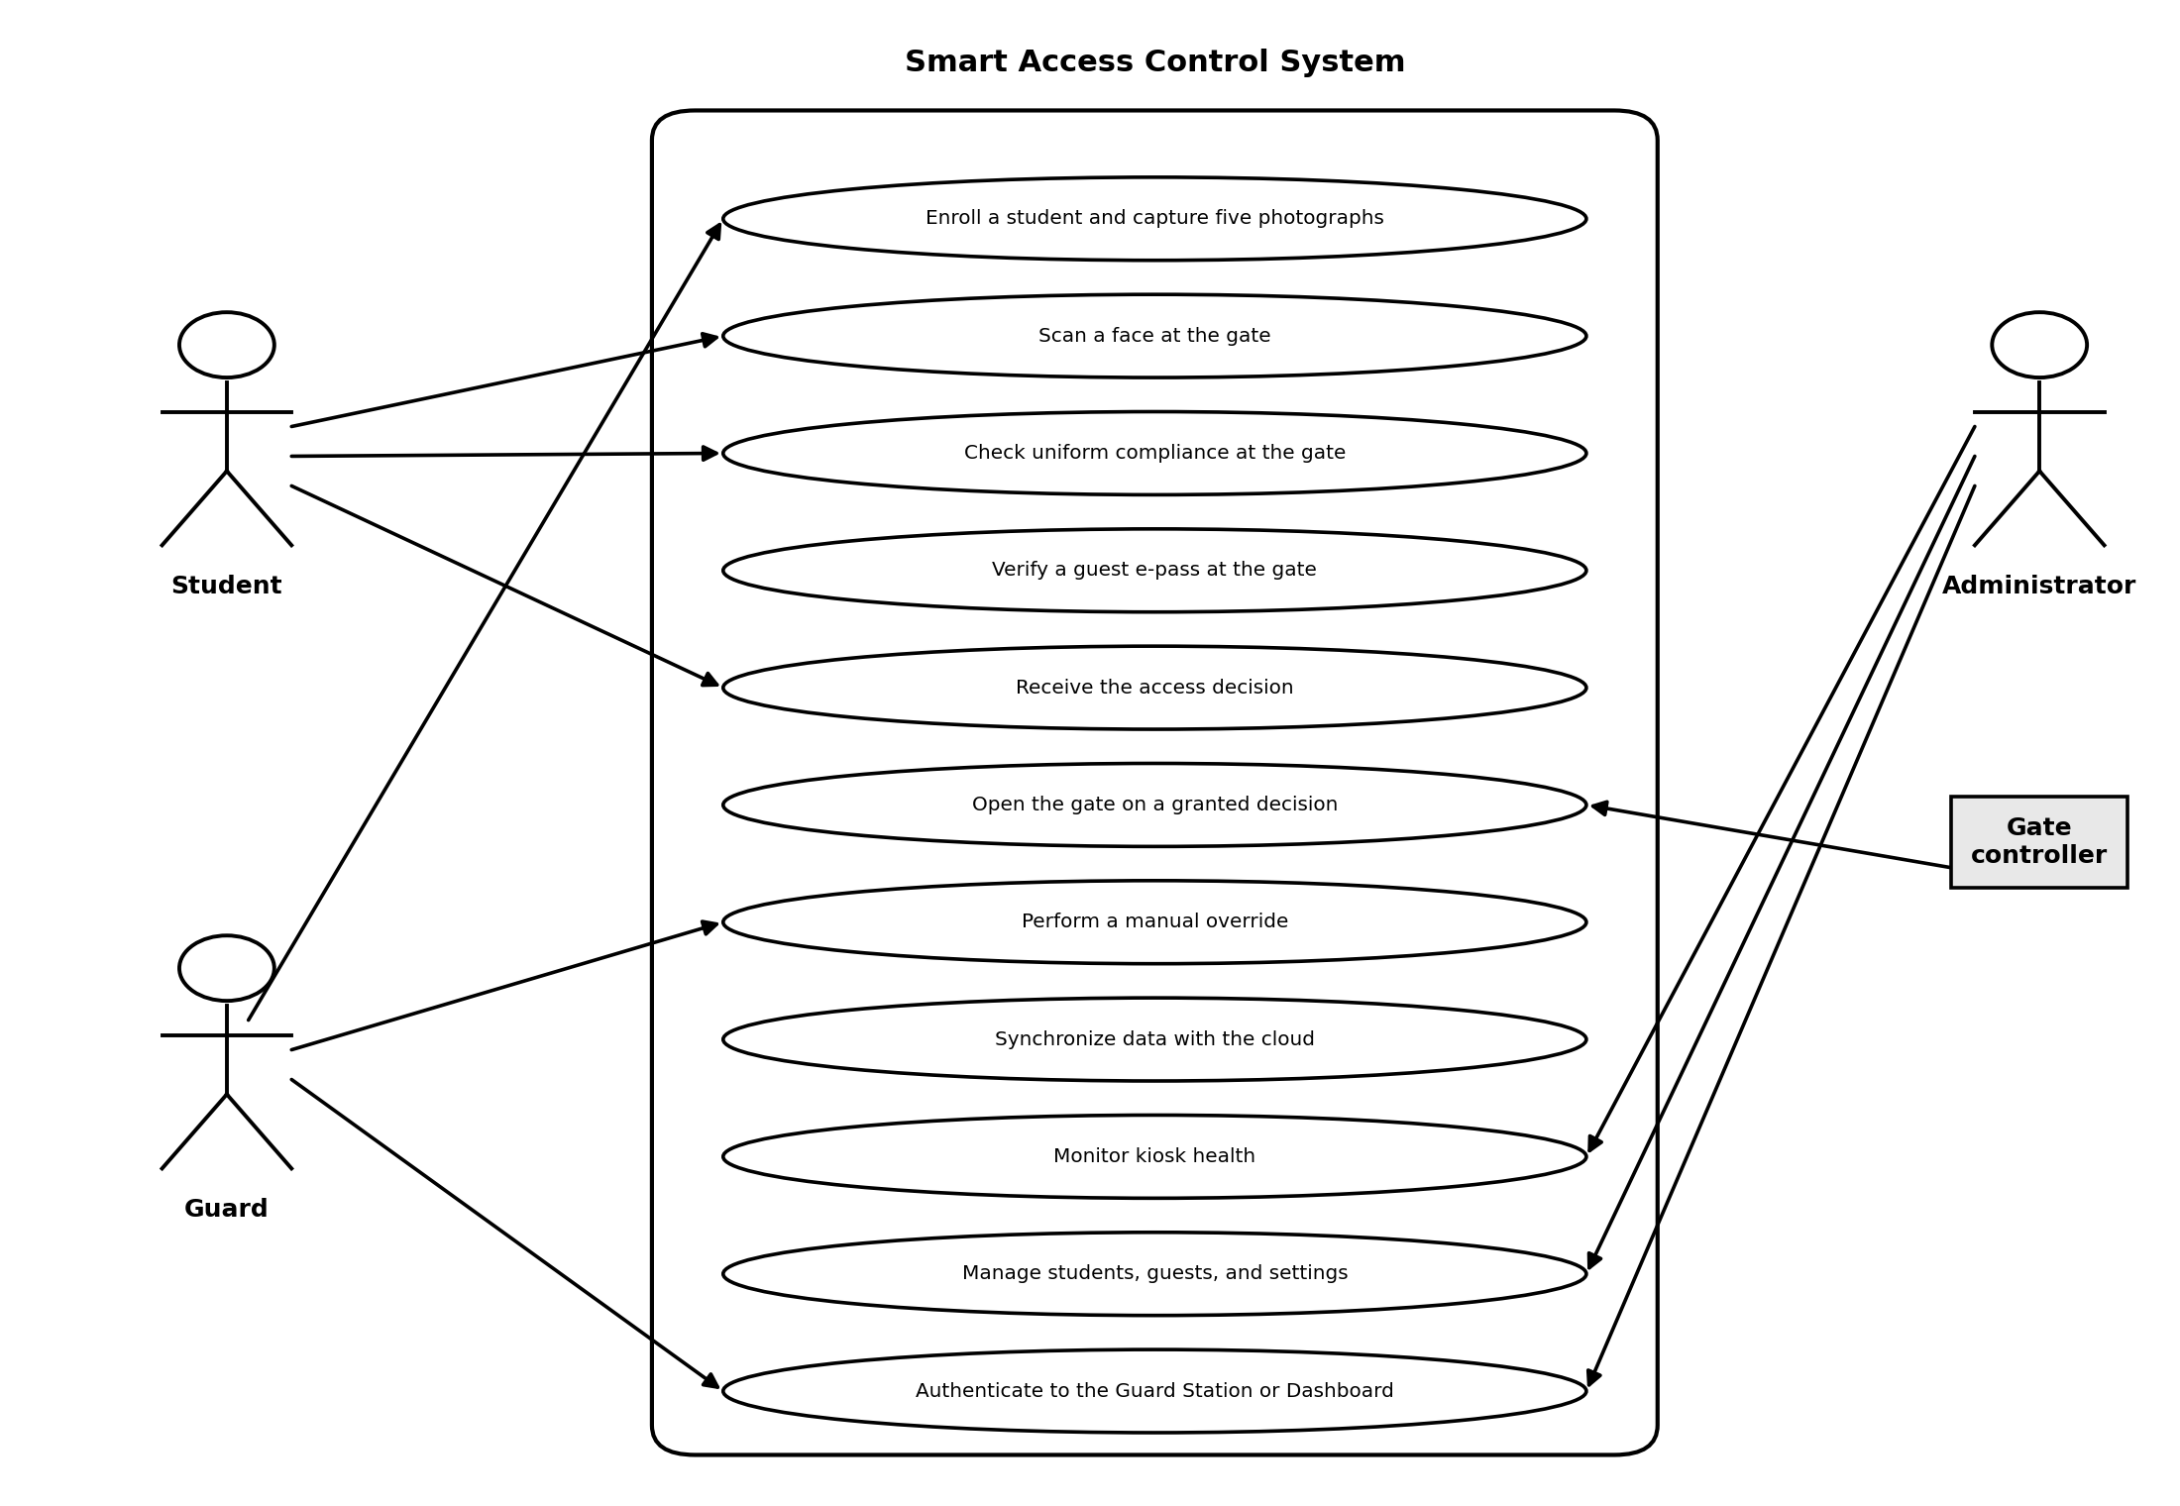
Figure 5. Use case diagram of the Smart Access Control System.
The logical data model is shown in Figure 6. The students table holds the enrollment information and the references to the stored photographs. The access_logs table holds one row per access attempt, including the person, the method used, the outcome, the measured confidence, the uniform verdict (uniform_ok), the decision code, the reported gate state, and the failure reason where applicable. The guests table holds the guard-issued visitor credentials with their expiries, and the system_settings table stores the operational parameters, including the recognition threshold, the Require Uniform switch with the recognition and uniform thresholds, the lockdown switch with its reason, the gate open duration, and the synchronization interval. The audit_logs table records administrative actions, the kiosk_heartbeats table records the periodic health reports sent by the kiosk, and the uniform_types table holds the display names for the uniform check.
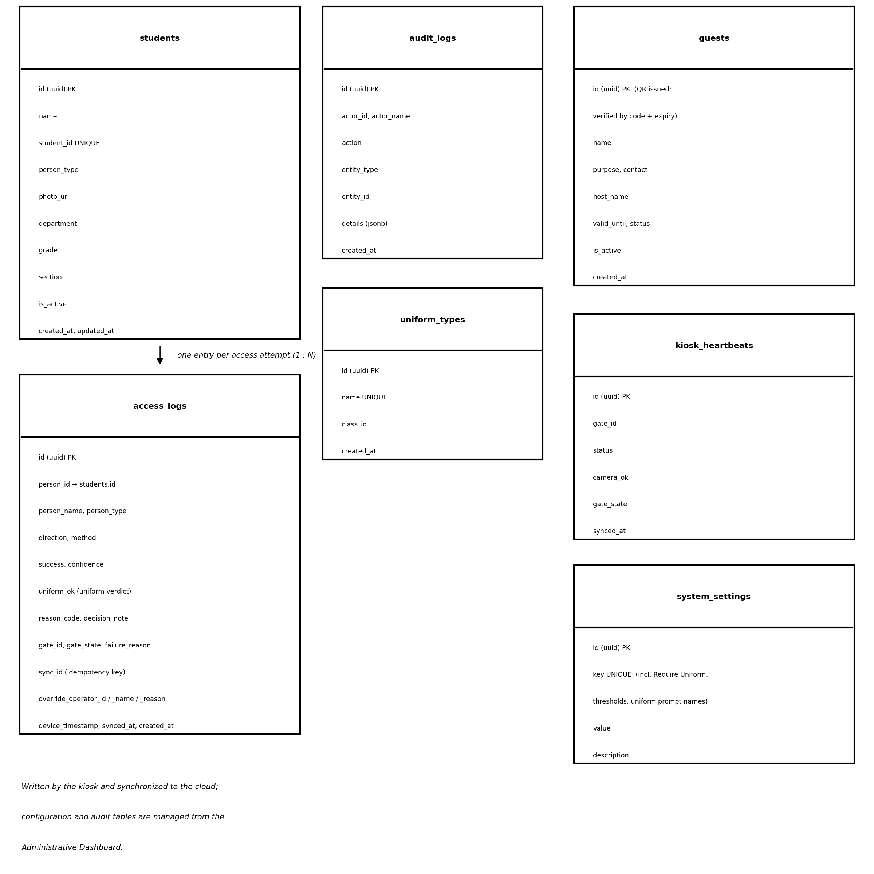
Figure 6. Entity-relationship diagram of the Smart Access Control System database schema.
Figure 7 presents the data flow at two levels. The level-0 context diagram treats the system as a single process exchanging data with four external entities: the student, the guard, the administrator, and the gate controller. The level-1 diagram decomposes the system into the processes that capture an image, identify the person, verify the uniform against the uniform prompts, verify the guest pass, evaluate policy, decide the outcome, log the event, and synchronize with the cloud.
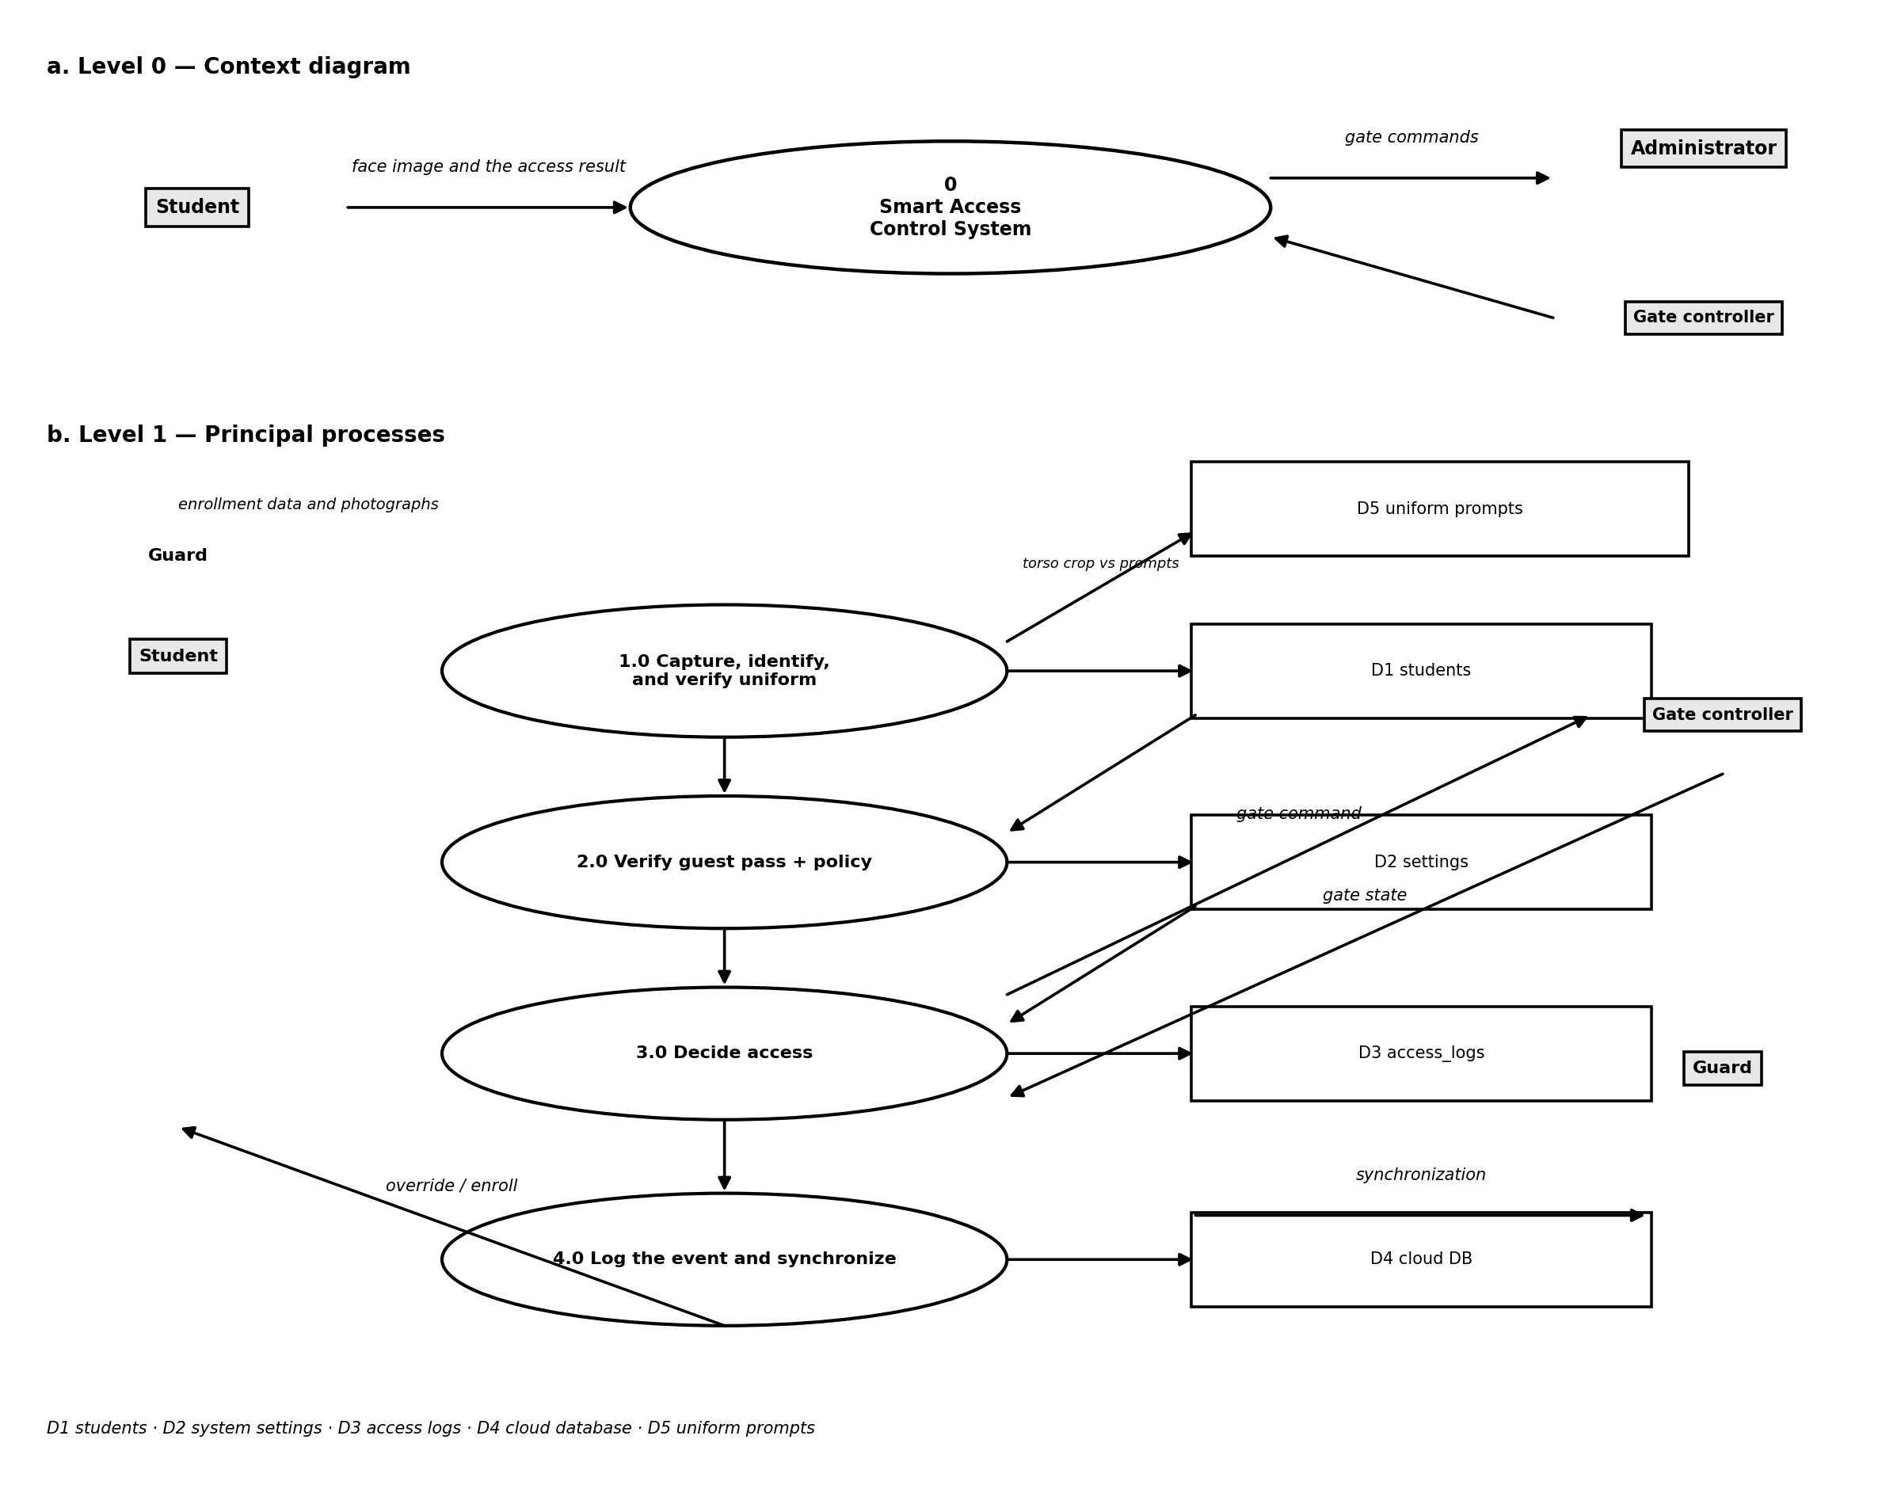
Figure 7. Level 0 context and Level 1 data flow diagrams of the Smart Access Control System.

3.4.2 User Interfaces
The kiosk interface is designed to be understood at a glance by a student who is walking past it. It opens on a tap-to-start screen that unlocks the camera permission and the audio channel, then displays the live camera view with a single framing guide at a time — an oval until a face is identified, then a torso rectangle while the uniform is read — plus a compact indicator showing the current stage of the pipeline. The result is presented as a large, unambiguous card: a grant card, held for five seconds and stating the uniform result alongside the name, accompanied by an offline Piper voice announcement when access is permitted, and a denial card stating the reason when access is refused. In keeping with the privacy decision described in Section 2.3, the live overlay carries only detector telemetry and never a student's identity; the matched student's own name, short identifier, department, and match percentage appear only on the decision card, after the decision, so that the person at the gate can confirm that they were recognised.
All diagnostics and configuration are moved behind a discreet gear icon that opens the operator panel. The panel reports the inference rate, the model-loading state, the synchronization state, and the gate state, including the Require Uniform enforcement toggle, and it provides the controls for forcing a synchronization, binding the gate, toggling voice announcements and the uniform requirement, and restarting the application. The Guard Station presents a single form with the student's name, student number, department, year level, and section, followed by five guided capture slots for the front, left-45-degree, right-45-degree, up, and down photographs, and it lists the most recent enrollments for immediate verification. The Administrative Dashboard presents a summary of the number of enrolled students, the number of access events recorded today, the success rate, and the single-kiosk health report, together with a table of recent access events, a dedicated page for reviewing and filtering the complete access log, and an AI daily incident briefing with an AI assistant. Figures 8 to 14 present the principal interfaces.
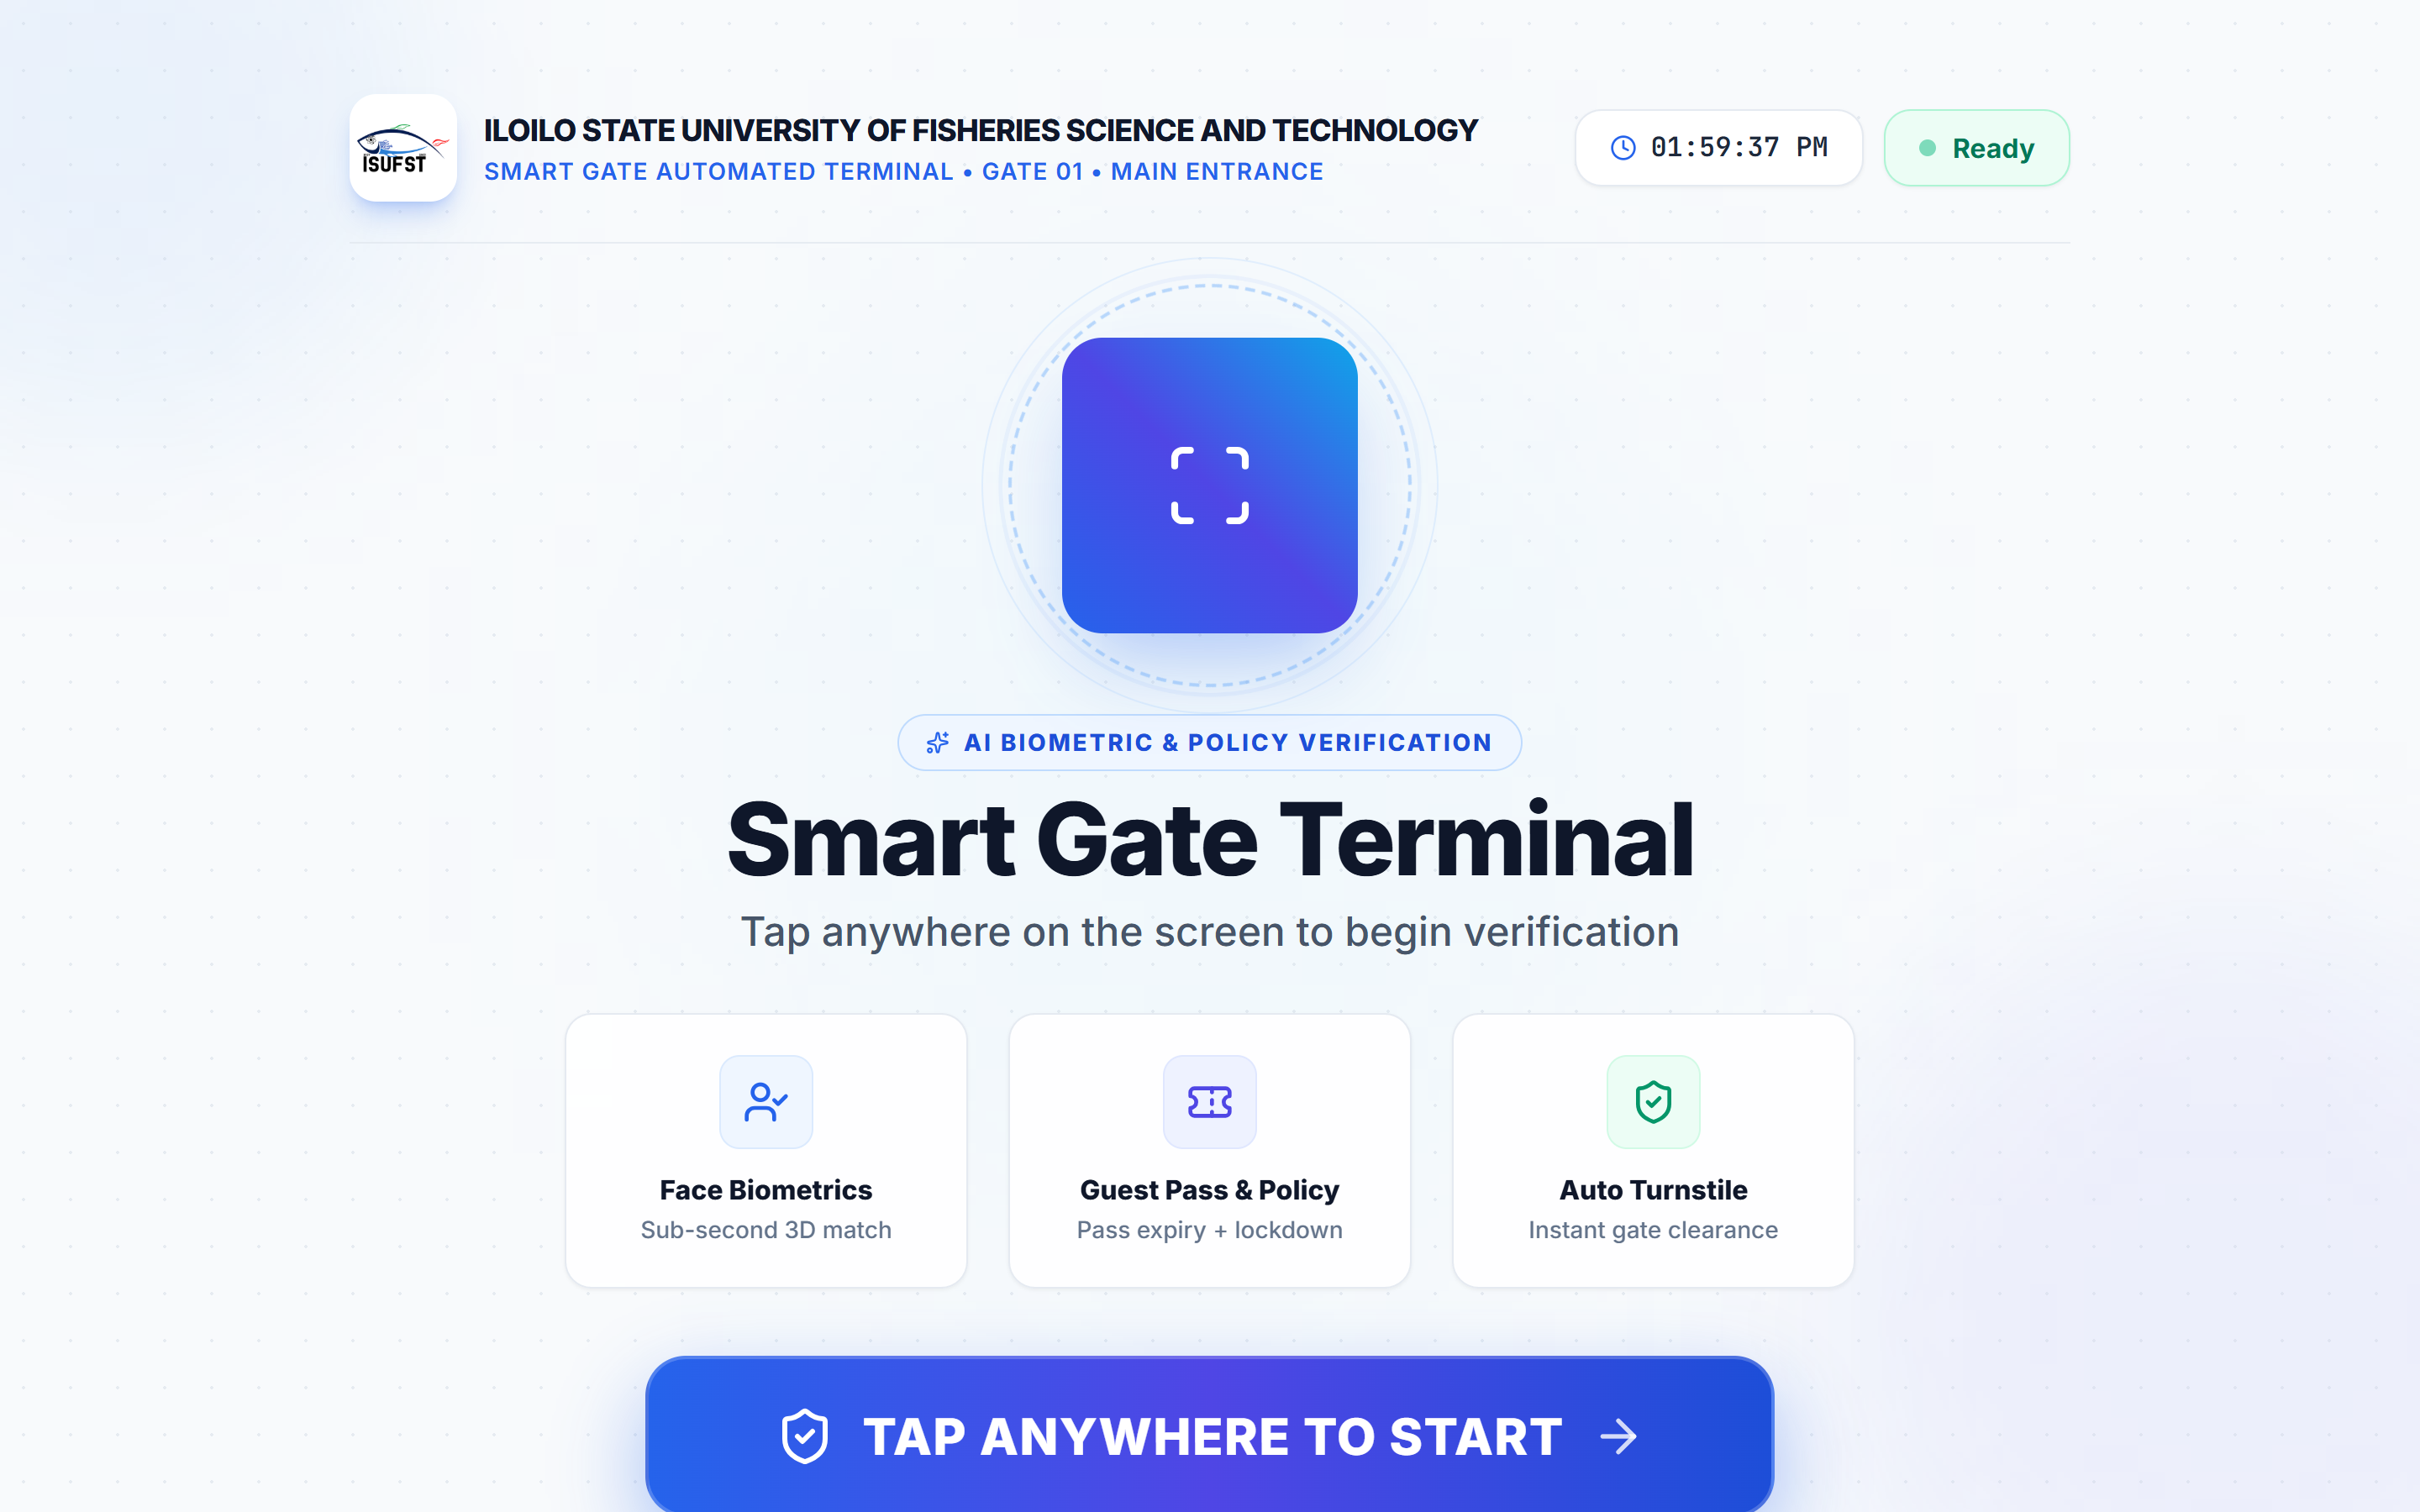
Figure 8. Kiosk tap-to-start screen, which is shown before the camera permission and the audio channel are unlocked.
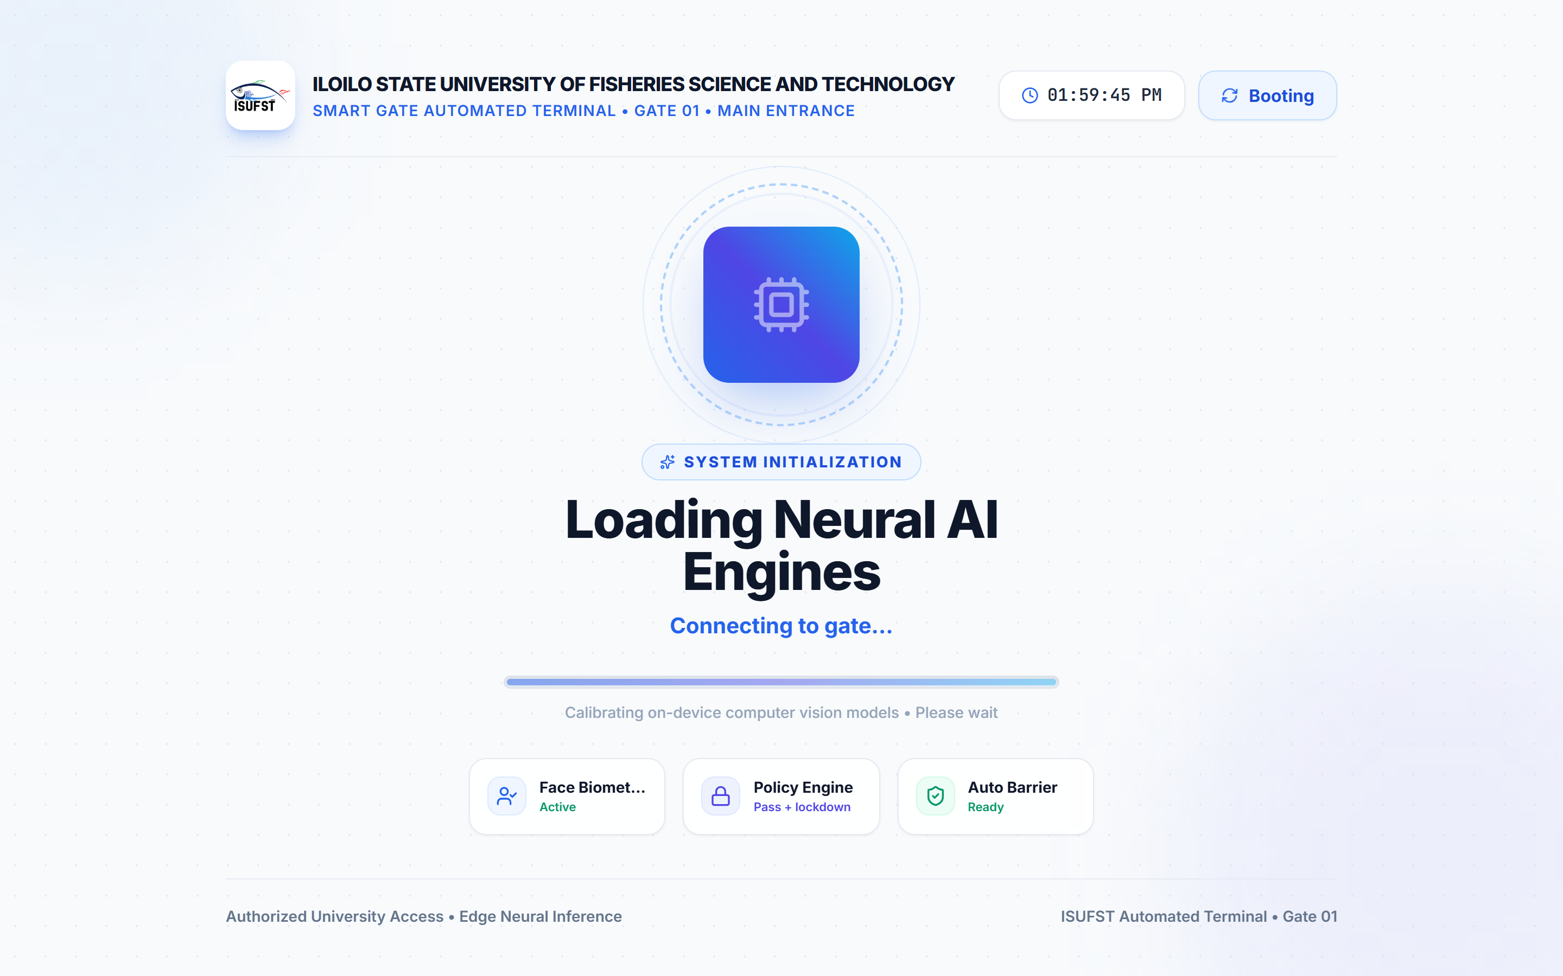
Figure 9. Kiosk initialization screen while the face-detection and face-recognition models are loaded and cached on the device.
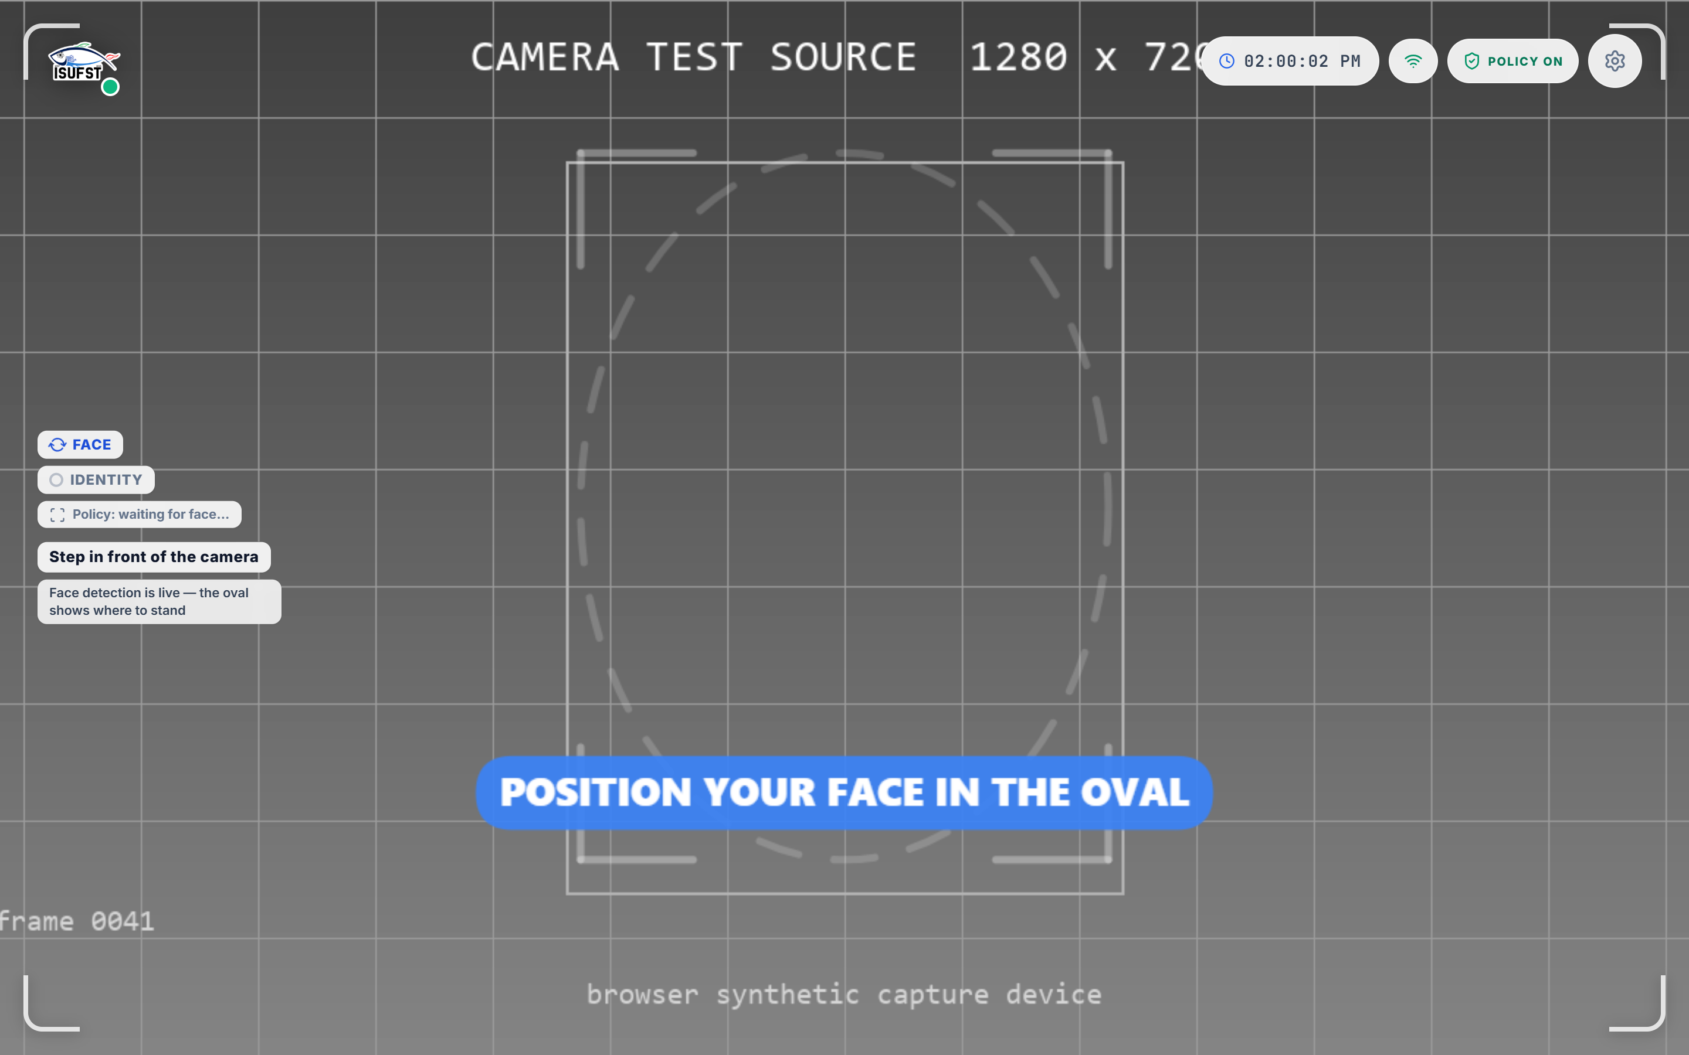
Figure 10. Kiosk verification screen showing the live camera view, the face reticle, the on-screen pipeline indicator, and the current instruction to the person at the gate. The camera input in this capture is the browser's synthetic test source.
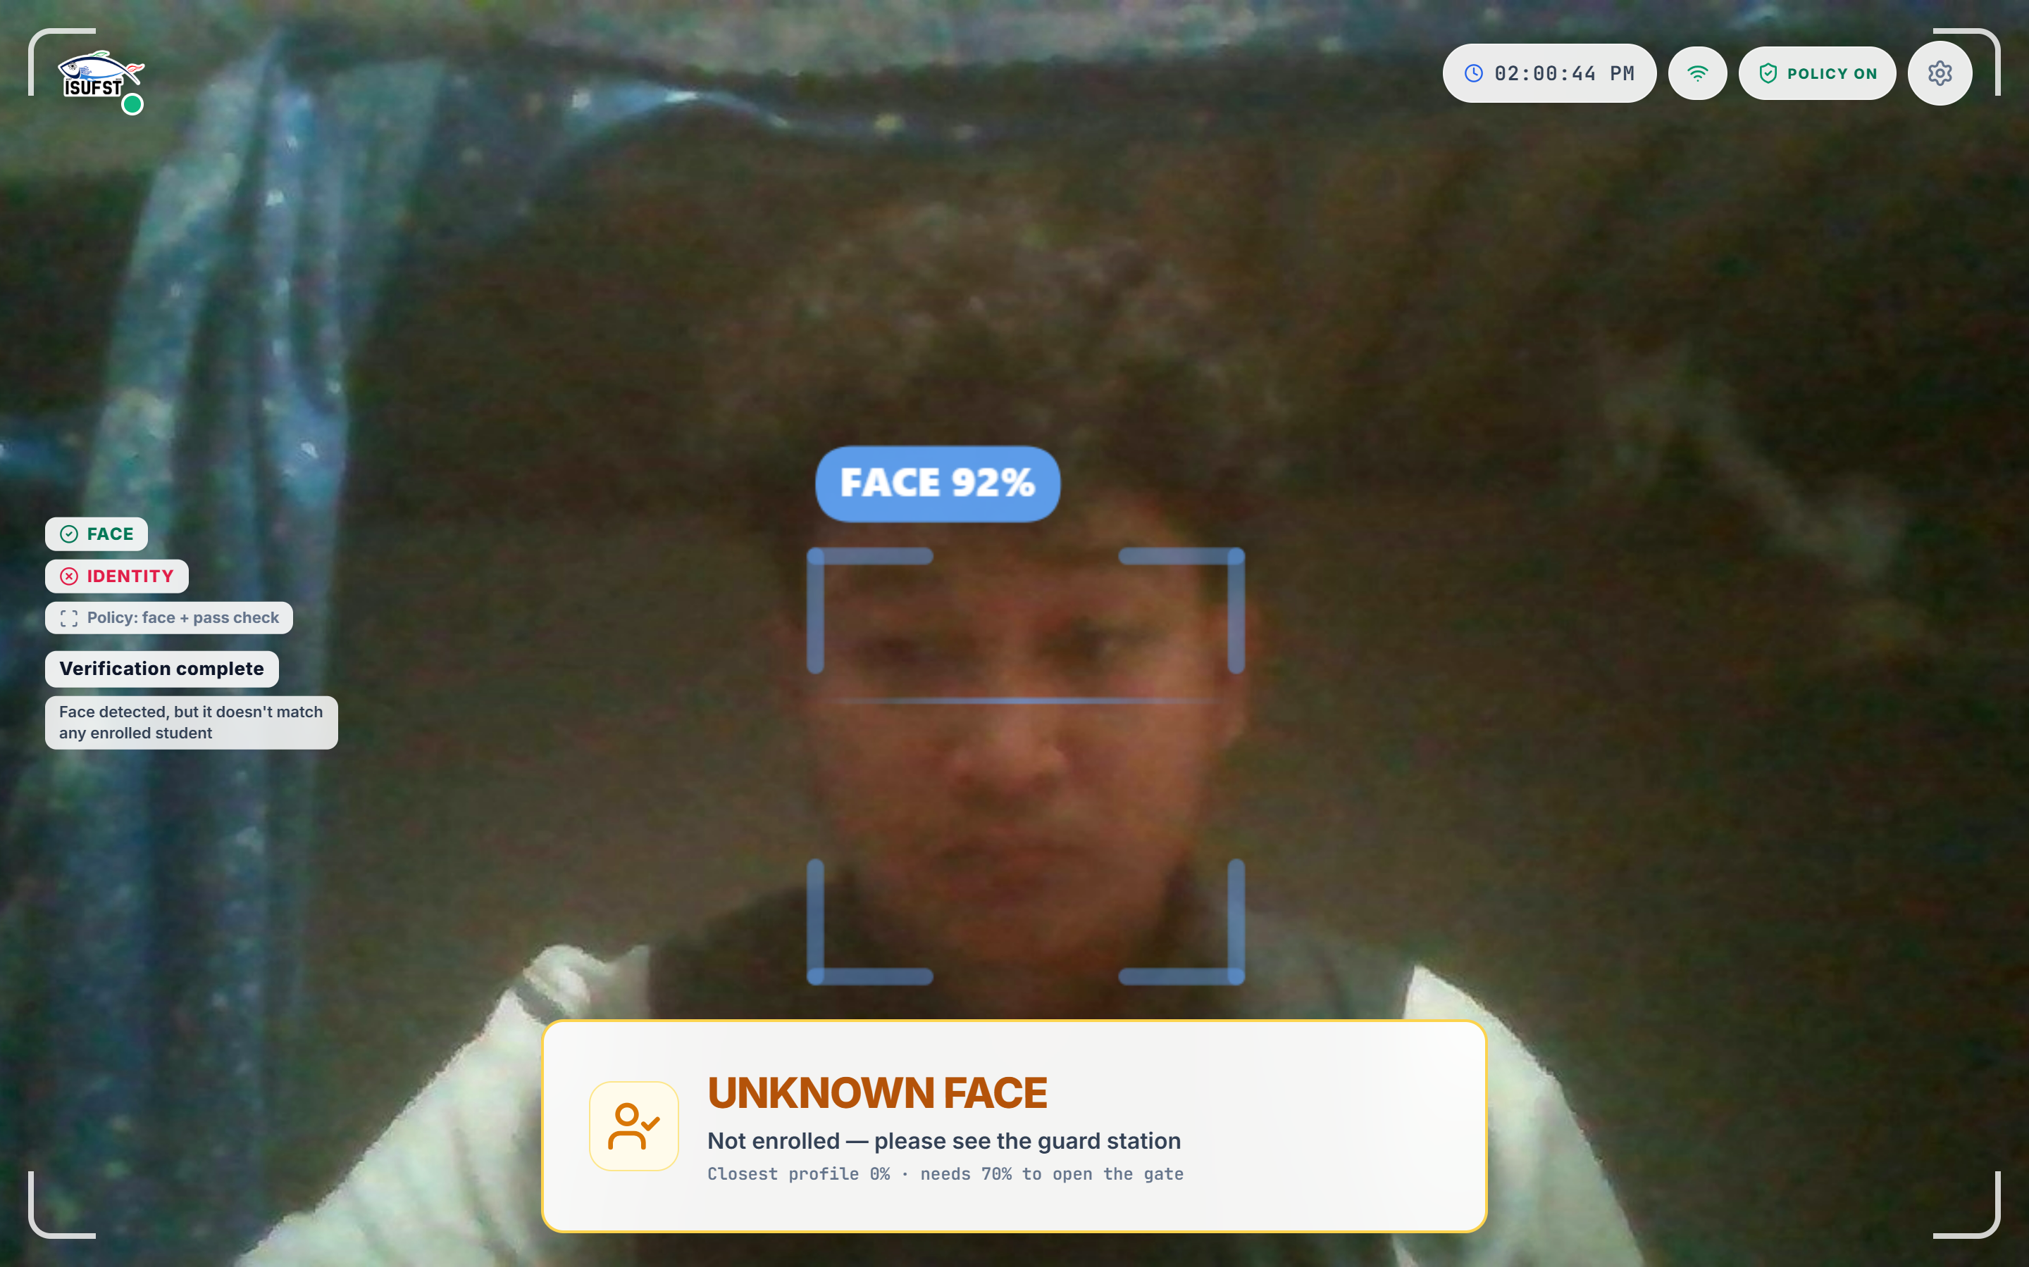
Figure 11. Kiosk access-decision card from a live run on the running system: the presented face was detected (FACE 92 per cent) but matched no enrolled profile (closest 0 per cent), so the terminal shows UNKNOWN FACE, denies entry, and refers the visitor to the guard station. The camera input is a still photograph supplied to the browser as a synthetic camera source.
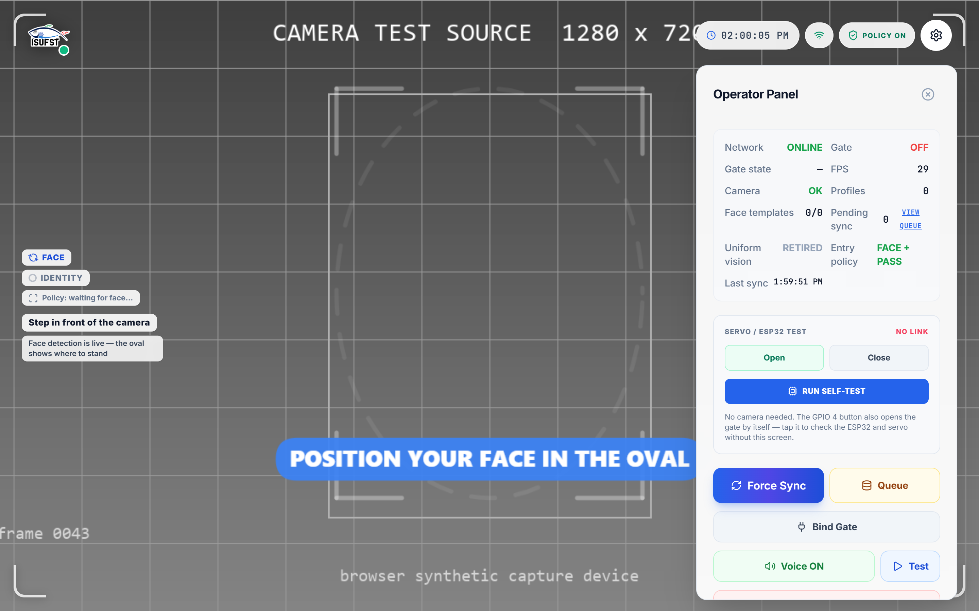
Figure 12. Kiosk operator panel showing live diagnostics: network state, gate state, inference rate, loaded profiles, pending synchronization, the offline queue, and the voice state; the current panel additionally carries the Require Uniform enforcement toggle.
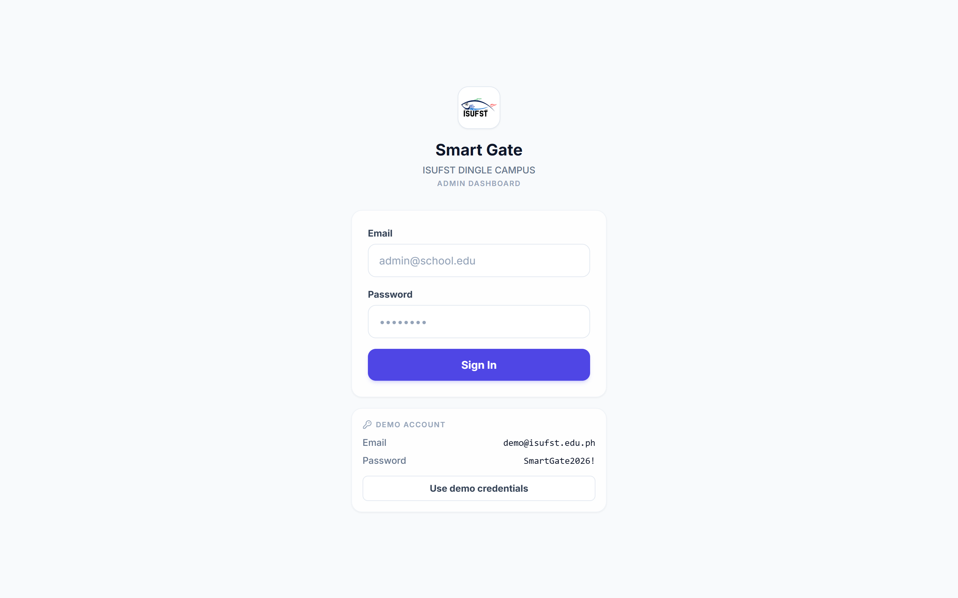
Figure 13. Administrative Dashboard sign-in page.
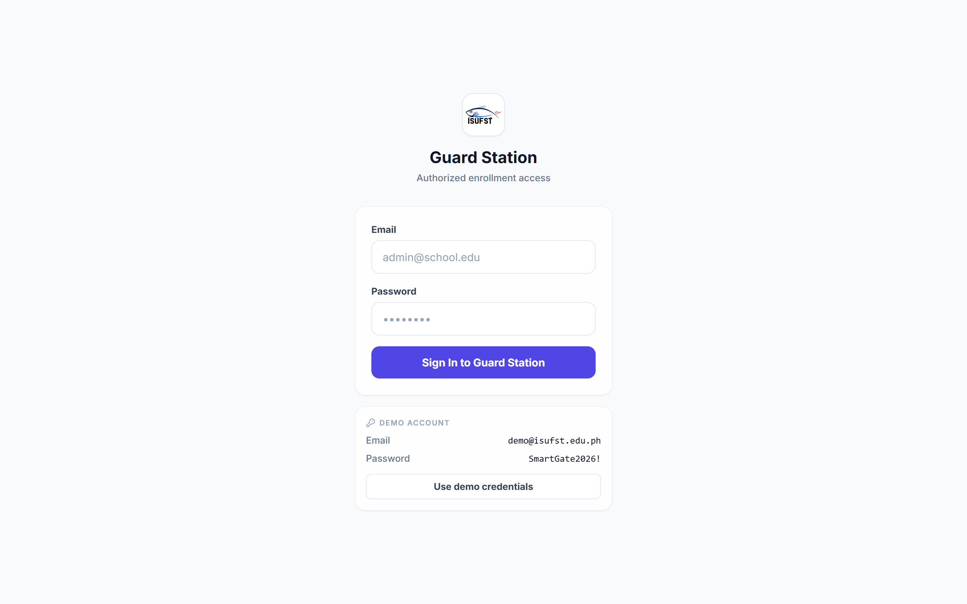
Figure 14. Guard Station sign-in page; the enrollment form becomes available to an authenticated guard.

3.5 Evaluation

3.5.1 System Evaluation
The system will undergo functional, performance, reliability, security, and user-acceptance evaluation. ISO/IEC 25010:2023 serves as the primary product-quality reference (ISO, 2023), and the characteristics selected for this prototype are functional suitability, performance efficiency, reliability, security, and interaction capability, with the remainder considered only to the extent that the prototype allows.
Functional suitability is assessed against the required functions: enrollment, face detection, face recognition, uniform compliance checking, guest e-pass verification, lockdown enforcement, access decision, gate actuation, offline operation, voice announcement, AI briefing generation, and synchronization. Performance efficiency is assessed through the inference latency of each stage of the pipeline and the total time from the detection of a face to the display of a decision. Reliability is assessed through repeated operation, operation with the network disconnected, and recovery from an interrupted synchronization. Security is assessed through the row-level security policies of the cloud database, the restriction of the enrollment and administrative functions to authenticated users, and the privacy-preserving behavior of the public gate screen. Interaction capability is assessed through the clarity and speed of the gate interface and the enrollment interface, and a supplementary user-acceptance measure records perceived ease of use, clarity, and acceptability among students and security personnel.
No model training is performed in this study: recognition reuses the published ArcFace weights deployed as ONNX and uniform checking reuses the published CLIP vision encoder deployed as ONNX, and the unit suite of 161 tests (146 kiosk, 15 dashboard, all passing) covers the threshold logic, the decision-window policy, the presence and re-arm behavior, the gate-state resolution, the uniform decision rule, and the attendance-date logic. The access policy itself is validated against a scenario matrix — enrolled and unknown faces, uniform and non-uniform dress, valid and expired guest passes, and active lockdown — with each scenario required to produce its specified decision code (POLICY_PASS, GUEST_PASS_VALID, GUEST_EXPIRED, LOCKDOWN_ACTIVE, NO_UNIFORM, WRONG_UNIFORM) and its specified gate behavior before the increment is accepted.
Testing includes unit testing of the individual components, integration testing of end-to-end scenarios, performance testing of the recognition pipeline, robustness testing under different lighting and camera conditions, and user-acceptance testing with students and security personnel. No accuracy figure is claimed for the face-recognition component of the deployed system until end-to-end testing with the enrolled population has been completed, since the accuracy of a recognition model on a public benchmark does not describe its behavior on this campus, with these cameras, and with this enrolled population.
Table 2 lists the performance targets used during the development of the recognition pipeline and the figures observed on the target tablet during development.
Table 2
Pipeline stage | Target | Observed during development
Face detection | under 10 ms per frame | approximately 5 ms (MediaPipe WASM)
Face recognition | under 100 ms | approximately 30–50 ms (ArcFace on WebGPU)
Policy evaluation | under 50 ms | approximately 5–10 ms (in-memory rules)
End-to-end decision | under 500 ms | approximately 200–300 ms
Model cold start | under 10 s | approximately 3–5 s (first model download)
Enrollment embeddings | 5 per student | 5 per student (front, left 45°, right 45°, up, down)
Uniform check (CLIP) | under 500 ms per check | a few hundred milliseconds per check on the development machine; on-tablet timing is part of the evaluation

3.5.2 Statistical Data Treatment
Data collected from the system evaluation questionnaire will be summarized using frequency, percentage, and weighted mean. For Likert-scale items, the weighted mean will be computed using the formula WM = Σ(fx) / N, where f is the frequency of responses for each scale point, x is the numerical value assigned to the scale point, and N is the total number of valid responses.
A five-point scale may be interpreted as follows: 4.21–5.00 = Very High/Excellent; 3.41–4.20 = High/Very Satisfactory; 2.61–3.40 = Moderate/Satisfactory; 1.81–2.60 = Low/Unsatisfactory; and 1.00–1.80 = Very Low/Very Unsatisfactory. The final verbal interpretation will be retained only if it is approved by the research adviser or follows the institution's required scale.
For technical performance, objective measures such as recognition accuracy, precision, recall, F1-score, detection and inference time, and gate-response time will be reported where applicable. These measures will be computed from actual test results rather than assumed or borrowed from published studies, because the performance reported for a general model does not represent the performance of the locally trained model.

REFERENCES
Arduino. (2024). Arduino documentation. https://docs.arduino.cc/
Bazarevsky, V., Kartynnik, Y., Vakunov, A., Raveendran, K., & Grundmann, M. (2019). BlazeFace: Sub-millisecond neural face detection on mobile GPUs. arXiv. https://arxiv.org/abs/1907.05047
Berkovich, I. (2025). The rise of AI-assisted instructional leadership: Empirical survey of generative AI integration in school leadership and management work. Frontiers in Education, 10, 1643023. https://doi.org/10.3389/feduc.2025.1643023
Dela Peña, L. V. C., Pineda, D., Miranda, V. J., Anito, Y. D. D., Ramones, R. E., Manuel, M. A., Gapasin, M. R., Salinas, R. N., Billedo, M., Dapiawen, K. J., et al. (2025). Visitors' information system of Saint Mary's University (VISSMU). Psychology and Education: A Multidisciplinary Journal, 35(6), 627-637. https://www.ejournals.ph/article.php?id=32825
Deng, J., Guo, J., Xue, N., & Zafeiriou, S. (2019). ArcFace: Additive angular margin loss for deep face recognition. Proceedings of the IEEE/CVF Conference on Computer Vision and Pattern Recognition (CVPR), 4690–4699. https://arxiv.org/abs/1801.07698
Do, T. K. D., Huynh, N. T., Le, N. T., & Le, T. T. (2024). Optimizing the student attendance system using facial recognition technology. The University of Phan Thiet Journal of Science, 2(4), 40–51. https://tapchikhoahocupt.vn/index.php/uptjs/article/view/28
Google. (2024). MediaPipe Solutions: Face detector. Google AI for Developers. https://developers.google.com/edge/mediapipe/solutions/vision/face_detector
Hendrawan, J., Perwitasari, I. D., & Maulana, F. (2025). QR code-based attendance systems in education: A systematic literature review on data accuracy and sustainable school management. Proceedings of the International Conference on Computer Science, Engineering, Social Science, and Multi-Disciplinary Studies, 1, 80–87. https://doi.org/10.64803/cessmuds.v1.14
Jin, Y., Yang, K., Yan, L., Echeverria, V., Zhao, L., Alfredo, R., Milesi, M., Fan, J. X., Li, X., Gašević, D., & Martinez-Maldonado, R. (2025). Chatting with a learning analytics dashboard: The role of generative AI literacy on learner interaction with conventional and scaffolding chatbots. In Proceedings of the 15th International Learning Analytics and Knowledge Conference (pp. 579–590). Association for Computing Machinery. https://doi.org/10.1145/3706468.3706545
International Organization for Standardization. (2015). ISO/IEC 2382:2015 Information technology — Vocabulary. https://www.iso.org/standard/63598.html
International Organization for Standardization. (2019). ISO 9241-210:2019 Ergonomics of human-system interaction — Part 210: Human-centred design for interactive systems. https://www.iso.org/standard/77520.html
International Organization for Standardization. (2023). ISO/IEC 25010:2023 Systems and software engineering — Systems and software Quality Requirements and Evaluation (SQuaRE) — Product quality model. https://www.iso.org/standard/78176.html
Kirtikar, A. (2025, June 30). New Gemini tools for students and educators. Google. https://blog.google/products-and-platforms/products/education/gemini-iste-2025/
Li, Z., Dong, Y., Shen, L., Liu, Y., Pei, Y., Yang, H., Zheng, L., & Ma, J. (2024). Development and challenges of object detection: A survey. Neurocomputing, 598, 128102. https://doi.org/10.1016/j.neucom.2024.128102
Microsoft. (2024). ONNX Runtime: Web. ONNX Runtime documentation. https://onnxruntime.ai/docs/tutorials/web/
Mozilla. (2024). IndexedDB API and Web Serial API. MDN Web Docs. https://developer.mozilla.org/en-US/docs/Web/API/IndexedDB_API
Nath, N. D., Behzadan, A. H., & Paal, S. G. (2020). Deep learning for site safety: Real-time detection of personal protective equipment. Automation in Construction, 112, 103085. https://doi.org/10.1016/j.autcon.2020.103085
Ng, G. C. (2018). A study of an agile methodology with Scrum approach to the Filipino company-sponsored I.T. capstone program. International Journal of Computing Sciences Research, 2(2), 68–88. https://doi.org/10.25147/ijcsr.2017.001.1.25
National Institute of Standards and Technology. (2023). Artificial intelligence risk management framework (AI RMF 1.0) (NIST AI 100-1). https://doi.org/10.6028/NIST.AI.100-1
National Institute of Standards and Technology. (2024). Face Technology Evaluations (FRTE/FATE). https://www.nist.gov/programs-projects/face-technology-evaluations-frtefate
OHF-Voice. (2025). piper1-gpl: Fast and local neural text-to-speech engine [Computer software]. GitHub. https://github.com/OHF-Voice/piper1-gpl
ONNX. (2024). ONNX: Open standard for machine learning interoperability. https://onnx.ai/
openHAB Foundation. (n.d.). Piper text-to-speech. openHAB documentation. https://www.openhab.org/addons/voice/pipertts/
Pertiwi, A. G. R., Sabariah, M. K., & Adrian, M. (2024). Penjaminan mutu perangkat lunak pada project Aplikasi Manajemen Informasi Fakultas Industri Kreatif (MI-FIK) di Universitas Telkom berdasarkan ISO 25010. LOGIC: Jurnal Penelitian Informatika, 2(1), 32–39. https://doi.org/10.25124/logic.v2i1.7420
Radford, A., Kim, J. W., Hallacy, C., Ramesh, A., Goh, G., Agarwal, S., Sastry, G., Askell, A., Mishkin, P., Clark, J., Krueger, G., & Sutskever, I. (2021). Learning transferable visual models from natural language supervision. In Proceedings of the 38th International Conference on Machine Learning (Proceedings of Machine Learning Research, Vol. 139, pp. 8748–8763). PMLR. https://arxiv.org/abs/2103.00020
Rojas, H., Renteria, R., Duran, V. M., Gutiérrez, Y. T., Cabrera, M. J. I., & Aminuddin, A. (2025). Mapping the evolution and future directions of ISO/IEC 25010: A bibliometric and thematic analysis. Engineering, Technology & Applied Science Research, 15(5), 27530–27541. https://doi.org/10.48084/etasr.11772
Schwaber, K., & Sutherland, J. (2020). The Scrum Guide: The definitive guide to Scrum: The rules of the game. Scrum.org & Scrum Inc. https://scrumguides.org/docs/scrumguide/v2020/2020-Scrum-Guide-US.pdf
Shi, W., Cao, J., Zhang, Q., Li, Y., & Xu, L. (2016). Edge computing: Vision and challenges. IEEE Internet of Things Journal, 3(5), 637–646. https://doi.org/10.1109/JIOT.2016.2579198
Sirigiri, K., Narra, A., & Sirumalla, A. (2023). Offline-first PWA: Case study on efficient data handling and synchronization. International Journal of Scientific Research in Computer Science, Engineering and Information Technology, 9(3), 747–754. https://doi.org/10.32628/CSEIT25112782
Sommerville, I. (2016). Software engineering (10th ed.). Pearson Education.
Suethanuwong, E., & Sukkasame, S. (2023). An access control system using RFID and face verification with QR code-based enrollment. Information Technology Journal KMUTNB. https://ph01.tci-thaijo.org/index.php/IT_Journal/article/view/251104
Supabase. (2024). Supabase documentation. https://supabase.com/docs
Thai, H.-D., Seo, Y.-S., & Huh, J.-H. (2024). Enhanced efficiency in SMEs attendance monitoring: Low cost artificial intelligence facial recognition mobile application. IEEE Access, 12, 184257–184274. https://doi.org/10.1109/ACCESS.2024.3504858
Woubie, A., Solomon, E., & Attieh, J. (2024). Maintaining privacy in face recognition using federated learning method. IEEE Access, 12, 39603–39613. https://doi.org/10.1109/ACCESS.2024.3373691

