**Oracle 10g User Administration**

**Create User Syntax**:

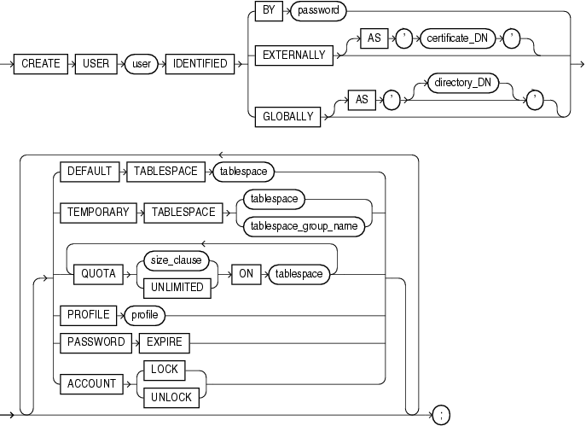

**CREATE USER *username***

**IDENTIFIED {BY *password* | EXTERNALLY | GLOBALLY AS '*external_name*'}**

***options*;**

***options*:**

**DEFAULT TABLESPACE *tablespace***

**TEMPORARY TABLESPACE *tablespace***

**QUOTA *int* {K | M} ON *tablespace***

**QUOTA UNLIMITED ON *tablespace***

[**PROFILE**](http://ss64.com/ora/profile_c.html) ***profile_name***

**PASSWORD EXPIRE**

**ACCOUNT {LOCK|UNLOCK}**

IDENTIFIED Clause   
The IDENTIFIED clause lets you indicate how Oracle Database authenticates the user.

BY password clause: lets you creates a local user and indicates that the user must specify password to log on to the database.

EXTERNALLY Clause:  specify EXTERNALLY to create an external user. Such a user must be authenticated by an external service, such as an operating system or a third-party service.

GLOBALLY Clause : lets you create a global user. Such a user must be authorized by the enterprise directory service (Oracle Internet Directory)  
  
DEFAULT TABLESPACE Clause : specify the default tablespace for objects that the user creates. If you omit this clause, then the user's objects are stored in the database default tablespace. If no default tablespace has been specified for the database, then the user's objects are stored in the SYSTEM tablespace.

TEMPORARY TABLESPACE Clause : specify the tablespace or tablespace group for the user's temporary segments. If you omit this clause, then the user's temporary segments are stored in the database default temporary tablespace or, if none has been specified, in the SYSTEM tablespace.

QUOTA Clause : specify the maximum amount of space the user can allocate in the tablespace.

PROFILE Clause : specify the profile you want to assign to the user. The profile limits the amount of database resources the user can use. If you omit this clause, then Oracle Database assigns the DEFAULT profile to the user.

PASSWORD EXPIRE Clause : specify PASSWORD EXPIRE if you want the user's password to expire. This setting forces the user or the DBA to change the password before the user can log in to the database.

ACCOUNT Clause : specify ACCOUNT LOCK to lock the user's account and disable access. Specify ACCOUNT UNLOCK to unlock the user's account and enable access to the account.

Profile example

* Drop Profile stud_prof;
* CREATE PROFILE Stud_PROF LIMIT
* SESSIONS_PER_USER UNLIMITED
* CPU_PER_SESSION UNLIMITED ***(you can set a limit. Oracle will calculate how much the resources used by the user)***
* CPU_PER_CALL 3000 ***(30 seconds)(***
* CONNECT_TIME 120 ***(measured in minutes)***
* LOGICAL_READS_PER_SESSION DEFAULT
* LOGICAL_READS_PER_CALL 1000
* PRIVATE_SGA 15K ***(15 kilo bytes of mem is allocated for each user)***
* COMPOSITE_LIMIT 5000000
* FAILED_LOGIN_ATTEMPTS 5***(all the above lines are related to resources)***
* PASSWORD_LIFE_TIME 100
* PASSWORD_REUSE_TIME 30
* PASSWORD_REUSE_MAX 3 ***(pwd should be changed 3 times before reusing the password)***
* PASSWORD_LOCK_TIME 1
* PASSWORD_GRACE_TIME 3
* PASSWORD_VERIFY_FUNCTION Ex_pwd_verify; ***(ude dd_pwd_fun in our project 3 in place of Ex_pwd_verify)***

You can skip the PASSWORD_VERIFY_FUNCTION Ex_pwd_verify; clause for our project while creating profile and create user accounts as we assign default passwords and add later by using the following command:

* *Alter profile Develop_prof Limit Password_verify_function dd_pwd_fun;*
* *Alter user <username> Password Expire.*

***SGA – System Global Area***

***COMPOSITE_LIMIT (checks whether the sum of weights allocated to these exceeds its value) CPU_PER_CALL, CONNECT_TIME, LOGICAL_READS_PER_CALL, PRIVATE_SGA.***

***By default composite_limit is not imposed i.e. all four will be zero to know these default values we will use the following command:*** *select * from resource_cost;*

***To alter these values u need to use following command:***

*alter resource cost*

*cpu_per_session 100*

*connect_time 1;*

***By default resource_limit will be false later we can alter it to true.***

*show parameter Resource_limit;*

*alter system set Resource_limit = true;*

**Password Verification Function Example**

CREATE OR REPLACE FUNCTION Ex_pwd_verify (P_userid varchar2, P_password varchar2, P_old_password varchar2)

RETURN BOOLEAN IS  
PWD_STR VARCHAR2(255);

BEGIN  
PWD_STR := UPPER(P_password);  
IF LENGTH(PWD_STR) < 8 THEN   
 RETURN FALSE;   
END IF;  
FOR i IN 1..LENGTH(PWD_STR) LOOP   
 IF INSTR('~!@#$%^&*', SUBSTR(PWD_STR, i,1)) > 0 THEN   
 RETURN TRUE;   
 END IF;   
END LOOP;  
RETURN FALSE;   
END;  
/

User Administration example ***(we should create our own table space for project 3)***

CREATE TABLESPACE MSIA643_ts   
DATAFILE 'tbs_IA643.dat' SIZE 500K  
AUTOEXTEND ON NEXT 500K MAXSIZE 100M***(max size100MB)***;

Create USER MyUser IDENTIFIED BY hispwd  
DEFAULT TABLESPACE MSIA643_ts  
QUOTA 10M ON MSIA643_ts  
TEMPORARY TABLESPACE TEMP  
PROFILE STUD_PROF  
PASSWORD EXPIRE  
ACCOUNT UNLOCK;  
GRANT CONNECT, RESOURCE TO MYUSER; ***(connect and resource are database roles)***

***Location of .dat file in vm***

*C:\oracle\product\10.2.0\db_2\database*

*How to add a profile to user?*

*How to remove profile to a user ?*

*ANS: Just set profile to DEFAULT*

*How to findout which profile he or she has?*

*Select username, profile from dba_users where username = ‘<username>’;*

*In single quotes and whwre clause, use upper case letters*

*How to change resource limit?*

*Alter profile <profile name> limit*

*<resource name like private_sga> <value>;*

*How to remove pwd verification function?*

*Alter profile <profile name> limit*

*<password verification fun> NULL;*

*How to find all the resource limits in a profile?*

*Select * from dba_profiles where profile = ‘<profile name>’;*

*How to find all profiles defined?*

*Select distinct profile from dba_profiles;*