Q1.

Yes. Iomega is a peripheral device used on this hard drive

Iomega is the brand name.

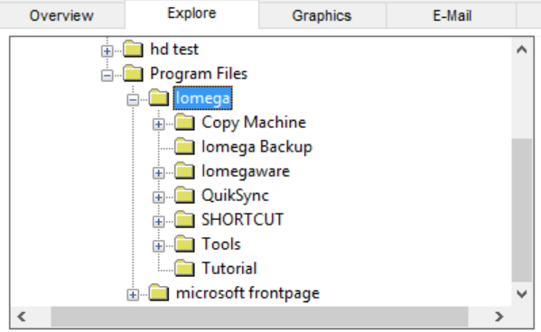

Q2.

|  |  |  |
| --- | --- | --- |
| Search Items | Hits | Files |
| Omega | 6 | 2 |
| Lemon | 4 | 2 |
| Classroom | 0 | 0 |
| Speed | 15 | 4 |
| Mississippi | 0 | 0 |
| Registration | 41 | 4 |
| Virus | 759 | 100 |
| Car | 7 | 5 |

Q3.

Yes there are 2 bad extensions and 24 bad extension files.

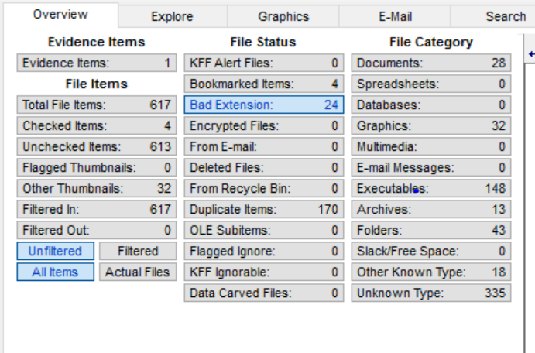

Q4

There are 4 jpg images

Q5.

There are no deleted files, we can tell this from the overview.

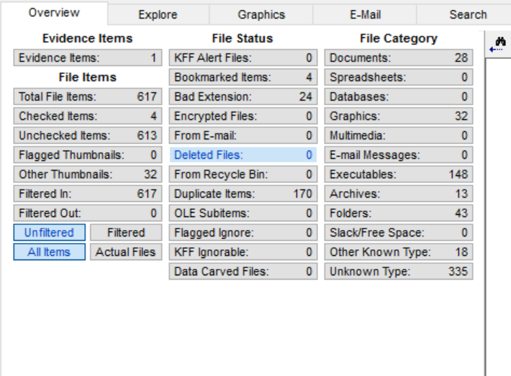

Q6.

MD5, SHA1

Yes, there are more than one algorithms.