First thing, get all the indicators in yellow. They are free, but you will need trading view premium to run this many.

[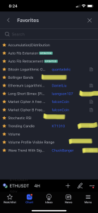](https://cdn.discordapp.com/attachments/944872098969559091/944939093320695818/image.png)

1. You need higher leverage to scalp, I recommend sticking to bitcoin while you learn it and playing with 20$ until you get the hang. For the leverage you need to think 1% price drops are your stop. So at 50x your stop is 50%

I like 25x

And most of my plays are between 25x and 50x. Start low and learn.

You also need to think 1% for getting out

So at 25x you close at 25%

1. This is the hardest part
2. [5:55 PM]

Everyone gets greedy and ignores this part

1. My entries are on the 5m and 1m combined
2. [5:56 PM]

I’m looking at both

1. Yep. I caught this trade late so I won’t use this long because it’s a shitty entry and I’m in at low leverage
2. [5:57 PM]

But I will use an example of a trade I took

1. [5:58 PM]

With the ss to show

1. [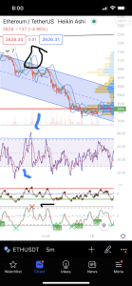](https://cdn.discordapp.com/attachments/944872098969559091/944941686025519144/image.png)

Let’s start at the bottom and work up

1. [6:01 PM]

Red x so I took

1. [6:01 PM]

Rsi extremely overbought

1. [6:02 PM]

And the bimex has the red green red at the top of the range

1. Yes
2. [6:02 PM]

The bimex is mostly what you are reading

1. [6:03 PM]

On the bimex it prints a pattern for a reversal. It alternates for a red green red at the top of range for a momentum shift

1. [6:03 PM]

Same at the bottom

1. Green red green
2. [6:04 PM]

[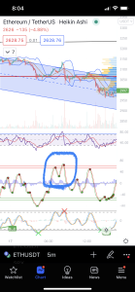](https://cdn.discordapp.com/attachments/944872098969559091/944942702447984650/image.png)

1. [6:05 PM]

This is the top of the range at the two red lines

1. [6:05 PM]

Red green red. Tren reversal

1. [6:06 PM]

On the 5m. You take the second red

1. The 1m is the same. So its a good short. I took on the top of the red at way above range

[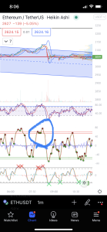](https://cdn.discordapp.com/attachments/944872098969559091/944943355639509012/image.png)

1. [6:08 PM]

So my entry was about 3$ from the perfect top

1. [6:09 PM]

Then go back to the 5m. We ignore the 1m now and set our stops

1. [6:09 PM]

We have taken this trad and we are in

1. [6:10 PM]

I closed at blue and took on black

[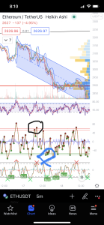](https://cdn.discordapp.com/attachments/944872098969559091/944944140007915540/image.png)

1. Cluster of dots means it could reverse again
2. [6:11 PM]

So I’m out.

1. [6:11 PM]

At 25x on Eth this was a 78% win

1. [6:12 PM]

We also had a bull flag on the lower indicator saying possible reversal

1. [6:12 PM]

Safe place to close

1. [6:13 PM]

That’s it

1. [6:13 PM]

Nothing fancy

1. [6:13 PM]

No trend analysis needed

1. [6:13 PM]

Don’t need to know price targets

1. [6:14 PM]

Just 100% indicator trading and don’t get greedy

1. Start with 20$
2. [6:14 PM]

Learn

1. [6:14 PM]

When you take 20$ and turn it into 50$ you are ready for 100$

1. [6:15 PM]

And just move up like that

1. [6:15 PM]

Chris Jensen started this and is now up to 250$

1. [6:15 PM]

And he is killing it

1. Heiken ashi candles!
2. [6:23 PM]

Forgot that part. Use them

1. [6:23 PM]

They show a doj candle for trend reversal

1. Here is one now on the 5m. Equal top and bottom wick with a tiny body

[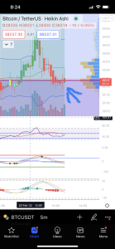](https://cdn.discordapp.com/attachments/944872098969559091/944947730625724466/image.png)

1. [6:25 PM]

This is a potential reversal signal. So Btc should go up now

1. So on a doj flip to the 1m and look for an entry
2. [6:29 PM]

Lots of guys just want to enter straight away. But we are patient

Bottom of the channel making it logical to long here as well

[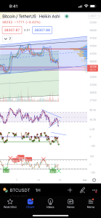](https://cdn.discordapp.com/attachments/944872098969559091/944952078323810394/image.png)

oOnGoingPaymentID change hojati pageload pr