CLIENT REFERENCE · BOOKING 2.6.1

Pricing &
Rate Management
How estimates are calculated and how to update the prices for each vehicle.

Start with the customer’s service choice
Customer selects | How its price is controlled
TRANSFER | Each vehicle uses one method: Mileage-Based Pricing (default) OR Time-Based Pricing.
HOURLY | Each vehicle has its own separate Hourly Booking rate and optional passenger-mileage rate.

Two services. Separate prices.
Time-Based Transfer is an alternative way to price a Transfer. It is not the customer’s Hourly service. The two Transfer methods are never added together.

The three parts of a Transfer
A · TO PICKUP  Service base → pickup | B · PASSENGER TRIP  Pickup → stops → drop-off | C · RETURN  Drop-off → service base
The service base is currently supplied as 304 Sype Dr., Carol Stream, IL 60188, USA.

Where to make changes
Task | Where to go | In this guide
Edit one vehicle’s rates | Tuxano Booking → Vehicles → Edit | Pages 6–7
Edit service base, extras or default gratuity | Tuxano Booking → Pricing | Page 8
Check the final estimate and existing bookings | Review the summary before confirming | Pages 5 and 9

All examples use USD and Premium SUV reference settings. Screenshots show the actual 2.6.1 admin interface with example/default values; they are not a live-site rate audit. Your saved rates determine each real quote.

02 / OWNER’S GUIDE

Transfer: Mileage-Based
The default Transfer method. Price is based on chargeable road miles, subject to a minimum fare.
Premium reference rate | Minimum driving fare | Free travel allowances
$3 per mile | $150 | 20 miles to pickup + 20 miles return

How the calculation works
- A: subtract its complimentary pickup miles; charge only the excess, if any.
- B: charge all passenger miles, including the route through every selected stop.
- C: subtract its separate complimentary return miles; charge only the excess.
- Add those chargeable miles, multiply by the per-mile rate, then use the minimum fare if it is higher.
The driving-fare rule
Driving fare = the higher of the minimum fare or (chargeable A + all B + chargeable C) × price per mile. Selected waiting, extras and gratuity are added afterwards.

Worked examples
Example route inputs | Chargeable mileage | Driving fare
Short local: A 15 mi / B 30 mi / C 10 mi | 0 + 30 + 0 = 30 miles  30 × $3 = $90 | $150 minimum
Long-distance: A 123 mi / B 96.5 mi / C 34.9 mi | 103 + 96.5 + 14.9 = 214.4 miles  214.4 × $3 = $643.20 | $643.20

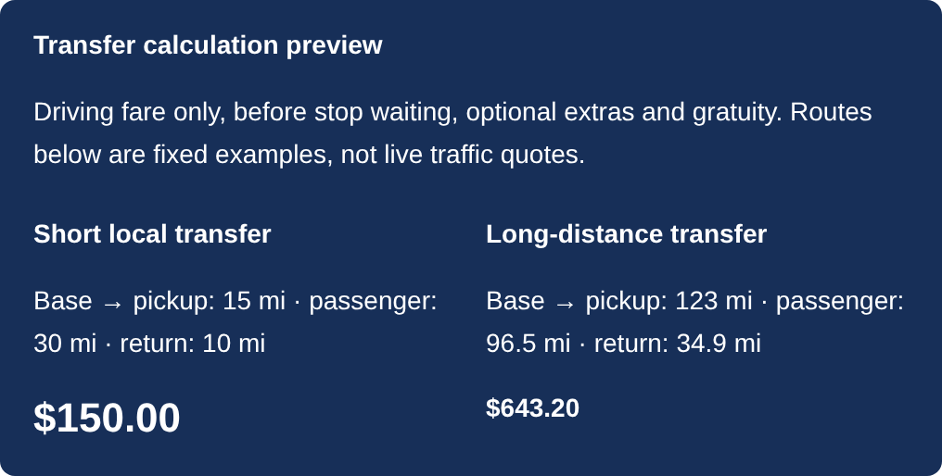
Figure 1. The admin’s fixed Mileage-Based examples show driving fare only, before waiting, extras and gratuity.
The free allowances belong to A and C separately. Unused free pickup miles do not reduce B or move to C. No driving-time charge is added in this method. Full road-distance precision is used, even when the customer sees rounded miles.

03 / OWNER’S GUIDE

Transfer: Time-Based
An alternative Transfer method selected by the administrator for a particular vehicle.
Premium reference settings | Value
Time-Based transfer hourly rate | $150 per hour
Complimentary travel to pickup / return | 30 minutes each
Passenger trip rounding increment | 15 minutes, rounded upward
Minimum charged transfer time | 60 minutes for the combined journey

Calculate minutes first, then convert to hours
- A and C: charge only the time above each separate free allowance. Do not round these excess minutes.
- B: round the complete passenger driving time up once to the next selected increment.
- Add the resulting A + B + C minutes. Apply the combined minimum time once, then divide by 60 and multiply by the Transfer hourly rate.
Example | Minutes charged | Driving fare
Short local  A 35 / B 30 / C 15 min | 5 + 30 + 0 = 35 min  Minimum increases this to 60 min | 1 hour × $150  = $150
Long-distance  A 120 / B 104 / C 45 min | 90 + 105 + 15 = 210 min  210 ÷ 60 = 3.5 hours | 3.5 hours × $150  = $525

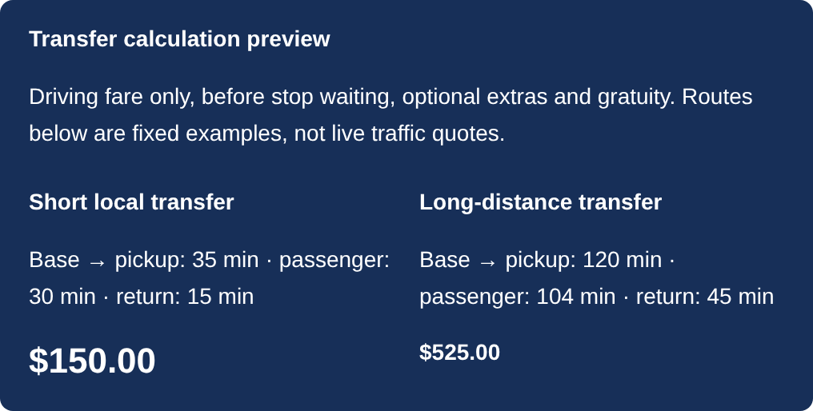
Figure 2. The Time-Based preview uses the same fixed route examples as the calculations above.
Only B is rounded; individual stop legs are not rounded separately. Do not also add Mileage-Based charges or its minimum fare. Base fare and Per driving minute inside Retained legacy transfer fields do not affect either current Transfer method.

04 / OWNER’S GUIDE

Hourly Booking
Customer-selected service hours use a separate set of rates for the selected vehicle.
The form offers 3–24 hours under the supplied setup. Waiting is included in new public Hourly requests, so they have no separate stop-waiting charge.
Hourly calculation
Use (the higher of booked hours or passenger driving hours) × Hourly Booking rate, then add passenger miles × Hourly Booking mileage rate. Transfer travel to/from base, free allowances, minimums and rounding do not apply.

Example: 3 booked hours and 20 passenger miles
Item | Calculation | Amount
Time charge | 3 chargeable hours × $150 | $450.00
Mileage charge | 20 passenger miles × an example $2 per mile | $40.00
Stop waiting | Included in the public Hourly service | $0.00
Before extras and gratuity | $450 + $40 | $490.00

The $150/hour Premium rate is supplied; the $2/mile shown here is an example carried over from saved settings. Read the actual mileage rate on your vehicle. If driving exceeds the booked hours, the higher driving duration is used.
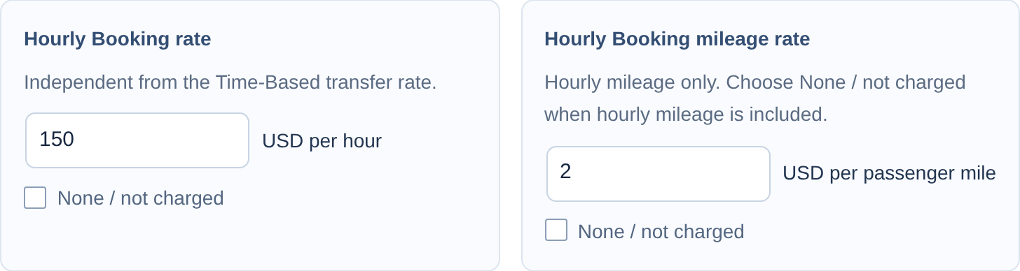
Figure 3. Independent Hourly rate inputs. To include mileage in the hourly rate, select None / not charged beside Hourly Booking mileage rate.
An Hourly Booking stop waiting rate and an older fixed admin example may still be present for historical/admin-edited records. They do not add waiting to new public Hourly requests. Changing the Time-Based Transfer hourly rate does not change the Hourly Booking rate.

05 / OWNER’S GUIDE

Waiting, extras & the final total
The final Price Summary combines the driving fare, any Transfer waiting, selected extras and the chosen gratuity.
Charge | Supplied reference setting | When it applies
Transfer stop waiting | $2.50 per minute | After the driving fare in either Transfer method
Meet & Greet | $50 per reservation | Only when selected
First child seat | $75 | First car seat OR booster
Each additional child seat | $50 | Every remaining car seat/booster, across both types
Default gratuity | 20% | Customer can choose another amount or pay in person

Transfer waiting choices are 15, 30, 45, 60, 75, 90 or 120 minutes per stop. One car seat plus one booster costs $125 in total: one first-seat charge plus one additional-seat charge.
Gratuity is calculated before the extra-service charges
Gratuity = (Transportation line + Waiting line) × selected percentage. Meet & Greet and child-seat charges are not included in the gratuity base. Paid in person adds $0 gratuity to the website estimate.

Complete example using the $150 short-local driving fare
Price Summary item | Calculation | Amount
Transportation (driving fare) | Mileage-Based minimum from page 2 | $150.00
Stop waiting | 15 minutes × $2.50 | $37.50
Meet & Greet | Selected | $50.00
One child seat | First seat selected | $75.00
Gratuity | 20% × ($150 + $37.50) | $37.50
ESTIMATED TOTAL | Each item above is included once | $350.00

Use the full Price Summary or Review & Submit total after choosing extras and gratuity. The vehicle-card transport amount alone is not the complete selected-extras total. Dollar amounts are rounded to cents; the examples are calculation illustrations, not live route quotes.

06 / OWNER’S GUIDE

Update one vehicle’s rates
Tuxano Booking → Vehicles → Edit the vehicle → Booking Vehicle & Pricing → Set this vehicle’s prices
Choose the exact vehicle you want to change. Select its Transfer pricing method, edit the active rates and allowances, then click Update. Use Publish for a new vehicle. Repeat for each car; changing Premium does not update the other vehicles.
Figure 4. Confirm the active method before editing Transfer prices.
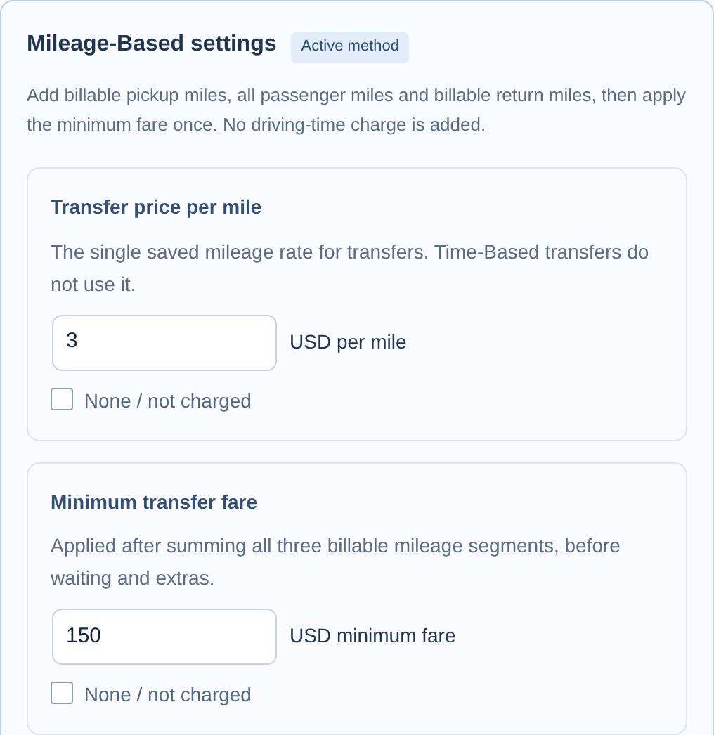
Figure 5. Mileage rate and minimum fare for the selected vehicle.
Also check on the same vehicle | What to enter
Complimentary miles to pickup / Complimentary return miles | Independent A/C allowances; supplied reference: 20 miles each.
Transfer stop waiting rate | Per waiting minute; supplied Premium reference: $2.50.
Hourly Booking pricing | Edit its separate hourly and mileage rates; see page 4.

After Update, reopen the vehicle and check its saved values. The Pricing page’s vehicle tables are an overview: click a vehicle name to edit it. Save pricing on that page saves global settings, not every vehicle’s tariff.

07 / OWNER’S GUIDE

Set a Time-Based Transfer
On the vehicle editor, choose Time-Based Pricing in Transfer pricing method. These values remain separate from Hourly Booking.
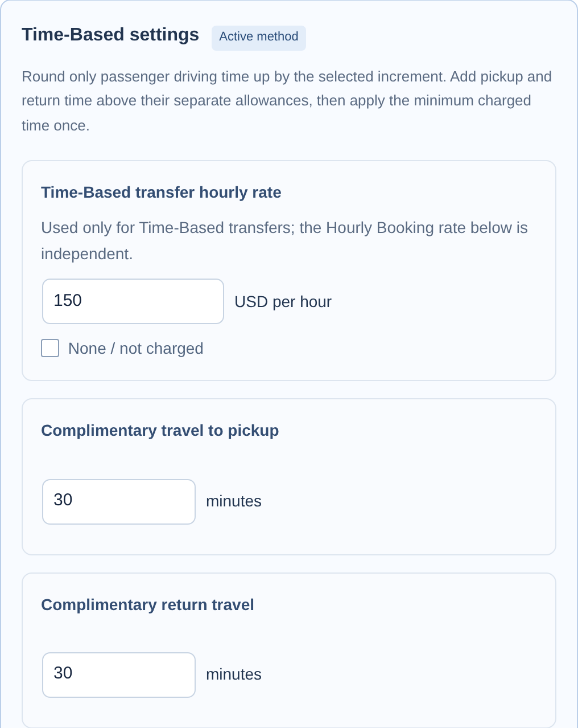
Figure 6. Time-Based hourly rate and separate free pickup/return travel.
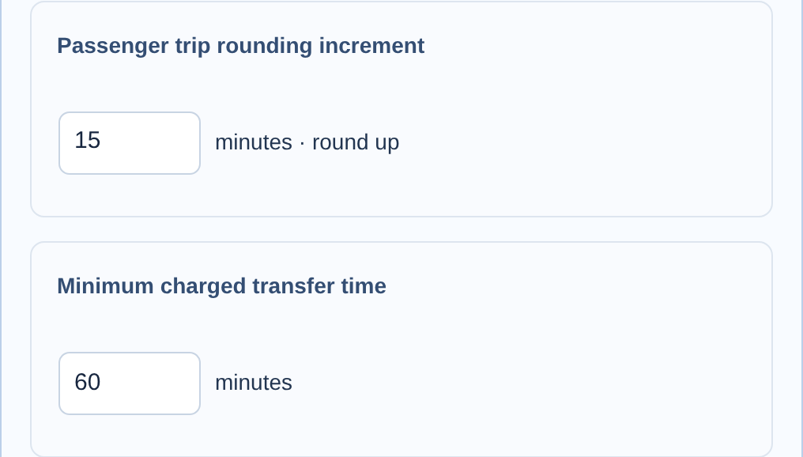
Figure 7. Rounding and the combined minimum. Set the Transfer stop waiting rate too, then click Update.

08 / OWNER’S GUIDE

Update the base & shared extras
Open Tuxano Booking → Pricing. These settings apply across the fleet.
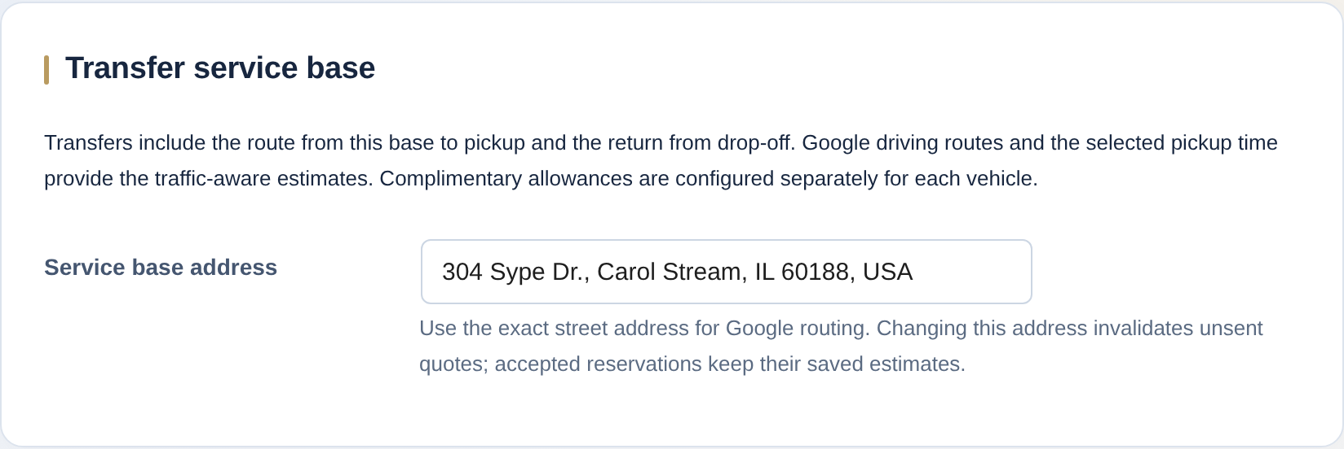
Figure 8. Service base address. Use the actual operating base and an exact street address.
Changing the service base changes travel A and C for new Transfer estimates. The base must be reachable by road from the selected trip. Hourly Booking does not charge these positioning legs.
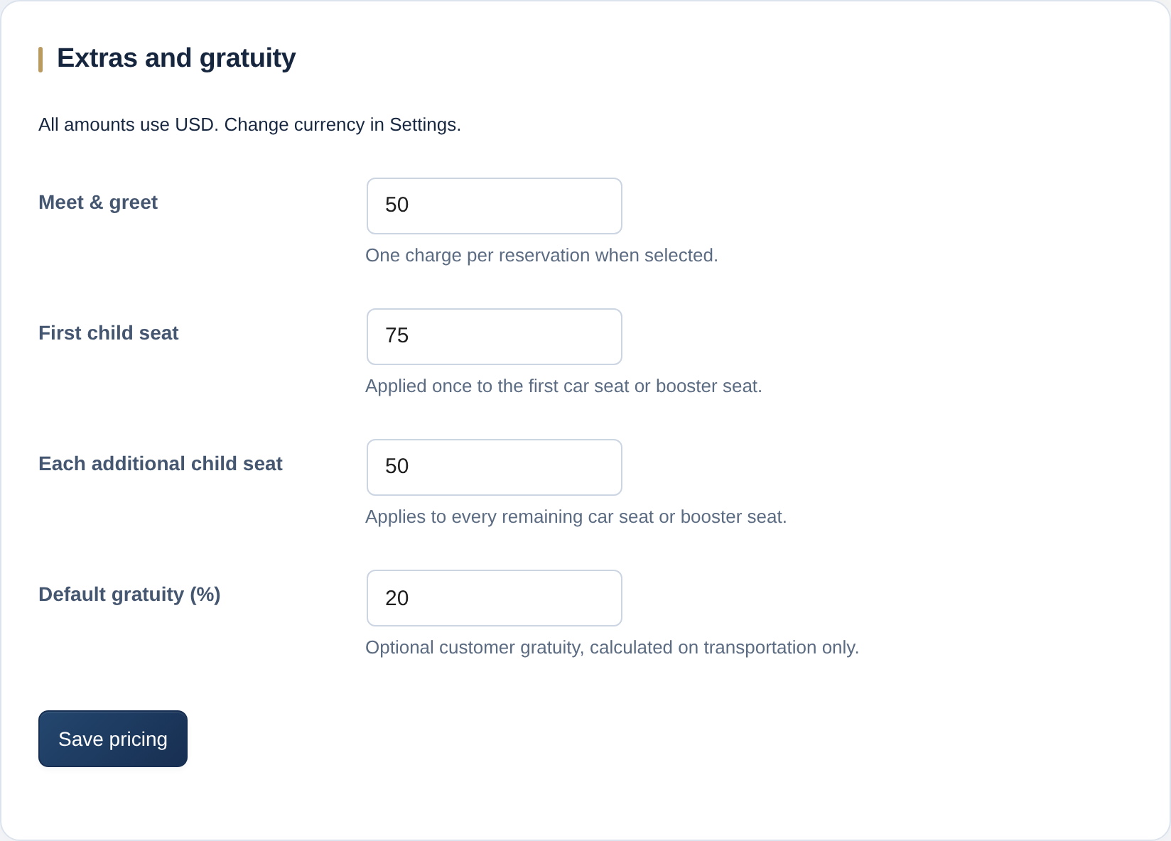
Figure 9. Shared extras and default gratuity. Click Save pricing after making changes.
Meet & Greet is a single selected charge. Seat pricing is shared across car seats and boosters. Default gratuity changes the preselected percentage; the customer can still choose another option. Vehicle-specific rates are changed in Vehicles → Edit, not in this global form.

09 / OWNER’S GUIDE

After saving: check a fresh estimate
A short review helps you confirm that each vehicle is configured as intended.
- Reopen the vehicle and confirm the saved Transfer method, active rate, allowances, waiting rate and separate Hourly values.
- Use a realistic pickup/drop-off within your service area. Enter a future pickup in that location’s local time and choose the same vehicle.
- For Transfer, check one short trip, one longer trip and a trip with a 15-minute stop. For Hourly, check a 3-hour trip and confirm there is no separate waiting fee.
- Review the full Price Summary after selecting extras and gratuity. Compare it with the rules in this guide, then repeat for each vehicle you update.

Why does passenger distance × per-mile rate differ from the total?
Step 1 shows passenger journey B distance and driving-plus-waiting time. The Transfer driving fare may also include chargeable A/C travel or a minimum. The final total may also include waiting, extras and gratuity.

Why can the same Transfer change when pickup time changes?
Google supplies road routes and traffic-aware estimates for the selected pickup date/time. A changed schedule can change the route or travel time. Your own saved rates determine the price. Hourly uses a standard passenger driving estimate without selected-time traffic forecasting.

What happens to existing reservations when I change a rate?
Existing submitted bookings keep their saved estimates when you update fleet rates. Contact or status-only edits preserve those amounts. An intentional reprice, or a priced itinerary/vehicle/extras change, uses current rates and the applicable fresh route. For requests created with the current Transfer pricing, changing the pickup date or time also refreshes the estimate.
To deliberately update an existing booking estimate
Open Tuxano Booking → Submissions → Edit. Select Recalculate using current rates, choose Save booking changes, then review the revised estimate on the request. Do this when you intend to revise that request’s price.

How should I use the admin previews?
Switching Transfer methods retains the inactive method’s values. Transfer previews are fixed examples of driving fare only; they are not live Google route quotes and do not include waiting, extras or gratuity. The retained Hourly example can include hypothetical historical waiting. Validate new public Hourly requests using the zero-wait calculation on page 4.
Reference: supplied Premium SUV settings and the pricing behavior in TUXANO Booking 2.6.1. Other vehicles retain their own saved numeric rates; review each vehicle before replacing its prices.

