**AGENDA:**

What is Linux?

Types of Linux?  
Advantages? Why we use it?  
Windows vs linux?

Linux Architechture?  
  
Basic commands of linux…!?  
additional commands…?

**Linux?**Developed by linus Torvald in 1991.  
Its an operating system, which is open sourced, and is based upon CLI(command line interface)- works on commands and its free of cost.

**Types of Linux?**

**Ubuntu(latest 24.04, we use 22.04)**, kali, fedora, centOS, Red hat linux…etc

**Advantages/ why we need it?**

1)Free of cost i.e no license req.  
2)Open sourced

3)customization

4)secured

5)community support

6)Stability

7)not much specifications req.

8)Multitasking

**Windows vs linux?**

Win(user friendly)---Linux(not user friendly)

Win(GUI based)—Linux(CLI based)

Win(Paid)—Linux(free)

Win(Prvt. Code)—Linux(Open sourced)

Linux is far more secured than win.

Linux is more customizable than windows.

**Linux Architechture:**

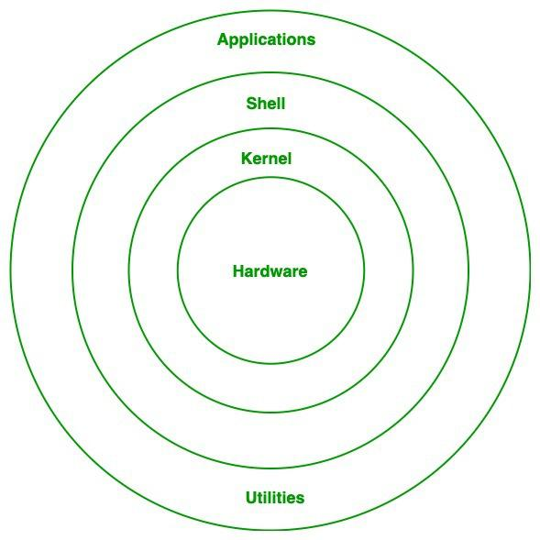

**Application:**

where you have tasks and utilities being carried out.  
**Shell:**

Medium by which we execute our tasks.

Allows u to interact with the os with commands

Shell is made to execute files or tasks.

We write scripts in diff language.

Command line interface that allows users to intersact with the os by typing commands, and execute them via kernel.

**Kernel:**

It is a bridge between user and the hardware,

Manage you hardware.  
resource utilization to the perfection

Takes care of process running, waiting and ended.  
eg. Multiple people printing at the same time, and the prinintg task is on hold till the initial tasks are complted.  
  
Harware: cpu cores, printer…!GPU.

Link for killercoda**

<https://killercoda.com/playgrounds/scenario/ubuntu>

1. **clear:** To clear the terminal
2. **mkdir <dir_name>:** To make directories (folders)
3. **ls:** To list your directories and files.
4. **ls -R**: List all the directories and files as well as the subdirectories.
5. **ls -a:** To list all the directories.(hidden as well)
6. **ls -s:** To list the block of memory occupied by the directories.
7. **ll:** To list all the directories with detailed information.
8. **ls -al**: T o list all the directories including (hidden) with detailed information.
9. **mkdir <folder_name1> <folder_name2>:** To create multiple folders at the same time.
10. **mkdir -p <folder_name>/<sub_folder_name>/<sub_folder_name>:** To create directories and subdirectories at the same time. ***[-p stands for parent : it creates the resource if something is not present from before]***
11. **cd <directory_name>:** CD stands for change directory and it will open the directory or folder.
12. **cd <directory_name>/<subdirectory>/<multi-subdirectory_name>:** To move to a directory.
13. **cd ..:** To come out of directory(folder).
14. **cd:** to move to home directory.
15. **cd ../../.. :** To come out of multiple directories
16. **touch <file_name>:** to create an empty file.
17. **nano <file_name>:** To create and add the conent in the file in nano editor.
18. **ctrl + s:** To save the changes.
19. **ctrl + x:** to exit the nano editor.
20. **nano <file_name>:** To edit a file (if it is alreay present)
21. **vi <file_name>:** To create a file using vi editor.

first, you need to press 'i' button to enter into insert mode to make changes to your file. To save the file you first need to come out of the insert mode by pressing 'esc' button.

Then to save your file you need to run the below command:

**':w':** to save

**':q':** to exit

**':wq':** To save and exit

**':wq!':** to forcefully save and exit from Vi editor.

1. **echo “Hello” >> file1.txt:** To append new file content in a file.
2. **cat <file_name>:** To see the content of the file.
3. **cat <file_name1> <filename_2> >> <final_file>:** To concatenate the content of two files into a single file.
4. **cat <file_name> > <file_name2>:** To replace the content of the file2 with the content of file1.

**>>:** will append and save the changes

**>:** will replace the content and save the changes.

1. **pwd:** Will show you your present working directory.
2. **history:** will show you the history of the terminal.
3. **rm <file_name>:**  To delete the file.
4. **rmdir <foder_name>:** to remove empty directory.
5. **rm -r <dir_name>:** To delete non-empty directories.
6. **cp <file_name> <dir_name>:** to copy the file to a target directory
7. **cp <file_name> <dir_name>/<sub_dir>:** To copy files from one
8. **cp -r <dir_name> <target_dir>:** To copy your directory.
9. **cp -r <dir_name> <target_dir>/<target_sub_dir>:** To copy dir to target sub dir.
10. **cp -pr <pathofthefile> <targetfolder>:** To copy files from one directory to another.
11. **mv <file_name> <dir_name>:** To move your file to any directory.
12. **mv <file_name> <dir/sub_dir>:** To move a file to sub directory.
13. **mv <dir_name> <target_dir>:** to move a dir to target dir.
14. **mv <file_name> <new_file_name>:** To rename a file.
15. **mv <dir_name> <new_dir_name>:** To rename a directory.
16. **head <file_name>:** To get top 10 lines of files.
17. **head -n 5 <file_name>:** To get top 5 lines of file as output.
18. **head -5 <file_name>:** To get top 5 lines of file as output.
19. **tail <file_name>:** To get last 10 line of file as output.
20. **tail -5 <file_name>:** To get last 5 lines of file as output.
21. **stat <filename>:** To get information about the files.
22. **grep <keyword> <file_name>:** To search for a keyword in a file.
23. **grep -r <keyword> <directory>:** To search for a keyword in a directory.
24. **grep -c -w -i <keyword> <file_name>:**

**-c :** To count the output.

**-w :** To get the output of exact matches

**-i :** case insesitive

**-o :** to get the matches

**-v :** To invert the search

**Search for files and directories based on various criteria.**

1. **find /path/to/search -name "*.txt"**
2. **Find / -name “*.txt” :** To Search from any of the disk
3. **sed -i 's/word/replacewith/' <filename> :** To find and replace a word in a file
4. **Df -hT path/of/the/file :** To get to know the disk on which it is stored
5. **sudo su:** To become a root user.
6. **exit:** to come out the root user.
7. **curl https://intellipaat.com:** This should display the content of the URL on the terminal.
8. **sudo apt update:** To update the packages.