**Lexical Environment, Scope chain**

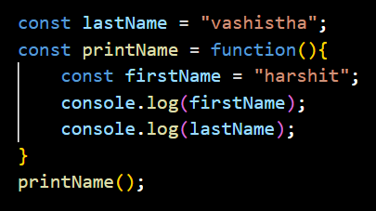

**How each line of code will execute**

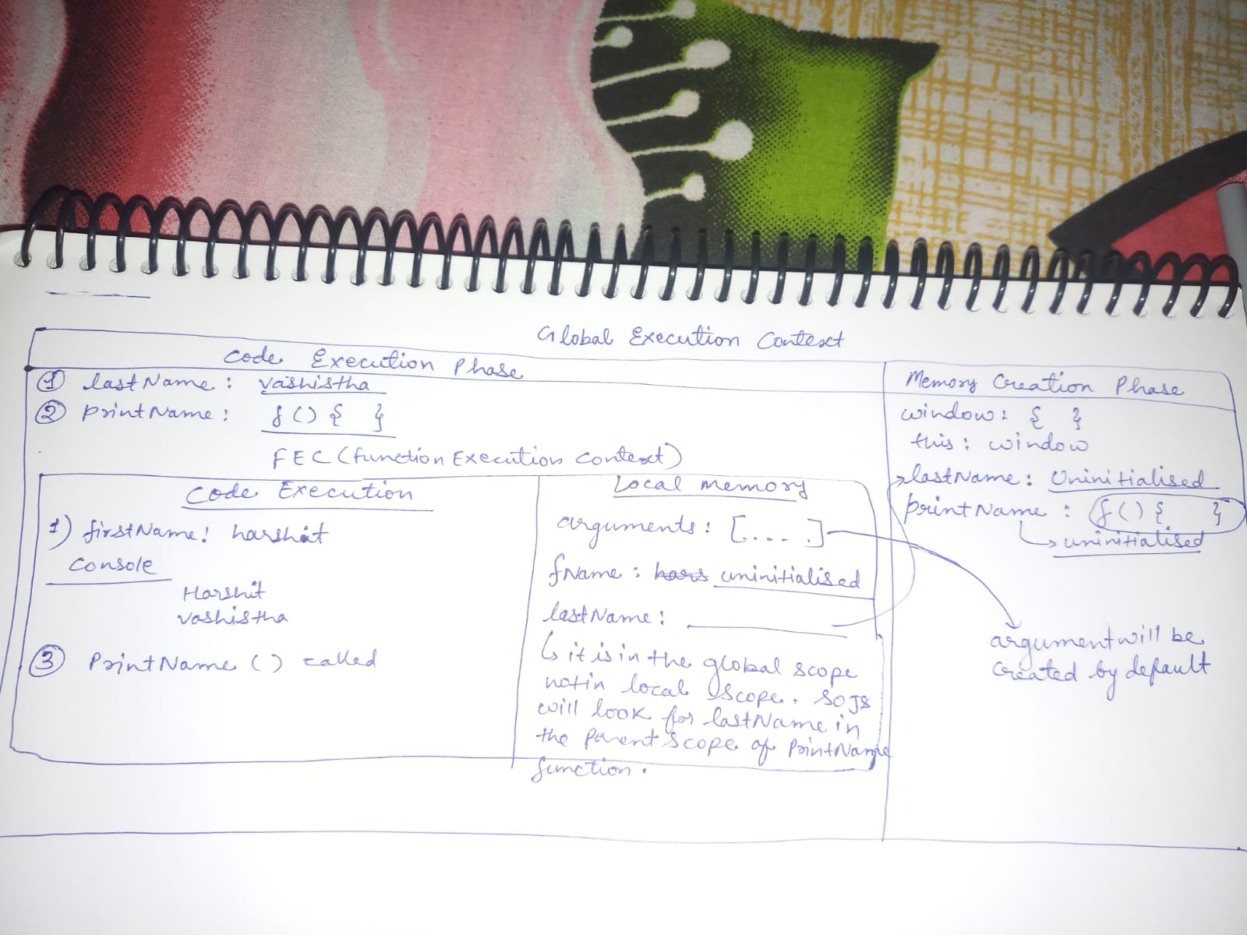

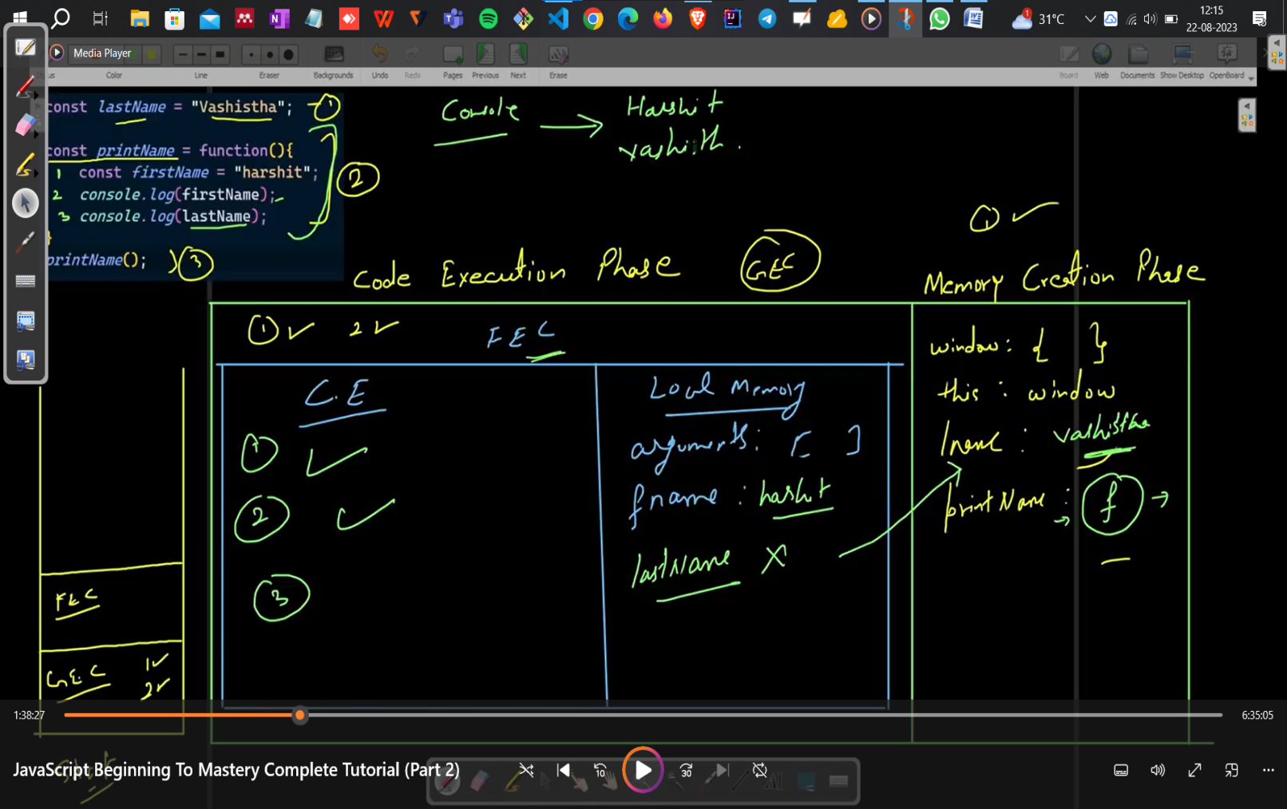

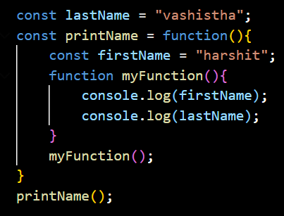

**Here, the function myFunction is present in the local environment of printName function.**

If firstName is not present in the myFunction then it will search it in the printName function. if there also it is not present then it will search in the global scope. This is how lexical environment works.