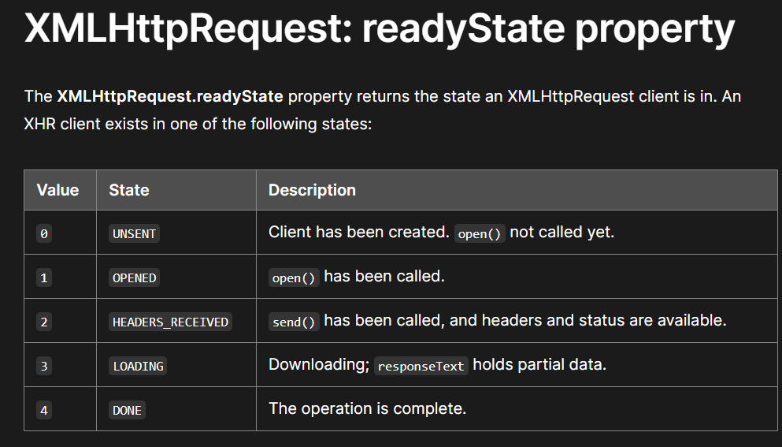

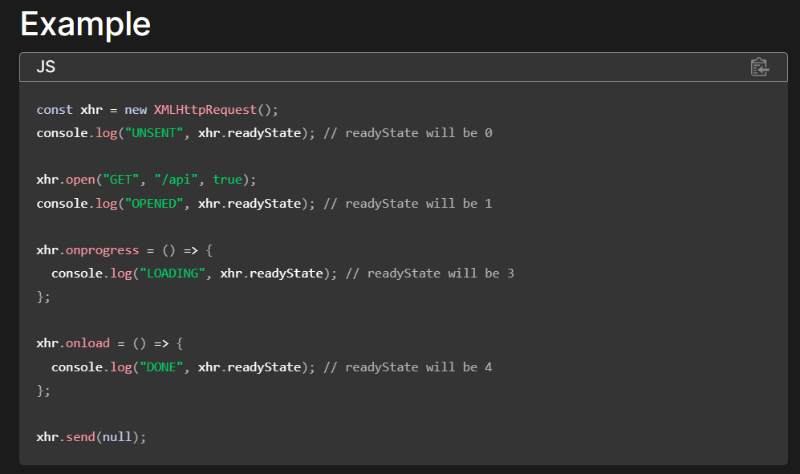

**List of HTTP Status codes :**

**XX - > Representing 00**

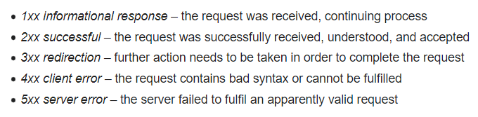

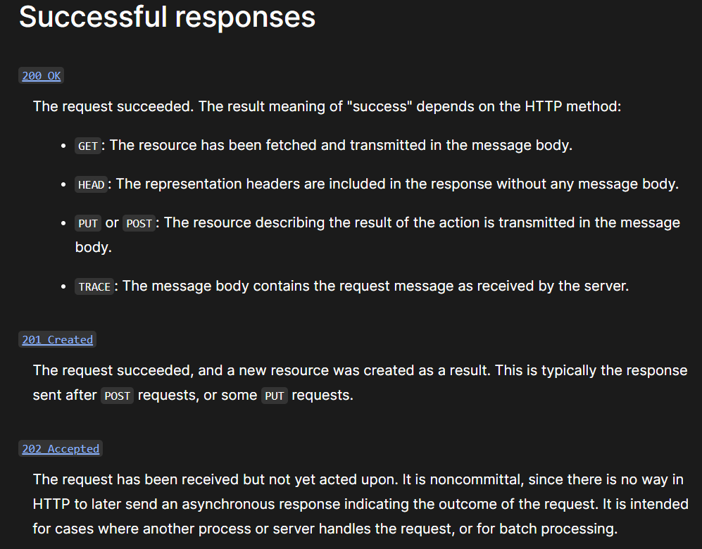

**400 Bad Request, 401 Unauthorized,** [**403 Forbidden**](https://en.wikipedia.org/wiki/HTTP_403)**,** [**404 Not Found**](https://en.wikipedia.org/wiki/HTTP_404)**, 406 Not Acceptable, 408 Request Timeout**