**try…catch…finally**

The try statement always starts with a try block. Then, a catch block or a finally block must be present. It's also possible to have both catch and finally blocks. This gives us three forms for the try statement:

* try...catch
* try...finally
* try...catch...finally

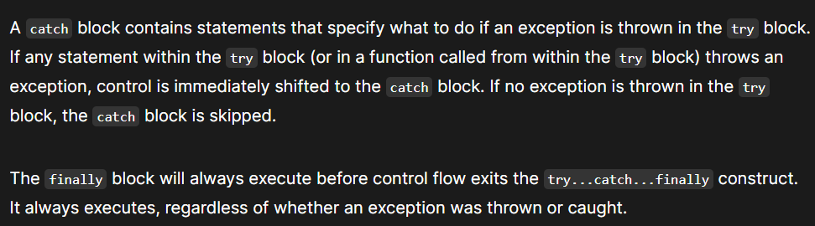

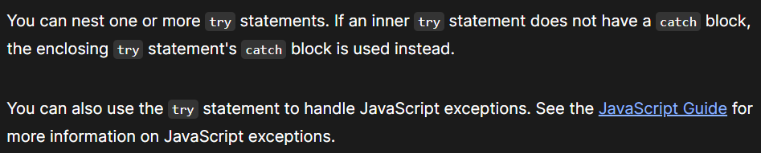

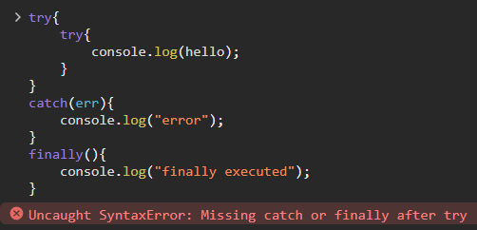

**Giving syntax error bcz outer try block has catch as well as finally block but inner don’t have neither catch nor finally but it should have one of them.**

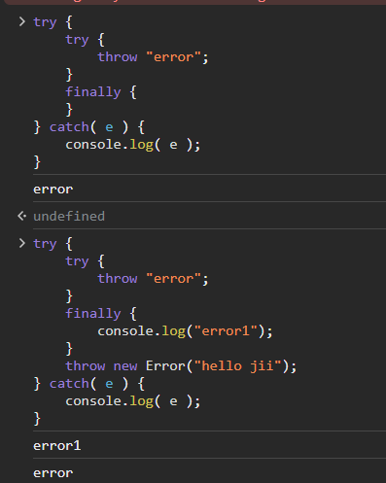

The try statement consists of a try block, which contains one or more statements, **and at least one catch clause or a finally clause**, or both.

If an inner try block does not have a corresponding catch block:

1. it must contain a finally block, and
2. the enclosing try...catch statement's catch block is checked for a match.

Finally clause is basically used for :

1. closing the file
2. exit from the loop
3. write to the log file
4. cleanup the file

finally block will always run phir chahe try aadha chale catch aadha chale yaa try or catch dono pura chale finally hamsha execute hoga

if finally exists it will runs in all cases:

1. after try if there were no errors
2. after catch if there were no errors

if there is a return in try, finally is executed just before the control returns to outer code

