RU GOING
Application for Aggregating and Suggesting Campus Events

FINAL PROJECT REPORT

PROJECT MEMBERS
FAN ZHANG
NAINISHA WAVHAL
RAUL S LASLUISA
SHARAT CHANDRA
SNEHA GALA

CONTENTS
- Project Summary
- Requirement Analysis
  - Purpose of the System
  - Scope of the system
  - Objectives and Success Criteria
  - Definitions, Acronyms and Abbreviations
  - References
  - Current System
  - Proposed System
  - Functional Requirements
  - Non-functional Requirements
1.10 Use Cases
- System Design
- Object Design
- Testing
- Team Assignment and Communications
- Project Status
- Use Cases
- Demo
- Appendix: test script
- Project Discussion
- Software Engineering Techniques
- Our Experience
REVIEW
1. Introduction
1.1 Purpose of the system

College life can sometimes be hectic with several curriculum and non-curriculum events that are organized on campus for the students throughout the year. It is difficult for the students to be aware of all the events on campus that they might find interesting. So to plan a schedule based on one’s interest becomes important in order to get full exposure to one’s interests.

In this project we will try to aggregate the entire Rutgers event catalog and find what events one should go to based on one’s personal preferences and trends with your friends. This site will hopefully inform the users of great events that they might not have even heard of until now. This will be useful for the university students to know of the vast range of events that take place on campus and also match the events with their interests and social circle. Besides the recommended events the user can also search for specific events. The user can also rate an event and upload photos for an event. He/She can find the exact location of the event on Google Maps. The students can also share the event using the Like button on Facebook. The user can comment on an event (Twitter and Facebook).

1.2 Scope of the System

- All users should be able to access the RU Going as a web application
- This application makes the user aware of various departmental and sporting events
- This application uses Google Maps for locating the events for the user
- This application uses Like button of Facebook for the user to share anevent
- RU Going also uses the comment application of Facebook and Twitter

1.3 Objectives and Success Criteria

- Provides a GUI for the user to sign up for this application in which the user provides personal data
- Provides a GUI enabling the user to find campus events based on specified interests and preferences
- Provides the student with data about the time, location, subject and social rating of the event.

1.4 Definitions, Acronyms and Abbreviations

- User: End user, uses this application to be updated about campus events. Most typically university students.
- Remote Server: The server/Database, which provides a suggestion based on the events that match user’s data
- GUI: Graphical User Interface, is a type of user interface, that allows users to interact with programs in more ways than typing such as computers, hand-held devices such as MP3 players, portable media players or gaming devices, household appliances and office equipment with images rather than text commands
- Campus Event: Curriculum events within the departments and co-curricular like sports and cultural events that are organized throughout the year
- Administrator: Manages the student accounts and data corruptions in events database

1.5 References

- http://www.squarespace.com/
- http://www.wikipedia.org/
- Object-Oriented Software Engineering
- Bernd Bruegge and Allen H. Dutoit
- Enterprise Architecture As Strategy: Creating a Foundation for Business Execution

2. Functional Requirements
2.1 Functional Requirements

RU Going supports two types of users:
- The student should be able to sign up and register to become a member of the application. The application provides a member form that lists the details that the user should be able to provide to shortlist the events according to his interest. The user should be able to update (add, modify, delete) his profile anytime. The user should be able to tag the event as “attending” if he decides to attend the event.
- The administrator should be able to manage student and event records. He should be able to, install, support, and maintain servers.

USE CASE TABLES AND USE CASE DIAGRAM
Register

Use case name | registerAccount
Participating actor | Initiated by User
Flow of events | - User requests a registration form from the homepage.  - RUGoing returns the online registration form.  - User fills out form (user id, password, name, major, email, interest/events preference etc). Once the form is completed, the User submits the form.  - RUGoing receives the form and stores data.  - RUGoing returns acknowledgement to User.
Entry condition: | - User clicks the RUGoing register button on homepage
Exit condition: | - User receives acknowledgement OR User receives an explanation indicating why the transaction could not be processed.
Quality requirements | - System should display the acknowledgement within 5 seconds
Figure 2-1 The registerAccount use case

Search

Use case name | searchEvents
Participating actor | Initiated by User
Flow of events | - User types keywords in RUGoing search box and submits the search query.  - RUGoing returns a list of events.
Entry condition | - User must be logged in and click search button.
Exit condition: | - User receives the list of events OR User receives an explanation indicating why the transaction could not be processed.
Quality requirements | - System should display the acknowledgement within 5 seconds
Figure 2-2 The searchEvents use case

Recommended Events

Use case name | RecommendedEvents
Participating actor | Initiated by User
Flow of events | - User request recommendations by choosing the recommended events button.  - RUGoing returns a webpage that displays recommended events (which are automatically selected by application system, based on user’s interest and events preference information).
Entry condition | - User must be logged in and click request recommendation.
Exit condition: | - User receives recommended events OR User receives an explanation indicating why the transaction could not be processed.
Quality requirements | - System should display the acknowledgement within 5 seconds
Figure 2-3 The RecommendedEvents use case

Upcoming Events
Comment (Facebook)
Comment(Twitter)
Share (use Facebook like button)
Rate event
Use case name | RateEvent
Participating Actor | Initiated by user
Flow of Events | - User request attended events  - RUGoing displays events requested by user.  - User will rate the events
Entry Condition | - User is logged in and request for attended events
Exit Condition | - Event will be rated based on users experience.
Quality Requirement | - System should display the requested events in “” sec
Figure 2-4 The rateEvent use case

Upload Photos of Event

Use case name | UploadPhotos
Participating actor | Initiated by User
Flow of events | - User selects an event from displayed list list of events  - User requests to upload photos  - RUGoing receives input and uploads the photos and stores it on the server  - User can view the photos
Entry Condition | - User must be logged in and click UploadPhotos
Exit Condition | - User can view the images he uploaded
Quality Requirement | - System should display the request within 5 seconds
Figure 2-5 The UploadPhotos use case

Modify Account
Use case name | modifyAccount
Participating actor | Initiated by User
Flow of events | - User requests to modify account.  - RU Going returns form.  - User modifies old information (e.g. reset password, edit personal interest) and submits. User may also request to have their account deleted.  - RU Going receives and stores data or flags for deletion.  - RU Going returns acknowledgement to User.
Entry condition | - User must be logged in RUGoing and click modify account button. User must already have an active account on the system.
Exit condition: | - User receives acknowledgement OR User receives an explanation indicating why the transaction could not be processed.
Quality requirements | - System should send an acknowledgement within 5 seconds
Figure 2-6 The modifyAccount use case

Use case name | LikeEvent
Participating Actor | Initiated by user
Flow of Events | - User request attended events  - RUGoing displays events requested by user.  - User will fill the like box next to the event
Entry Condition | - User is logged in and request for attended events either by searching OR viewing past recommended events.
Exit Condition | - Event will be liked based on user’s experience.
Quality Requirement | - System should display the requested events in “” sec
Figure 2-7 The LikeEvent use case

Use Case for ViewMap

Use case name | ViewMap
Participating actor | Initiated by User
Flow of events | - User request for the location of the Event  2. RUGoing returns the Map with requested location
Entry Condition | - User must be logged in and click ViewMap
Exit Condition | - User receives a Map displaying event location
Quality Requirement | - System should display the request within 5 seconds
Figure 2-8 The ViewMap use case

Delete User (system admin)
3. Nonfunctional Requirements

Usability: The user should be able to use this application without any specialized training. The user should only be familiar with filling out basic html forms such as input boxes and dropdowns. The user shall not feel like they are filling out a questionnaire. In order to do this we will limit our registration form to 10 fields. The user in the case they don’t understand what information is needed in a particular field shall be provided with a hover over help button which explain what should be the input.

Reliability: The application once running may be restarted at anytime and keep the state in which it was before reboot. Any errors or warnings that are encountered by any part of the application shall be logged in a centralized file. Errors based on user input shall be returned back to the user. All login credentials shall be encrypted with standard SSL.

Performance: The system should be able to handle 50 simultaneous request and up to 300 request in a queue. The system should be able to do any event search within 5 seconds of user submission.

Supportability: Any updates to the system will have to be installed manually by the administrator of the application. Any updates will be given in tar balls and windows executables to simplify installation.

Implementation: Entire application will need 3 servers or virtual machines to run. All users having an internet connection should be able to access RU Going through a web interface.

Interface: This application will be able to interact with the outside world using web services using SOAP. These services will allow data to be exported in XML format.

Packaging: The application will be packaged in 1 tar ball and 1 windows executable. Installation instruction will be provided in a separate README file.

Legal: The application will need to adhere to federal laws in the USA in terms of the length to which data must be stored. TWITTER FACEBOOK

4. System and Object Design
4.1 System Design Overview
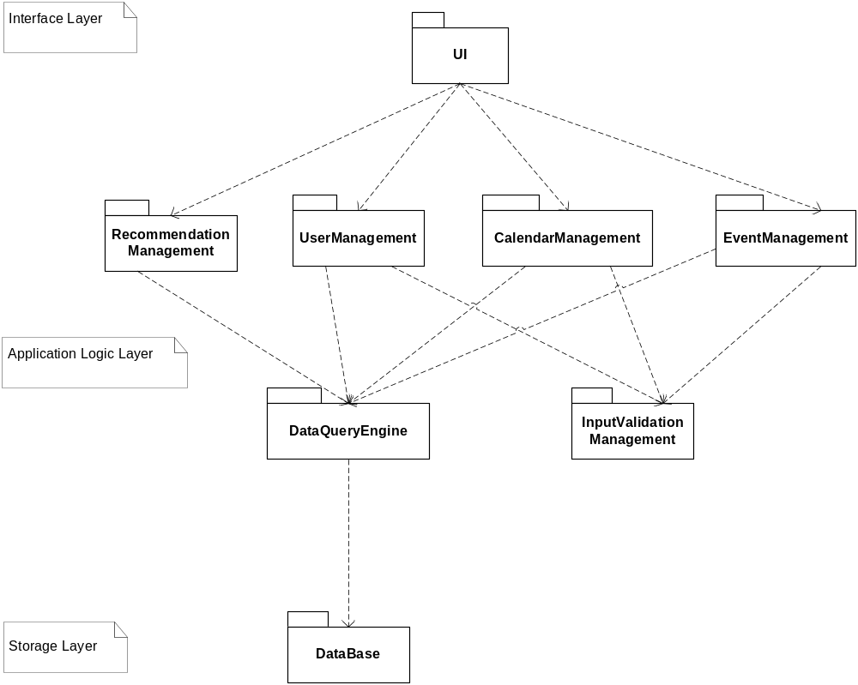

WRONG PIC!!!!!!!!!!!!!!!!
Explain why we chose this arc (in old report)

Need to Update comments on each module
User Interface (UI)

This subsystem belongs to interface layer of RUGoing system architecture. Classes, objects and procedures encapsulated in this subsystem will handle the presentation, layout arrangement, rendering of data records, forms, and graphics on the RUGoing web pages. This subsystem has direct dependence links to most subsystems in the application logic layer, because all the data presented by UI is from the application logic layer, and user input data should be sent from UI to various application procedures defined in the logic layer.

EventManagement

This subsystem, part of the application logic layer, encapsulates the objects and procedures related to the following: Event Insertion--there is an daemon thread procedure (runs in the background) named Data Miner (which we consider as “internal actor” in this subsystem) to automatically crawl new events information from Rutgers Events web page and update the events library of RUGoing; Event Expiration check--this subsystem checks the event date and marks past events as “expired”; In addition, this subsystem is responsible for events deletion, events commenting and rating. EventManagement depends on DataQueryEngine to get/put event data from/into storage. This subsystem depends on peer subsystem InputValidationManagement in the same layer to verify input data. Also, this subsystem provides event-related information to upper-level UI subsystem.

UserManagement

This subsystem, part of the application logic layer, encapsulates the objects and procedures related to user registration, user login/authentication, user account modification (e.g. reset password, add personal interest). This subsystem depends on DataQueryEngine to get/put user related data records from/into storage, and depends on InputValidationManagement to verify input data. Also, this subsystem provides user-related information to upper-level UI subsystem.

DataQueryEngine

This subsystem, part of the application logic layer, encapsulates the objects and procedures related to issuing SQL queries to underlying data base system. This subsystem provides data query service. It directly interacts with the DataBase subsystem in storage layer.

DataBase

This subsystem, part of the storage layer, includes a relational database system for management (using tables), and storage (using disks) of persistent data records generated in RUGoing. This subsystem would respond to SQL queries from DataQueryEngine subsystem.

4.2 Class Design
BOTH WRONG PICTURE

Class Diagram
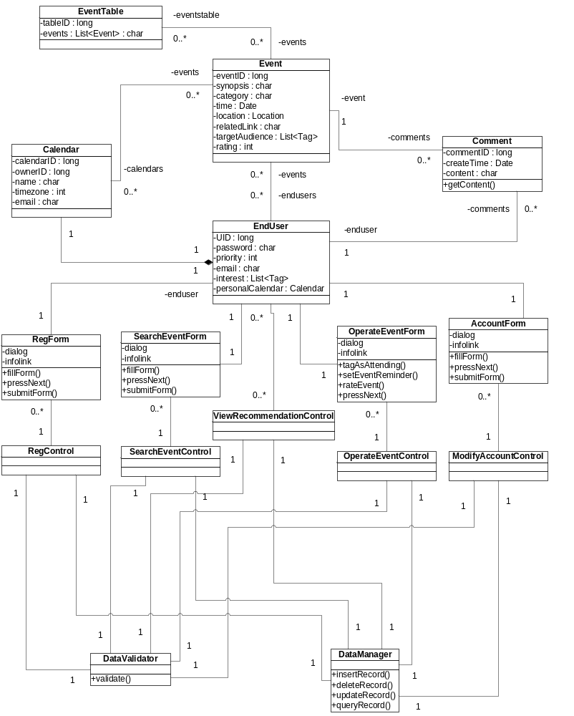

Class hierarchy of User class:
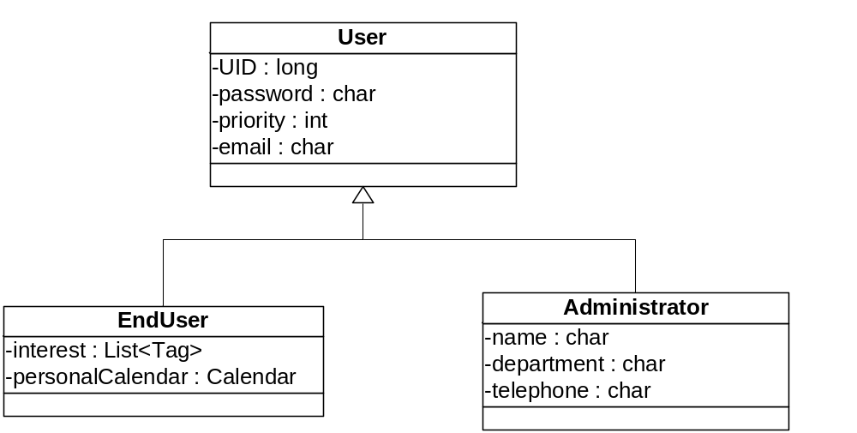

5. Testing Approach

We choose PyUnit the standard unit testing framework module for Python, to implement our test cases for RUGoing.

Test RegisterUser Use Case

Purpose: registerUser() function allows user to register in the application. User has to provide data that includes username, firstname, lastname, interests fields required to maintain his/her profile information. To make sure user provides correct information (valid input data) we run 3 test

Boundary Testing Test1: User fills out all required input field (check for valid inputs) The function tested is registerUser() which takes in input fields such as username, password, firstname, lastname, interest as parameters and it is observed that the function accepts the input and returns TRUE.

Equivalence Testing Test2: Check for not accepting same input data by different users Test is run providing same username, firstname, lastname as given for the first test case and this time return value is FALSE as it invalidates the input considering it incorrect because it already exist and should not be accepted again. There can be several classes of invalid or incorrect inputs, but this one of the important one to consider for testing.

Boundary Testing Test3: User does not fill in all required input field User does not provide complete information by leaving some input fields blank, function returns FALSE as it is not a valid or complete data.

Modifyaccount Use Case:

Purpose: We tested the Modifyaccount function provided to the user using which he/she can modify his/her account details. The password, interests, first name and last name can be changed according to the user will once he logins in using the correct username and password and then chooses the option to modify his account. We have tested for three conditions using PyUnit:
1. Test case for correct username and password
2. Test case for correct username and wrong password.
3. Test case wrong username.

Equivalence Test 1: Test case for correct username and password. Allows user to modify her password. The user can then login with the new password. When the input data is correct username and password then the test returns TRUE

Equivalence Test 2: Test case for correct username and wrong password does not allow the user to modify. If the username and password are not matching the user cannot modify his/her account details. When the input data is correct username and wrong password then the test returns FALSE
Equivalence Test 3: Test case wrong username does not allow the user to modify. When the input data is wrong username the test returns FALSE

Test RatingEvent Use Case

Purpose: A person can by-pass the UI and insert rating values apart from the 5-stars visible on the events page by communicating with the underlying webservice .To make sure that the rating of an event by a user does not violate the norms , we have included 3 test cases that guard the system from such meddling. Requirement Report
The conditions that we have tested for are :
1. The rating should not be negative. –(Equivalence Testing)
2. The rating should not be greater than 5 – (Equivalence Testing)
3. The eventID should be of a valid event – (Equivalence Testing)

Equivalence Test 1: Rating should not negative
a) If the input data is negative, the test returns FALSE (Boolean)
b) If the input data is a positive integer , the test returns TRUE (Boolean)

Equivalence Test 2: Rating should not be greater than 5
a) If the input data is negative integer , it returns TRUE
b) If the input data is positive integer between 0 and 5 it returns TRUE
c) If the input data is greater than 5 , it returns FALSE

Equivalence Testing 3: A valid eventID that is present in the database
a) If eventID for which the rating was done is not found, then it returns FALSE

Test InsertEvent use case:

Purpose: To make sure the events that inserted into RUGoing by the data miners do have valid content and values, we have used 2 test cases to protect our system from being polluted by invalid events data. The conditions that we have tested for:
1. The eventtime of inserted event should be equal to or larger than the BoundaryDate = date of today.
2. The eventname of inserted event should be a string with number of characters as NameStrLen, and 6<=NameStrLen<=60.

Boundary Test 1 Inserted event should have valid eventtime The tested action is “InsertEvent”, and we use 3 input data:
a) Input: event that have eventtime < BoundaryDate.

Output: it returns FALSE.
b) Input: event that have eventtime = BoundaryDate.

Output: it returns TRUE.
c) Input: event that have eventtime > BoundaryDate.

Output: it returns FALSE.

Equivalence Test 1 Inserted event should have valid eventname The tested action is “InsertEvent”, and we divide input data into 3 partitions:
a) Input: event that have NameStrLen < 6.

Output: it returns FALSE.
b) Input: event that have 6<= NameStrLen <=60.

Output: it returns TRUE.
c) Input: event that have NameStrLen > 60.

Output: it returns FALSE.

Test Get Recommended Events Use case

Purpose: To test proper functionality of getRecommndedEvents use case. In this use case there are two types of users, ones that exist in the system and those that don’t. Because of this we have decided to use equivalence testing to test the functionality of this function. The conditions that we have tested for are :
1. The user is in the system. –(Equivalence Testing)
2. The user is not in the system – (Equivalence Testing)
3. Invalid username due to size of username being provided – (Boundary Testing)

Equivalence Test 1 User should exist in the system
- If the input data is a valid user the system will return a list of events.
- The application will return at least one recommended event when the above condition is met.

Equivalence Test 2 User does not exist in the system
If the input data is an invalid user the system will return an empty list of events.
The application will return no events when this above condition occurs.

Boundary Testing 3 Username cannot be greater than 20 characters long
If the input data is invalid (too many characters) the system will return an empty list of events.
The application will return no events when this above condition occurs
6. Assignment of Responsibilities

