Project Plan

Mapbox Weather Information

IS 217

Table of Contents
1. Introduction
1.1 Foreword
1.2 Background
2. Development Model
3. Risk Analysis
4. Hardware and Software Requirements
5. Schedule and Breakdown Structure

1. Introduction

1.1 Project purpose and goals:
Our project is going to start as something simple yet functional we are going to use mapbox to create a simple interface for the user to show local weather information. Depending how things go we might include historic view for up to 10 years.
- We are going to need mapbox API and a copy of their GITHUB repository.
- We are going to use a template from boiler-plate or map-site.
- Might include visualizing.org API to show current weather status.
- Incorporates backbone.js library to simply functionality.

1.2 Background
Khaled and I have little to no programming experience. This is going to be our first full scale project using javascript. We are hoping for the best and know this is going to be a hard project to accomplish. Especially since we using mapbox which we have no clue how to use yet and mapbox itself is pretty extensive and complicated. Not to mention we are incorporating others APIs in this project. Our previous experience is mostly with HTML and CSS which is also going to be used.

2.1 Development Model

We will be using the waterfall because is a perfect fit for a small project like this one. The steps we are to follow are:

Requirements.

Design.

Implementation.

Verification.

Maintenance.

3. Risk Analysis

On further analysis our biggest enemy is time the project itself doesn’t seem that complicated but as stated previously we don’t possess any programming background. Basically if we aren’t able to complete the project in time we risk failing this assignment. The only positive side of failing is that there isn’t any money involved.

3.2 Risk Analysis Strategy

Our strategy is going to be pretty much trial and error and get as much done with the time that we have. To minimize the risk of failure we will discuss ideas and solutions with any other groups that are doing a similar project.

4. Hardware and Software Requirements
The project is going to use the AFS server provided by NJIT and since we are using this we don’t expect it to be fast. Adobe Illustrator is also going to be used to have a mockup of the final product. And GITHUB also is going to be used to share the work done.

5. Schedule and Work Breakdown Structure
We are going to meet every week at least once and discuss the progress that has been done. We will maintain communication using email, skype and text messaging. Each week we are to add more progress. And our first order of business is to have a mockup of what our project is going to look like by the 25th of March. After that we would like to have a working prototype within the next 15 days.

6- Project preview: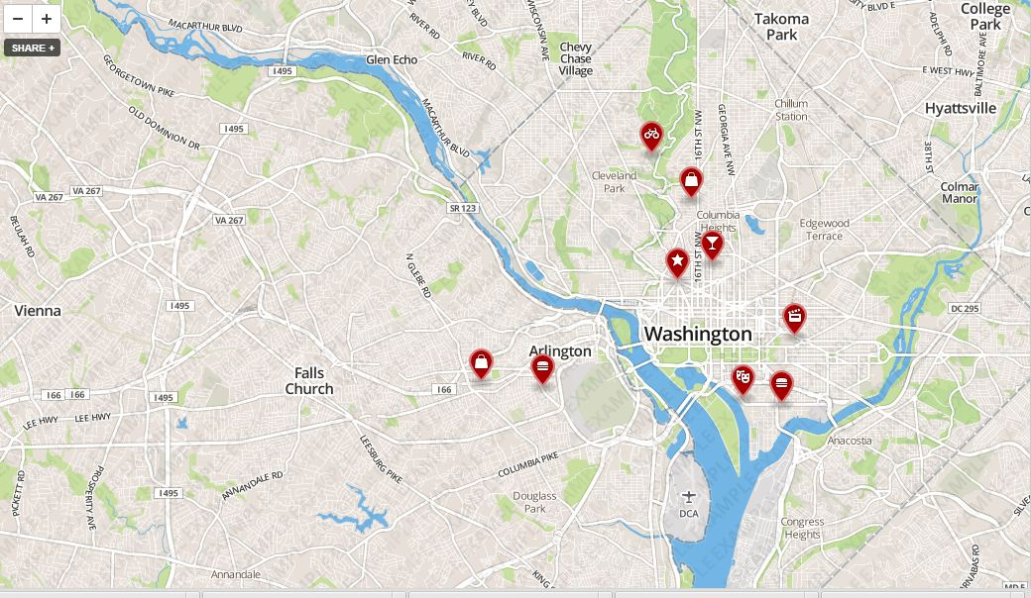

Dynamic map with markers

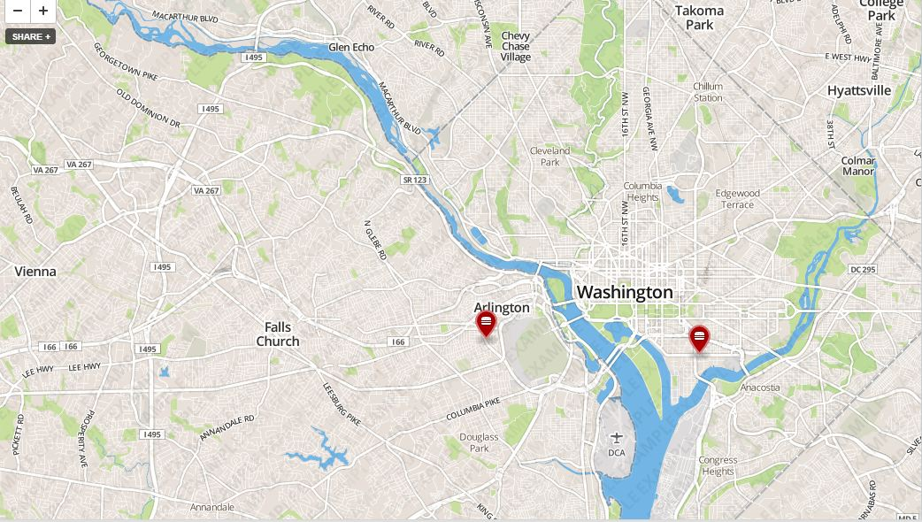

Map with selective markers

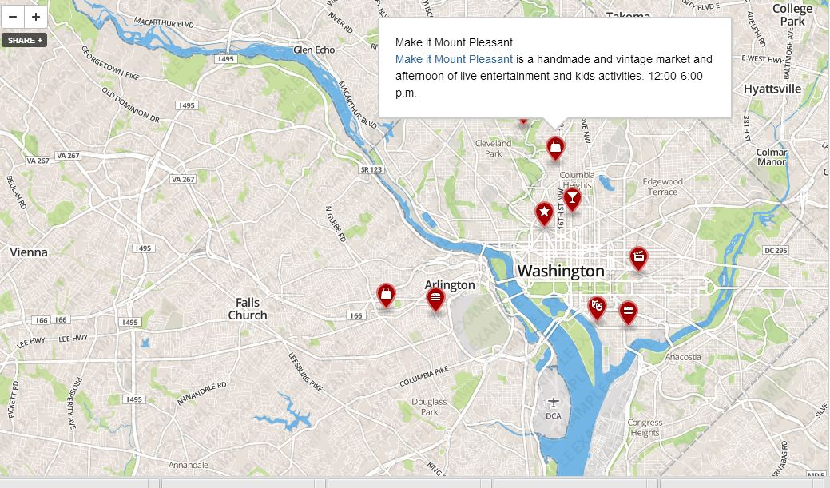

Markers pop ups

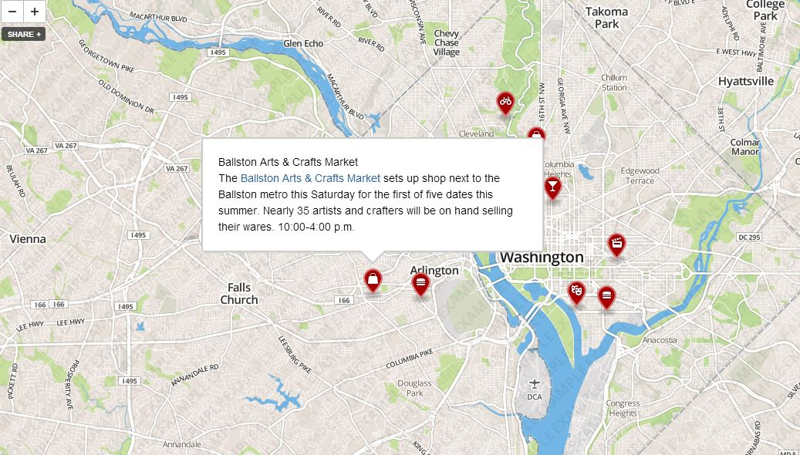

Filtered markers with pop ups

