HABILELABS PVT. LTD.

SOP ON NODE.JS

By: Prachi Lakhera
Abhishek Gupta

Table of Content

1. INTODUCTION TO NODE.JS
2. INSTALLATION OF NODE.JS
2.1. Node.Js NPM (Node Package Manager)
2.2. Getting Started
3. HTTP
3.1. Built an HTTP Server
3.1.1. Add a HTTP Header
3.1.2. Read the Query String
3.2. Representational State Transfer
3.2.1. HTTP Methods
3.2.2. Creating RESTful for a Library
4. FILE SYSTEM
4.1. __dirname and __filename
4.1.1. __dirname
4.1.1.1. Working with directories
- Making New Directories
- Pointing to Directories
- Adding Files to Directory
4.1.2. __filename
4.2. Node.Js file as a Server
4.2.1. Read Files
4.2.2. Create Files
4.2.3. Update Files
4.2.4. Delete Files
4.2.5. Rename Files
5. SYNCHRONOUS VS. ASYNCHORNOUS I/O
5.1.1. Synchronous Methods
5.1.2. Asynchronous Methods
6. CALLBACK CONCEPT
7. PROMISES
7.1. Callbacks to Promises
7.2. Nested Promises
7.3. Creating Custom Promises
8. ASYNC / AWAIT FUNCTION
9. EVENTS, BUFFER AND STREAMS
9.1. Events
9.1.1. Event Driven Programming
9.1.2. EventEmitter Methods
9.2. Buffers
9.2.1. Creating Buffers
9.2.2. Writing to Buffers
9.3. Streams
9.3.1. Reading from a Stream
9.3.2. Writing to a Stream
9.3.3. Piping the Stream
9.3.4. Flowing and Non-Flowing Stream
9.3.5. Example of streaming
10. MODULES
10.1. Core Modules
10.2. Local Modules
10.3. Third Party Modules
11. EXPRESS.JS
11.1. Installation of Express
11.2 Express.Js Templating Engine
11.3. Express.Js Request Object
11.4. Express.Js Response Object
11.5. Express.Js GET Request
11.6. Express.Js POST Request
11.7. Express.Js PUT Request
11.8. Express.Js DELETE Request
11.9. Express.Js Routing
11.10. Express.Js Middleware
12. JSONWEBTOKENS (JWT)
12.1. Token Expiration
12.2. Example of APIs and JWT

INTRODUCTION TO NODE.JS

Node.js is an open-source and cross-platform JavaScript runtime environment. It is a popular tool for almost any kind of project!

Node.js runs the V8 JavaScript engine, the core of Google Chrome, outside of the browser. This allows Node.js to be very performant.

A Node.js app runs in a single process, without creating a new thread for every request. Node.js provides a set of asynchronous I/O primitives in its standard library that prevent JavaScript code from blocking and generally, libraries in Node.js are written using non-blocking paradigms, making blocking behavior the exception rather than the norm.

When Node.js performs an I/O operation, like reading from the network, accessing a database or the filesystem, instead of blocking the thread and wasting CPU cycles waiting, Node.js will resume the operations when the response comes back.

This allows Node.js to handle thousands of concurrent connections with a single server without introducing the burden of managing thread concurrency, which could be a significant source of bugs.

Node.js has a unique advantage because millions of frontend developers that write JavaScript for the browser are now able to write the server-side code in addition to the client-side code without the need to learn a completely different language.

In Node.js the new ECMAScript standards can be used without problems, as you don't have to wait for all your users to update their browsers - you are in charge of deciding which ECMAScript version to use by changing the Node.js version, and you can also enable specific experimental features by running Node.js with flags.

INSTALLATION OF NODE.JS

Step 1: Open your terminal or press Ctrl + Alt + T.
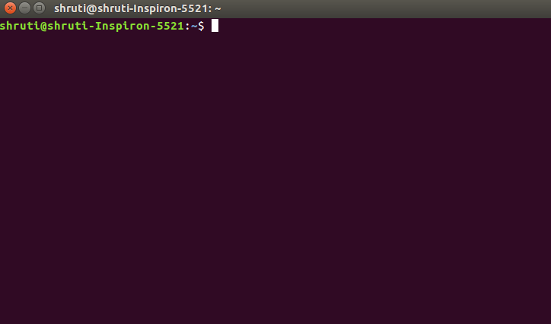

Step 2: To install node.js use the following command:
sudo apt install nodejs

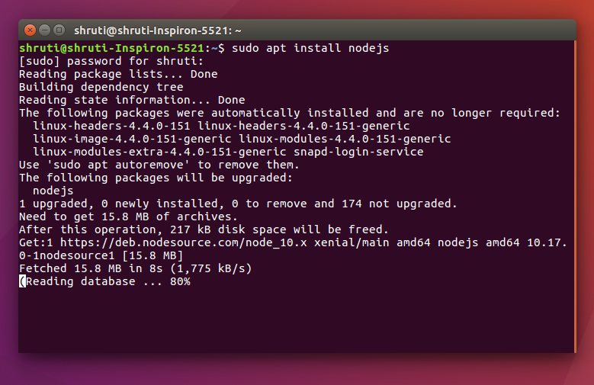

Step 3: Once installed, verify it by checking the installed version using the following command:

node -v or node –version

Note: It is recommended to install Node Package Manager(NPM) with Node.js. NPM is an open source library of Node.js packages.
To install NPM, use the following commands:

sudo apt install npm
npm -v or npm –version

NODE.JS NPM (Node Package Manager)

NPM (Node Package Manager) is the default package manager for Node.js and is written entirely in Javascript. Developed by Isaac Z. Schlueter, it was initially released in January 12, 2010. NPM manages all the packages and modules for Node.js and consists of command line client npm. It gets installed into the system with installation of Node.js. The required packages and modules in Node project are installed using NPM.

A package contains all the files needed for a module and modules are the JavaScript libraries that can be included in Node project according to the requirement of the project.
Creating a Node Project:
To create a Node project, npm init is used in the folder in which user want to create project. The npm command line will ask a number of questions like name, license, scripts, description, author, keywords, version, main file etc. After npm is done creating the project, a package.json file will be visible in project folder as a proof that the project has been initialized.

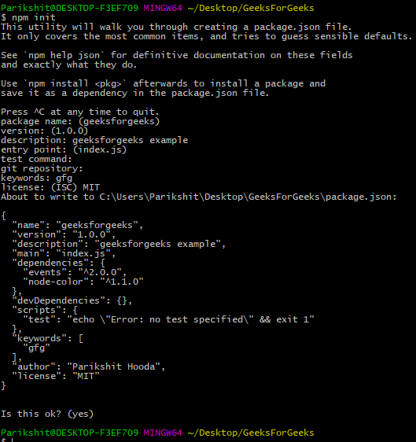

Installing Packages:
After creating the project, next step is to incorporate the packages and modules to be used in the Node Project. To install packages and modules in the project use the following syntax:
Syntax:
npm install package_name

Example: Installing the express package into the project. Express is the web development framework used by the Node.
Syntax:
npm install express

GETTING STARTED

A Node.js application consists of the following three important components −
- Import required modules − We use the require directive to load Node.js modules.
- Create server − A server which will listen to client's requests similar to Apache HTTP Server.
- Read request and return response − The server created in an earlier step will read the HTTP request made by the client which can be a browser or a console and return the response.
REPL stands for Read Eval Print Loop and it represents a computer environment like a
Windows console or Unix/Linux shell where a command is entered and the system responds
with an output in an interactive mode. Node.js or Node comes bundled with a REPL
environment. It performs the following tasks −
- Read − Reads user's input, parses the input into JavaScript data-structure, and stores in memory.
- Eval − Takes and evaluates the data structure.
- Print − Prints the result.
- Loop − Loops the above command until the user presses ctrl-c twice.
The REPL feature of Node is very useful in experimenting with Node.js codes and to debug JavaScript codes.
Once you have downloaded and installed Node.js on your computer, let's try to display "Hello World" in a web browser.
Create a Node.js file named "myfirst.js", and add the following code:
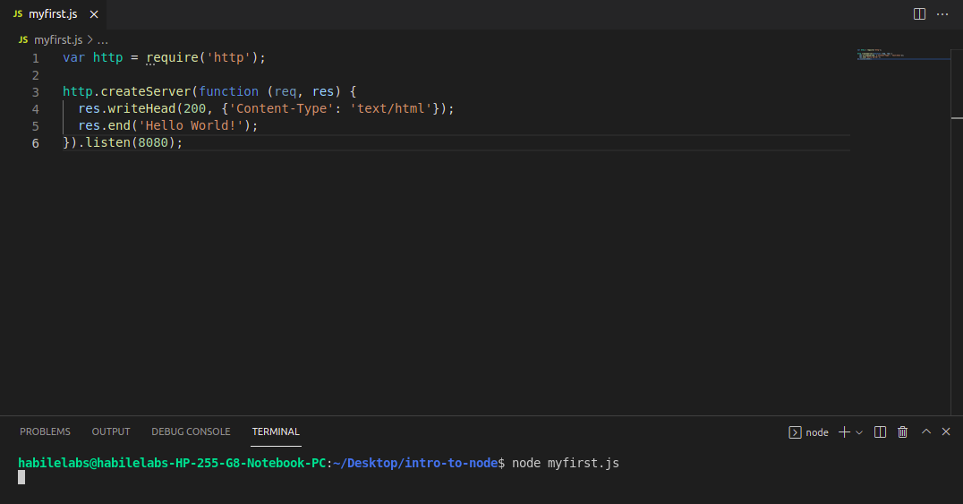
Output:

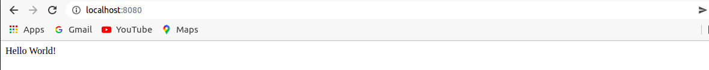
We use the created http instance and call http.createServer() method to create a server instance and then we bind it at port 8080 using the listen method associated with the server instance. Pass it a function with parameters request and response. Write the sample implementation to always return "Hello World".

HTTP

BUILT AN HTTP SERVER

The HTTP interfaces in Node.js are designed to support many features of the protocol which have been traditionally difficult to use. In particular, large, possibly chunk-encoded, messages. The interface is careful to never buffer entire requests or responses, so the user is able to stream data.

In order to support the full spectrum of possible HTTP applications, the Node.js HTTP API is very low-level. It deals with stream handling and message parsing only. It parses a message into headers and body but it does not parse the actual headers or the body.

The HTTP module can create an HTTP server that listens to server ports and gives a response back to the client.
Use the createServer() method to create an HTTP server:
To use the HTTP server and client one must require(‘http’).
Example of HTTP web-server
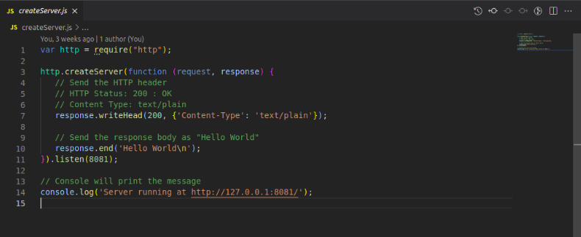

Step to run this program: Run this createServer.js file using the below command:
node createServer.js

Output: Hello World

The function passed into the http.createServer() method, will be executed when someone tries to access the computer on port 8081.
The first argument of the res.writeHead() method is the status code, 200 means that all is OK, the second argument is an object containing the response headers.
Whenever the server is running, and accessing the route http://localhost:8081/, it will output the plain text hello world!.

ADD AN HTTP HEADER
If the response from the HTTP server is supposed to be displayed as HTML, you should include an HTTP header with the correct content type:
Example
var http = require('http');
http.createServer(function (req, res) {
// add a HTTP header:
res.writeHead(200, {'Content-Type': 'text/html'});
res.write('Hello World!');
res.end();
}).listen(8080);

Output:
Hello World!
The first argument of the res.writeHead() method is the status code, 200 means that all is OK, the second argument is an object containing the response headers.

READ THE QUERY STRING
The function passed into the http.createServer() has a req argument that represents the request from the client, as an object (http.IncomingMessage object).
This object has a property called "url" which holds the part of the url that comes after the domain name:
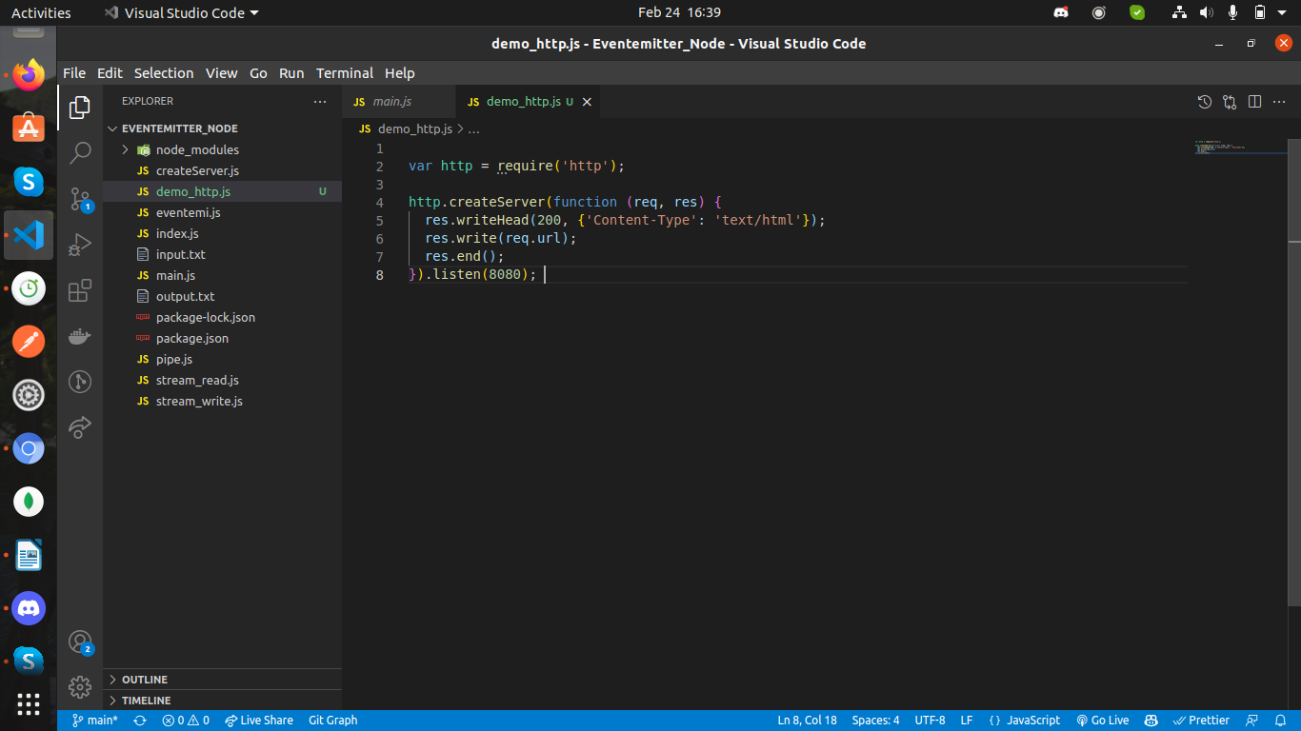
Save the code above in a file called "demo_http_url.js" and initiate the file:
node demo_http_url.js
Now you will two different results while opening these two addresses:

- http://localhost:8080/summer
Output: /summer

- http://localhost:8080/winter
Output: /winter

REPRESENTATIONAL STATE TRANSFER

What is REST architecture?
REST stands for REpresentational State Transfer. REST is web standards based architecture and uses HTTP Protocol. It revolves around resource where every component is a resource and a resource is accessed by a common interface using HTTP standard methods. REST was first introduced by Roy Fielding in 2000.
A web service is a collection of open protocols and standards used for exchanging data between applications or systems. Software applications written in various programming languages and running on various platforms can use web services to exchange data over computer networks like the Internet in a manner similar to inter-process communication on a single computer. This interoperability (e.g., communication between Java and Python, or Windows and Linux applications) is due to the use of open standards.
A REST Server simply provides access to resources and REST client accesses and modifies the resources using HTTP protocol. Here each resource is identified by URIs/ global IDs. REST uses various representation to represent a resource like text, JSON, XML but JSON is the most popular one.

HTTP methods:
Following four HTTP methods are commonly used in REST based architecture.
- GET − This is used to provide a read only access to a resource.
- PUT − This is used to create a new resource.
- DELETE − This is used to remove a resource.
- POST − This is used to update a existing resource or create a new resource.

Creating RESTful for A Library
Consider we have a JSON based database of users having the following users in a file users.json:
{
"user1" : {
"name" : "mahesh",
"password" : "password1",
"profession" : "teacher",
"id": 1
},

"user2" : {
"name" : "suresh",
"password" : "password2",
"profession" : "librarian",
"id": 2
},

"user3" : {
"name" : "ramesh",
"password" : "password3",
"profession" : "clerk",
"id": 3
}
}

List Users
Let's implement our first RESTful API list users using the following code in a server.js file −
server.js
var express = require('express');
var app = express();
var fs = require("fs");

app.get('/listUsers', function (req, res) {
fs.readFile( __dirname + "/" + "users.json", 'utf8', function (err, data) {
console.log( data );
res.end( data );
});
})

var server = app.listen(8081, function () {
var host = server.address().address
var port = server.address().port
console.log("Example app listening at http://%s:%s", host, port)
})
Now try to access defined API using URL: http://127.0.0.1:8081/listUsers and HTTP Method : GET on local machine using any REST client.

FILE SYSTEM

__dirname AND __filename
__dirname
__dirname is an environment variable that tells you the absolute path of the directory containing the currently executing file.
Dirname example

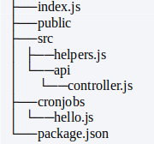

You can use __dirname to check on which directories your files live.
Create and edit controller.js in the api subdirectory in the src directory:
src/api/controller.js
console.log(__dirname) // “/Users/Sam/dirname-example/src/api”
console.log(process.cwd()) // “/Users/Sam/dirname-example”
Notice that __dirname has a different value depending on which file you console it out. The process.cwd() method also returns a value, but the project directory instead. The __dirnamevariable always returns the absolute path of where your files live.

Working With Directories-

Making New Directories:
To create a new directory in your index.js file, insert __dirname as the first argument to path.join() and the name of the new directory as the second:
index.js
const fs = require('fs');
const path = require('path')
const dirPath = path.join(__dirname, '/pictures');

fs.mkdirSync(dirPath);

Now you’ve created a new directory, pictures,after calling on the mkdirSync()method, which contains __dirname as the absolute path.

Pointing to Directories:
Another unique feature is its ability to point to directories. In your index.js file, declare a variable and pass in the value of __dirname as the first argument in path.join(), and your directory containing static files as the second:
index.js
express.static(path.join(__dirname,'/public'));
Here, you’re telling Node.js to use __dirname to point to the public directory that contains static files.

Adding Files to a Directory:
You may also add files to an existing directory. In your index.js file,declare a variable and include __dirname as the first argument and the file you want to add as the second:
index.js
const fs = require('fs');
const path = require('path')
const filePath = path.join(__dirname, '/pictures');
fs.opesync(filePath, 'hello.jpeg');

Using the openSync() method will add the file if it does not exist within your directory.

__filename
The __filename in the Node.js returns the filename of the code which is executed. It gives the absolute path of the code file. The following approach covers how to implement __filename in the NodeJS project.
Syntax:
console.log(__filename)
Return Value: It returns the absolute filename of the current module.

Example: Create a JavaScript file index.js and write down the following code:
// Node.js code to demonstrate the absolute
// file name of the current Module.
console.log("Filename of the current file is: ",
__filename);

Run the index.js file using the following command:
node index.js
Output:
Filename of the current file is:
C:\Users\Pallavi\Desktop\node_func\app.js

Node.js as a File Server
The Node.js file system module allows you to work with the file system on your computer.
To include the File System module, use the require() method:
var fs = require('fs');
Common use for the File System module:
- Read files
- Create files
- Update files
- Delete files
- Rename files

Read Files
The fs.readFile() method is used to read files on your computer.

Create Files
The File System module has methods for creating new files:
- fs.appendFile()
- fs.open()
- fs.writeFile()

Update Files
The File System module has methods for updating files:
- fs.appendFile()
- fs.writeFile()

Delete Files
To delete a file with the File System module, use the fs.unlink() method.

Rename Files
To rename a file with the File System module, use the fs.rename() method.

SYNCHRONOUS VS. ASYNCHRONOUS I/O

NodeJS provides us with an inbuilt fs (File System) module for various file handling operations like read a file, write a file, delete a file etc. fs module can be installed using the below statement:
Syntax:
npm install fs –save

For using the fs module, append the following statement in the code:
const fs = require('fs');
SYNCHRONOUS METHODS
Synchronous functions block the execution of the program until the file operation is performed. These functions are also called blocking functions. The synchronous methods have File Descriptor as the last argument. File Descriptor is a reference to opened files. It is a number or a reference id to the file returned after opening the file using fs.open() method of the fs module. All asynchronous methods can perform synchronously just by appending “Sync” to the function name. Some of the synchronous methods of fs module in NodeJS are:
- fs.readFileSync()
- fs.renameSync()
- fs.writeSync()
- fs.writeFileSync()
- fs.fsyncSync()
- fs.appendFileSync()
- fs.statSync()
- fs.readdirSync()
- fs.existsSync()
Example: Synchronous read method

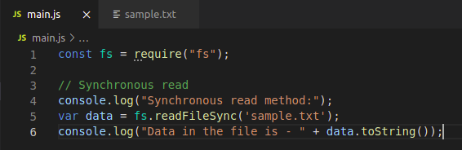
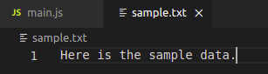

Output:
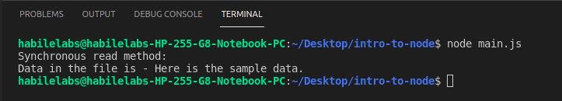

ASYNCHRONOUS METHODS
Asynchronous functions do not block the execution of the program and each command is executed after the previous command even if the previous command has not computed the result. The previous command runs in the background and loads the result once it has finished processing. Thus, these functions are called non-blocking functions. They take a callback function as the last parameter. Asynchronous functions are generally preferred over synchronous functions as they do not block the execution of the program whereas synchronous functions block the execution of the program until it has finished processing. Some of the asynchronous methods of fs module in NodeJS are:
- fs.readFile()
- fs.rename()
- fs.write()
- fs.writeFile()
- fs.fsync()
- fs.appendFile()
- fs.stat()
- fs.readdir()
- fs.exists()
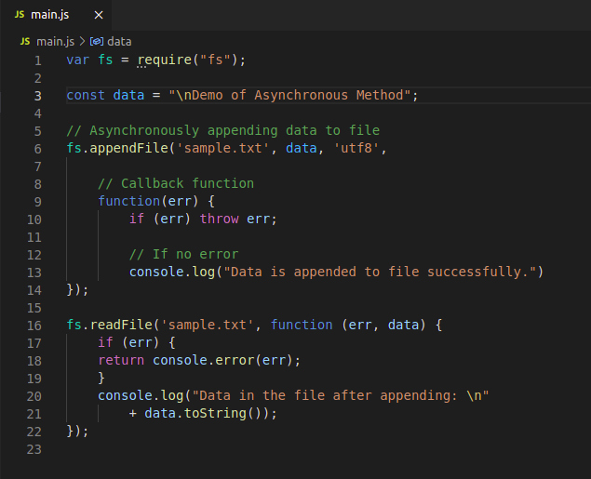
Example: Asynchronous append method

Output:

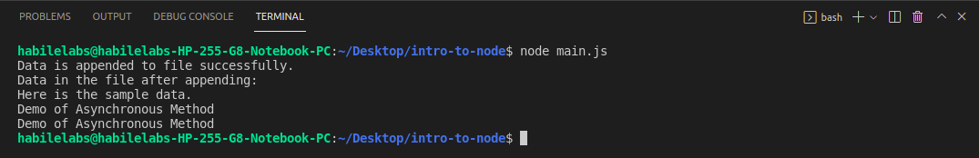

CALLBACK CONCEPT
A callback is a function which is called when a task is completed, thus helps in preventing any kind of blocking and a callback function allows other code to run in the meantime. Callback is called when task get completed and is asynchronous equivalent for a function.
In Node.js, when a function start reading file, it returns the control to execution environment immediately so that the next instruction can be executed. Once file I/O gets completed, callback function will get called to avoid blocking or wait for File I/O.
Example 1: Code for reading a file synchronously (blocking code) in Node.js. Create a text file inputfile1.txtwith the following content:
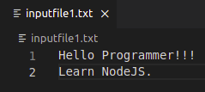

Create a sync.js file with the following code:

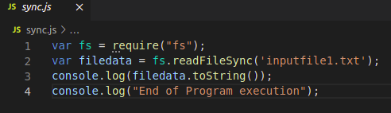

Explanation: fs library is loaded to handle file-system related operations. The readFileSync() function is synchronous and blocks execution until finished. The function blocks the program until it reads the file and then only it proceeds to end the program
Output:
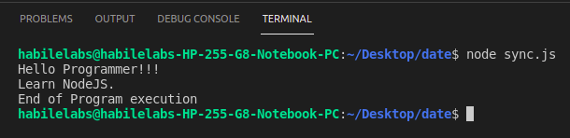
Example 2: Code for reading a file asynchronously (non-blocking code) in Node.js. Create a text file inputfile1.txt with the following content.

Create a async.js file with the following code:
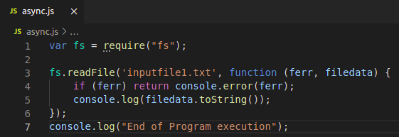
Explanation: fs library is loaded to handle file-system related operations. The readFile() function is asynchronous and control return immediately to the next instruction in the program while the function keep running in the background. A callback function is passed which gets called when the task running in the background are finished.
Output:
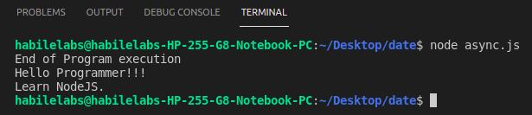

PROMISES
Promises are used to handle asynchronous operations. They are easy to manage when dealing with multiple asynchronous operations where callbacks can create callback hell leading to unmanageable code.
Promises are the ideal choice for handling asynchronous operations in the simplest manner. They can handle multiple asynchronous operations easily and provide better error handling than callbacks and events. In other words also, we may say that, promises are the ideal choice for handling multiple callbacks at the same time, thus avoiding the undesired callback hell situation. Promises do provide a better chance to a user to read the code in a more effective and efficient manner especially it that particular code is used for implementing multiple asynchronous operations.
Syntax
var promise = new Promise(function(resolve, reject){
//do something
});
Callbacks to Promises
Promises notify whether the request is fulfilled or rejected. Callbacks can be registered with the .then() to handle fulfillment and rejection. The .then() can be chained to handle the fulfillment and rejection whereas .catch() can be used for handling the errors(if any).
Nested Promises
Often you will encounter situations where you need to make use of nested Promises. Nested promises begin with a .then() and in each of the .then() we have a return statement. After the return statement, .then() follows in the same manner.
Creating custom Promises
You can always create your own custom Promises in Node using the new constructor.

ASYNC / AWAIT FUNCTION
Async/Await is the extension of promises which we get as a support in the language.
Async:
It simply allows us to write promises based code as if it was synchronous and it checks that we are not breaking the execution thread. It operates asynchronously via the event-loop. Async functions will always return a value. It makes sure that a promise is returned and if it is not returned then javascript automatically wraps it in a promise which is resolved with its value.
Examples
const getData = async() => {
var data = "Hello World";
return data; }
getData().then(data => console.log(data));
Output:
Hello World
Await:
Await function is used to wait for the promise. It could be used within the async block only. It makes the code wait until the promise returns a result. It only makes the async block wait.
Example
const getData = async() => {
var y = await "Hello World";
console.log(y); }
console.log(1);
getData();
console.log(2);

Output:
1
2
Hello World

Example of Promise function and async and await function:

Create inputfile1.txt .

Create index.js .

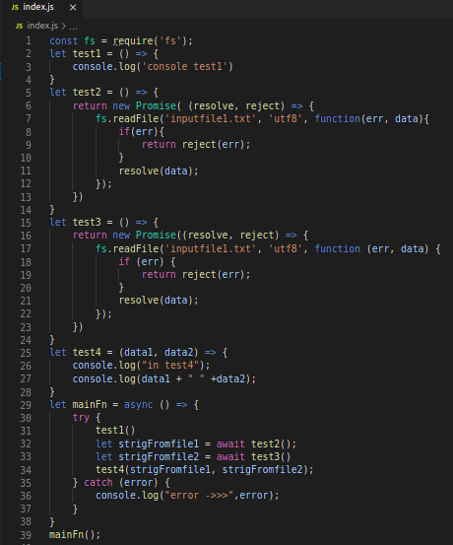

Output:

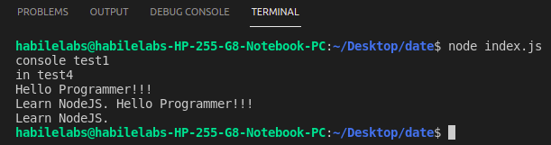

EVENTS, BUFFERS AND STREAMS

EVENTS
Node.js is a single-threaded application, but it can support concurrency via the concept of event and callbacks. Every API of Node.js is asynchronous and being single-threaded, they use async function calls to maintain concurrency. Node uses observer pattern. Node thread keeps an event loop and whenever a task gets completed, it fires the corresponding event which signals the event-listener function to execute.

Event-Driven Programming
Node.js uses events heavily and it is also one of the reasons why Node.js is pretty fast compared to other similar technologies. As soon as Node starts its server, it simply initiates its variables, declares functions and then simply waits for the event to occur.
In an event-driven application, there is generally a main loop that listens for events, and then triggers a callback function when one of those events is detected.
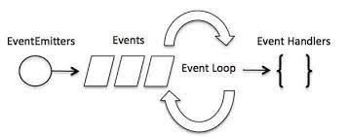

Although events look quite similar to callbacks, the difference lies in the fact that callback functions are called when an asynchronous function returns its result, whereas event handling works on the observer pattern. The functions that listen to events act as Observers. Whenever an event gets fired, its listener function starts executing.
Node.js has multiple in-built events available through events module and EventEmitter class which are used to bind events and event-listeners as follows-
// Import events module
var events = require('events');

// Create an eventEmitter object
var eventEmitter = new events.EventEmitter();
Following is the syntax to bind an event handler with an event −
// Bind event and event handler as follows
eventEmitter.on('eventName', eventHandler);
We can fire an event programmatically as follows −
// Fire an event
eventEmitter.emit('eventName');

Example
Create a js file named main.js with the following code −
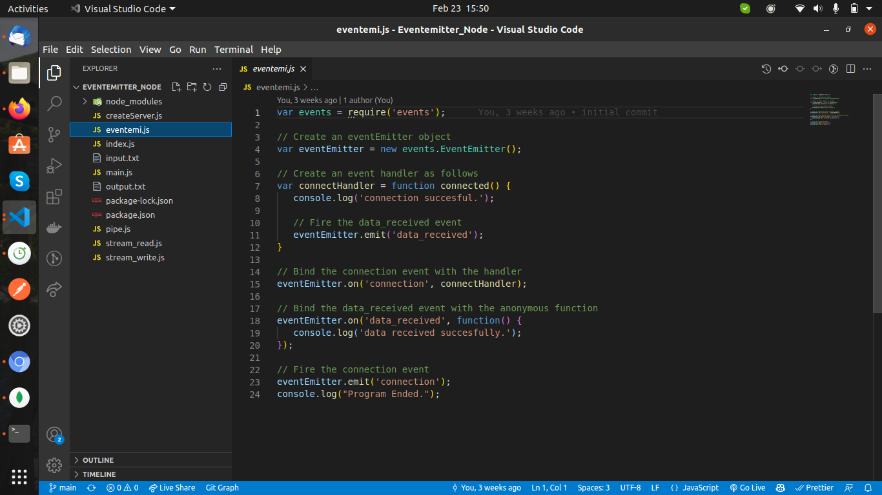
Now let's try to run the above program and check its output −
$ node main.js
IT should produce the following result −
connection successful.
data received successfully.

Making an async fuction using callback -
In Node Application, any async function accepts a callback as the last parameter and a callback function accepts an error as the first parameter. Let's revisit the previous example again. Create a text file named input.txt with the following content.
This is self learning content.
It is simple and easy !!!!!
Create a js file named main.js having the following code −
var fs = require("fs");

fs.readFile('input.txt', function (err, data) {
if (err) {
console.log(err.stack);
return;
}
console.log(data.toString());
});
console.log("Program Ended");
Here fs.readFile() is a async function whose purpose is to read a file. If an error occurs during the read operation, then the err object will contain the corresponding error, else data will contain the contents of the file. readFile passes err and data to the callback function after the read operation is complete, which finally prints the content.
Output

Program Ended
This is self learning content.
It is simple and easy !!!!!

EventEmitter Methods

When an EventEmitter instance faces any error, it emits an 'error' event. When a new listener is added, 'newListener' event is fired and when a listener is removed, 'removeListener' event is fired.
EventEmitter provides multiple properties like on and emit. on property is used to bind a function with the event and emit is used to fire an event.

Methods-
Sr.No. | Method & Description
1 | addListener(event, listener)  Adds a listener at the end of the listeners array for the specified event. No checks are made to see if the listener has already been added. Multiple calls passing the same combination of event and listener will result in the listener being added multiple times. Returns emitter, so calls can be chained.
2 | on(event, listener)  Adds a listener at the end of the listeners array for the specified event. No checks are made to see if the listener has already been added. Multiple calls passing the same combination of event and listener will result in the listener being added multiple times. Returns emitter, so calls can be chained.
3 | once(event, listener)  Adds a one time listener to the event. This listener is invoked only the next time the event is fired, after which it is removed. Returns emitter, so calls can be chained.
4 | removeListener(event, listener)  Removes a listener from the listener array for the specified event. Caution − It changes the array indices in the listener array behind the listener. removeListener will remove, at most, one instance of a listener from the listener array. If any single listener has been added multiple times to the listener array for the specified event, then removeListener must be called multiple times to remove each instance. Returns emitter, so calls can be chained.
5 | removeAllListeners([event])  Removes all listeners, or those of the specified event. It's not a good idea to remove listeners that were added elsewhere in the code, especially when it's on an emitter that you didn't create (e.g. sockets or file streams). Returns emitter, so calls can be chained.
6 | setMaxListeners(n)  By default, EventEmitters will print a warning if more than 10 listeners are added for a particular event. This is a useful default which helps finding memory leaks. Obviously not all Emitters should be limited to 10. This function allows that to be increased. Set to zero for unlimited.
7 | listeners(event)  Returns an array of listeners for the specified event.
8 | emit(event, [arg1], [arg2], [...])  Execute each of the listeners in order with the supplied arguments. Returns true if the event had listeners, false otherwise.

BUFFER

Node provides Buffer class which provides instances to store raw data similar to an array of integers but corresponds to a raw memory allocation outside the V8 heap.
Buffer class is a global class that can be accessed in an application without importing the buffer module.

Creating Buffers
Node Buffer can be constructed in a variety of ways.

Method 1
Following is the syntax to create an uninitiated Buffer of 10 octets −
var buf = new Buffer(10);

Method 2
Following is the syntax to create a Buffer from a given array −
var buf = new Buffer([10, 20, 30, 40, 50]);

Method 3
Following is the syntax to create a Buffer from a given string and optionally encoding type −
var buf = new Buffer("Simply Easy Learning", "utf-8");
Though "utf8" is the default encoding, you can use any of the following encodings "ascii", "utf8", "utf16le", "ucs2", "base64" or "hex".

Writing to Buffers

Syntax
Following is the syntax of the method to write into a Node Buffer −
buf.write(string[, offset][, length][, encoding])

Parameters
Here is the description of the parameters used −
- string − This is the string data to be written to buffer.
- offset − This is the index of the buffer to start writing at. Default value is 0.
- length − This is the number of bytes to write. Defaults to buffer.length.
- encoding − Encoding to use. 'utf8' is the default encoding.

Return Value
This method returns the number of octets written. If there is not enough space in the buffer to fit the entire string, it will write a part of the string.

Example
buf = new Buffer(256);
len = buf.write("Simply Easy Learning");

console.log("Octets written : "+ len);
When the above program is executed, it produces the following result −
Octets written : 20

Reading from Buffers

Syntax
Following is the syntax of the method to read data from a Node Buffer −
buf.toString([encoding][, start][, end])

Parameters
Here is the description of the parameters used −
- encoding − Encoding to use. 'utf8' is the default encoding.
- start − Beginning index to start reading, defaults to 0.
- end − End index to end reading, defaults is complete buffer.

Return Value
This method decodes and returns a string from buffer data encoded using the specified character set encoding.

Example
buf = new Buffer(26);
for (var i = 0 ; i < 26 ; i++) {
buf[i] = i + 97;
}

console.log( buf.toString('ascii')); // outputs: abcdefghijklmnopqrstuvwxyz
console.log( buf.toString('ascii',0,5)); // outputs: abcde
console.log( buf.toString('utf8',0,5)); // outputs: abcde
console.log( buf.toString(undefined,0,5)); // encoding defaults to 'utf8', outputs abcde
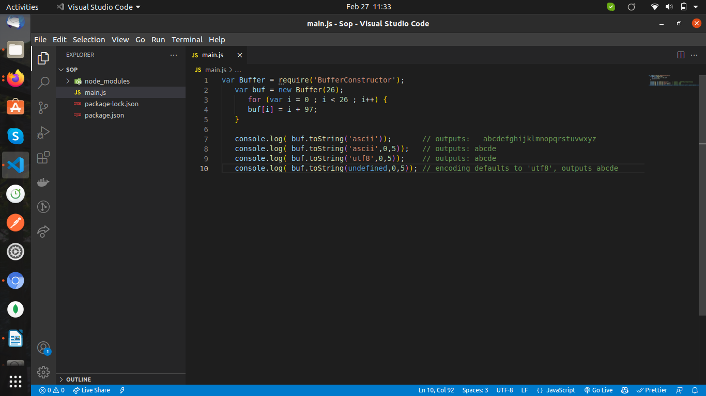
Output
When the above program is executed, it produces the following result −
abcdefghijklmnopqrstuvwxyz
abcde
abcde
abcde

STREAMS

Streams are objects that let you read data from a source or write data to a destination in continuous fashion. In Node.js, there are four types of streams −
- Readable − Stream which is used for read operation.
- Writable − Stream which is used for write operation.
- Duplex − Stream which can be used for both read and write operation.
- Transform − A type of duplex stream where the output is computed based on input.
Each type of Stream is an EventEmitter instance and throws several events at different instance of times. For example, some of the commonly used events are −
- data − This event is fired when there is data is available to read.
- end − This event is fired when there is no more data to read.
- error − This event is fired when there is any error receiving or writing data.
- finish − This event is fired when all the data has been flushed to underlying system.
This tutorial provides a basic understanding of the commonly used operations on Streams.

Reading from a Stream
Create a text file named input.txt having the following content −
This is self learning content.
It is simple and easy !!!!!
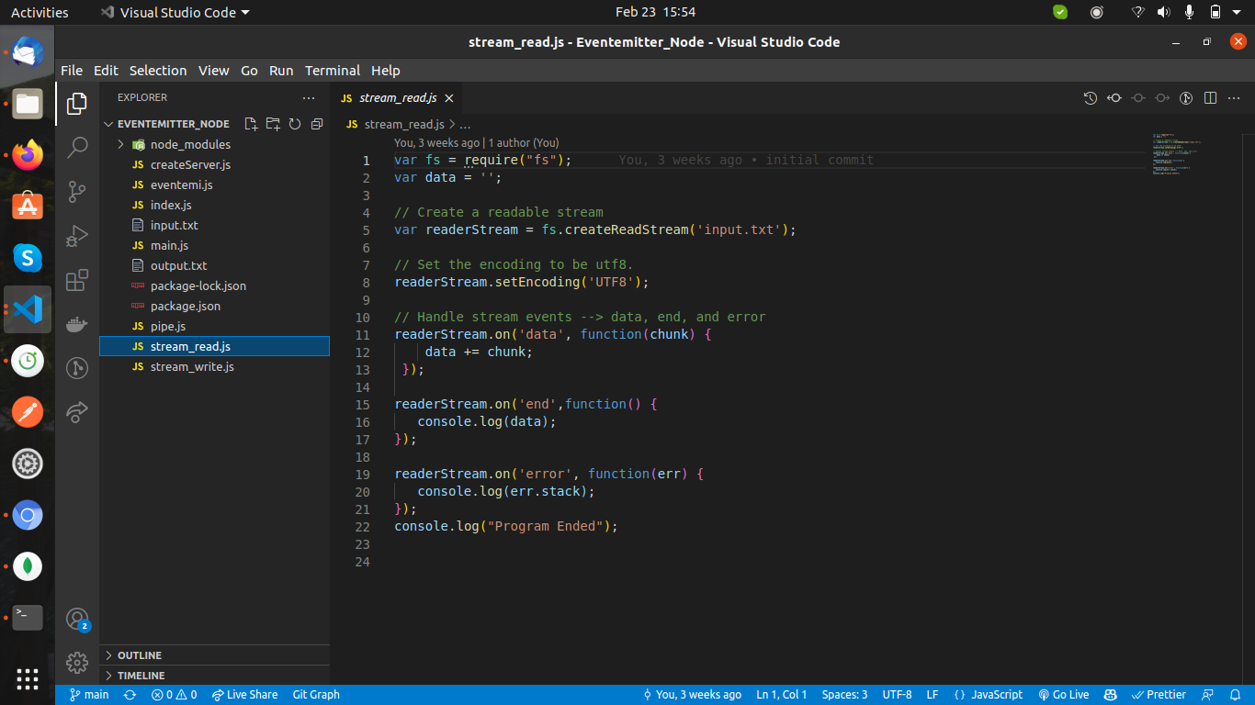

Now run the main.js to see the result −
$ node main.js
Verify the Output.
Program Ended
This is self learning content.
It is simple and easy !!!!!

Writing to a Stream

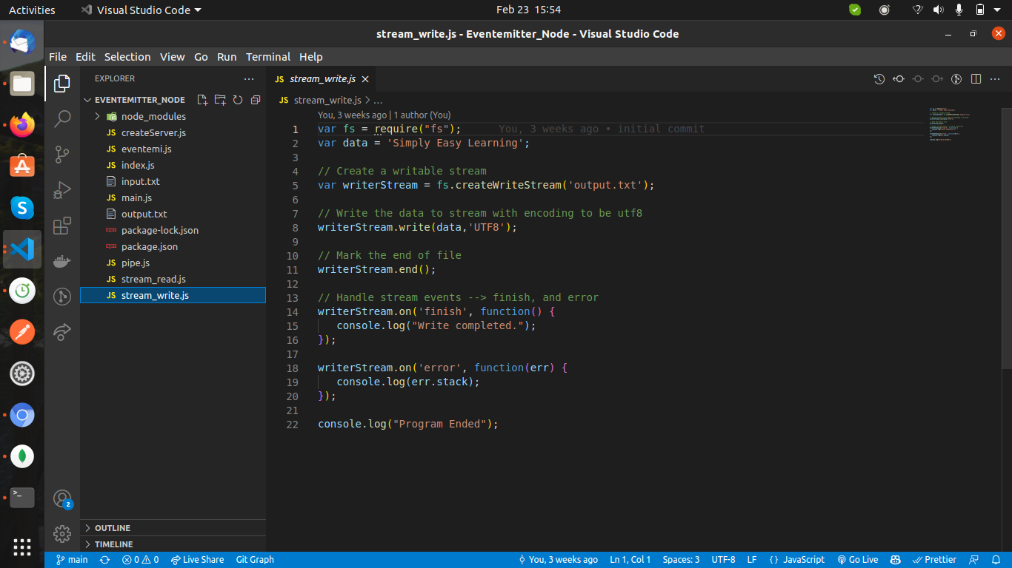

Now run the main.js to see the result −
$ node main.js
Verify the Output.
Program Ended
Write completed.
Now open output.txt created in your current directory; it should contain the following −
Simply Easy Learning

Piping the Streams
Piping is a mechanism where we provide the output of one stream as the input to another stream. It is normally used to get data from one stream and to pass the output of that stream to another stream. There is no limit on piping operations. Now we'll show a piping example for reading from one file and writing it to another file.
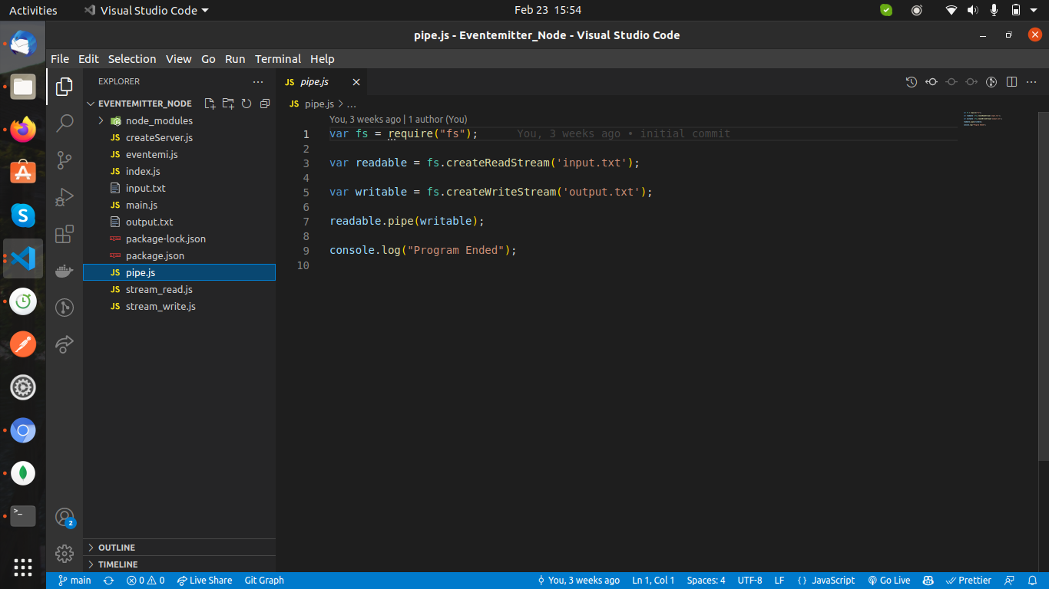
Now run the main.js to see the result −
$ node main.js
Verify the Output.
Program Ended
Open output.txt created in your current directory; it should contain the following −
This is self learning content.
It is simple and easy !!!!!

Flowing and Non-Flowing Streams
There are two types of readable streams:
- Flowing stream — A stream that keeps on passing the data that can be directly listened to by using the data event on the stream.
- Non-flowing stream — A stream that does not push data automatically. Instead, the stream stores the data in the buffer and we need to explicitly call the read() method of the stream to read it.

Example Of Streaming
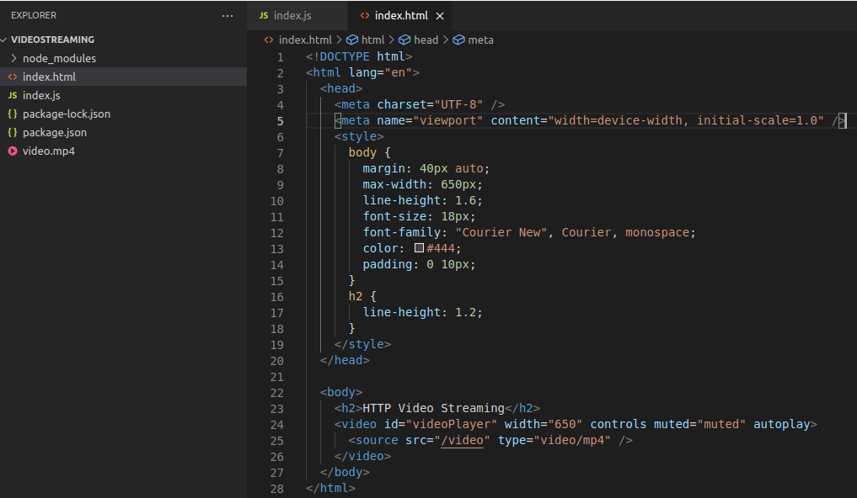
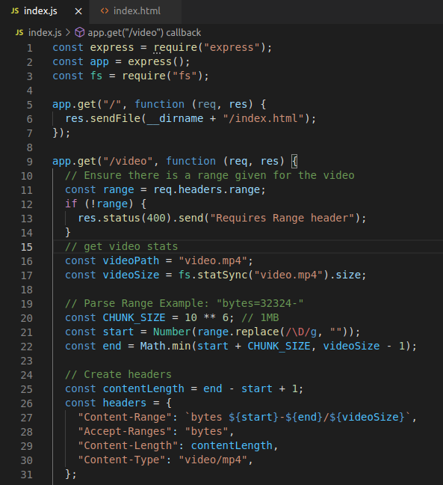

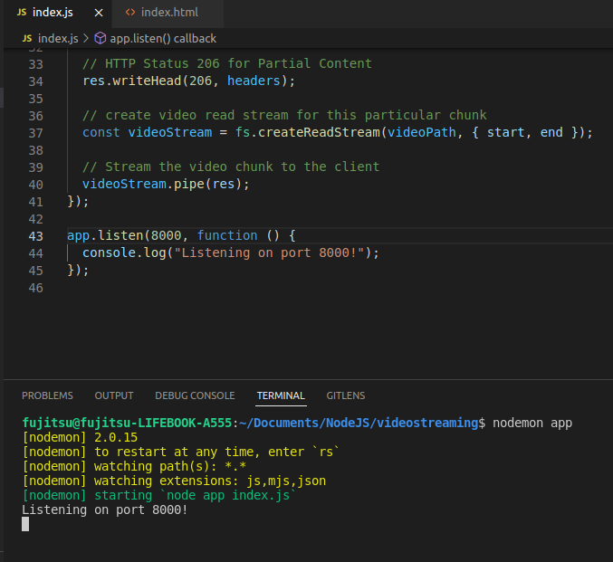

MODULES

In Node.js, Modules are the blocks of encapsulated code that communicates with an external application on the basis of their related functionality. Modules can be a single file or a collection of multiples files/folders.The reason programmers are heavily reliant on modules is because of their re-usability as well as the ability to break down a complex piece of code into manageable chunks.
Modules are of three types:
- Core Modules
- Local Modules
- Third-party Modules
Core Modules: Node.js has many built-in modules that are part of the platform and comes
with Node.js installation. These modules can be loaded into the program by using the require function.
Syntax:
var module = require('module_name');
Example:
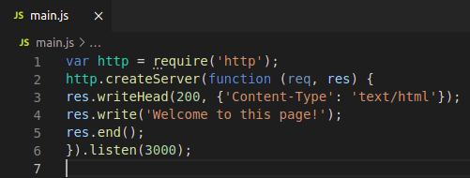

In the above example, the require() function returns an object because the Http module returns its functionality as an object. The function http.createServer() method will be executed when someone tries to access the computer on port 3000. The res.writeHead() method is the status code where 200 means it is OK, while the second argument is an object containing the response headers.
The following list contains some of the important core modules in Node.js:
Core Modules | Description
http | creates an HTTP server in Node.js.
assert | set of assertion functions useful for testing.
fs | used to handle file system.
path | includes methods to deal with file paths.
process | provides information and control about the current Node.js process.
os | provides information about the operating system.
querystring | utility used for parsing and formatting URL query strings.
url | module provides utilities for URL resolution and parsing.

Local Modules: Local modules are created locally in your Node.js application. Let’s create a simple calculating module that calculates various operations.
Example: Create a calc.js file.
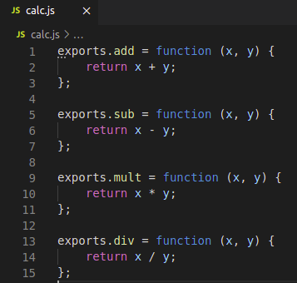

Since this file provides attributes to the outer world via exports, another file can use its exported functionality using the require() function.

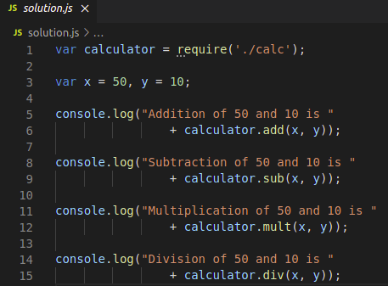
Create another file solution.js.

Step to run this program: Run solution.js file using the following command:
node solution.js
Output:
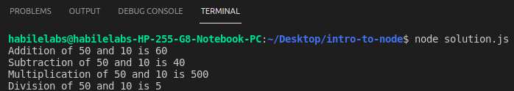
Third-party Modules: Third-party modules are modules that are available online using the Node Package Manager(NPM). These modules can be installed in the project folder or globally. Some of the popular third-party modules are mongoose, express, angular, and react.
Example:
- npm install express
- npm install mongoose

EXPRESS.JS
Express is a fast, assertive, essential and moderate web framework of Node.js. You can assume express as a layer built on the top of the Node.js that helps manage a server and routes. It provides a robust set of features to develop web and mobile applications.

INSTALLATION OF EXPRESS
As we have already installed Node.js, create a directory to hold your application, and make that your working directory.
$ mkdir myapp
$ cd myapp
Use the npm init command to create a package.json file for your application.
$ npm init

Now install Express in the myapp directory and save it in the dependencies list.
$ npm install express
Example:
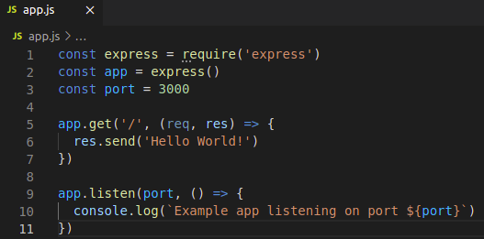

This app starts a server and listens on port 3000 for connections. The app responds with “Hello World!” for requests to the root URL (/) or route. For every other path, it will respond with a 404 Not Found.
Run the app with the following command: $ node app.js
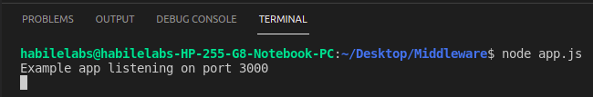
Output:
Then, load http://localhost:3000 in a browser to see the output.
EXPRESS.JS TEMPLATING ENGINE
A template engine facilitates you to use static template files in your applications. At runtime, it replaces variables in a template file with actual values, and transforms the template into an HTML file sent to the client. So this approach is preferred to design HTML pages easily.
Following is a list of some popular template engines that work with Express.js:
Pug (formerly known as jade)
mustache
dust
atpl
eco
ect
ejs
haml
haml-coffee
handlebars
hogan
jazz
jqtpl
JUST
liquor
QEJS
swig
templayed
toffee
underscore
walrus
whiskers
In the above template engines, pug (formerly known as jade) and mustache seems to be most popular choice. Pug is similar to Haml which uses whitespace. According to the template-benchmark, pug is 2x slower than Handlebars, EJS, Underscore. ECT seems to be the fastest. Many programmers like mustache template engine mostly because it is one of the simplest and versatile template engines.

Using template engines with Express
Template engine makes you able to use static template files in your application. To render template files you have to set the following application setting properties:
Views: It specifies a directory where the template files are located.
app.set('views', './views').
view engine:It specifies the template engine that you use.
app.set('view engine', 'pug').

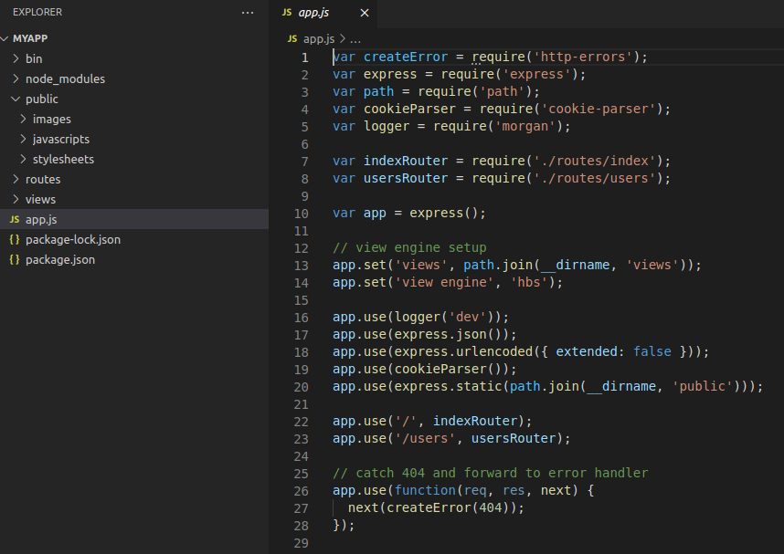

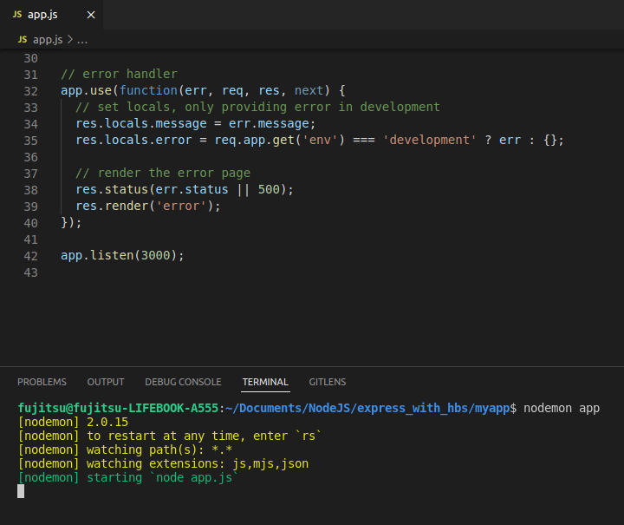

EXPRESS.JS REQUEST OBJECT
Express.js Request Object and Response objects are the parameters of the callback function which is used in Express applications.
The express.js request object represents the HTTP request and has properties for the request query string, parameters, body, HTTP headers, and so on.
Syntax:
app.get('/', function (req, res) {
//--
})

EXPRESS.JS RESPONSE OBJECT
The Response object (res) specifies the HTTP response which is sent by an Express app when it gets an HTTP request.

What it does
- It sends response back to the client browser.
- It facilitates you to put new cookies value and that will write to the client browser (under cross domain rule).
- Once you res.send() or res.redirect() or res.render(), you cannot do it again, otherwise, there will be uncaught error.
Syntax:
res.send(body)

EXPRESS.JS GET REQUEST
GET is used to request data from a specified resource. It is one of the most common HTTP methods.

Example: Respond with Hello World! on the homepage:
app.get('/', (req, res) => {
res.send('Hello World!')
})
EXPRESS.JS POST REQUEST
POST is used to send data to a server to create/update a resource. Post method facilitates you to send large amount of data because data is send in the body.

Example: Respond to POST request on the root route (/), the application’s home page:
app.post('/', (req, res) => {
res.send('Got a POST request')
})

EXPRESS.JS PUT REQUEST
PUT is used to send data to a server to create/update a resource. The difference between POST and PUT is that PUT requests are idempotent. That is, calling the same PUT request multiple times will always produce the same result. In contrast, calling a POST request repeatedly have side effects of creating the same resource multiple times.
Example: Respond to a PUT request to the /user route:
app.put('/user', (req, res) => {
res.send('Got a PUT request at /user')
})
EXPRESS.JS DELETE REQUEST
The DELETE method deletes the specified resource.

Example: Respond to a DELETE request to the /user route:
app.delete('/user', (req, res) => {
res.send('Got a DELETE request at /user')
})
EXPRESS.JS ROUTING
Routing refers to determining how an application responds to a client request to a particular endpoint, which is a URI (or path) and a specific HTTP request method (GET, POST, and so on).
Each route can have one or more handler functions, which are executed when the route is matched.
Route definition takes the following structure:
app.METHOD(PATH, HANDLER)

Where:
- app is an instance of express.
- METHOD is an HTTP request menthod, in lowercase.
- PATH is a path on the server.
- HANDLER is the function executed when the route is matched.
Let's take an example to see basic routing.
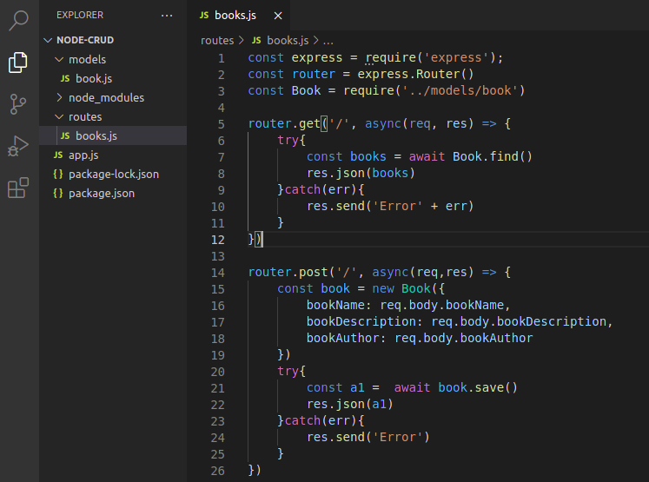

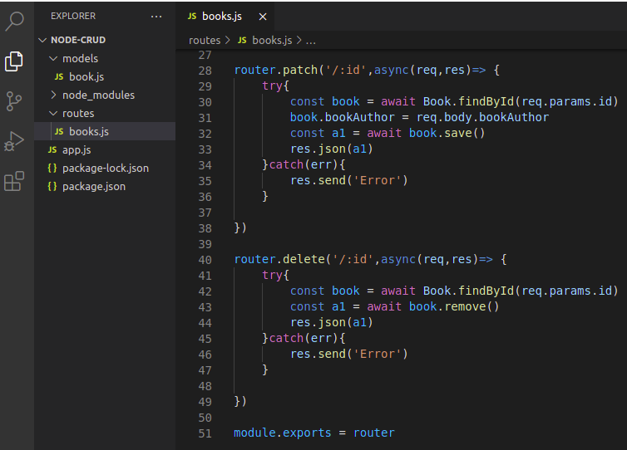

EXPRESS.JS MIDDLEWARE
Express.js Middleware are different types of functions that are invoked by the Express.js routing layer before the final request handler. As the name specified, Middleware appears in the middle between an initial request and final intended route. In stack, middleware functions are always invoked in the order in which they are added.
Middleware is commonly used to perform tasks like body parsing for URL-encoded or JSON requests, cookie parsing for basic cookie handling, or even building JavaScript modules on the fly.
Middleware functions are the functions that access to the request and response object (req, res) in request-response cycle.
A middleware function can perform the following tasks:
- It can execute any code.
- It can make changes to the request and the response objects.
- It can end the request-response cycle.
- It can call the next middleware function in the stack.
Example:
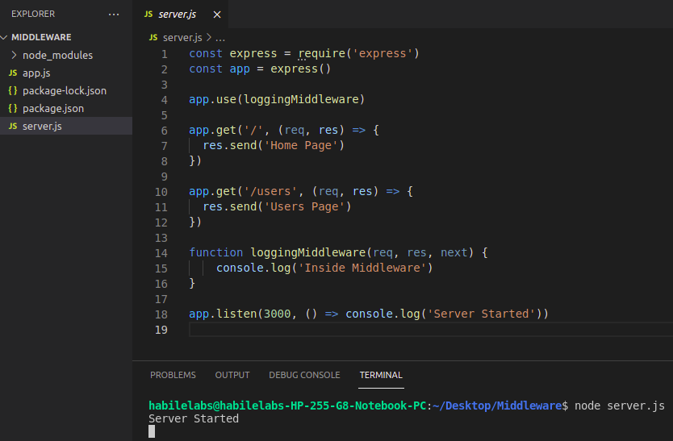

JSONWEBTOKEN (JWT)
JSON web token is an open standard for securely transferring data within parties using a JSON object. JWT is used for stateless authentication mechanisms for users and providers, this means maintaining session is on the client-side instead of storing sessions on the server. Here, we will implement the JWT authentication system in NodeJs.
Modules Required:
- NodeJs: NodeJs for backend
- dotenv: For handling configuration data
npm install dotenv
- ExpressJS: ExpressJS for Handling routes.
- jsonwebtoken module:
npm install jsonwebtoken

Usage-

jwt.sign(payload, secretOrPrivateKey, [options, callback])
(Asynchronous) If a callback is supplied, the callback is called with the err or the JWT.
(Synchronous) Returns the JsonWebToken as string
payload could be an object literal, buffer or string representing valid JSON.
secretOrPrivateKey is a string, buffer, or object containing either the secret for HMAC algorithms or the PEM encoded private key for RSA and ECDSA. In case of a private key with passphrase an object { key, passphrase } can be used (based on crypto documentation), in this case be sure you pass the algorithm option.
Synchronous Sign with default (HMAC SHA256)
var jwt=require('jsonwebtoken');
var token=jwt.sign({foo:'bar'},'shhhhh');
Sign asynchronously
jwt.sign({foo:'bar'},privateKey,{algorithm:'RS256'},function(err,token){
console.log(token);});

Token Expiration (exp claim)-
The standard for JWT defines an exp claim for expiration. The expiration is represented as a NumericDate:
A JSON numeric value representing the number of seconds from 1970-01-01T00:00:00Z UTC until the specified UTC date/time, ignoring leap seconds.
Signing a token with 1 hour of expiration:
jwt.sign({
exp:Math.floor(Date.now()/1000)+(60*60),
data:'foobar'
},'secret');
jwt.verify(token, secretOrPublicKey, [options, callback])
(Asynchronous) If a callback is supplied, function acts asynchronously. The callback is called with the decoded payload if the signature is valid and optional expiration, audience, or issuer are valid. If not, it will be called with the error.
(Synchronous) If a callback is not supplied, function acts synchronously. Returns the payload decoded if the signature is valid and optional expiration, audience, or issuer are valid. If not, it will throw the error.
token is the JsonWebToken string
secretOrPublicKey is a string or buffer containing either the secret for HMAC algorithms, or the PEM encoded public key for RSA and ECDSA. If jwt.verify is called asynchronous, secretOrPublicKey can be a function that should fetch the secret or public key. See below for a detailed example
//verify a token symmetric-synchronous
var decoded=jwt.verify(token,'shhhhh');
console.log(decoded.foo)//bar
//verify jwt id
var cert =fs.readFileSync('public.pem');//get public key
jwt.verify(token,cert,{audience:'urn:foo',issuer: 'urn:issuer', jwtid: 'jwtid'},function(err,decoded){
//if jwt id mismatch,err==invalid jwt id
});

jwt.decode(token [, options])
(Synchronous) Returns the decoded payload without verifying if the signature is valid.
Warning: This will not verify whether the signature is valid. You should not use this for untrusted messages. You most likely want to use jwt.verify instead.
token is the JsonWebToken string
options:
- json: force JSON.parse on the payload even if the header doesn't contain "typ":"JWT".
- complete: return an object with the decoded payload and header.
Example
// get the decoded payload ignoring signature, no secretOrPrivateKey needed
var decoded = jwt.decode(token);
// get the decoded payload and header
var decoded = jwt.decode(token, {complete: true});
console.log(decoded.header);
console.log(decoded.payload)
Example of APIs and JWT
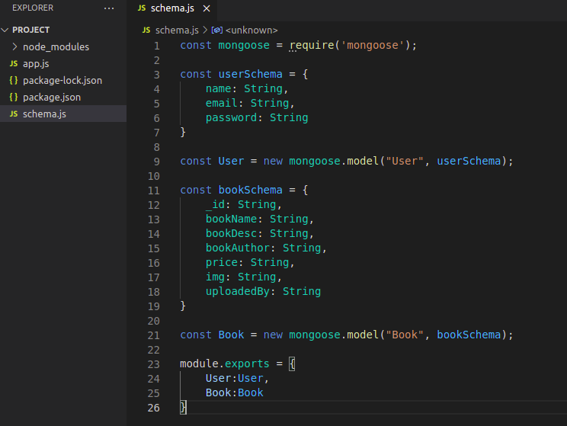
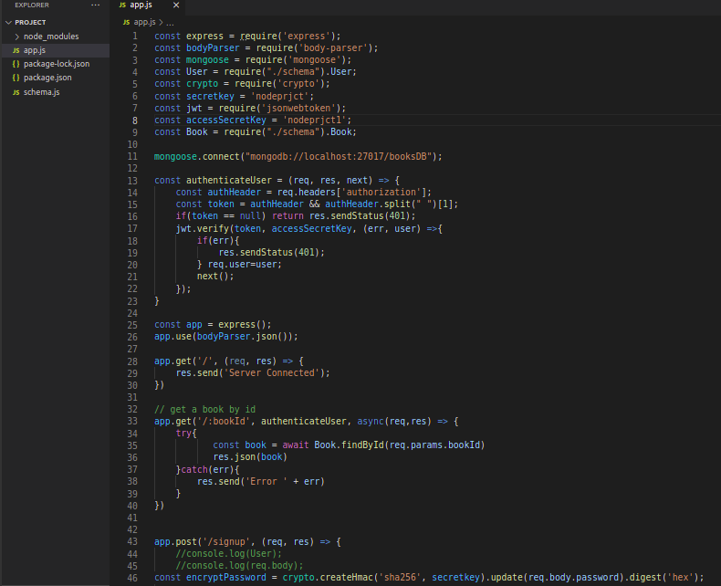

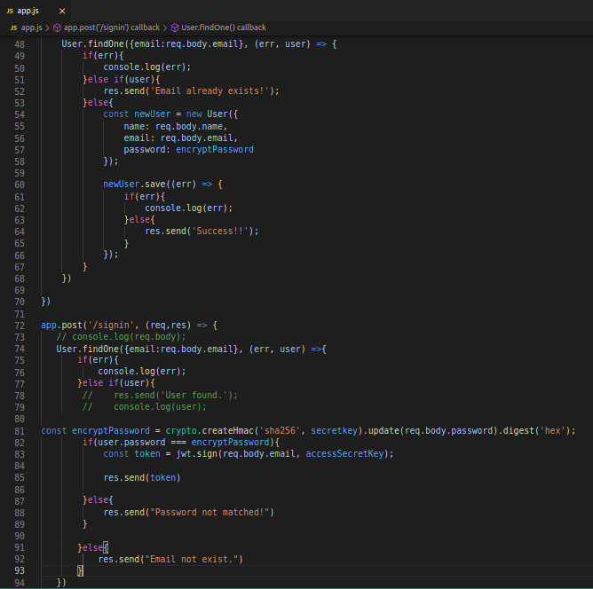

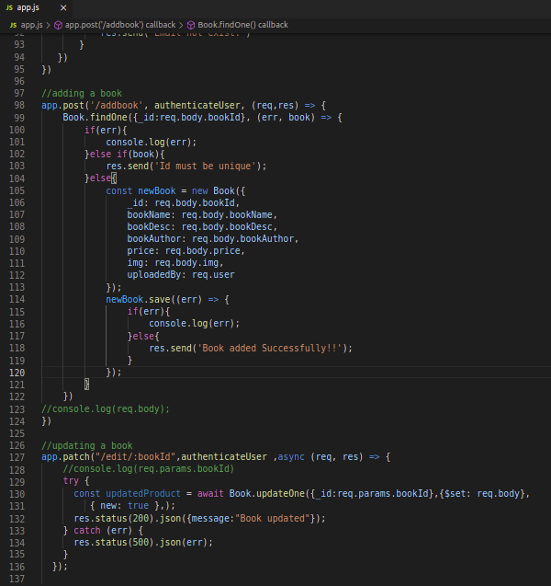

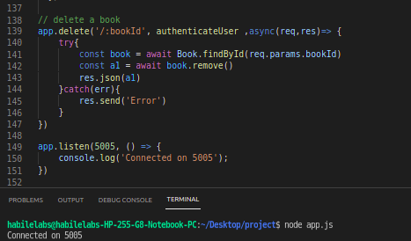

REFERENCE:
https://nodejs.org/en/
https://www.npmjs.com/
https://www.w3schools.com/nodejs/nodejs_get_started.asp
https://www.tutorialspoint.com/nodejs/
https://www.geeksforgeeks.org/nodejs/?ref=lbp
https://www.npmjs.com/package/jsonwebtoken
https://expressjs.com/

