POWER QUERY TASK

WEEK IV

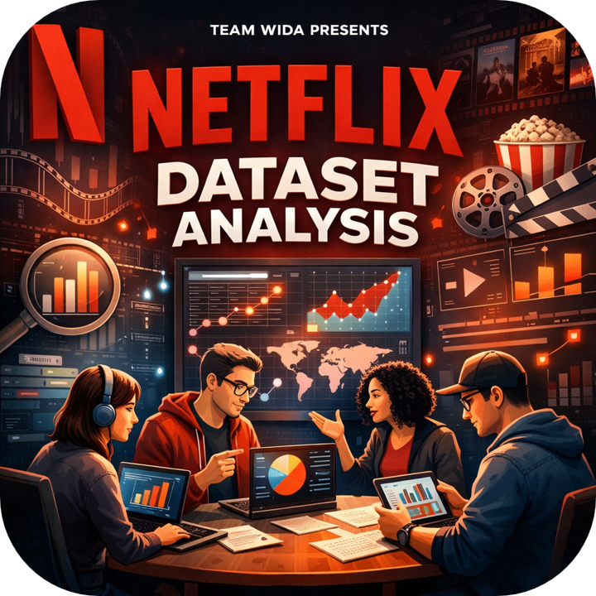
Bashir Aminat | Damilare
Lateefah Abdur-Rahman | Oluwajuwonlo
Hawwa D. Atta | Toyyib A. Olalekan
Jimoh Abdur-Rahman

1.0 PROJECT OVERVIEW
Use the Netflix Movies & TV Shows dataset as the source to practice cleaning, transformation, and analysis using Power Query.

2.0 DATA DESCRIPTION Table 1.0
Dataset | All TV Shows and Movies meta data on Netflix. Updated every month.  2_netflix_titles_raw_data.csv.csv
Dataset Introduction | The dataset contains information about movies and TV shows available on Netflix as of 2021.  Total Records: 8,809  Total Columns: 12  Data Cleaning Summary  To improve data quality and handle missing values, the following transformations were applied:  Director, Cast, Country: Missing values were replaced with "Unknown".  Date Added: Converted to datetime format to extract the year of addition.  Duration: Numeric values were extracted (minutes for movies, number of seasons for TV shows) for statistical analysis.
Tools used | - PowerQuery  - Excel  - PowerBI
Data Output | 3_netflix_titles_Agregates.xlsx

3.0 STEPS TAKEN TO CLEAN DATA
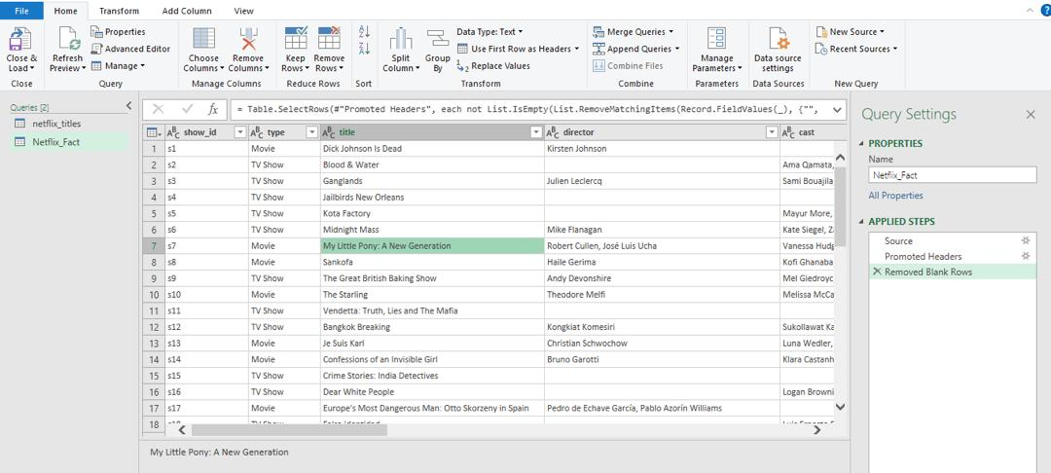
Figure 1.1: Removed blank rows

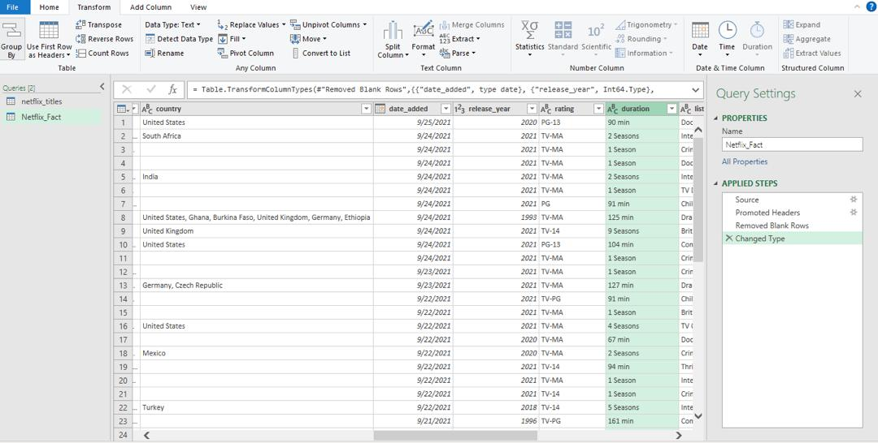
Figure 1.2: Changed data type
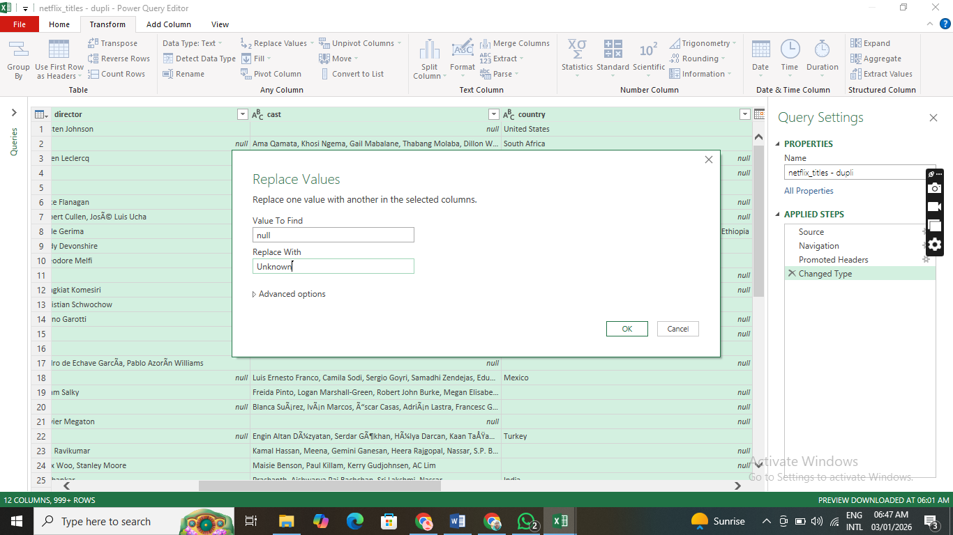
Figure 1.3: Replacing null values for Director, Cast, and Country with Unknown
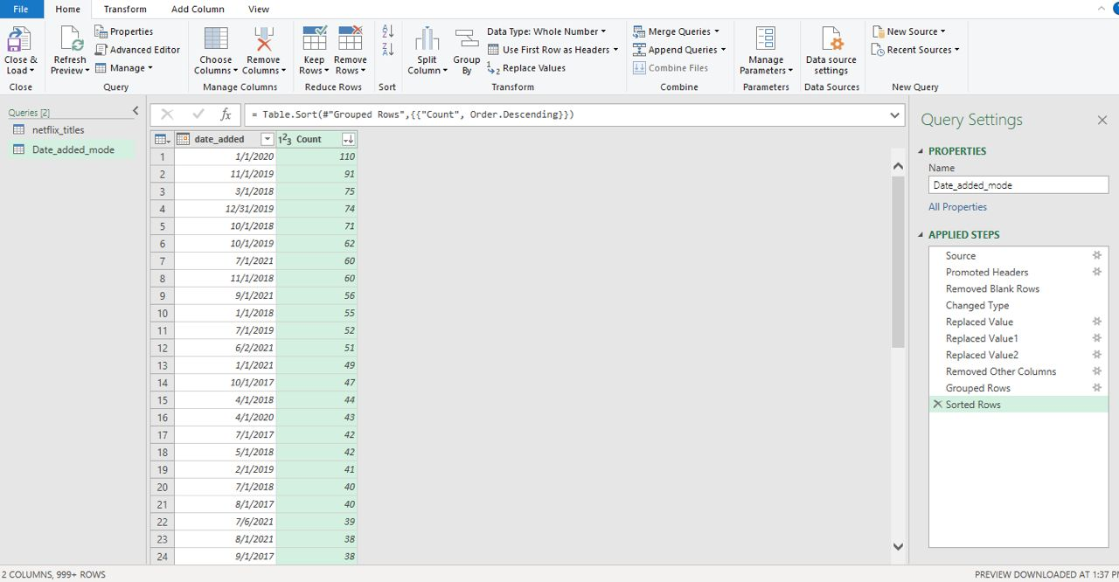
Figure 1.4: Get number of movies added by date and sort in descending order
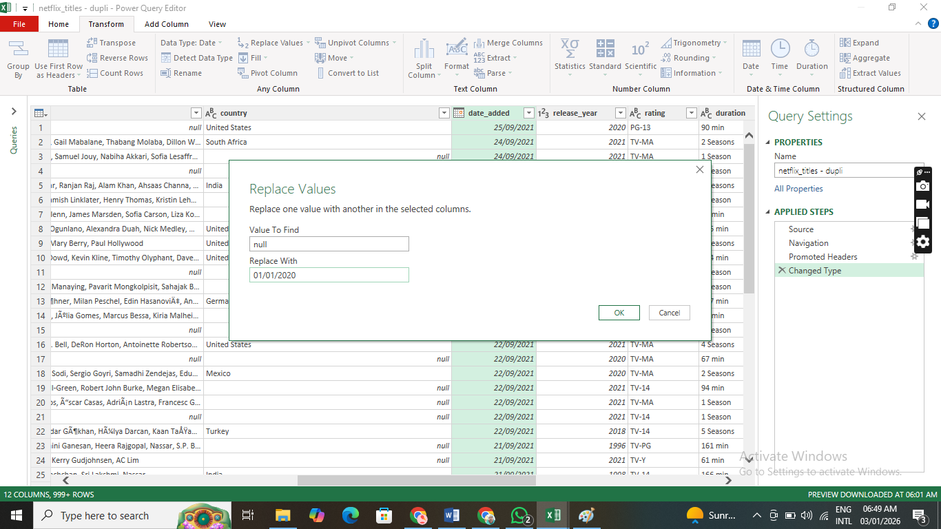
Figure 1.5: Pick the date with the highest count and use it to replace null values in the date column
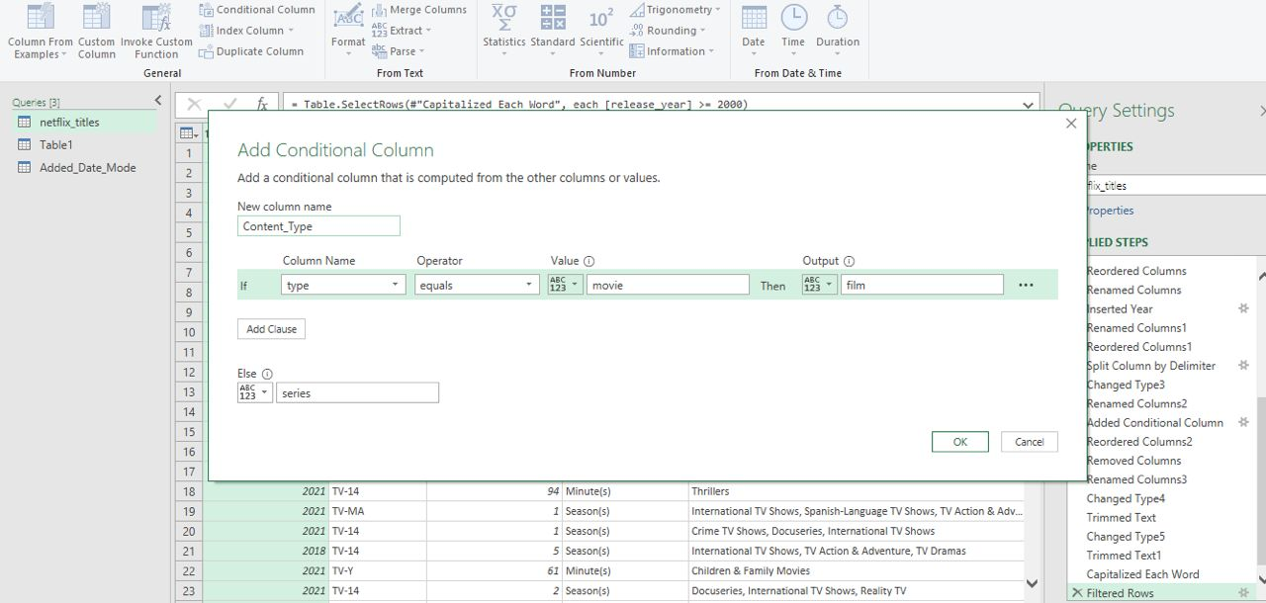
Figure 1.6: Added column “content_type”

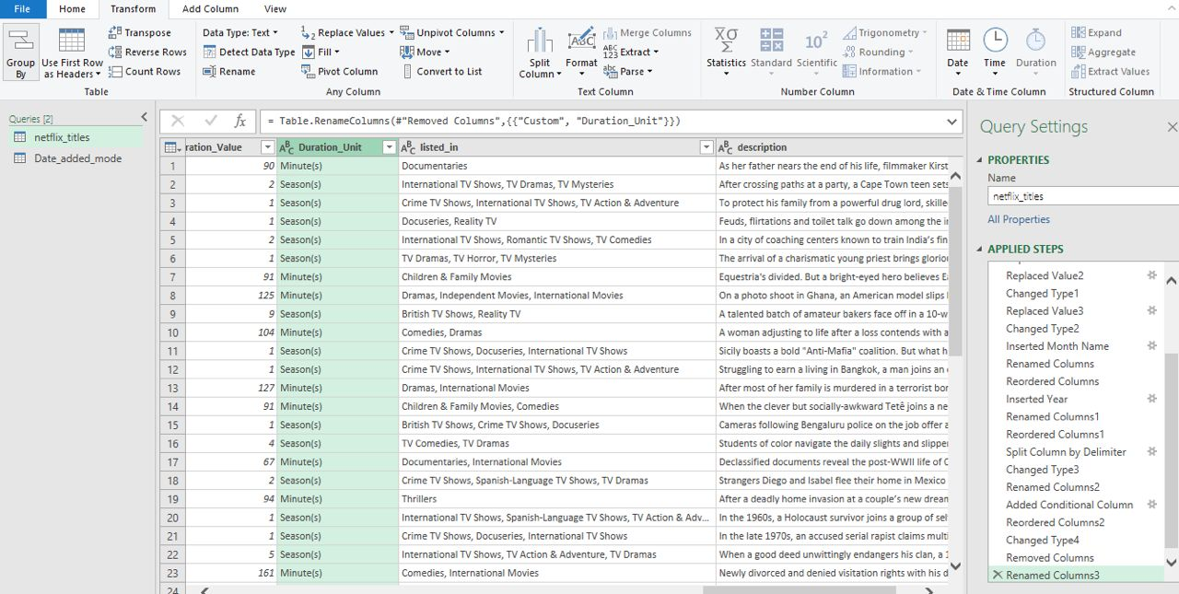
Figure 1.7: Created separate columns for duration value and duration unit
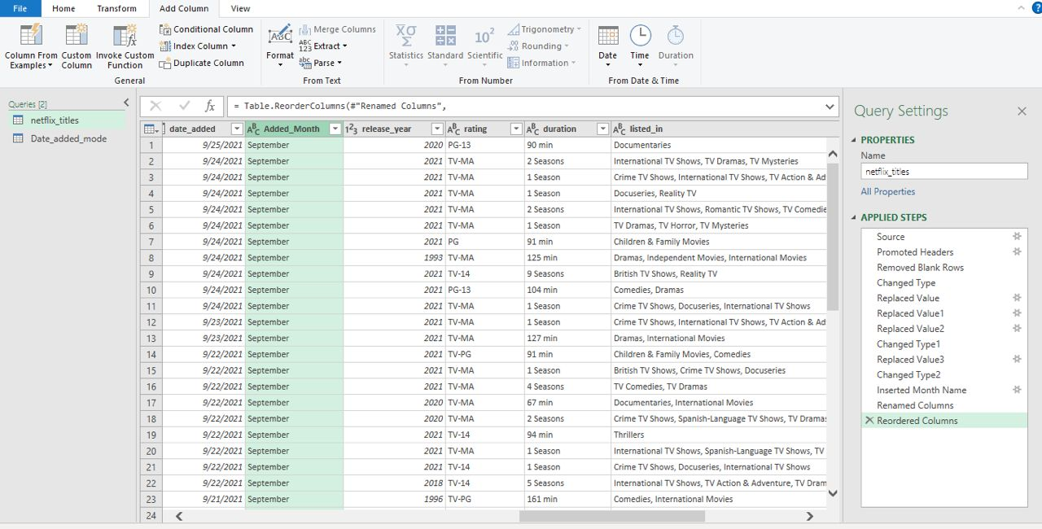
Figure 1.8: Split date added into added month using the Add column tab

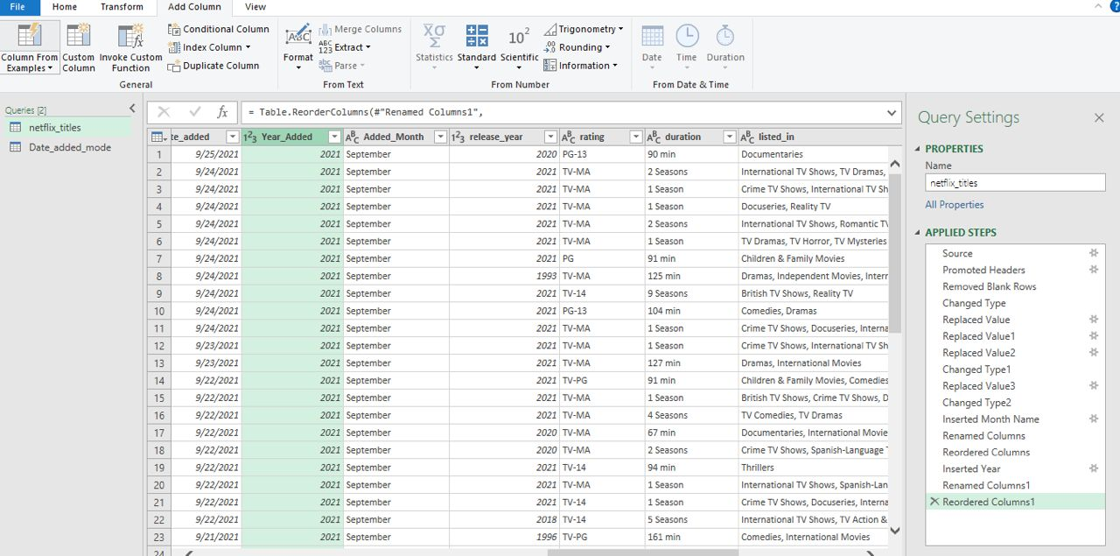
Figure 1.9: Split date added to Year added using the Add column tab
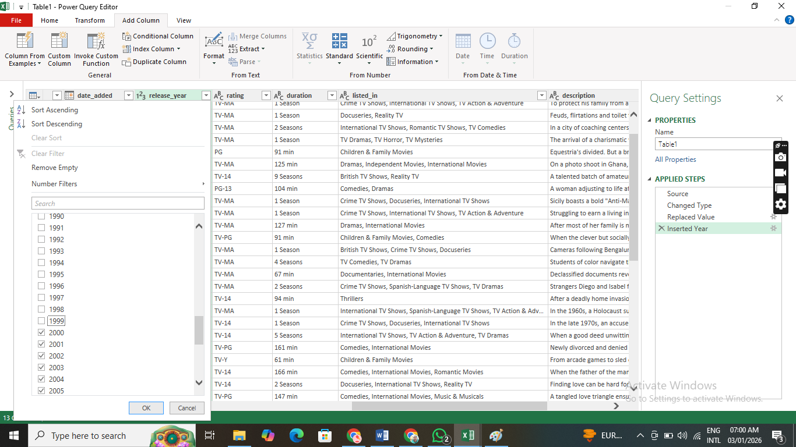
Figure 1.10: Filtered out release year earlier than 2000. We now have 8282 rows
4.0 STEPS TAKEN TO GET AGGREGATES
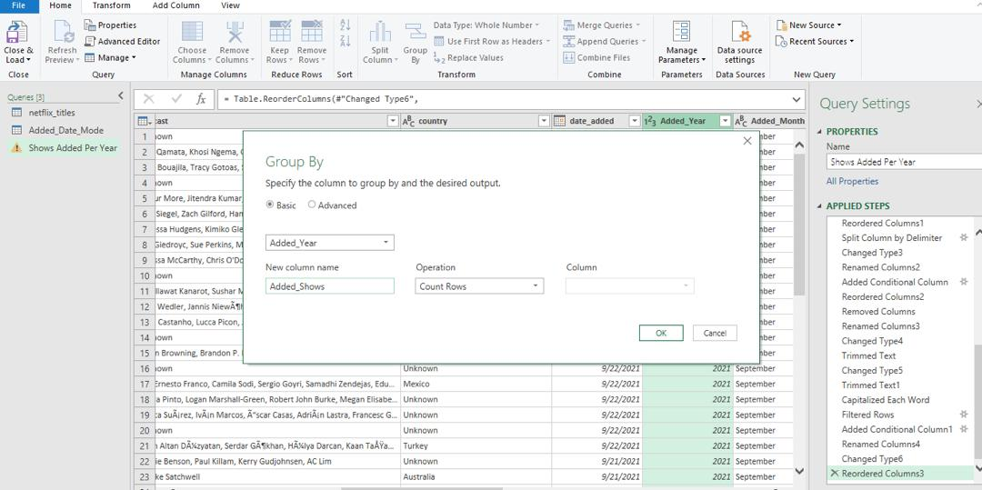
Figure 2.1: How to get counts of added shows per year
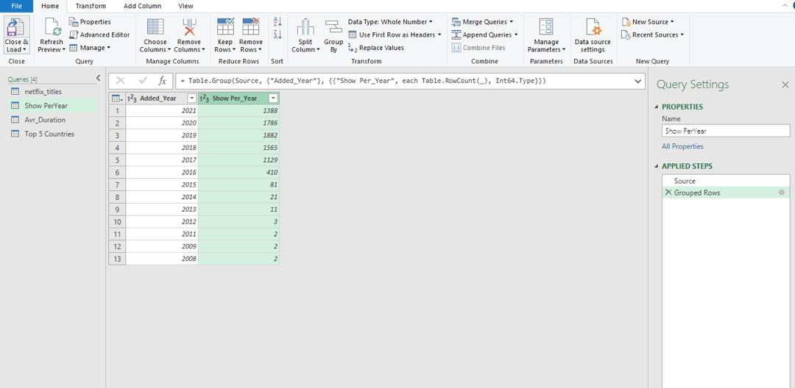
Figure 2.2: Shows per year
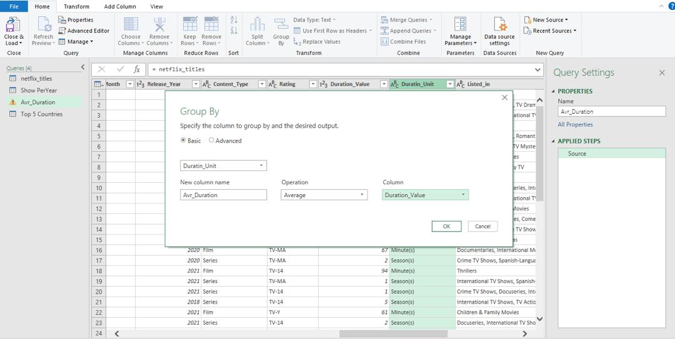
Figure 2.3: How to get the average duration by duration unit
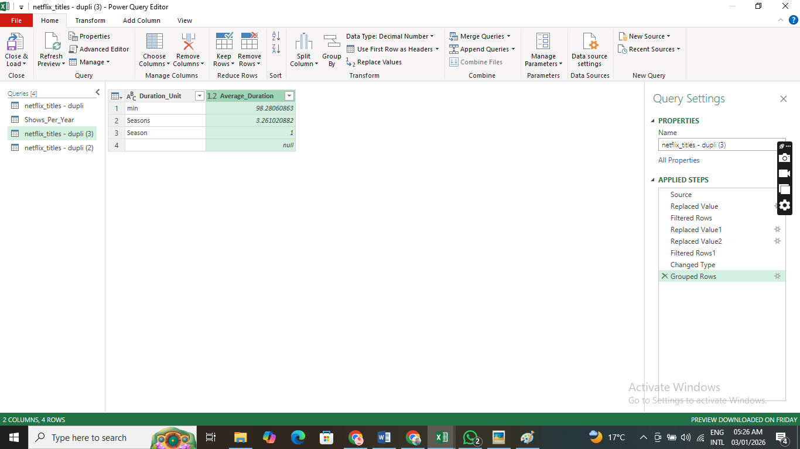
Figure 2.4: The average duration by duration unit
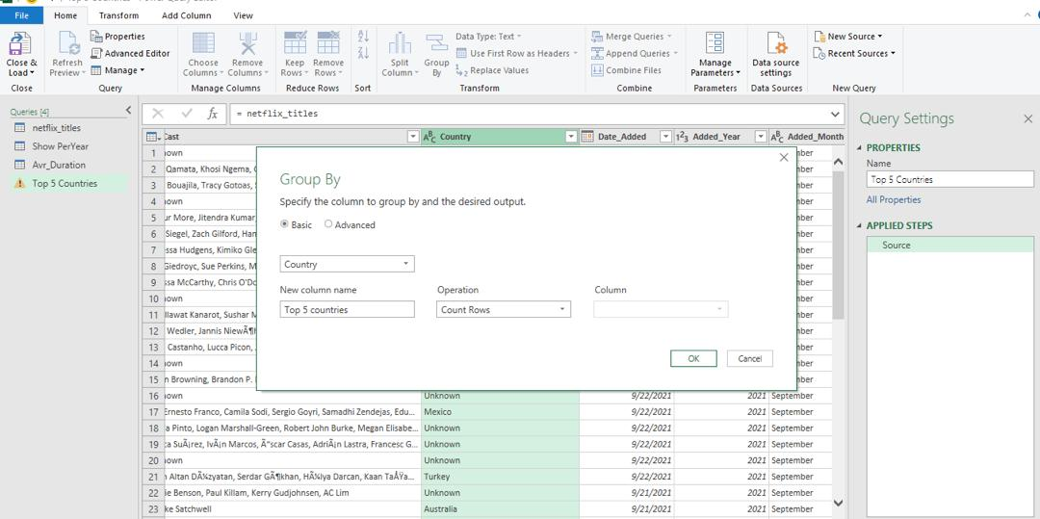
Figure 2.5: Getting the count for shows by countries
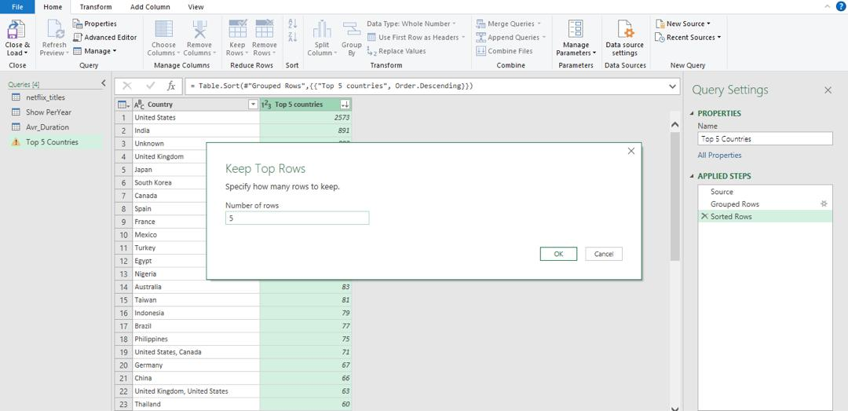
Figure 2.6: Sort by descending order and keep top five rows
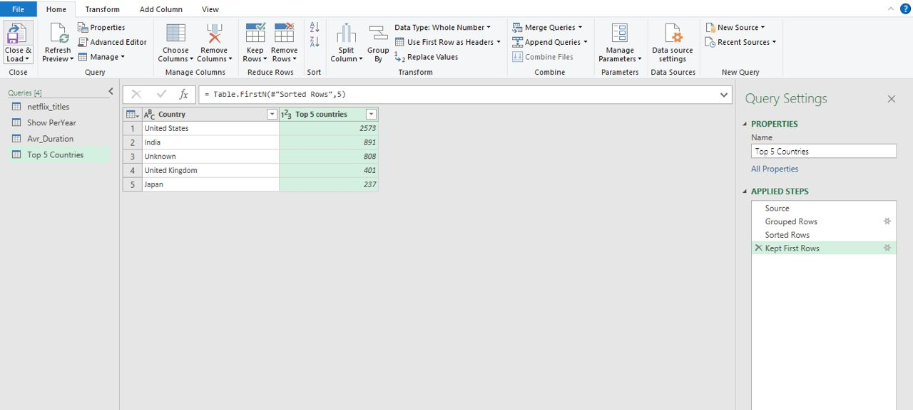
Figure 2.7: Top 5 countries
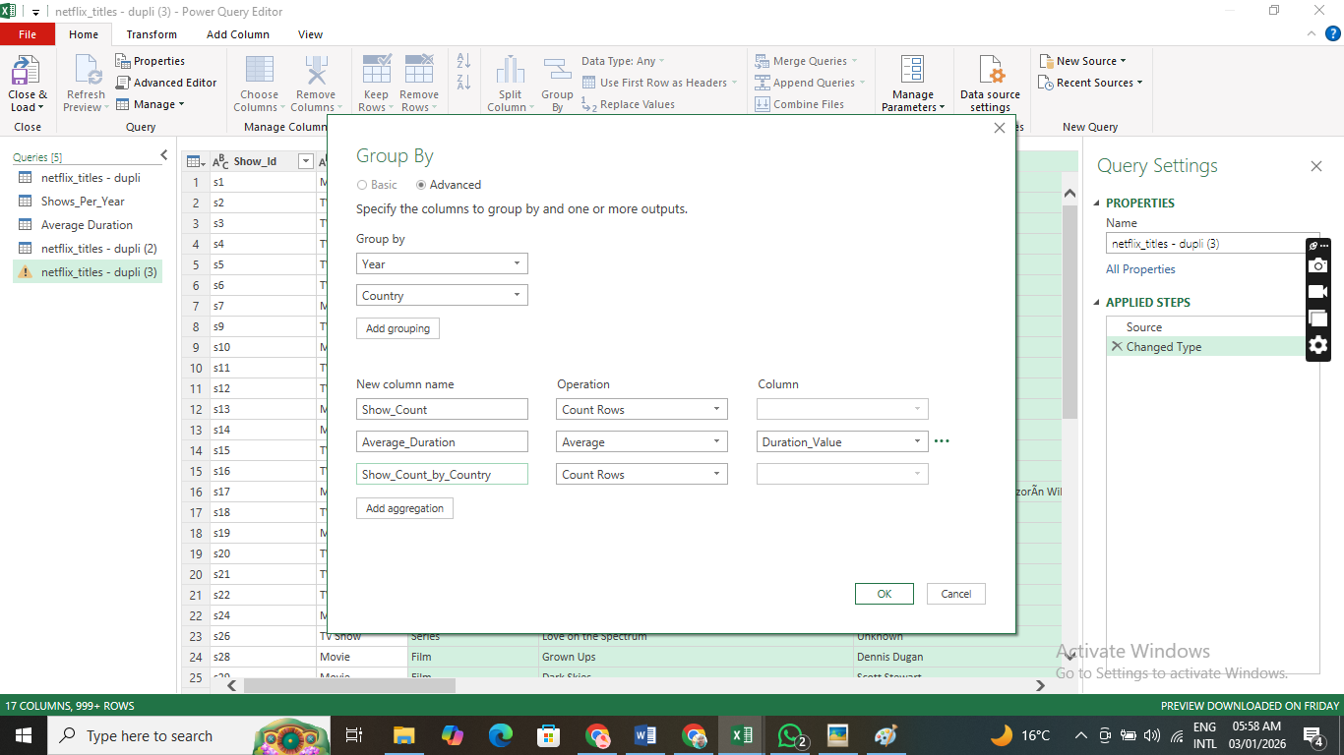
Figure 2.8: Getting summary of the aggregates

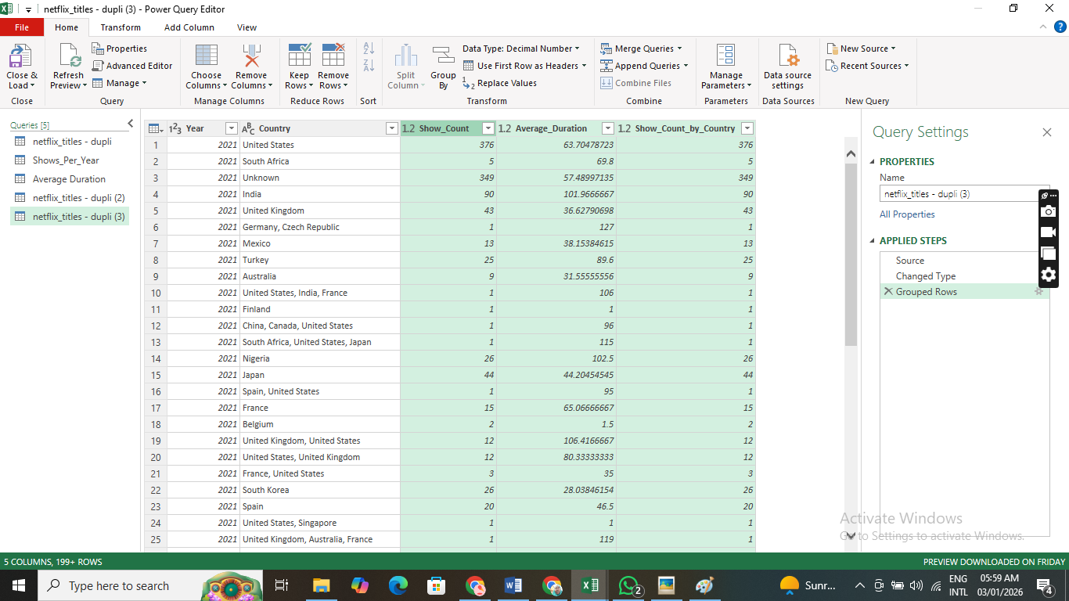
Figure 2.9: The aggregates in one table

5.0 VISUALISATION
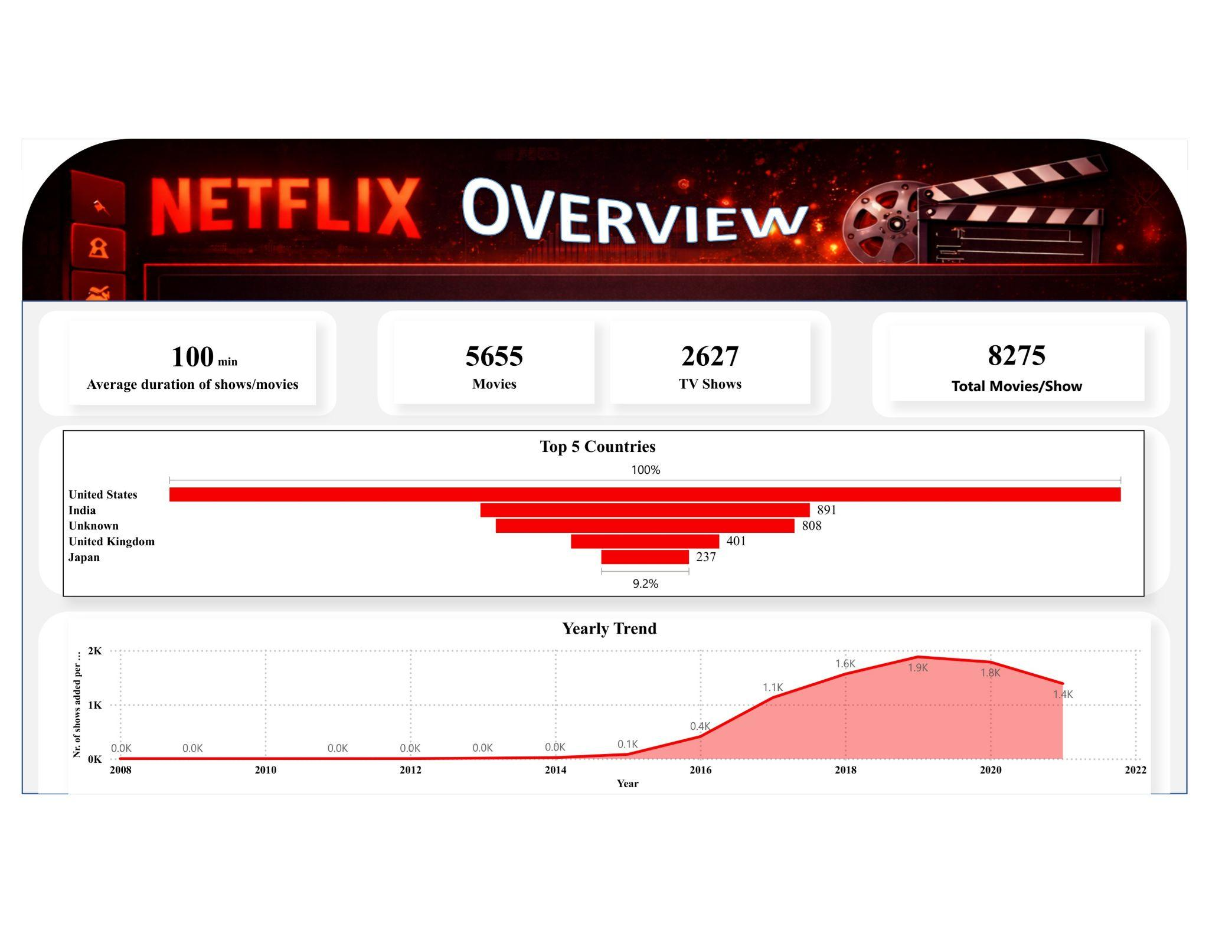
Figure 3.1: Visualization in PowerBI

6.0 CHALLENGES ENCOUNTERED
Working with the Netflix raw dataset presented several technical and structural challenges:
- Handling Substantial Missing Data: The most significant hurdle was the heavy volume of missing values in the Director (2,634 missing), Cast (825 missing), and Country (831 missing) columns. Simply dropping these records would have resulted in the loss of nearly 30% of the dataset, distorting the overall analysis. Replacing them with "Unknown" was necessary to preserve the integrity of the total counts.
- Inconsistent Duration Formats: The duration column was non-homogeneous, there were some entries for duration which were mistakenly entered under rate. The values had to be re-entered in the duration field. Also, the mixed string format entered in the duration field prevented direct mathematical operations (like calculating an average) without first implementing string-splitting logic to isolate the numeric values and separate the content types.
- Tool Interoperability and Platform Limitations: The cleaning process initially utilized Power Query in Power BI due to its advanced interface. However, a significant roadblock was encountered when attempting to export the finalized tables to Excel to meet project deliverables. This required a full restart of the cleaning logic within Excel’s version of Power Query. Furthermore, compatibility issues occurred with an older version of Excel, necessitating the manual download and installation of the Power Query add-in to complete the task.

7.0 CONCLUSION
The analysis of the Netflix titles dataset reveals a dynamic and rapidly evolving content library. By addressing missing data and aggregating key metrics, we can draw the following comprehensive conclusions:
Data Integrity and Cleaning: The initial dataset contained significant gaps, particularly in the Director, Cast, and Country columns (over 2,600 missing directors). By systematically replacing these with "Unknown", we transformed the data from a "dirty" state into a structured format suitable for high-level dashboarding. This process was critical for ensuring that visualizations (like the "Top 5 Countries" chart) accurately reflected the volume of content without excluding significant segments of the catalog.
Content Strategy Shift: Netflix has maintained a strong emphasis on feature films, with Movies (5,655) outnumbering TV Shows (2,627) by a ratio of roughly 2:1. However, the average duration of 100 minutes suggests a curated focus on "standard" feature-length content that fits the traditional viewing habits of a global audience.
Geographical Dominance vs. Localization: The United States remains the undisputed powerhouse of Netflix content, followed by India. The high presence of "Unknown" countries (808) highlights a potential area for further data enrichment, as these titles likely represent emerging markets or independent productions where metadata is sparse. The inclusion of Japan and South Korea in the top rankings underscores Netflix's successful pivot towards Asian content (Anime and K-Dramas), which has become a cornerstone of their international growth strategy.
Growth and Scaling: The "Yearly Trend" shows a parabolic growth curve beginning in 2014, driven by Netflix's transition from a distributor to a heavy producer of original content. The peak in 2019 (2,016 titles added) represents the "Golden Era" of scaling before the production logistics likely faced challenges during the global pandemic in 2020-2021. Despite this, the sustained volume of content additions (over 1,400 in 2021) demonstrates a resilient and aggressive expansion model.
In summary, the Netflix ecosystem is defined by a massive, US-centric but increasingly globalized library. The strategic focus on standard-length movies and a diverse international portfolio has established Netflix as a dominant global platform, even as it navigates the complexities of data completeness and global production cycles.

