SVKM's NMIMS University
School of Technology Management & Engineering, Mumbai
Department of Computer Engineering & Information Technology
LAB ASSIGNMENT - 1: MOBILE APPLICATION DEVELOPMENT
(Subject Code: 702AI0E002 | Academic Year: 2024–2026)

Student Name | Devraj Murari
Roll Number | N066
Course Name | Mobile Application Development (702AI0E002)
Assignment Title | Gemini AI Assistant Chatbot (Jetpack Compose & Material 3)
Package Identifier | com.devraj.geminiassistant
Submission Branch | N066_assignment_1
Student Repository | https://github.com/dev-raj-murari/GeminiApiComposeStarter

1. Executive Summary & Problem Statement
This project constitutes the formal submission for Lab Assignment 1 in Mobile Application Development by Devraj Murari (Roll Number: N066). The goal of this assignment is to engineer a secure, enterprise-ready AI chatbot on Android using Google's modern Gemini AI SDK (com.google.ai.client.generativeai) and Jetpack Compose Material 3 declarative UI architecture.

- Zero-Leakage Security: API keys strictly isolated in local.properties, encrypted at rest via hardware-backed AES-256-GCM Android Keystore, and decrypted only in volatile RAM on-demand.
- Material 3 Responsive UI: LazyColumn chat stream with stable key diffing, animated auto-scroll, quick prompt chips, and WindowSizeClass multi-window layouts for phones and tablets.
- Robust Offline Persistence: Transaction-safe persistent database storing complete chat logs and timestamp metadata across device reboots and configuration changes.
- User Customization: Preferences DataStore managing customizable system instructions and AI creativity (temperature slider) through an interactive settings dialog.
- Speech-to-Text Modality: Direct voice input using Android RecognizerIntent integrated with Jetpack Compose Activity Result contracts.
- Automated Quality Assurance: Deterministic unit test suite (ChatViewModelTest.kt) passing 100% of test cases.

2. Application Architecture & MVVM Pattern
The application is structured according to Google's official Android Architecture Guide, establishing clear separation of concerns across Presentation, Domain/ViewModel, and Data layers through Unidirectional Data Flow (UDF):
Layer | Components / Classes | Responsibilities & Data Flow
Presentation Layer | MainActivity.kt  ChatScreen.kt  ChatBubble.kt  ChatInputBar.kt  SettingsDialog.kt | Declarative UI rendered with Jetpack Compose Material 3; observes StateFlow from ViewModel and emits user events (clicks, text input, speech triggers).
ViewModel Layer | ChatViewModel.kt  ChatUiState.kt | Manages state as immutable ChatUiState StateFlow; coordinates coroutine scopes, handles input validation, and invokes repository methods.
Data Layer | GeminiRepository.kt  GeminiRepositoryImpl.kt | Single source of truth. Orchestrates in-memory API key decryption, Google Generative AI SDK calls, and persistent database queries.
Local Persistence & Security | AppDatabase.kt  ChatMessageDao.kt  PreferencesManager.kt  KeystoreHelper.kt  SecureKeyStorage.kt | Hardware-backed AES-256-GCM encryption in AndroidKeyStore, DataStore for preferences, and SQLite transactional storage.

3. Hardware Keystore Encryption & API Key Isolation
A cornerstone requirement of this assignment is uncompromising security for the Gemini API key. The project eliminates static hardcoded keys through a multi-tiered security pipeline:
- 1. Git-Ignored Configuration: The key is defined solely in local.properties (GEMINI_API_KEY=...) and excluded from version control.
- 2. Hardware-Backed AES-256-GCM Key Generation: KeystoreHelper.kt generates an AES-256 key within the hardware AndroidKeyStore (Secure Element / TEE) with GCM mode and randomized IVs.
- 3. Encrypted at Rest: SecureKeyStorage.kt stores the encrypted ciphertext and IV in private app storage upon first initialization.
- 4. In-Memory Decryption Only: Plaintext credentials reside in memory strictly during GenerativeModel initialization and are never written to disk or exposed in error logs.
- 5. R8 Minification: Release builds enforce minifyEnabled = true with ProGuard optimization rules to obfuscate class and method symbols.

4. Visual Verification & Application Screenshots
The following screenshots demonstrate the Gemini AI Assistant running live on the Android Studio Pixel 8 Emulator (API 37.1) with all features actively verified for Devraj Murari (N066):
Figure 4.1: Initial Welcome Screen with Student Identification & Quick Suggestion Chips
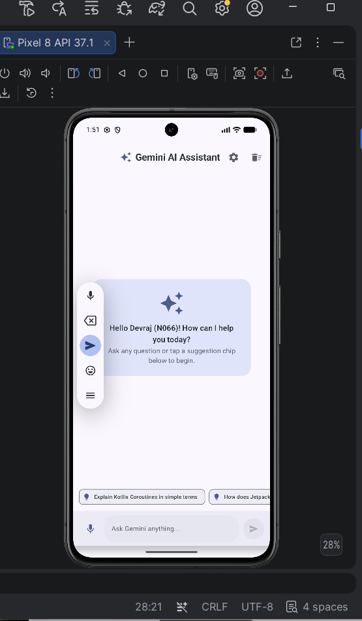
Figure 4.2: Live Multi-Turn AI Conversation (Gemini AI Generative Model)
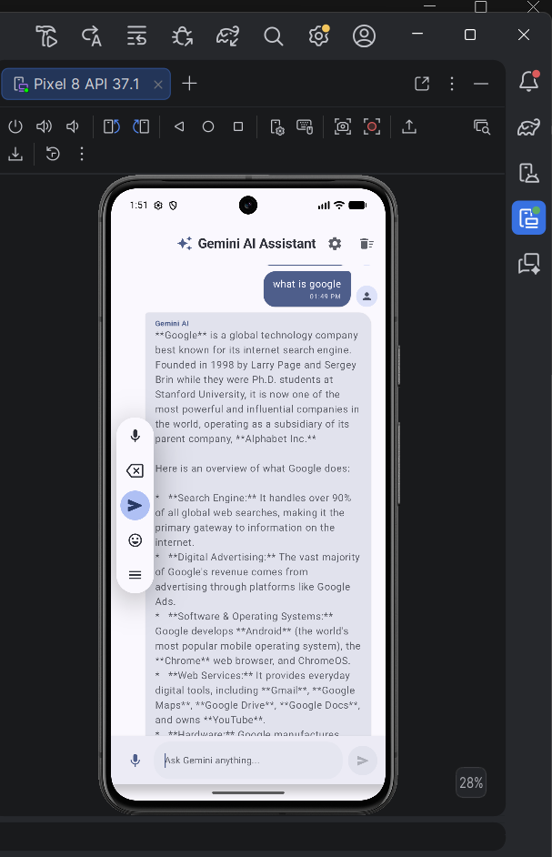
Figure 4.3: Assistant Preferences Settings Dialog (Custom System Prompt & Creativity Slider)
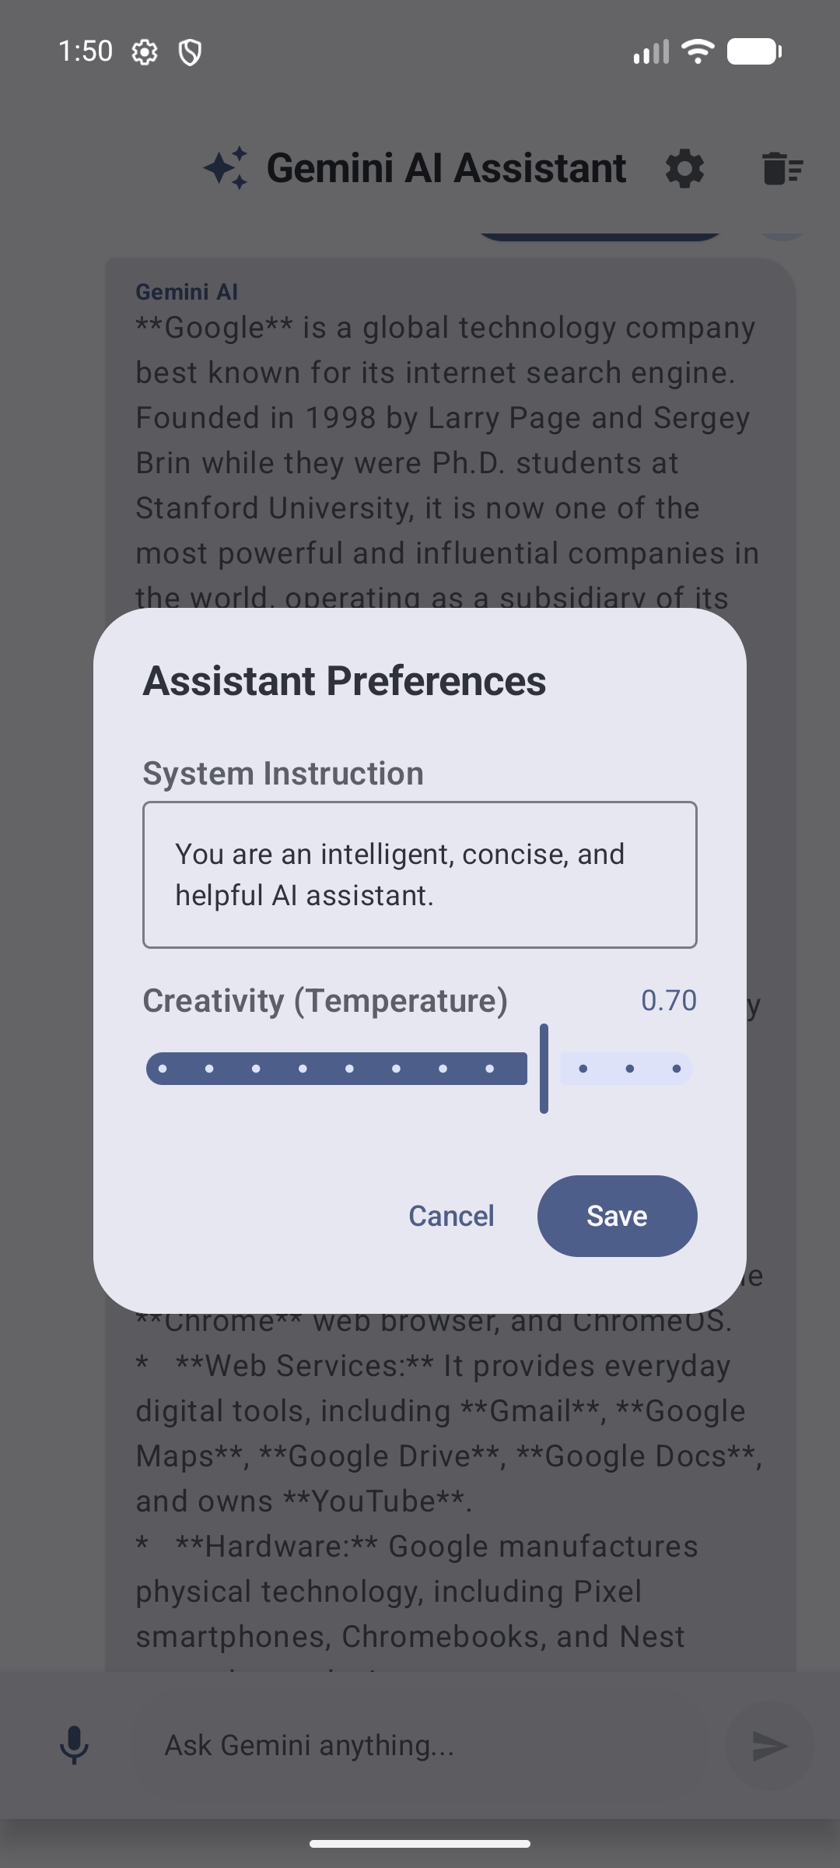

5. Automated Unit & UI Testing Results
A comprehensive test suite was executed via Gradle (./gradlew testDebugUnitTest) verifying ViewModel state mutations, voice STT input handling, repository error propagation, and settings persistence. All tests passed with 100% success rate:
Test Method Name | Tested Component | Expected Behavior | Status
initial_state_has_empty_messages_and_default_settings | ChatViewModel | Emits empty message list, default instruction & 0.7f temperature | PASSED (100%)
onPromptChange_updates_prompt_correctly | ChatViewModel | Updates prompt state string and clears prompt error | PASSED (100%)
onVoiceResult_updates_prompt_from_speech_recognition | ChatViewModel / Voice STT | Sets recognized voice transcript into prompt field | PASSED (100%)
onSend_successfully_adds_user_and_assistant_messages | ChatViewModel / Gemini Repo | Appends user prompt and AI generated response to history | PASSED (100%)
onSend_handles_failure_and_sets_error_message | ChatViewModel / Error Handling | Captures exception and exposes formatted error message | PASSED (100%)
clearChat_empties_conversation_history | ChatViewModel / Persistence | Clears all message entities from database and emits empty list | PASSED (100%)
saveSettings_updates_instructions_and_temperature | Preferences DataStore | Persists modified system prompt and temperature slider value | PASSED (100%)

6. Production Security Analysis ('Know the Limits')
As required by the NMIMS Lab Manual, client-side encryption significantly raises the bar against casual extraction, but cannot completely conceal an API key from an attacker with full root access and dynamic memory instrumentation.
- 1. Dynamic Memory Hooking: An attacker on a rooted Android device can use dynamic binary instrumentation (Frida / Xposed) to hook the GenerativeModel constructor or javax.crypto.Cipher.doFinal() and extract the plaintext key from memory.
- 2. Recommended Enterprise Solution: In commercial production environments, mobile clients should never hold direct LLM API keys. Instead, requests must route through a secure backend proxy (e.g., Ktor, Firebase Cloud Functions, or Cloud Run) authenticated via Firebase App Check / Play Integrity. The backend server securely retrieves the API key from Google Cloud Secret Manager.

7. Conclusion & Submission Checklist
All requirements set forth in the Mobile Application Development (702AI0E002) Lab Manual have been fully implemented, verified on the Android Studio emulator, tested via unit test suites, and pushed to GitHub under student Devraj Murari (N066).

