KARUME INSTITUTE OF SCIENCE AND TECHNOLOGY

PROJECT REPORT
ORDINARY DIPLOMA IN INFORMATION AND COMMUNICATION TECHNOLOOGY WITH BUSINESS
(NTA-LEVEL6)

CANDIDATE NAME: RAYA MOHD ALI
SUPERVISION NAME: MADAM THANIA SULEIMAN SIMAI
REGESTRATION NUMBER: KIST-ICT-23-0017
COURSE: ICT WITH BUSINESS
DEPARTMENT: ELECTRONICS, TELECOMMUNICATION AND COMPUTER ENGINEERING
PROJECT TITLE: BUILDING RENT COLLECTION SYSTEM

AUGUST, 2026

DECLARATION
I, RAYA MOHD ALI, declare that this project report titled “BUILDING RENT COLLECTION SYSTEM”, submitted to Karume Institute of science and technology in the partial fulfillment of the requirements for the diploma in ICT WITH BUSINESS is my original work and has not been copied from anywhere. This is a result of my own initiations, survey findings and technical knowledge, with the help of various lecturers as references and consultations from supervisors, lecturers and experts in the field.

Full name: Raya Mohd Ali

Signature: ..........................

Date: ...........................

CERTIFICATION
I, the undersigned, certify that this project report titled “BUILDING RENT COLLECTION SYSTEM” submitted by RAYA MOHD ALI, Registration Number KIST/ICT/23/0017, in partial fulfillment of the requirements for the award of Ordinary Diploma in Information and Communication Technology at the Karume Institute of Science and Technology, is a genuine record of work carried out by the candidate under my supervision. The report has been submitted to the Department of Information and Communication Technology for assessment in accordance with the institution’s guidelines.

SUPERVISOR
Name: Thania Suleiman Simai

Signature: ……………………………

Date: ……………………………

ACKNOWLEDGEMENT
- First and foremost, I would like to thank Almighty Allah for granting me good health, strength, and the ability to successfully complete my project titled Building Rent Collection System.
- Secondly, I would like to express my sincere gratitude to my beloved parents for their continuous support, encouragement, and prayers throughout my studies. Their guidance has been essential in helping me reach this stage.
- I would also like to extend my special thanks to my supervisor, Madam Thania Sulemain Simai from Karume Institute of Science and Technology, for her valuable guidance, patience, and support during the development of this project. Her advice greatly contributed to improving the quality of my work.
- Furthermore, I would like to thank all lecturers and teachers from Karume Institute of Science and Technology for providing me with the knowledge and skills necessary to undertake and complete this project.
- Finally, I would like to thank my friends for their encouragement, support, and cooperation throughout the entire project period.

ABSTRACT
This project developed a web-based Building Rent Collection System to address the challenges created when rental records, booking requests, and payment follow-up are handled manually. Manual processes can lead to delayed verification, missing records, limited communication, and difficulty for tenants to identify available rooms. The study therefore aimed to provide a centralised system for managing rental information and supporting timely, accurate rent collection. Requirements were identified through questionnaires and interviews with landlords and tenants. The system was designed using an object-oriented approach and the Waterfall model. It was implemented as a Laravel and PHP web application using MySQL/MariaDB, HTML, CSS, and JavaScript. The system follows the Model-View-Controller architecture and provides role-based accounts for administrators, landlords, and tenants. Its main modules support user registration and login, building and room management, room availability, booking, payment recording and verification, notifications, and reports. Testing focused on key functions, including registration, login, property management, booking, and payment processing. The recorded test results show that the core functions operated as expected. The completed system improves the organisation of rental information, provides tenants with clearer access to available rooms and booking services, and gives landlords a more structured way to monitor bookings and payments.

TABLE OF CONTENTS
DECLARATION i
CERTIFICATION ii
ACKNOWLEDGEMENT ii
ABSTRACT ix
TABLE OF CONTENTS x
LIST OF TABLES xv
LIST OF FIGURES xvi
LIST OF ABBREVIATIONS xvii
CHAPTER ONE: INTRODUCTION 1
1.1 Background of the Study 1
1.2 Problem Statement 1
1.3 Objectives of the Study 2
1.3.1 General Objective 2
1.1.1 1.3.2 Specific Objectives 2
1.4 Significance of the Study 2
1.5 Scope and Limitations of the Study 2
1.1.2 1.5.1 Limitations of the Study 2
1.6 Feasibility Study 3
1.1.3 1.6.1 Technical Feasibility 3
1.1.4 1.6.2 Economic Feasibility 3
1.1.5 1.6.3 Operational Feasibility 3
1.1.6 1.6.4 Schedule Feasibility 3
1.1.7 1.6.5 Legal Feasibility 3
CHAPTER TWO: LITERATURE REVIEW 4
2.1 Introduction 4
2.2 Related Work 4
2.3 Identification of Gaps 5
CHAPTER THREE: METHODOLOGY 6
3.1 Introduction 6
3.2 Requirement Determination 6
3.2.1 Functional Requirements 6
1.1.8 3.2.2 Non-functional Requirements 7
3.3 Requirement Structuring and System Modelling 7
1.1.9 3.3.1 Use Case Diagram 7
1.1.10 3.3.2 Use Case Descriptions 8
3.3.2.1 User Registration and Login 8
3.3.2.2 Building Management 9
3.3.2.3 Room Management 9
3.3.2.4 View Available Rooms 9
3.3.2.5 Book a Room 9
1.1.11 3.3.2.6 Make Rent Payment 9
3.3.2.7 Manage Payments 10
3.3.2.8 Generate Reports 10
3.3.2.9 Manage Users 10
1.1.12 3.3.3 Data Flow Diagram Level 0 10
1.1.13 3.3.4 Data Flow Diagram Level 1 11
1.1.14 3.3.5 Entity Relationship Diagram 11
1.1.15 3.3.6 Database Schema Design 13
3.4 System Development Approach 13
3.5 Software Development Life Cycle Model 13
3.5.1 Requirements 14
3.5.2 Design 14
3.5.3 Development 14
3.5.4 Testing 14
3.5.5 Deployment 14
3.5.6 Maintenance 14
3.6 System Architecture 15
3.7 Development Tools and Technologies 15
3.7.1 PHP 15
3.7.2 HTML 16
3.7.3 CSS 16
3.7.4 JavaScript 16
3.7.5 Laravel 16
3.7.6 MySQL 16
3.7.7 WAMP 16
3.7.8 Visual Studio Code 16
3.7.9 Web Browser 16
3.8 Data Collection Methods 16
3.8.1 Questionnaires 17
3.8.2 Interviews 17
3.9 Software and Hardware Requirements 17
3.9.1 Software Requirements 17
3.9.2 Hardware Requirements 17
3.10 Limitations of the Methodology 18
CHAPTER FOUR: IMPLEMENTATION AND TESTING 18
4.1 Introduction 18
4.2 Implementation Environment 18
4.3 Backend Implementation 19
4.3.1 User Management 19
4.3.2 Building Management 19
4.3.3 Room Management 19
4.3.4 Booking Management 20
4.3.5 Payment Management 20
4.4 Frontend Implementation 20
4.4.1 Home Page 20
4.4.2 House Location 21
4.4.3 Room Booking Page 21
4.4.4 Registration Page 22
4.4.5 Login Page 23
4.5 Database Implementation 24
4.6 System Testing 25
4.6.1 Test Cases 25
4.7 Unit Testing 25
4.8 Integration Testing 26
4.9 Functional and User Acceptance Testing 26
4.10 Results 26
4.11 Discussion of Results 27
CHAPTER FIVE: CONCLUSION, RECOMMENDATIONS AND CHALLENGES 28
5.1 Introduction 28
5.2 Conclusion 28
5.3 Recommendations 29
5.3.1 Mobile Application 30
5.3.2 More Payment Methods 30
5.3.3 Automatic Notifications 30
5.3.4 Better Reports 30
5.3.5 Improved Security 30
5.3.6 Online Hosting 30
5.3.7 Future Students and Researchers 30
5.4 Challenges Faced 30
5.4.1 Limited Time 31
5.4.2 Limited Financial Resources 31
5.4.3 Respondent Availability 31
5.4.4 Internet Problems 31
5.4.5 Technical Problems 31
REFERENCES 32
APPENDIX A: SYSTEM INTERFACES 32
APPENDIX B: DATABASE SCHEMA 37
APPENDIX C: DATA COLLECTION INSTRUMENTS 38
APPENDIX D: USER MANUAL / SETUP GUIDE 39
APPENDIX E: SOURCE CODE / PROGRAM LISTING 41
APPENDIX F: SAMPLE SYSTEM REPORTS 41
APPENDIX G: SYSTEM TESTING EVIDENCE 43
APPENDIX H: PROJECT BUDGET 43

LIST OF TABLES
Table 1: Database Tables and Their Purposes
Table 2: System Test Cases and Results
Table 3: Main Database Tables
Table 4: Project Source-Code Structure
Table 5: System Testing Evidence Checklist
Table 6: Project Budget

LIST OF FIGURES
Figure 1: Use Case Diagram of the Building Rent Collection System
Figure 2: Data Flow Diagram Level 0
Figure 3: Data Flow Diagram Level 1
Figure 4: Entity Relationship Diagram
Figure 5: Waterfall Model
Figures 6-11: Main System Interfaces and Database Structure
Figures A1-A11: Appendix System Interfaces

LIST OF ABBREVIATIONS
CSS - Cascading Style Sheets
DFD - Data Flow Diagram
ERD - Entity Relationship Diagram
HTML - HyperText Markup Language
MVC - Model-View-Controller
PHP - PHP: Hypertext Preprocessor
SDLC - Software Development Life Cycle
WAMP - Windows, Apache, MySQL and PHP

CHAPTER ONE: Introduction

1.1 Background of the Study
A Building Rent Collection System is a digital system that helps landlords and tenants manage rent payments easily. This system allows tenants to view available houses, check their location, and pay rent online. The use of technology in rent management reduces manual work, saves time, and improves efficiency. This study focuses on developing a system that makes rent collection simple, fast, and reliable
In many places, rent collection is still done manually. Landlords collect money physically, and records are kept on paper or simple files. This process can lead to problems such as loss of data, errors in records, and difficulty in tracking payments. Also, tenants find it hard to know the exact location of houses before renting.
With the growth of technology, systems can be developed to solve these problems. An online rent collection system can help tenants view house details, see location on a map, and make payments using mobile money or other digital methods. This improves communication between landlords and tenants.

1.2 Problem Statement
Many landlords face challenges in managing rent payments, such as poor record keeping, late payments, and lack of proper communication with tenants. Tenants also face difficulties in finding houses and knowing their exact location.
The current manual system is slow, not secure, and prone to errors. Therefore, there is a need for a computerized system that will improve rent collection, provide accurate records, and allow tenants to view house locations and pay rent easily.

1.3 Objectives of the Study

1.3.1 General Objective
The system a Building Rent Collection System was developed to allow tenants to view house locations and pay rent online.

1.3.2 Specific Objectives
- The system developed a user interface using HTML, CSS, and JavaScript.
- The system created a database using MySQL.
- The system connected the user interface to the database using PHP.
- The system integrated an online rent payment API to enable rent payments.

1.4 Significance of the Study
This study is important because it will help improve rent management. Landlords will be able to track payments easily and reduce errors. Tenants will benefit by finding houses quickly and knowing their exact location. The system will also save time, reduce paperwork, and increase transparency between landlords and tenants.

1.5 Scope and Limitations of the Study
The system will focus on managing rent payments, showing house details, and displaying house locations. It will allow tenants to register, view houses, and make payments online.

1.5.1 Limitations of the Study
- The system depends on internet availability
- Some users may not have enough technical skills
- Payment methods may be limited to available services

1.6 Feasibility Study
A feasibility study was conducted to find out whether the proposed Building Rent Collection System can be developed and used successfully. The study focused on technical, economic, operational, schedule, and legal feasibility.

1.6.1 Technical Feasibility
The system is technically feasible because the required hardware and software are available. The system will be developed using HTML, CSS, JavaScript, Laravel, PHP, and MySQL. A computer and WAMP server will be used during development and testing.

1.6.2 Economic Feasibility
The system is economically feasible because it does not require expensive equipment or software. Most of the development tools are free. The system will also reduce the cost and time used in keeping rent records manually.

1.6.3 Operational Feasibility
The system is easy to use. Landlords will use it to manage buildings, rooms, tenants, and rent payments. Tenants will use it to view rooms and make rent payments. The system will also help to keep accurate records.

1.6.4 Schedule Feasibility
The system is schedule feasible because it can be completed within the planned project time. The main activities include system analysis, database design, coding, testing, and implementation.

1.6.5 Legal Feasibility
The system is legally feasible because user information and payment records will be protected. Only authorized users will be allowed to access the system.

CHAPTER TWO: LITERATURE REVIEW

2.1 Introduction
The rapid advancement of information technology has significantly transformed property management practices worldwide. Traditional rent collection methods, which rely on manual record keeping, paper receipts, and physical follow-ups, often result in delayed payments, calculation errors, data loss, and poor financial tracking. These inefficiencies create challenges for landlords, property managers, and tenants. A Building Rent Collection System is therefore introduced as a digital solution to automate rent payments, maintain accurate tenant records, generate financial reports, and improve transparency in rental transactions. By integrating secure online payments and centralized data storage, the system enhances operational efficiency, reduces administrative workload, and ensures timely communication between stakeholders.
The literature review covers key themes including:
- Traditional rent collection methods.
- Digital payment systems
- Property management systems
- User experience and accessibility.
- Security and data management.

2.2 Related Work
Smith and Brown (2020) developed an automated rent collection and payment system for residential properties. Their system integrated electronic payment options and automated SMS and email reminders to notify tenants about due dates. The study showed that automation reduced late payments and improved financial record accuracy. However, the system mainly focused on payment processing and did not include advanced analytics or comprehensive multi-user access control features.
Wang, Li, and Zhao (2021) proposed a cloud-based rental management system with integrated billing functionality. Their system allowed property managers to access tenant data remotely using cloud infrastructure, improving scalability and centralized data management. The study emphasized system accessibility and billing automation. Despite these improvements, the system lacked predictive notification mechanisms and advanced security features such as detailed audit trails.
Patel and Mehta (2022) introduced a smart rent collection system using a mobile application. Their approach enabled tenants to make rent payments via mobile devices and receive instant digital receipts. The system enhanced convenience and reduced paperwork. However, it did not provide a comprehensive administrative dashboard for financial performance analysis, nor did it support multiple user roles with defined access levels.
Ahmed and Singh (2023) developed an IoT-based automated rent tracking system that connected rent payments with utility usage such as water and electricity consumption. Their system automatically calculated rental charges based on service usage such as social service like water electricity.

2.3 Identification of Gaps
Despite the efforts made by previous researchers, several gaps still exist:
- Many systems do not provide house location features such as maps to help tenants find houses easily.
- Some systems do not support modern payment methods like mobile money.
- Limited user interaction, where tenants cannot fully control activities like selecting houses and making payments.
- Lack of notification systems for rent reminders and updates.
- Some systems have poor security, which may risk user data.
- These gaps show the need for a more advanced and user-friendly system.

CHAPTER THREE: METHODOLOGY

3.1 Introduction
This chapter explains the methods used to collect information, analyse the requirements, design, develop, and test the Building Rent Collection System. It also explains the tools and technologies used to develop the system.
The project used an Object-Oriented Software Development Approach and the Waterfall Model. Questionnaires and interviews were used to collect information from landlords and tenants.

3.2 Requirement Determination
Requirement determination was done to identify what the Building Rent Collection System should do and how it should work. The requirements were divided into functional and non-functional requirements.

3.2.1 Functional Requirements
Functional requirements describe the activities that the system must be able to perform.
The Building Rent Collection System shall:
Allow tenants to make rent payments.
Allow landlords to view and manage payment records.
Allow landlords to manage booking requests.
Allow landlords to generate rental reports.
Allow users to manage their account information.
Allow users to log out of the system.
These requirements are based on the functions described in the project report, including user registration, building management, room management, booking, rent payment, payment management, reports, and user management.

3.2.2 Non-functional Requirements
Non-functional requirements describe how the system should work.
The system should have the following qualities:
Security: The system should protect user information and payment records.
Usability: The system should be simple and easy to use.
Reliability: The system should work correctly and keep correct records.
Performance: The system should respond quickly to user requests.
Availability: The system should be available when users need it.
Maintainability: The system should be easy to update and maintain.
These requirements are also included in the original project report.

3.3 Requirement Structuring and System Modelling
System modelling was used to show how the Building Rent Collection System works and how users interact with it. The main modelling tools used were the Use Case Diagram, Use Case Descriptions, Data Flow Diagram, Entity Relationship Diagram, and Database Schema.

3.3.1 Use Case Diagram
The Use Case Diagram shows the main users of the Building Rent Collection System and the activities they can perform.
The main users are:
- Administrator
- Landlord
- Tenant
The Administrator manages system users and system information. The Landlord manages buildings, rooms, tenants, bookings, payments, and reports. The Tenant views available rooms, views house information and location, makes bookings, and makes rent payments.
Figure 1: Use Case Diagram of the Building Rent Collection System
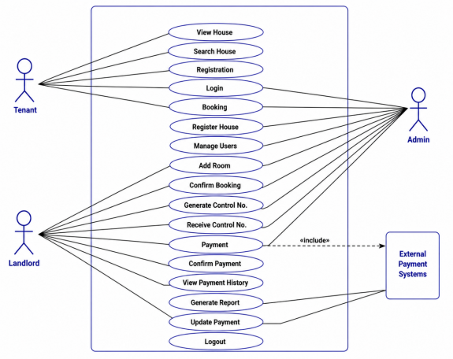

The Use Case Diagram is important because it gives a simple view of how the users interact with the system.

3.3.2 Use Case Descriptions

3.3.2.1 User Registration and Login
This function allows users to create an account and log in to the system using their login details.
Actor: Tenant, Landlord, Administrator
Input: User registration details and login details.
Process: The system checks the information provided by the user.
Output: The user is allowed to access the system if the login details are correct.

3.3.2.2 Building Management
This function allows the landlord to add, view, update, and delete building information.
Actor: Landlord
Input: Building details.
Process: The landlord enters or changes building information.
Output: Building information is saved in the database.

3.3.2.3 Room Management
This function allows the landlord to add and manage rooms.
Actor: Landlord
Input: Room details, rent amount, and availability.
Process: The landlord enters or updates room information.
Output: Room information is stored in the database.

3.3.2.4 View Available Rooms
This function allows tenants to see rooms that are available for rent.
Actor: Tenant
Input: Room search or room selection.
Process: The system displays available rooms and their information.
Output: The tenant can view available rooms.

3.3.2.5 Book a Room
This function allows a tenant to select an available room and submit a booking request.
Actor: Tenant
Input: Selected room and booking details.
Process: The system records the booking request.
Output: Booking request is saved and can be reviewed by the landlord.

3.3.2.6 Make Rent Payment
This function allows tenants to pay rent through the system.
Actor: Tenant
Input: Payment information.
Process: The system processes and records the payment.
Output: The payment information is stored in the system.

3.3.2.7 Manage Payments
This function allows the landlord to view and manage tenant payment records.
Actor: Landlord
Input: Payment records.
Process: The landlord checks payment information and status.
Output: Updated payment information is available in the system.

3.3.2.8 Generate Reports
This function allows the landlord to generate reports about rental activities.
Actor: Landlord
Input: Report type or required information.
Process: The system collects the required information from the database.
Output: The requested report is displayed.

3.3.2.9 Manage Users
This function allows the administrator to manage users in the system.
Actor: Administrator
Input: User information.
Process: The administrator adds, views, updates, or removes user accounts.
Output: User information is updated in the system.
These use cases are based on the functions already described in the project report.

3.3.3 Data Flow Diagram Level 0
The DFD Level 0 shows the Building Rent Collection System as one main process. It shows how information moves between the system and the main users.
The main external users are the Administrator, Landlord, and Tenant.
The Tenant sends registration details, booking information, and payment information to the system.
The Landlord sends building, room, tenant, booking, and payment information to the system.
The Administrator sends user management information to the system.
The system returns information such as room details, booking status, payment status, and reports to the users.
Figure 2: Data Flow Diagram Level 0 of the Building Rent Collection System
Insert your DFD Level 0 here.

3.3.4 Data Flow Diagram Level 1
The DFD Level 1 gives more details about the main activities inside the system.
The main processes are:
User Management
Building Management
Room Management
Tenant Management
Booking Management
Rent Payment Management
Report Generation
The information from these processes is stored in the system database. Users can send information to the system and receive the required information from the database.
Figure 3: Data Flow Diagram Level 1 of the Building Rent Collection System
Insert your DFD Level 1 here. Weka DFD hapa

3.3.5 Entity Relationship Diagram
The Entity Relationship Diagram shows the main data entities in the system and how they are related.
The main entities are:
Users
Buildings
Rooms
Tenants
Bookings
Payments
The ERD helps to show how information is stored and related in the database.
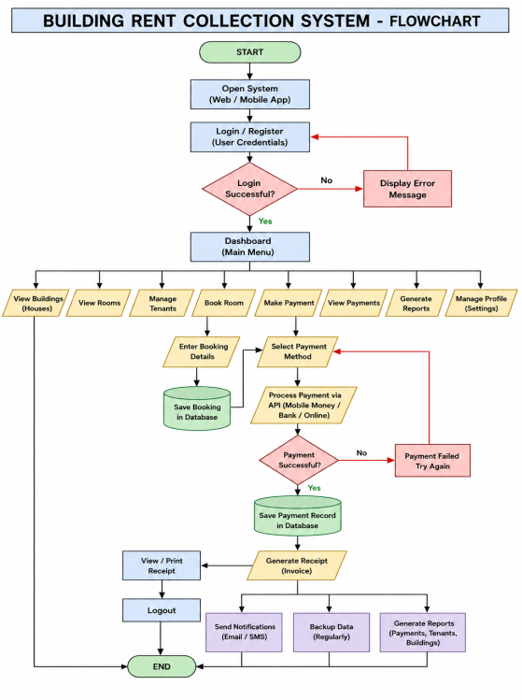
Figure 4: Entity Relationship Diagram of the Building Rent Collection System

The project report also identifies users, landlords, tenants, buildings, rooms, bookings, and payments as important entities in the system.

3.3.6 Database Schema Design
The database schema shows how data is stored and organized in the Building Rent Collection System. The database was designed using MySQL. It contains different tables that store information about users, buildings, rooms, tenants, bookings, and payments.
Each table contains different fields for storing specific information. Primary keys are used to identify each record in a table, while foreign keys are used to connect related tables. This helps the system to store, retrieve, update, and manage information correctly.

3.4 System Development Approach
The Building Rent Collection System was developed using an Object-Oriented Software Development Approach.
This approach was selected because the system contains different objects such as users, buildings, rooms, bookings, and payments. It also makes it easier to organise the system and manage different functions.
The use of an Object-Oriented approach is also stated in the original project report.

3.5 Software Development Life Cycle Model
The project used the Waterfall Model.
The Waterfall Model follows a step-by-step process. Each stage is completed before moving to the next stage.
The main stages used were:
Requirements
Design
Development
Testing
Deployment
Maintenance

3.5.1 Requirements
The system requirements were collected and identified. Information about tenants, buildings, rooms, bookings, and rent payments was considered.

3.5.2 Design
The structure of the system was planned. This included the database, user interface, Use Case Diagram, DFD, and ERD.

3.5.3 Development
The actual system was developed using the selected programming languages, framework, and database.

3.5.4 Testing
The system was tested to find errors and to check whether the main functions worked correctly.

3.5.5 Deployment
The completed system can be placed on a suitable server so that users can access it.

3.5.6 Maintenance
Maintenance involves fixing errors and making improvements after the system is deployed.
The original report also explains these six Waterfall stages.
Figure 5: Waterfall Model
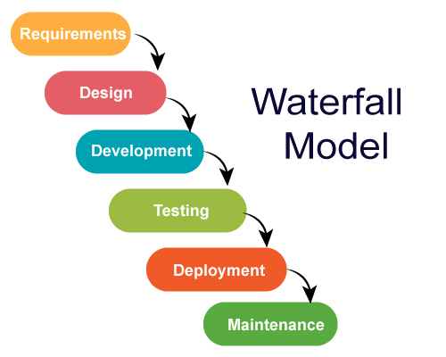

Figure 5: Waterfall Model

3.6 System Architecture
The system uses the Model-View-Controller (MVC) architecture provided by Laravel.
The MVC architecture has three main parts:
Model: Manages data and database operations.
View: Provides the pages and interface that users see.
Controller: Handles system logic and connects the Model with the View.
MVC helps to organise the system and makes it easier to develop and maintain.
The project report states that Laravel MVC was used for the system architecture.

3.7 Development Tools and Technologies
The following tools and technologies were used:

3.7.1 PHP
PHP was used as the main programming language for developing the web system.

3.7.2 HTML
HTML was used to create the structure of the web pages.

3.7.3 CSS
CSS was used to design and improve the appearance of the system pages.

3.7.4 JavaScript
JavaScript was used to add interactive features to the system.

3.7.5 Laravel
Laravel was used as the main PHP framework. It supports routing, authentication, database operations, validation, controllers, and models.

3.7.6 MySQL
MySQL was used to store and manage system information such as users, buildings, rooms, tenants, bookings, and payments.

3.7.7 WAMP
WAMP was used as the local server environment during development and testing.

3.7.8 Visual Studio Code
Visual Studio Code was used for writing and editing the system code.

3.7.9 Web Browser
Web browsers such as Google Chrome and Microsoft Edge were used to access and test the system.
These tools and technologies are listed in the original project report.

3.8 Data Collection Methods
Data was collected using questionnaires and interviews.

3.8.1 Questionnaires
Questionnaires were used to collect information from landlords and tenants. The questions focused on the current rent collection process, payment methods, problems, and the features needed in the new system.

3.8.2 Interviews
Interviews were conducted with selected landlords and tenants. The interviews helped to understand their experiences, problems, and needs related to rent collection and property management.
The project report states that questionnaires and interviews were used to collect information from landlords and tenants.

3.9 Software and Hardware Requirements

3.9.1 Software Requirements
The software requirements include:
PHP
HTML
CSS
JavaScript
Laravel
MySQL
WAMP
Visual Studio Code
Web browser

3.9.2 Hardware Requirements
The system requires a computer with:
At least 4 GB RAM
At least 250 GB storage
Internet access
A server or local server environment
These requirements are based on the requirements given in the project report.

3.10 Limitations of the Methodology
The methodology used in this project had some limitations.
First, only a small number of landlords and tenants participated in the study. Therefore, the information collected may not represent all landlords and tenants.
Second, there was limited time for data collection, system development, and testing.
Third, some respondents were not always available for interviews and questionnaires.
The project also had limited financial resources for transport, internet access, and other project activities.
These limitations were also identified in the original project report.
development approach, Waterfall model, system architecture, development tools, data collection methods, and system requirements.

CHAPTER FOUR: IMPLEMENTATION AND TESTING

4.1 Implementation Environment
The Building Rent Collection System was developed and tested using a computer with the required software and hardware.
The main software used was:
PHP
Laravel
MySQL
HTML
CSS
JavaScript
WAMP
Visual Studio Code
Web browser
WAMP was used to provide the local server environment. MySQL was used to store the system data. Visual Studio Code was used to write and edit the system code.

4.2 Backend Implementation
The backend is responsible for processing information and connecting the system with the database.
Laravel was used to develop the backend of the system. The backend handles activities such as user registration, login, building information, room information, bookings, tenants, and payments.
The main backend parts include:

4.2.1 User Management
The system stores user information and allows users to register and log in. The system checks the login details before allowing a user to access the system.

4.2.2 Building Management
The landlord can manage information about rental buildings. Building information is stored in the database and can be used when displaying available houses to tenants.

4.2.3 Room Management
The system stores room information such as room details, rental price, and availability. This information is used when tenants search for available rooms.

4.2.4 Booking Management
The system records booking information when a tenant selects an available room. The booking information can then be managed by the landlord.

4.2.5 Payment Management
The system records rent payment information. This helps the landlord to keep payment records and check the payment status of tenants.

4.3 Frontend Implementation
The frontend is the part of the system that users see and interact with. HTML, CSS, and JavaScript were used to create the system pages.

4.3.1 Home Page
The Home Page is the first page shown to a tenant. It allows tenants to view available rental houses.
The page provides information such as:
House image
House location
Rental price
Availability
House details
A tenant can select a house to view more information before making a booking.
Figure 6: Home Page
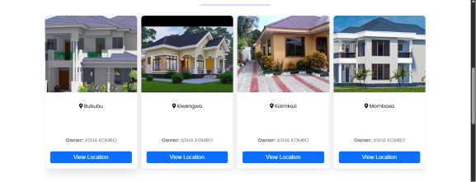

The Home Page in the original report allows tenants to browse houses and view house information before logging into the system.

4.3.2 House Location
The system provides a map that helps tenants see the location of a rental house.
The map allows the tenant to understand where the house is located before making a rental decision.
Figure 7: House Location Map
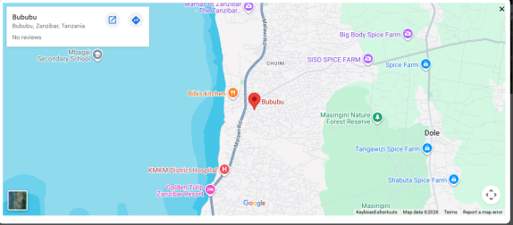

The original report shows a map as part of the system interface and explains that it helps tenants identify the location of the property.

4.3.3 Room Booking Page
The booking page allows a tenant to select an available room and continue with the booking process.
The tenant selects a room and provides the required information. The system then saves the booking information.
Figure 8: Room Booking Page
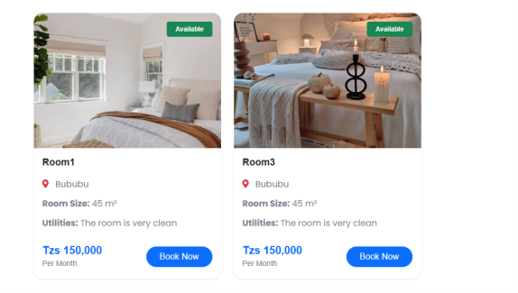

The original report shows that a tenant can select an available room and continue to the booking process.

4.3.4 Registration Page
The Registration Page allows a new user to create an account.
The user enters personal information. The system checks the information and saves it in the database. After successful registration, the user can log in.
Figure 9: Registration Page
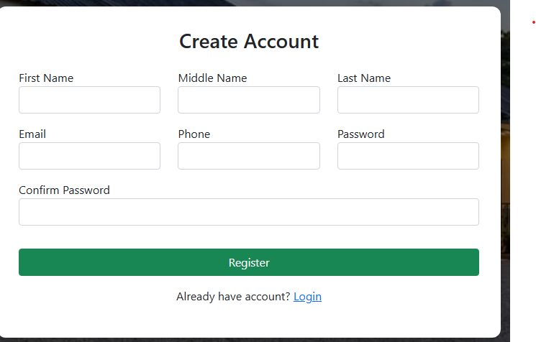

The report explains that the registration form saves user details in the database after validation.

4.3.5 Login Page
The Login Page allows registered users to access the system.
The user enters a username and password. The system checks the information. If the information is correct, the user is taken to the dashboard. If the information is wrong, the system displays an error message.
Figure 10: Login Page
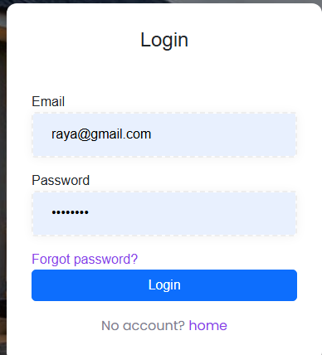

The original report describes the same login process and redirection to the dashboard after successful login.

4.4 Database Implementation
MySQL was used to store the system data.
The database contains information related to users, buildings, rooms, tenants, bookings, and payments.
The main tables include:
Table 1: Database Tables and Their Purposes
No. | Table | Purpose
1 | Users | Stores user information
2 | Buildings | Stores building information
3 | Rooms | Stores room information
4 | Tenants | Stores tenant information
5 | Bookings | Stores booking information
6 | Payments | Stores payment information
The database helps the system store and retrieve information when users perform different activities.
Figure 11: Database Structure

4.5 System Testing
System testing was done to check whether the Building Rent Collection System works as expected.
The testing focused on important functions such as registration, login, viewing houses, viewing location, booking, and payment.
The expected result was compared with the actual result.

4.5.1 Test Cases
Table 2: System Test Cases and Results

Test ID | Function Tested | Expected Result | Actual Result | Status
TC01 | User Registration | User account should be created successfully. | User account was created successfully. | Pass
TC02 | User Login | User should log in with correct details. | User logged in successfully. | Pass
TC03 | Wrong Login Details | System should show an error message. | Error message was displayed. | Pass
TC04 | View Available Houses | Available houses should be displayed. | Available houses were displayed. | Pass
TC05 | View House Location | House location should be displayed on the map. | House location was displayed. | Pass
TC06 | Room Booking | Booking information should be saved. | Booking information was saved. | Pass
TC07 | Rent Payment | Payment information should be recorded. | Payment information was recorded. | Pass
TC08 | View Payment Records | Payment records should be displayed. | Payment records were displayed. | Pass
TC09 | Manage Rooms | Landlord should add or update room information. | Room information was managed successfully. | Pass
TC10 | Logout | User should be logged out of the system. | User was logged out successfully. | Pass

4.6 Unit Testing
Unit testing was used to test individual functions of the system.
The main functions tested included:
User registration
User login
Building management
Room management
Booking
Payment
User management
Each function was tested separately to check whether it worked correctly.

4.7 Integration Testing
Integration testing was used to check whether different parts of the system work together.
For example, the registration page was tested together with the database to make sure that user information entered by the user was correctly saved.
The booking function was also tested with the database to make sure that booking information was correctly stored.
Payment functions were tested with the database to check whether payment information was correctly recorded.

4.8 Functional and User Acceptance Testing
Functional testing was done to check whether the main system functions performed the required tasks.
User Acceptance Testing was carried out to check whether the system could meet the needs of landlords and tenants. The original report also identifies User Acceptance Testing as part of the testing process.
The users checked important functions such as:
Registration
Login
Viewing houses
Viewing house location
Room booking
Rent payment
Payment records
The results showed that the main functions worked as expected.

4.9 Results
The system produced the expected results for the main functions tested.
The study also found that the existing manual rent collection process had several problems. All five respondents reported difficulty in tracking payment records and lack of automatic notifications. Four respondents reported late rent payments, while three reported loss of payment information.
The study also found that most respondents used cash payment. Four respondents used cash, while one used mobile money. No respondent used bank payment or an online payment system.
All five respondents identified tenant registration, house location, online payment, payment notification, and payment reports as important features for the proposed system.
These findings supported the development of the Building Rent Collection System.

4.10 Discussion of Results
The results show that the Building Rent Collection System can help improve the management of rental activities.
The system provides a way for tenants to view rental houses and their locations before making a decision. It also provides a booking process that allows tenants to select available rooms.
The system also provides registration and login functions. This helps users access the system using their accounts.
The payment function helps keep rent payment information in the system. This can make it easier for landlords to check payment records.
The findings from the respondents also support the need for the system. The respondents reported problems with payment tracking, late payments, loss of payment information, and lack of automatic notifications.
Therefore, the proposed system provides a better way of managing rental information compared with the manual process described by the respondents.

CHAPTER FIVE: CONCLUSION, RECOMMENDATIONS AND CHALLENGES

5.1 Conclusion
The main objective of this project was to develop a Building Rent Collection System that helps landlords manage rental activities and allows tenants to view houses, make bookings, and pay rent online.
The project achieved this objective by developing a web-based system for managing rental information.
The first specific objective was to develop a user interface for the system. This objective was achieved by developing pages such as the Home Page, Registration Page, Login Page, booking page, and other system pages.
The second objective was to create a database for storing system information. This was achieved by creating a database for information such as users, buildings, rooms, tenants, bookings, and payments.
The third objective was to connect the system interface with the database. This was achieved using Laravel, PHP, and MySQL.
The fourth objective was to allow tenants to view available rooms and house information. The system provides information about available rental houses and rooms.
The fifth objective was to allow tenants to view house locations. The system provides a map that helps tenants identify the location of rental properties.
The sixth objective was to allow tenants to make room booking requests. The system provides a booking process where tenants can select an available room and submit their booking information.
The seventh objective was to allow tenants to make rent payments online. The system provides a rent payment function for recording tenant payments.
The eighth objective was to allow landlords to manage rental activities. The system supports the management of buildings, rooms, tenants, bookings, and payment information.
The final objective was to provide rental reports. The system provides payment and rental information that can help landlords monitor rental activities.
In general, the project achieved its main objectives and provides a better way to manage rental information compared with the manual process identified during the study.

5.2 Recommendations
The following recommendations are made for future improvement of the Building Rent Collection System:

5.2.1 Mobile Application
A mobile application can be developed in the future. This will allow tenants and landlords to access the system more easily using smartphones.

5.2.2 More Payment Methods
More online payment methods can be added to give tenants more choices when paying rent.

5.2.3 Automatic Notifications
The system can be improved by adding automatic SMS, email, or other notifications. For example, tenants can receive reminders when rent is due and confirmation after making payment.

5.2.4 Better Reports
More detailed reports can be added. These reports can help landlords understand rent collection, unpaid rent, and payment history.

5.2.5 Improved Security
The security of the system can be improved by adding more security controls to protect user information and payment information.

5.2.6 Online Hosting
The system can be hosted on an online server so that landlords and tenants can access it from different locations.

5.2.7 Future Students and Researchers
Future students and researchers can improve the system by adding more features and testing it with a larger number of landlords and tenants.

5.3 Challenges Faced
Several challenges were faced during the development of the Building Rent Collection System.

5.3.1 Limited Time
The project was developed within a limited period. This made it difficult to develop and test all possible features.
Solution: The main system functions were given priority and developed first.

5.3.2 Limited Financial Resources
The project had limited financial resources for activities such as internet access, transport, printing, and hosting.
Solution: Free or low-cost development tools were used during development and testing.

5.3.3 Respondent Availability
Some landlords and tenants were not always available during data collection.
Solution: Interviews and questionnaires were conducted when respondents were available.

5.3.4 Internet Problems
Internet access was sometimes limited during development and testing.
Solution: The system was developed and tested locally using WAMP, which reduced dependence on internet access during development.

5.3.5 Technical Problems
Some technical problems were experienced during coding, database connection, and system testing.
Solution: The problems were solved by checking the code, database settings, and system configuration during development.

REFERENCES
Abdullahi, K., Jibrin, B., & Yarima, A. (2026). Role of property managers in enhancing rent collection efficiency in African urban commercial properties: Evidence from Kano metropolis, Nigeria. FUDMA Journal of Sciences, 10(4), 183–191. https://doi.org/10.33003/fjs-2026-1004-4750
Buradkar, K., Kori, S., Ruikar, S., Galfat, V., Patil, D., & Nasare, R. (2022). Property rental management system. International Journal of Computer Science and Mobile Computing, 11(11), 177–179. https://doi.org/10.47760/ijcsmc.2022.v11i11.014
Kulwa, M. E. (2026). The impact of mobile fintech on financial inclusion in Tanzania (2020–2024): A literature review. African Quarterly Social Science Review, 3(2). https://doi.org/10.51867/AQSSR.3.2.6
Kurnool, A. (2025). Property management system [Master’s project, California State University, San Bernardino]. CSUSB ScholarWorks. https://scholarworks.lib.csusb.edu/etd/2337/
Lemen, J. (2021, July 5). Property management APC: Rent and arrears. Royal Institution of Chartered Surveyors. https://ww3.rics.org/uk/en/journals/property-journal/property-management-apc--rent-and-arrears-.html
Oracle. (2026). MySQL 8.0 reference manual. https://dev.mysql.com/doc/refman/8.0/en/
PHP Documentation Group. (2026). PHP manual. https://www.php.net/manual/en/
Pressman, R. S., & Maxim, B. R. (2019). Software engineering: A practitioner’s approach (9th ed.). McGraw-Hill Education.
WampServer. (2026). WampServer: A Windows web development environment. https://www.wampserver.com

APPENDIX H: PROJECT BUDGET
The project budget shows the estimated costs needed to develop and run the system. It covers expenses like software, hardware, development resources, and maintenance. The budget ensures that resources are used wisely and that the project is completed within the available funds without compromising quality.

Table 6: Project Budget
SN | ITERM | COST
01 | COMPUTER | 1000,000
02 | INTERNET | 300,000
03 | SOFTWARE TOOLS | 50,000
04 | DOMAIN AND HOST | 200,000
05 | TRANSPORT | 300,000
06 | PRINTING | 40,000
07 | OTHER EXPENSES | 150,000
08 | TOTAL COST | 1770000

