KARUME INSTITUTE OF SCIENCE AND TECHNOLOGY

PROJECT REPORT
ORDINARY DIPLOMA IN INFORMATION AND COMMUNICATION TECHNOLOOGY WITH BUSINESS
(NTA-LEVEL6)

CANDIDATE NAME: RAYA MOHD ALI
SUPERVISION NAME: MADAM THANIA SULEIMAN SIMAI
REGESTRATION NUMBER: KIST-ICT-23-0017
COURSE: ICT WITH BUSINESS
DEPARTMENT: ELECTRONICS, TELECOMMUNICATION AND COMPUTER ENGINEERING
PROJECT TITLE: BUILDING RENT COLLECTION SYSTEM

AUGUST, 2026

DECLARATION
I, RAYA MOHD ALI, declare that this project report titled “BUILDING RENT COLLECTION SYSTEM”, submitted to Karume Institute of science and technology in the partial fulfillment of the requirements for the diploma in ICT WITH BUSINESS is my original work and has not been copied from anywhere. This is a result of my own initiations, survey findings and technical knowledge, with the help of various lecturers as references and consultations from supervisors, lecturers and experts in the field.

Full name: Raya Mohd Ali

Signature: ..........................

Date: ...........................

CERTIFICATION
I, the undersigned, certify that this project report titled “BUILDING RENT COLLECTION SYSTEM” submitted by RAYA MOHD ALI, Registration Number KIST/ICT/23/0017, in partial fulfillment of the requirements for the award of Ordinary Diploma in Information and Communication Technology at the Karume Institute of Science and Technology, is a genuine record of work carried out by the candidate under my supervision. The report has been submitted to the Department of Information and Communication Technology for assessment in accordance with the institution’s guidelines.

SUPERVISOR
Name: Thania Suleiman Simai

Signature: ……………………………

Date: ……………………………

ACKNOWLEDGEMENT
- First and foremost, I would like to thank Almighty Allah for granting me good health, strength, and the ability to successfully complete my project titled Building Rent Collection System.
- Secondly, I would like to express my sincere gratitude to my beloved parents for their continuous support, encouragement, and prayers throughout my studies. Their guidance has been essential in helping me reach this stage.
- I would also like to extend my special thanks to my supervisor, Madam Thania Sulemain Simai from Karume Institute of Science and Technology, for her valuable guidance, patience, and support during the development of this project. Her advice greatly contributed to improving the quality of my work.
- Furthermore, I would like to thank all lecturers and teachers from Karume Institute of Science and Technology for providing me with the knowledge and skills necessary to undertake and complete this project.
- Finally, I would like to thank my friends for their encouragement, support, and cooperation throughout the entire project period.

ABSTRACT
This project developed a web-based Building Rent Collection System to address the challenges created when rental records, booking requests, and payment follow-up are handled manually. Manual processes can lead to delayed verification, missing records, limited communication, and difficulty for tenants to identify available rooms. The study therefore aimed to provide a centralised system for managing rental information and supporting timely, accurate rent collection. Requirements were identified through questionnaires and interviews with landlords and tenants. The system was designed using an object-oriented approach and the Waterfall model. It was implemented as a Laravel and PHP web application using MySQL/MariaDB, HTML, CSS, and JavaScript. The system follows the Model-View-Controller architecture and provides role-based accounts for administrators, landlords, and tenants. Its main modules support user registration and login, building and room management, room availability, booking, payment recording and verification, notifications, and reports. Testing focused on key functions, including registration, login, property management, booking, and payment processing. The recorded test results show that the core functions operated as expected. The completed system improves the organisation of rental information, provides tenants with clearer access to available rooms and booking services, and gives landlords a more structured way to monitor bookings and payments.

TABLE OF CONTENTS
DECLARATION ii
CERTIFICATION iii
ACKNOWLEDGEMENT iv
ABSTRACT v
TABLE OF CONTENTS vi
LIST OF TABLES xi
LIST OF FIGURES xii
LIST OF ABBREVIATIONS xiii
CHAPTER ONE: Introduction 1
1.1 Background of the Study 1
1.2 Problem Statement 1
1.3 Objectives of the Study 2
1.3.1 General Objective 2
1.3.2 Specific Objectives 2
1.4 Significance of the Study 2
1.5 Scope of the Study 2
1.5.1 Limitations of the Study 2
1.6 Feasibility Study 3
1.6.1 Technical Feasibility 3
1.6.2 Economic Feasibility 3
1.6.3 Operational Feasibility 3
1.6.4 Schedule Feasibility 3
1.6.5 Legal Feasibility 3
CHAPTER TWO: Literature Review 4
2.1 Introduction 4
2.2 Related Work 4
2.3 Identification of Gaps 5
CHAPTER THREE: Methodology 6
3.1 Requirement Determination 6
3.1.1 Functional Requirements 6
3.1.2 Non-functional Requirements 6
3.2 Requirement Structuring and System Modeling 7
3.2.1 Use Case Diagram 7
3.2.2 Use Case Descriptions 8
3.2.2.1 User Registration and Login 8
3.2.2.2 Building Management 9
3.2.2.3 Room Management 9
3.2.2.4 View Available Rooms 9
3.2.2.5 Book a Room 9
3.2.2.6 Make Rent Payment 9
3.2.2.7 Manage Payments 10
3.2.2.8 Generate Reports 10
3.2.2.9 Manage Users 10
3.4.3 Data Flow Diagram Level 0 10
3.4.4 Data Flow Diagram Level 1 11
3.3.5 Entity Relationship Diagram 12
3.3.6 Database Schema Design 13
3.4 System Development Approach 14
3.5 Software Development Life Cycle Model 14
3.5.1 Requirements 14
3.5.2 Design 14
3.5.3 Development 15
3.5.4 Testing 15
3.5.5 Deployment 15
3.5.6 Maintenance 15
3.6 System Architecture 16
3.7 Development Tools and Technologies 16
3.7.1 PHP 16
3.7.2 HTML 16
3.7.3 CSS 16
3.7.4 JavaScript 16
3.7.5 Laravel 17
3.7.6 MySQL 17
3.7.7 WAMP 17
3.7.8 Visual Studio Code 17
3.7.9 Web Browser 17
3.8 Data Collection Methods 17
3.8.1 Questionnaires 17
3.8.2 Interviews 17
3.9 Software and Hardware Requirements 18
3.9.1 Software Requirements 18
3.9.2 Hardware Requirements 18
3.10 Limitations of the Methodology 18
CHAPTER FOUR: Implementation and testing 20
4.1 Implementation Environment 20
4.2 Backend Implementation 20
4.2.1 User Management 20
4.2.2 Building Management 21
4.2.3 Room Management 21
4.2.4 Booking Management 21
4.2.5 Payment Management 21
4.3 Frontend Implementation 21
4.3.1 Home Page 21
4.3.2 House Location 22
4.3.3 Room Booking Page 23
4.3.4 Registration Page 23
4.3.5 Login Page 24
4.4 Database Implementation 25
4.5 System Testing 26
4.5.1 Test Cases 26
4.6 Unit Testing 26
4.7 Integration Testing 27
4.8 Functional and User Acceptance Testing 27
4.9 Results 28
4.10 Discussion of Results 28
CHAPTER FIVE: Conclusion, Recommendation and challenges 30
5.1 Conclusion 30
5.2 Recommendations 31
5.2.1 Mobile Application 31
5.2.2 More Payment Methods 31
5.2.3 Automatic Notifications 31
5.2.4 Better Reports 31
5.2.5 Improved Security 31
5.2.6 Online Hosting 31
5.2.7 Future Students and Researchers 32
5.3 Challenges Faced 32
5.3.1 Limited Time 32
5.3.2 Limited Financial Resources 32
5.3.3 Respondent Availability 32
5.3.4 Internet Problems 32
5.3.5 Technical Problems 32
REFERENCES 34
APPENDIX A: SYSTEM INTERFACES 35
APPENDIX B: DATABASE SCHEMA 41
APPENDIX C: DATA COLLECTION INSTRUMENTS 42
APPENDIX D: USER MANUAL / SETUP GUIDE 44
APPENDIX E: SOURCE CODE / PROGRAM LISTING 46
APPENDIX F: SAMPLE SYSTEM REPORTS 47
APPENDIX G: SYSTEM TESTING EVIDENCE 49
APPENDIX H: PROJECT BUDGET 49

LIST OF TABLES
Table 1: Database Tables and Their Purposes
Table 2: System Test Cases and Results
Table 3: Main Database Tables
Table 4: Project Source-Code Structure
Table 5: System Testing Evidence Checklist
Table 6: Project Budget

LIST OF FIGURES
Figure 1: Use Case Diagram of the Building Rent Collection System
Figure 2: Data Flow Diagram Level 0
Figure 3: Data Flow Diagram Level 1
Figure 4: Entity Relationship Diagram
Figure 5: Waterfall Model
Figures 6-11: Main System Interfaces and Database Structure
Figures A1-A11: Appendix System Interfaces

LIST OF ABBREVIATIONS
CSS - Cascading Style Sheets
DFD - Data Flow Diagram
ERD - Entity Relationship Diagram
HTML - HyperText Markup Language
MVC - Model-View-Controller
PHP - PHP: Hypertext Preprocessor
SDLC - Software Development Life Cycle
WAMP - Windows, Apache, MySQL and PHP

CHAPTER ONE: Introduction

1.1 Background of the Study
A Building Rent Collection System was a digital system that helped landlords and tenants manage rent payments easily. The system allowed tenants to view available houses, check their location, and pay rent online. The use of technology in rent management reduced manual work, saved time, and improved efficiency. This study focused on developing a system that made rent collection simple, fast, and reliable
In many places, rent collection was still done manually. Landlords collected money physically, and records were kept on paper or simple files. This process could lead to problems such as loss of data, errors in records, and difficulty in tracking payments. Also, tenants found it hard to know the exact location of houses before renting.
With the growth of technology, systems could be developed to solve these problems. An online rent collection system could help tenants view house details, see location on a map, and make payments using mobile money or other digital methods. This improved communication between landlords and tenants.

1.2 Problem Statement
Many landlords faced challenges in managing rent payments, such as poor record keeping, late payments, and lack of proper communication with tenants. Tenants also faced difficulties in finding houses and knowing their exact location.
The current manual system was slow, not secure, and prone to errors. Therefore, there was a need for a computerized system that would improve rent collection, provide accurate records, and allow tenants to view house locations and pay rent easily.

1.3 Objectives of the Study

1.3.1 General Objective
The system a Building Rent Collection System was developed to allow tenants to view house locations and pay rent online.

1.3.2 Specific Objectives
- The system developed a user interface using HTML, CSS, and JavaScript.
- The system created a database using MySQL.
- The system connected the user interface to the database using PHP.
- The system integrated an online rent payment API to enable rent payments.

1.4 Significance of the Study
This study was important because it helped improve rent management. Landlords were able to track payments easily and reduce errors. Tenants benefited by finding houses quickly and knowing their exact location. The system also saved time, reduced paperwork, and increased transparency between landlords and tenants.

1.5 Scope of the Study
The system focused on managing rent payments, showing house details, and displaying house locations. It allowed tenants to register, view houses, and make payments online.

1.5.1 Limitations of the Study
- The system depended on internet availability
- Some users might not have had enough technical skills
- Payment methods were limited to available services

1.6 Feasibility Study
A feasibility study was conducted to find out whether the proposed Building Rent Collection System can be developed and used successfully. The study focused on technical, economic, operational, schedule, and legal feasibility.

1.6.1 Technical Feasibility
The system was technically feasible because the required hardware and software were available. The system was developed using HTML, CSS, JavaScript, Laravel, PHP, and MySQL. A computer and WAMP server were used during development and testing.

1.6.2 Economic Feasibility
The system was economically feasible because it did not require expensive equipment or software. Most of the development tools were free. The system also reduced the cost and time used in keeping rent records manually.

1.6.3 Operational Feasibility
The system was easy to use. Landlords used it to manage buildings, rooms, tenants, and rent payments. Tenants used it to view rooms and make rent payments. The system also helped to keep accurate records.

1.6.4 Schedule Feasibility
The system was schedule feasible because it could be completed within the planned project time. The main activities included system analysis, database design, coding, testing, and implementation.

1.6.5 Legal Feasibility
The system was legally feasible because user information and payment records were protected. Only authorized users were allowed to access the system.

CHAPTER TWO: Literature Review

2.1 Introduction
The rapid advancement of information technology has significantly transformed property management practices worldwide. Traditional rent collection methods, which rely on manual record keeping, paper receipts, and physical follow-ups, often result in delayed payments, calculation errors, data loss, and poor financial tracking. These inefficiencies create challenges for landlords, property managers, and tenants. A Building Rent Collection System was therefore introduced as a digital solution to automate rent payments, maintain accurate tenant records, generate financial reports, and improve transparency in rental transactions. By integrating secure online payments and centralized data storage, the system enhanced operational efficiency, reduced administrative workload, and ensured timely communication between stakeholders.
The literature review covers key themes including:
- Traditional rent collection methods.
- Digital payment systems
- Property management systems
- User experience and accessibility.
- Security and data management.

2.2 Related Work
Smith and Brown (2020) developed an automated rent collection and payment system for residential properties. Their system integrated electronic payment options and automated SMS and email reminders to notify tenants about due dates. The study showed that automation reduced late payments and improved financial record accuracy. However, the system mainly focused on payment processing and did not include advanced analytics or comprehensive multi-user access control features.
Wang, Li, and Zhao (2021) proposed a cloud-based rental management system with integrated billing functionality. Their system allowed property managers to access tenant data remotely using cloud infrastructure, improving scalability and centralized data management. The study emphasized system accessibility and billing automation. Despite these improvements, the system lacked predictive notification mechanisms and advanced security features such as detailed audit trails.
Patel and Mehta (2022) introduced a smart rent collection system using a mobile application. Their approach enabled tenants to make rent payments via mobile devices and receive instant digital receipts. The system enhanced convenience and reduced paperwork. However, it did not provide a comprehensive administrative dashboard for financial performance analysis, nor did it support multiple user roles with defined access levels.
Ahmed and Singh (2023) developed an IoT-based automated rent tracking system that connected rent payments with utility usage such as water and electricity consumption. Their system automatically calculated rental charges based on service usage such as social service like water electricity.

2.3 Identification of Gaps
Despite the efforts made by previous researchers, several gaps still exist:
- Many systems did not provide house location features such as maps to help tenants find houses easily.
- Some systems did not support modern payment methods like mobile money.
- Limited user interaction, where tenants could not fully control activities like selecting houses and making payments.
- Lack of notification systems for rent reminders and updates.
- Some systems had poor security, which risked user data.
- These gaps showed the need for a more advanced and user-friendly system.

CHAPTER THREE: Methodology

3.1 Requirement Determination
Requirement determination was done to identify what the Building Rent Collection System should do and how it should work. The requirements were divided into functional and non-functional requirements.

3.1.1 Functional Requirements
Functional requirements described the activities that the system had to be able to perform.
The Building Rent Collection System was required to:
Allow tenants to make rent payments.
Allow landlords to view and manage payment records.
Allow landlords to manage booking requests.
Allow landlords to generate rental reports.
Allow users to manage their account information.
Allow users to log out of the system.
These requirements were based on the functions described in the project report, including user registration, building management, room management, booking, rent payment, payment management, reports, and user management.

3.1.2 Non-functional Requirements
Non-functional requirements described how the system was to work.
The system had the following qualities:
Security: The system protected user information and payment records.
Usability: The system was simple and easy to use.
Reliability: The system worked correctly and kept correct records.
Performance: The system responded quickly to user requests.
Availability: The system was available when users needed it.
Maintainability: The system was easy to update and maintain.
These requirements were also included in the original project report.

3.2 Requirement Structuring and System Modeling
System modeling was used to show how the Building Rent Collection System worked and how users interacted with it. The main modeling tools used were the Use Case Diagram, Use Case Descriptions, Data Flow Diagram, Entity Relationship Diagram, and Database Schema.

3.2.1 Use Case Diagram
The Use Case Diagram showed the main users of the Building Rent Collection System and the activities they could perform.
The main users were:
- Administrator
- Landlord
- Tenant
The Administrator managed system users and system information. The Landlord managed buildings, rooms, tenants, bookings, payments, and reports. The Tenant viewed available rooms, viewed house information and location, made bookings, and made rent payments.
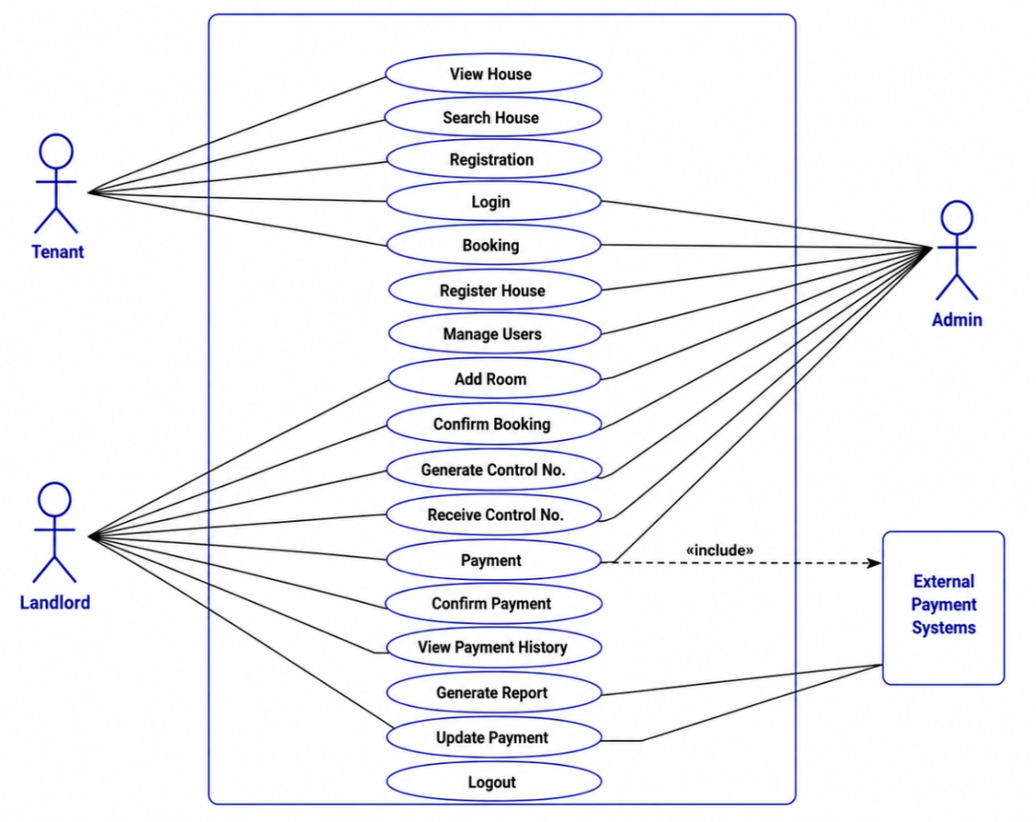
Figure 1: Use Case Diagram of the Building Rent Collection System

The Use Case Diagram was important because it gave a simple view of how the users interacted with the system.

3.2.2 Use Case Descriptions

3.2.2.1 User Registration and Login
This function allowed users to create an account and log in to the system using their login details.
Actor: Tenant, Landlord, Administrator
Input: User registration details and login details.
Process: The system checked the information provided by the user.
Output: The user was allowed to access the system if the login details were correct.

3.2.2.2 Building Management
This function allowed the landlord to add, view, update, and delete building information.
Actor: Landlord
Input: Building details.
Process: The landlord entered or changed building information.
Output: Building information was saved in the database.

3.2.2.3 Room Management
This function allowed the landlord to add and manage rooms.
Actor: Landlord
Input: Room details, rent amount, and availability.
Process: The landlord entered or updated room information.
Output: Room information was stored in the database.

3.2.2.4 View Available Rooms
This function allowed tenants to see rooms that were available for rent.
Actor: Tenant
Input: Room search or room selection.
Process: The system displayed available rooms and their information.
Output: The tenant could view available rooms.

3.2.2.5 Book a Room
This function allowed a tenant to select an available room and submit a booking request.
Actor: Tenant
Input: Selected room and booking details.
Process: The system recorded the booking request.
Output: Booking request was saved and could be reviewed by the landlord.

3.2.2.6 Make Rent Payment
This function allowed tenants to pay rent through the system.
Actor: Tenant
Input: Payment information.
Process: The system processed and recorded the payment.
Output: The payment information was stored in the system.

3.2.2.7 Manage Payments
This function allowed the landlord to view and manage tenant payment records.
Actor: Landlord
Input: Payment records.
Process: The landlord checked payment information and status.
Output: Updated payment information was available in the system.

3.2.2.8 Generate Reports
This function allowed the landlord to generate reports about rental activities.
Actor: Landlord
Input: Report type or required information.
Process: The system collected the required information from the database.
Output: The requested report was displayed.

3.2.2.9 Manage Users
This function allowed the administrator to manage users in the system.
Actor: Administrator
Input: User information.
Process: The administrator added, viewed, updated, or removed user accounts.
Output: User information was updated in the system.
These use cases were based on the functions already described in the project report.

3.4.3 Data Flow Diagram Level 0
The DFD Level 0 showed the Building Rent Collection System as one main process. It showed how information moved between the system and the main users.
The main external users were the Administrator, Landlord, and Tenant.
The Tenant sent registration details, booking information, and payment information to the system.
The Landlord sent building, room, tenant, booking, and payment information to the system.
The Administrator sent user management information to the system.
The system returned information such as room details, booking status, payment status, and reports to the users.
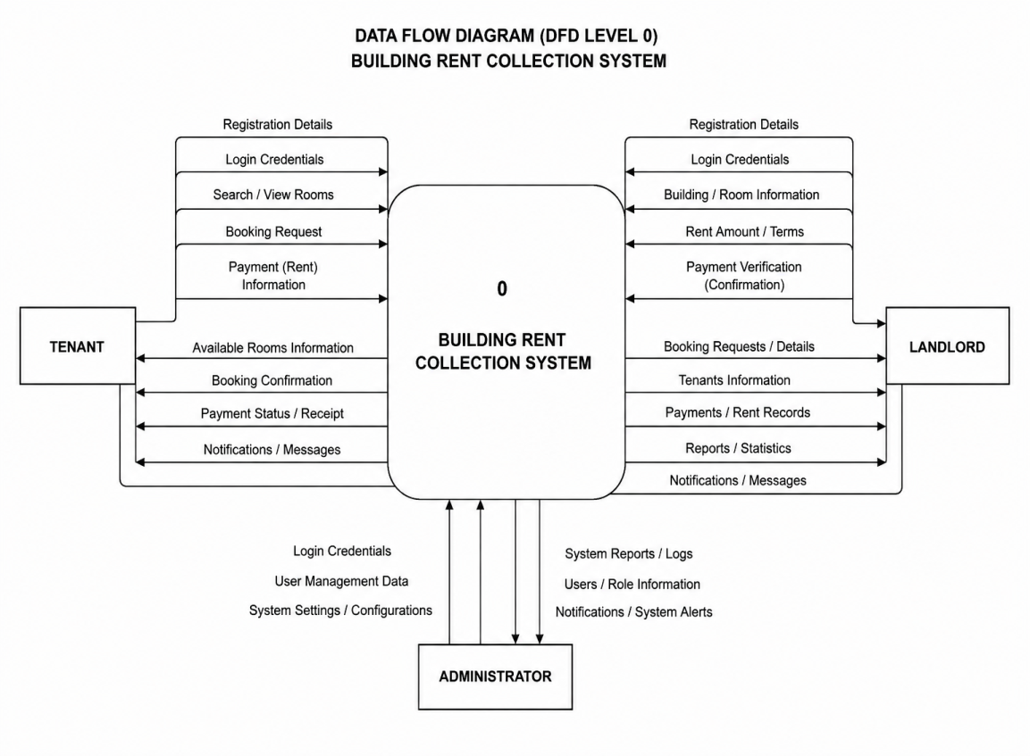
Figure 2: Data Flow Diagram Level 0 of the Building Rent Collection System

3.4.4 Data Flow Diagram Level 1
The DFD Level 1 gave more details about the main activities inside the system.
The main processes were:
User Management
Building Management
Room Management
Tenant Management
Booking Management
Rent Payment Management
Report Generation
The information from these processes was stored in the system database. Users could send information to the system and receive the required information from the database.

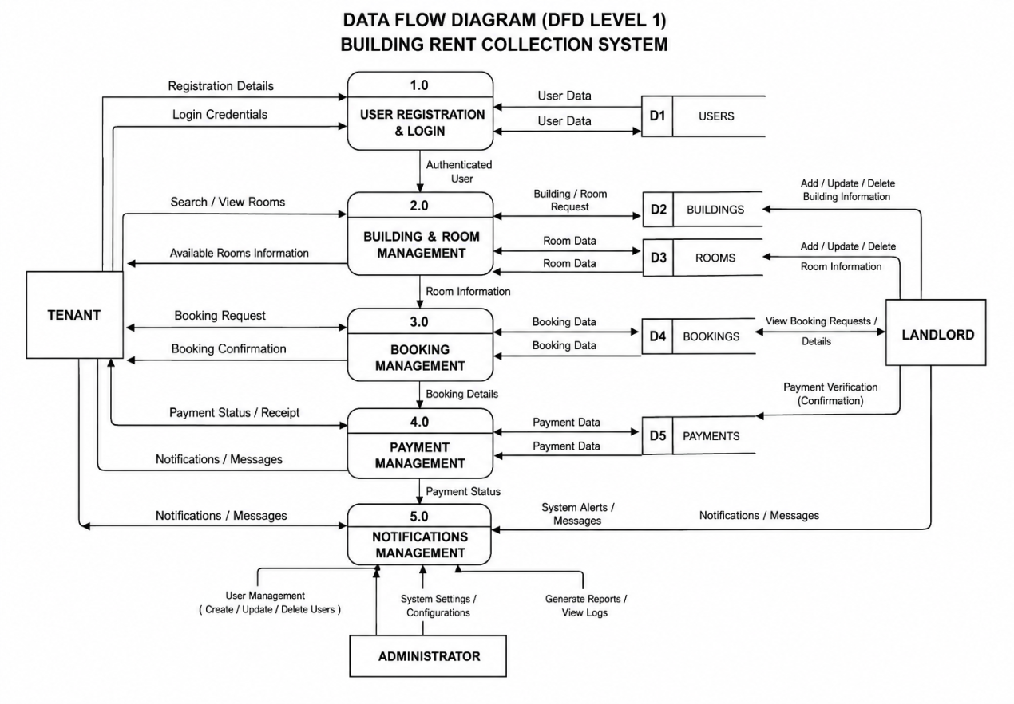
Figure 3: Data Flow Diagram Level 1 of the Building Rent Collection System

3.3.5 Entity Relationship Diagram
The Entity Relationship Diagram showed the main data entities in the system and how they were related.
The main entities were:
Users
Buildings
Rooms
Tenants
Bookings
Payments
The ERD helped to show how information was stored and related in the database. 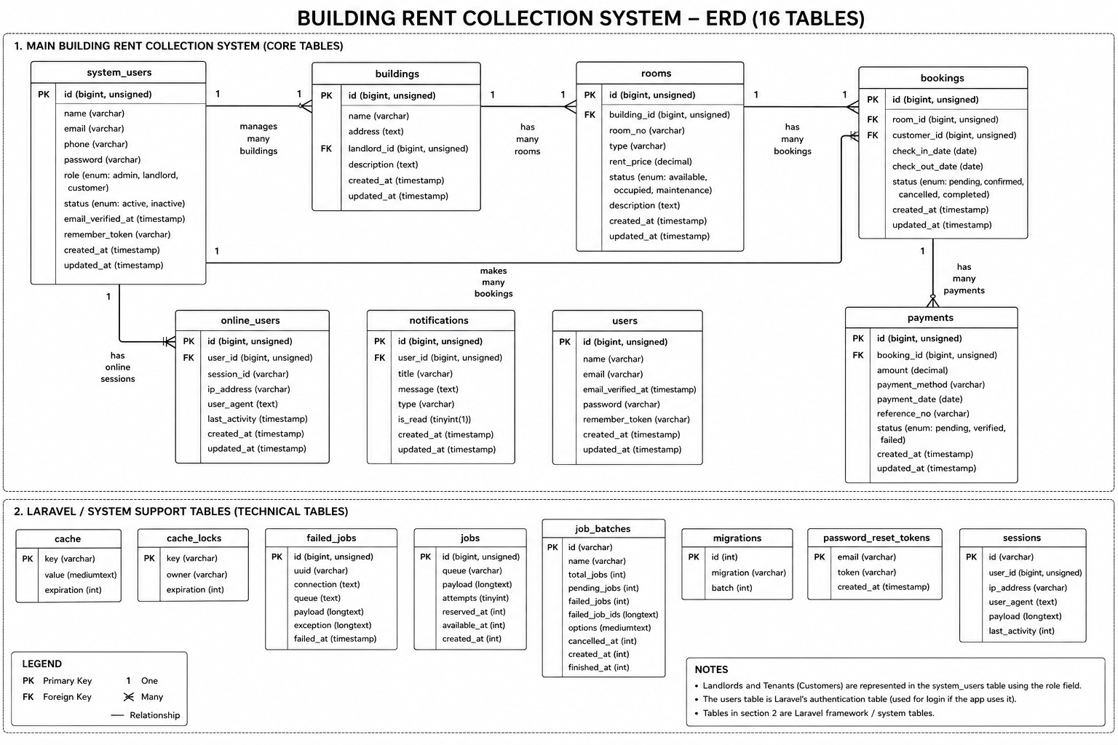

Figure 4: Entity Relationship Diagram of the Building Rent Collection System

The project report also identified users, landlords, tenants, buildings, rooms, bookings, and payments as important entities in the system.

3.3.6 Database Schema Design
The database schema showed how data was stored and organized in the Building Rent Collection System. The database was designed using MySQL. It contained different tables that stored information about users, buildings, rooms, tenants, bookings, and payments.
Each table contained different fields for storing specific information. Primary keys were used to identify each record in a table, while foreign keys were used to connect related tables. This helped the system to store, retrieve, update, and manage information correctly.

3.4 System Development Approach
The Building Rent Collection System was developed using an Object-Oriented Software Development Approach.
This approach was selected because the system contained different objects such as users, buildings, rooms, bookings, and payments. It also made it easier to organise the system and manage different functions.
The use of an Object-Oriented approach was also stated in the original project report.

3.5 Software Development Life Cycle Model
The project used the Waterfall Model.
The Waterfall Model followed a step-by-step process. Each stage was completed before moving to the next stage.
The main stages used were:
Requirements
Design
Development
Testing
Deployment
Maintenance

3.5.1 Requirements
The system requirements were collected and identified. Information about tenants, buildings, rooms, bookings, and rent payments was considered.

3.5.2 Design
The structure of the system was planned. This included the database, user interface, Use Case Diagram, DFD, and ERD.

3.5.3 Development
The actual system was developed using the selected programming languages, framework, and database.

3.5.4 Testing
The system was tested to find errors and to check whether the main functions worked correctly.

3.5.5 Deployment
The completed system could be placed on a suitable server so that users could access it.

3.5.6 Maintenance
Maintenance involved fixing errors and making improvements after the system was deployed.
The original report also explained these six Waterfall stages.
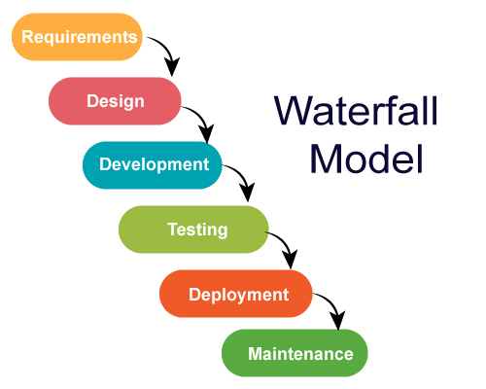

Figure 5: Waterfall Model

3.6 System Architecture
The system used the Model-View-Controller (MVC) architecture provided by Laravel.
The MVC architecture had three main parts:
Model: Managed data and database operations.
View: Provided the pages and interface that users saw.
Controller: Handled system logic and connected the Model with the View.
MVC helped to organise the system and made it easier to develop and maintain.
The project report stated that Laravel MVC was used for the system architecture.

3.7 Development Tools and Technologies
The following tools and technologies were used:

3.7.1 PHP
PHP was used as the main programming language for developing the web system.

3.7.2 HTML
HTML was used to create the structure of the web pages.

3.7.3 CSS
CSS was used to design and improve the appearance of the system pages.

3.7.4 JavaScript
JavaScript was used to add interactive features to the system.

3.7.5 Laravel
Laravel was used as the main PHP framework. It supported routing, authentication, database operations, validation, controllers, and models.

3.7.6 MySQL
MySQL was used to store and manage system information such as users, buildings, rooms, tenants, bookings, and payments.

3.7.7 WAMP
WAMP was used as the local server environment during development and testing.

3.7.8 Visual Studio Code
Visual Studio Code was used for writing and editing the system code.

3.7.9 Web Browser
Web browsers such as Google Chrome and Microsoft Edge were used to access and test the system.
These tools and technologies were listed in the original project report.

3.8 Data Collection Methods
Data was collected using questionnaires and interviews.

3.8.1 Questionnaires
Questionnaires were used to collect information from landlords and tenants. The questions focused on the current rent collection process, payment methods, problems, and the features needed in the new system.

3.8.2 Interviews
Interviews were conducted with selected landlords and tenants. The interviews helped to understand their experiences, problems, and needs related to rent collection and property management.
The project report stated that questionnaires and interviews were used to collect information from landlords and tenants.

3.9 Software and Hardware Requirements

3.9.1 Software Requirements
The software requirements include:
PHP
HTML
CSS
JavaScript
Laravel
MySQL
WAMP
Visual Studio Code
Web browser

3.9.2 Hardware Requirements
The system required a computer with:
At least 4 GB RAM
At least 250 GB storage
Internet access
A server or local server environment
These requirements were based on the requirements given in the project report.

3.10 Limitations of the Methodology
The methodology used in this project had some limitations.
First, only a small number of landlords and tenants participated in the study. Therefore, the information collected might not represent all landlords and tenants.
Second, there was limited time for data collection, system development, and testing.
Third, some respondents were not always available for interviews and questionnaires.
The project also had limited financial resources for transport, internet access, and other project activities.
These limitations were also identified in the original project report.
development approach, Waterfall model, system architecture, development tools, data collection methods, and system requirements.

CHAPTER FOUR: Implementation and testing

4.1 Implementation Environment
The Building Rent Collection System was developed and tested using a computer with the required software and hardware.
The main software used was:
PHP
Laravel
MySQL
HTML
CSS
JavaScript
WAMP
Visual Studio Code
Web browser
WAMP was used to provide the local server environment. MySQL was used to store the system data. Visual Studio Code was used to write and edit the system code.

4.2 Backend Implementation
The backend was responsible for processing information and connecting the system with the database.
Laravel was used to develop the backend of the system. The backend handled activities such as user registration, login, building information, room information, bookings, tenants, and payments.
The main backend parts included:

4.2.1 User Management
The system stored user information and allowed users to register and log in. The system checked the login details before allowing a user to access the system.

4.2.2 Building Management
The landlord could manage information about rental buildings. Building information was stored in the database and could be used when displaying available houses to tenants.

4.2.3 Room Management
The system stored room information such as room details, rental price, and availability. This information was used when tenants searched for available rooms.

4.2.4 Booking Management
The system recorded booking information when a tenant selected an available room. The booking information could then be managed by the landlord.

4.2.5 Payment Management
The system recorded rent payment information. This helped the landlord to keep payment records and check the payment status of tenants.

4.3 Frontend Implementation
The frontend was the part of the system that users saw and interacted with. HTML, CSS, and JavaScript were used to create the system pages.

4.3.1 Home Page
The Home Page was the first page shown to a tenant. It allowed tenants to view available rental houses.
The page provided information such as:
House image
House location
Rental price
Availability
House details
A tenant could select a house to view more information before making a booking.
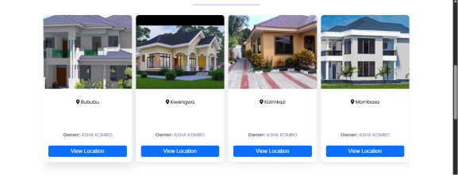
Figure 6: Home Page

The Home Page in the original report allowed tenants to browse houses and view house information before logging into the system.

4.3.2 House Location
The system provided a map that helped tenants see the location of a rental house.
The map allowed the tenant to understand where the house was located before making a rental decision.
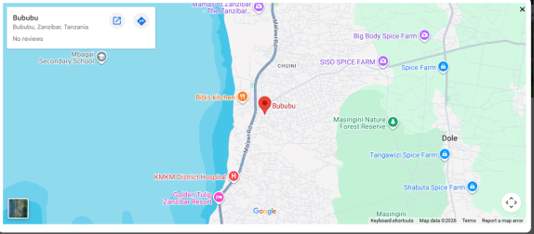
Figure 7: House Location Map

The original report showed a map as part of the system interface and explained that it helped tenants identify the location of the property.

4.3.3 Room Booking Page
The booking page allowed a tenant to select an available room and continue with the booking process.
The tenant selected a room and provided the required information. The system then saved the booking information.
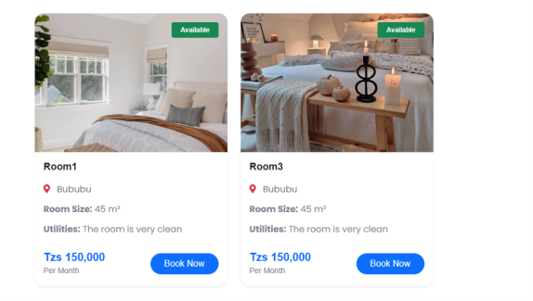
Figure 8: Room Booking Page

The original report showed that a tenant could select an available room and continue to the booking process.

4.3.4 Registration Page
The Registration Page allowed a new user to create an account.
The user entered personal information. The system checked the information and saved it in the database. After successful registration, the user could log in.
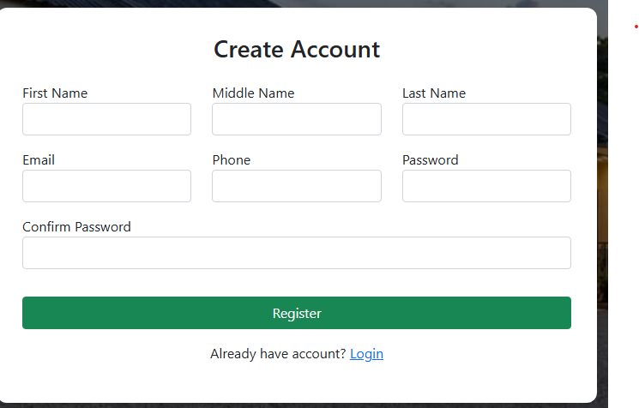
Figure 9: Registration Page

The report explained that the registration form saved user details in the database after validation.

4.3.5 Login Page
The Login Page allowed registered users to access the system.
The user entered a username and password. The system checked the information. If the information was correct, the user was taken to the dashboard. If the information was wrong, the system displayed an error message.
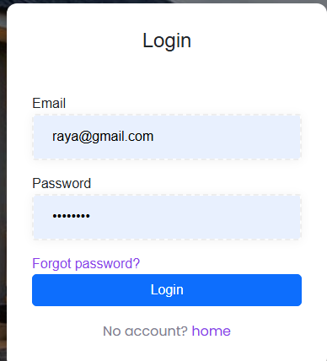
Figure 10: Login Page

The original report described the same login process and redirection to the dashboard after successful login.

4.4 Database Implementation
MySQL was used to store the system data.
The database contained information related to users, buildings, rooms, tenants, bookings, and payments.
The main tables included:
Table 1: Database Tables and Their Purposes
No. | Table | Purpose
1 | Users | Stores user information
2 | Buildings | Stores building information
3 | Rooms | Stores room information
4 | Tenants | Stores tenant information
5 | Bookings | Stores booking information
6 | Payments | Stores payment information
The database helped the system store and retrieve information when users performed different activities.
Figure 11: Database Structure
Insert screenshot of your database tables here.

4.5 System Testing
System testing was done to check whether the Building Rent Collection System worked as expected.
The testing focused on important functions such as registration, login, viewing houses, viewing location, booking, and payment.
The expected result was compared with the actual result.

4.5.1 Test Cases
Table 2: System Test Cases and Results

Test ID | Function Tested | Expected Result | Actual Result | Status
TC01 | User Registration | User account should be created successfully. | User account was created successfully. | Pass
TC02 | User Login | User should log in with correct details. | User logged in successfully. | Pass
TC03 | Wrong Login Details | System should show an error message. | Error message was displayed. | Pass
TC04 | View Available Houses | Available houses should be displayed. | Available houses were displayed. | Pass
TC05 | View House Location | House location should be displayed on the map. | House location was displayed. | Pass
TC06 | Room Booking | Booking information should be saved. | Booking information was saved. | Pass
TC07 | Rent Payment | Payment information should be recorded. | Payment information was recorded. | Pass
TC08 | View Payment Records | Payment records should be displayed. | Payment records were displayed. | Pass
TC09 | Manage Rooms | Landlord should add or update room information. | Room information was managed successfully. | Pass
TC10 | Logout | User should be logged out of the system. | User was logged out successfully. | Pass

4.6 Unit Testing
Unit testing was used to test individual functions of the system.
The main functions tested included:
User registration
User login
Building management
Room management
Booking
Payment
User management
Each function was tested separately to check whether it worked correctly.

4.7 Integration Testing
Integration testing was used to check whether different parts of the system worked together.
For example, the registration page was tested together with the database to make sure that user information entered by the user was correctly saved.
The booking function was also tested with the database to make sure that booking information was correctly stored.
Payment functions were tested with the database to check whether payment information was correctly recorded.

4.8 Functional and User Acceptance Testing
Functional testing was done to check whether the main system functions performed the required tasks.
User Acceptance Testing was carried out to check whether the system could meet the needs of landlords and tenants. The original report also identified User Acceptance Testing as part of the testing process.
The users checked important functions such as:
Registration
Login
Viewing houses
Viewing house location
Room booking
Rent payment
Payment records
The results showed that the main functions worked as expected.

4.9 Results
The system produced the expected results for the main functions tested.
The study also found that the existing manual rent collection process had several problems. All five respondents reported difficulty in tracking payment records and lack of automatic notifications. Four respondents reported late rent payments, while three reported loss of payment information.
The study also found that most respondents used cash payment. Four respondents used cash, while one used mobile money. No respondent used bank payment or an online payment system.
All five respondents identified tenant registration, house location, online payment, payment notification, and payment reports as important features for the proposed system.
These findings supported the development of the Building Rent Collection System.

4.10 Discussion of Results
The results showed that the Building Rent Collection System could help improve the management of rental activities.
The system provided a way for tenants to view rental houses and their locations before making a decision. It also provided a booking process that allowed tenants to select available rooms.
The system also provided registration and login functions. This helped users access the system using their accounts.
The payment function helped keep rent payment information in the system. This could make it easier for landlords to check payment records.
The findings from the respondents also supported the need for the system. The respondents reported problems with payment tracking, late payments, loss of payment information, and lack of automatic notifications.
Therefore, the proposed system provided a better way of managing rental information compared with the manual process described by the respondents.

CHAPTER FIVE: Conclusion, Recommendation and challenges

5.1 Conclusion
The main objective of this project was to develop a Building Rent Collection System that helped landlords manage rental activities and allowed tenants to view houses, make bookings, and pay rent online.
The project achieved this objective by developing a web-based system for managing rental information.
The first specific objective was to develop a user interface for the system. This objective was achieved by developing pages such as the Home Page, Registration Page, Login Page, booking page, and other system pages.
The second objective was to create a database for storing system information. This was achieved by creating a database for information such as users, buildings, rooms, tenants, bookings, and payments.
The third objective was to connect the system interface with the database. This was achieved using Laravel, PHP, and MySQL.
The fourth objective was to allow tenants to view available rooms and house information. The system provided information about available rental houses and rooms.
The fifth objective was to allow tenants to view house locations. The system provided a map that helped tenants identify the location of rental properties.
The sixth objective was to allow tenants to make room booking requests. The system provided a booking process where tenants could select an available room and submit their booking information.
The seventh objective was to allow tenants to make rent payments online. The system provided a rent payment function for recording tenant payments.
The eighth objective was to allow landlords to manage rental activities. The system supported the management of buildings, rooms, tenants, bookings, and payment information.
The final objective was to provide rental reports. The system provided payment and rental information that could help landlords monitor rental activities.
In general, the project achieved its main objectives and provided a better way to manage rental information compared with the manual process identified during the study.

5.2 Recommendations
The following recommendations were made for future improvement of the Building Rent Collection System:

5.2.1 Mobile Application
A mobile application could be developed in the future. This would allow tenants and landlords to access the system more easily using smartphones.

5.2.2 More Payment Methods
More online payment methods could be added to give tenants more choices when paying rent.

5.2.3 Automatic Notifications
The system could be improved by adding automatic SMS, email, or other notifications. For example, tenants could receive reminders when rent was due and confirmation after making payment.

5.2.4 Better Reports
More detailed reports could be added. These reports could help landlords understand rent collection, unpaid rent, and payment history.

5.2.5 Improved Security
The security of the system could be improved by adding more security controls to protect user information and payment information.

5.2.6 Online Hosting
The system could be hosted on an online server so that landlords and tenants could access it from different locations.

5.2.7 Future Students and Researchers
Future students and researchers could improve the system by adding more features and testing it with a larger number of landlords and tenants.

5.3 Challenges Faced
Several challenges were faced during the development of the Building Rent Collection System.

5.3.1 Limited Time
The project was developed within a limited period. This made it difficult to develop and test all possible features.
Solution: The main system functions were given priority and developed first.

5.3.2 Limited Financial Resources
The project had limited financial resources for activities such as internet access, transport, printing, and hosting.
Solution: Free or low-cost development tools were used during development and testing.

5.3.3 Respondent Availability
Some landlords and tenants were not always available during data collection.
Solution: Interviews and questionnaires were conducted when respondents were available.

5.3.4 Internet Problems
Internet access was sometimes limited during development and testing.
Solution: The system was developed and tested locally using WAMP, which reduced dependence on internet access during development.

5.3.5 Technical Problems
Some technical problems were experienced during coding, database connection, and system testing.
Solution: The problems were solved by checking the code, database settings, and system configuration during development.

REFERENCES
- Abdullahi, K., Jibrin, B., & Yarima, A. (2026). Role of property managers in enhancing rent collection efficiency in African urban commercial properties: Evidence from Kano metropolis, Nigeria. FUDMA Journal of Sciences, 10(4), 183–191. https://doi.org/10.33003/fjs-2026-1004-4750
- Buradkar, K., Kori, S., Ruikar, S., Galfat, V., Patil, D., & Nasare, R. (2022). Property rental management system. International Journal of Computer Science and Mobile Computing, 11(11), 177–179. https://doi.org/10.47760/ijcsmc.2022.v11i11.014
- Kulwa, M. E. (2026). The impact of mobile fintech on financial inclusion in Tanzania (2020–2024): A literature review. African Quarterly Social Science Review, 3(2). https://doi.org/10.51867/AQSSR.3.2.6
- Kurnool, A. (2025). Property management system [Master’s project, California State University, San Bernardino]. CSUSB ScholarWorks. https://scholarworks.lib.csusb.edu/etd/2337/
- Lemen, J. (2021, July 5). Property management APC: Rent and arrears. Royal Institution of Chartered Surveyors. https://ww3.rics.org/uk/en/journals/property-journal/property-management-apc--rent-and-arrears-.html
- Oracle. (2026). MySQL 8.0 reference manual. https://dev.mysql.com/doc/refman/8.0/en/
- PHP Documentation Group. (2026). PHP manual. https://www.php.net/manual/en/
- Pressman, R. S., & Maxim, B. R. (2019). Software engineering: A practitioner’s approach (9th ed.). McGraw-Hill Education.
- WampServer. (2026). WampServer: A Windows web development environment. https://www.wampserver.com

APPENDIX A: SYSTEM INTERFACES
Insert the actual screenshots from the developed Building Rent Collection System under the captions below.

Figure A1: Login Interface


Figure A2: Registration Interface

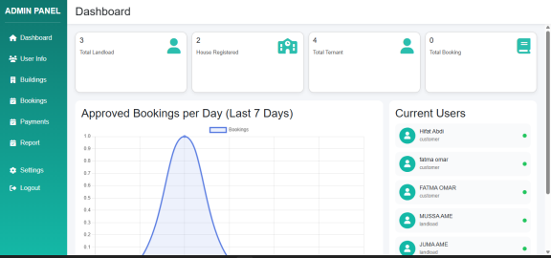

Figure A3: Dashboard Interface

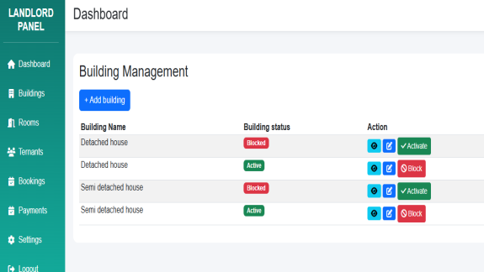
Figure A4: Building Management Interface

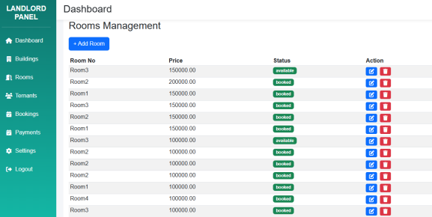
Figure A5: Room Management Interface

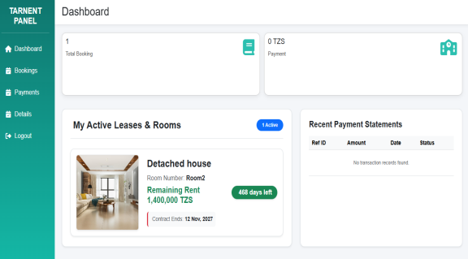
Figure A6: Tenant Management Interface

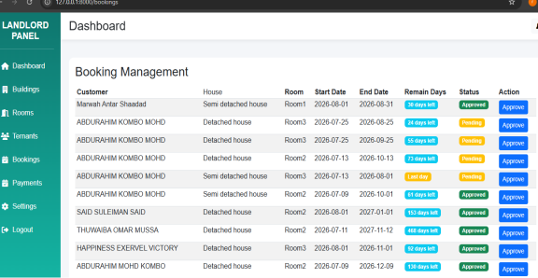
Figure A7: Booking Management Interface

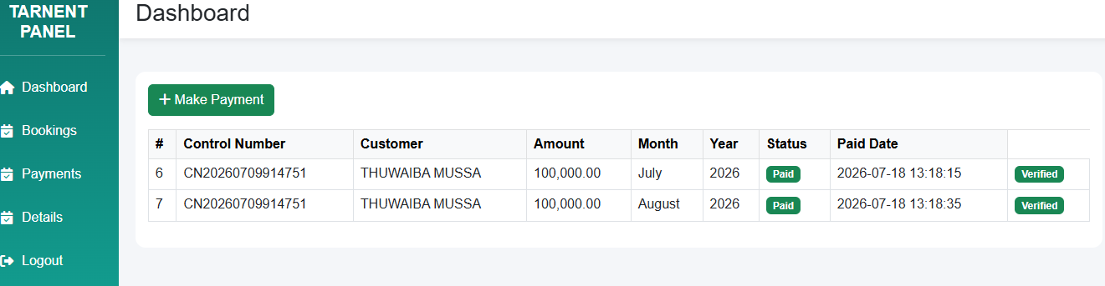
Figure A8: Make Payment Interface

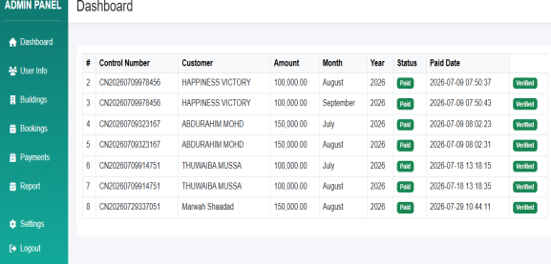
Figure A9: Payment Verification Interface

s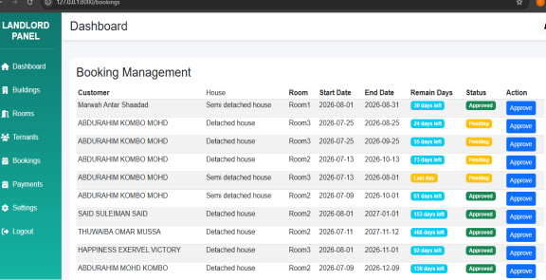
Figure A10: Payment Records Interface

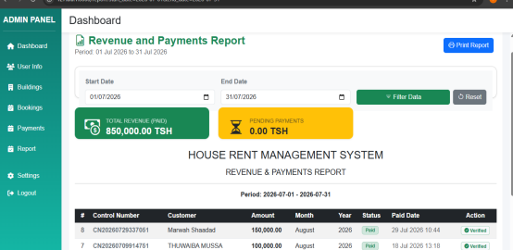
Figure A11: Reports Interface

APPENDIX B: DATABASE SCHEMA
The Building Rent Collection System uses MySQL to store users, landlords, buildings, rooms, tenants, bookings and payments.

B.1 Main Database Tables

Table 3: Main Database Tables
Table | Purpose
users | Stores system user accounts and roles
landlords | Stores landlord information
buildings | Stores rental building information
rooms | Stores rental room information and status
tenants | Stores tenant information
bookings | Stores rental/booking information
payments | Stores rent payment information
online_users | Stores online/session presence where implemented

B.2 Database Relationships
A landlord can manage one or more buildings.
A building can contain one or more rooms.
A tenant can have rental/booking records.
A booking links a tenant to a rental room.
A booking can have one or more payment records, including multiple-month payments where supported.
Payments are linked to the relevant booking for rent monitoring.
B.3 Full Schema
Insert the exported MySQL schema or screenshots of the implemented table definitions here.

APPENDIX C: DATA COLLECTION INSTRUMENTS
C.1 Landlord Questionnaire
Dear Respondent, this questionnaire is for academic purposes and collects requirements for the Building Rent Collection System.
1. Name: ______________________________
2. Number of rental houses/rooms: ______________________________
3. Location of rental property: ______________________________
4. Average rent amount: ______________________________
5. Payment frequency: □ Monthly □ Yearly □ Other: ______
6. Current payment methods: □ Cash □ Mobile Money □ Bank □ Other
7. How do you currently keep payment records? ______________________________
8. What challenges do you face when tracking payments? ______________________
9. Do you experience late rent payments? □ Yes □ No
10. Have you lost/misplaced payment information? □ Yes □ No
11. Would automatic rent notifications be useful? □ Yes □ No
12. Which features would be most useful? ______________________________
13. Would you like payment reports? □ Yes □ No
14. Would you like a searchable tenant list? □ Yes □ No
15. Would you need automatic backup? □ Yes □ No
16. Other recommended feature: ______________________________
C.2 Tenant Questionnaire
1. Name: ______________________________
2. Type of rental room/house: ______________________________
3. Current payment method: □ Cash □ Mobile Money □ Bank □ Other
4. How do you receive payment confirmation? ______________________________
5. Is it easy to keep your rent records? □ Yes □ No
6. Do you have difficulty confirming rent payment? □ Yes □ No
7. Would you like to view rental/payment information online? □ Yes □ No
8. Would automatic rent reminders be useful? □ Yes □ No
9. Would you prefer electronic payment options? □ Yes □ No
10. What feature would make rent payment easier? ______________________________
C.3 Interview Guide
1. How do you currently manage rental buildings and tenants?
2. How are rent payments recorded and verified?
3. What are the main problems with the current method?
4. How do you identify tenants with outstanding rent?
5. What information should the system store?
6. Which reports would be useful?
7. Which notification features would be useful?
8. Which payment methods should be supported?
9. What security controls should the system have?
10. What improvements would you recommend?

APPENDIX D: USER MANUAL / SETUP GUIDE
D.1 Start the System
1. Configure PHP, WAMP/MySQL and Laravel.
2. Place the project in the development directory.
3. Create/configure the MySQL database.
4. Configure the Laravel environment/database connection.
5. Run required migrations/seeders.
6. Start the web server and database service.
7. Open the system in a web browser.
D.2 Login
1. Open the login page.
2. Enter valid credentials.
3. Click Login.
4. The system opens the authorised dashboard.
D.3 Manage Buildings
1. Open Building Management.
2. Select Add Building.
3. Enter building details.
4. Save the record.
5. View, edit or delete when required.
D.4 Manage Rooms
1. Open Room Management.
2. Select the building.
3. Enter room details.
4. Save the room.
5. Update room status when required.
D.5 Manage Tenants
1. Open Tenant Management.
2. Enter tenant details.
3. Save the tenant.
4. View or update the record.
D.6 Create Booking
1. Select an available room.
2. Select the tenant.
3. Enter rental/booking details.
4. Save the booking.
D.7 Record Payment
1. Open the relevant booking.
2. Open Make Payment.
3. Enter required payment information.
4. Select the month or months to pay where supported.
5. Submit the payment.
D.8 Verify Payment
1. Open pending payments.
2. Review payment details.
3. Verify the payment.
4. The status is updated.
D.9 View Reports
1. Open Reports.
2. Select the required report.
3. Review the generated information.
D.10 Logout
1. Select Logout after completing system activities.

APPENDIX E: SOURCE CODE / PROGRAM LISTING
The guideline requires source code/program listing or a repository link. The actual source files were not attached with this request, so this appendix provides the structure for inserting the implemented code.
Table 4: Project Source-Code Structure
Location | Purpose
app/Models | Database models
app/Http/Controllers | Backend logic
database/migrations | Database definitions
resources/views | Blade/frontend pages
routes/web.php | Web routes
public/ | CSS, JavaScript and images
.env | Environment/database configuration; do not expose passwords
Insert selected important source-code listings or the approved repository/project archive here.

APPENDIX F: SAMPLE SYSTEM REPORTS

F.1 Payment Report
.


F.2 Outstanding Rent Report

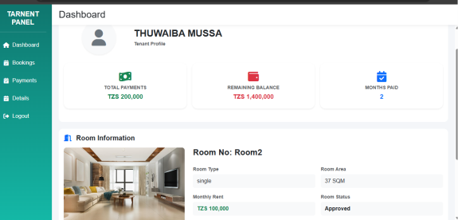
F.3 Tenant Payment History


F.4 Building/Room Report

APPENDIX G: SYSTEM TESTING EVIDENCE
Table 5: System Testing Evidence Checklist
Test ID | Evidence to Attach
TC01 | Successful login screenshot
TC02 | Invalid login/error screenshot
TC03 | Saved building screenshot
TC04 | Saved room screenshot
TC05 | Registered tenant screenshot
TC06 | Created booking screenshot
TC07 | Recorded payment screenshot
TC08 | Verified payment screenshot
TC09 | Generated report screenshot
TC10 | Access-control/error screenshot
Attach the real screenshots from the tested system before submission.

APPENDIX H: PROJECT BUDGET
The project budget shows the estimated costs needed to develop and run the system. It covers expenses like software, hardware, development resources, and maintenance. The budget ensures that resources are used wisely and that the project is completed within the available funds without compromising quality.

Table 6: Project Budget
SN | ITERM | COST
01 | COMPUTER | 1000,000
02 | INTERNET | 300,000
03 | SOFTWARE TOOLS | 50,000
04 | DOMAIN AND HOST | 200,000
05 | TRANSPORT | 300,000
06 | PRINTING | 40,000
07 | OTHER EXPENSES | 150,000
08 | TOTAL COST | 1770000

