Step 1:
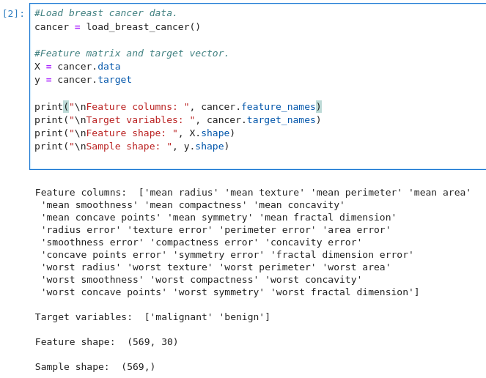
Screenshot of the features (columns), target variables, and the number of samples which is 569.

All 30 feature columns are numerical, and all with the exception of one are stored as float64. The remaining column, target, is stored is int64.

Their are no missing values, so no missing value handling is required. The target is already encoded numerically, with 0 representing malignant and 1 representing benign.

We can use the StandardScaler since the features have different numerical scales.

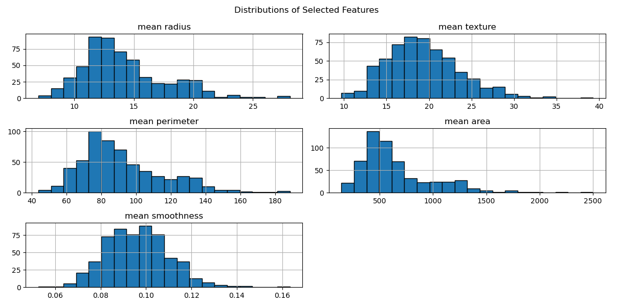
K-nearest neighbors and logistic regression would be god models to apply to the dataset because the Breast Cancer dataset is a binary classification problem with numerical features. k-NN can model nonlinear decision boundaries without making strong assumptions about the relationship between features and targets. Logistic regression is designed for classification and estimates that probability that a sample belongs to a particular class. k-NN is useful for detecting local patterns, while logistics regression provides and interpretable linear relationship between the features and diagnosis.

Step 2:
We standardize the data to put each feature on a comparable scale.

Step 3:
Changing k affects the balance between flexibility and stability. Small differences are expected between k 3, 5, and 7. A lower k creates a more flexible model, while a higher k creates a smoother, less sensitive model.

Step 4: Cross Validations
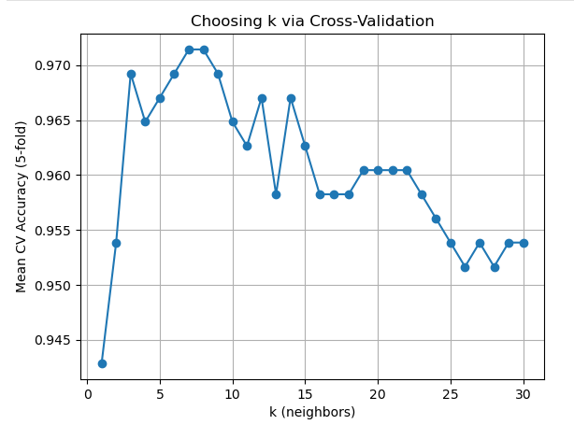
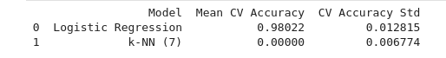

Step 5:
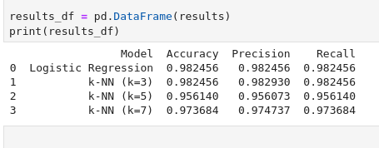
The Logistic Regression and k-NN (k-3) models did better. They both have an accuracy score of 0.982456. However, because k-NN (k=3) has a slightly higher precision score, it did better overall.

Step 6:
k-NN achieved a higher precision and both Logistic Regression and k-NN (k=3) have the highest recalls.

I would choose the k-NN model for detecting cancer because, going off of the data, it has a slightly higher precision rate. K-NN’s slightly higher precision rate indicated that it had fewer false positive predictions on average. Since the difference was small, neither model is clearly superior than that other in this scenario.

