AI-Based Smart Farming Support Application
(Mobile Application: “Smart Krishi”)
A project report submitted in partial fulfillment of the requirements for the degree of Bachelor of Science in Computer Science and Engineering
Submitted By
[Your Full Name]
ID: [Student ID]
[Teammate Full Name]
ID: [Student ID]
Supervisor
[Supervisor's Full Name]
[Designation, e.g., Lecturer / Assistant Professor]
Department of Computer Science and Engineering
[University Name]
DEPARTMENT OF COMPUTER SCIENCE AND ENGINEERING
[UNIVERSITY NAME]
[CITY], BANGLADESH
[Month, Year]

DECLARATION
We declare that this project report titled “AI-Based Smart Farming Support Application” is the result of our own work except where explicitly cited and referenced. This project is submitted in partial fulfillment of the requirement for the award of the degree of Bachelor of Science in Computer Science and Engineering, [University Name]. The project report has been carried out under the guidance of [Supervisor's Full Name] and is a record of work carried out during [Start Month]-[Year] to [End Month]-[Year]. To the best of our knowledge, this project has not been submitted anywhere else in partial fulfillment for any degree of this or any other university.
Signature of Author(s) | Signature of Supervisor
____________________  [Your Full Name]  ID: [Student ID]  Department of Computer Science and Engineering  [University Name]  ____________________  [Teammate Full Name]  ID: [Student ID]  Department of Computer Science and Engineering  [University Name] | ____________________  [Supervisor's Full Name]  [Designation, e.g., Lecturer / Assistant Professor]  Department of Computer Science and Engineering  [University Name]

ACKNOWLEDGEMENT
First, we would like to convey our heartfelt gratitude to the Almighty for giving us the strength and opportunity to complete this project as part of our partial fulfillment of the requirements for the degree of B.Sc. in Computer Science and Engineering. We express our sincere gratitude and appreciation to our supervisor, [Supervisor's Full Name], [Designation, e.g., Lecturer / Assistant Professor], Department of Computer Science and Engineering, [University Name], for the invaluable guidance, patience and encouragement extended throughout the development of this project. We would also like to thank our Head of Department, [Head of Department Name], [Designation], Department of Computer Science and Engineering, for the constant support and coordination. We are grateful to [Dean's Name], Dean, Faculty of Science & Engineering, [University Name], for allowing us the opportunity to undertake this project. We also thank all the faculty members of the department for their cooperation throughout this period. Finally, we acknowledge, with due respect, the constant support and patience of our families.

ABSTRACT
Agriculture remains one of the most important sectors of the economy, yet farmers frequently struggle to identify crop diseases early and to access timely, reliable agronomic advice. Traditional solutions either depend on costly hardware sensor networks (soil-moisture probes, temperature/humidity sensors, IoT microcontrollers) installed in the field, or on physically consulting an agricultural expert, which is often slow, expensive, and inaccessible to small and marginal farmers. This project presents an AI-Based Smart Farming Support Application — a cross-platform mobile application named “Smart Krishi” — that removes the need for any external hardware by turning an ordinary smartphone camera into an instant crop-health diagnostic tool. The application allows a farmer to simply capture or upload a photo of a plant leaf; the image is sent to Google's Gemini generative-AI vision model, which analyses the leaf and returns a bilingual (Bangla/English) diagnosis consisting of the disease name, its symptoms, its severity (mild, moderate or severe), a list of recommended medicines with dosage and type (fungicide, insecticide or bactericide), and a day-wise recovery plan. In addition, the application integrates a live weather module (built on the Open-Meteo API) that gives farmers a daily, condition-aware advisory — for example, warning them to clear drainage paths before heavy rain or to avoid midday irrigation during high UV conditions. Secure user authentication and profile management are handled through Firebase Authentication, while Firebase Remote Config is used to manage and rotate multiple Gemini API keys dynamically, improving reliability and availability without requiring an app update. The application is built using Flutter with a Clean Architecture and BLoC/Cubit state-management pattern, making it maintainable, testable, and scalable to new features. Overall, the project demonstrates that a purely software-based, AI-driven approach can deliver the core benefits of smart farming — real-time monitoring, disease diagnosis and actionable advisory — at effectively zero hardware cost, making precision-agriculture assistance accessible to any farmer who owns a smartphone.

TABLE OF CONTENTS
Right-click here and choose “Update Field” → “Update entire table” to generate the Table of Contents.

LIST OF FIGURES
Figure 1: Work Procedure of the Project
Figure 2: System Block Diagram of Smart Krishi
Figure 3: Use Case Diagram of Smart Krishi
Figure 4: Activity Diagram of Smart Krishi
Figure 5: Gantt Chart of Project Development Timeline
Figure 6: Splash / Onboarding Screen
Figure 7: Login Screen
Figure 8: Home Dashboard with Live Weather Advisory
Figure 9: Leaf Image Capture Screen
Figure 10: AI Analysis in Progress
Figure 11: Diagnosis Result Screen
Figure 12: Medicine Recommendation & Recovery Plan

LIST OF TABLES
Table 1: Comparison of Proposed System with Existing Solutions
Table 2: Project Tentative Cost (Cloud Services)

CHAPTER 1 – INTRODUCTION

1.1 Introduction
Agriculture continues to be the backbone of the national economy and a primary source of livelihood for a large portion of the population. However, farmers, especially small and marginal ones, often lack quick access to agricultural experts who can identify crop diseases early and recommend proper treatment. A delay of even a few days in identifying a leaf disease can result in significant crop loss. At the same time, unpredictable weather — sudden rainfall, heat waves, or high humidity — further complicates decisions such as when to irrigate, fertilize, or spray pesticide. Existing smart-farming solutions largely rely on physical IoT hardware — soil-moisture sensors, temperature/humidity sensors, microcontrollers and wireless modules — that must be purchased, wired, and maintained in the field. Such hardware-centric systems are costly, hard to scale, and mostly help with irrigation-related greenhouse monitoring rather than actual disease diagnosis. This project proposes an alternative, purely software-driven approach: an AI-Based Smart Farming Support Application, delivered as a mobile app named “Smart Krishi”, that uses a smartphone camera together with a cloud-based generative-AI vision model to diagnose plant/leaf disease instantly, recommend medicine and dosage, and provide a live, location-aware weather advisory — all without requiring any additional hardware sensor.

1.2 Motivation
The motivation for this project stems from the gap between the promise of “smart farming” and its real-world accessibility. Most existing IoT-based smart-gardening/farming projects (see Chapter 2) focus on greenhouse-scale, sensor-driven automation — useful for a controlled indoor garden, but impractical and expensive for an open field or for a farmer who cannot afford hardware installation. Meanwhile, nearly every farmer today owns, or has access to, a basic smartphone. Advances in generative AI vision models (such as Google Gemini) now make it possible to analyze a photograph of a leaf and produce an expert-level diagnosis in seconds, at negligible marginal cost. Combining this AI capability with a live weather feed and a bilingual (Bangla/English) interface can bring the core benefits of precision agriculture — monitoring, early disease detection, and actionable advisory — directly into the hands of ordinary farmers, without the cost, installation, and maintenance burden of physical sensor networks.

1.3 Goal and Objective
- Provide instant, AI-based crop/leaf disease diagnosis using only a smartphone camera — no external hardware sensors required.
- Deliver bilingual (Bangla/English) diagnosis reports covering disease name, symptoms and severity (mild/moderate/severe).
- Recommend appropriate medicine (fungicide/insecticide/bactericide) with dosage guidance for the detected disease.
- Generate a day-wise recovery plan so farmers know exactly what action to take and when.
- Provide a real-time, location-aware weather dashboard with an actionable daily farming advisory.
- Offer secure user authentication, profile management, and a notification system.
- Ensure high API availability through dynamic, remote-managed multi-key rotation.
- Design a low-cost, scalable, cloud-based (serverless) smart farming assistant that requires zero field hardware.

1.4 Project Overview
“Smart Krishi” is a cross-platform Flutter mobile application built using Clean Architecture and the BLoC/Cubit state-management pattern. When a user captures or selects a leaf image, the app encodes it and sends it, together with a structured Bangla diagnostic prompt, to Google's Gemini vision-language model (gemini-flash-latest) over a secure HTTPS request. The model's response is parsed into a structured result — disease name (Bangla & English), symptoms, severity, a list of recommended medicines with dosage, and a day-wise recovery plan — and rendered in the UI. In parallel, the Home dashboard calls the Open-Meteo weather API for the user's region and derives simple, actionable farming advice from the current temperature, humidity, rain probability and UV index. User accounts are managed through Firebase Authentication, and the Gemini API key pool is centrally managed and rotated through Firebase Remote Config, so keys can be added, removed or rotated without publishing a new app version.

1.5 Features
- AI-powered leaf disease detection from a photo (camera or gallery).
- Bilingual (Bangla/English) diagnosis report: disease name, symptoms, and severity.
- Medicine / pesticide recommendation with dosage and type (fungicide / insecticide / bactericide).
- Day-wise recovery plan for the diagnosed condition.
- Real-time weather dashboard — temperature, feels-like temperature, humidity, rain chance, UV index.
- Condition-aware daily farming advisory (e.g., drainage warnings, irrigation timing).
- Daily farming tips tab.
- In-app notification center.
- Secure login / signup and profile management (Firebase Authentication).
- Automatic multi-key API rotation with retry/backoff for high availability.

1.6 Used Technology
- Flutter & Dart (cross-platform mobile UI)
- Google Gemini API — gemini-flash-latest (generative AI vision model for disease detection)
- Firebase Authentication (secure login / signup)
- Firebase Remote Config (dynamic, over-the-air Gemini API key management)
- Open-Meteo Weather API (live weather forecast data)
- BLoC / Cubit (reactive state management)
- GetIt (dependency injection)
- Clean Architecture (data / domain / presentation layering)

CHAPTER 2 – BACKGROUND STUDY/RELATED WORK

2.1 Related Work
Existing Work 01 – Deep Learning for Image-Based Plant Disease Detection.
Mohanty, Hughes and Salathé (2016) trained a deep convolutional neural network on the PlantVillage dataset (54,306 images of 14 crop species and 26 diseases) and showed that a smartphone-camera image alone can be used to identify plant disease with high accuracy, demonstrating the feasibility of camera-based, non-hardware disease diagnosis [1].
Existing Work 02 – Plantix – AI-based Crop Advisory Application.
Plantix is a widely used commercial mobile application that uses image-recognition to identify crop pests, diseases and nutrient deficiencies from a leaf photograph and suggests remedies, but it does not integrate a live, location-based weather advisory or a day-wise recovery timeline within the same flow [2].
Existing Work 03 – IOT Based Smart Indoor Gardening.
Hardware-sensor based systems built around a NodeMCU/ESP8266 microcontroller use a DHT11 sensor, a soil-moisture sensor and a PIR sensor to automatically water a plant and detect nearby motion, reporting values on the Blynk IoT cloud. Such systems require sensors, wiring, a power supply and physical installation, and are practical mainly for a single indoor pot rather than an open field of crops [3].
Existing Work 04 – IOT Based Smart Farming System.
Sensor-network based smart-farming systems collect temperature and soil-moisture readings from field-deployed nodes and transmit them wirelessly for monitoring, improving irrigation efficiency but requiring recurring hardware cost and maintenance, and offering no AI-based disease diagnosis [4].
Existing Work 05 – Smart Home Garden Management System (SHGMS).
Cloud-connected home-garden systems measure and manage temperature and humidity for greenhouse-scale automation, but similarly depend on installed sensors and do not provide bilingual, AI-generated disease diagnosis or medicine recommendation [5].

2.2 Review of Existing Work
The reviewed systems fall into two broad categories. The first category (Existing Work 03–05) is hardware/IoT-sensor centric: accurate for the specific physical quantity being sensed (soil moisture, temperature, humidity) but limited to that quantity, dependent on purchased components, wiring and a stable local power/Wi-Fi setup, and incapable of diagnosing a disease from a leaf's visual symptoms. The second category (Existing Work 01–02) is vision/AI centric: capable of diagnosing disease directly from a photograph without any hardware, but the reviewed systems either stop at research-level accuracy reporting (Existing Work 01) or, in the case of a commercial product like Plantix, do not combine the diagnosis with a live weather-based daily advisory, a structured day-wise recovery plan, and dosage-level medicine recommendations inside one bilingual mobile experience. The proposed system, “Smart Krishi”, is designed to combine the strengths of both categories — zero-hardware, camera-based AI diagnosis together with live weather advisory, dosage-level medicine guidance and a day-wise recovery plan — in a single bilingual application.

2.3 Comparison Table
Feature | IoT Sensor  Systems [3][4][5] | Plantix-style  AI Apps [2] | Proposed System  (Smart Krishi)
Requires field hardware / sensors | Yes | No | No
AI-based image disease diagnosis | No | Yes | Yes
Bilingual (Bangla/English) output | No | Partial | Yes
Live, location-based weather advisory | Limited (temp/humidity only) | No | Yes
Medicine name + dosage recommendation | No | Partial | Yes
Day-wise recovery plan | No | No | Yes
Notification system | Limited | Yes | Yes
Approx. setup cost per user | High (hardware) | Low | Very Low (software-only)

Table 1: Comparison of Proposed System with Existing Solutions

CHAPTER 3 – RESEARCH METHODOLOGY

3.1 Introduction
This chapter presents the methodology followed to design and develop the AI-Based Smart Farming Support Application. It covers the feasibility study, the overall work procedure, the system architecture, the use-case and activity models, the tools and technologies used, and the project timeline and tentative cost.

3.2 Feasibility Study

3.2.1 Technical Feasibility
The project uses widely available, well-documented technologies — Flutter for the cross-platform client, Google's Gemini API for AI-based image analysis, Firebase for authentication and remote configuration, and the free Open-Meteo API for weather data. All of these are accessible with a standard developer account and a smartphone, making the system technically feasible to build and deploy without specialized hardware.

3.2.2 Operational Feasibility
The application's user interface is designed to be simple and bilingual (Bangla/English) so that farmers with limited technical literacy can operate it with minimal guidance — capturing a photo and tapping “Analyze” is the only action required to get a diagnosis.

3.2.3 Economical Feasibility
Because the system relies only on cloud APIs with generous free tiers (see Table 2) and the farmer's own smartphone, there is no recurring hardware cost, making the solution significantly cheaper to scale to many users than a sensor-based alternative.

3.3 Work Procedure
Figure 1 shows the overall work procedure followed during development — from problem analysis through to deployment.
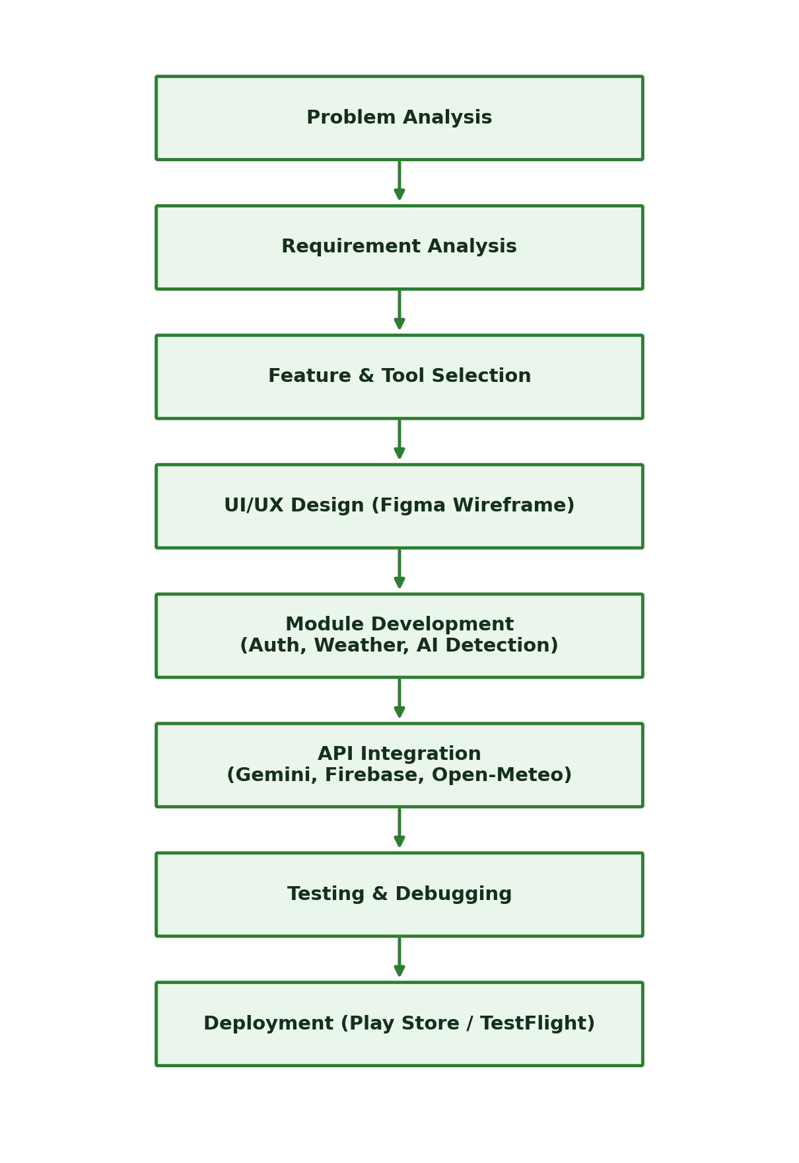
Figure 1: Work Procedure of the Project

3.4 System Block Diagram
Figure 2 shows the system architecture. The Flutter mobile application is the central component; it exchanges data with the camera/gallery for image input, with the Google Gemini AI API for disease detection, with Firebase Authentication for login/signup, with Firebase Remote Config for dynamic API key management, and with the Open-Meteo Weather API for live forecast data. Results are rendered back to the user through the in-app display (diagnosis result, tips, notifications).
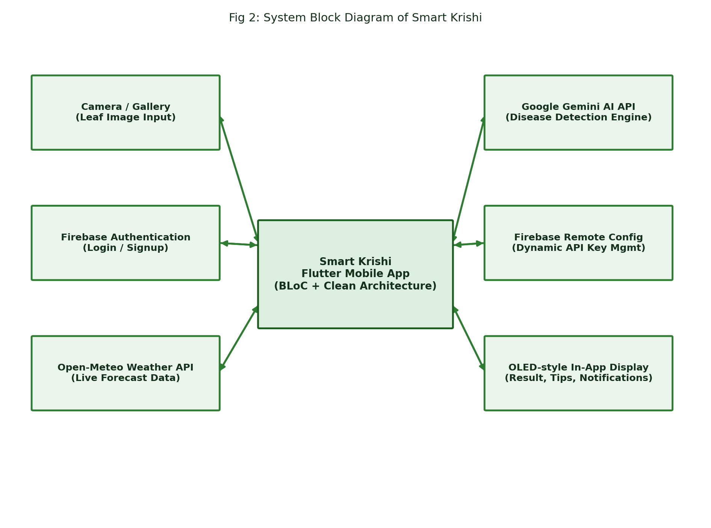
Figure 2: System Block Diagram of Smart Krishi

3.5 Use Case Diagram
Figure 3 identifies two actors — the User (Farmer) and the System (Cloud Services) — and the use cases each participates in, including registration/login, capturing a leaf image, viewing the diagnosis, medicine recommendation, recovery plan, weather advisory, farming tips, and notifications.
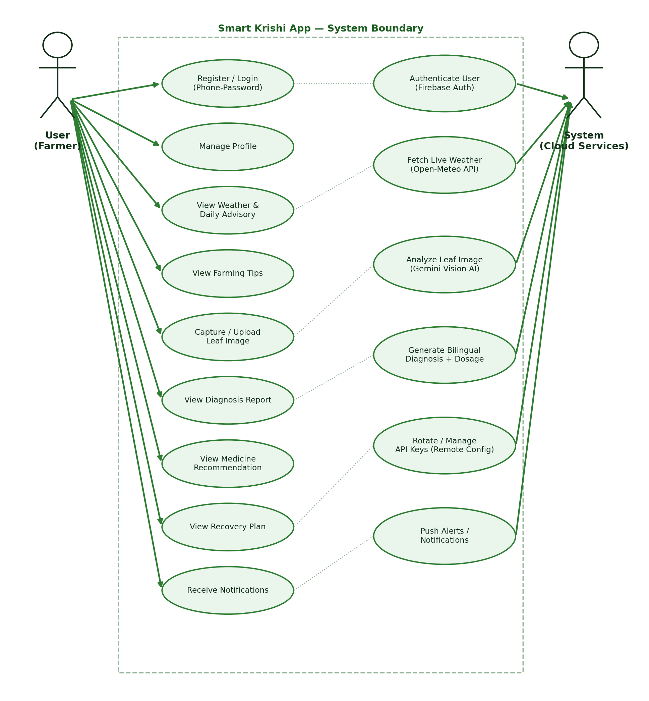
Figure 3: Use Case Diagram of Smart Krishi

3.6 Activity Diagram
Figure 4 illustrates the flow of activities from opening the application, through authentication, to the four parallel actions available on the home dashboard (scan a leaf, view tips, view notifications, manage profile), and back to the decision point until the user exits the app.
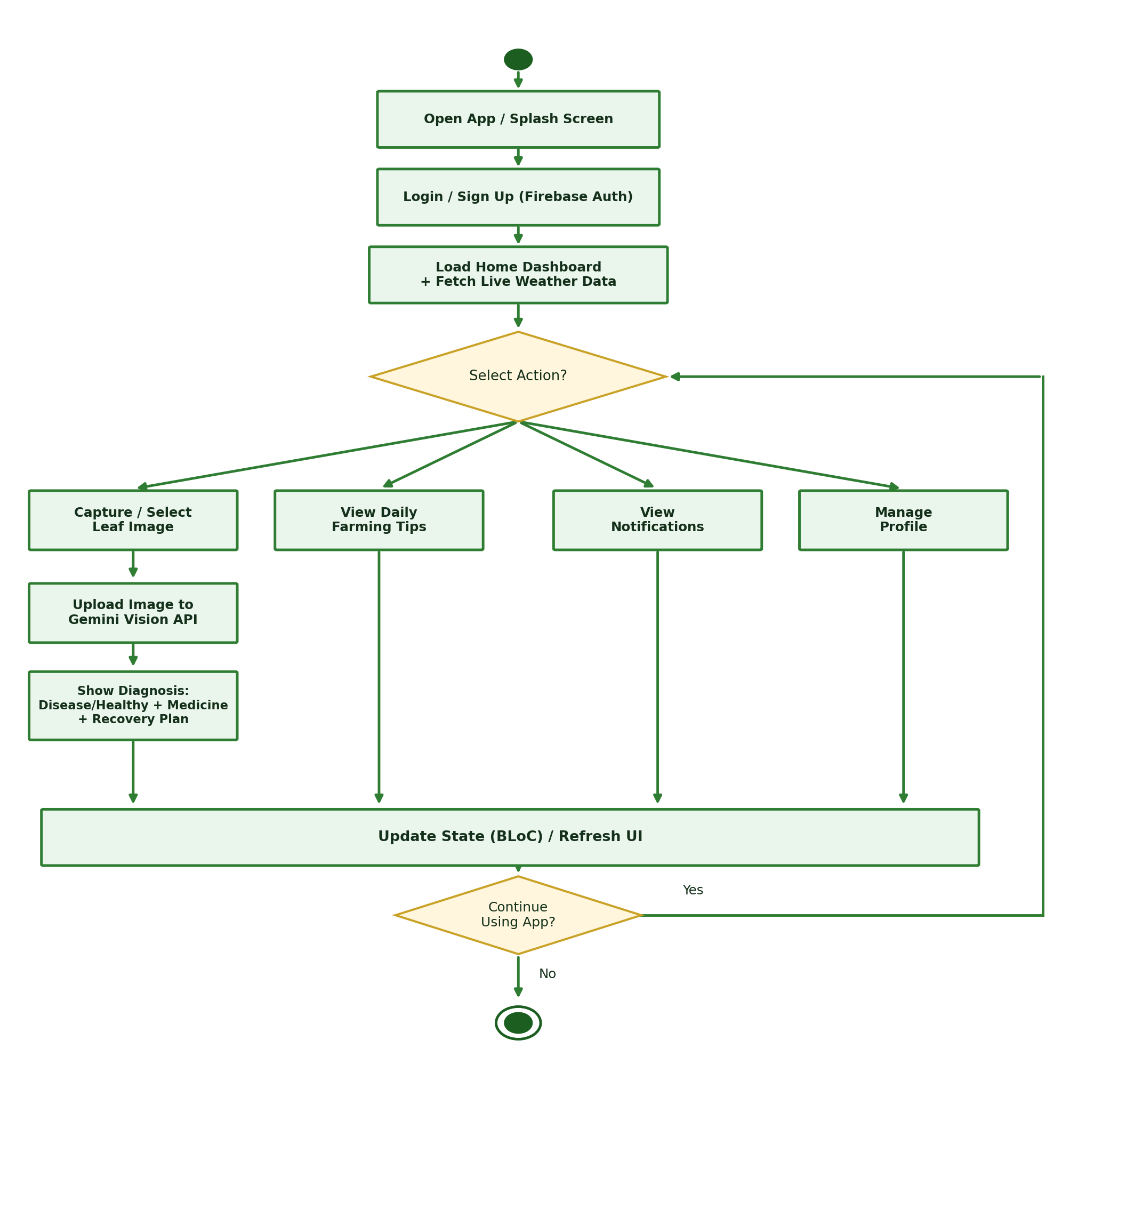
Figure 4: Activity Diagram of Smart Krishi

3.7 Required Tools and Technologies
- Flutter SDK & Dart
- Android Studio / VS Code (IDE)
- Google Gemini API (gemini-flash-latest)
- Firebase Authentication
- Firebase Remote Config
- Open-Meteo Weather API
- GetIt (Dependency Injection)
- flutter_bloc (BLoC / Cubit state management)
- image_picker (camera & gallery access)
- Git & GitHub (version control)

3.8 Description of Tools and Technologies

3.8.1 Flutter & Dart
Flutter is Google's open-source UI toolkit for building natively compiled, cross-platform (Android/iOS) applications from a single Dart codebase. It was chosen for its fast development cycle, rich widget library and native performance.

3.8.2 Google Gemini API (Vision Model)
Gemini is a multimodal generative-AI model capable of understanding both text and images. The application sends a base64-encoded leaf image together with a structured Bangla prompt to the gemini-flash-latest endpoint, which returns a detailed diagnosis — disease name, symptoms, severity, medicine and dosage.

3.8.3 Firebase Authentication
A managed authentication backend used to securely register and sign in users, removing the need to build and secure a custom authentication server.

3.8.4 Firebase Remote Config
Used to store and dynamically update the pool of Gemini API keys used by the app. If a key expires, is blocked, or exceeds its quota, the app automatically rotates to the next available key fetched from Remote Config — without requiring an app store update.

3.8.5 Open-Meteo Weather API
A free, no-API-key weather-forecast service used to fetch current temperature, feels-like temperature, humidity, precipitation, wind speed, and daily max/min temperature, rain probability and UV index for the user's region.

3.8.6 BLoC / Cubit State Management
The BLoC (Business Logic Component) pattern separates business logic from the UI layer, using Events and States (or Cubit methods) to produce a predictable, testable, reactive user interface.

3.8.7 GetIt (Dependency Injection)
A simple service-locator package used to register and resolve singletons and factories (repositories, use cases, BLoCs) throughout the app.

3.8.8 Clean Architecture
The codebase is organized into Data, Domain and Presentation layers, each with a single responsibility, which keeps the business logic independent of any specific UI framework or data source and makes the app easier to test and extend.

3.9 Required Language
Dart (Flutter framework).

3.10 Gantt Chart
Figure 5 shows the project development timeline, broken down into planning, design, module-wise development (authentication, weather, AI disease detection, tips & notifications, remote-config key rotation), two rounds of testing, and final documentation.
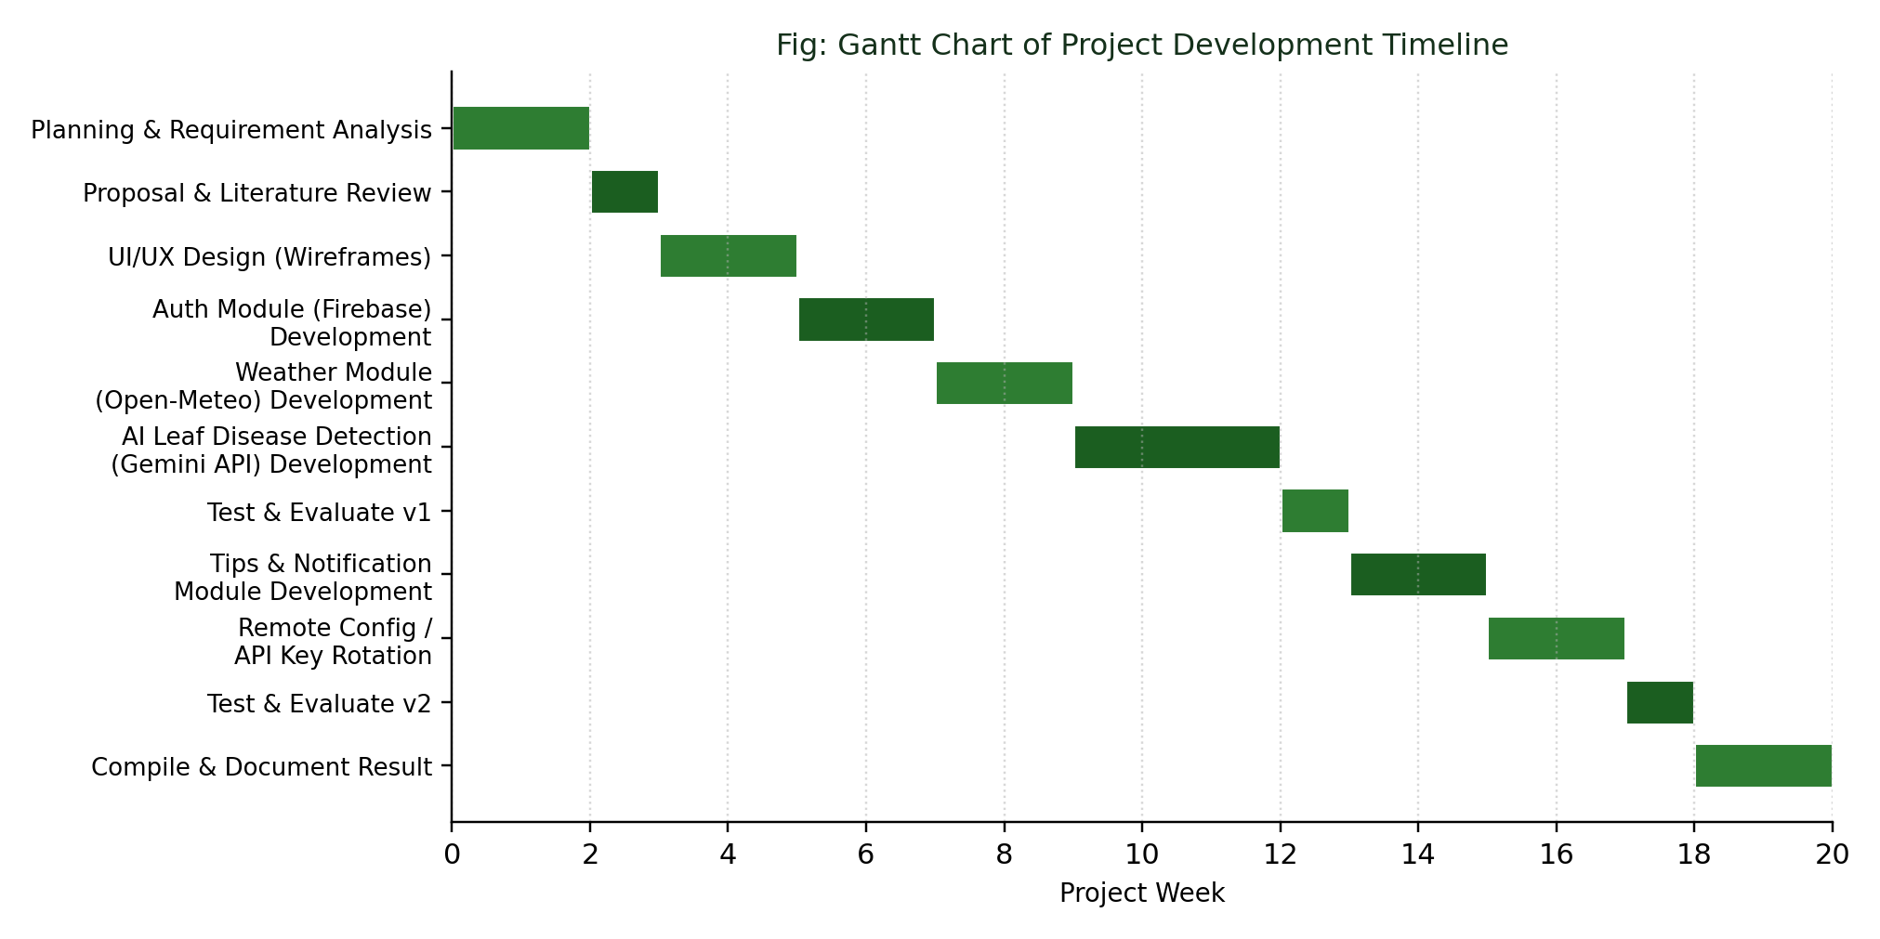
Figure 5: Gantt Chart of Project Development Timeline

3.11 Project Tentative Cost
Unlike a hardware-based smart-farming system, this application requires no field sensors, wiring or microcontrollers. The only recurring costs are cloud service usage, most of which fall within generous free tiers at the current, small-to-medium user scale.
Service / Item | Type | Free-Tier Limit | Estimated Cost
Firebase Authentication | Cloud Service | Generous free quota | Free (current scale)
Firebase Remote Config | Cloud Service | Free for standard use | Free
Google Gemini API (gemini-flash-latest) | AI Service | Free-tier request quota / key | Free–Low (multi-key rotation)
Open-Meteo Weather API | Weather Service | Free, no API key required | Free
Google Play Console (one-time) | Distribution | — | ≈ $25 (one-time)
Developer Device / Testing | Hardware | — | Existing smartphone
Total (approx.) |  |  | ≈ $25 (one-time) + Free ongoing

Table 2: Project Tentative Cost (Cloud Services)

CHAPTER 4 – RESULT AND DISCUSSION

4.1 System Result Overview
This section presents the working application through screenshots captured on a real device, covering onboarding, authentication, the weather-aware home dashboard, the AI leaf-scanning flow, and the final diagnosis result.

4.1.1 Splash / Onboarding Screen
The onboarding screen introduces the application name (“Smart Krishi”), its tagline (“AI-driven crop analysis and disease diagnosis”), and entry points to log in or create a new account.
[ PASTE SCREENSHOT HERE ]
Figure 6: Splash / Onboarding Screen
Figure 6: Splash / Onboarding Screen

4.1.2 Login Screen
Users authenticate using a phone number and password, handled securely through Firebase Authentication.
[ PASTE SCREENSHOT HERE ]
Figure 7: Login Screen
Figure 7: Login Screen

4.1.3 Home Dashboard with Weather Advisory
The home dashboard fetches live weather data (temperature, feels-like temperature, humidity, rain probability) for the user's location from the Open-Meteo API and derives an actionable, condition-aware daily advisory — for example, clearing drainage paths before expected rainfall and recommending the best irrigation window.
[ PASTE SCREENSHOT HERE ]
Figure 8: Home Dashboard with Live Weather Advisory
Figure 8: Home Dashboard with Live Weather Advisory

4.1.4 Leaf Image Capture
The Scan tab lets the user capture a photo directly from the camera or choose an existing image from the gallery for analysis.
[ PASTE SCREENSHOT HERE ]
Figure 9: Leaf Image Capture Screen
Figure 9: Leaf Image Capture Screen

4.1.5 AI Analysis in Progress
While the image is uploaded to and analyzed by the Gemini vision model, the app shows a loading indicator with the message “Analyzing your crop...”.
[ PASTE SCREENSHOT HERE ]
Figure 10: AI Analysis in Progress
Figure 10: AI Analysis in Progress

4.1.6 Diagnosis Result and Medicine Recommendation
The result screen displays the detected condition (e.g. “Leaf Yellowing”), a detailed bilingual description of the symptoms, and a card-based list of recommended medicines (e.g. Mancozeb, Neem Oil, Carbendazim) with their type (fungicide/insecticide) and dosage guidance, along with a day-wise recovery plan.
[ PASTE SCREENSHOT HERE ]
Figure 11 & 12: Diagnosis Result / Medicine Recommendation & Recovery Plan
Figure 11 & 12: Diagnosis Result / Medicine Recommendation & Recovery Plan

4.2 Result Discussion
During functional testing, the application successfully captured leaf images and returned a structured, bilingual diagnosis — including disease name, symptoms, severity, medicine recommendations, and a recovery plan — within the model's typical response time. The multi-key rotation mechanism (Firebase Remote Config) was verified to automatically switch to a backup Gemini API key when a key returned an expired/blocked/quota-exceeded error, and to retry with backoff on transient server errors, improving overall reliability. The live weather module correctly reflected current conditions for the configured location and produced context-appropriate advisory messages. Overall, the results confirm that a purely software-based, AI-driven approach can deliver the core value of smart farming — disease diagnosis, treatment guidance, and weather advisory — without any field hardware.

CHAPTER 5 – CONCLUSION AND FUTURE WORK

5.1 Conclusion
This project has demonstrated that combining a smartphone camera with a generative-AI vision model can provide farmers with instant, bilingual, expert-level crop-disease diagnosis and treatment guidance — without the cost and complexity of installing physical sensor hardware. By further integrating a live, location-aware weather advisory and a secure, cloud-managed authentication and configuration system, “Smart Krishi” brings together monitoring, diagnosis, and actionable advice in a single, low-cost, scalable mobile application. The system's Clean Architecture and BLoC-based design also ensure that it can be extended with new features with minimal disruption to existing functionality.

5.2 Future Work
- Add offline/on-device disease detection (TensorFlow Lite) for areas with poor internet connectivity.
- Expand the weather module to support multiple saved locations and push-based weather alerts.
- Introduce a community/forum feature so farmers can share experiences and ask questions.
- Add historical tracking of past scans per crop to visualize recovery progress over time.
- Integrate marketplace/e-commerce links so recommended medicines can be purchased directly from the app.
- Extend language support beyond Bangla and English to other regional languages.

5.3 Limitation
- The application requires an active internet connection for both AI-based diagnosis and live weather data.
- Diagnosis accuracy depends on the quality and clarity of the captured leaf image.
- The Gemini API free-tier request quota may limit the number of scans available per key at very high user volumes.

REFERENCES
[1] S. P. Mohanty, D. P. Hughes, and M. Salathé, “Using Deep Learning for Image-Based Plant Disease Detection,” Frontiers in Plant Science, vol. 7, Article 1419, September 2016.
[2] PEAT GmbH, “Plantix – Your Crop Doctor,” Plantix mobile application, https://plantix.net (accessed 2026).
[3] M. Akter and N. A. Naba, “IOT Based Smart Indoor Gardening,” B.Sc. Project Report, Department of Computer Science and Engineering, City University, Dhaka, October 2023.
[4] Y. Fahim and T. Sarkar, “A Mini Project Report on IoT-Based Smart Farming System,” December 2018.
[5] T. Thamaraimanalan, S. P. Vivekk, G. Sathees Kumar, and P. Saravanan, “Smart Indoor Gardening Monitoring System Using IOT,” April 2020.
[6] Google, “Gemini API Documentation,” https://ai.google.dev (accessed 2026).
[7] Google, “Firebase Documentation — Authentication & Remote Config,” https://firebase.google.com/docs (accessed 2026).
[8] Open-Meteo, “Free Weather Forecast API,” https://open-meteo.com (accessed 2026).
[9] Google, “Flutter Documentation,” https://docs.flutter.dev (accessed 2026).

APPENDIX
Key source-code excerpts from the application are presented below.

A.1 Weather Data Fetch (lib/services/weather_service.dart)

A.2 Gemini AI Diagnosis Request (lib/features/plant_detection/data/datasources/plant_detection_remote_datasource.dart)
class WeatherService {
const WeatherService();
static const double _latitude = 23.8103; // Dhaka
static const double _longitude = 90.4125;
Future<WeatherInfo> fetchCurrentWeather() async {
final uri = Uri.parse(
'https://api.open-meteo.com/v1/forecast?latitude=$_latitude'
'&longitude=$_longitude&timezone=auto&forecast_days=1'
'&current=temperature_2m,relative_humidity_2m,apparent_temperature,'
'precipitation,weather_code,wind_speed_10m'
'&daily=temperature_2m_max,temperature_2m_min,'
'precipitation_probability_max,uv_index_max',
);
final response = await http.get(uri);
if (response.statusCode != 200) {
throw Exception('Failed to load weather');
}
// ... parse JSON into WeatherInfo (temperature, humidity, rain chance, UV index)
}
}
class PlantDetectionRemoteDataSourceImpl
implements PlantDetectionRemoteDataSource {
final String baseUrl = 'https://generativelanguage.googleapis.com/'
'v1beta/models/gemini-flash-latest:generateContent';
Future<PlantAnalysisResultModel> analyzePlantImage(String imagePath) async {
final imageBytes = await File(imagePath).readAsBytes();
final base64Image = base64Encode(imageBytes);
final requestBody = {
'contents': [
{
'parts': [
// NOTE: the live prompt is written in Bangla so Gemini answers in
// Bangla for the farmer; shown here translated to English for readability.
{'text': '''
Analyze in detail and provide the following information:
1. Is the crop healthy or diseased (yes/no)
2. Disease name, severity (mild/moderate/severe), symptoms
3. Recommended medicine(s) and dosage
4. Necessary care and next steps
'''},
{'inline_data': {'mime_type': mimeType, 'data': base64Image}}
]
}
]
};
// Tries every key in the Remote-Config pool; rotates on
// expired/blocked/quota errors, retries with backoff on 5xx.
}
}

