CSE-313, System Analysis and Design Suggestion [Final Exam]

1. Explain System Analysis? Which skills are required by System Analyst?

**Explain System Analysis**

Systems analysis the process of observing systems for troubleshooting or development purposes. It is applied to information technology, where computer-based systems require defined analysis according to their makeup and design.

In IT, systems analysis can include looking at end-user implementation of a software package or product; looking in-depth at source code to define the methodologies used in building software; or taking feasibility studies and other types of research to support the use and production of a software product, among other things.

Systems analysis professionals are often called upon to look critically at systems, and redesign or recommend changes as necessary. Inside and outside of the business world, systems analysts help to evaluate whether a system is viable or efficient within the context of its overall architecture, and help to uncover the options available to the employing business or other party.

Systems analysts are different than systems administrators, who maintain systems day to day, and their roles generally involve a top-level view of a system to determine its overall effectiveness according to its design.

**Skills Required by Systems Analysts:**

• Working knowledge of information technology

• Computer programming experience and expertise

• General business knowledge

• Problem-solving skills

• Interpersonal communication skills

• Interpersonal relations skills

• Flexibility and adaptability

• Character and ethics

• Systems analysis and design skills

1. Discuss Requirements Discovery? Write down the results of incorrect requirements.

**Requirements discovery:**

Requirements discovery includes those techniques to be used by systems analysts to identify or extract system problems and solution requirements from the user community.

Problem analysis is the activity of identifying the problem, understanding the problem (including causes and effects), and understanding any constraints that may limit the solution.

A system requirement (also called a business requirement) is a description of the needs and desires for an information system. A requirement may describe functions, features (attributes), and constraints.

An Ambiguous Requirements Statement:

Requirement: Create a means to transport a single individual from home to place of work.

1. Management Interpretation
2. I T Interpretation
3. User Interpretation

**Results of Incorrect Requirements:**

1. The system may cost more than planned.
2. The system may be delivered later than promised.
3. The system may not meet the users’ expectations and that dissatisfaction may cause them not to use it.
4. Once in production, the costs of maintaining and enhancing the system may be excessively high.
5. The system may be unreliable and prone to errors and downtime.
6. The reputation of the IT staff on the team is tarnished because any failure, regardless of who is at fault, will be perceived as a mistake by the team.
7. Define system fact-finding method. Briefly explain fact-finding tools.

**Define Fact-Finding Method:**

Fact-finding method is the formal process of using research, interviews, questionnaires, sampling, and other techniques to collect information about problems, requirements, and preferences. It is also called information gathering.

**Seven Fact-Finding Methods:**

* 1. Sampling of existing documentation, forms, and databases.
  2. Research and site visits.
  3. Observation of the work environment.
  4. Questionnaires.
  5. Interviews.
  6. Prototyping.
  7. Joint requirements planning (JRP).

**Sampling:**

Sampling is the process of collecting a representative sample of documents, forms, and records.

Determining the sample size: Sample Size = 0.25 x (Certainty factor/Acceptable error)2 For a 90% certainty: Sample Size = 0.25(1.645/0.10)2 = 68

**Observation:**

Observation is a fact-finding technique wherein the systems analyst either participates in or watches a person perform activities to learn about the system.

**Questionnaires:**

Questionnaires are special-purpose documents that allow the analyst to collect information and opinions from respondents.

Types of Questionnaires: - Free-format questionnaires - Fixed-format questionnaires

Free-format questionnaires:A question is asked, and the respondent records the answer in the space provided after the question.

Fixed-format questionnaires: Fixed-format questionnaires contain questions that require selection of predefined responses from individuals. - Multiple Choice Questions.

**Interviews:**

Interviews are a fact-finding technique whereby the systems analysts collect information from individuals through face-to-face interaction.

Types of Interviews: -

* + Unstructured interviews
  + Structured interviews

Unstructured interviews are conducted with only a general goal or subject in mind and with few, if any, specific questions.

In structured interviews the interviewer has a specific set of questions to ask of the interviewee.

**Prototyping:**

Discovery prototyping is the act of building a small scale, representative or working model of the users requirements in order to discover or verify those requirements.

**Joint Requirements Planning:**

Joint requirements planning (JRP) is a process whereby highly structured group meetings are conducted for the purpose of analyzing problems and defining requirements.

JRP Participants: -

* + Sponsor
  + Fascinator
  + Managers
  + IT Staff

1. State Normalization & Functional Dependency. Explain 2NF with proper example.

**Normalization** – is the process of organizing data into database to minimize duplication and inconsistency.

Normalization:

Normalization has Five types:

* First Normal Form (1NF)
* Second Normal Form (2NF)
* Third Normal Form (3NF)
* Fourth Normal Form (4NF)
* Fifth Normal Form (5NF)

**Functional Dependency:**

Functional dependency describes the relationship between attributes in a relation.

For example, if A and B are attributes of relation R, and B is functionally dependent on A ( denoted A B), if each value ofA is associated with exactly one value of B.

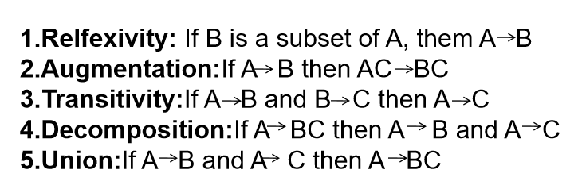

**Second Normal Form(**2NF**) :**

* + A relation schema R is in 2NF if and only if it is in 1NF and every non-prime attribute A in R is fully functionally dependent on the primary key.
  + A functional dependency A B is partially dependent if there is some attributes that can be removed from A and the dependency still holds.
  + Prime attribute-attribute that is member of the primary key K

**Example:**

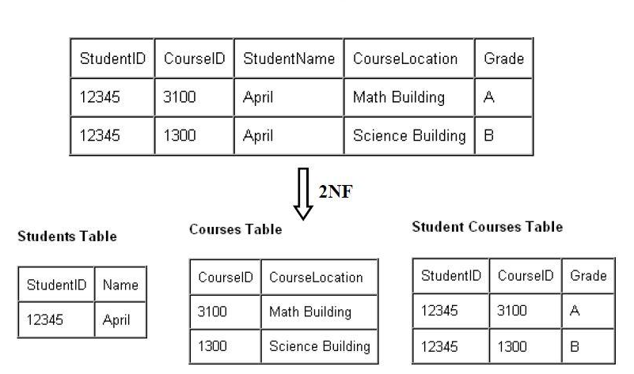

1. Mention the elements of Data Flow Diagram (DFD) with simple example.

**Elements of Data Flow Diagrams:**

* **Process** – A process is an activity or a function performed for some specific business reason.
* **Data Flow** – A data flow is a single piece of data, or a logical collection of several pieces of information.
* **Data Store** – A data store is a collection of data that is stored in some way.
* 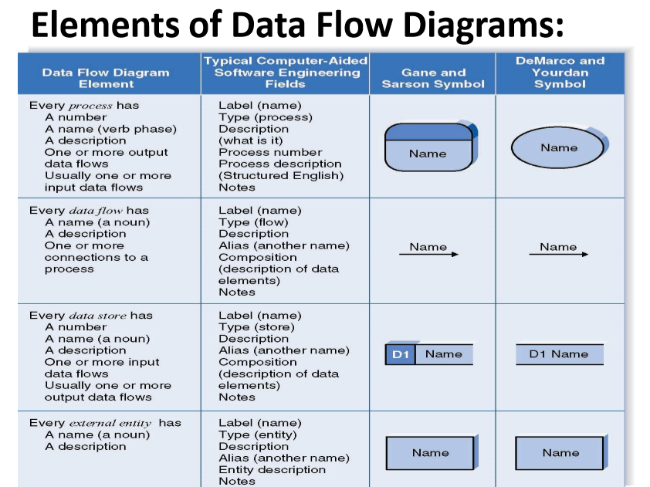**External Entity** – An external entity is a person, organization, organization unit, or system that is external to the system, but interacts with it.

**Data Flow Diagrams (Simple Example):**

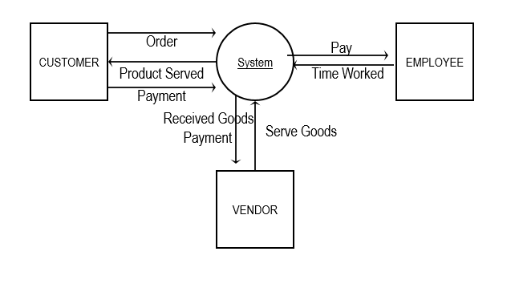

1. What is User Interface design? Discuss User Interface design process with proper flow diagram

**User Interface design**

User interface design (UI design) refers to the design of various types of software and hardware interfaces through which users interact with computers and other technologies.

In general, UI design principles revolve around a user-friendly result. Developers and engineers should look at what is most convenient for a user audience, as well as the requirements of the system and other aspects of research that feed into UI design.

System users often judge a system by its interface rather than its functionality.

Poor user interface design is the reason why so many software systems are never used.

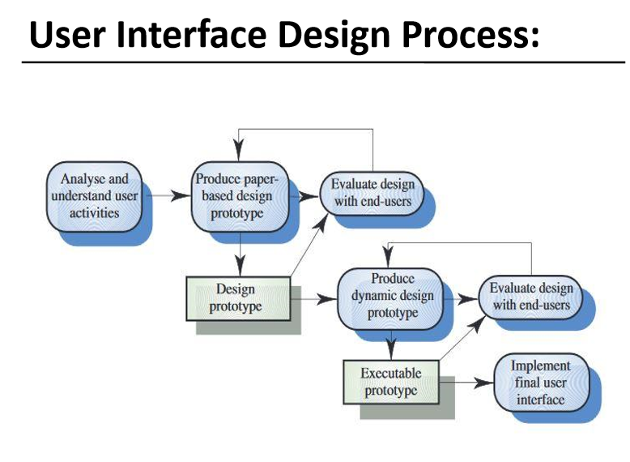

------------------------------------------------------------------------------------------------

1. Define System Support. Briefly Explain System Support activities.

**Systems support:**

Systems support is the on-going technical support for users, as well as the maintenance required to fix any errors, omissions, or new requirements that may arise.

**System Support Activities:**

* **System maintenance** corrects bugs or errors that slipped through the system development process.
* **System recovery** is the restoration of the system and data after a system failure.
* **Technical support** is any assistance provided to users in response to inexperience or unanticipated situations.
* **System enhancement** is the improvement of the system to handle new business problems, new technical problems, or new technology requirements.

1. State System Design? Explain Modern-Structured design approach.

**System Design:**

Systems design – the specification of a detailed computer-based solution. ▪Also called physical design. ▪systems analysis emphasizes the business problem ▪systems design emphasizes the technical or implementation concerns of the system.

**Modern Structured Design:**

Modern structured design – a system design technique that decomposes the system’s processes into manageable components.

* Synonyms (although technically inaccurate) are top-down program design and structured programming.
* Design in a top-down hierarchy of modules
* Easier to implement and maintain (change).

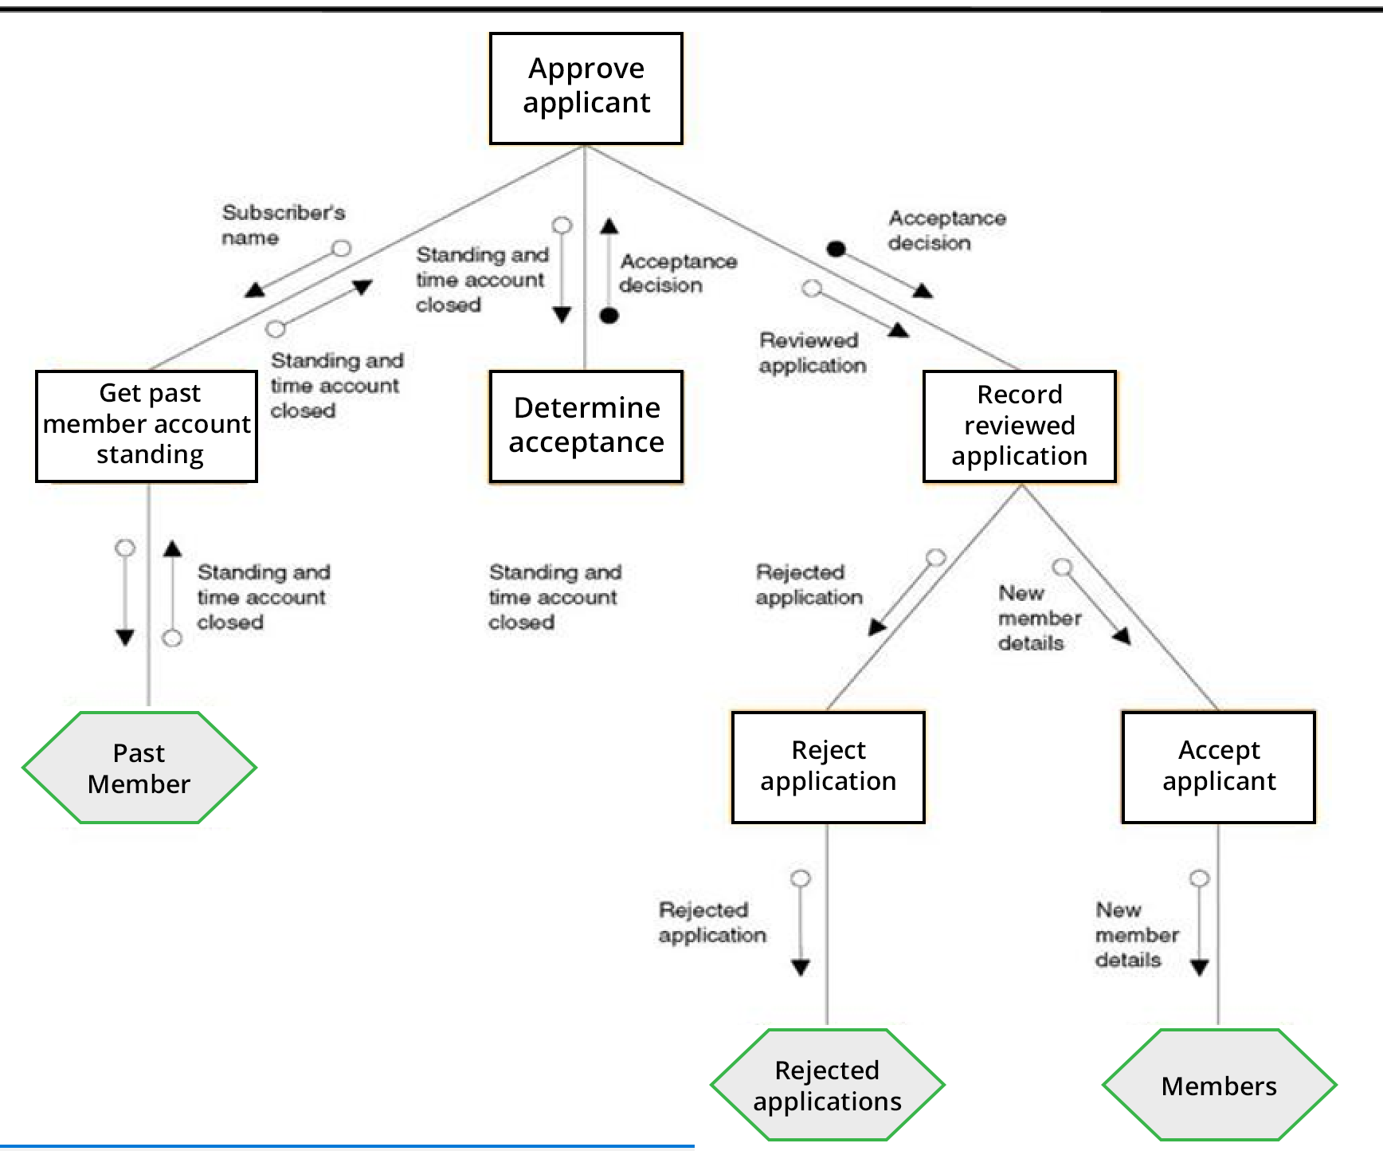

**Fig : Modern Structured Design**

1. Discuss Graphical User Interface (GUI)? Explain GUI properties.

**Graphical User Interface:**

Most users of business systems interact with these systems through graphical interfaces although, in some cases, legacy text-based interfaces are still used.

**GUI Properties:**

Most users of business systems interact with these systems through graphical interfaces although, in some cases, legacy text-based interfaces are still used.

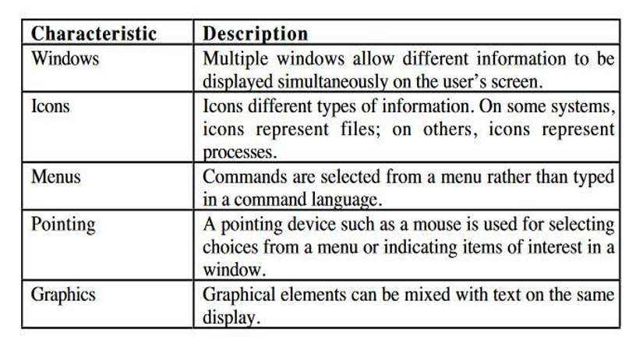

1. Define User Interaction? Write down the advantages, disadvantages and application of Interaction’s style.

**User Interaction:**

User interaction is the interface or system, that is how easily a user interact into the system

**Interaction Style:**

* + Direct manipulation
  + Menu selection
  + Form fill-in
  + Command language
  + Natural language

**Direct Manipulation:**

**Advantages:**

* Fast and intuitive interaction
* Easy to learn

**Disadvantage:**

* May be hard to implement.
* Only suitable where there is a visual metaphor for tasks and objects.

Application Example: Video Games

**Menu Selection:**

**Advantages:**

* Avoid user’s error.
* Typing may not required.

**Disadvantage:**

* Slow for experienced users
* Application Example: General purpose system

**Form fill-in:**

**Advantages:**

* Simple data entry.
* Easy to learn.

**Disadvantage:**

* Takes a lot of screen space

**Application Example:** Online form registration.

**Command Language:**

**Advantages:**

* Powerful and flexible.

**Disadvantage:**

* Hard to learn.

**Application Example:** Operating Systems.

------------------------------------------------------------------------------------------------

1. Write about Information Gathering? Briefly explain Information Gathering tools.

**Information Gathering:**

As defined in the dictionary, **information gathering** is the act of collecting **information** from various sources through various means. In the literal sense, **information gathering** is a basic human skill necessary for undertaking basic human activities such as eating, sleeping, working etc.

**Information Gathering tools :**

There are many different methods of information gathering that people have used to good advantage and here are a few:

* **Questionnaires, surveys and checklists**

Used when you want to collect a lot of information from people in a non-threatening way.

* **Personal interviews** 
  + Used when you want to fully understand a person’s opinions or point of view or to get additional information to a questionnaire.
* **Documentation review** 
  + Used when you want to gather information on current practices without interrupting the program by examining program monitoring reports, program statistics, learner progress reports, annual reports, performance appraisals, board evaluations, written policies and procedures, memos, minutes, financial records, etc.
* **Observation** 
  + Used to watch the program in operation to gather information about what actually happens day-to-day.
* **Focus group** 
  + Used to explore a topic in depth with key stakeholders to learn what the common understanding is on various issues.
* **Case Studies** 
  + Used to depict experiences, processes or practices with a view to developing understanding through examination and cross comparisons.

1. Define Data Modeling. Briefly explain about attributes in Data Modeling concepts.

**Data Modeling:**

Data modeling is a technique for organizing and documenting a system’s data. Sometimes called database modeling.

**Data Modeling Concept: Attributes**

An entity is represented by a set of attributes, that is descriptive properties by all members of an entity set.

**Attribute types:**

* + Simple and composite attributes
  + Single-valued and multi-valued attributes

Ex. Single-valued attribute: room-number multi valued attribute: phone-numbers

* + Derived attributes Can be computed from other attributes

Ex. age, given date of birth

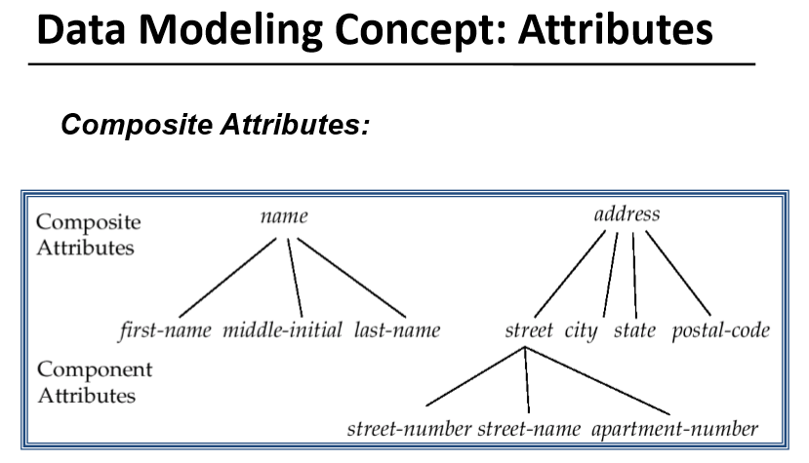

1. State System Design? Explain Information Engineering (IE).

**System Design:**

Systems design – the specification of a detailed computer-based solution.

* Also called physical design.
* systems analysis emphasizes the business problem
* systems design emphasizes the technical or implementation concerns of the system.

**System Design Approaches:**

* **Model-Driven** 
  + Modern structured design
  + Information engineering
  + Prototyping
  + Object-oriented
* RAD
* JAD

**Information Engineering:**

Information engineering (IE) – a model-driven and data-centered, but process-sensitive technique for planning, analyzing, and designing information systems. IE models are pictures that illustrate and synchronize the system’s data and processes.

The primary tool of IE is a data model diagram

