1. **Summarize one real-world business report that can be created from the attached Data Sets and Associated Dictionaries.** What types of films by category are rented the most?
   1. The data that will be used for the report includes how many videos were rented and which category of movie was rented the most (e.g., Action, Comedy, Sci-Fi). Based on what category of movie was rented the most, the rental store can make inventory decisions. For instance, if action films were rented the most, then the rental store should order more action films.
   2. The data tables that provide the data necessary for this report are as follows: *rental, inventory, film, film_category, and category*
   3. The detailed section(i), and the summary section (ii) will include the following fields
      1. rental_id, inventory_id, film_id, title, category_id, name
      2. category_id, name(from category), units_rented, percentage_rented
   4. The field in the detailed section that will need transformation is the name column. There is a category named ‘New’ that is not a genre of film and as such is not of any value to the business report. A more useful title for this category of film is ‘unspecified’. ‘New’ does not tell us anything about the kind of film it is nor does it help make decisions about which films to buy.
   5. The detailed section will give those in charge of buying inventory the ability to see what kinds of films are being rented. It will also let them see rentals attached to specific film titles, rather than just an inventory_id, which gives no specific information about what film is being rented. The summary section will give them an idea of what category of movie is being rented the most by unit and percentage. This will give them some data to go off when they buy new inventory.
   6. I think the data should be refreshed monthly to reflect how often new movies are released. Then, with at least a year's worth of data, trends can be found based on quarter and holiday season. For instance, we could test a hypothesis that during tax season patrons will rent more and adjust inventory accordingly. During the cold season, customers might watch more dramas, classics, and romance titles. So, we could keep up with the anticipated inventory needs by month and then by extension any insights derived from the exercises.
2. **Write a SQL code that creates the tables to hold your report sections**

-- create detailed table

DROP TABLE IF EXISTS detailed_section;

CREATE TABLE detailed_section

(

rental_id integer,

inventory_id integer,

film_id smallint,

title varchar(255),

name varchar(25),

category_id smallint

);

INSERT INTO detailed_section

(

rental_id,

inventory_id,

film_id,

title,

name,

category_id

)

SELECT

r.rental_id,

r.inventory_id,

i.film_id,

f.title,

c.name,

cat.category_id

FROM rental AS r

INNER JOIN inventory AS i

ON r.inventory_id = i.inventory_id

INNER JOIN film AS f

ON i.film_id = f.film_id

INNER JOIN film_category as cat

ON f.film_id = cat.film_id

INNER JOIN category as c

ON cat.category_id = c.category_id;

-- create summary section

DROP TABLE IF EXISTS summary_section;

CREATE TABLE summary_section

AS

SELECT * FROM category;

ALTER TABLE summary_section

DROP COLUMN last_update;

ALTER TABLE summary_section

ADD COLUMN units_rented INT,

ADD COLUMN percentage_rented DECIMAL(5,2);

1. **Write a SQL query that will extract the raw data needed for the Detailed section of your report from source database and verify the data’s accuracy.**

-- create detailed table

DROP TABLE IF EXISTS detailed_section;

CREATE TABLE detailed_section

(

rental_id integer,

inventory_id integer,

film_id smallint,

title varchar(255),

name varchar(25),

category_id smallint

);

INSERT INTO detailed_section

(

rental_id,

inventory_id,

film_id,

title,

name,

category_id

)

SELECT

r.rental_id,

r.inventory_id,

i.film_id,

f.title,

c.name,

cat.category_id

FROM rental AS r

INNER JOIN inventory AS i

ON r.inventory_id = i.inventory_id

INNER JOIN film AS f

ON i.film_id = f.film_id

INNER JOIN film_category as cat

ON f.film_id = cat.film_id

INNER JOIN category as c

ON cat.category_id = c.category_id;

-- function to transform 'New' category to 'unspecified'

CREATE OR REPLACE FUNCTION transform_new()

RETURNS varchar(25)

language plpgsql

AS

$$

DECLARE

unspecified varchar(25) = 'unspecified';

BEGIN

return unspecified;

END;

$$;

-- update query using function

UPDATE detailed_section

SET name = (SELECT transform_new())

WHERE name = 'New';

-- create summary section

DROP TABLE IF EXISTS summary_section;

CREATE TABLE summary_section

AS

SELECT * FROM category;

ALTER TABLE summary_section

DROP COLUMN last_update;

ALTER TABLE summary_section

ADD COLUMN units_rented INT,

ADD COLUMN percentage_rented DECIMAL(5,2);

-- function to get the count per film category

CREATE OR REPLACE FUNCTION get_count

(

cat_id INT

)

RETURNS numeric

language plpgsql

AS

$$

DECLARE

film_count numeric;

BEGIN

SELECT COUNT(category_id)

INTO film_count

FROM detailed_section

WHERE category_id = cat_id;

return film_count;

END;

$$;

-- populate units_rented column with rent counts

UPDATE summary_section

SET units_rented =

(SELECT get_count(1))

WHERE category_id = 1;

UPDATE summary_section

SET units_rented =

(SELECT get_count(2))

WHERE category_id = 2;

UPDATE summary_section

SET units_rented =

(SELECT get_count(3))

WHERE category_id = 3;

UPDATE summary_section

SET units_rented =

(SELECT get_count(4))

WHERE category_id = 4;

UPDATE summary_section

SET units_rented =

(SELECT get_count(5))

WHERE category_id = 5;

UPDATE summary_section

SET units_rented =

(SELECT get_count(6))

WHERE category_id = 6;

UPDATE summary_section

SET units_rented =

(SELECT get_count(7))

WHERE category_id = 7;

UPDATE summary_section

SET units_rented =

(SELECT get_count(8))

WHERE category_id = 8;

UPDATE summary_section

SET units_rented =

(SELECT get_count(9))

WHERE category_id = 9;

UPDATE summary_section

SET units_rented =

(SELECT get_count(10))

WHERE category_id = 10;

UPDATE summary_section

SET units_rented =

(SELECT get_count(11))

WHERE category_id = 11;

UPDATE summary_section

SET units_rented =

(SELECT get_count(12))

WHERE category_id = 12;

UPDATE summary_section

SET units_rented =

(SELECT get_count(13))

WHERE category_id = 13;

UPDATE summary_section

SET units_rented =

(SELECT get_count(14))

WHERE category_id = 14;

UPDATE summary_section

SET units_rented =

(SELECT get_count(15))

WHERE category_id = 15;

UPDATE summary_section

SET units_rented =

(SELECT get_count(16))

WHERE category_id = 16;

-- function to get count of total rentals

CREATE OR REPLACE FUNCTION get_rental_count()

RETURNS numeric

language plpgsql

AS

$$

DECLARE

rentals numeric;

BEGIN

SELECT SUM(units_rented)

INTO rentals

FROM summary_section;

RETURN rentals;

END;

$$;

-- function to get count of rentals by category

CREATE OR REPLACE FUNCTION get_count_by_type(cat_id integer)

RETURNS numeric

language plpgsql

AS

$$

DECLARE

rentals numeric;

BEGIN

SELECT SUM(units_rented)

INTO rentals

FROM summary_section

WHERE category_id = cat_id;

RETURN rentals;

END;

$$;

-- insert the percentages of films rented in summary section

-- using the scalar functions to divide

UPDATE summary_section

SET percentage_rented =

(SELECT get_count_by_type(1)/get_rental_count() * 100)

WHERE category_id = 1;

UPDATE summary_section

SET percentage_rented =

(SELECT get_count_by_type(2)/get_rental_count() * 100)

WHERE category_id = 2;

UPDATE summary_section

SET percentage_rented =

(SELECT get_count_by_type(3)/get_rental_count() * 100)

WHERE category_id = 3;

UPDATE summary_section

SET percentage_rented =

(SELECT get_count_by_type(4)/get_rental_count() * 100)

WHERE category_id = 4;

UPDATE summary_section

SET percentage_rented =

(SELECT get_count_by_type(5)/get_rental_count() * 100)

WHERE category_id = 5;

UPDATE summary_section

SET percentage_rented =

(SELECT get_count_by_type(6)/get_rental_count() * 100)

WHERE category_id = 6;

UPDATE summary_section

SET percentage_rented =

(SELECT get_count_by_type(7)/get_rental_count() * 100)

WHERE category_id = 7;

UPDATE summary_section

SET percentage_rented =

(SELECT get_count_by_type(8)/get_rental_count() * 100)

WHERE category_id = 8;

UPDATE summary_section

SET percentage_rented =

(SELECT get_count_by_type(9)/get_rental_count() * 100)

WHERE category_id = 9;

UPDATE summary_section

SET percentage_rented =

(SELECT get_count_by_type(10)/get_rental_count() * 100)

WHERE category_id = 10;

UPDATE summary_section

SET percentage_rented =

(SELECT get_count_by_type(11)/get_rental_count() * 100)

WHERE category_id = 11;

UPDATE summary_section

SET percentage_rented =

(SELECT get_count_by_type(12)/get_rental_count() * 100)

WHERE category_id = 12;

UPDATE summary_section

SET percentage_rented =

(SELECT get_count_by_type(13)/get_rental_count() * 100)

WHERE category_id = 13;

UPDATE summary_section

SET percentage_rented =

(SELECT get_count_by_type(14)/get_rental_count() * 100)

WHERE category_id = 14;

UPDATE summary_section

SET percentage_rented =

(SELECT get_count_by_type(15)/get_rental_count() * 100)

WHERE category_id = 15;

UPDATE summary_section

SET percentage_rented =

(SELECT get_count_by_type(16)/get_rental_count() * 100)

WHERE category_id = 16;

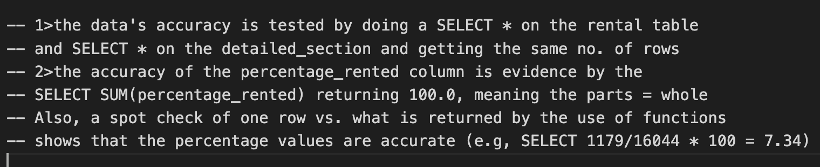

1. **Write code for function(s) that perform the transformation(s) you identified in part A4.**

CREATE OR REPLACE FUNCTION transform_new()

RETURNS varchar(25)

language plpgsql

AS

$$

DECLARE

unspecified varchar(25) = 'unspecified';

BEGIN

return unspecified;

END;

$$;

UPDATE summary_section

SET name = (SELECT transform_new())

WHERE name = 'New';

1. **Write a SQL code that creates a trigger on the detailed table of the report that will continually update the summary table as the data is added to the detailed table.**

-- create function that will be invoked when trigger is -- called

CREATE OR REPLACE FUNCTION update_detailed_sec()

RETURNS TRIGGER

language plpgsql

AS

$$

BEGIN

-- delete contents of detailed table

DELETE FROM detailed_section;

-- re-insert into table with new row/s

INSERT INTO detailed_section

(

rental_id,

inventory_id,

film_id,

title,

name,

category_id

)

SELECT

r.rental_id,

r.inventory_id,

i.film_id,

f.title,

c.name,

cat.category_id

FROM rental AS r

INNER JOIN inventory AS i

ON r.inventory_id = i.inventory_id

INNER JOIN film AS f

ON i.film_id = f.film_id

INNER JOIN film_category as cat

ON f.film_id = cat.film_id

INNER JOIN category as c

ON cat.category_id = c.category_id;

-- Apply transformation to 'New' column

UPDATE detailed_section

SET name = (SELECT transform_new())

WHERE name = 'New';

-- DELETE contents of summary_section

DELETE FROM summary_section;

-- INSERT DATA BACK INTO summary_section

INSERT INTO summary_section

(category_id, name)

(SELECT category_id, name from category);

-- populate units_rented column with rent counts

UPDATE summary_section

SET units_rented =

(SELECT get_count(1))

WHERE category_id = 1;

UPDATE summary_section

SET units_rented =

(SELECT get_count(2))

WHERE category_id = 2;

UPDATE summary_section

SET units_rented =

(SELECT get_count(3))

WHERE category_id = 3;

UPDATE summary_section

SET units_rented =

(SELECT get_count(4))

WHERE category_id = 4;

UPDATE summary_section

SET units_rented =

(SELECT get_count(5))

WHERE category_id = 5;

UPDATE summary_section

SET units_rented =

(SELECT get_count(6))

WHERE category_id = 6;

UPDATE summary_section

SET units_rented =

(SELECT get_count(7))

WHERE category_id = 7;

UPDATE summary_section

SET units_rented =

(SELECT get_count(8))

WHERE category_id = 8;

UPDATE summary_section

SET units_rented =

(SELECT get_count(9))

WHERE category_id = 9;

UPDATE summary_section

SET units_rented =

(SELECT get_count(10))

WHERE category_id = 10;

UPDATE summary_section

SET units_rented =

(SELECT get_count(11))

WHERE category_id = 11;

UPDATE summary_section

SET units_rented =

(SELECT get_count(12))

WHERE category_id = 12;

UPDATE summary_section

SET units_rented =

(SELECT get_count(13))

WHERE category_id = 13;

UPDATE summary_section

SET units_rented =

(SELECT get_count(14))

WHERE category_id = 14;

UPDATE summary_section

SET units_rented =

(SELECT get_count(15))

WHERE category_id = 15;

UPDATE summary_section

SET units_rented =

(SELECT get_count(16))

WHERE category_id = 16;

UPDATE summary_section

SET percentage_rented =

(SELECT get_count_by_type(1)/get_rental_count() * 100)

WHERE category_id = 1;

UPDATE summary_section

SET percentage_rented =

(SELECT get_count_by_type(2)/get_rental_count() * 100)

WHERE category_id = 2;

UPDATE summary_section

SET percentage_rented =

(SELECT get_count_by_type(3)/get_rental_count() * 100)

WHERE category_id = 3;

UPDATE summary_section

SET percentage_rented =

(SELECT get_count_by_type(4)/get_rental_count() * 100)

WHERE category_id = 4;

UPDATE summary_section

SET percentage_rented =

(SELECT get_count_by_type(5)/get_rental_count() * 100)

WHERE category_id = 5;

UPDATE summary_section

SET percentage_rented =

(SELECT get_count_by_type(6)/get_rental_count() * 100)

WHERE category_id = 6;

UPDATE summary_section

SET percentage_rented =

(SELECT get_count_by_type(7)/get_rental_count() * 100)

WHERE category_id = 7;

UPDATE summary_section

SET percentage_rented =

(SELECT get_count_by_type(8)/get_rental_count() * 100)

WHERE category_id = 8;

UPDATE summary_section

SET percentage_rented =

(SELECT get_count_by_type(9)/get_rental_count() * 100)

WHERE category_id = 9;

UPDATE summary_section

SET percentage_rented =

(SELECT get_count_by_type(10)/get_rental_count() * 100)

WHERE category_id = 10;

UPDATE summary_section

SET percentage_rented =

(SELECT get_count_by_type(11)/get_rental_count() * 100)

WHERE category_id = 11;

UPDATE summary_section

SET percentage_rented =

(SELECT get_count_by_type(12)/get_rental_count() * 100)

WHERE category_id = 12;

UPDATE summary_section

SET percentage_rented =

(SELECT get_count_by_type(13)/get_rental_count() * 100)

WHERE category_id = 13;

UPDATE summary_section

SET percentage_rented =

(SELECT get_count_by_type(14)/get_rental_count() * 100)

WHERE category_id = 14;

UPDATE summary_section

SET percentage_rented =

(SELECT get_count_by_type(15)/get_rental_count() * 100)

WHERE category_id = 15;

UPDATE summary_section

SET percentage_rented =

(SELECT get_count_by_type(16)/get_rental_count() * 100)

WHERE category_id = 16;

RETURN NULL;

END;

$$;

-- create trigger

CREATE OR REPLACE TRIGGER refresh_tables

AFTER INSERT

ON rental

FOR EACH STATEMENT

EXECUTE PROCEDURE update_detailed_sec();

1. **Create a stored procedure that can be used to refresh the data in *both* your detailed and summary tables. The procedure should clear the contents of the detailed and summary tables and perform the ETL load process from part C and include comments that identify how often the stored procedure should be executed.**

1. **Explain how the stored procedure can be run on a schedule to ensure data freshness.**

The stored procedure can be run on a schedule using pgAgent, the scheduling app that comes with PostgreSQL. A "job" can be created and the procedure can be called when the job is created.

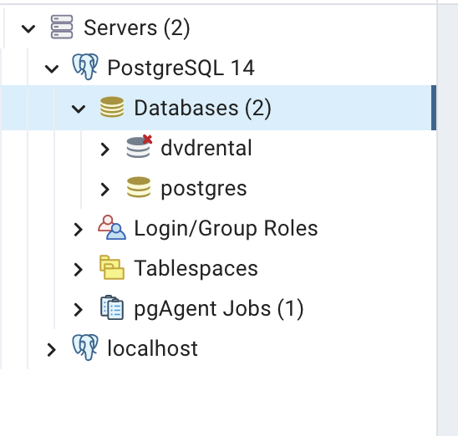

The job is set up to call the procedure I have written called *refresh_data.*

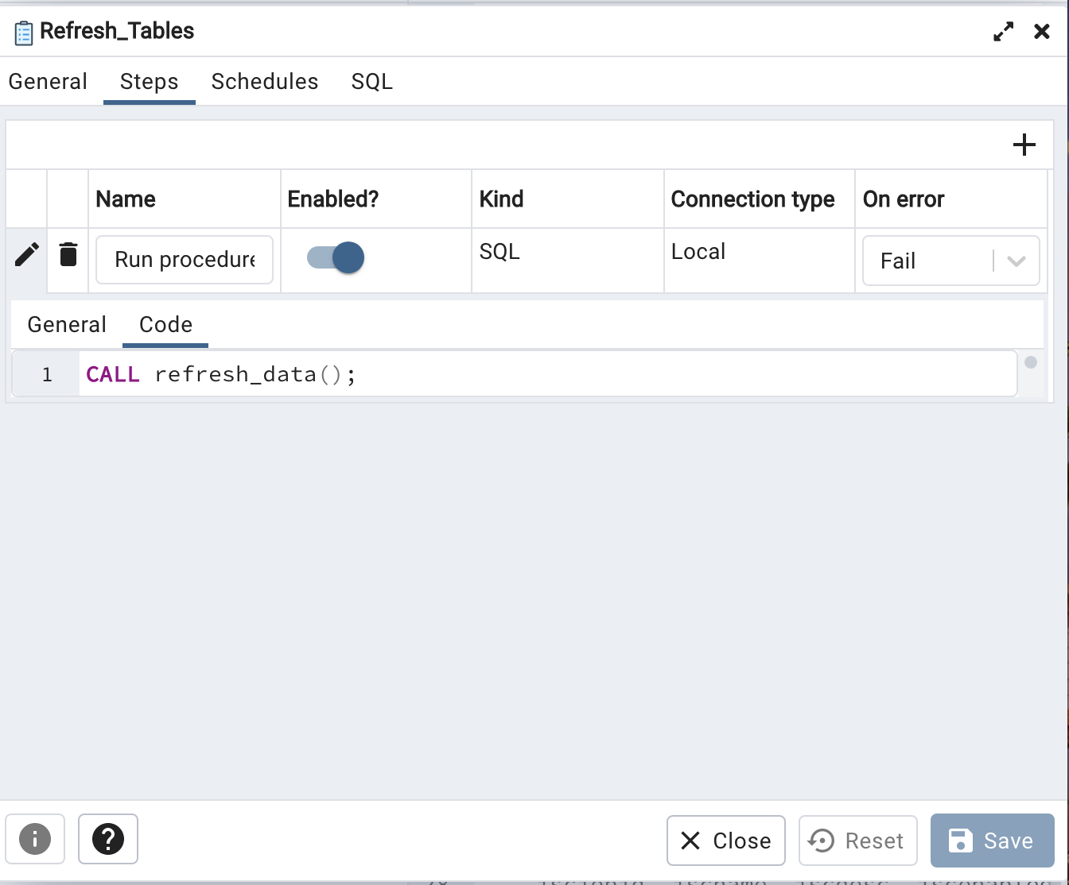

Then the job is set to run monthly per my recommendation in A.6.

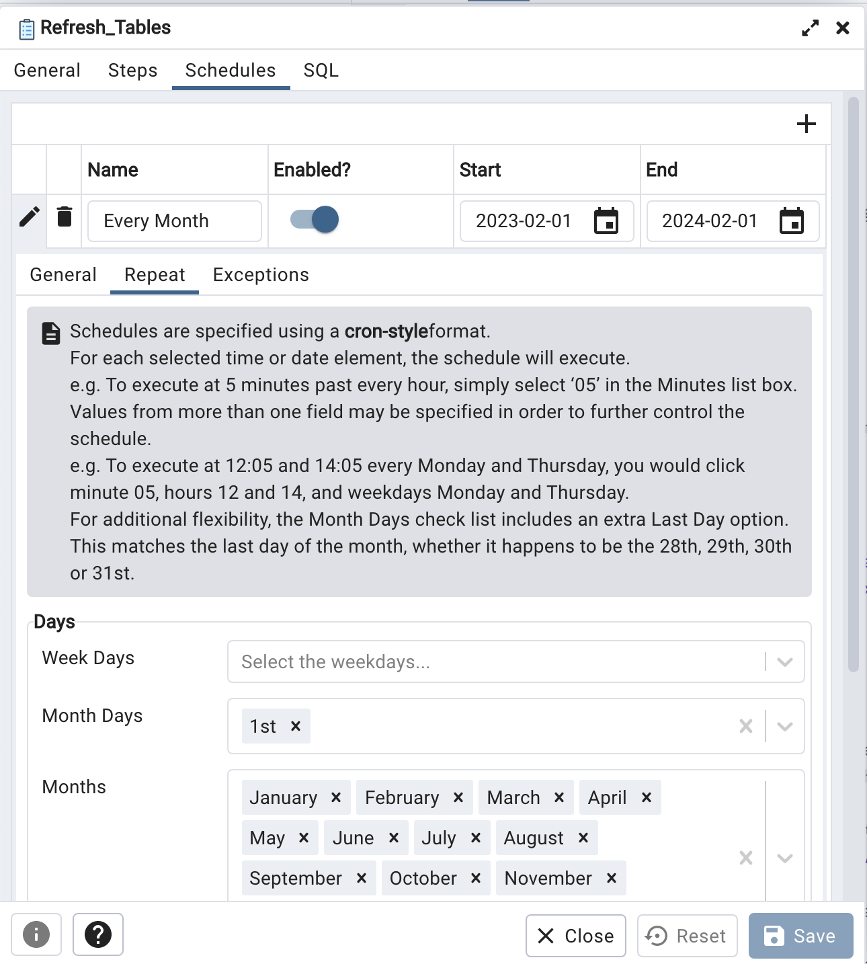

CREATE OR REPLACE PROCEDURE refresh_data()

LANGUAGE plpgsql

AS $$

BEGIN

DROP TABLE IF EXISTS detailed_section;

CREATE TABLE detailed_section

(

rental_id integer,

inventory_id integer,

film_id smallint,

title varchar(255),

name varchar(25),

category_id smallint

);

INSERT INTO detailed_section

(

rental_id,

inventory_id,

film_id,

title,

name,

category_id

)

SELECT

r.rental_id,

r.inventory_id,

i.film_id,

f.title,

c.name,

cat.category_id

FROM rental AS r

INNER JOIN inventory AS i

ON r.inventory_id = i.inventory_id

INNER JOIN film AS f

ON i.film_id = f.film_id

INNER JOIN film_category as cat

ON f.film_id = cat.film_id

INNER JOIN category as c

ON cat.category_id = c.category_id;

UPDATE detailed_section

SET name = (SELECT transform_new())

WHERE name = 'New';

DROP TABLE IF EXISTS summary_section;

CREATE TABLE summary_section

AS

SELECT * FROM category;

ALTER TABLE summary_section

DROP COLUMN last_update;

ALTER TABLE summary_section

ADD COLUMN units_rented INT,

ADD COLUMN percentage_rented DECIMAL(5,2);

UPDATE summary_section

SET units_rented =

(SELECT get_count(1))

WHERE category_id = 1;

UPDATE summary_section

SET units_rented =

(SELECT get_count(2))

WHERE category_id = 2;

UPDATE summary_section

SET units_rented =

(SELECT get_count(3))

WHERE category_id = 3;

UPDATE summary_section

SET units_rented =

(SELECT get_count(4))

WHERE category_id = 4;

UPDATE summary_section

SET units_rented =

(SELECT get_count(5))

WHERE category_id = 5;

UPDATE summary_section

SET units_rented =

(SELECT get_count(6))

WHERE category_id = 6;

UPDATE summary_section

SET units_rented =

(SELECT get_count(7))

WHERE category_id = 7;

UPDATE summary_section

SET units_rented =

(SELECT get_count(8))

WHERE category_id = 8;

UPDATE summary_section

SET units_rented =

(SELECT get_count(9))

WHERE category_id = 9;

UPDATE summary_section

SET units_rented =

(SELECT get_count(10))

WHERE category_id = 10;

UPDATE summary_section

SET units_rented =

(SELECT get_count(11))

WHERE category_id = 11;

UPDATE summary_section

SET units_rented =

(SELECT get_count(12))

WHERE category_id = 12;

UPDATE summary_section

SET units_rented =

(SELECT get_count(13))

WHERE category_id = 13;

UPDATE summary_section

SET units_rented =

(SELECT get_count(14))

WHERE category_id = 14;

UPDATE summary_section

SET units_rented =

(SELECT get_count(15))

WHERE category_id = 15;

UPDATE summary_section

SET units_rented =

(SELECT get_count(16))

WHERE category_id = 16;

UPDATE summary_section

SET percentage_rented =

(SELECT get_count_by_type(1)/get_rental_count() * 100)

WHERE category_id = 1;

UPDATE summary_section

SET percentage_rented =

(SELECT get_count_by_type(2)/get_rental_count() * 100)

WHERE category_id = 2;

UPDATE summary_section

SET percentage_rented =

(SELECT get_count_by_type(3)/get_rental_count() * 100)

WHERE category_id = 3;

UPDATE summary_section

SET percentage_rented =

(SELECT get_count_by_type(4)/get_rental_count() * 100)

WHERE category_id = 4;

UPDATE summary_section

SET percentage_rented =

(SELECT get_count_by_type(5)/get_rental_count() * 100)

WHERE category_id = 5;

UPDATE summary_section

SET percentage_rented =

(SELECT get_count_by_type(6)/get_rental_count() * 100)

WHERE category_id = 6;

UPDATE summary_section

SET percentage_rented =

(SELECT get_count_by_type(7)/get_rental_count() * 100)

WHERE category_id = 7;

UPDATE summary_section

SET percentage_rented =

(SELECT get_count_by_type(8)/get_rental_count() * 100)

WHERE category_id = 8;

UPDATE summary_section

SET percentage_rented =

(SELECT get_count_by_type(9)/get_rental_count() * 100)

WHERE category_id = 9;

UPDATE summary_section

SET percentage_rented =

(SELECT get_count_by_type(10)/get_rental_count() * 100)

WHERE category_id = 10;

UPDATE summary_section

SET percentage_rented =

(SELECT get_count_by_type(11)/get_rental_count() * 100)

WHERE category_id = 11;

UPDATE summary_section

SET percentage_rented =

(SELECT get_count_by_type(12)/get_rental_count() * 100)

WHERE category_id = 12;

UPDATE summary_section

SET percentage_rented =

(SELECT get_count_by_type(13)/get_rental_count() * 100)

WHERE category_id = 13;

UPDATE summary_section

SET percentage_rented =

(SELECT get_count_by_type(14)/get_rental_count() * 100)

WHERE category_id = 14;

UPDATE summary_section

SET percentage_rented =

(SELECT get_count_by_type(15)/get_rental_count() * 100)

WHERE category_id = 15;

UPDATE summary_section

SET percentage_rented =

(SELECT get_count_by_type(16)/get_rental_count() * 100)

WHERE category_id = 16;

RETURN;

END;

$$;

***G. Video URL is attached to submission***

**H. Record the web sources you used to acquire data or segments of third-party code to support the application if applicable. Be sure the web sources are reliable.**

This is where I downloaded the dvd rental database and postgresql applications pgAdmin4 and pgAgent

https://www.postgresqltutorial.com/postgresql-getting-started/postgresql-sample-database/

https://www.postgresql.org/download/

**I.**  **Acknowledge sources, using in-text citations and references, for content that is quoted, paraphrased, or summarized.**

I did not use any citations or references in the production of this project.