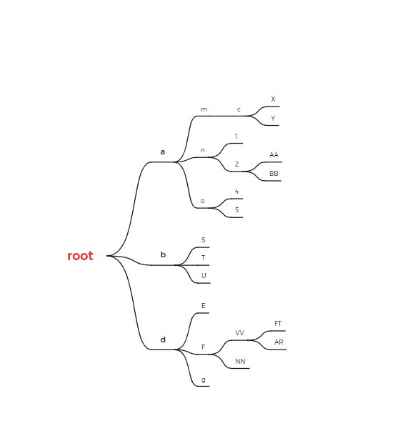

Task #1: Prepare an array from this tree (PHP/C)

Ans:

—----------------

$root = [“d”=>[“e”,”f’=>[“vv”=>[“FT”,”AR”],”nn”],g]

Task #2: Find the root for a node

Input: **FT**

Output: **VV**

Task #3:

$a = 123;

$b = 'a';

echo $$b; // 123

$a = 123;

echo $a; // 123 +

echo $a++; // 124 +

echo ++$a; // 123-

$x = 8;

$y = 8.0;

echo ($x === $y); // False+

==============

B = BROWSE

R = READ

E = EDIT

A = ADD

D = DELETE

BREAD