[](https://upload.wikimedia.org/wikipedia/commons/thumb/1/11/Glass-of-water.jpg/220px-Glass-of-water.jpg)     I can guarantee that most of the readers know the famous "Half empty? or half full?" phrase.  And I can hear some of you saying "Ugh this is going to be one of those post".

     My answer is half yes.  Don't leave yet, and hear me out.  I want to talk about the way we view things is not always limited to one way.

     Here is [an example](https://medium.com/99-mph/1-trillion-of-real-estate-is-on-the-move-heres-why-94ee9233e5eb).  I never thought of self-driving car as a real estate play.  Seeing things from different point of view results in innovation.

     I am emphasizing that we all should have ability to see things differently.  When market crashes, there are **three** major type of people : people who sell, people who hold, and people who buy.  It is a same event that occurred, but why do people react differently?  This is because people see things differently.  We **must not**be the ones who sell when market crashes.

     Warren Buffet held on to stocks during many crashes.  Some, he bought more (actually this is how he accumulated his wealth - buy companies at discount).

     In [one of my favorite blog posts](https://medium.com/personal-finance-series-by-richard-reis/for-successful-investing-think-long-term-1677fdedd58e), the author provides many facts on how market is proven to go up in the **long run.**

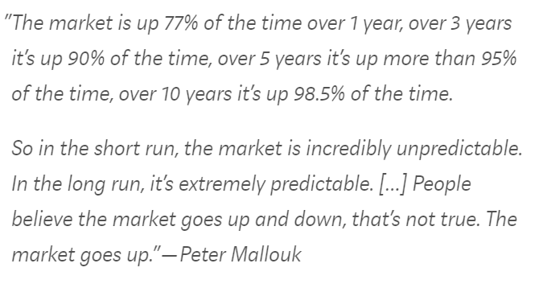

     If you took introduction to statistics, you know many statisticians accept a hypothesis when it has above 95% accuracy.  Even if you never studied statistics, doesn't 95% of winning chance look like a good odd?  If you think stock investing is a gamble, would you not bet on 95% winning chance?

     The point I am trying to make here is that when market is crashing, you can see it as a buy opportunity (it is not necessarily bad).  Why?  Because stocks have been proven to go up if you wait long enough (95% chance in 5 years, and 98.5% in 10 years).  When stocks fall for really long period, you will have something else to worry about than your money in stocks (ex. nuclear wipe-out, or robots have taken over the world destroyed a humanity).

     And that is it.  I kept this post short to reduce time you spend reading this.  I believe this is sufficient to deliver points I am trying to prove, and I really hope this post introduced you to be interested in investing.