[](https://si.wsj.net/public/resources/images/BI-AA979_AI_P_20150506144558.jpg)     Yes.  You read that right.  A whopping $800/hr job offer.  Before I lose your trust, let me tell you something quick.

     After finishing reading couple blog posts, I decided to follow some of authors' advice on marketing.  Coming up with a title that draws reader's attention is important.  However, it cannot be a "click-bait" because people will lose trust in your future contents.  For this post, I tried my best to come up with the most lucrative title for the topic I wanted to discuss, hence here you are.

    That being said, you may be wondering why I declined a $800/hr job offer.  Or to begin with, what kind of job offers $800/hr salary for a 22 years old guy?  Considering a normal full time job (working 40 hours a week), that gives me **$1,664,000** salary.  In fact, this job offered an option to work 24/7, so the maximum amount I could make in a year was **$7,008,000.**

     As you know this series is related to finance, so some of you may have figured out what this job is.  A hint : what is open 24/7?

     The (partial) answer is...

...

...

...

...

...

...

...

...

...

...

...

...

...

...

...

...

...

...

...

**FOREX!**

[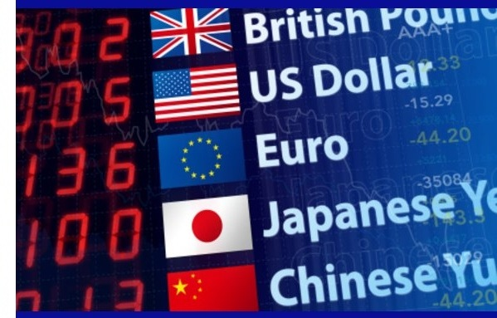](http://bfbddad795fe6760de935eb7.ltttm.netdna-cdn.com/wp-content/uploads/foreximagefc.jpg?x36428)

    For whoever does not know what FOREX is, it is exchanging currencies.  As currency rate changes, there may exist an opportunity to make money.  There are many ways to benefit from FOREX, but the method my job required is **arbitrage.**

     Below is the definition of arbitrage from Google.

     Arbitrage is a term for one of the basics of making money : buy low and sell high.  Usually when there is an arbitrage opportunity, the opportunity disappears quick as people realize, and "correct" the prices.  In addition, a common arbitrage opportunity offers 1~2% gain, so unless you have massive amount of capital (like banks), it is not worth the time.

     Now, what arbitrage opportunity offered $800/hr you ask?  A cryptocurrency market.  Cryptocurrency market is open 24/7 regardless of any countries' holidays, and is available in multiple countries.  Due to a booming interest in investing in cryptocurrency, a constantarbitrage opportunity existed.  Also, people from certain country were so eager to invest in crypto, the crypto price was dramatically different from the rest of the market.

     Again, some may already know what I am talking about : **Kimchi Premium.**Kimchi is known for Korean food, and because Koreans were so eager to invest in crypto, they were paying massive premium on any coins.  The internet named such premium a Kimchi Premium.  When I found this opportunity, the average premium was at 20%.  This was very profitable even after transaction, and trading fees.  At one point, this premium went up to **65%!**Imagine, every time you trade, you are guaranteed 65% return.  Wouldn't that be amazing?  So this was my job offer that pays $800/hr.

[](http://store.hallsigns.com/thumbnail.asp?file=assets/images/R1-1.png&maxx=600&maxy=0)

     Stop!  ~~Before you open up a crypto account, I need to stop you there~~.  Before you start trading cryptocurrency, I need to stop you there. (**EDIT**: It is not a terrible idea to open up a free trading account as soon as possible, as I pointed it out in [Series 1 : My Personal Investing Journey](https://connect.fg.rbc.com/blogs/skimblog/2018/01/19/my-personal-investing-journey).  Start trading with that account, however, may be a terrible idea if you don't know what you're doing.)

     What I learned over time is that **it is tougher to make money than you think**.  There were some serious aspects of this job that made me not to take it.

[This post](https://medium.com/santiment/kimchi-premium-the-hidden-history-of-cryptocurrency-in-korea-91b7022a7c65) actually covers what I was going to write, so I will leave out details in this post.  In short, limitations from exchange ($4000/day limit on instant deposit), and government ($10,000 limit for regular citizen, and $100,000 yearly limit for studying/working abroad citizen) set back the amount I could legally earn.  Also, the time it takes to transfer goods (coins) from one wallet to the other added more risk.  One of current drawbacks of Bitcoin is its transaction time; in average it takes an hour to settle the transaction.  How can you be sure that 20% gap will still exist an hour after when price moves faster than nano-seconds?

     The key point I am trying to emphasize is that it is tougher to make money than you think legally.  You must do an extensive research to make sure your method of accumulating wealth is **legal, and works properly**.  And lastly, keep proof of transactions to prepare for your tax.  This implies that you must pay tax if applicable.  You never know when those in black suits and dark sunglasses on (this is what tax agents look like in my head) will be knocking on your door asking you for all the proofs.

     Know the difference between tax savings and tax evasion.