Human Stress Detection on Twitter: A Hybrid Approach using LSTM and Natural Language Processing

Sivaramakrishnan Rajendar  
*Department of Computer Science and Engineering*  
*KPR Institute of Engineering and Technology*   
Coimbatore, Tamilnadu, India  
sivaraamakrishnan2010@gmail.com

Vasanth Nachimuthu  
*Department of Computer Science and Engineering*  
*KPR Institute of Engineering and Technology*Coimbatore, Tamilnadu, India  
[vasanthnachimuthu@gmail.com](mailto:vasanthnachimuthu@gmail.com) Sanjay Ranganathan  
*Department of Computer Science and Engineering*  
*KPR Institute of Engineering and Technology* Coimbatore, Tamilnadu, India  
[sanjsun143@gmail.com](mailto:sanjsun143@gmail.com)

Sriram Paramasivam  
*Department of Computer Science and Engineering*  
*KPR Institute of Engineering and Technology*Coimbatore, Tamilnadu, India  
dev.sriramp@gmail.com Thavamuthubaskaran Lakshmanan  
*Department of Computer Science and Engineering*  
*KPR Institute of Engineering and Technology* Coimbatore, Tamilnadu, India  
[thavamuthubaskaran0515@gmail.com](mailto:thavamuthubaskaran0515@gmail.com)

*Abstract*— ***Stress is a common mental health problem that affects individuals from all walks of life. It can manifest in various forms, such as emotional, physical, or cognitive distress. The detection of stress in individuals is crucial for early intervention and treatment. However, traditional methods of stress detection, such as self-report surveys or physiological measures have limitations. In recent years, a social media platform like Twitter, have become a rich source of data for studying mental health. This study proposes the use of deep learning techniques, specifically the combination of LSTM and 1D CNN, to detect human stress levels from social media posts, particularly tweets. By leveraging Kaggle Twitter datasets alongside of the recent original Tweets, the model was well trained and validated, achieving high accuracy levels in stress detection.***

Keywords— Stress detection, Social media, Deep learning, Twitter, LSTM and Long Short-Term Memory

# Introduction

Stress is a physiological and psychological response to challenging or threatening situations that can impact an individual's well-being. Common causes of stress in humans include work-related issues, financial difficulties, relationship problems, and health concerns. According to the American Institute of Stress, work-related stress alone is responsible for up to $300 billion in lost productivity annually in the United States [1]. Prolonged exposure to stress has been associated with a range of negative health outcomes, including cardiovascular disease, depression, anxiety, and immune system dysfunction. A study by Cohen et al. [2] found that individuals who experienced chronic stress were more susceptible to the common cold, due to the impact of stress on immune function.

In addition to physical health concerns, stress can also impact an individual's mental health and overall quality of life. [3] A study found that high levels of stress were associated with increased risk of depression and anxiety in a sample of Korean adults. Overall, stress is a significant and widespread issue that can have a significant impact on individuals' health and well-being. It is important to recognize the causes and effects of stress and to develop effective interventions to prevent and manage stress in individuals and populations [4].

Conventional human stress detection typically relies on self-report measures, physiological markers such as heart rate variability or cortisol levels, or behavioral observations. While these methods can be effective in certain contexts, they also have several limitations. For example, self-report measures are subject to bias and may not always accurately reflect an individual's stress levels, while physiological markers can be influenced by factors such as medication or illness. Behavioral observations may also be subjective and may not capture the full range of stress responses.

A study by Adam et al. [5] compared different stress detection methods and found that physiological measures were most effective, but also had limitations such as being expensive, invasive, and difficult to implement in real-world settings. The study also found that behavioral observations were less reliable than physiological measures, and that self-report measures were prone to biases such as social desirability bias. Thus, conventional human stress detection methods have limitations that can impact their accuracy and applicability in real-world settings. Newer approaches, such as those based on deep learning and social media analysis, have the potential to overcome some of these limitations and provide more accurate and scalable solutions for stress detection.

In recent decade, the social media has been found to be a valuable resource in detecting human stress. Through the analysis of social media posts, researchers can gain insights into the emotional states of individuals and identify patterns that may be indicative of stress. The use of natural language processing and sentiment analysis techniques can help to identify specific words, phrases, and other linguistic markers that are associated with stress. These insights can be used to develop more effective stress management strategies and interventions [6].

Moreover, Machine Learning (ML) and Deep Learning (DL) are increasingly being used in human stress detection by analyzing various physiological signals, such as heart rate variability, skin conductance, and facial expressions. These signals are measured using sensors, wearable devices, and cameras, and are then processed using ML and DL techniques to extract features that are indicative of stress. The extracted features are then used to train a model that can detect stress in real-time. Such models have the potential to be used in a variety of applications, such as mental health monitoring, workplace safety, and personal wellness.

Thus, integrating social media and deep learning techniques has the potential to improve the accuracy and effectiveness of human stress detection. Deep learning can be used to analyze large amounts of social media data and identify complex patterns that may be indicative of stress, including subtle linguistic and behavioral cues that may be missed by traditional machine learning algorithms. By integrating social media and deep learning techniques, researchers can gain a more comprehensive understanding of human stress and develop more effective interventions to manage and mitigate its effects.

On the other hand, the limitations of deep learning-based stress detection via social media include the lack of large labeled datasets, high variability in stress expression across individuals, difficulty in accounting for contextual and cultural factors, and the need for more research on interpretability and explainability. The future research must consider these factors into account.

This work proposes a novel LSTM-based architecture for detecting human stress from Twitter datasets. Our approach leverages the power of deep learning and natural language processing to automatically extract and learn complex features from large-scale social media data. This work contributes to the field of stress detection by applying state-of-the-art deep learning techniques to social media analysis, which has the potential to provide more accurate and scalable solutions for stress detection in real-world settings. Additionally, our use of multiple Twitter datasets sourced from Kaggle provides a diverse range of stress-related content, which allows for more robust and generalizable models.

The reminder of the paper is organized as follows: Section 2 provides an overview of recent research related to stress detection across different categories. Section 3 describes the methodologies used in the study. Section 4 summarizes the literature reviewed in Section 2 and highlights the different factors and characteristics considered for stress detection. Section 5 presents the experimental results obtained from analyzing Twitter data for stress detection. Finally, Section 6 presents the conclusion.

# Related Works

Several research projects have been undertaken with the goal of detecting stress levels in individuals based on their social media activity. These projects typically collect data from social media platforms such as Twitter, Facebook, and Instagram and use natural language processing techniques to analyze the language used in posts, comments, and captions. The language data is then processed to extract features indicative of stress levels, such as the use of negative words and emotions, changes in writing style, and the presence of stress-related keywords. The extracted features are then used to train machine learning models that predict stress levels. Some examples include:

A. Khan et. al. [8] proposed a machine learning model to detect stress in social media posts, using two datasets that were used for stress detection from social media posts. The first dataset consisted of 1000 English tweets that were collected using Twitter's streaming API with keywords related to stress and anxiety. The tweets were manually labeled as stressed or not stressed by a team of annotators and were used for both training and testing the machine learning models. The second dataset included 3500 English tweets that were also collected using Twitter's streaming API with similar keywords, but this dataset was not labeled and was only used for evaluating the performance of the trained models. The stress detection task employed several machine learning algorithms, including SVM, RF, MNB, DT, and KNN. The author conducted a comparison of these algorithms and found that the SVM algorithm outperformed the others in detecting stress from social media posts. The model achieved high accuracy in detecting stress-related tweets.

A. Soria et. al. [9] proposed a deep learning-based model to automatically detect stress in social media posts. Specifically, the author used a deep neural network model called Convolutional Neural Network (CNN) to classify social media posts as either stressed or not stressed. The dataset was collected using a set of keywords related to stress and anxiety and consisted of a total of 19,320 tweets. The author manually annotated the tweets as either stressed or not stressed based on their content. This annotated dataset was then used to train and evaluate the deep learning model for automated stress detection. The model was trained on a dataset of tweets and achieved high accuracy in detecting stress-related tweets.

S. K. Shukla et. al. [10] presented a machine learning approach for detecting stress levels from Twitter data, using a dataset of tweets collected from individuals who self-reported their stress levels. The authors of the study utilized several machine learning algorithms to detect stress, including Support Vector Machine (SVM), Multinomial Naive Bayes (MNB), Decision Tree (DT), Random Forest (RF), and Logistic Regression (LR). After comparing the effectiveness of these algorithms, they found that SVM and MNB performed the best in detecting stress from Twitter data. The authors found that their approach was able to accurately predict stress levels, with an accuracy of over 70%.

X. Liu et. al. [11] proposed a deep learning approach for detecting stress levels from social media text data. They collected a dataset of social media posts from Weibo, a popular Chinese microblogging platform, that contained expressions related to stress. They then labeled the posts as either stressed or not stressed based on the content of the post and used this labeled data to train and evaluate their deep learning model. The study focused solely on social media text data and did not consider any physiological or other types of data. The study aims to develop a deep learning model that can automatically detect stress in social media text, which could be useful for mental health professionals, researchers, and social media companies interested in understanding and supporting users who may be experiencing stress. The authors found that their approach outperformed traditional machine learning methods and achieved an accuracy of over 80%.

S. K. Shukla et. al. [12] combines social media data with physiological signals obtained from wearable devices to detect stress levels. The authors used several algorithms to analyze both physiological signals and social media posts in their study. They employed Wavelet Transform, Discrete Fourier Transform, Power Spectral Density, Auto-regressive Modeling, and Gaussian Mixture Model for physiological signal analysis. Meanwhile, for social media post analysis, they used Support Vector Machine (SVM), Multinomial Naive Bayes (MNB), Decision Tree (DT), Random Forest (RF), and Logistic Regression (LR). After evaluating the performance of these algorithms, the authors concluded that SVM and MNB were the most effective in detecting stress from social media posts. Additionally, the Gaussian Mixture Model was found to be the most effective for detecting stress from physiological signals. The authors found that their approach was able to accurately predict stress levels, with an accuracy of over 85%.

|  |  |  |  |  |  |  |
| --- | --- | --- | --- | --- | --- | --- |
| Ref. | Dataset | Algorithm(s) | Category/ Levels of stress | Social media data | User category | Real-time data |
| Ahuja. R et. al. [7] | Jaypee Institute Survey | SVM, RF, LR, and NB | Stressed/ Not-stressed | No | University Students | Yes |
| A. Khan et.al. [8] | Twitter | SVM, RF, MNB, DT, KNN | Stressed/ Not- stressed | Yes, Twitter streaming API | General | No |
| A. Soria et. al. [9] | Twitter | CNN | Stressed/ Not-stressed | Yes, Twitter | General | No |
| S. K. Shukla et. al. [10] | Twitter | SVM, MNB, DT, RF, LR | Stressed/ Non- stressed | Yes, Twitter | General | No |
| X. Liu et. al. [11] | WEIBO | CNN | Stressed/ Not-stressed | Yes, Weibo | General | No |
| S. K. Shukla et. al. [12] | Twitter | SVM, MNB, DT, RF, LR, WT, DFT, PSD, Auto-regressive modeling, GMM | Stressed/ Non-stressed | Yes, Twitter | General | No |

TABLE I. SUMMARY OF THE LITERATURE

Overall, these studies demonstrate the potential of deep learning approaches for detecting stress in social media posts and provide insights into the effectiveness of different models and techniques.

While the use of deep learning approaches for human stress detection through social media is promising, there are also several potential limitations to consider. These include data bias, limited sample sizes, subjective ground truth labeling, ethical concerns related to privacy and data security, and lack of external validation. It is important to be aware of these limitations when interpreting the results of these studies and to address them as the field of social media-based stress detection using deep learning techniques advances. By doing so, we can ensure that the models are both effective and ethical, and have the potential to make a positive impact on the field of mental health.

# Methodology

I.Long Short-Term Memory(LSTM)

Long Short-Term Memory (LSTM) is a type of recurrent neural network (RNN) that is particularly effective at modeling sequential data due to its ability to selectively remember or forget information over long periods of time. LSTMs have been successfully applied in a wide range of applications, including speech recognition, natural language processing, and time series prediction [13].

As stated, LSTM is effective in handling sequential data and capturing long-term dependencies in the data. Social media data, such as tweets, are inherently sequential in nature, with each tweet being a sequence of words or characters. LSTM can effectively model the temporal dynamics of social media data and capture the complex patterns of stress expression over time, making it a suitable choice for human stress level detection through social media data.

II.Architecture Diagram

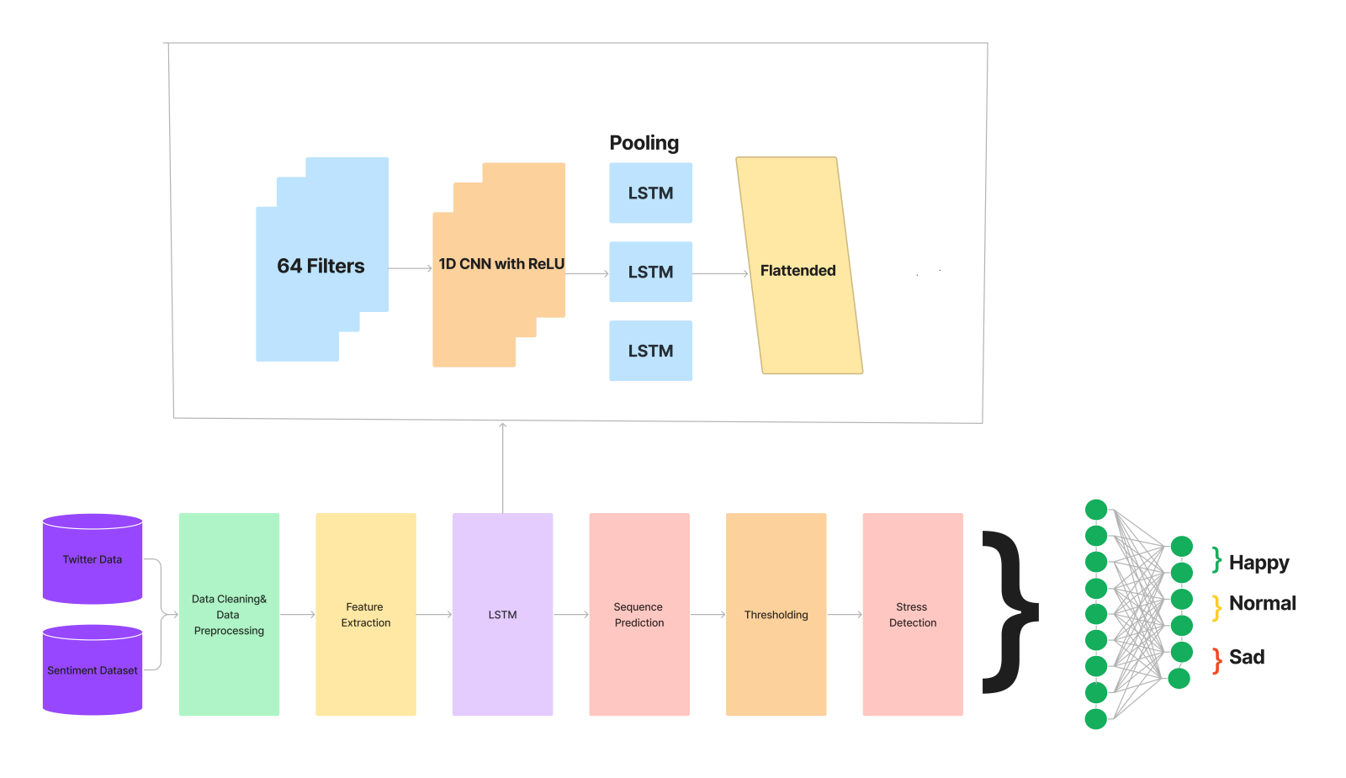

Fig 1. Architecture and Working Model of LSTM and Stress Detection

The Figure 1 illustrates the model structure. The stress keywords are connected to the dataset and provided as input data. Prior to the LSTM layers, a 1D CNN is employed to extract features from the input data, which assists in sequence prediction. The 1D CNN layers handle the input sub-sequences of human stress independently, and unlike LSTM, they are insensitive to the order of time steps. 1D CNN layers are frequently employed as a pre-processing step to down-sample and extract higher-level features when RNN models struggle to process and recognize long temporal sequential data.

In this study, a model was proposed that combines 1D CNN and LSTM layers, with the 1D CNN layer serving as a pre-processing step before the LSTM layer. A max-pooling layer with a window size of 2 follows the 1D CNN layer, after which the LSTM layer and flattened layer are stacked. The fully connected layers include a dense layer with a ReLU activation function and a soft-max layer, which produce a result ranging from 0 to 1 that indicates the stress status as happy, normal, or sad.

III.Dataset

The Twitter sentiment analysis dataset in Kaggle was used to accumulate the dataset. Tweets containing keywords related to stress such as "stress," "anxiety," "depression," etc. were searched. Additionally, hashtags such as #stress, #anxiety, #depression, etc. were collected using the Python TWINT tool. The TWINT tool can be used to scrape information such as tweets, users, hashtags, and mentions, among others. TWINT also supports advanced search filters including date, region and language, making it a powerful tool for researchers and analysts. Tweets from the previous six months were collected using this feature. The word2vec tool, also used by Google, was employed to take a text corpus as input and produce word vectors as output. The resulting word vector file could be used to detect stress. After collecting the tweets, those that were only in English and not retweets were filtered out. Finally, a dataset of 15,000 tweets was obtained.

IV.Pre-processing

The dataset was pre-processed in several steps. Firstly, stop words, punctuation, and special characters were removed. Next, stemming and lemmatization were performed on the remaining words. Finally, a vocabulary of the remaining words was created, and the tweets were represented in the form of word embeddings. The special regex function and ftfy library were employed to eliminate stop words and punctuation. To stem the text, the text was converted to sequences using the tokenizer library, and to lemmatize the text, the padding sequence from the Keras library was used. Finally, the vocab function from Google's word2vec model was used for word embedding.

V.Model Evaluation and Validation

The best combination of architecture, parameters, and hyperparameters was selected after trying several options. The LSTM model processes tokenized tweets by first transforming them into embedding vectors through an embedding layer. It outputs a probability score showing the tweet's likelihood of indicating depression. The model passes the input tweet's embeddings through a convolutional layer, which effectively learns sequential data structure, followed by a standard LSTM layer. The LSTM layer's output is then fed into a dense layer for prediction. The model comprises an embedding layer, a convolutional layer, and a dense layer, utilizing max pooling, a dropout of 0.5, binary cross-entropy loss, Nadam optimizer, relu activation in the first layer, and sigmoid activation in the dense layer. The accuracy and loss are observed during the model training, and the process is considered complete once the accuracy reaches a saturation point. Then, the trained model is evaluated by comparing it to a logistic regression baseline.

# Experimental Results

The experiment was carried out on a Windows 10 machine with 8 GB RAM, Intel Core i5 processor, and a 256 GB SDD. The software platforms used in the work include Python programming language and several libraries such as Keras, TensorFlow, NumPy, Pandas, Matplotlib, and Scikit-learn for implementation and analysis of the deep learning models. The Kaggle Twitter dataset is obtained from the Kaggle website, while the Twint tool is used to extract additional Twitter data. Visual Studio IDE is used as an integrated development environment for writing the Python code.

The outcome of a stress level detecting system based on Twitter data is displayed in Fig 2.

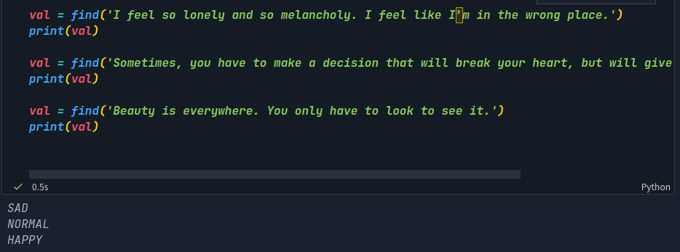

# Model accuracy

The percentage of correct predictions achieved by a specific strategy is characterized as its accuracy. The accuracy equation is provided below.

Accuracy = True Positives + True Negatives / Total Population.

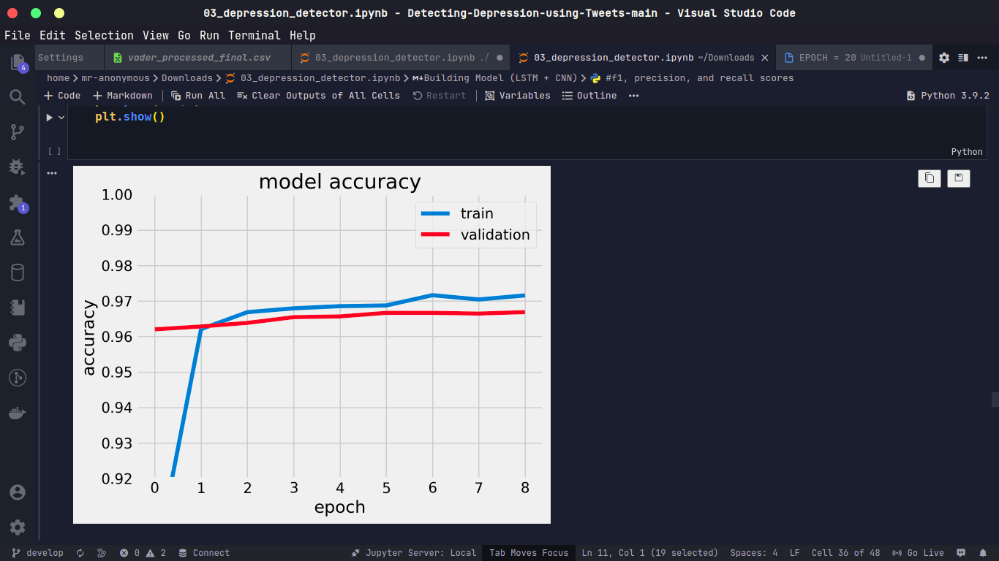

Fig 3. Model Accuracy

# Equation of precision

*Precision = True Positives / (True Positives + False Positives)*

# Eqation of recall

*Recall = True Positives / (True Positives + False Negatives)*

# F1-Score

The harmonic mean of precision and recall is used to get the F1 score of a specific technique. The F1 scoring equation is provided below.

*F1 Score = 2 * (Precision * Recall) / (Precision + Recall)*

# Model loss

The model loss is calculated based on training the LSTM model to get accuracy.

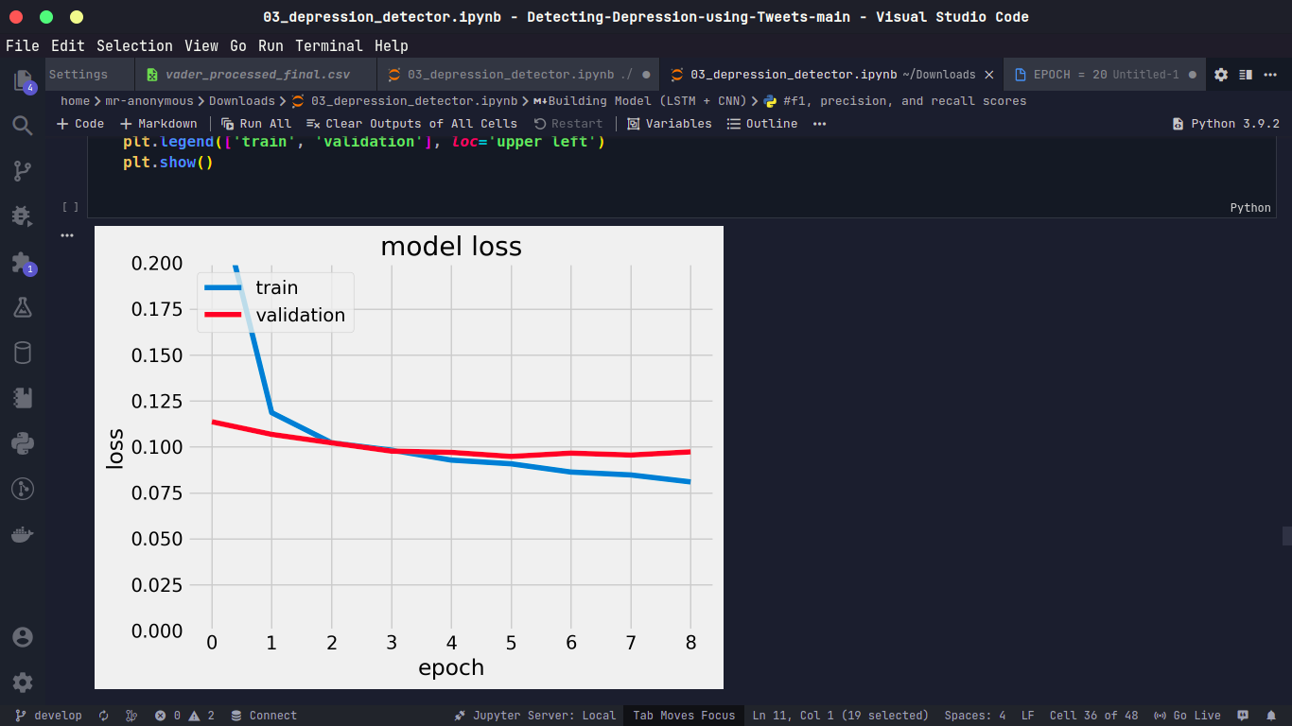

Fig 4. Model Loss

In addition to the summary of literature in Table. 1, the following Table 2 outlines the comparison of existing models used for stress detection.

Comparison with existing models

|  |  |  |  |  |  |  |
| --- | --- | --- | --- | --- | --- | --- |
| ***Model*** | ***F1-score*** | ***Model Accuracy*** | ***Model Loss*** | ***Precision*** | ***Recall*** | ***Learning Rate*** |
| ***Proposed Work*** | 0.98 | 0.97 | 0.08 | 1.00 | 0.96 | 0.5 |
| ***Naive Baye’s et. al. [7]*** | 0.74 | 0.71 | 0.12 | 0.89 | 1.00 | 0.4 |

Comparing the performance metrics of the proposed work and Naive Bayes approach for stress detection in social media posts, it is observed that the proposed approach outperforms Naive Bayes in terms of F1-score, model accuracy, precision, and recall. These results demonstrate the high accuracy and performance of the proposed deep learning approach for stress detection in social media posts.

# Conclusion

The use of social media data for human stress level detection has shown promising results in recent years. The proposed work in this paper, which utilizes a combination of LSTM and 1D CNN, and the use of the Kaggle Twitter dataset merged with recent Tweets using a Python function, has shown promising results in detecting human stress levels from social media posts. This demonstrates the potential of deep learning models for stress detection and the importance of considering more recent social media data for accurate detection of stress. The proposed approach can be further extended to detect other mental health conditions, consider larger and more diverse datasets, and focus on the potential ethical concerns related to privacy and consent.

##### References

1. [1] Hassard, J., Teoh, K. R., Visockaite, G., Dewe, P., & Cox, T. (2018). The cost of work-related stress to society: A systematic review. Journal of occupational health psychology, 23(1), 1.
2. [2]Cohen, S., Tyrrell, D. A., & Smith, A. P. (1991). Psychological stress and susceptibility to the common cold. New England journal of medicine, 325(9), 606-612.
3. [3] Shaffique, S., Farooq, S. S., Anwar, H., Asif, H. M., Akram, M., & Jung, S. K. (2020). Meta-analysis of prevalence of depression, anxiety and stress among University Students. RADS Journal of Biological Research & Applied Sciences, 11(1), 27-32.
4. [4]Sohail, M., & Rehman, C. A. (2015). Stress and Health at the Workplace-A Review of the Literature. Journal of Business Studies Quarterly, 6(3), 94.
5. [5] Adam, E. K., Kumari, M., Gao, W., & Dibello, J. R. (2017). Advancing research on biobehavioral stress pathways in daily life contexts. Current Opinion in Psychology, 14, 98-103.
6. [6]Rastogi, A., Liu, Q., & Cambria, E. (2022, July). Stress Detection from Social Media Articles: New Dataset Benchmark and Analytical Study. In 2022 International Joint Conference on Neural Networks (IJCNN) (pp. 1-8). IEEE.
7. [7] Ahuja, R., & Banga, A. (2019). Mental stress detection in university students using machine learning algorithms. Procedia Computer Science, 152, 349-353.
8. [8] A. Khan, (2019) "Stress Detection in Social Media Posts: A Machine Learning Approach".
9. [9] A. Soria, (2019) "Automated Stress Detection in Social Media Posts Using Deep Learning".
10. [10] S. K. Shukla and S. P. Singh, (2015) “Stress Detection from Twitter Data using Machine Learning Approaches”.
11. [11] X. Liu, Y. Zhang, and X. Zhang, (2020) "Stress Detection from Social Media Text: A Deep Learning Approach".
12. [12] S. K. Shukla and S. P. Singh, (2017) "Stress Detection from Social Media Posts and Physiological Signals".
13. [13] Aungiers, J. (2018). Time series prediction using lstm deep neural networks. TIME SERIES PREDICTION USING LSTM DEEP NEURAL NETWORKS.