MANIPAL UNIVERSITY JAIPUR
Department of Computer Science and Engineering
A DBMS MINI PROJECT REPORT ON
ShopEasy: E-Commerce Website
using Python Flask and MySQL
Submitted in partial fulfilment of the requirements of
Bachelor of Technology (Computer Science and Engineering) - 3rd Semester
Submitted by: [Your Full Name]
Registration No.: [Your Reg. No.]
Section / Roll No.: [Section / Roll No.]
Under the guidance of: [Teacher's Name]
Academic Year 2026 - 2027
CERTIFICATE
This is to certify that the project report entitled "ShopEasy: E-Commerce Website using Python Flask and MySQL" is a bonafide work carried out by (Registration No. ), a student of B.Tech Computer Science and Engineering, 3rd Semester, Manipal University Jaipur, in partial fulfilment of the requirements for the Database Management Systems course during the academic year 2026-2027.
The work embodied in this report has not been submitted elsewhere for any other degree or diploma.

Project Guide Head of Department
ACKNOWLEDGEMENT
I would like to express my sincere gratitude to my project guide, , for the guidance and encouragement given throughout this project. I also thank the Department of Computer Science and Engineering, Manipal University Jaipur, for providing the laboratory facilities needed to complete this work.
I am also thankful to my friends and family for their constant support.

ABSTRACT
Online shopping is now a part of daily life. This project, ShopEasy, is a small e-commerce website where a user can register, log in, search products, add them to a cart, place an order and pay. All the data is stored in a MySQL database that has six tables: users, seller, product, orders, orderitem and payment. The tables are connected with primary keys and foreign keys, as shown in the ER diagram.
The backend is written in Python with the Flask framework and the pages are made with HTML and CSS. The project uses DBMS topics like DDL and DML commands, joins, GROUP BY, constraints and transactions. When an order is placed, the orders, orderitem, product and payment tables are changed together in one transaction, so either everything is saved or nothing is. Passwords are stored as hashes and queries use parameters to avoid SQL injection.
The result is a simple working prototype that shows how a web page, Python code and a database work together.
Keywords: E-commerce, DBMS, MySQL, Flask, Python, SQL, Transaction, Normalization.
TABLE OF CONTENTS
1. Introduction 6
1.1 Background 6
1.2 Problem Statement 6
1.3 Objectives 6
1.4 Scope 6
2. System Requirements 7
2.1 Software Requirements 7
2.2 Hardware Requirements 7
3. Technologies Used 8
4. System Design 9
4.1 System Architecture 9
4.2 ER Diagram 9
4.3 Relationships 10
4.4 Data Dictionary 10
4.5 Normalization 11
5. Implementation 12
5.1 Database Implementation 12
5.2 Backend Modules 12
5.3 Frontend Pages 12
5.4 Placing an Order (Transaction) 12
5.5 Security Measures 13
5.6 Business Rules 13
6. Testing 14
7. Screenshots 15
8. Limitations and Future Scope 18
8.1 Limitations 18
8.2 Future Scope 18
9. Conclusion 19
References 20
(This contents list is normal text. If you change the report, update the page numbers by hand.)

1. Introduction

1.1 Background
E-commerce means buying and selling goods over the internet. Websites such as Amazon and Flipkart store a huge amount of data about customers, products, orders and payments. A Database Management System (DBMS) is needed to store this data safely and to get it back quickly. This project builds a small version of such a website to understand how a database and a web application work together.

1.2 Problem Statement
Small shops often keep records in notebooks or Excel sheets. It is hard to search products, check stock, find old orders and avoid billing mistakes. A simple system is needed where customers can order online and all records are kept properly in one place.

1.3 Objectives
- To design a database for an online shop using an ER diagram.
- To implement the database in MySQL using DDL and DML commands.
- To build a website where users can register, log in, search products and use a cart.
- To place orders and record payments using a transaction so that data stays consistent.
- To show reports using JOIN, GROUP BY and aggregate functions.
- To use basic security: password hashing and parameterized queries.

1.4 Scope
The project has registration and login, product list with search, a shopping cart, checkout with payment, order history, a seller list and a small sales report. Real payment, delivery tracking and an admin panel are not included.

2. System Requirements

2.1 Software Requirements
Software | Purpose / Version
Operating System | Windows 10/11, Linux or macOS
Python | Version 3.9 or higher
Flask | Web framework (backend)
MySQL Server | Version 8.x (database)
mysql-connector-python | Connects Python with MySQL
MySQL Workbench | To run SQL scripts and view tables
Web browser | Chrome / Edge / Firefox
Code editor | VS Code or any text editor

2.2 Hardware Requirements
Component | Minimum
Processor | Intel i3 or equivalent
RAM | 4 GB
Storage | 1 GB free space
Display | Any standard monitor

3. Technologies Used
Python and Flask: Python is an easy language to learn. Flask is a light framework in which every web page is linked to a Python function called a route. It is suitable for beginners because it needs very little setup.
MySQL: A popular open-source relational database. Data is kept in tables and is handled with SQL. It supports primary keys, foreign keys, constraints and transactions.
HTML and CSS: HTML builds the structure of the pages and CSS gives them colours and layout. Flask fills the HTML templates with data using the Jinja2 template language.
Werkzeug security: Used to convert passwords into hashes and to check them at login.

4. System Design

4.1 System Architecture
The project follows a simple three-part structure. The user works in the browser (frontend). Each click sends a request to the Flask application (backend). Flask runs the SQL queries on the MySQL database, gets the result and returns an HTML page to the browser.
Layer | Technology | Work done
Frontend | HTML, CSS, Jinja2 templates | Shows pages and forms to the user
Backend | Python, Flask | Handles requests, checks input, runs business rules
Database | MySQL | Stores and retrieves all data

4.2 ER Diagram
The ER diagram below shows the six tables and how they are connected. A seller lists many products, a user places many orders, an order contains many order items and is paid by one payment, and a product can appear in many order items.
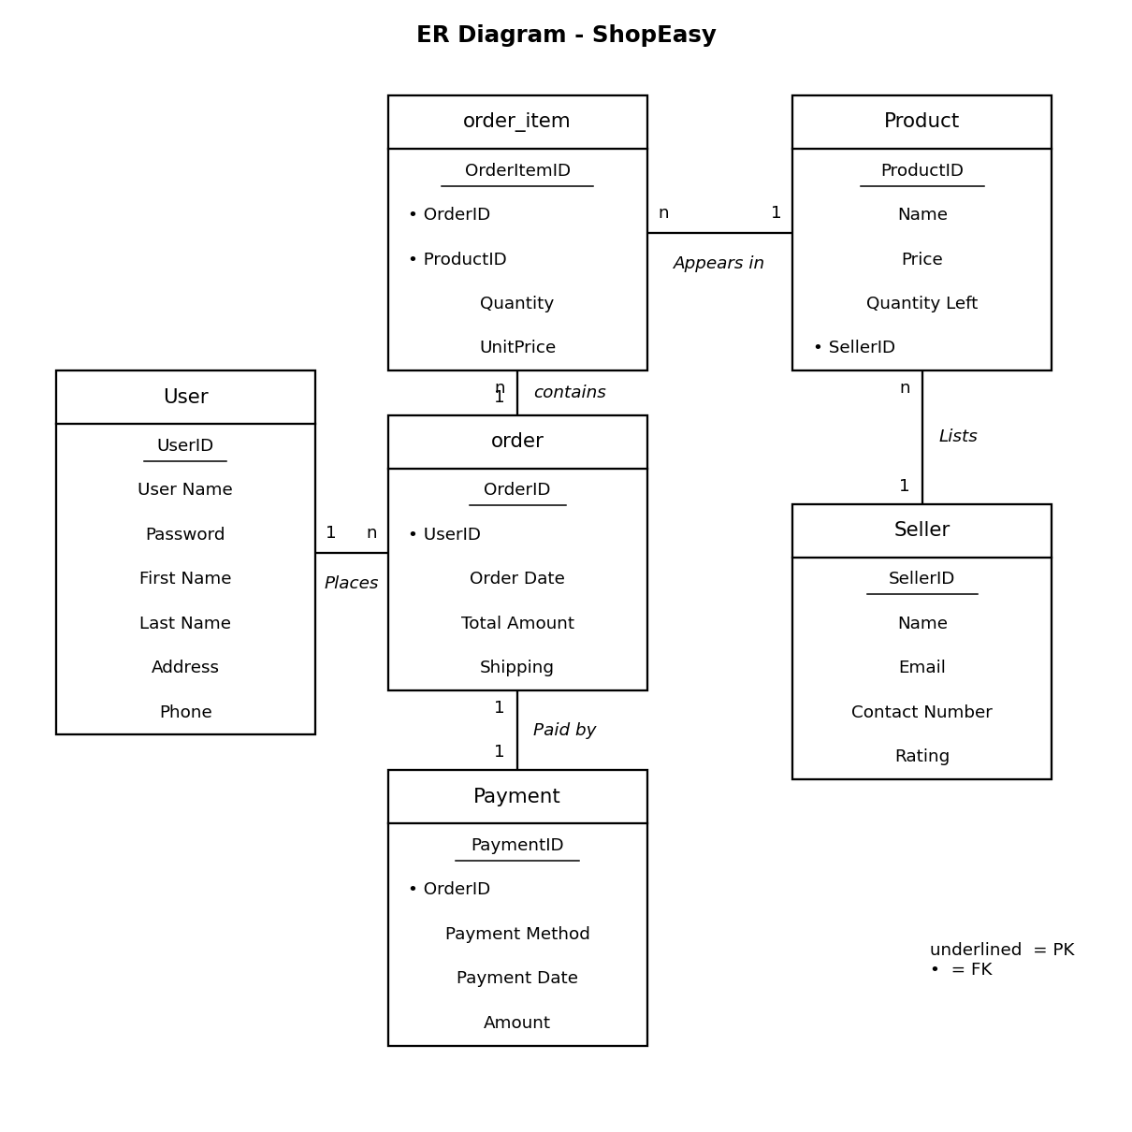
Figure 4.1: ER diagram of ShopEasy (names as in the ER diagram; the SQL tables are users, seller, product, orders, orderitem, payment)

4.3 Relationships
Relationship | Type | Foreign key used
seller lists product | 1 : n | product.sellerid
user places order | 1 : n | orders.userid
order contains order items | 1 : n | orderitem.orderid
product appears in order items | 1 : n | orderitem.productid
order is paid by payment | 1 : 1 | payment.orderid

4.4 Data Dictionary
The structure of every table is given below.
Table 4.1: users
Column | Data type | Constraint | Description
userid | INT | PRIMARY KEY, AUTO_INCREMENT | Unique id of the customer
username | VARCHAR(45) | NOT NULL, UNIQUE | Login name
firstname | VARCHAR(45) | NOT NULL | First name
lastname | VARCHAR(45) | NOT NULL | Last name
address | VARCHAR(120) | NOT NULL | Delivery address
mobile | BIGINT | NOT NULL | 10-digit mobile number
email | VARCHAR(100) | - | Email address
password | VARCHAR(255) | NOT NULL | Hashed password
Table 4.2: seller
Column | Data type | Constraint | Description
sellerid | INT | PRIMARY KEY | Unique id of the seller
sname | VARCHAR(45) | NOT NULL | Shop name
email | VARCHAR(45) | NOT NULL | Seller email
rating | DECIMAL(2,1) | - | Rating out of 5
phone | BIGINT | NOT NULL | Contact number
Table 4.3: product
Column | Data type | Constraint | Description
productid | INT | PRIMARY KEY | Unique id of the product
pname | VARCHAR(45) | NOT NULL | Product name
price | FLOAT | NOT NULL | Price in rupees
qty | INT | NOT NULL | Stock available
sellerid | INT | FOREIGN KEY -> seller | Who sells the product
Table 4.4: orders
Column | Data type | Constraint | Description
orderid | INT | PRIMARY KEY, AUTO_INCREMENT | Unique order number
userid | INT | FOREIGN KEY -> users | Customer who ordered
orderdate | DATETIME | - | Date and time of order
total | DECIMAL(10,2) | NOT NULL | Total price of the items
shipping | VARCHAR(6) | NOT NULL | FREE or 50
Table 4.5: orderitem
Column | Data type | Constraint | Description
orderitemid | INT | PRIMARY KEY, AUTO_INCREMENT | Unique id of the line
orderid | INT | FOREIGN KEY -> orders | Order it belongs to
productid | INT | FOREIGN KEY -> product | Product bought
quantity | INT | NOT NULL | Pieces bought
unitprice | DECIMAL(10,2) | NOT NULL | Price at time of buying
Table 4.6: payment
Column | Data type | Constraint | Description
paymentid | INT | PRIMARY KEY, AUTO_INCREMENT | Unique payment id
paymethod | VARCHAR(20) | NOT NULL | UPI / Card / Net Banking / COD
paydate | DATETIME | - | Date and time of payment
amount | DECIMAL(10,2) | NOT NULL | Amount paid
orderid | INT | FOREIGN KEY -> orders | Order paid for

4.5 Normalization
- 1NF: every column has one value. The products of an order are not kept in one cell; each product is a separate row in orderitem.
- 2NF: columns depend on the full primary key. Product name and price are only in product, not repeated in orderitem.
- 3NF: no column depends on another non-key column. Seller details are in seller and product only keeps sellerid.
unitprice is also saved in orderitem on purpose. The price of a product can change later, but an old order must show the price at which it was bought.

5. Implementation

5.1 Database Implementation
The database is created by schema.sql. It has CREATE TABLE commands with primary keys, foreign keys, UNIQUE and NOT NULL, and then INSERT commands for sample data. The lab script (lab_script_original.sql) shows ALTER TABLE (add column, rename column, rename table), UPDATE, TRUNCATE and a JOIN of users and orders. queries.sql has more queries: WHERE, ORDER BY, JOIN of three tables, GROUP BY with SUM, COUNT and AVG, subquery, LEFT JOIN and a VIEW.

5.2 Backend Modules
Module | Route | Function
Home | / | Lists products; search by name, filter by seller
Register | /register | Validates input, hashes password, inserts a user
Login / Logout | /login, /logout | Checks the password hash and stores the user in the session
Add to cart | /add_to_cart/<id> | Adds a product to the cart (kept in the session) after checking stock
Cart | /cart, /cart/update, /cart/remove | Shows the cart, changes quantity, removes items
Checkout | /checkout | Saves the order, order items and payment; reduces stock
Orders | /orders, /order/<id> | Order history and details of one order
Sellers | /sellers | Shows sellers with product count
Report | /report | Totals, sales per seller, low stock products

5.3 Frontend Pages
All pages use one common file, base.html, which has the navigation bar, the message area and the footer. The other pages are home, register, login, cart, checkout, orders, order detail, sellers and report. The colours and layout are in style.css.

5.4 Placing an Order (Transaction)
Placing an order changes four tables: orders, orderitem, product (stock) and payment. If one step fails, the earlier steps must be undone, so we use commit and rollback. The cart is not a table; it is kept in the session and is emptied after the order is saved.
conn = get_connection()
cursor = conn.cursor()
try:
cursor.execute("INSERT INTO orders (...) VALUES (...)", ...)
orderid = cursor.lastrowid
for item in items:
cursor.execute("UPDATE product SET qty = qty - %s
WHERE productid = %s AND qty >= %s", ...)
if cursor.rowcount == 0:
raise ValueError("Not enough stock")
cursor.execute("INSERT INTO orderitem (...) VALUES (...)", ...)
cursor.execute("INSERT INTO payment (...) VALUES (...)", ...)
conn.commit() # save everything
except Exception:
conn.rollback() # undo everything

5.5 Security Measures
- Passwords are saved as hashes (generate_password_hash) and checked with check_password_hash.
- All SQL queries use %s placeholders (parameterized queries) to prevent SQL injection.
- Cart, checkout and order pages need login. A user can open only his own orders.
- Inputs are validated: all fields required, mobile number of 10 digits, minimum password length, stock limits.

5.6 Business Rules
- Shipping is free if the value of items is Rs. 5000 or more; otherwise Rs. 50 is charged.
- Order total = price of the items. Shipping (FREE or 50) is shown separately, like in the sample data.
- Stock is reduced when an order is placed. More than the available stock cannot be added to the cart.

6. Testing
The application was tested module by module. The important test cases and their results are given below.
No. | Test case | Expected result | Result
1 | Open home page | All 9 products shown | Pass
2 | Search 'app' | Only Apple products shown | Pass
3 | Filter by seller | Only that seller's products shown | Pass
4 | Register with 5-digit mobile | Error message, user not created | Pass
5 | Register with existing username | Error: username already taken | Pass
6 | Register with valid details | User created, redirect to login | Pass
7 | Login with wrong password | Error message shown | Pass
8 | Login with correct password | Welcome message, user in session | Pass
9 | Open cart without login | Redirected to login page | Pass
10 | Add same product twice | Cart shows quantity 2 | Pass
11 | Update quantity above stock | Error: only N in stock | Pass
12 | Checkout with cart value above Rs. 5000 | Shipping FREE, order saved | Pass
13 | Checkout with small cart | Shipping saved as 50 | Pass
14 | After order | Stock reduced, cart empty, payment saved | Pass
15 | Open another user's order | Order not found message | Pass
16 | Stock becomes insufficient during checkout | Order rolled back, nothing saved | Pass

7. Screenshots
Run the project, take screenshots of the following pages and paste them in the boxes below.
[ Paste screenshot here ]
Figure 7.1: Home page with products
[ Paste screenshot here ]
Figure 7.2: Registration page
[ Paste screenshot here ]
Figure 7.3: Login page
[ Paste screenshot here ]
Figure 7.4: Shopping cart
[ Paste screenshot here ]
Figure 7.5: Checkout page
[ Paste screenshot here ]
Figure 7.6: Order details
[ Paste screenshot here ]
Figure 7.7: Sales report page
[ Paste screenshot here ]
Figure 7.8: Tables in MySQL Workbench

8. Limitations and Future Scope

8.1 Limitations
- Payment is only recorded; no real payment gateway is connected.
- There is no admin login, so the report page is open to everyone.
- Sellers cannot add or edit their products from the website.
- Products have no images, reviews or ratings given by customers.
- A new database connection is opened for every query, which is slow if many users use it.

8.2 Future Scope
- Integrate a payment gateway such as Razorpay.
- Add an admin panel and a seller dashboard.
- Add product images, reviews and a wishlist.
- Add order cancellation, tracking and email notifications.
- Use connection pooling and deploy the project on a cloud server.

9. Conclusion
The ShopEasy project helped me understand how a website and a database work together. A database with six tables was designed from the ER diagram and made in MySQL, and a Flask website was built on it. The project used many topics from our DBMS course: keys and constraints, DDL and DML, joins, GROUP BY, normalization and transactions. I also learnt the basics of web development and security. The prototype works for all the test cases and more features can be added later.
REFERENCES
- Flask Documentation - https://flask.palletsprojects.com
- MySQL 8.0 Reference Manual - https://dev.mysql.com/doc/
- MySQL Connector/Python Developer Guide - https://dev.mysql.com/doc/connector-python/en/
- Jinja2 Template Documentation - https://jinja.palletsprojects.com
- W3Schools SQL Tutorial - https://www.w3schools.com/sql/
- R. Elmasri and S. Navathe, Fundamentals of Database Systems, Pearson.
- A. Silberschatz, H. Korth and S. Sudarshan, Database System Concepts, McGraw-Hill.

