Q.1
CREATE TABLE Customer (
customer_id INT PRIMARY KEY,
customer_name VARCHAR(50),
city VARCHAR(50)
);

CREATE TABLE Orders (
order_id INT PRIMARY KEY,
customer_id INT REFERENCES Customer(customer_id),
amount INT
);
INSERT INTO Customer (customer_id, customer_name, city)
VALUES
(1, 'Aman', 'Delhi'),
(2, 'Neha', 'Delhi'),
(3, 'Raj', 'Mumbai'),
(4, 'Priya', 'Mumbai'),
(5, 'Karan', 'Pune');

INSERT INTO Orders (order_id, customer_id, amount)
VALUES
(101, 1, 4000),
(102, 1, 3000),
(103, 2, 5000),
(104, 3, 6000),
(105, 3, 2000),
(106, 4, 8000),
(107, 5, 4500);

select
c.customer_name as customer,
c.city,
sum(o.amount) as total_purachase
from Customer c join Orders o on c.customer_id = o.customer_id
group by c.customer_id
having sum(o.amount)>=all(
select sum(o1.amount) as tamount
from Customer c1 join Orders o1 on c1.customer_id = o1.customer_id
group by c1.customer_id
having c1.city=c.city
)

Output:
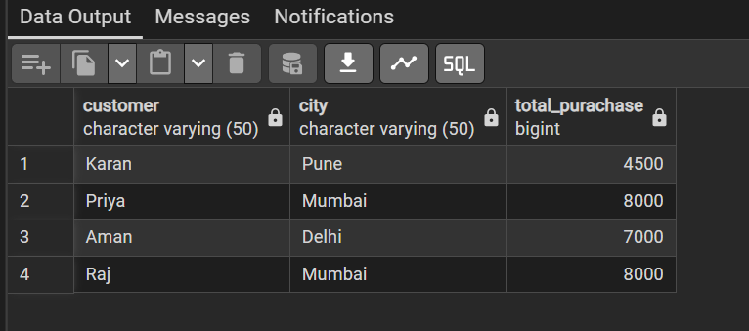

Q.2
CREATE TABLE product_inventory (
product_id INT PRIMARY KEY,
product_name VARCHAR(50),
price INT
);

create table product_inventory_logs (
product_id INT,
product_name varchar(50),
action varchar(50),
at_time time
);

create or replace function logs()
returns trigger as $$
begin
if tg_op='INSERT' then
insert into product_inventory_logs values(new.product_id,new.product_name,"insert",current_date);
return new;
elseif tg_op='DELETE' then
insert into product_inventory_logs values(old.product_id,old.product_name,"delete",current_date);
return old;
end if;
return null;
end;
$$ language plpgsql;

create trigger tg_logs
after insert or delete on product_inventory
for each row
execute function logs();

insert into product_inventory values(2,'25 Ultra',96000);

select * from product_inventory;

select * from product_inventory_logs;

Ouptut:
