Experiment 1

Student Name: Sumir Malhotra UID: 24BAI70227
Branch: CSE - AIML Section/Group: 24AIT_KRG G1
Semester: 4 Date of Performance: 9/1/26
Subject Name: DBMS Subject Code: 24CSH-298

Aim
To design and implement a Library Management System database using appropriate tables, primary keys, foreign keys, and constraints, and to perform DML operations along with DCL commands such as role creation, privilege granting, and revoking to ensure database security.

Software Requirements
- Database Management System:
  - PostgreSQL
- Database Administration Tool:
  - pgAdmin

Objectives
To gain practical experience in implementing Data Definition Language (DDL), Data Manipulation Language (DML), and Data Control Language (DCL) operations in a real database environment. This will also include implementing role-based privileges to secure data.

Problem Statement
- A Library wants to develop a Library Management System database to manage information about books, members, and book issue records efficiently. The database should be designed using appropriate tables, primary keys, foreign keys, and constraints to ensure data integrity.
- The system must support basic database operations such as inserting records, updating existing data, and deleting obsolete entries. To ensure database security.
- To ensure database security, a database role named Librarian must be created. This role should be password protected and granted SELECT, INSERT, and DELETE permissions on the required tables. The system administrator (pgAdmin) should also have the ability to revoke these permissions when required using role-based access control.

Code
CREATE TABLE BOOK_S(
BOOK_ID INT PRIMARY KEY,
BOOK_NAME VARCHAR(20) NOT NULL,
AUTHOR_NAME VARCHAR(20) NOT NULL
)

SELECT * FROM BOOK_S

ALTER TABLE BOOK_S
ADD BOOK_COUNT INT CHECK(BOOK_COUNT>0) NOT NULL

INSERT INTO BOOK_S VALUES(101,'HARRY POTTER','DAVID',3)

CREATE TABLE LIBRARY_VISITORS(
USER_ID INT PRIMARY KEY,
NAME VARCHAR(20) NOT NULL,
AGE INT CHECK(AGE>=17) NOT NULL,
EMAIL VARCHAR(20) NOT NULL UNIQUE
)

SELECT * FROM LIBRARY_VISITORS

INSERT INTO LIBRARY_VISITORS VALUES(501,'SUMIR MALHOTRA',20,'SUMIR227@GMAIL.COM')

CREATE TABLE BOOK_ISSUE(
BOOK_ISSUE_ID INT PRIMARY KEY,
USER_ID INT NOT NULL,
BOOK_ID INT NOT NULL,
FOREIGN KEY(BOOK_ID) REFERENCES BOOK_S(BOOK_ID),
FOREIGN KEY(USER_ID) REFERENCES LIBRARY_VISITORS(USER_ID)
)

INSERT INTO BOOK_ISSUE VALUES(701,501,101)

SELECT * FROM BOOK_ISSUE

ALTER TABLE BOOK_ISSUE ADD ISSUE_DATE DATE

UPDATE BOOK_ISSUE SET ISSUE_DATE='2026-01-09' WHERE BOOK_ISSUE_ID=701

CREATE ROLE LIBRARIAN WITH LOGIN PASSWORD 'Sumir@12'

GRANT SELECT,INSERT,DELETE,UPDATE ON BOOK_S TO LIBRARIAN
GRANT SELECT,INSERT,DELETE,UPDATE ON BOOK_ISSUE TO LIBRARIAN
GRANT SELECT,INSERT,DELETE,UPDATE ON LIBRARY_VISITORS TO LIBRARIAN

REVOKE SELECT,INSERT,DELETE,UPDATE ON BOOK_S,BOOK_ISSUE,LIBRARY_VISITORS FROM LIBRARIAN

Output
Table books:
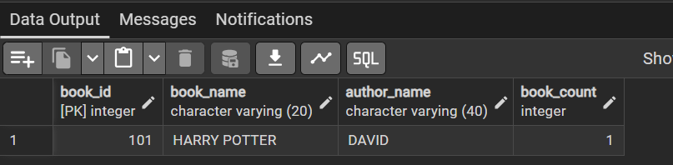

Table library_visitors:

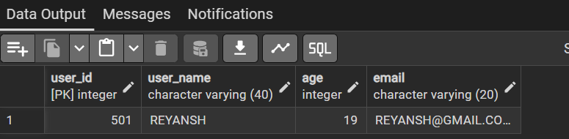

Table book_issue:
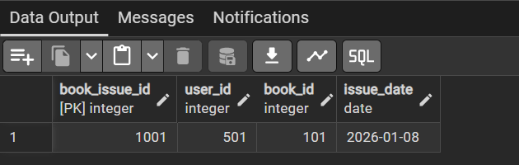

Access granted to role – librarian:
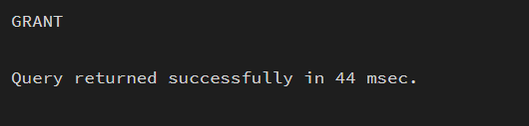

Learning Outcomes
- Gained hands-on experience to work with PostgreSQL and pgAdmin
- Writing queries to create and delete tables
- Learnt to alter tables, view tables, create roles, granting and revoking access to the roles
- Primary and foreign keys implementations and roles

