Experiment 10

Student Name: Sumir Malhotra UID: 24BAI70227
Branch: CSE - AIML Section/Group: 24AIT_KRG G1
Semester: 4 Date of Performance: 24/4/26
Subject Name: DBMS Subject Code: 24CSH-298

Aim
To design a trigger that automatically implements the functionality of a primary key, ensuring unique identification of records without manual intervention.

Software Requirements
- Database Management System:
  - Oracle Database Express Edition (Oracle XE)
  - PostgreSQL Database
- Database Administration Tool / Client Tool:
  - Oracle SQL Developer (for Oracle XE)
  - pgAdmin (for PostgreSQL)

Objectives
- To create a database trigger that automatically enforces primary key constraints or generates unique key values, replicating the functionality of a stored procedure.

Problem Statement
- In enterprise databases, primary keys must be unique for every record. Manual assignment of keys can lead to errors.
- Design a trigger that:
  - Automatically generates or enforces a primary key value during record insertion.
  - Implements the logic similar to a stored procedure.
  - Demonstrates automated primary key functionality for a table.

Practical/Experiment Steps
- Schema Provisioning: Created the employees table with a structured format for personal and departmental data, specifically focusing on the emp_id as the unique identifier.
- Sequence Generation: Established an independent Database Sequence (emp_seq) to provide a continuous and reliable stream of unique numerical values.
- Trigger Function Development: Authored a PL/pgSQL function designed to intercept incoming data and check for the presence of a primary key value.
- Automated Logic Injection: Configured the function to automatically fetch the next value from the sequence using nextval() whenever a record is inserted without an ID.
- Before-Insert Activation: Bound the function to the table using a BEFORE INSERT trigger, ensuring that identity assignment occurs prior to data storage to prevent null constraint violations.
- Validation Testing: Conducted multiple insertions without specifying IDs to verify the trigger’s ability to maintain data integrity automatically.

Procedure
- Logged into the PostgreSQL environment and initialized the database session for the experiment.
- Executed the CREATE TABLE command to define the employee structure.
- Initialized a Sequence starting at 1 to serve as the source for automated ID generation.
- Defined the auto_emp_id() trigger function to act as the primary key generator.
- Implemented conditional logic within the function to ensure that if a user does not provide an emp_id, the system assigns one dynamically.
- Created the trg_auto_emp_id trigger and attached it to the employees table for each row.
- Performed test insertions by providing only the name and department, leaving the primary key field blank.
- Executed a SELECT * query to verify that the system successfully assigned sequential IDs (1, 2, etc.) to the new records.
- Documented the results to demonstrate how the trigger replicates the functionality of auto-incrementing fields used in companies like Amazon and Oracle.

Input/Output Analysis
SQL Input Queries
CREATE TABLE employees (
emp_id INTEGER PRIMARY KEY,
emp_name VARCHAR(100),
department VARCHAR(50)
);

Output

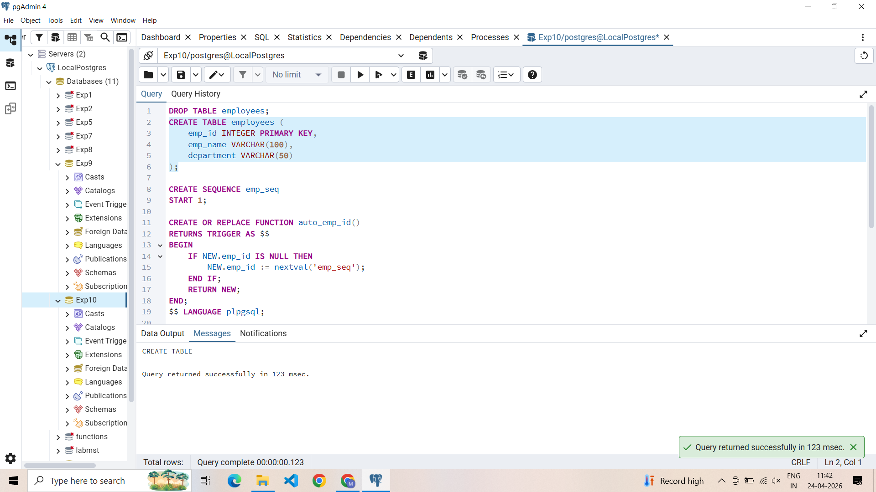

SQL Input Queries
CREATE SEQUENCE emp_seq
START 1;

Output

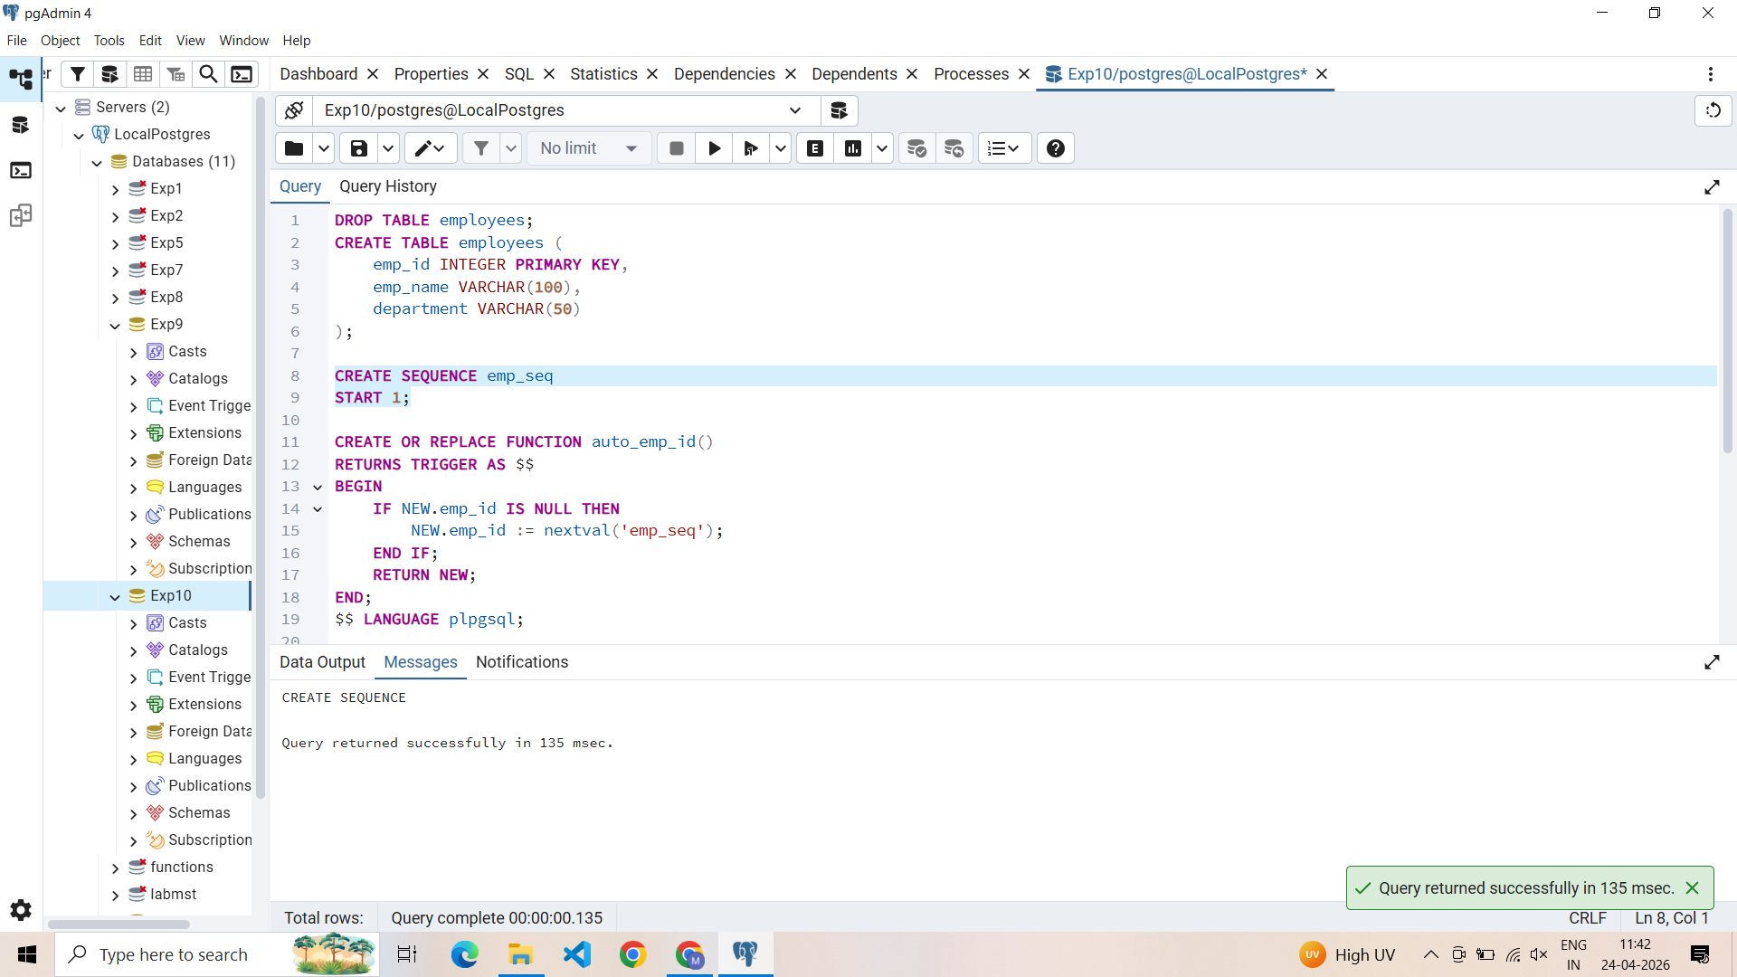

SQL Input Queries
CREATE OR REPLACE FUNCTION auto_emp_id()
RETURNS TRIGGER AS $$
BEGIN
IF NEW.emp_id IS NULL THEN
NEW.emp_id := nextval('emp_seq');
END IF;
RETURN NEW;
END;
$$ LANGUAGE plpgsql;
Output
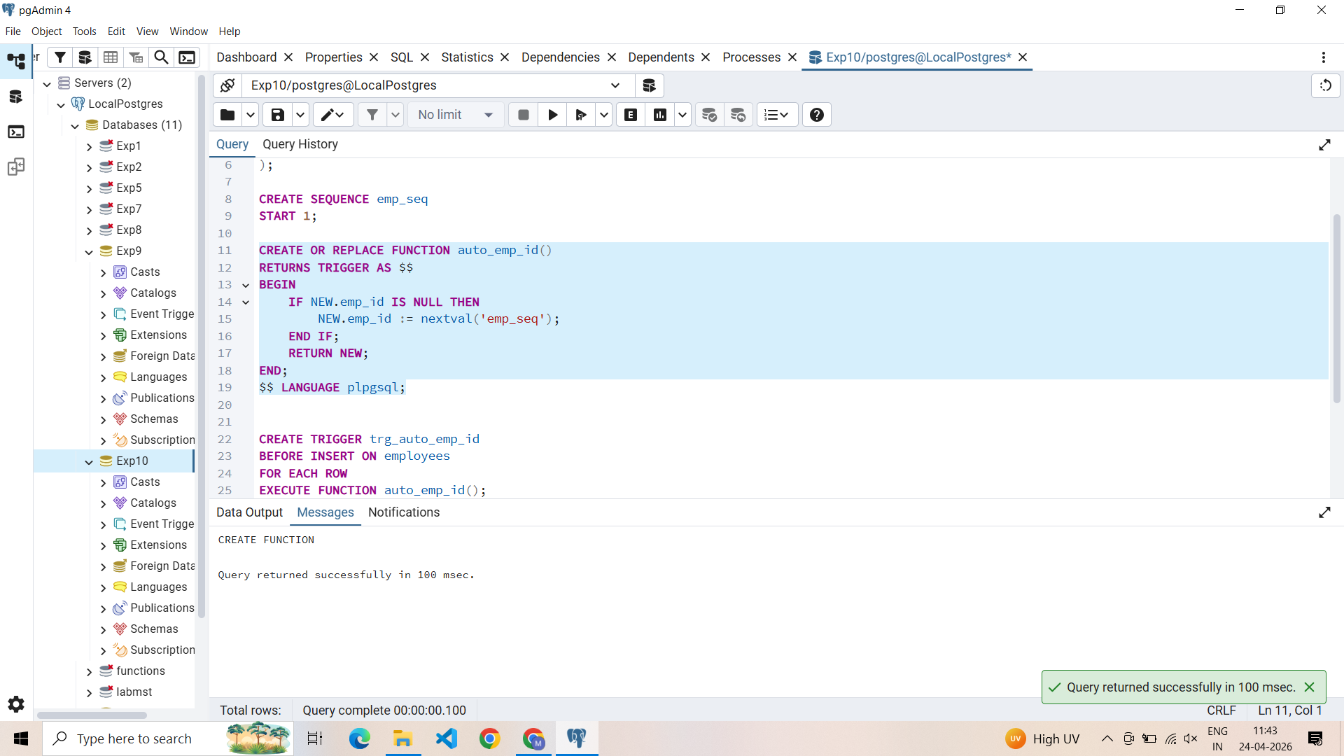

SQL Input Queries
CREATE TRIGGER trg_auto_emp_id
BEFORE INSERT ON employees
FOR EACH ROW
EXECUTE FUNCTION auto_emp_id();

Output
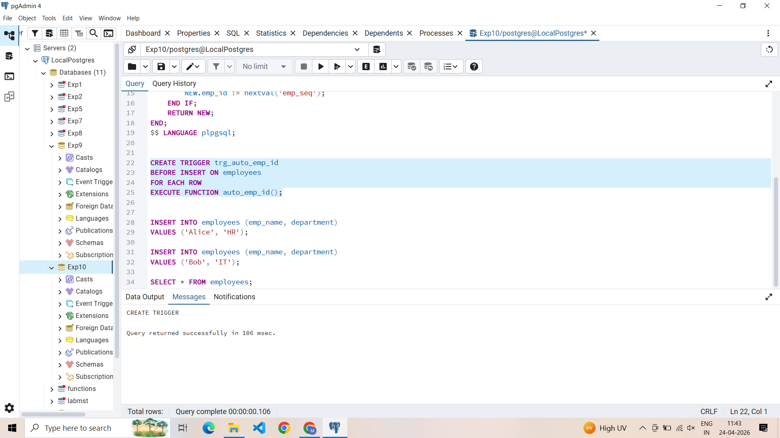

SQL Input Queries
INSERT INTO employees (emp_name, department)
VALUES ('Alice', 'HR');

INSERT INTO employees (emp_name, department)
VALUES ('Bob', 'IT');

Output
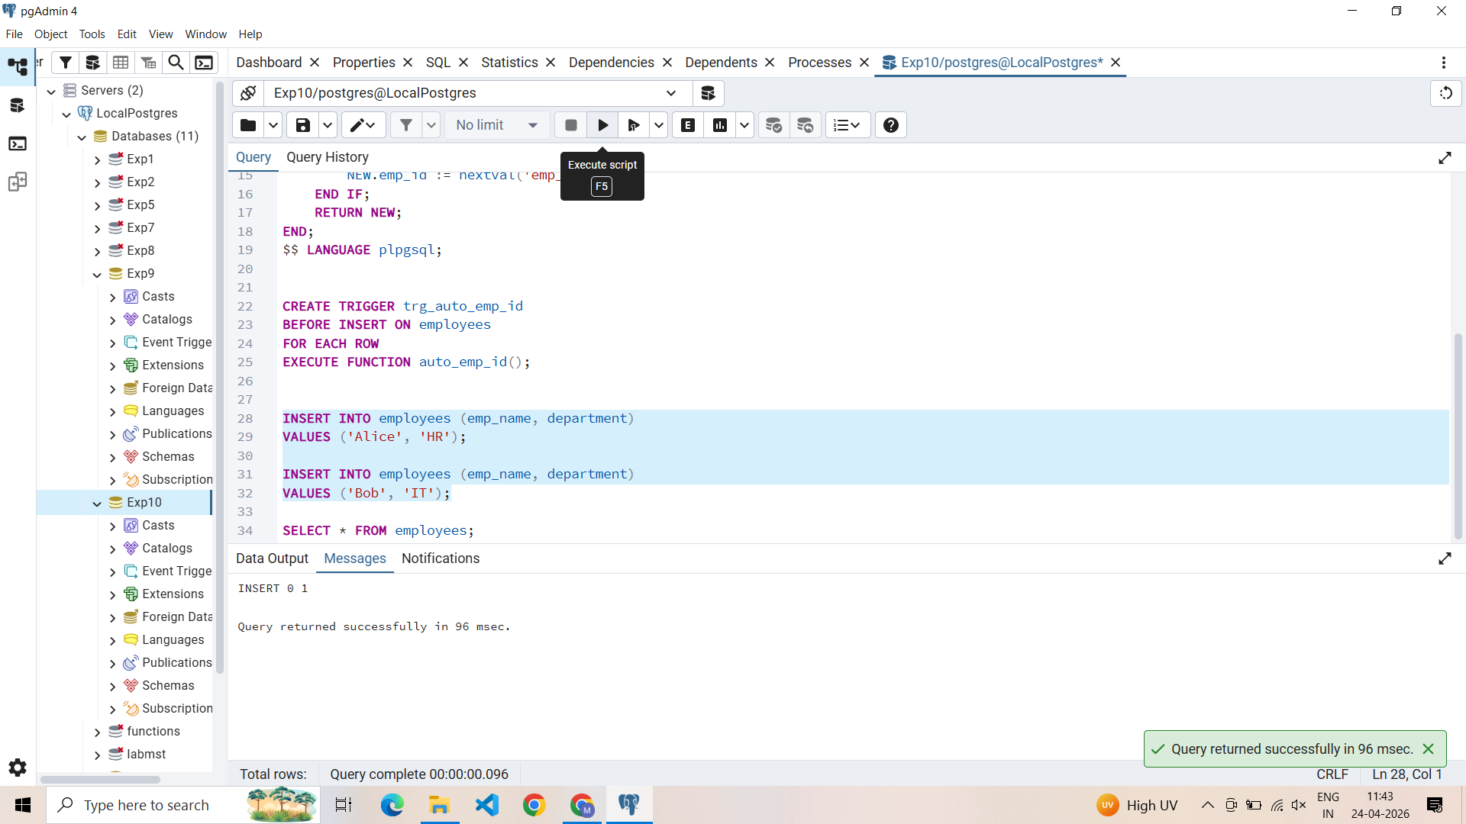

SQL Input Queries
SELECT * FROM employees;

Output
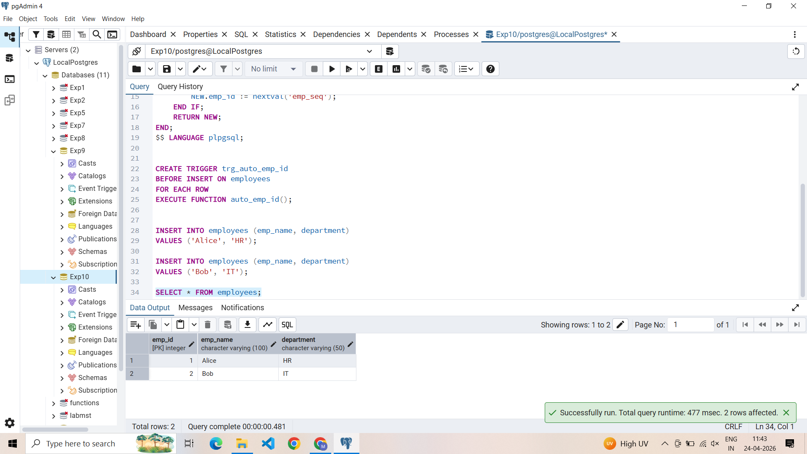

Learning Outcomes
- Trigger-Based Automation: Proficiency in designing triggers that eliminate the need for manual primary key assignment during data entry.
- Sequence Management: Understanding how to create and utilize database sequences for generating guaranteed unique identifiers.
- Data Integrity Enforcement: Mastery of ‘Before-Action’ triggers to intercept and validate records before they are committed to the database.
- Backend Logic Encapsulation: Gained the ability to implement enterprise-level automation where the database handles identity management independently of the application layer.

