Batch: B1 Roll No.: 1411072
Experiment No. 1
Grade: AA / AB / BB / BC / CC / CD /DD

Signature of the Staff In-charge with date

Title: Encryption and Decryption

Objective:
To encrypt a message using Caesar cipher and Transposition cipher encryption algorithm and decrypt it to the original message. Also doing cryptanalysis by finding key to a shift cipher using virtual labs.

Expected Outcome of Experiment:

CO | Outcome
2
  Identify the principles of cryptographic techniques and Apply various cryptographic algorithms for securing systems

Books/ Journals/ Websites referred:
1. Charles P. Pfleeger, “Security in Computing”, Pearson Education.
2. http://cse29-iiith.virtual-labs.ac.in/index.php?section=Experiments

Abstract:
This experiment deals with two Cryptography algorithms: Caesar Cipher and Transposition cipher. The experiment makes us understand how these algorithms help in achieving encryption. It also aims to perform cryptanalysis for finding key to a shift cipher algorithm using virtual labs.
Related Theory:
- Caesar cipher
  - In cryptography, a Caesar cipher, also known as Caesar's cipher, the shift cipher, Caesar's code or Caesar shift, is one of the simplest and most widely known encryption techniques.
  - It is a type of substitution cipher in which each letter in the plaintext is replaced by a letter some fixed number of positions down the alphabet.
  - For example, with a left shift of 3, D would be replaced by A, E would become B, and so on.
  - The method is named after Julius Caesar, who used it in his private correspondence.
  - E (x) = (x + k) % 26 & D (x) = (x – k) % 26
where E (x) is encryption function and D (x) is decryption algorithm.
- Transposition cipher
  - Transposition cipher is a method of encryption by which the positions held by units of plaintext (which are commonly characters or groups of characters) are shifted according to a regular system, so that the ciphertext constitutes a permutation of the plaintext.
  - That is, the order of the units is changed (the plaintext is reordered).
  - Mathematically a bijective function is used on the characters' positions to encrypt and an inverse function to decrypt.
  - Example:
Message: defend the east wall of the castle
Matrix representation:
1 2 3 4 5 6
d e f e n d
t h e e a s
t w a l l o
f t h e c a
s t l e x x
x: Padding
By substituting columns (5,2,1,4,6,3) -> (1,2,3,4,5,6)
Ciphered text matrix representation:
5 2 1 4 6 3
n e d e d f
a h t e s e
l w t l o a
c t f e a h
x t s e x l
Ciphered text: nalcxehwttdttfseeleedsoaxfeahl

Implementation Details:
How to run Caesar cipher and transposition cipher programs:
Input message into encrypt.cpp from stdin. It produces a cipher text which must be output using stdout.
Use this output cipher text as input from stdin into decrypt.cpp program, which converts cipher back to original text.
Details:
- Caesar cipher:
encrypt.cpp converts shifts each character by 3 units mod 26.
Importance: Encrypted Message may look like garbage text, and data remains confidential in case any naïve user gets access to it.
Code:
Encryption
#include<iostream>
#include<cctype>
#include<string>
using namespace std;

int main(){
string s;
getline(cin,s);
for(int i=0;i<s.length();i++){
if(tolower(s[i])>='a' && tolower(s[i])<='z'){
int c = tolower(s[i]) - 'a';
c = (c+23)%26;
char ch = c + 'a';
cout<<ch;
}
else cout<<s[i];
}
cout<<endl;
}
Decryption
#include<iostream>
#include<cctype>
#include<string>
using namespace std;

int main(){
string s;
getline(cin,s);
for(int i=0;i<s.length();i++){
if(tolower(s[i])>='a' && tolower(s[i])<='z'){
int c = tolower(s[i]) - 'a';
c = (c+3)%26;
char ch = c + 'a';
cout<<ch;
}
else cout<<s[i];
}
cout<<endl;
}

- Transposition cipher
encrypt.cpp represents message into rows and columns with padding to complete the row, no. of columns fixed and the columns to be swapped into cipher matrix is stored into a string. Using this string, programs generates a cipher matrix, which contains columns swapped from the original message matrix.
decrypt.cpp performs the inverse operation and regenerates message text from cipher text.
Importance: This algorithm is more sophisticated than Caesar cipher and is hard to recognize what pattern is used for encryption. So any user won’t be able to predict the actual message, as it can be done in Caesar cipher by some careful observation.
Code
Encryption
#include<iostream>
#include<cmath>
#define columns 5
using namespace std;

int pattern[5] = {4,1,5,3,2};
int main(){
string s;
cin>>s;
int n = s.length();
int m = ceil((double)n/(double)columns);
char arr[m][columns], cip[m][columns];
int j,ptr=0;
for(int i=0; i<m; i++) for(j=0; j<columns; j++) {
cip[i][j] = s[ptr++];
}
for(int i=0;i<columns;i++){
int swap = pattern[i]-1;
for(int j=0;j<m;j++) arr[j][swap] = cip[j][i];
}
for(int i=0; i<m; i++) for(j=0; j<columns; j++) cout<<arr[i][j];
return 0;
}
Decryption
#include<iostream>
#include<cmath>
#define columns 5
using namespace std;

int pattern[5] = {4,1,5,3,2};
int main(){
string s;
cin>>s;
int n = s.length();
int m = ceil((double)n/(double)columns);
char arr[m][columns], cip[m][columns];
int j,ptr=0;
for(int i=0; i<m; i++) for(j=0; j<columns; j++) {
arr[i][j] = s[ptr++];
if(ptr==n) break;
}
j++;
while(j<columns) arr[m-1][j++] = 'a';
for(int i=0;i<columns;i++){
int swap = pattern[i]-1;
for(int j=0;j<m;j++) cip[j][i] = arr[j][swap];
}
for(int i=0; i<m; i++) for(j=0; j<columns; j++) cout<<cip[i][j];
return 0;
}

- Virtual Labs
Breaking the shift cipher experiment:
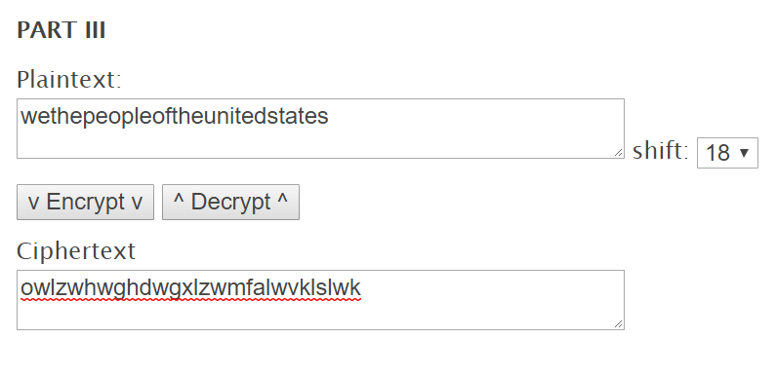
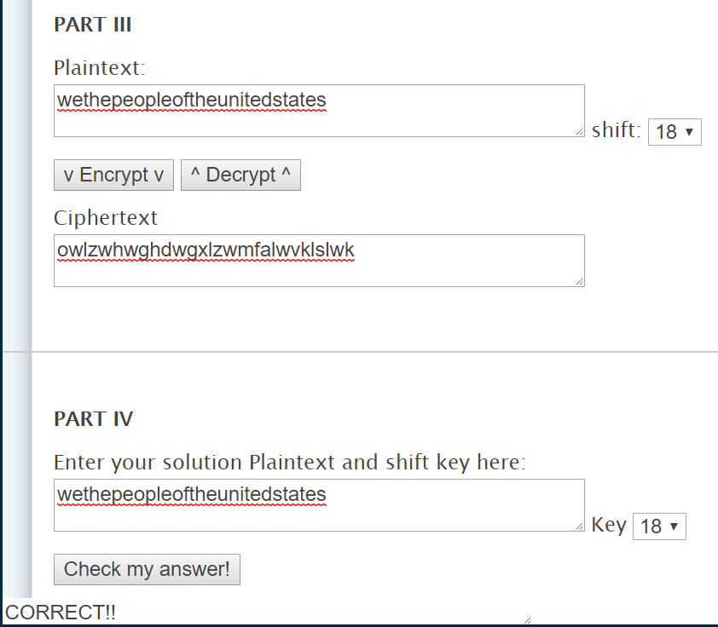
Conclusion:
Thus, we have successfully implemented various encryption algorithms, and performed cryptanalysis on virtual labs.

Date: _____________ Signature of faculty in-charge

