

CS2403 COMPUTER NETWORKS

Mini Project Report

Fortress-Net: A Self-Healing, AI-Assisted Secure Network for a Military Base

Submitted

By

Devarshee J Mude (USN: __________)
Team member name (USN: __________)
Team member name (USN: __________)

Under the guidance of:

Dr./Prof. ____________________

School of Computer Science and Engineering

RV University, Bangalore

School of Computer Science and Engineering

CERTIFICATE

Certified that the CS2403 Computer Networks Mini Project work titled Fortress-Net: A Self-Healing, AI-Assisted Secure Network for a Military Base is carried out by Devarshee J Mude (USN: ______), ______ (USN: ______) and ______ (USN: ______), who are bonafide students of the School of Computer Science and Engineering, RV University, Bengaluru, during the year 2025–26. It is certified that all corrections/ suggestions from all the continuous internal evaluations have been incorporated into the project and in this report.

Dr./ Prof. ________________
Faculty Guide Program Director

1. Problem Statement
A military base network must keep working while things go wrong: cables are cut, routers fail, and the most dangerous attacker is often already inside the perimeter. Conventional campus-style designs handle failures with manual reconfiguration or slow protocol timers, and handle security only with firewalls at the edge, which do nothing against an insider. This project designs, builds and measures Fortress-Net, a network for a military base that (1) recovers from link and equipment failures by itself and proves how fast it does so; (2) keeps zones of different sensitivity (Command, Intelligence, Communications, Barracks, Servers, Management and a Forward Operating Base) strictly apart; and (3) detects an attack launched from inside the base, explains why it believes it is an attack, and contains the attacker automatically without human intervention. Instead of a simulator, the network is emulated in Mininet using real Linux networking software, so every protocol runs exactly as it would on real equipment.

2. Introduction
Fortress-Net models the network of a military base with six internal zones and a remote Forward Operating Base (FOB). Each zone has its own VLAN and IP subnet, and a written policy decides which zone may start connections to which: for example, Barracks may reach only the servers and the internet, while Intelligence talks only to the Command Center. Such networks are relevant well beyond the military: hospitals, power utilities, airports and banks all need networks that stay up during failures and that can contain a compromised device before it spreads. The whole network runs on a single laptop inside an Ubuntu 22.04 virtual machine, using Mininet to create the hosts and links and Open vSwitch (OVS) as the switches.
The switching layer uses Software-Defined Networking (SDN). Instead of every switch deciding forwarding on its own, a central Ryu controller speaks OpenFlow 1.3 to all eight switches, sees the complete topology through LLDP, and installs a four-table pipeline on each switch: ingress (802.1Q VLAN tagging, port security, DHCP guard, blocking), policy (zone isolation), QoS (queue selection) and forwarding (a loop-free shortest-path tree per destination). Two failover strategies were implemented and compared: reactive rerouting, where the controller recomputes paths after a port goes down, and proactive rerouting using OpenFlow fast-failover groups, where backup ports are pre-installed so the switch itself moves traffic the instant a link dies.
Routing and redundancy use standard protocols running in FRRouting. OSPF (area 0, 1-second hellos) connects the four routers and selects the primary WAN link to the FOB by link cost, with a floating static route as a last-resort backup. VRRP lets the two gateway routers r1 and r2 share a virtual gateway address (.1) in every zone, so hosts never notice when r1 fails. The two core switches are joined by two cables combined into one logical link (link aggregation, the open equivalent of Cisco EtherChannel), and every access switch has an uplink to both cores, so there is no single point of failure anywhere in the base.
Security is layered. Zone isolation is enforced twice, by controller flow rules and by stateful iptables firewalls on the gateways, which also perform NAT towards the simulated internet. Traffic to the FOB is encrypted with an IPsec site-to-site VPN (strongSwan, IKEv2, AES-256-GCM ESP in tunnel mode) anchored on router loopbacks, so it survives a cut WAN cable. Supporting services include DHCP and DNS (dnsmasq, with relays on the gateways), central syslog (rsyslog) and SSH administration allowed only from the Management VLAN. Rogue devices and rogue DHCP servers are blocked by the controller.
Finally, the network defends itself. A sensor (ids1) with no IP address receives a mirrored copy of all core traffic. Suricata matches known attack signatures, while an Isolation Forest machine-learning model, trained only on normal traffic, flags unusual behaviour from per-host traffic features. A threat engine combines these signals with failed-login events into an explainable score from 0 to 100, where every point has a written reason. A score of 70 or more triggers an automatic response: the controller cuts the attacker off at its own switch port, an incident report is written, and an alert is sent through Grafana and Telegram, with Prometheus collecting the network's metrics.

3. Network Diagram
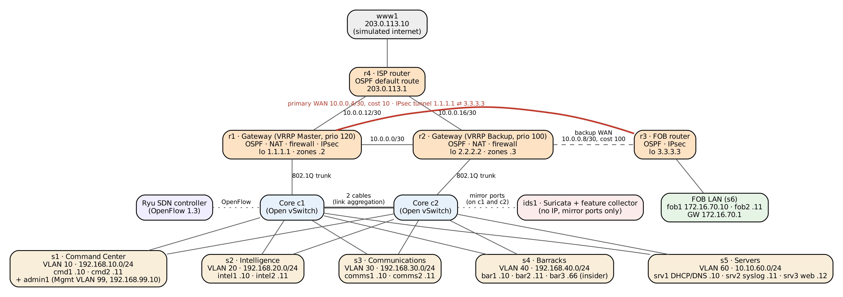
Figure 1: Fortress-Net topology. Thick red line: primary WAN carrying the IPsec tunnel; dashed: backup WAN; dotted: control and monitoring connections.
Reading the diagram. Five access switches (s1 to s5), one per zone, each connect to both core switches c1 and c2. The cores are joined by two aggregated cables. Gateway r1 trunks into c1 and r2 into c2, and they share each zone's gateway through VRRP. r1 reaches the FOB router r3 over the primary WAN (OSPF cost 10) and r2 over the backup WAN (cost 100). r4 acts as the internet service provider. The Ryu controller manages every switch over OpenFlow, and ids1 listens silently on mirror ports of both cores.

4. Configuration Setup
Every address and name is defined once, in the file config/fortress.yaml. A Python script renders every router and server configuration from that file using Jinja2 templates, so the design and the running network can never drift apart. The excerpts below are taken from those generated configurations (comments removed for space).

4.1 Lab platform
Item | Configuration
Host machine | Apple Silicon MacBook (arm64)
Virtual machine | Ubuntu 22.04 LTS in Multipass (VM name fortress), 40 GB disk; 8 GB RAM / 4 vCPU on a Mac with 16 GB or more (4 GB / 2 vCPU on an 8 GB Mac, with the smaller --small lab)
Network emulator | Mininet: every host and router is a Linux network namespace
Switches | Open vSwitch, OpenFlow 1.3, secure fail-mode (controller decides all forwarding)
SDN controller | Ryu 4.34 on Python 3.9 (controller/fortress_ctrl.py)
Routing suite | FRRouting: ospfd, vrrpd, staticd, one instance per router
Start / test | scripts/start_all.sh (one command starts the whole lab), start_all.sh --check (142 checks)

4.2 Addressing plan (all zones)
Zone | VLAN | Subnet | Gateway (VRRP) | Access switch | May start connections to
Command Center | 10 | 192.168.10.0/24 | .1 (r1 .2, r2 .3) | s1 | All zones, FOB, internet
Intelligence | 20 | 192.168.20.0/24 | .1 | s2 | Command only
Communications | 30 | 192.168.30.0/24 | .1 | s3 | Command, Servers, FOB
Barracks | 40 | 192.168.40.0/24 | .1 | s4 | Servers, internet
Servers | 60 | 10.10.60.0/24 | .1 | s5 | All zones
Management | 99 | 192.168.99.0/24 | .1 | s1 (tagged port) | Admin SSH only
FOB | — | 172.16.70.0/24 | 172.16.70.1 (r3) | s6 | Command, Servers (over VPN)
Internet | — | 203.0.113.0/24 | 203.0.113.1 (r4) | — | —

Zones use /24 subnets (254 usable hosts each). Router-to-router links use /30 subnets carved from 10.0.0.0/24, which give exactly the two usable addresses a point-to-point link needs. Each router also has a /32 loopback equal to its OSPF router ID.
Link | Subnet | Addresses | OSPF cost | Purpose
r1 – r2 | 10.0.0.0/30 | r1 .1, r2 .2 | 10 | Gateway interconnect
r1 – r3 | 10.0.0.4/30 | r1 .5, r3 .6 | 10 | Primary WAN to FOB (carries the VPN)
r2 – r3 | 10.0.0.8/30 | r2 .9, r3 .10 | 100 | Backup WAN to FOB
r1 – r4 | 10.0.0.12/30 | r1 .13, r4 .14 | 10 | Internet uplink
r2 – r4 | 10.0.0.16/30 | r2 .17, r4 .18 | 10 | Internet uplink

4.3 End devices (PCs, servers and workstations)
Zone hosts receive their address, gateway and DNS server from DHCP (srv1), with a fixed reservation per MAC address so that detection and incident reports always name the same host. Servers and FOB hosts use static addresses.
Device | Zone / VLAN | IP address | Default gateway | DNS | Role
cmd1, cmd2 | Command / 10 | 192.168.10.10, .11 | 192.168.10.1 | 10.10.60.10 | Command workstations
intel1, intel2 | Intelligence / 20 | 192.168.20.10, .11 | 192.168.20.1 | 10.10.60.10 | Intelligence workstations
comms1, comms2 | Communications / 30 | 192.168.30.10, .11 | 192.168.30.1 | 10.10.60.10 | Communications workstations
bar1, bar2 | Barracks / 40 | 192.168.40.10, .11 | 192.168.40.1 | 10.10.60.10 | Soldier PCs
bar3 | Barracks / 40 | 192.168.40.66 | 192.168.40.1 | 10.10.60.10 | Compromised insider (test attacker)
admin1 | Management / 99 | 192.168.99.10 | 192.168.99.1 | 10.10.60.10 | Network administrator
srv1 | Servers / 60 | 10.10.60.10 (static) | 10.10.60.1 | — | DHCP and DNS (dnsmasq)
srv2 | Servers / 60 | 10.10.60.11 (static) | 10.10.60.1 | — | Central syslog (rsyslog)
srv3 | Servers / 60 | 10.10.60.12 (static) | 10.10.60.1 | — | Web and file server
fob1, fob2 | FOB | 172.16.70.10, .11 (static) | 172.16.70.1 | — | Forward base hosts
www1 | Internet | 203.0.113.10 | 203.0.113.1 | — | Simulated internet server
ids1 | Mirror ports c1, c2 | none (listen only) | — | — | Suricata + feature collector
mon0 | Management / 99 | 192.168.99.250 | static routes into the lab | — | Monitoring link for Prometheus

4.4 Switches (c1, c2, s1 – s6) and the SDN controller
Switch | Type | Ports / connections | Configuration
c1, c2 | Core (OVS) | Uplinks from s1–s5; 2 cables to each other; trunk to r1 (c1) / r2 (c2); mirror to ids1 | OpenFlow 1.3 under Ryu; c1–c2 cables in an OpenFlow select group (link aggregation); OVS mirror of all traffic to ids1
s1 | Access (OVS) | cmd1, cmd2 (VLAN 10), admin1 (VLAN 99), uplinks to c1 and c2 | Access ports tagged by the controller
s2 | Access (OVS) | intel1, intel2 (VLAN 20), uplinks to c1 and c2 | Access ports tagged by the controller
s3 | Access (OVS) | comms1, comms2 (VLAN 30), uplinks to c1 and c2 | Access ports tagged by the controller
s4 | Access (OVS) | bar1, bar2, bar3 (VLAN 40), uplinks to c1 and c2 | Access ports tagged by the controller; Barracks traffic in the bulk QoS queue
s5 | Access (OVS) | srv1, srv2, srv3 (VLAN 60), uplinks to c1 and c2 | DHCP replies allowed only from srv1's port
s6 | FOB LAN | fob1, fob2, r3 | Plain LAN behind r3

Controller pipeline (installed on every switch):
• Table 0 – Ingress: pushes the zone's 802.1Q VLAN tag on access ports, enforces port security (only known MAC addresses forward), drops DHCP offers from any port except srv1's, and holds block rules for contained attackers.
• Table 1 – Policy: drops zone pairs that may never communicate (for example Barracks to Intelligence).
• Table 2 – QoS: places packets in one of three HTB queues on 50 Mbit/s shared ports: mission (Command and Communications, 30 Mbit/s guaranteed, highest priority), normal (10 Mbit/s) and bulk (Barracks, 5 Mbit/s, lowest priority).
• Table 3 – Forward: one loop-free shortest-path tree per destination. In proactive mode each rule points to a fast-failover group holding a primary and a backup port.

4.5 Router r1 (primary gateway)
Interfaces: VLAN sub-interfaces r1-lan.10/.20/.30/.40/.60/.99 with addresses x.x.x.2/24 on an 802.1Q trunk to c1; r1-r2 10.0.0.1/30, r1-r3 10.0.0.5/30, r1-r4 10.0.0.13/30; loopback 1.1.1.1/32.
FRRouting configuration (frr.conf, excerpt)
hostname r1
interface lo
ip address 1.1.1.1/32
ip ospf area 0
ip ospf passive
interface r1-r3
ip ospf area 0
ip ospf network point-to-point
ip ospf cost 10
ip ospf hello-interval 1
ip ospf dead-interval 4
interface r1-lan.10
ip ospf area 0
ip ospf passive
vrrp 10 version 3
vrrp 10 priority 120
vrrp 10 advertisement-interval 200
vrrp 10 preempt
vrrp 10 ip 192.168.10.1
(same OSPF + VRRP block for VLANs 20, 30, 40, 60, 99 and links r1-r2, r1-r4)
router ospf
ospf router-id 1.1.1.1

NAT and zone firewall (iptables, excerpt)
*nat
-A POSTROUTING -o r1-r4 -d <internal subnets> -j RETURN
-A POSTROUTING -o r1-r4 -j MASQUERADE
*filter
:FORWARD DROP
-A FORWARD -m conntrack --ctstate ESTABLISHED,RELATED -j ACCEPT
-A FORWARD -d 10.10.60.10 -p udp --dport 53 -j ACCEPT
-A INPUT -p tcp --dport 22 ! -s 192.168.99.0/24 -j DROP
-A FORWARD -s 1.1.1.1 -d 3.3.3.3 -p esp -j ACCEPT
-A FORWARD -s 192.168.20.0/24 -d 192.168.10.0/24 -j ACCEPT (Intelligence -> Command)
-A FORWARD -s 192.168.40.0/24 -d 10.10.60.0/24 -j ACCEPT (Barracks -> Servers)
-A FORWARD -s 192.168.40.0/24 -o r1-r4 -j ACCEPT (Barracks -> internet)
(one ACCEPT rule per allowed zone pair; everything else is dropped)

IPsec VPN to the FOB (strongSwan swanctl, summary)
connection base-fob:
version 2 (IKEv2), local 1.1.1.1 <-> remote 3.3.3.3, auth pre-shared key
IKE proposal aes256-sha256-modp2048, dead-peer detection every 1 s
child SA: local 192.168.0.0/16, 10.10.60.0/24 <-> remote 172.16.70.0/24
mode tunnel, ESP aes256gcm16-modp2048, start_action start

SSH: sshd listens only on the Management address 192.168.99.2, root login disabled, user ubuntu only. Logs are forwarded to srv2 (10.10.60.11, UDP 514). DHCP relay forwards requests from every zone to srv1.

4.6 Router r2 (backup gateway)
Identical structure to r1 with addresses x.x.x.3/24, trunk to c2, r2-r1 10.0.0.2/30, r2-r3 10.0.0.9/30, r2-r4 10.0.0.17/30 and loopback 2.2.2.2/32. Differences:
r2 frr.conf (differences from r1)
interface r2-r3
ip ospf cost 100 (backup WAN: only used if r1-r3 fails)
interface r2-lan.10
vrrp 10 priority 100 (Backup; becomes Master if r1 fails)
vrrp 10 preempt
vrrp 10 ip 192.168.10.1
router ospf
ospf router-id 2.2.2.2
ip route 172.16.70.0/24 10.0.0.10 250 (floating static route to the FOB)

4.7 Router r3 (Forward Operating Base) and r4 (ISP)
r3 and r4 frr.conf (excerpt)
! r3
interface lo
ip address 3.3.3.3/32
interface r3-r1
ip ospf cost 10
interface r3-r2
ip ospf cost 100
interface r3-lan (172.16.70.1/24, passive)
router ospf
ospf router-id 3.3.3.3
+ IPsec peer of r1 (1.1.1.1), same proposals as r1

! r4
interface r4-r1 / r4-r2 (OSPF point-to-point, cost 10)
interface r4-inet (203.0.113.1/24, passive)
router ospf
ospf router-id 4.4.4.4
default-information originate always (advertises the default route)

4.8 Servers
srv1: DHCP and DNS (dnsmasq.conf, excerpt)
domain=fortress.mil
host-record=srv1.fortress.mil,10.10.60.10
host-record=srv3.fortress.mil,10.10.60.12 (one record per fixed host and router)
dhcp-authoritative
dhcp-range=set:command,192.168.10.100,192.168.10.199,255.255.255.0,12h
dhcp-option=tag:command,option:router,192.168.10.1
dhcp-option=tag:command,option:dns-server,10.10.60.10
(same three lines for Intelligence, Communications, Barracks and Management)

srv2: central syslog server (rsyslog.conf)
module(load="imudp")
input(type="imudp" address="10.10.60.11" port="514")
template(name="PerNode" type="string"
string="/var/log/fortress/srv2/remote/%HOSTNAME%.log")
*.* action(type="omfile" dynaFile="PerNode")

srv3 runs a web and file server that acts as the target of normal traffic (web, file transfer, DNS) used to train the anomaly model. All servers accept SSH only from the Management VLAN.

4.9 Detection, response and monitoring
ids1: Suricata custom rules (local.rules, excerpt)
alert tcp any any -> $HOME_NET any (msg:"FORTRESS scan: TCP SYN sweep (possible nmap -sS)";
flow:not_established; flags:S,12; detection_filter:track by_src, count 30, seconds 10;
classtype:attempted-recon; sid:1000001;)
alert tcp any any -> $HOME_NET 22 (msg:"FORTRESS brute force: repeated SSH connections";
flow:to_server; flags:S,12; detection_filter:track by_src, count 5, seconds 20; sid:1000010;)
(plus NULL, FIN and Xmas scan rules)

Signal | Points | Source
Traffic outside the normal baseline | up to +30 | Isolation Forest on 6 per-host features (5 s windows)
Suricata attack signature | +30 | ids1 (eve.json)
More than 50 destination ports in one window | +30 | feature collector
Many refused or unanswered connections | +15 | feature collector
5 or more failed SSH logins | +25 | central logs on srv2
Port scan followed by login attempts (same host) | +15 | correlation
IDS brute-force rule and the central log agree | +15 | correlation
Score ≥ 70 = BREACH | — | block at own switch port (300 s), incident report, Telegram alert

The threat engine scores every host every 5 seconds. Because no single signal is worth 70 points, a breach always needs at least two independent sources to agree. Prometheus scrapes a custom exporter (link state, traffic per zone, threat score per host, blocked hosts, reroutes) and Grafana shows the Command Center dashboard and sends alerts to Telegram.

5. Results
All results below come from scripts in the project repository, run on the live emulated network. Raw data is in docs/results/.

Proof 1: Automated health and failure suite (142/142 checks passed)
The command start_all.sh --check starts the whole network and runs 142 automated checks, including eight disruptive tests that deliberately break part of the network and verify the repair.
What was verified | Result
Ryu sees all 8 switches and every link; no broadcast storm despite the looped uplinks | Pass
Every host receives its address from srv1 through the DHCP relays; srv1.fortress.mil resolves | Pass
OSPF: every router has all neighbours in Full state; traffic to the FOB uses r1 → r3 | Pass
VRRP: r1 Master and r2 Backup in all 6 zones; hosts use the virtual MAC | Pass
NAT: the internet sees only r1's ISP-side address | Pass
Zone isolation: every allowed and denied zone pair from the policy | Pass
IPsec: tunnel up; WAN capture contains only ESP, no readable ICMP | Pass
SSH only from Management; a failed login on r1 appears in srv2's log | Pass
Rogue device and fake DHCP server both blocked | Pass
r1 killed: r2 becomes Master in 0.7 s, 0 of 188 gateway pings lost, r1 takes over again | Pass
Insider scan → Suricata alert → breach score → blocked at its own port; neighbour unaffected | Pass
Total | 142 / 142

[Insert screenshot: terminal output of ./scripts/vm/vm.sh sudo ./scripts/start_all.sh --check showing the final 142/142 summary]

Proof 2: Self-healing, measured (chaos test)
The chaos test repeated every failure 5 times in each controller mode while a high-rate ping ran between two hosts, and recorded the longest gap in replies. All 50 runs healed by themselves.
Failure injected | Mechanism | Reactive (median) | Proactive (median) | Healed
Core–access cable c1–s1 cut | SDN reroute / fast-failover | 29 ms | 21 ms | 10/10
One of the two c1–c2 cables cut | Link aggregation | 20 ms | 19 ms | 10/10
Gateway router r1 loses power | VRRP | 50 ms | 26 ms | 10/10
Primary WAN r1–r3 cut | OSPF (VPN on loopbacks) | 57 ms | 56 ms | 10/10

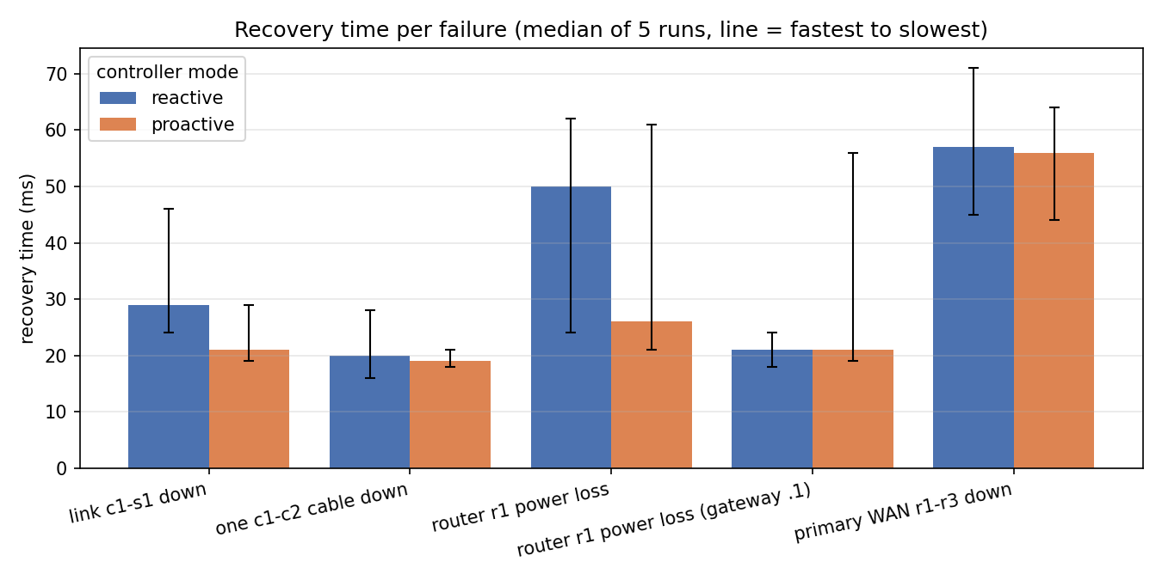
Figure 2: Recovery time per failure, reactive vs proactive (median of 5 runs; bars show fastest to slowest).
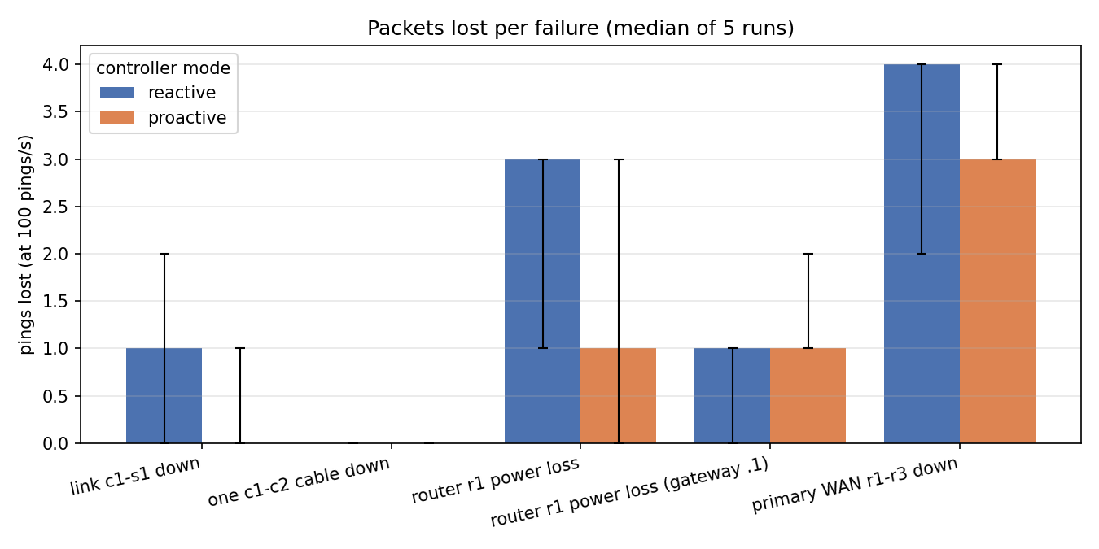
Figure 3: Packets lost per failure in each controller mode.
Every failure is bypassed automatically in well under a tenth of a second. The measurement resolves about 20 ms, so differences smaller than that are not meaningful; the clearest advantage of proactive fast-failover appears when gateway r1 dies (26 ms instead of 50 ms).
[Insert screenshot: continuous ping from cmd1 to srv3 while running link c1 s1 down in the Mininet CLI, showing only 1–2 lost replies]

Proof 3: Insider attack detected, explained and contained
Barracks host bar3 ran a 200-port TCP SYN sweep (nmap -sS) against the network. Suricata raised its first alert about 1.3 s after the sweep started, the threat engine scored the host 92/100 from four independent signals, and the controller cut bar3 off at its own switch port 1.3–6.3 s after the sweep began, while bar1 on the same switch kept working. The incident report below was written automatically:
Automatically generated incident report (docs/incidents/)
# Incident: bar3 scored 92/100
- When: 2026-11-07T16:51:23+00:00
- Level: BREACH (70 or more is a breach)
- Host: bar3 (192.168.40.66)

Why the score is what it is
1. traffic 0.57 outside the normal baseline +17
2. Suricata "FORTRESS scan: TCP SYN sweep (possible nmap -sS)" (372) +30
3. 105 different destination ports in one window +30
4. 312 connection attempts refused or unanswered +15

Traffic in the 5 second window: 21 packets/s, 20.81 new connections/s,
105 distinct destination ports, 1 destination host, 312 failed handshakes

Action taken
- Cut off at its own access port s4-bar3 on s4 by the SDN controller, for 300 seconds.
- Nothing else on the network was changed.

The anomaly model produced 2.2% false positives on 489 unseen rows of normal traffic (target below 5%). Its mean score on normal traffic was 0.010, and it can contribute at most 30 of the 100 points, so normal traffic can never cause a breach on its own.
[Insert screenshot: the Telegram BREACH alert on the phone, or the Grafana Command Center dashboard showing bar3's threat score and the block]

Proof 4: Encrypted link to the FOB
A 4-second capture of the packets leaving r1 on the primary WAN cable (r1–r3), taken while the Command Center talked to the FOB, contained 29 ESP packets between the two loopbacks and 0 readable ICMP packets (file docs/evidence/demo-vpn.pcap, filter 'esp or icmp'):
Capture of the primary WAN link r1–r3
$ tcpdump -nn -r demo-vpn.pcap
16:45:43.568417 IP 1.1.1.1 > 3.3.3.3: ESP(spi=0xcb72839c,seq=0x8b), length 120
16:45:43.672472 IP 1.1.1.1 > 3.3.3.3: ESP(spi=0xcb72839c,seq=0x8c), length 120
16:45:43.776423 IP 1.1.1.1 > 3.3.3.3: ESP(spi=0xcb72839c,seq=0x8d), length 120
16:45:43.880480 IP 1.1.1.1 > 3.3.3.3: ESP(spi=0xcb72839c,seq=0x8e), length 120
16:45:43.988423 IP 1.1.1.1 > 3.3.3.3: ESP(spi=0xcb72839c,seq=0x8f), length 120

Proof 5: Mission-priority QoS
With the Barracks flooding at twice the 50 Mbit/s link rate, the Barracks' own round-trip time rose from under 1 ms to about 11.4 ms, while Command Center traffic in the mission queue stayed below 0.1 ms (18 repeated measurements, docs/results/qos.csv). The flood hurts only the zone that causes it.

6. Conclusion
We designed and built Fortress-Net, a military base network in which every component is real Linux networking software: Open vSwitch switches controlled by a Ryu SDN controller, FRRouting routers running OSPF and VRRP, a strongSwan IPsec VPN to a forward base, and a detection layer combining Suricata with an Isolation Forest model. All configuration is generated from a single source-of-truth file, and the network was verified by 142 automated checks and a chaos test that measured every failure repeatedly. The network repaired itself in all 50 measured failures, typically within 20–60 ms, and an insider attack was detected from four independent signals, explained point by point, and contained at its own switch port within seconds without human action. Such self-healing, self-defending designs matter for any critical network, from hospitals to power grids, where downtime and insider threats are costly. In the future the design can be extended with a second VPN tunnel on r2 to remove the short FOB pause when r1 fails, a three-tier topology that allows rerouting around a compromised zone, per-flow instead of per-host containment, and deployment on physical OpenFlow switches.

References
• OpenFlow Switch Specification 1.3, Open Networking Foundation.
• RFC 2328 (OSPF v2), RFC 5798 (VRRP v3), RFC 7296 (IKEv2), RFC 4303 (ESP).
• IEEE 802.1Q, Bridges and Bridged Networks (VLAN tagging).
• B. Lantz, B. Heller, N. McKeown, "A Network in a Laptop: Rapid Prototyping for Software-Defined Networks", ACM HotNets 2010.
• F. T. Liu, K. M. Ting, Z.-H. Zhou, "Isolation Forest", IEEE ICDM 2008.
• Ryu SDN Framework, FRRouting, strongSwan and Suricata official documentation.

