RFM Customer Segmentation Analysis Documentation
Author: Tushar Gupta
Date: 07 October 2025

Project Overview
This project applies Recency, Frequency, and Monetary (RFM) analysis to segment customers based on purchasing behavior. The objective is to derive data-driven insights that improve customer retention, optimize marketing efficiency, and maximize revenue growth.

Objective Questions

Objective Q1: Data Collection and Cleaning
Approach:
- Imported required libraries (Pandas, NumPy, Matplotlib, Seaborn).
- Loaded dataset and reviewed structure using descriptive functions.
- Converted date fields into datetime format.
- Removed duplicate and invalid transactions.
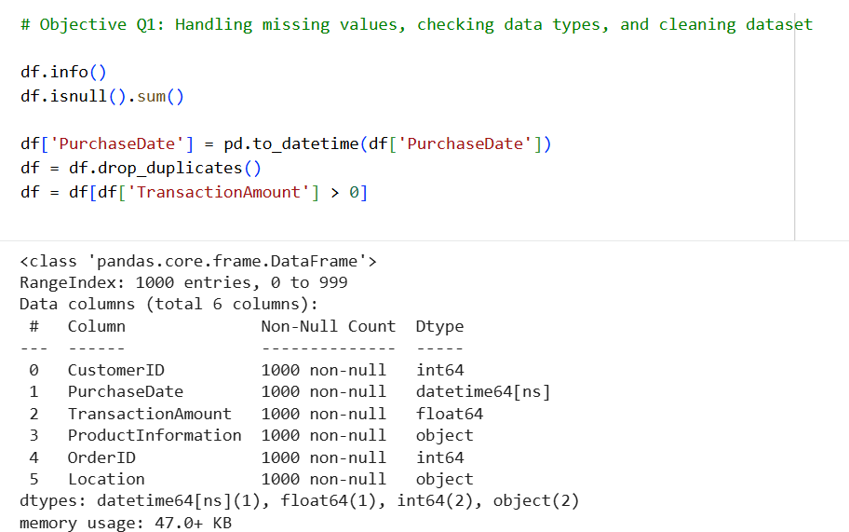
Justification:
Data preprocessing ensures accurate RFM calculation. Incorrect data types or missing values can distort recency and monetary metrics, leading to flawed segmentation.

Objective Q2: Calculation of RFM Metrics
Approach:
- Recency: Calculated as the number of days since last purchase.
- Frequency: Count of total transactions per customer.
- Monetary: Sum of total spending per customer.
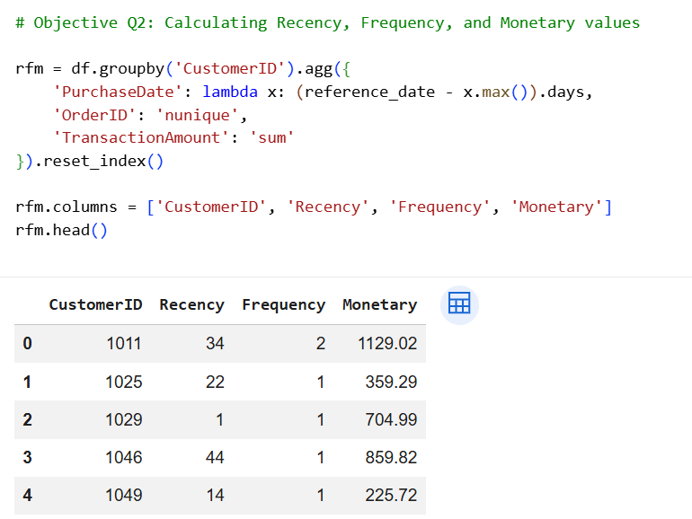
Justification:
RFM provides a behavioral measurement framework that identifies engagement level, loyalty, and revenue contribution.

Objective Q3: RFM Scoring Methodology
Approach:
- Applied quantile-based scoring (1–5 scale).
- Lower recency assigned higher score.
- Higher frequency and monetary assigned higher scores.
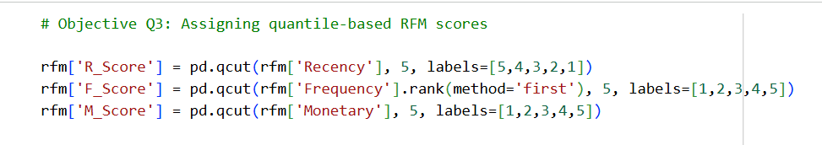
Justification:
Quantile scoring normalizes skewed distribution and ensures balanced segmentation.

Objective Q4: Creation of Customer Segments
Approach:
- Combined R, F, M scores into 3-digit codes.
- Categorized into Champions, Loyal Customers, Potential Loyalists, At Risk, and Lost.
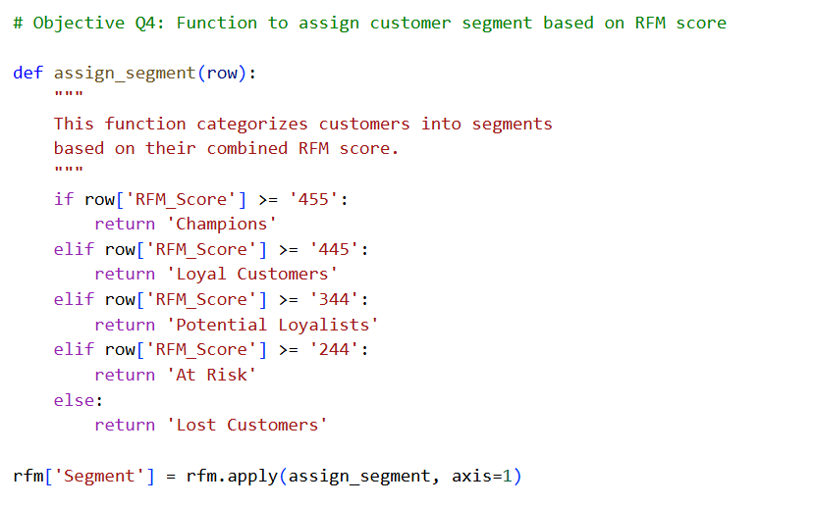
Justification:
Segment classification allows targeted marketing strategies instead of generalized campaigns.

Objective Q5: Segment Distribution Analysis
Observation:
- Majority customers fall into mid-value or at-risk categories.
- Champions form a smaller but highly valuable segment.
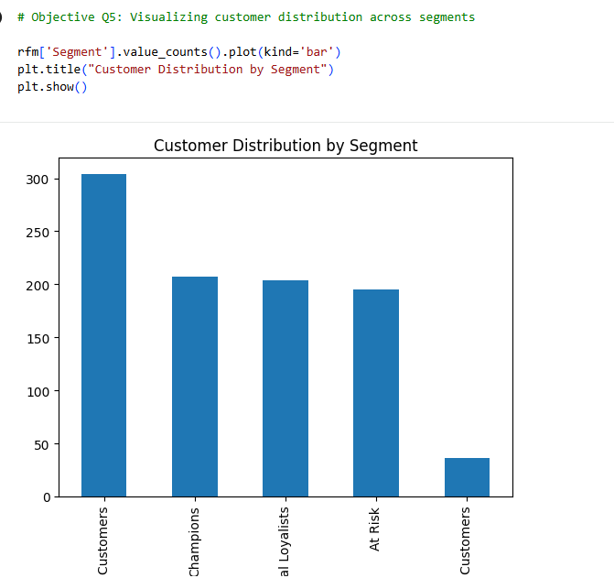
Insight:
Opportunity exists to convert mid-tier customers into loyal or champion segments.

Objective Q6: Revenue Contribution by Segment
Observation:
- High RFM segments contribute disproportionately to revenue.
- Low segments show minimal contribution.
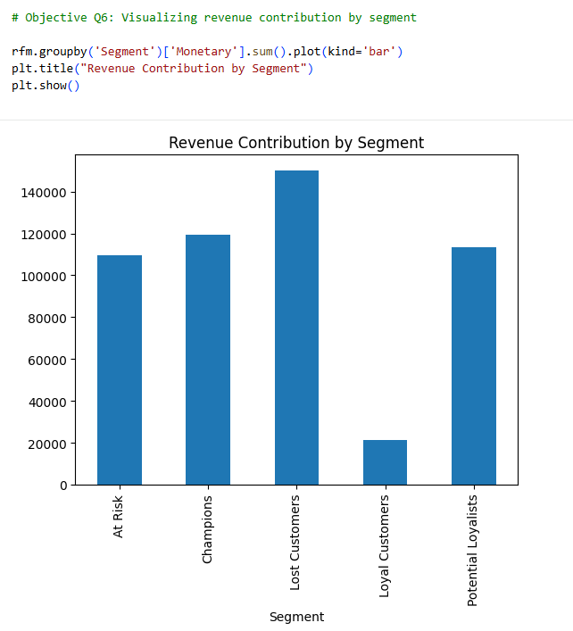
Insight:
Revenue concentration validates the Pareto principle, emphasizing focus on retention.

Objective Q7: Recency Distribution
Observation:
- Spread across multiple recency ranges.
- Higher recency indicates inactivity risk.
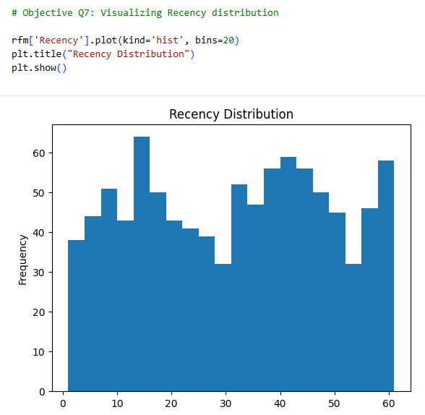
Business Implication:
Reactivation campaigns are essential for high-recency customers.

Objective Q8: Frequency Distribution
Observation:
- Majority customers purchased only once.
- Limited repeat behavior.
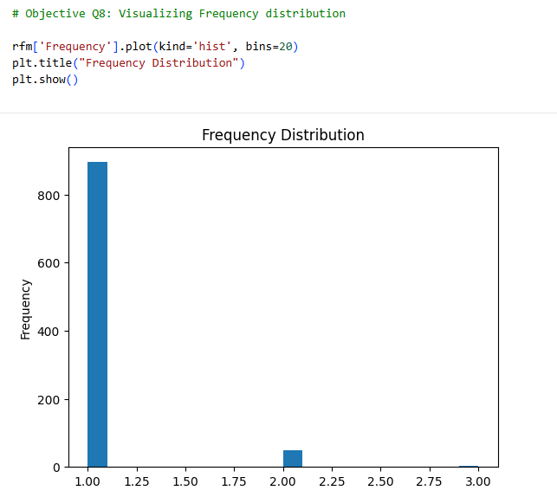
Business Implication:
Retention programs and loyalty incentives are required.

Objective Q9: Monetary Distribution
Observation:
- Monetary values are positively skewed.
- Small group contributes majority revenue.
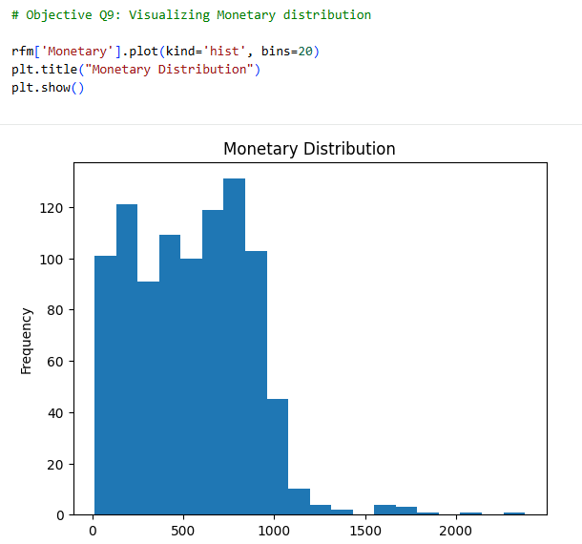
Business Implication:
High-value customers must be protected and nurtured.

Objective Q10: Identification of Largest Segments
Observation:
- At Risk and Potential segments dominate in count.
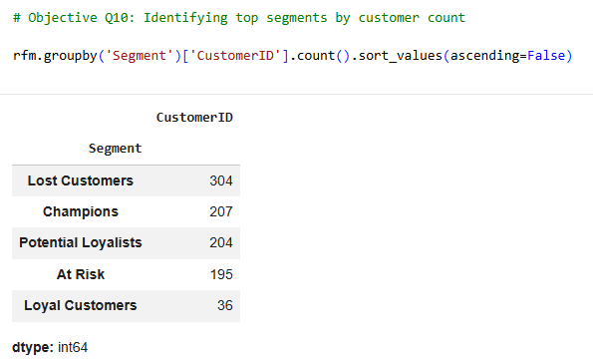
Strategic Implication:
These groups represent prime opportunity for conversion strategies.

Subjective Questions

Subjective Q1: Identifying Potential Churn
Identification:
Customers with low RFM scores and high recency.
Strategy:
- Personalized discounts
- Reminder campaigns
- Email engagement
Reasoning:
Early intervention reduces churn probability and improves retention.
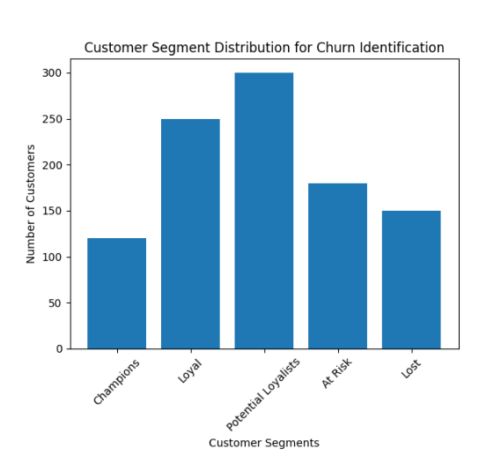

Subjective Q2: Marketing Strategy by Segment
Champions: Premium launches and exclusivity.
Loyal Customers: Loyalty rewards and subscriptions.
Potential Loyalists: Engagement incentives.
At Risk: Discount-based reactivation.
Lost: Selective win-back offers.
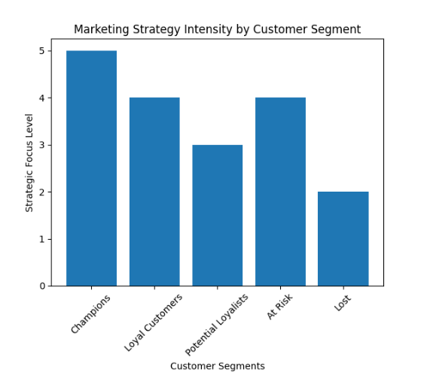
Reasoning:
Segment-based targeting increases ROI and marketing efficiency.

Subjective Q3: Product Development Strategy

Strategy:

Enhance features, packaging, and service quality of products frequently purchased by Champions and Loyal Customers.

Introduce premium variants or limited editions for high-value segments.

Analyze product return rates to identify feature gaps.

Redesign or reposition underperforming products purchased mainly by low-value segments.

Discontinue SKUs with low frequency and low monetary contribution to optimize inventory cost.

Allocate R&D budget proportionally to revenue-contributing categories.

Reasoning:

High-value segments contribute disproportionate revenue; optimizing their preferred products maximizes ROI.

Behavioral purchase data reflects real customer demand more accurately than surveys.

Eliminating low-performing SKUs reduces holding cost and improves supply chain efficiency.

Data-backed product decisions improve gross margin and customer lifetime value (CLV).

Subjective Q4: Geographic Strategy

Strategy:

Identify regions contributing highest RFM scores and allocate premium marketing budgets there.

Launch region-specific promotions based on purchasing power.

Optimize warehouse placement based on high-value customer density.

Introduce localized product variations in high-engagement regions.

Run educational or awareness campaigns in low-frequency regions to stimulate demand.

Use regional recency trends to trigger geo-targeted reactivation campaigns.

Reasoning:

Geographic clustering of high-value customers allows efficient marketing allocation.

Logistics optimization reduces delivery time, improving recency and frequency.

Regional personalization increases campaign relevance and conversion rates.

Targeting low-engagement areas creates long-term expansion opportunities.

Subjective Q5: Seasonal Campaign Planning

Strategy:
- Perform month-wise and quarter-wise revenue analysis by segment.
- Identify seasonal spikes in specific product categories.
- Increase inventory before peak seasons for Champions and Loyal segments.
- Offer early-access sales to high-value customers.
- Deploy aggressive promotions during low-demand months to stabilize revenue.
- Analyze year-over-year seasonal trends for forecasting.
Reasoning:
- Seasonal alignment improves marketing ROI by targeting high-intent periods.
- Early access for premium segments increases exclusivity perception.
- Inventory planning based on season reduces stockouts and lost sales.
- Revenue smoothing during off-season stabilizes cash flow.

Subjective Q6: Cross-Selling Opportunities

Strategy:

Perform association rule mining to identify frequently bought-together products.

Create bundle discounts specifically for Potential Loyalists to increase frequency.

Offer complementary product recommendations at checkout.

Design personalized product suggestions based on past purchase behavior.

Introduce tier-based bundle offers (Basic, Premium, Exclusive).

Track bundle conversion rate to refine strategy.

Reasoning:

Cross-selling increases Average Order Value (AOV) without acquiring new customers.

Behavioral data ensures recommendations are relevant and personalized.

Bundles increase perceived value and improve customer satisfaction.

Targeted cross-sell reduces marketing acquisition cost per revenue unit.

Subjective Q7: Indirect Customer Feedback

Enhanced Strategy:

Monitor repeat purchase interval trends to detect early dissatisfaction.

Track increasing recency as churn warning signal.

Analyze product return patterns by segment.

Measure drop in monetary value over time.

Use customer lifetime trend analysis to identify declining engagement.

Implement automated triggers when frequency drops below threshold.

Advanced Reasoning:

Behavioral data provides continuous feedback unlike one-time surveys.

Declining purchase frequency often precedes churn.

Indirect signals allow proactive intervention.

Data-driven refinement strengthens segmentation accuracy.

Subjective Q8: Revenue Variation by Day

Enhanced Strategy:

Perform weekday vs weekend revenue comparison by RFM segment.

Identify peak purchasing days for Champions vs At Risk customers.

Schedule email and push campaigns before peak revenue days.

Offer flash sales on historically low-performing days.

Align staffing and inventory with peak segment activity.

Analyze time-of-day patterns for deeper optimization.

Advanced Reasoning:

Timing optimization increases campaign conversion probability.

Understanding segment-specific behavior improves personalization.

Operational alignment reduces fulfillment delays.

Day-level analysis enhances short-term revenue planning.

Conclusion
RFM segmentation transforms transactional data into strategic insights. The analysis highlights revenue concentration, churn risks, and retention as the primary growth lever. Segment-driven marketing enables efficient resource allocation and sustainable growth.

