PROJECT

on

**WEBPAGE CREATION**

Project Report

Submitted by

**Student name (Reg No)**

In partial fulfillment of the requirement for the award of the degree of

**B.COM (CA)**

(Bachelor of Commerce with Computer Applications)



**GRD SCHOOL OF COMMERCE AND INTERNATIONAL BUSINESS**

**Dr. G R DAMODARAN COLLEGE OF SCIENCE**

(Autonomous and affiliated to Bharathiar University)

Avinashi Road, Coimbatore – 641014

October 2021

**GRD SCHOOL OF COMMERCE AND INTERNATIONAL BUSINESS**

**Dr. GRD COLLEGE OF SCIENCE**

(Autonomous and affiliated to Bharathiar University)

Accredited at the FIVE STAR level by NAAC and ISO 9001:2008 certified

Coimbatore – 641014

Certificate

This is to certify that the Project report on webpage creation

Submitted by

**STUDENT NAME (REG NO)**

is submitted in partial fulfillment of the requirement

for the award of the degree of

**B. Com (CA)**

of Bharathiar University, Coimbatore.

____________________ ___________________

Head of the Department Director

Viva-voce examination held on _______________.

______________

Examiner

**DECLARATION**

I, **student name (Reg no)** hereby declare that the project report entitled **“XXXXXXXX”** submitted to **GRD SCHOOL OF COMMERCE AND INTERNATIONAL BUSINESS**, in partial fulfilment of the requirement for the award of the degree of **BACHELOR OF** **COMMERCE (COMPUTER APPLICATION**S) is a record of the original work done by me during my period of study in **Dr. G R DAMODARAN COLLEGE OF SCIENCE,** Coimbatore.

Place: Coimbatore

Date : (Student Name)

**ACKNOWLEDGEMENT**

I wish to express my sincere gratitude to the management of **Dr. G R DAMODARAN COLLEGE OF SCIENCE** for giving me this wonderful opportunity to pursue my graduation B.Com (CA) and undergo the project.

My special thanks go to The Principal of our college **Dr. Mrs. T. SANTHA**, for her support in allowing me to complete my Project successfully.

I wish to express my deep sense of gratitude to our respected Director, **Dr. K K RAMACHANDRAN, M.Com., MFT., MBA., M.Phil., PGDCA., Ph.D.,** for his unfaltering faith in his students and providing us with new ways to excel in the field of commerce and computer applications.

I would like to express my sincere thanks to **Dr. S. DHANARAJ,** Head of the Department, Department of Commerce, for his motivation and timely assistance.

I would like to place my sincere thanks to **Dr. S. SITRARASU,** Co-ordinator, B.Com(CA), for his support and inspiration for the completion of the project report.

I would like to place my sincere thanks to **Mrs. D. SANGEETHA,** Assistant Professor, B.Com (CA) for her continuous help and guidance throughout the project.

I would like to express my thanks to all the faculty members of B.Com (CA) for their support and continuous help to complete the project.

I also extend a huge thanks to my parents, friends and the Almighty for having supported me in doing this project.

**STUDENT NAME**

**CONTENTS**

**Chapter No Chapter Name Page No**

1 Introduction 01

2 System Specifications 04

2.1 Hardware Specifications 04

2.2 Software Specifications 06

3 Project Design 08

4 Detailed Design 10

5 5.1 Conclusion 12

5.2 Scope 13

Bibliography 14

Annexure

Webpage Screens 15

Coding xx

**INTRODUCTION**

We see the future of Animal Shelter as a compassionate society where companion animals are valued and treated with respect and are guaranteed to find loving homes and families.

Every year hundreds of animals such as dogs or cats become homeless for many reasons. Our mission is to find the homeless animals around the country and give them a better life.

**SYSTEM SPECIFICATIONS**

**CHAPTER-2**

**SYSTEM STUDY**

## 2.1 HARDWARE REQUIREMENTS

Building a website has become a much more feasible task for the average user with the availability of free website creation software and services. With the software readily available, the only other things required are a few key hardware components. Luckily, highly specialized and expensive equipment is not needed to create a website.

Web designing takes much more than most people think. It is about ensuring that you have all relevant hardware required to design a good and appealing website. One of the most important tools you need is a computer or laptop. A computer or laptop to be used for web designing should have a large hard disk and Random-Access Memory, high processing speed and large storage capacity to be able to process the large video files.

#### Processor

A processor is the logic circuitry that responds to and processes the basic instructions that drive a computer. The four primary functions of a processor are fetched, decode, execute and write back.

Intel Pentium IV or Higher

#### Ram

The purpose of RAM is to provide quick read and write access to a storage device. Computer uses RAM to load data because it’s much quicker than running that same data directly off a hard drive.

#### Hard Disk Drive

A hard disk drive (HDD), hard disk, hard drive, or fixed disk is an electromechanical data storage device that uses magnetic storage to store and retrieve digital information using one or more rapidly rotating disks coated with magnetic material.

1 GB Hard Disk Space or more.

##### 2.2 SOFTWARE REQUIREMENTS

Building a website has become a much more feasible task for the average user with the availability of free website creation software and services. With the software readily available, the only thing required is to know how to use them, the developers can also use text editing applications like notepad, word, etc., to code the websites.

#### Opearating System

An operating system in its most general sense, is software that allows a user to run other applications on a computing device. While it is possible for a software application to interface directly with hardware, the vast majority of application are written for an OS, which allows them to take advantage of common libraries and not to worry about specific hardware details.

Windows XP, 7 or Higher.

#### Text Editor

A text editor is a program on your computer that allows you to create and edit a range of programming languages files. AKA this is the place where you write your code.

Text editors handle “hand coding” many different languages: HTML, CSS, JavaScript, PHP, Ruby and so forth.

* Notepad- A notepad is a generic text editor include withal versions of Microsoft Windows that allows to create, open, and read plaintext files.
* MS Word- Microsoft Word is a word processor.

#### Web Browser

A web browser is a software program that allows a user to locate, access, and display webpages. Browsers are used primarily for displaying and accessing websites on the internet, as well as other content created using languages such as HTML and XML.

* Chrome - Google Chrome browser is an open source program for accessing the World Wide Web and running Web-based applications. The Google Chrome Web browser is based on the open source Chromium project.
* Mozilla Firefox - Mozilla Firefox or simply Firefox isa free and open-source web browser developed by the Mozilla Foundation and its subsidiary, the Mozilla Corporation.

**PROJECT DESIGN**

**CHAPTER-3**

**PROJECT DESIGN**

**PAGE TITLE**

**Home**

**OUR GALLERY**

**ADOPT DOGS**

**ABOUT US**

**CONTACT US**

**DETAILED DESIGN**

**CHAPTER-4**

**DETAILED DESIGN**

The web page is divided into two frames; The Menu frame, and The Main page frame. Different files are constructed for each frame with respective filenames. The menu in the menu frame is hyperlinked using html tags, which when clicked will appear in the main page frame. Each and every menu is connected to its respective files.

There are totally FOUR menus in the menus in the menu frame which are connected to its respective file. Each page gives detailed information about the crops and its content under different point of view. This website explores these things in a detailed manner.

**MENU FRAME:** It contains all the menus of the webpage. It has five menus.

**CONTENT FRAME:** It contains the information of the products of Xiaomi.

**PAGE WISE DESCRIPTION ARE AS FOLLOWS:**

* **Home** – We will display the title page of along with three images of dog.
* **Our Gallery** -In Gallery, we will show the category of dog.

1. First category,
2. Second category,
3. Third category. .

* **About Us** - We will tell few words about us along with our mission, goal and vision.
* **Contact Us** -we will give out contact details.

**CONCLUSION**

**CHAPTER-5**

# 5.1 CONCLUSION

The webpage “Dog rescue” has been designed as per the requirements and specifications.

This is used to save many shelter-less dogs around the world. From this we can able to provide a home for them.

**SCOPE**

## 5.2 SCOPE

#### More Dogs

More dogs will be added along will more images and optimizes.

##### Adopt Option

many more Adopt options will be added and are planning about it.

**BIBLIOGRAPHY**

##### CHAPTER-6

**BIBLIOGRAPHY**

|  |  |
| --- | --- |
| The following are the context and references concerned with the web page creation project. Most | |
| of the context and information of the web page was referred online. |  |

<https://en.wikipedia.org/wiki/Main_Page>

<https://www.google.com/imghp?hl=en>

<https://www.w3schools.com/>

**WEB PAGE SCREENS**

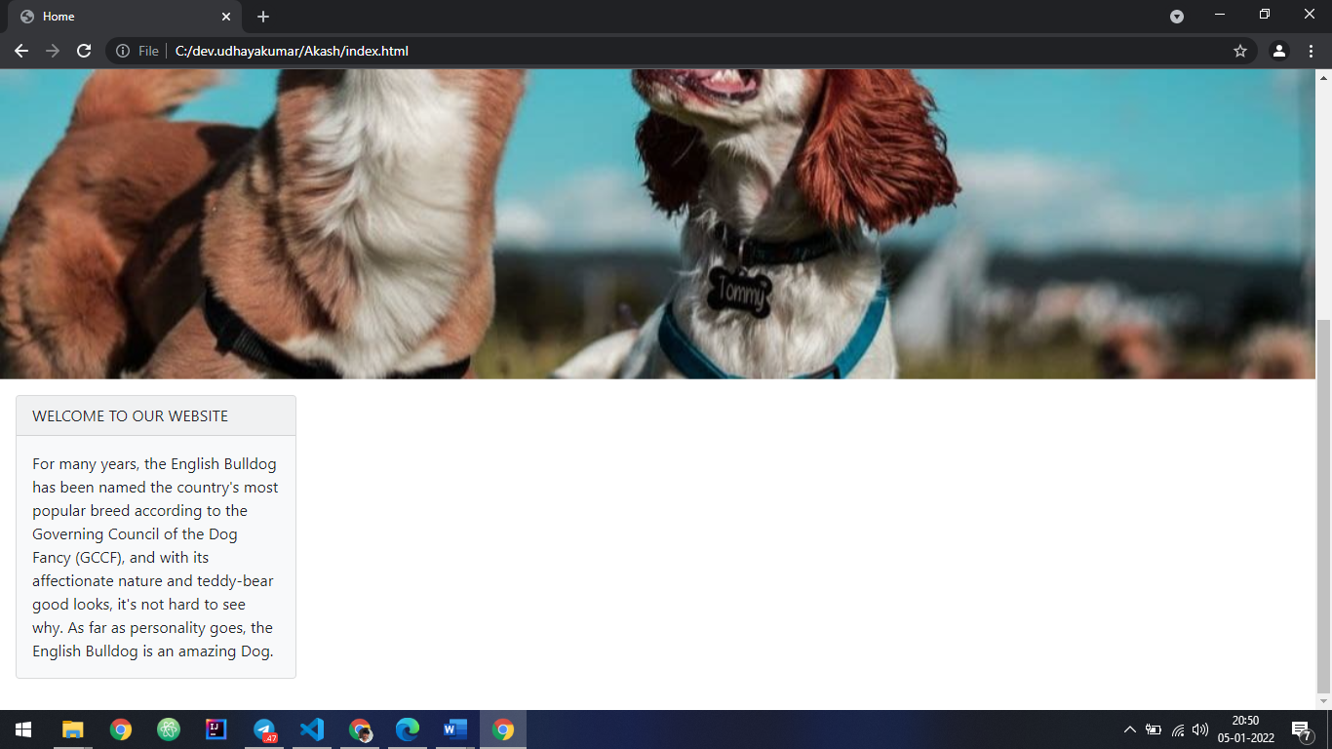

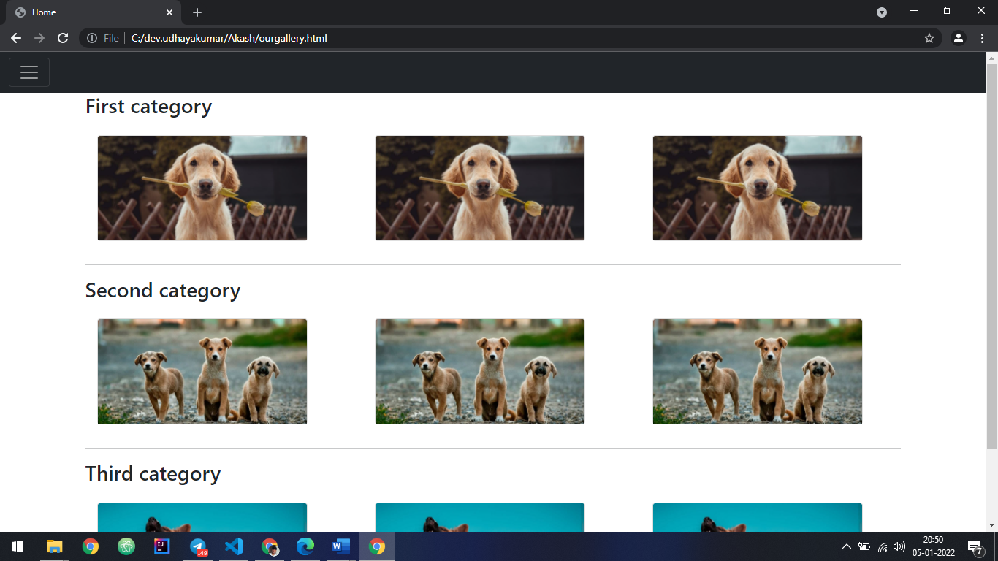

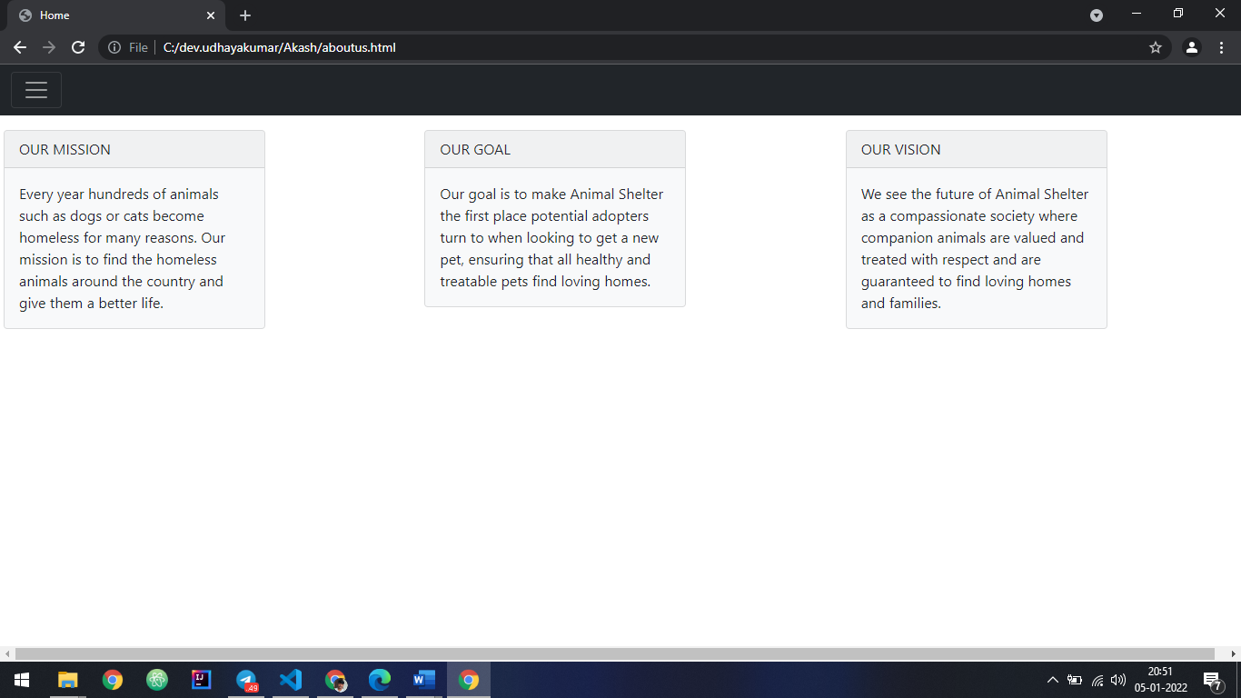

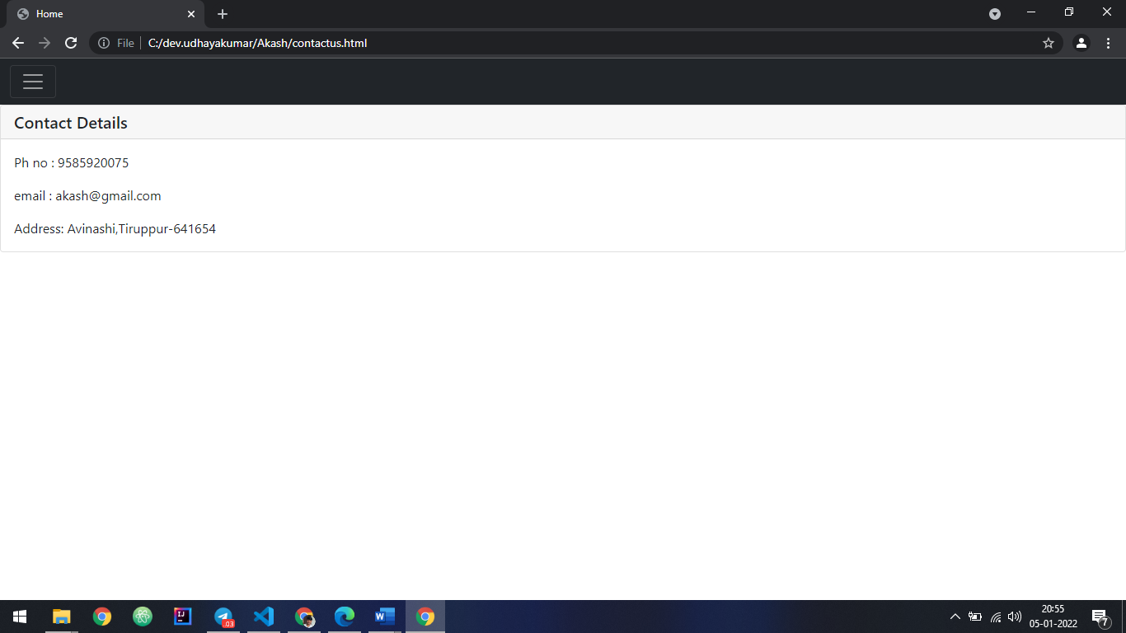

**CODING**

**Home page HTML**

<!DOCTYPE html>

<html lang="en">

<head>

<meta charset="UTF-8">

<meta http-equiv="X-UA-Compatible" content="IE=edge">

<meta name="viewport" content="width=device-width, initial-scale=1.0">

<title>Home</title>

</head>

<link href="https://cdn.jsdelivr.net/npm/bootstrap@5.0.2/dist/css/bootstrap.min.css" rel="stylesheet" integrity="sha384-EVSTQN3/azprG1Anm3QDgpJLIm9Nao0Yz1ztcQTwFspd3yD65VohhpuuCOmLASjC" crossorigin="anonymous">

<script src="https://cdn.jsdelivr.net/npm/bootstrap@5.0.2/dist/js/bootstrap.bundle.min.js" integrity="sha384-MrcW6ZMFYlzcLA8Nl+NtUVF0sA7MsXsP1UyJoMp4YLEuNSfAP+JcXn/tWtIaxVXM" crossorigin="anonymous"></script>

<script src="https://cdn.jsdelivr.net/npm/@popperjs/core@2.9.2/dist/umd/popper.min.js" integrity="sha384-IQsoLXl5PILFhosVNubq5LC7Qb9DXgDA9i+tQ8Zj3iwWAwPtgFTxbJ8NT4GN1R8p" crossorigin="anonymous"></script>

<script src="https://cdn.jsdelivr.net/npm/bootstrap@5.0.2/dist/js/bootstrap.min.js" integrity="sha384-cVKIPhGWiC2Al4u+LWgxfKTRIcfu0JTxR+EQDz/bgldoEyl4H0zUF0QKbrJ0EcQF" crossorigin="anonymous"></script>

<body>

<div class="collapse" id="navbarToggleExternalContent">

<div class="bg-dark p-4">

<ul class="navbar-nav me-auto mb-2 mb-lg-0">

<li class="nav-item">

<a class="nav-link disabled" aria-current="page" href="#">Home</a>

</li>

<li class="nav-item">

<a class="nav-link" href="ourgallery.html">Our Gallery</a>

</li>

<li class="nav-item">

<a class="nav-link " href="contactus.html">Contact Us</a>

</li>

<li class="nav-item">

<a class="nav-link" href="aboutus.html">About Us</a>

</li>

</ul>

</div>

</div>

<nav class="navbar navbar-dark bg-dark">

<div class="container-fluid">

<button class="navbar-toggler" type="button" data-bs-toggle="collapse" data-bs-target="#navbarToggleExternalContent" aria-controls="navbarToggleExternalContent" aria-expanded="false" aria-label="Toggle navigation">

<span class="navbar-toggler-icon"></span>

</button>

</div>

</nav>

<div id="carouselExampleInterval" class="carousel slide" data-bs-ride="carousel">

<div class="carousel-inner">

<div class="carousel-item active" data-bs-interval="2000">

<img src="src/photo_2022-01-04_21-58-09.jpg" class="d-block w-100" alt="...">

</div>

<div class="carousel-item" data-bs-interval="2000">

<img src="src/photo_2022-01-04_21-58-13.jpg" class="d-block w-100" alt="...">

</div>

<div class="carousel-item">

<img src="src/photo_2022-01-04_21-58-18.jpg" class="d-block w-100" alt="...">

</div>

</div>

<button class="carousel-control-prev" type="button" data-bs-target="#carouselExampleInterval" data-bs-slide="prev">

<span class="carousel-control-prev-icon" aria-hidden="true"></span>

<span class="visually-hidden">Previous</span>

</button>

<button class="carousel-control-next" type="button" data-bs-target="#carouselExampleInterval" data-bs-slide="next">

<span class="carousel-control-next-icon" aria-hidden="true"></span>

<span class="visually-hidden">Next</span>

</button>

</div>

<div class="col-md p-3">

<div class="card text-dark bg-light mb-3" style="max-width: 18rem;">

<div class="card-header">WELCOME TO OUR WEBSITE</div>

<div class="card-body">

<p class="card-text">For many years, the English Bulldog has been named the country's most popular breed according to the Governing Council of the Dog Fancy (GCCF), and with its affectionate nature and teddy-bear good looks, it's not hard to see why. As far as personality goes, the English Bulldog is an amazing Dog.

</p>

</div>

</div>

</div>

</body>

</html>

Our Gallery HTML

<!DOCTYPE html>

<html lang="en">

<head>

<meta charset="UTF-8">

<meta http-equiv="X-UA-Compatible" content="IE=edge">

<meta name="viewport" content="width=device-width, initial-scale=1.0">

<title>Home</title>

</head>

<link href="https://cdn.jsdelivr.net/npm/bootstrap@5.0.2/dist/css/bootstrap.min.css" rel="stylesheet" integrity="sha384-EVSTQN3/azprG1Anm3QDgpJLIm9Nao0Yz1ztcQTwFspd3yD65VohhpuuCOmLASjC" crossorigin="anonymous">

<script src="https://cdn.jsdelivr.net/npm/bootstrap@5.0.2/dist/js/bootstrap.bundle.min.js" integrity="sha384-MrcW6ZMFYlzcLA8Nl+NtUVF0sA7MsXsP1UyJoMp4YLEuNSfAP+JcXn/tWtIaxVXM" crossorigin="anonymous"></script>

<script src="https://cdn.jsdelivr.net/npm/@popperjs/core@2.9.2/dist/umd/popper.min.js" integrity="sha384-IQsoLXl5PILFhosVNubq5LC7Qb9DXgDA9i+tQ8Zj3iwWAwPtgFTxbJ8NT4GN1R8p" crossorigin="anonymous"></script>

<script src="https://cdn.jsdelivr.net/npm/bootstrap@5.0.2/dist/js/bootstrap.min.js" integrity="sha384-cVKIPhGWiC2Al4u+LWgxfKTRIcfu0JTxR+EQDz/bgldoEyl4H0zUF0QKbrJ0EcQF" crossorigin="anonymous"></script>

<body>

<div class="collapse" id="navbarToggleExternalContent">

<div class="bg-dark p-4">

<ul class="navbar-nav me-auto mb-2 mb-lg-0">

<li class="nav-item">

<a class="nav-link "  href="index.html">Home</a>

</li>

<li class="nav-item">

<a class="nav-link disabled" href="ourgallery.html">Our Gallery</a>

</li>

<li class="nav-item">

<a class="nav-link " href="contactus.html">Contact Us</a>

</li>

<li class="nav-item">

<a class="nav-link " href="aboutus.html">About Us</a>

</li>

</ul>

</div>

</div>

<nav class="navbar navbar-dark bg-dark">

<div class="container-fluid">

<button class="navbar-toggler" type="button" data-bs-toggle="collapse" data-bs-target="#navbarToggleExternalContent" aria-controls="navbarToggleExternalContent" aria-expanded="false" aria-label="Toggle navigation">

<span class="navbar-toggler-icon"></span>

</button>

</div>

</nav>

<div class="container">

<h3>First category</h3>

<div class="row align-items-start">

<div class="col">

<div class="col p-3">

<div class="card" style="width: 18rem;">

<img src="src/photo_2022-01-04_21-58-18.jpg" class="card-img-top" alt="...">

</div>

</div>

</div>

<div class="col">

<div class="col p-3">

<div class="card" style="width: 18rem;">

<img src="src/photo_2022-01-04_21-58-18.jpg" class="card-img-top" alt="...">

</div>

</div>

</div>

<div class="col">

<div class="col p-3">

<div class="card" style="width: 18rem;">

<img src="src/photo_2022-01-04_21-58-18.jpg" class="card-img-top" alt="...">

</div>

</div>

</div>

</div>

<hr>

<h3>Second category</h3>

<div class="row align-items-center">

<div class="col">

<div class="col p-3">

<div class="card" style="width: 18rem;">

<img src="src/photo_2022-01-04_21-58-13.jpg" class="card-img-top" alt="...">

</div>

</div>

</div>

<div class="col">

<div class="col p-3">

<div class="card" style="width: 18rem;">

<img src="src/photo_2022-01-04_21-58-13.jpg" class="card-img-top" alt="...">

</div>

</div>

</div>

<div class="col">

<div class="col p-3">

<div class="card" style="width: 18rem;">

<img src="src/photo_2022-01-04_21-58-13.jpg" class="card-img-top" alt="...">

</div>

</div>

</div>

</div>

<hr>

<h3>Third category</h3>

<div class="row align-items-end">

<div class="col">

<div class="col p-3">

<div class="card" style="width: 18rem;">

<img src="src/photo_2022-01-04_21-58-09.jpg" class="card-img-top" alt="...">

</div>

</div>

</div>

<div class="col">

<div class="col p-3">

<div class="card" style="width: 18rem;">

<img src="src/photo_2022-01-04_21-58-09.jpg" class="card-img-top" alt="...">

</div>

</div>

</div>

<div class="col">

<div class="col p-3">

<div class="card" style="width: 18rem;">

<img src="src/photo_2022-01-04_21-58-09.jpg" class="card-img-top" alt="...">

</div>

</div>

</div>

</div>

</div>

</body>

</html>

Contact Us HTML

<!DOCTYPE html>

<html lang="en">

<head>

<meta charset="UTF-8">

<meta http-equiv="X-UA-Compatible" content="IE=edge">

<meta name="viewport" content="width=device-width, initial-scale=1.0">

<title>Home</title>

</head>

<link href="https://cdn.jsdelivr.net/npm/bootstrap@5.0.2/dist/css/bootstrap.min.css" rel="stylesheet" integrity="sha384-EVSTQN3/azprG1Anm3QDgpJLIm9Nao0Yz1ztcQTwFspd3yD65VohhpuuCOmLASjC" crossorigin="anonymous">

<script src="https://cdn.jsdelivr.net/npm/bootstrap@5.0.2/dist/js/bootstrap.bundle.min.js" integrity="sha384-MrcW6ZMFYlzcLA8Nl+NtUVF0sA7MsXsP1UyJoMp4YLEuNSfAP+JcXn/tWtIaxVXM" crossorigin="anonymous"></script>

<script src="https://cdn.jsdelivr.net/npm/@popperjs/core@2.9.2/dist/umd/popper.min.js" integrity="sha384-IQsoLXl5PILFhosVNubq5LC7Qb9DXgDA9i+tQ8Zj3iwWAwPtgFTxbJ8NT4GN1R8p" crossorigin="anonymous"></script>

<script src="https://cdn.jsdelivr.net/npm/bootstrap@5.0.2/dist/js/bootstrap.min.js" integrity="sha384-cVKIPhGWiC2Al4u+LWgxfKTRIcfu0JTxR+EQDz/bgldoEyl4H0zUF0QKbrJ0EcQF" crossorigin="anonymous"></script>

<body>

<div class="collapse" id="navbarToggleExternalContent">

<div class="bg-dark p-4">

<ul class="navbar-nav me-auto mb-2 mb-lg-0">

<li class="nav-item">

<a class="nav-link "  href="index.html">Home</a>

</li>

<li class="nav-item">

<a class="nav-link " href="ourgallery.html">Our Gallery</a>

</li>

<li class="nav-item">

<a class="nav-link disabled " href="contactus.html">Contact Us</a>

</li>

<li class="nav-item">

<a class="nav-link " href="aboutus.html">About Us</a>

</li>

</ul>

</div>

</div>

<nav class="navbar navbar-dark bg-dark">

<div class="container-fluid">

<button class="navbar-toggler" type="button" data-bs-toggle="collapse" data-bs-target="#navbarToggleExternalContent" aria-controls="navbarToggleExternalContent" aria-expanded="false" aria-label="Toggle navigation">

<span class="navbar-toggler-icon"></span>

</button>

</div>

</nav>

<div class="card">

<h5 class="card-header">Contact Details</h5>

<div class="card-body">

<p class="card-text">Ph no  : 9585920075</p>

<p class="card-text">email  : akash@gmail.com</p>

<p class="card-text">Address: Avinashi,Tiruppur-641654</p>

</div>

</div>

</body>

</html>

About Us HTML

<!DOCTYPE html>

<html lang="en">

<head>

<meta charset="UTF-8">

<meta http-equiv="X-UA-Compatible" content="IE=edge">

<meta name="viewport" content="width=device-width, initial-scale=1.0">

<title>Home</title>

</head>

<link href="https://cdn.jsdelivr.net/npm/bootstrap@5.0.2/dist/css/bootstrap.min.css" rel="stylesheet" integrity="sha384-EVSTQN3/azprG1Anm3QDgpJLIm9Nao0Yz1ztcQTwFspd3yD65VohhpuuCOmLASjC" crossorigin="anonymous">

<script src="https://cdn.jsdelivr.net/npm/bootstrap@5.0.2/dist/js/bootstrap.bundle.min.js" integrity="sha384-MrcW6ZMFYlzcLA8Nl+NtUVF0sA7MsXsP1UyJoMp4YLEuNSfAP+JcXn/tWtIaxVXM" crossorigin="anonymous"></script>

<script src="https://cdn.jsdelivr.net/npm/@popperjs/core@2.9.2/dist/umd/popper.min.js" integrity="sha384-IQsoLXl5PILFhosVNubq5LC7Qb9DXgDA9i+tQ8Zj3iwWAwPtgFTxbJ8NT4GN1R8p" crossorigin="anonymous"></script>

<script src="https://cdn.jsdelivr.net/npm/bootstrap@5.0.2/dist/js/bootstrap.min.js" integrity="sha384-cVKIPhGWiC2Al4u+LWgxfKTRIcfu0JTxR+EQDz/bgldoEyl4H0zUF0QKbrJ0EcQF" crossorigin="anonymous"></script>

<body>

<div class="collapse" id="navbarToggleExternalContent">

<div class="bg-dark p-4">

<ul class="navbar-nav me-auto mb-2 mb-lg-0">

<li class="nav-item">

<a class="nav-link "  href="index.html">Home</a>

</li>

<li class="nav-item">

<a class="nav-link" href="ourgallery.html">Our Gallery</a>

</li>

<li class="nav-item">

<a class="nav-link " href="contactus.html">Contact Us</a>

</li>

<li class="nav-item">

<a class="nav-link disabled" href="aboutus.html">About Us</a>

</li>

</ul>

</div>

</div>

<nav class="navbar navbar-dark bg-dark">

<div class="container-fluid">

<button class="navbar-toggler" type="button" data-bs-toggle="collapse" data-bs-target="#navbarToggleExternalContent" aria-controls="navbarToggleExternalContent" aria-expanded="false" aria-label="Toggle navigation">

<span class="navbar-toggler-icon"></span>

</button>

</div>

</nav>

<div class="row align-items-start">

<div class="col-md p-3">

<div class="card text-dark bg-light mb-3" style="max-width: 18rem;">

<div class="card-header">OUR MISSION</div>

<div class="card-body">

<p class="card-text">Every year hundreds of animals such as dogs or cats become homeless for many reasons. Our mission is to find the homeless animals around the country and give them a better life.</p>

</div>

</div>

</div>

<div class="col-md p-3">

<div class="card text-dark bg-light mb-3" style="max-width: 18rem;">

<div class="card-header">OUR GOAL</div>

<div class="card-body">

<p class="card-text">Our goal is to make Animal Shelter the first place potential adopters turn to when looking to get a new pet, ensuring that all healthy and treatable pets find loving homes.</p>

</div>

</div>

</div>

<div class="col-md p-3">

<div class="card text-dark bg-light mb-3" style="max-width: 18rem;">

<div class="card-header">OUR VISION</div>

<div class="card-body">

<p class="card-text">We see the future of Animal Shelter as a compassionate society where companion animals are valued and treated with respect and are guaranteed to find loving homes and families.</p>

</div>

</div>

</div>

</div>

</body>

</html>