Impact of Air Pollution on our Lives

# *By ( Vibhor Singh) Mail: vibsin95@outlook.com*

# *Air pollution occurs when harmful or excessive quantities of substances are introduced into Earth's atmosphere. Sources of air pollution include gases, particulates, and biological molecules. In the year 2020 we can see how the pollution level is decreased significantly in India due to COVID-19 and nationwide lockdown*

# 966907-bihar.jpg

# *The above picture represents , how lower air pollution levels due to the ongoing nationwide lockdown and covid-19 is attributing to the visibility of Mount Everest in a village in Bihar's Sitamarhi district.*

# *So lets see analysed data of recorded pollution level in India in two fragments : Pre Corona & Post Corona* Data source : <https://www.kaggle.com/parulpandey/breathe-india-covid-19-effect-on-pollution/data?select=city_day.csv>

# Source Code : <https://github.com/dev-vibhor/pollution_covid19India>

Data Info :

**Data is divided in to 16 columns and two more are added through manual calculation and each row contains details of recorded level of pollutants from year 2015 to 2020 day wise for different cities**

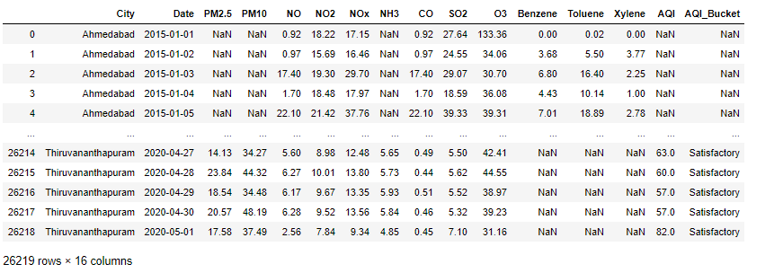

METHODLOGY for ANALYSIS

1. **Reading the CSV FILE using python libraries.**
2. **Replacing the NULL values using accurate method ( calculating mean using group by cities , year , month and replacing NULL values by it ) to increase accuracy.**
3. **Calculating BTX and Particulate Matter and updating it in the data .**
4. **Replacing left over NAN or NULL values with '0' to detect fault in cities for recording pollutants level.**
5. **summarizing the pollutant level of different Types of Air Pollutants group by year month and city for better analysis.**
6. **Summarizing of different levels of pollutants amount of cities over the period 2015 to 2020 and check if any pollutants is not recorded properly .**

Analysis categories :

1. **The mean level of different Types of Air Pollutants and factors (AQI , Particulate Matter , BTX , CO ) grouped by year and city**
2. **Different levels of AQI level of major cities ( Ahmedabad , Delhi , Bangalore , Mumbai , Hyderabad , Chennai , Kolkata ) before and after lockdown.**

Limitations and Errors :

* **There are some empty values in dataset.**
* **Empty values may indicate cities are not well equipped with instruments to capture pollutant levels and faulty instruments . Note : (fault detection is implemented in code) .**
* **Pollutant levels changes in different seasons.**
* **For the year 2020 complete data is not present as it is ongoing.**
* **In this report only few cities and pollutants has been shown but everything can be analysed in the code**

Basic Knowledge :

**Pollutants can be classified as :**

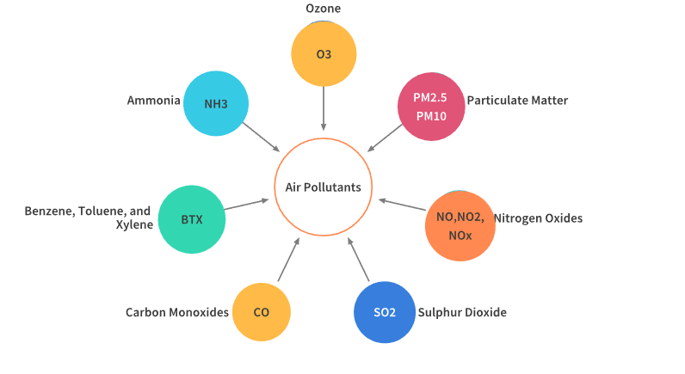

* **Particulate matter (PM2.5 and PM10)** > Particulate matter is a mix of solids and liquids, including carbon, complex organic chemicals, sulphates, nitrates, mineral dust, and water suspended in the air. PM varies in size. Some particles, such as dust, soot, dirt or smoke are large or dark enough to be seen with the naked eye. But the most damaging particles are the smaller particles, known as PM10 and PM2.5 . The following diagram will help to understand the concept more concretely.
* **Nitrogen Oxides** (NO, NO2, NOx) > Nitrogen oxides are a group of seven gases and compounds composed of nitrogen and oxygen, sometimes collectively known as NOx gases. The two most common and hazardous oxides of nitrogen are nitric oxide(NO) and nitrogen dioxide(NO2)
* **Sulphur Dioxide**(SO2) > Sulfur dioxide, or SO2 is a colourless gas with a strong odor, similar to a just-struck match. It is formed when fuel containing sulfur, such as coal and oil, is burned, creating air pollution.
* **Carbon Monoxide**(CO) > Carbon monoxide is a colourless, highly poisonous gas. Under pressure, it becomes a liquid. It is produced by burning gasoline, natural gas, charcoal, wood, and other fuels.
* **Benzene, Toluene and Xylene** (BTX) > Benzene, toluene, xylene, and formaldehyde are well-known indoor air pollutants, especially after house decoration. They are also common pollutants in the working places of the plastic industry, chemical industry, and leather industry
* **Ammonia**( NH3) > Ammonia pollution is pollution by the chemical ammonia (NH3) – a compound of nitrogen and hydrogen which is a by-product of agriculture and industry.
* **Ozone**(O3) > Ground-level ozone is a colourless and highly irritating gas that forms just above the earth's surface. It is called a "secondary" pollutant because it is produced when two primary pollutants react in sunlight and stagnant air. These two primary pollutants are nitrogen oxides (NOx) and volatile organic compounds (VOCs).

A) The mean levels of Particulate Matter , AQI , BTX , CO grouped by year and city

**A.1) Particulate Matter...................**

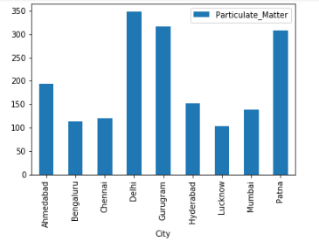

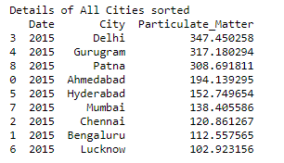

**YEAR :2015 Analysis for Particulate Matter Levels**

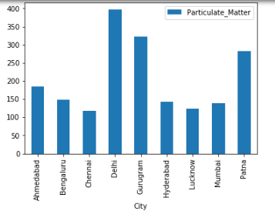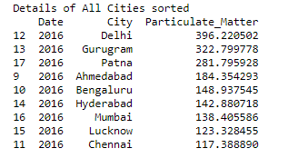

**YEAR :2016 Analysis for Particulate Matter Levels**

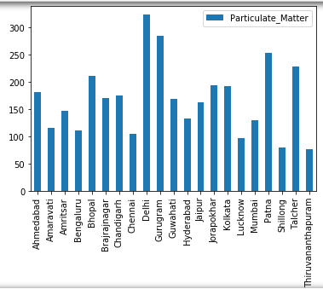

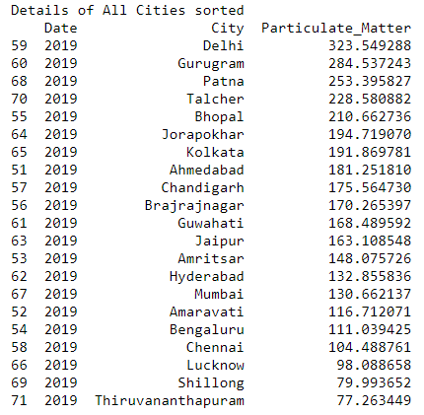

**YEAR :2019 Analysis for Particulate Matter Levels**

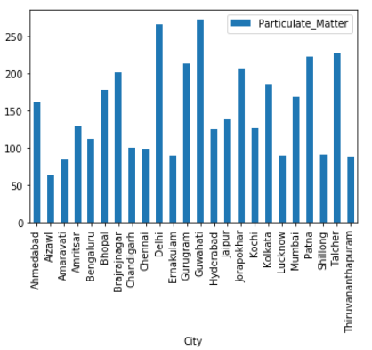

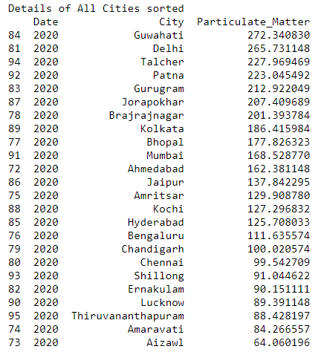

**YEAR :2020 Analysis for Particulate Matter Levels**

**"As we can see how lockdown has affected the Particulate Matter level of cities such that it has decreased in most of the cities significantly**

**and thus making air more suitable to breathe "**

**A.2) AQI...................**

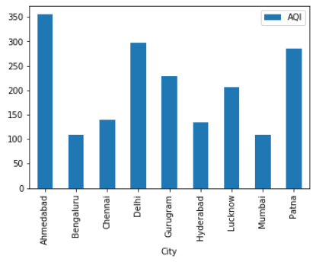 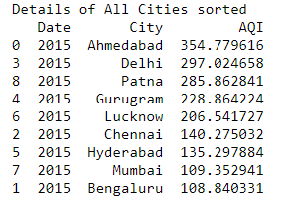

**YEAR :2015 Analysis for AQI Levels**

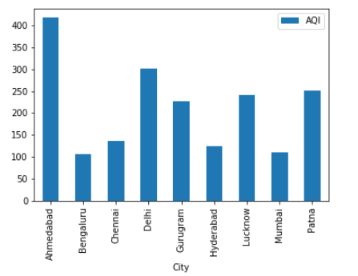 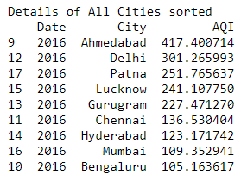

**YEAR :2016 Analysis for AQI Levels**

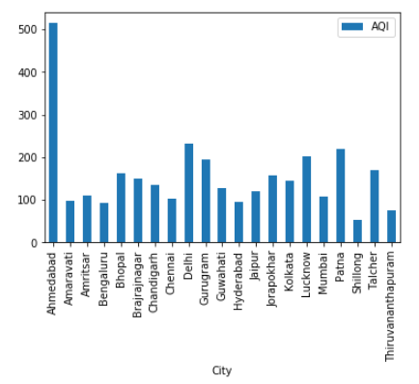 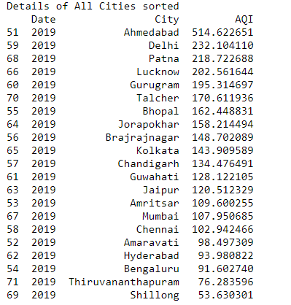

**YEAR :2019 Analysis for AQI Levels**

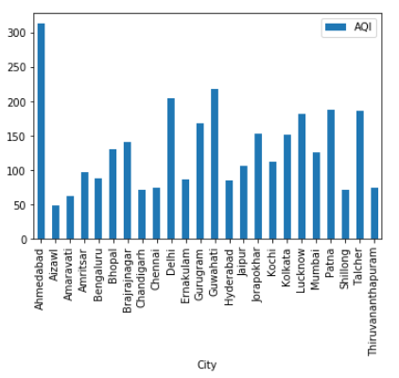

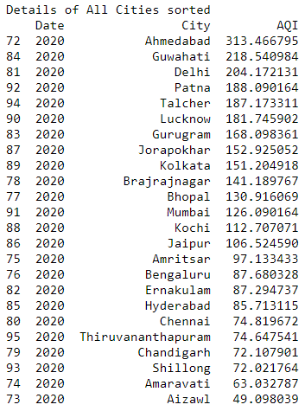

**YEAR :2020 Analysis for AQI Levels**

**" As we can see how AQI levels decreased in the year 2020 compared to other years even though 2020 is still on going and only two months of lock down has improved air quality "**

**A.3) Benzene, Toluene and Xylene (BTX)...................**

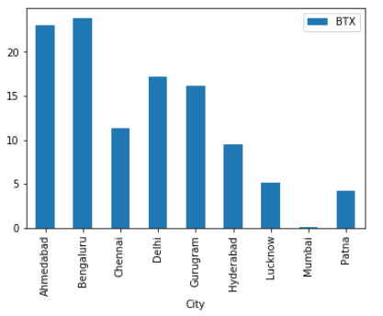 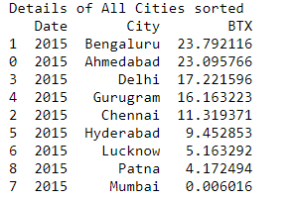

**YEAR :2015 Analysis for BTX Levels**

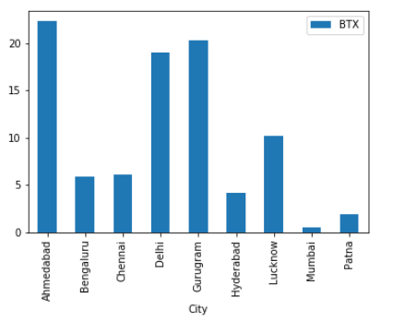 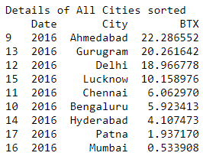

**YEAR :2016 Analysis for BTX Levels**

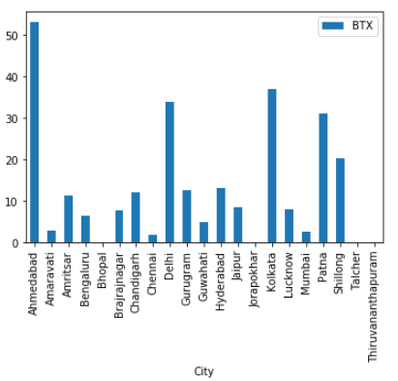

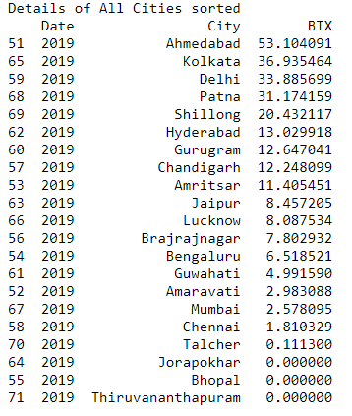

**YEAR :2019 Analysis for BTX Levels**

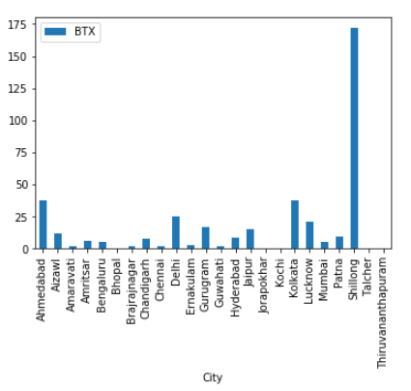

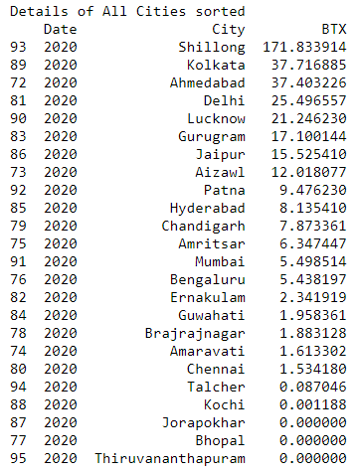

**YEAR :2020 Analysis for BTX Levels**

**" As BTX is an measure of Industrial pollution we can see how the level got down in year 2020 due to various Industries shutting down temporarily due to covid-19 "**

**A.4) Carbon Monoxide(CO)...................**

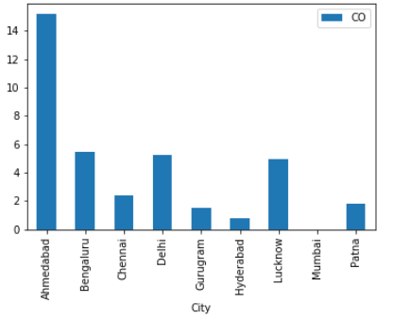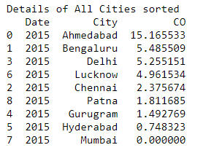**YEAR :2015 Analysis for CO Levels**

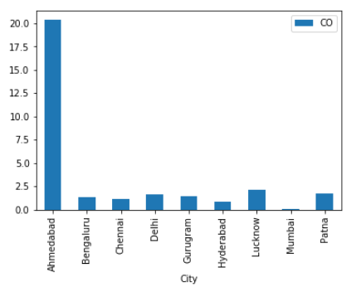 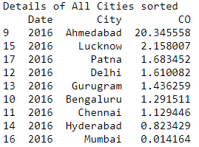

**YEAR :2016 Analysis for CO Levels**

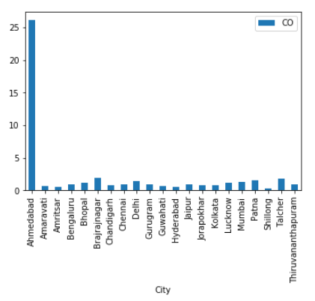

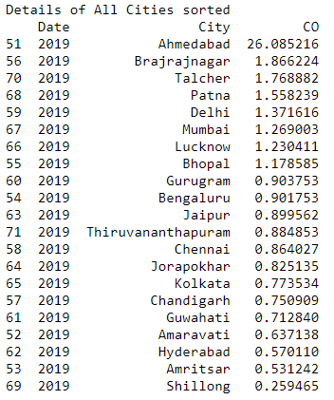

**YEAR :2019 Analysis for CO Levels**

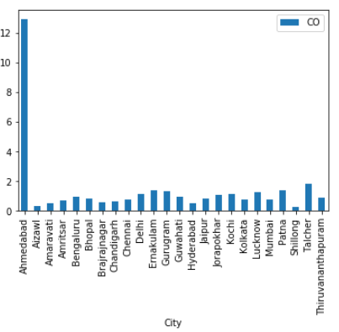

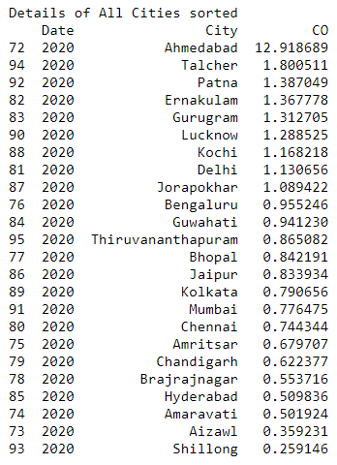

**YEAR :2020 Analysis for CO Levels**

**" As CO is one of the vehicle related pollutants and in most of the cities it got reduced in year 2020 due to lockdown by viewing above graphs "**

B) AQI analysis of major cities before and after lockdown

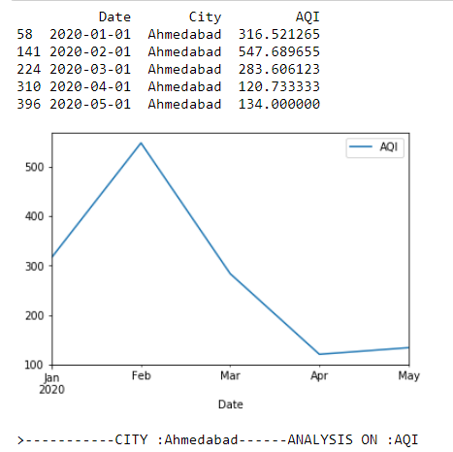

**CITY : Ahmedabad Analysis on AQI Levels**

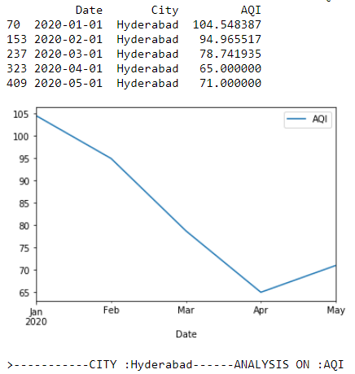

**CITY : Hyderabad Analysis on AQI Levels**

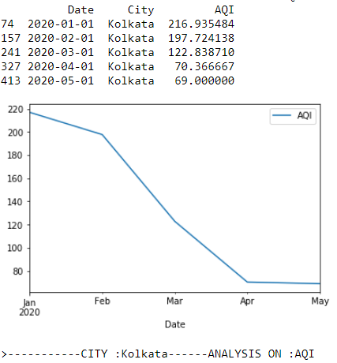

**CITY : Kolkata Analysis on AQI Levels**

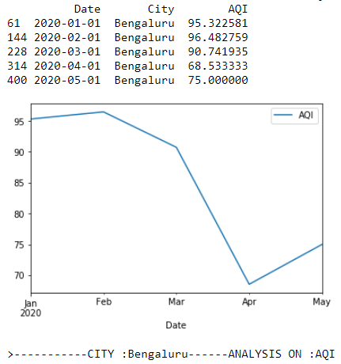

**CITY : Bengaluru Analysis on AQI Levels**

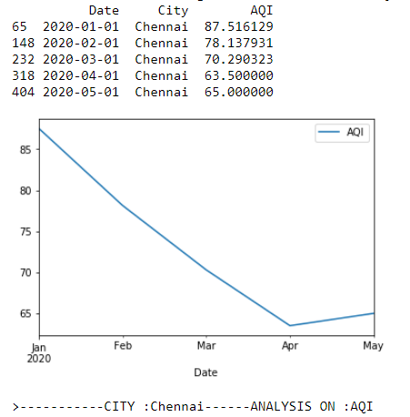

**CITY : Chennai Analysis on AQI Levels**

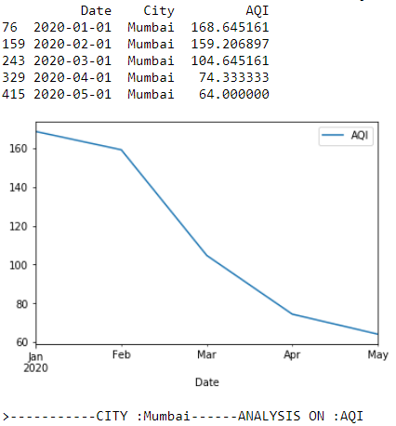

**CITY : Mumbai Analysis on AQI Levels**

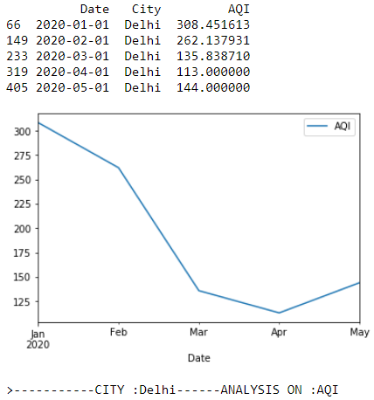

**CITY : Delhi Analysis on AQI Levels**

**"Less the AQI value = more healthy air , and we can see for above major cities**

**that air quality improved in the month of april and march after implementing lockdown in 2020"**

# __________________________REFERENCES_____________________________

# https://www.kaggle.com/parulpandey/breathe-india-covid-19- effect-on-pollution/data?select=city_day.csv

# <https://www.epa.gov/sites/production/files/2014-05/documents/zell-aqi.pdf>

# <https://matplotlib.org/3.2.1/api/_as_gen/matplotlib.pyplot.bar.html>

# <https://matplotlib.org/tutorials/introductory/pyplot.html>