Engineering Intelligence Agent
Technical Design & Build Guide
Flow 1 — direct API integration (selected by the team)
Prepared by: Hasnain
20 July 2026 · v2.0 — updated for the selected flow

How to read this document Every concept is a figure. Code blocks are the actual artifacts to copy into the repository. Yellow boxes mark the places where skipping a check will cost real time.

Verify before building Endpoints and payload shapes follow Jira Cloud REST v3 and the SonarQube Web API, but both evolve — validate every endpoint, field name and Bedrock model ID against current documentation at build time. Every metric function must be validated against its matching Grafana panel.

1. Scope
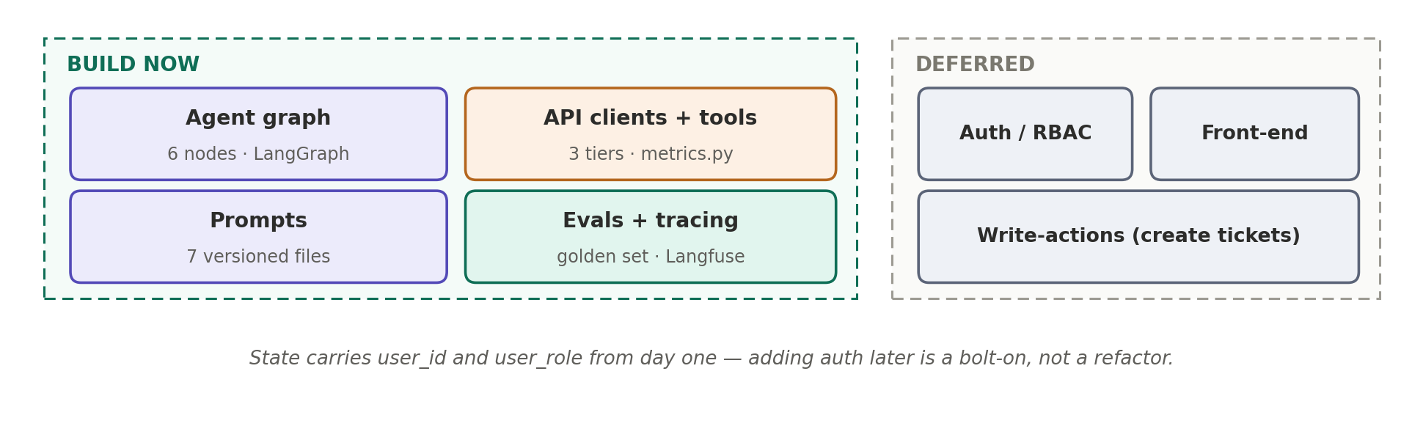
Figure 1 — What is built now vs deferred
The team selected Flow 1: the agent connects directly to the Jira, SonarQube and Engage APIs. DevLake and Grafana continue unchanged and are not touched by the agent. Section 12 records the decision and its consequences.

2. One Question, End to End
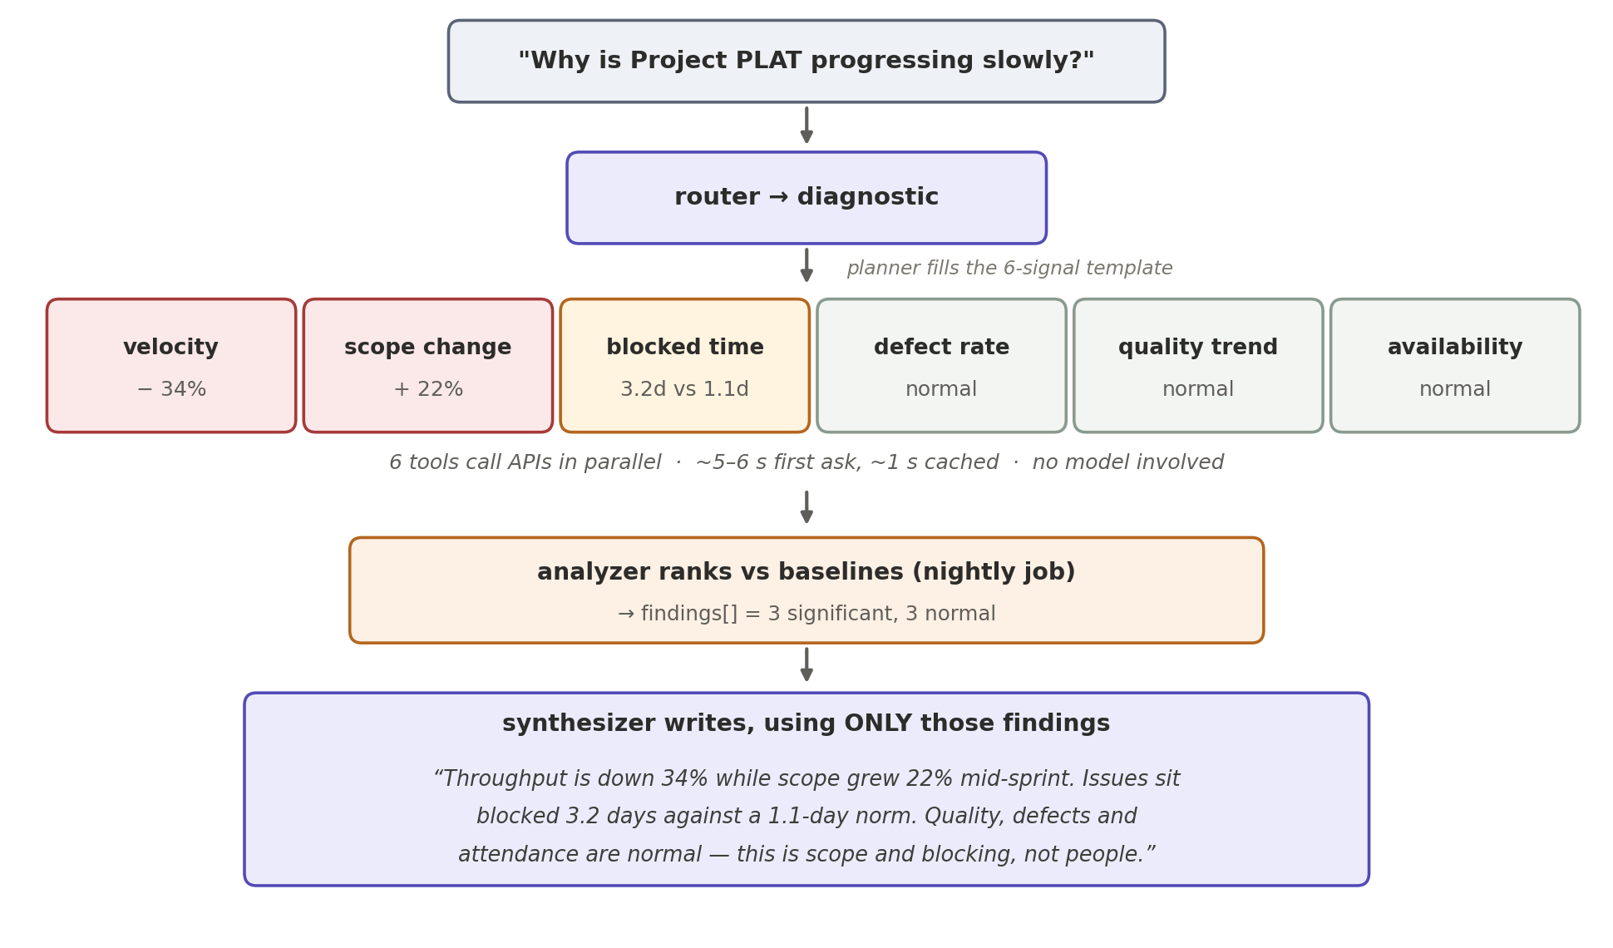
Figure 2 — A diagnostic question, start to finish
- Six tools call the APIs in parallel: ~5–6 s first ask, ~1 s when cached.
- The model appears twice: choose what to fetch, explain what came back.
- Every number was computed by metrics.py — never by the model.
- Normal signals are reported as normal — ruling out causes is part of the answer.

3. The Five Design Rules
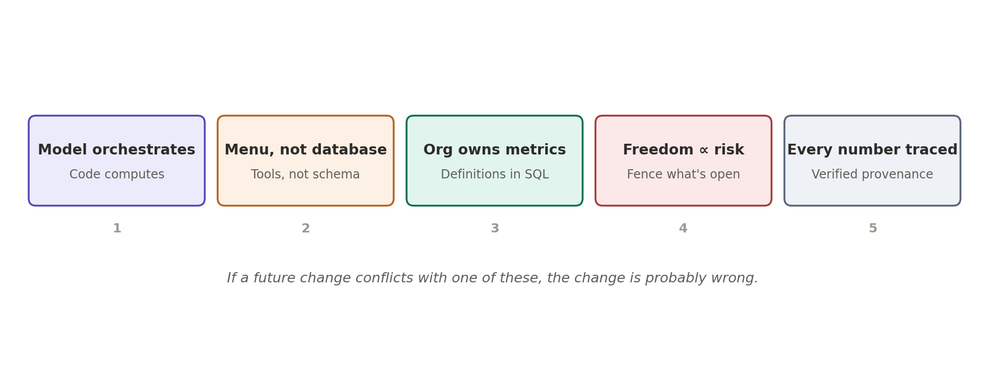
Figure 3 — If a change conflicts with one of these, the change is wrong
Rule | In practice
Model orchestrates, code computes | Every figure comes from metrics.py — code we wrote and can test
Menu, not raw APIs | Model sees ~12 tool descriptions, never endpoints or payloads
Org owns metric definitions | Each metric defined once in metrics.py, version-controlled, validated vs Grafana
Freedom in proportion to risk | Pre-built API tools by default; generated JQL only behind a validator
Every number traced | Findings carry provenance; the verifier enforces it

4. System Architecture
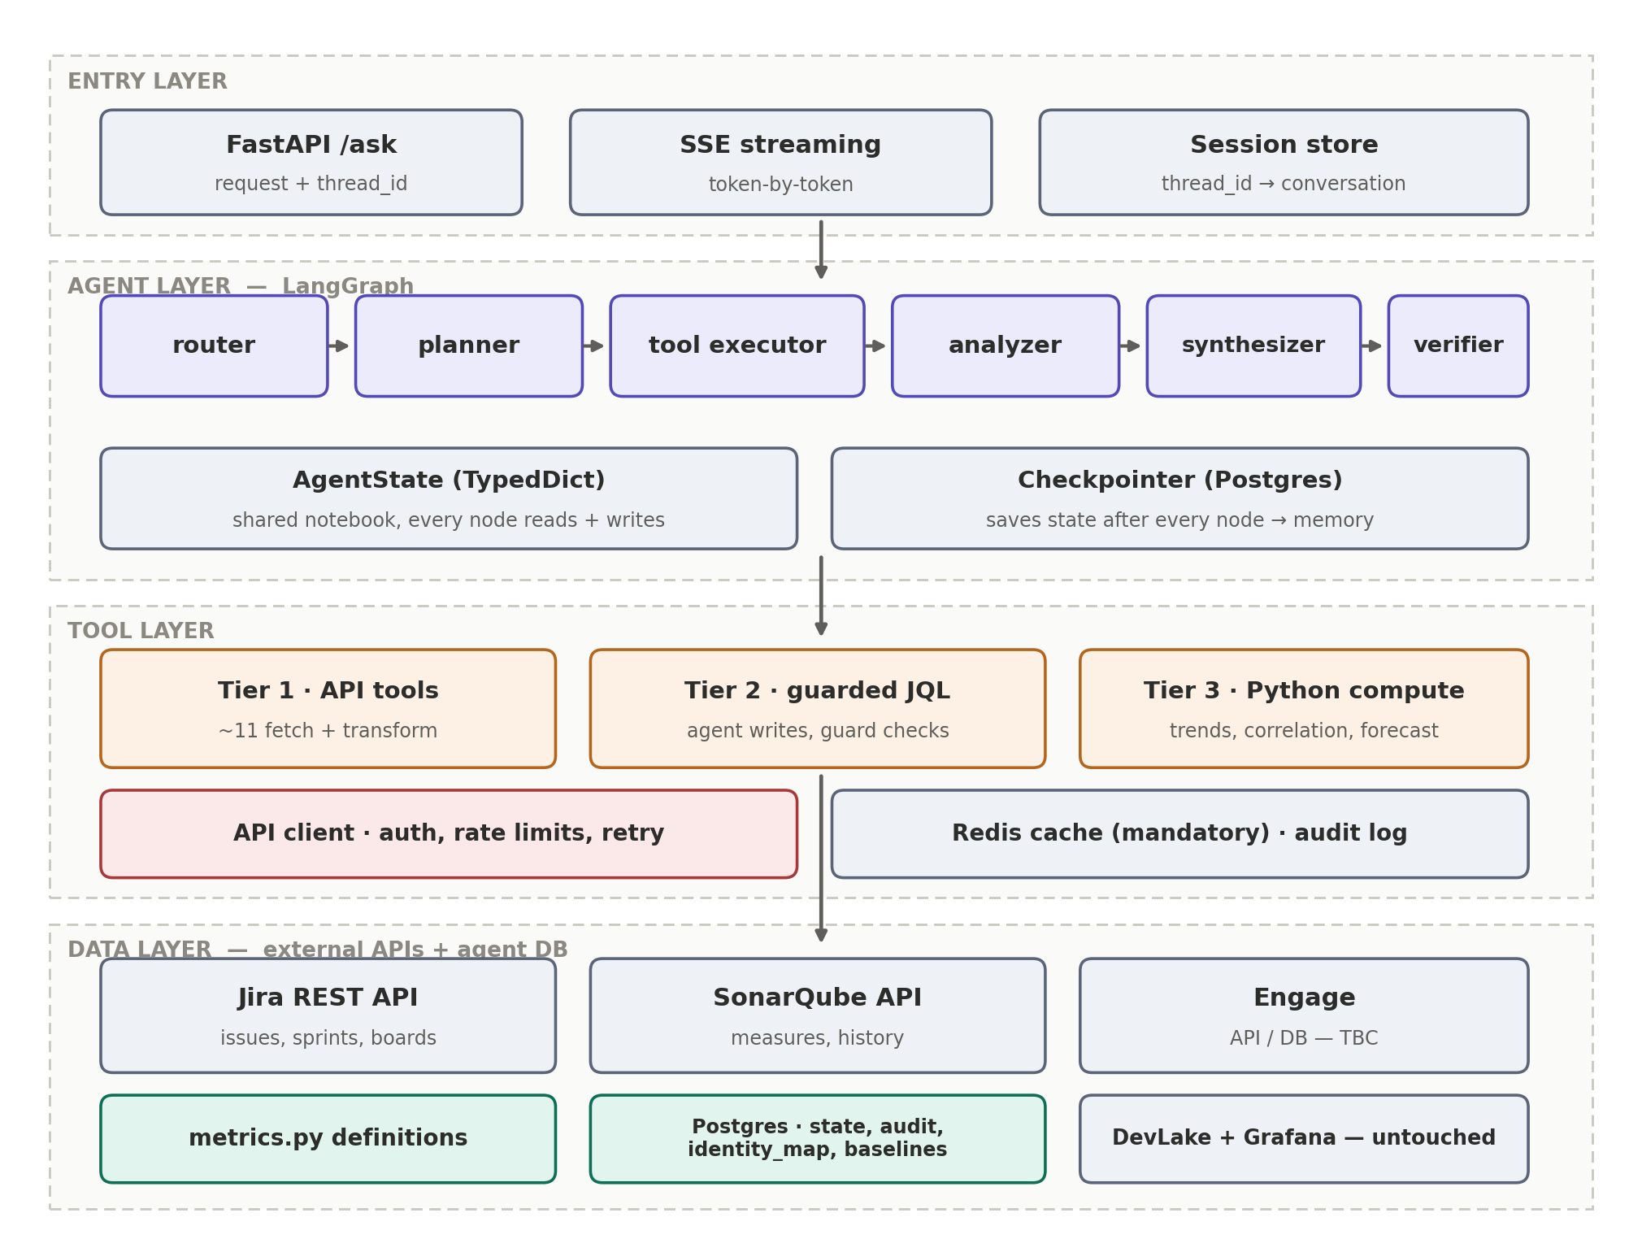
Figure 4 — Four layers; only the tool layer reaches the external APIs
Layer | Technology | Responsibility
Entry | FastAPI | Accept question + thread_id, stream the answer (SSE)
Agent | LangGraph | Decide → execute → analyse → explain → verify (Section 7)
Tool | Python + API clients | Sole data access: clients, cache, guard, audit live here (Sections 6, 9)
Data | External APIs + Postgres | Jira / SonarQube / Engage APIs; agent DB for state, audit, identity, baselines (Section 5)

5. Data & API Layer
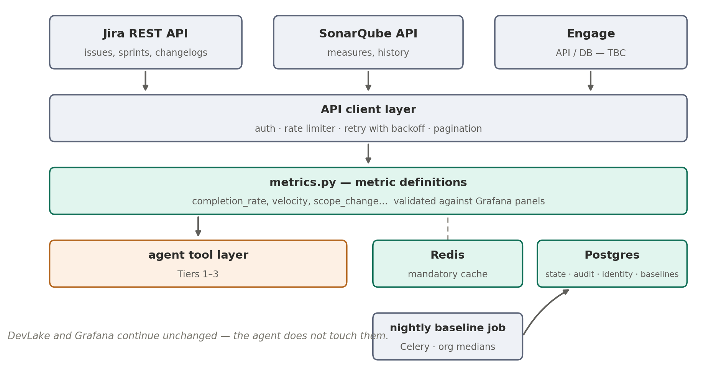
Figure 5 — Build this first; the metric definitions determine answer quality

5.1 metrics.py — the metric definitions
Under Flow 1 the semantic layer is code, not SQL views. Each metric is one pure function: API payloads in, numbers out. This is where “at risk”, “velocity” and “completion rate” are defined — once, version-controlled, reviewed like any other code.
# metrics/definitions.py — the single source of metric truth

def project_health(issues: list[dict], weeks: int) -> dict:
"""Mirrors the 'Project Delivery' Grafana panel definition."""
done = [i for i in issues
if i["fields"]["status"]["statusCategory"]["key"] == "done"]
completion_rate = round(len(done) / max(len(issues), 1), 3)
cycle = [days_between(i["fields"]["created"],
i["fields"]["resolutiondate"])
for i in done if i["fields"]["resolutiondate"]]
return {
"issues_total": len(issues),
"issues_closed": len(done),
"completion_rate": completion_rate,
"avg_cycle_time_days": round(mean(cycle), 1) if cycle else None,
}
The one test that matters For every metric function: run it, open the matching Grafana panel (which reads DevLake), compare. Numbers differ → the function is wrong. The agent computes independently of the dashboards, so this validation is the only thing keeping the two consistent.

Domain | metrics.py functions | Answers
Delivery | project_health, velocity_trend, scope_change, blocked_time | progress, risk, sprints
Quality | repo_tech_debt, quality_trend, defect_rate | technical debt, code quality
People | team_performance, team_availability | team output, availability
Reference | project_list, org_summary | lookup, roll-ups

5.2 API client layer
One client per system. All rate limiting, retries and pagination live here — tools never call httpx directly.
class JiraClient:
BASE = "https://<org>.atlassian.net/rest/api/3"

def __init__(self, token: str):
self.http = httpx.AsyncClient(timeout=20)
self.sem = asyncio.Semaphore(4) # concurrency cap

async def search_all(self, jql: str, fields: list[str],
max_pages: int = 10) -> list[dict]:
issues, start = [], 0
for _ in range(max_pages):
page = await self._get("/search", params={
"jql": jql, "fields": ",".join(fields),
"startAt": start, "maxResults": 100})
issues += page["issues"]
if start + 100 >= page["total"]:
break
start += 100
return issues

async def _get(self, path: str, params: dict) -> dict:
for attempt in range(3):
async with self.sem:
r = await self.http.get(self.BASE + path,
params=params,
headers=auth_headers())
if r.status_code == 429: # rate limited
wait = int(r.headers.get("Retry-After", 2))
await asyncio.sleep(wait)
continue
r.raise_for_status()
return r.json()
raise ApiExhausted(path)

5.3 Identity map (build early — every people question needs it)
CREATE TABLE identity_map (
employee_id VARCHAR(64) PRIMARY KEY, -- Engage
company_email VARCHAR(255) UNIQUE NOT NULL,
jira_account_id VARCHAR(128),
sonar_login VARCHAR(128),
team_name VARCHAR(128),
is_active BOOLEAN DEFAULT TRUE
);

5.4 Baselines — precomputed nightly
The analyzer needs “normal” to compare against. Computing org medians live would mean crawling every project per question, so a nightly Celery job precomputes them. This is the only stored aggregate Flow 1 requires.
CREATE TABLE baselines (
signal VARCHAR(64),
entity VARCHAR(128), -- project key, team, or 'org'
median_value NUMERIC,
p25 NUMERIC,
p75 NUMERIC,
computed_at TIMESTAMPTZ,
PRIMARY KEY (signal, entity)
);
@celery.task # scheduled nightly via Celery beat
def refresh_baselines():
for project in jira.list_project_keys():
for signal, fn in BASELINE_FNS.items():
upsert_baseline(signal, project, fn(project))
upsert_org_medians() # 'org' rows = medians across projects

5.5 Supporting stores
Store | Purpose
Postgres (agent DB) | Checkpointer (conversation state), audit log, identity map, baselines
Redis — mandatory | API tool result cache, TTL per endpoint (5–30 min), key = tool + args

6. The Three Tiers
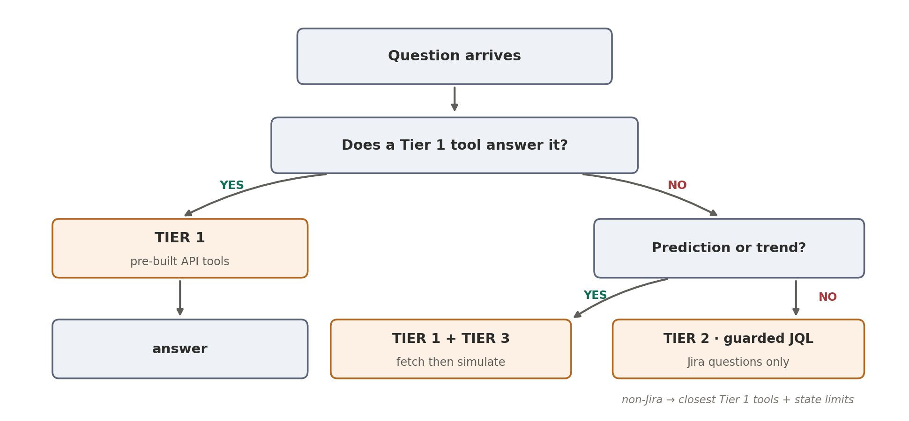
Figure 6 — Tier = how much freedom the agent has; chosen by the planner, never the user
Tier | Who writes the logic | When | Target share | Risk
1 | We do | Before deployment | ~85% | Very low
2 | The agent (JQL) | At request time | ~10% | Medium — fenced
3 | We write, agent calls | Before deployment | ~5% | Low — isolated
Track the shares in production: a rising Tier 2 share = missing Tier 1 tools. Promote repeated JQL questions monthly.

6.1 Tier 1 — pre-built API tools (~85%)
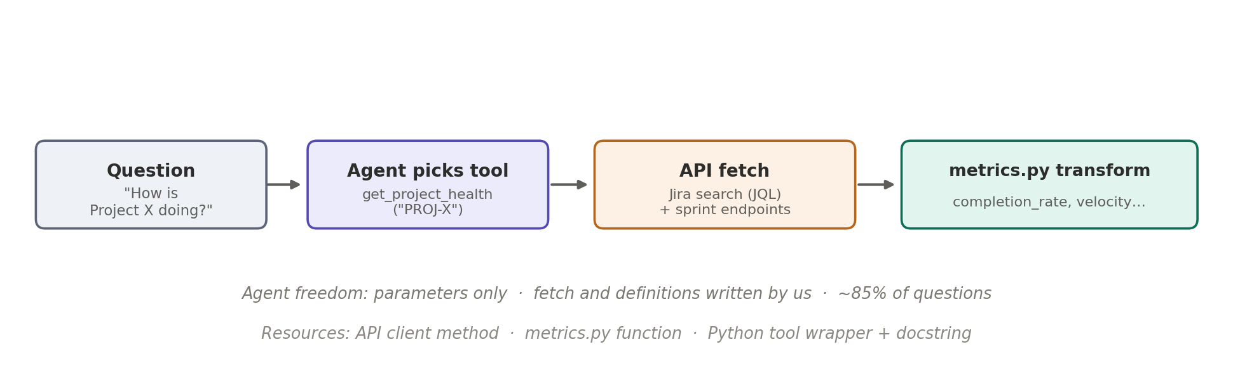
Figure 7 — Agent chooses and parameterises; fetch and definitions are ours
Question: "How is Project PLAT doing?"

Agent emits: {"tool": "get_project_health",
"args": {"project_key": "PLAT", "weeks": 6}}

Executor runs: jira.search_all(...) → metrics.project_health(...)
Returns: {"completion_rate": 0.58, "avg_cycle_time_days": 9.4,
"issues_total": 143, "issues_closed": 83}

6.2 Tier 2 — guarded generated JQL (~10%, Jira only)
For Jira questions no tool anticipates, the agent writes a JQL search query. SonarQube and Engage expose fixed endpoints rather than a query language, so unanticipated non-Jira questions fall back to the closest Tier 1 tools with the limitation stated.
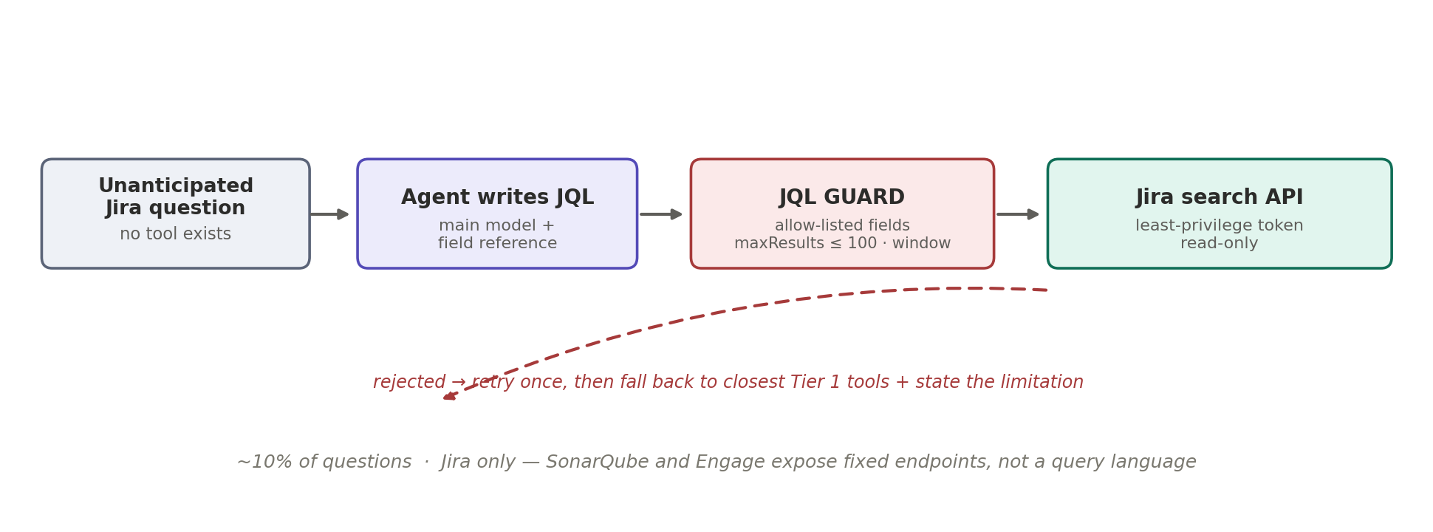
Figure 8 — Tier 2 path with the JQL guard
ALLOWED_FIELDS = {"project", "status", "issuetype", "sprint",
"assignee", "priority", "labels", "created",
"updated", "resolutiondate", "resolution"}
JQL_KEYWORDS = {"AND", "OR", "NOT", "IN", "IS", "EMPTY", "ORDER",
"BY", "ASC", "DESC", "WAS", "CHANGED"}
FIELD_RE = re.compile(r"[A-Za-z][A-Za-z0-9_.]*")

def guard_jql(jql: str) -> str:
if len(jql) > 400:
raise Unsafe("query too long")
tokens = set(FIELD_RE.findall(jql))
unknown = tokens - ALLOWED_FIELDS - JQL_KEYWORDS \
- known_project_keys() - known_values()
if unknown:
raise Unsafe(f"not allowed: {unknown}")
if "updated" not in jql and "created" not in jql:
jql += " AND updated >= -26w" # force a time bound
return jql # executed with maxResults ≤ 100 + client timeout
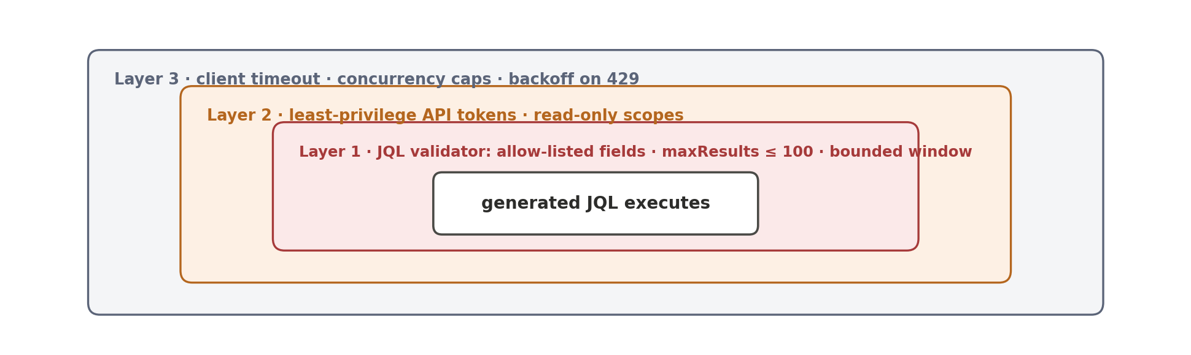
Figure 9 — Three independent fences around generated JQL

6.3 Tier 3 — Python computation (~5%)
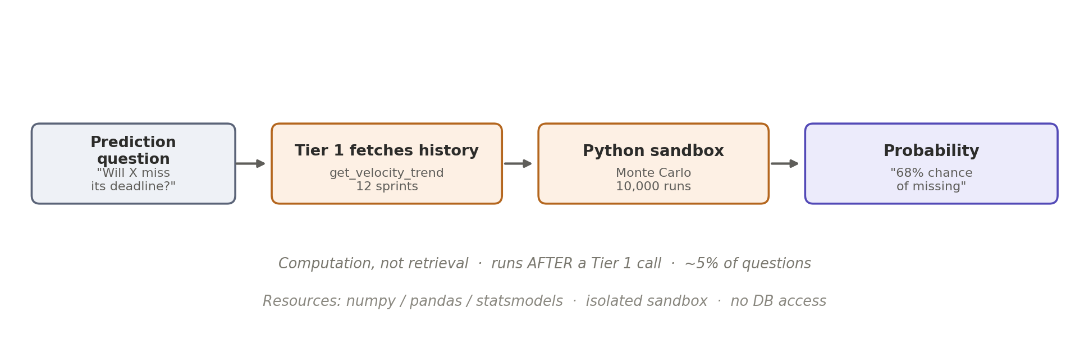
Figure 10 — Computes on fetched data; runs AFTER Tier 1, never instead of it
Step 1 (Tier 1): get_velocity_trend("PLAT", sprints=12) # via Jira
→ [23, 19, 25, 17, 21, 15, 18, 22, 16, 20, 14, 19]
Step 2 (Tier 3): monte_carlo_completion(history, remaining_points=94,
sprints_left=4, runs=10000)
→ {"p_on_time": 0.32, "p50_sprints": 5, "p90_sprints": 7}
Step 3: the model explains the 32% — it does not produce it.
Function | Purpose
monte_carlo_completion | P(finish remaining scope in N sprints)
trend_fit | Regression + significance: “is this getting worse?”
detect_anomalies | Values far outside historical range
correlate_signals | Metric relationship, with causation caveat
compare_to_baseline | Deviation vs history and the baselines table

Sandbox constraints: numpy / pandas / statsmodels only · no network, API or filesystem access · fixed function set · predictions always reported with assumptions and uncertainty.

7. The Agent Graph
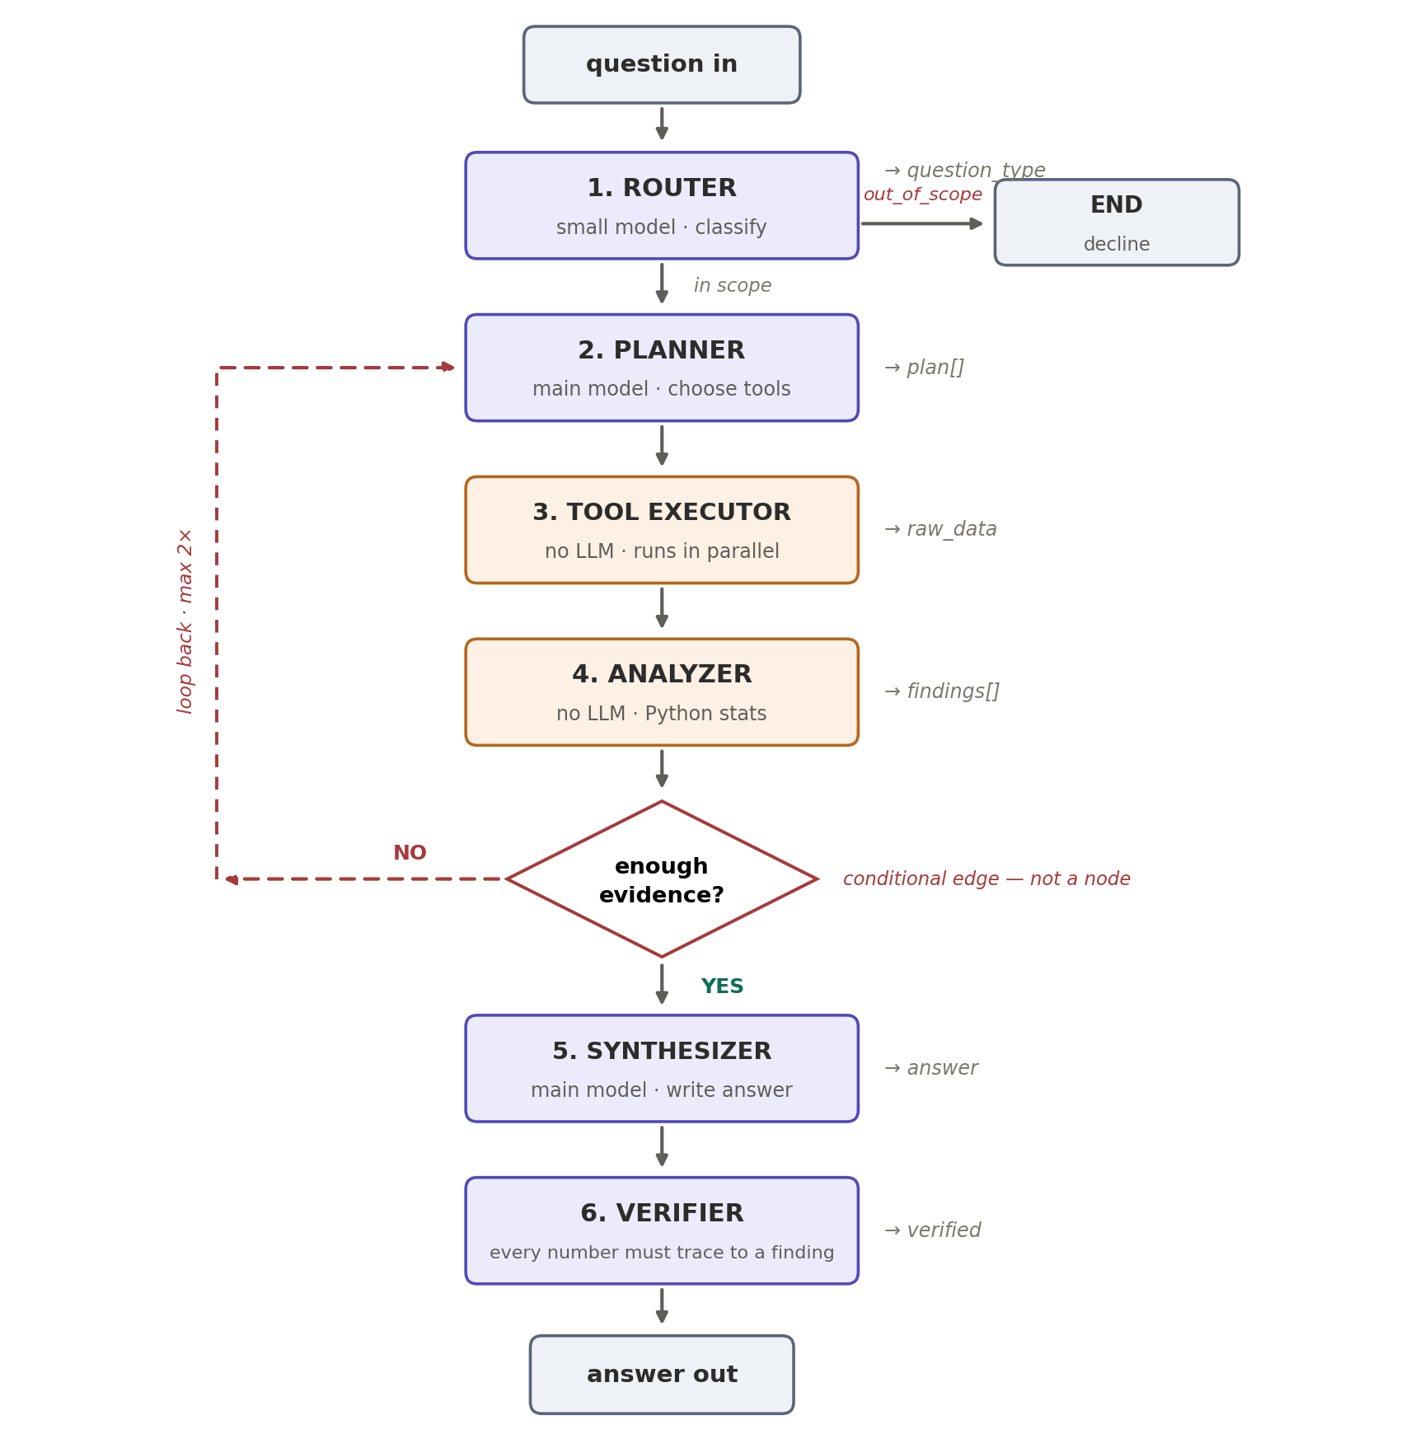
Figure 11 — Six nodes, two conditional edges. The analyzer writes findings[]; only the synthesizer writes the answer.
Node | Model? | Writes to state
1. router | small | question_type
2. planner | main | plan[] (max 8 calls)
3. tool executor | none | raw_data{}
4. analyzer | none | findings[] — every number a user sees
5. synthesizer | main | answer, citations[]
6. verifier | small | verified, warnings[]

7.1 State
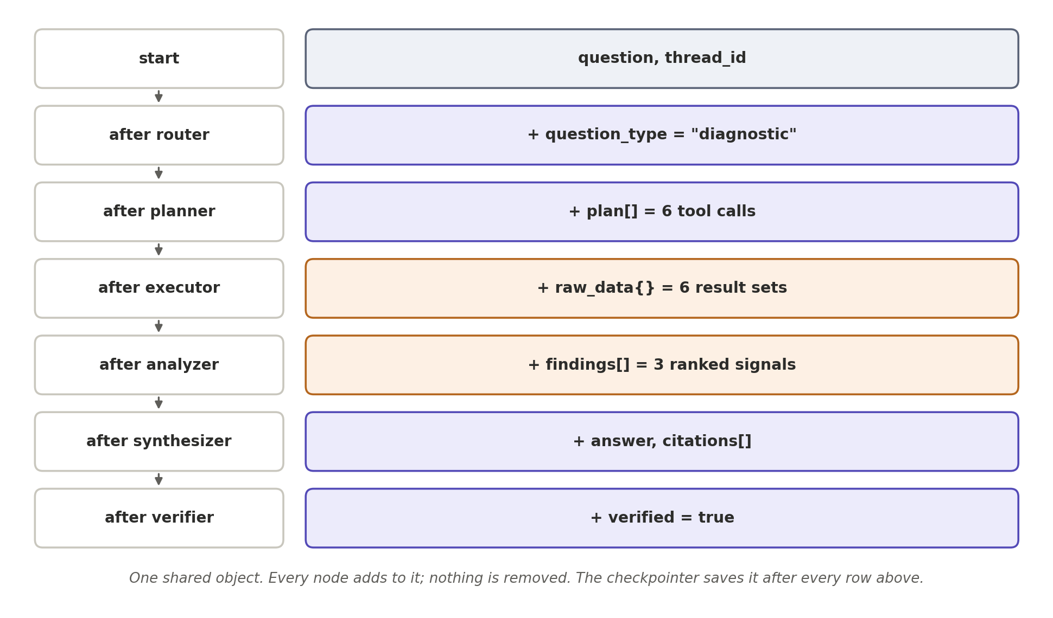
Figure 12 — The state fills up; the checkpointer saves it after every row
from typing import TypedDict, Literal
from pydantic import BaseModel

class ToolCall(BaseModel):
tool: str
args: dict
reason: str # why the planner chose it

class Finding(BaseModel):
signal: str # "blocked_time"
value: float # 3.2
unit: str # "days"
baseline: float # 1.1
deviation_pct: float # +191
severity: Literal["high", "medium", "normal"]
source_tool: str # provenance for the verifier

class AgentState(TypedDict):
user_id: str # carried now, enforced later
user_role: str
thread_id: str
question: str
question_type: str # router
plan: list[ToolCall] # planner
raw_data: dict # executor
findings: list[Finding] # analyzer
loop_count: int
answer: str # synthesizer
citations: list[str]
verified: bool # verifier
warnings: list[str]

7.2 Node code

router
def router(state: AgentState) -> dict:
prompt = render("router.md", question=state["question"])
label = small_llm.invoke(prompt).content.strip().lower()
if label not in VALID_TYPES:
label = "simple" # safe default
return {"question_type": label}

planner
def planner(state: AgentState) -> dict:
template = f"planner_{state['question_type']}.md"
prompt = render(template,
question=state["question"],
tools=tool_catalogue(),
glossary=glossary_for(state["question"]),
prior=state.get("findings", []))
raw = main_llm.invoke(prompt).content
plan = [ToolCall(**c) for c in parse_json(raw)["calls"]]
return {"plan": plan[:8],
"loop_count": state.get("loop_count", 0) + 1}

tool executor
Do not use LangGraph's ToolNode here ToolNode operates on message-based state (state["messages"]). This design uses a structured plan list, so a custom executor is required — it keeps the diagnostic template deterministic and the plan inspectable.

async def tool_executor(state: AgentState) -> dict:
async def run(call: ToolCall):
fn = TOOL_REGISTRY[call.tool]
key = cache_key(call)
if (hit := await redis.get(key)):
return call.tool, json.loads(hit)
try:
result = await fn(**call.args)
await redis.setex(key, ttl_for(call.tool),
json.dumps(result))
except Exception as e:
result = {"error": str(e)}
await audit_log(state, call, result)
return call.tool, result

results = await asyncio.gather(*[run(c) for c in state["plan"]])
return {"raw_data": dict(results)}

analyzer
def analyzer(state: AgentState) -> dict:
findings = []
for tool, data in state["raw_data"].items():
if "error" in data:
continue
for signal, value in extract_signals(data).items():
base = baseline_for(signal, data.get("entity"))
# ^ reads the nightly baselines table (5.4)
dev = pct_change(value, base)
findings.append(Finding(
signal=signal, value=value, unit=UNITS[signal],
baseline=base, deviation_pct=dev,
severity=classify(dev, signal),
source_tool=tool))
findings.sort(key=lambda f: abs(f.deviation_pct), reverse=True)
return {"findings": findings}

synthesizer
def synthesizer(state: AgentState) -> dict:
prompt = render("synthesizer.md",
question=state["question"],
question_type=state["question_type"],
findings=[f.model_dump() for f in state["findings"]])
answer = main_llm.invoke(prompt).content
return {"answer": answer,
"citations": [f.source_tool for f in state["findings"]]}

verifier
def verifier(state: AgentState) -> dict:
numbers = extract_numbers(state["answer"])
known = {round(f.value, 2) for f in state["findings"]}
known |= {round(f.deviation_pct, 2) for f in state["findings"]}
unsupported = [n for n in numbers if round(n, 2) not in known]
if unsupported:
return {"verified": False,
"warnings": [f"unsupported figure: {n}"
for n in unsupported]}
return {"verified": True, "warnings": []}
Expect occasional false positives on rounded figures — tune tolerance; treat failure as a review flag, not an automatic block.

7.3 Edges + assembly
def route_by_type(state: AgentState) -> str:
if state["question_type"] == "out_of_scope":
return "end"
return "planner"

def enough_evidence(state: AgentState) -> str:
if state["loop_count"] >= 2: # hard stop — not optional
return "synthesize"
if any(f.severity in ("high", "medium") for f in state["findings"]):
return "synthesize"
if state["question_type"] == "simple":
return "synthesize"
return "replan" # widen the search
from langgraph.graph import StateGraph, END
from langgraph.checkpoint.postgres import PostgresSaver

g = StateGraph(AgentState)
g.add_node("router", router)
g.add_node("planner", planner)
g.add_node("tools", tool_executor)
g.add_node("analyzer", analyzer)
g.add_node("synthesizer", synthesizer)
g.add_node("verifier", verifier)

g.set_entry_point("router")
g.add_conditional_edges("router", route_by_type,
{"planner": "planner", "end": END})
g.add_edge("planner", "tools")
g.add_edge("tools", "analyzer")
g.add_conditional_edges("analyzer", enough_evidence,
{"replan": "planner",
"synthesize": "synthesizer"})
g.add_edge("synthesizer", "verifier")
g.add_edge("verifier", END)

app = g.compile(checkpointer=PostgresSaver(pool))

7.4 Memory
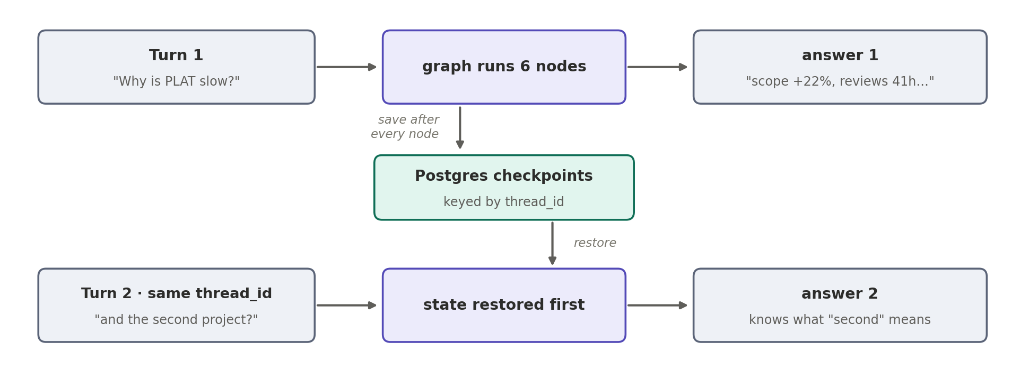
Figure 13 — Same thread_id restores the state; follow-ups just work
result = app.invoke(
{"question": q, "user_id": uid, "thread_id": tid},
config={"configurable": {"thread_id": tid}})

8. Prompt Templates (the actual files)
prompts/
├── router.md → node 1
├── planner_simple.md ┐
├── planner_diagnostic.md ├→ node 2 (chosen by question_type)
├── planner_predictive.md ┘
├── jql_writer.md → Tier 2 tool only
├── synthesizer.md → node 5
└── verifier.md → node 6
Starting points — expected to grow during evaluation. Version each file; tie every change to an eval run.

8.1 router.md
You classify questions about an engineering organisation.

Return exactly one word from this list, nothing else:

simple a direct lookup or count
("how many open bugs in PLAT?")
diagnostic asks why something is happening
("why is PLAT slow?")
predictive asks about the future
("will PLAT miss its deadline?")
prescriptive asks what should be done
("how do we improve throughput?")
out_of_scope not about our engineering data

If unsure between simple and diagnostic, choose diagnostic.

Question: {{ question }}

8.2 planner_diagnostic.md (the most important prompt)
You plan data retrieval for a "why" question about engineering
performance. You do not answer the question.

METHOD
A project underperforms for a limited set of reasons. Gather
evidence for each, then let the analysis decide which apply.
Retrieve all six signals unless one is clearly irrelevant.

1. delivery throughput get_velocity_trend
2. scope stability get_scope_change
3. blocked / wait time get_blocked_time
4. defect inflow get_defect_rate
5. quality trend get_quality_trend
6. team availability get_team_availability

AVAILABLE TOOLS
{{ tools }}

GLOSSARY
{{ glossary }}

{% if prior %}
ALREADY RETRIEVED (do not repeat; widen window or scope)
{{ prior }}
{% endif %}

RULES
- Resolve names to keys via the glossary. If ambiguous, call
list_projects first and stop.
- Default window: 6 sprints or 90 days.
- Maximum 8 tool calls.

Return JSON only:
{"calls": [{"tool": "...", "args": {...}, "reason": "..."}]}

Question: {{ question }}

8.3 planner_simple.md
You select the single best tool to answer a direct question.

AVAILABLE TOOLS
{{ tools }}

GLOSSARY
{{ glossary }}

RULES
- Prefer exactly one tool call. Two only if truly required.
- If no tool fits and it is a Jira question, return
{"calls": [], "needs_jql": true}.
- Never invent tool names or arguments.

Return JSON only:
{"calls": [{"tool": "...", "args": {...}, "reason": "..."}]}

Question: {{ question }}

8.4 planner_predictive.md
You plan a forecast. Forecasts are computed by simulation,
never estimated by you.

REQUIRED SEQUENCE
1. get_velocity_trend (>= 8 sprints of history)
2. get_project_health (remaining scope)
3. monte_carlo_completion with both

If fewer than 6 sprints of history exist, return:
{"calls": [], "insufficient_history": true}

AVAILABLE TOOLS
{{ tools }}

Return JSON only:
{"calls": [{"tool": "...", "args": {...}, "reason": "..."}]}

Question: {{ question }}

8.5 jql_writer.md (Tier 2)
You write one Jira JQL query for a read-only search.

AVAILABLE FIELDS — you may not use anything else
{{ field_reference }}

EXAMPLES
{{ examples }}

RULES
- Read-only search only.
- Use only the fields listed above.
- Always include a time bound (e.g. updated >= -26w) unless
the question specifies one.
- Results are capped at 100.
- If the question is not answerable from Jira, return:
{"jql": null, "reason": "..."}

Return JSON only:
{"jql": "...", "fields": ["..."], "explanation": "..."}

Question: {{ question }}

8.6 synthesizer.md
You explain engineering findings to a senior executive.

FINDINGS — the only facts available to you
{{ findings }}

RULES
- Every number you write must appear in FINDINGS. Never
estimate or infer a figure.
- State value and baseline together:
"3.2 days against a 1.1-day norm".
- Lead with the answer. No preamble.
- Mention only high and medium severity findings, unless the
absence of a problem is itself the answer.
- If FINDINGS is empty or all errors, say the data does not
support an answer and state what is missing. Do not guess.
- For predictions, state the probability and its assumptions.
- Distinguish correlation from causation explicitly.

FORMAT
Sentence 1: the direct answer.
Then: the 2–3 strongest factors, each with number + baseline.
Then (only if asked): actions, each tied to a finding.

Under 200 words unless the question demands more.

Question: {{ question }}

8.7 verifier.md
Check an answer against the findings that produced it.

FINDINGS
{{ findings }}

ANSWER
{{ answer }}

Return JSON only:
{"supported": true|false,
"unsupported_claims": ["..."],
"severity": "none|minor|major"}

A claim is unsupported if it states a number, trend or causal
relationship not present in FINDINGS. Ignore wording and tone.

9. Tool Layer
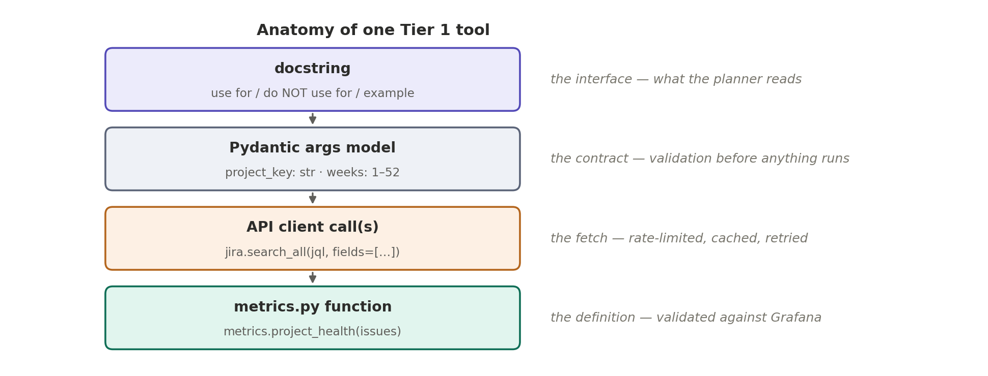
Figure 14 — Four parts of every Tier 1 tool
class ProjectHealthArgs(BaseModel):
project_key: str = Field(description="Jira project key, e.g. PLAT")
weeks: int = Field(default=6, ge=1, le=52)

@register("get_project_health", ProjectHealthArgs)
async def get_project_health(project_key: str, weeks: int = 6) -> dict:
"""Overall delivery health for one project.

Use for: "how is Project X doing", "is Project X at risk".
Do NOT use for: individual people (use get_team_performance),
or code quality (use get_repo_tech_debt).

Returns issues_total, issues_closed, completion_rate,
avg_cycle_time_days.

Example: get_project_health("PLAT", weeks=12)
"""
jql = f'project = "{project_key}" AND updated >= -{weeks}w'
issues = await jira.search_all(jql,
fields=["status", "created", "resolutiondate", "issuetype"])
return {"entity": project_key,
**metrics.project_health(issues, weeks)}
The “Do NOT use for” line prevents more wrong calls than anything else in the system.

9.1 Tier 1 catalogue (12 tools)
Tool | Source endpoints | Returns
get_project_health | Jira search (JQL) | completion rate, cycle time, totals
get_velocity_trend | Jira board sprints + search | throughput per sprint
get_scope_change | Jira sprint issues + changelog | added mid-sprint vs committed
get_blocked_time | Jira search + changelog | time in blocked status, by reason
get_sprint_bottlenecks | Jira board + sprint | stage-level wait times
get_defect_rate | Jira search (type = Bug) | bug inflow vs resolution
get_repo_tech_debt | SonarQube measures/component | debt, issues by severity
get_quality_trend | SonarQube measures/search_history | quality metrics over time
get_team_performance | Jira search + identity_map | team-level aggregates
get_team_availability | Engage (API / DB — TBC) | attendance / capacity
list_projects | Jira project search | projects and keys, disambiguation
get_org_summary | composition of the above | organisation-wide roll-up

People data Both people tools return team-level aggregates by default; individual breakdown stays behind access control when auth arrives. DORA and Microsoft's SPACE framework both advise against ranking individuals on activity metrics.

Errors: the executor returns {"error": ...} instead of crashing; the analyzer skips it; the synthesizer names the gap. A partial answer that names its gaps beats a confident wrong one.

10. Lifecycle, Debugging and Evaluation
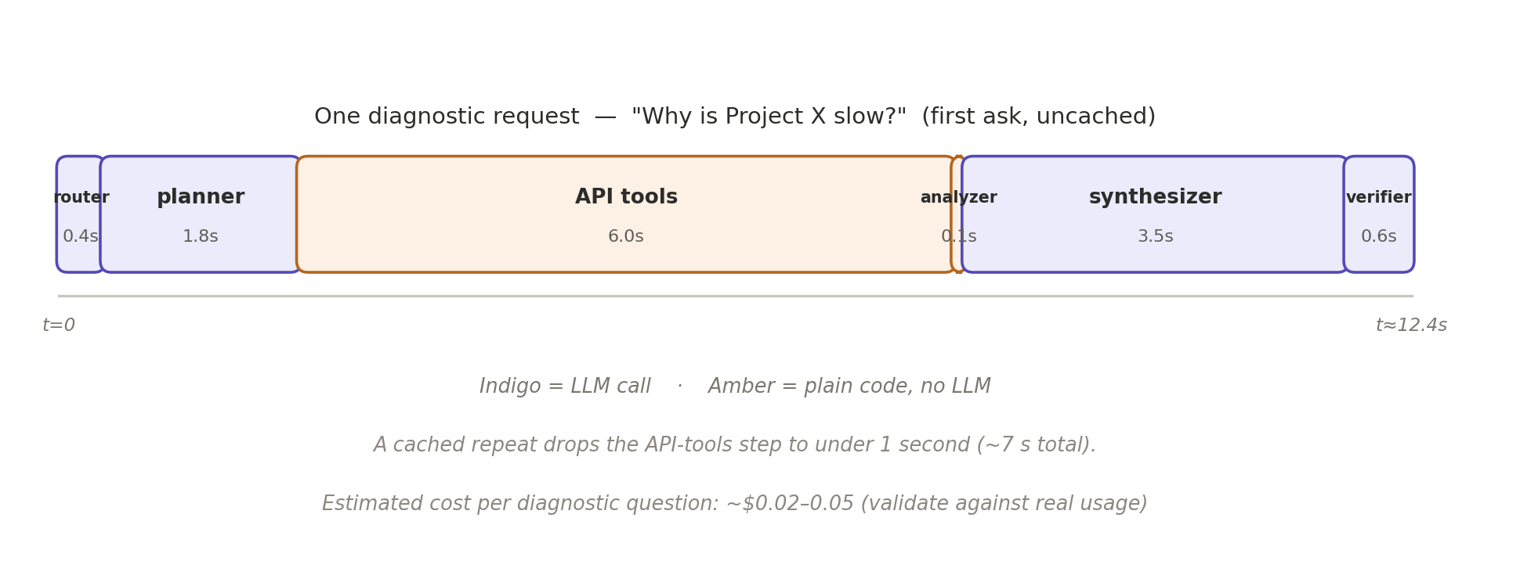
Figure 15 — One diagnostic request (uncached); only 4 of 6 steps use a model
Indicative: diagnostic 12–25 s first ask, ~7 s cached · simple 3–6 s · ~USD 0.02–0.05 per question. Validate against real usage.

10.1 When an answer is wrong
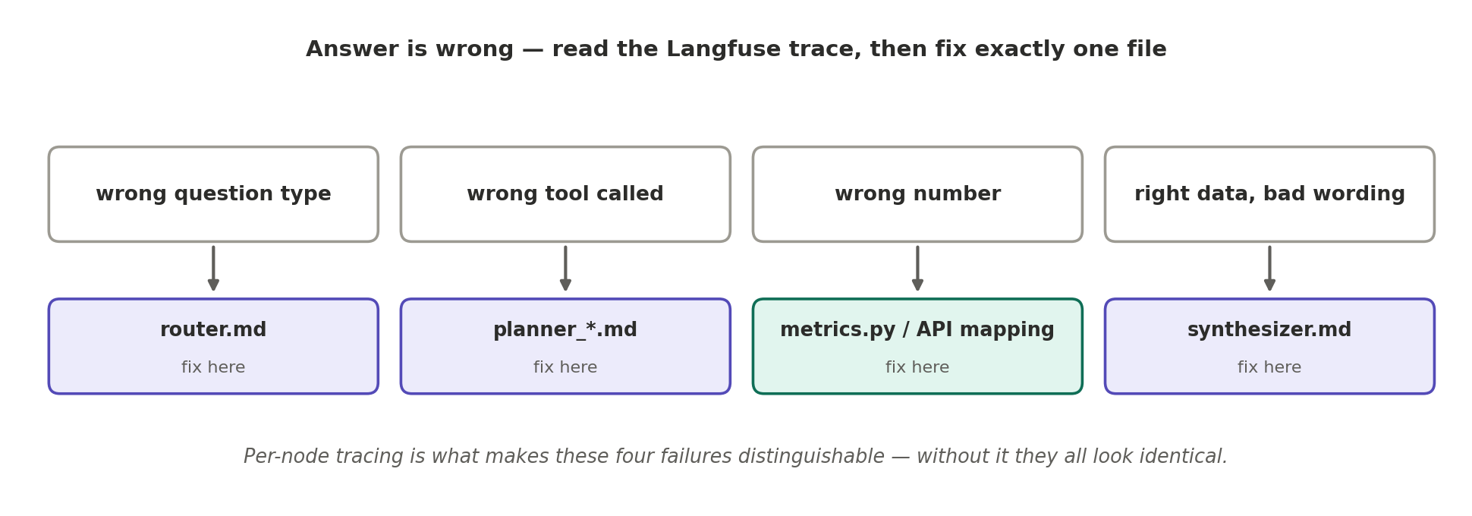
Figure 16 — Symptom → the one file to fix

10.2 Audit log
CREATE TABLE agent_audit (
id BIGSERIAL PRIMARY KEY,
ts TIMESTAMPTZ DEFAULT NOW(),
thread_id VARCHAR(64),
user_id VARCHAR(64),
question TEXT,
question_type VARCHAR(32),
tool_name VARCHAR(64),
tool_args JSONB,
generated_jql TEXT, -- Tier 2 only
api_calls INT, -- requests consumed
duration_ms INT,
error TEXT
);

10.3 Evaluation harness
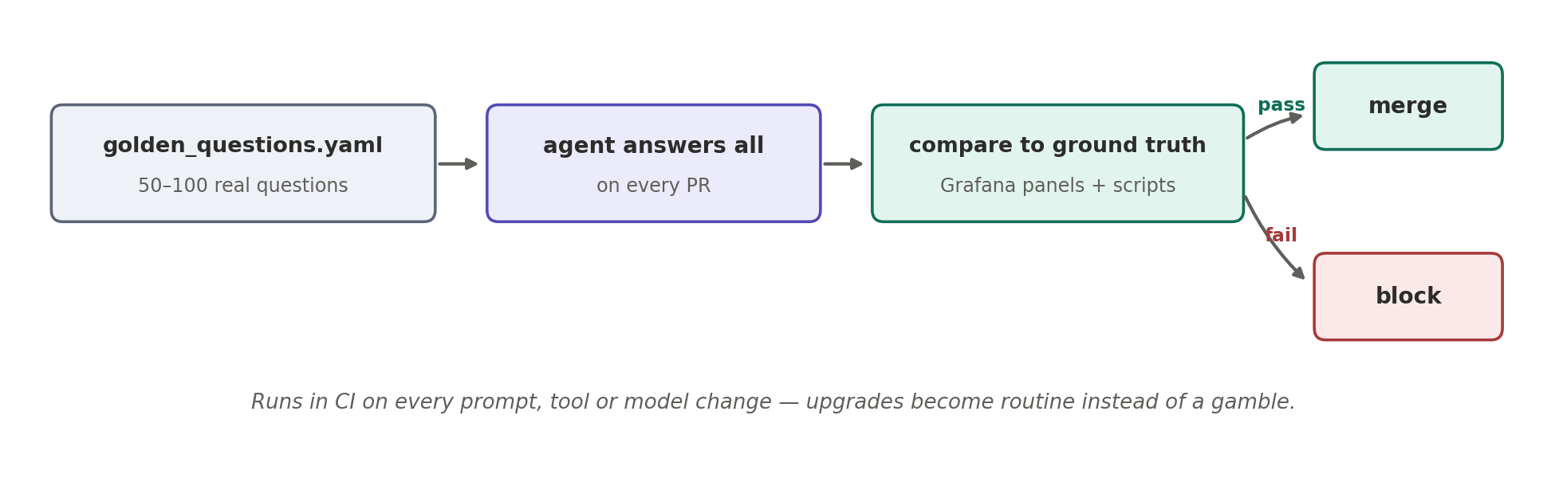
Figure 17 — The gate that makes prompt and model changes safe
# evals/golden_questions.yaml
- id: q001
question: "How many open bugs in PLAT?"
expected_type: simple
expected_tools: [get_defect_rate]
ground_truth: script:count_open_bugs.py # direct API count
tolerance: 0

- id: q014
question: "Why is PLAT slow?"
expected_type: diagnostic
expected_tools: [get_velocity_trend, get_scope_change,
get_blocked_time, get_defect_rate]
must_mention: [velocity, scope]
must_not_mention: [individual_names]
Metric per run | Definition
Routing accuracy | Correct question_type
Tool selection | Expected tools called, none spurious
Numeric accuracy | Figures match ground-truth scripts / Grafana within tolerance
Faithfulness | No claim unsupported by findings
Latency / cost / API calls | P50 and P95 per question type

11. Technology Stack
Layer | Technology | Why
API | FastAPI | Async parallel tool calls; SSE streaming built in
Orchestration | LangGraph | Graph control, checkpointing, conditional edges
State store | PostgreSQL | Checkpointer + audit + identity_map + baselines in one DB
Main model | Claude (frontier tier), AWS Bedrock | Strong tool-calling; inference stays in our AWS boundary
Small model | Claude (fast tier), AWS Bedrock | Routing and verification at a fraction of the cost
HTTP client | httpx (async) | Parallel API calls, timeouts, connection pooling
Tool schemas | Pydantic | Typed arguments, validation
JQL safety | Custom validator | Field allowlist, forced time bounds, result caps
Cache | Redis — mandatory | Rate-limit protection and latency; TTL per endpoint
Sandbox | Isolated Python process | Stats + simulation; no network or API access
Observability | Langfuse (self-hosted) | Per-node tracing, prompt versions, cost, API-call counts
Templating | Jinja2 | Prompt rendering
Jobs | Celery + beat | Nightly baselines, digests
Runtime | ECS Fargate | Managed containers; outbound HTTPS to the tool APIs
Secrets | AWS Secrets Manager | API tokens never in code, config or prompts

Model IDs Confirm current Bedrock model identifiers at build time; benchmark candidates against the golden set, not leaderboards. Azure OpenAI is a viable alternative — the architecture is not model-specific.

Infrastructure estimate: ~USD 150–250 / month excluding model usage. To be validated.

11.1 Repository
engineering-agent/
├── api/main.py FastAPI, /ask endpoint
├── graph/
│ ├── state.py AgentState, ToolCall, Finding
│ ├── nodes.py the six node functions
│ ├── edges.py conditional edges
│ └── build.py assembly + compile
├── api_clients/
│ ├── jira.py auth, rate limits, pagination
│ ├── sonarqube.py
│ └── engage.py
├── metrics/definitions.py metric truth — validated vs Grafana
├── tools/
│ ├── registry.py name → function
│ ├── delivery.py quality.py people.py Tier 1
│ ├── jql_tool.py Tier 2 + guard
│ └── compute.py Tier 3 sandbox
├── prompts/ Section 8 files
├── reference/
│ ├── jira_fields.yaml Tier 2 field reference
│ ├── glossary.yaml org terms → keys
│ └── examples.yaml question → JQL pairs
├── jobs/baselines.py nightly Celery task (5.4)
├── evals/ golden_questions.yaml, run_eval.py
└── infra/ Dockerfile, ECS task defs

12. Decision Record — Flow 1 Selected
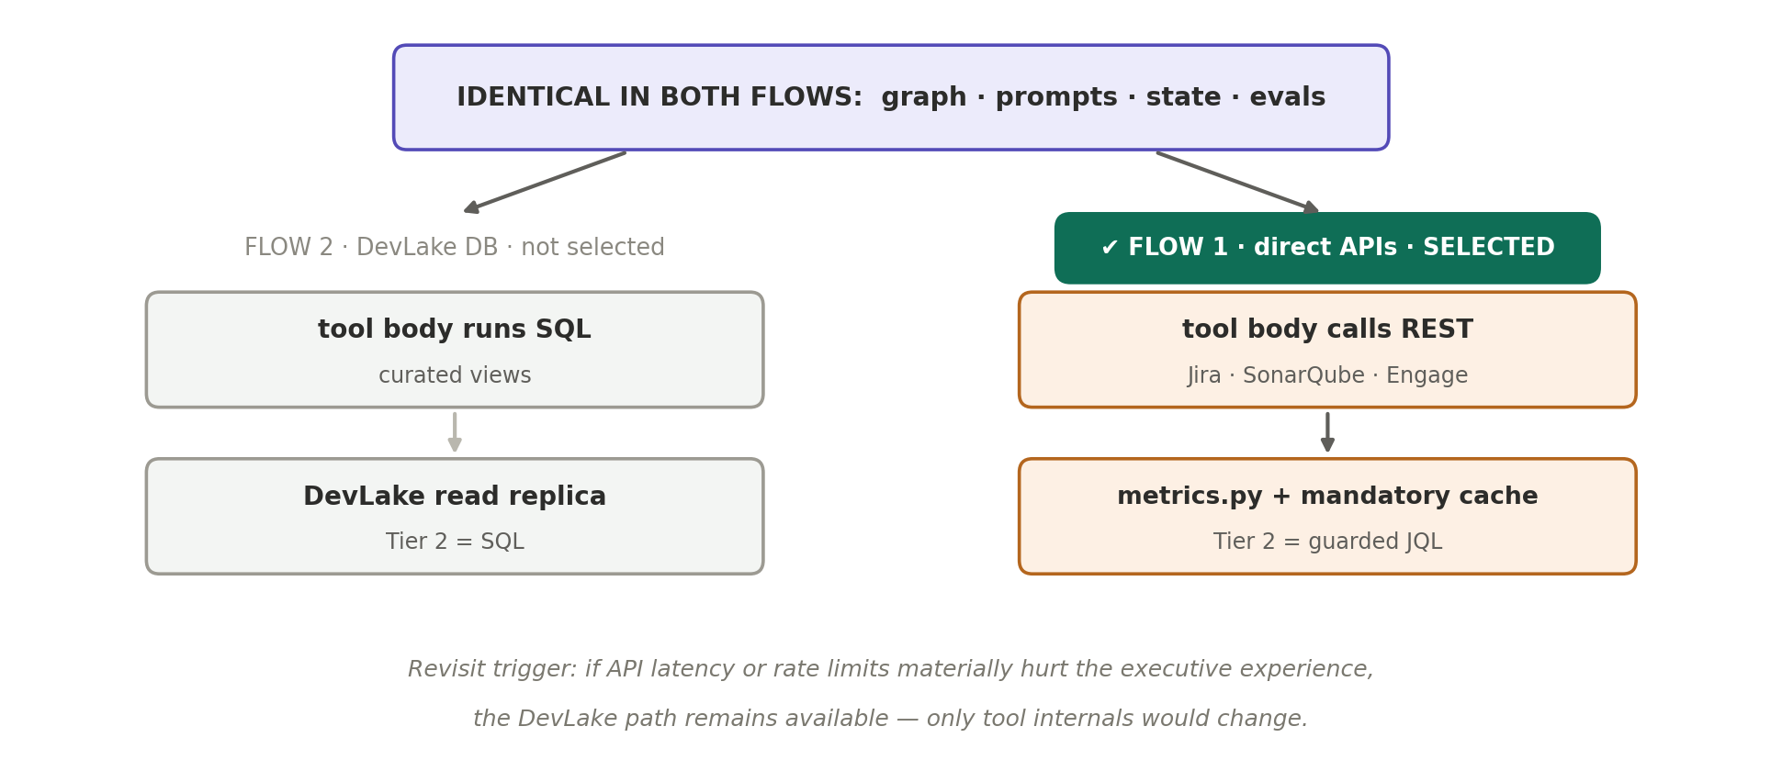
Figure 18 — The team selected direct API integration; the agent core is unchanged
Consequence | Handled by
Metric definitions live in code | metrics.py — version-controlled, validated per metric vs Grafana
Tier 2 is JQL, not SQL | JQL validator + read-only tokens + timeouts (Figures 8–9)
Rate limits and latency | Mandatory Redis cache, concurrency caps, backoff, parallel calls
Baselines can't be computed live | Nightly Celery job → baselines table (Section 5.4)
No GitHub activity signals | Diagnostic template uses defect rate + quality trend instead (agreed scope)
DevLake / Grafana | Untouched — continue exactly as today

Revisit trigger: if API latency or rate limits materially hurt the executive experience in production, the DevLake path remains available — only the internals of the data-access tools would change; graph, prompts, state and evals are flow-independent.

13. Roadmap
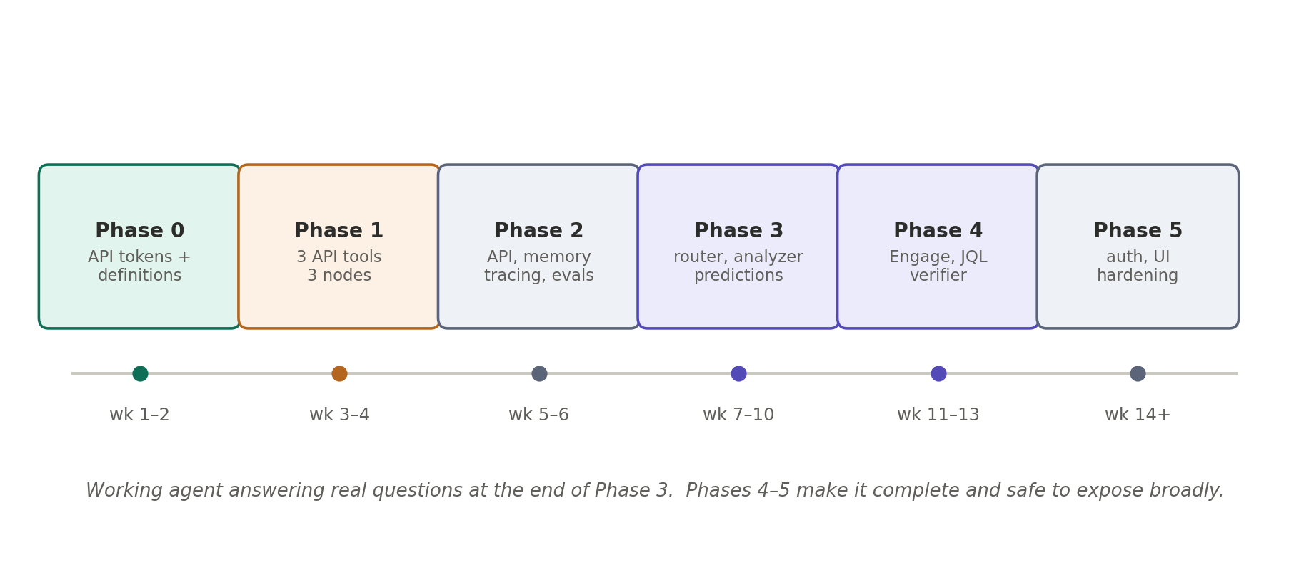
Figure 19 — Working agent at Phase 3; complete and safe at Phase 5
Phase | Weeks | Deliverables | Exit test
0 Foundations | 1–2 | Least-privilege read-only tokens · endpoint audit · metric definitions agreed · API clients with rate limiting · sample metrics vs Grafana | metrics match panels
1 Minimum agent | 3–4 | 3 API tools · 3 nodes · runs in terminal | 10 golden Qs correct
2 System shape | 5–6 | FastAPI · checkpointer · Langfuse · 30-Q evals · remaining Tier 1 | evals green in CI
3 Reasoning | 7–10 | router · analyzer + nightly baselines · diagnostic template · Tier 3 | “why” Qs evidenced
4 Breadth | 11–13 | Engage + identity_map · people tools · guarded JQL · verifier | cross-source Qs work
5 Production | 14+ | auth/RBAC · front-end · digests · load test · runbook | exec rollout

14. Risks
Risk | Impact | Mitigation
Figures disagree with Grafana | Trust lost — hardest failure to recover | metrics.py mirrors panel definitions; validated per metric before release
API rate limits hit | Slow or failed answers | Mandatory cache, concurrency caps, backoff, nightly baselines
Latency on deep questions | Executive frustration | Parallel calls, cache, bounded windows, streamed progress
Fabricated numbers | Wrong executive decisions | Model never computes; verifier checks provenance
Disputed metric definitions | Endless rework | Agreed with leadership in Phase 0; versioned in metrics.py
JQL abuse / runaway queries | API cost, throttling | Validator, forced time bounds, result caps (Figure 9)
Prompt injection via ticket text | Manipulated behaviour | Read-only tokens; no write actions; ingested text untrusted
Individual metrics misuse | Morale damage, adoption failure | Team-level default; individual gated behind auth
Silent prompt regression | Quality decay | Golden evals in CI (Figure 17)
Tool API version changes | Client breakage | Pinned API versions; contract tests per client in CI

15. Immediate Next Steps
- Provision least-privilege, read-only API tokens for Jira and SonarQube; confirm rate-limit budgets.
- Agree metric definitions with engineering leadership; record them in metrics.py stubs.
- Build the Jira and SonarQube API clients; validate three sample metrics against their Grafana panels.
- Build the Phase 1 three-node agent on those three tools.

Where the effort goes ~80% of this project is the API clients and metrics.py — fetching correctly and defining metrics that match the dashboards. The graph is ~40 lines. Build the data layer first.

